**Techno India NJR Institute of Technology**



**Course File**

**Session 2022-23**

**Electronic Devices (3EC4-07)**

Hitesh Sen

(Assistant Professor)

**Department of ECE**

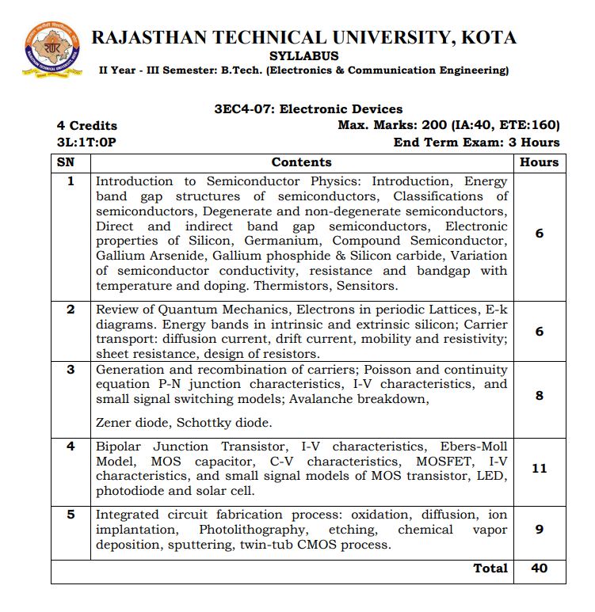

|  |
| --- |
| **Course Overview** |

The course is designed to teach the physics behind electronic device operations and also prepare students for advanced courses in solid state and quantum electronics. The course is intended to increase knowledge gained in undergraduate level courses in electronic devices. The main emphasis is on the fundamental physics behind device operation. Topics include the background physics and the basic principles of electronic device operation with emphasis on bipolar transistors.

|  |
| --- |
| **Course Outcomes:** |

|  |  |  |
| --- | --- | --- |
| **CO.NO.** | **Cognitive Level** | **Course Outcome** |
| 1 | Knowledge | Understanding the semiconductor physics of the intrinsic, P and N materials. |
| 2 | Knowledge | Understanding the characteristics of current flow in a bipolar junction transistor and MOSFET. |
| 3 | Application | Understand and Apply the mathematical models of semiconductor junctions and MOS transistors for circuits and systems. |
| 4 | Analysis | Analyze the characteristics of different electronic devices such as Amplifiers, LEDs, Solar cells, etc. |
| 5 | Knowledge | Theoretical as well as experimental understanding of Integrated circuit fabrication. |

|  |
| --- |
| **Prerequisites:** |

1. Knowledge of semiconductor Physics

|  |
| --- |
| **Course Outcome Mapping with Program Outcome:** |

|  |  |  |  |  |  |  |  |  |  |  |  |  |
| --- | --- | --- | --- | --- | --- | --- | --- | --- | --- | --- | --- | --- |
| **Course Outcome** | **Program Outcomes (PO’s)** | | | | | | | | | | | |
| **CO. NO.** | **Domain Specific** | | | | | **Domain Independent** | | | | | | |
|  | **PO1** | **PO2** | **PO3** | **PO4** | **PO5** | **PO6** | **PO7** | **PO8** | **PO9** | **PO10** | **PO11** | **PO12** |
| CO1 | 3 | 1 | 0 | 2 | 1 | 1 | 0 | 0 | 0 | 0 | 0 | 0 |
| CO2 | 3 | 2 | 1 | 0 | 0 | 2 | 0 | 0 | 0 | 0 | 0 | 0 |
| CO3 | 2 | 1 | 0 | 2 | 0 | 1 | 2 | 0 | 0 | 0 | 0 | 0 |
| CO4 | 3 | 1 | 1 | 0 | 0 | 0 | 2 | 0 | 0 | 0 | 0 | 0 |
| CO5 | 3 | 1 | 1 | 1 | 1 | 0 | 0 | 0 | 0 | 0 | 0 | 2 |
| 1: Slight (Low) , 2: Moderate (Medium), 3: Substantial (High) | | | | | | | | | | | | |
| **Course Coverage Module Wise:** | | | | | | | | | | | | |

|  |  |  |
| --- | --- | --- |
| **Lecture No.** | **Unit** | **Topic** |
| 1 | **1** | **INTRODUCTION TO SEMICONDUCTOR PHYSICS:INTRODUCTION** |
| 2 | 1 | Energy band gap structures of semiconductors |
| 3 | 1 | Classifications of semiconductors |
| 4 | 1 | Degenerate and non-degenerate semiconductors |
| 5 | 1 | Direct and indirect band gap semiconductors |
| 6 | 1 | Electronic properties of Silicon |
| 7 | 1 | Electronic properties of Germanium |
| 8 | 1 | Compound SemiconductorGallium Arsenide, Gallium phosphide & Silicon carbide |
| 9 | 1 | Variation of semiconductor conductivity, |
| 10 | 1 | Resistance and bandgap with temperature and doping |
| 11 | 1 | Thermistors,Sensitors, Numerical |
| 12 | **2** | **REVIEW OF QUANTUM MECHANICS:** |
| 13 | 2 | Electrons in periodic Lattices |
| 14 | 2 | E-k diagrams |
| 15 | 2 | Energy bands in intrinsic and extrinsic silicon |
| 16 | 2 | Carrier transport: diffusion current, drift current |
| 17 | 2 | Mobility and resistivity, sheet resistance |
| 18 | 2 | Design of resistors, Numerical |
| 19 | **3** | **GENERATION AND RECOMBINATION OF CARRIERS:** |
| 20 | 3 | Poisson and continuity equation |
| 21 | 3 | P-N junction characteristicsI-V characteristics, |
| 22 | 3 | Small signal switching models |
| 23 | 3 | Avalanche breakdown, Zener diode |
| 24 | 3 | Schottky diode, Numerical |
| 25 | **4** | **BIPOLAR JUNCTION TRANSISTOR:** |
| 26 | 4 | (Contd.) Bipolar Junction Transistor, BJT I-V characteristics |
| 27 | 4 | Ebers-Moll Model, MOS capacitor |
| 28 | 4 | C-V characteristics |
| 29 | 4 | MOSFET, MOSFET I-V characteristics |
| 31 | 4 | Small signal models of MOS transistor |
| 34 | 4 | LED, photodiode, solar cell, Numerical |
| 35 | 5 | **INTEGRATED CIRCUIT FABRICATION PROCESS:** |
| 36 | 5 | Oxidation, diffusion |
| 37 | 5 | Ion implantation, Photolithography |
| 38 | 5 | Etching, chemical vapor deposition |
| 39 | 5 | Sputtering |
| 40 | 5 | Twin-tub CMOS process, Numerical |

|  |
| --- |
| **Text/Reference Books** |

1. Microelectronic Circuits – Theory and Applications, Adel S Sedra, Kenneth C Smith and Arun N Chandorkar, Oxford University Press.
2. Electronic Devices and Circuit Theory, Robert L Boylestad and Louis Nashelsky, Pearson India Education Services Pv Ltd.
3. Electronic Devices and Circuits, J.B. Gupta, S.K. Kataria& Sons.

|  |
| --- |
| **NPTEL Courses Link** |
| https://onlinecourses.nptel.ac.in/noc22_ee91/preview |

|  |
| --- |
| **Faculty Notes Link** |
| https://drive.google.com/drive/folders/1cRrIX1ffVfx6D4OYKscAax0ez9nhCAG_ |

|  |
| --- |
| **Quiz Link** |
| [**https://www.sanfoundry.com/1000-electronic-devices-circuits-questions-answers/**](https://www.sanfoundry.com/1000-electronic-devices-circuits-questions-answers/) |

|  |
| --- |
| **Assessment Methodology:** |

1. Viva and circuit design in practical lab.
2. Two class test to identify classroom learning level.
3. Two Midterm exams where student have to showcase subjective learning.
4. Final Exam (subjective paper) at the end of the semester.

|  |
| --- |
| **ASSIGNMENT#1** |

Q.1 Explain the process of P-type and N-type semiconductor formation with doping.

Q.2 Explain working principle of thermistor. Explain liquid level indicator using thermistor.

Q.3 A bar intrinsic silicon has a cross-sectional area of 2.5x10-4 m2. The electron density is 1.5x1016 per m3. How long the bar be in order that current in the bar will 1.2mA when 9 volts are applied across it. Assume: µn=0.14m2/volt-sec, µp=0.05m2/volt-sec

Q.4 Explain the concept of sheet resistance. Design a resistor for which the resistivity is given

as 0.44Ω-m, thickness(t) is 0.01µm, L & W both are 2µm.

Q.5 Explain the construction, working principal and V-I characteristics of schottky diode with the help of suitable diagrams.

Q.6 Explain generation and recombination of charge carriers.

Q.7 Explain the motion of electrons in periodic lattices.

Q.8 Explain mobility and conductivity in reference to semiconductor.

|  |
| --- |
| **ASSIGNMENT#2** |

Q.1 Explain input and output characteristics of Commom-Emitter (CB) transistor.

Q.2 Explain C-V characteristics of MOSFET with the help of suitable diagram.

Q.3 Explain the working principal of depletion mode MOSFET in detail.

Q.4 Explain process flow for the fabrication of CMOS p-well process.

Q.5 Explain MOS capacitor with the help of suitable diagram.

Q.6. Write short note on the following:

(a) Photolithography

(b) Etching

(c) Diffusion

(d) Oxidation

|  |
| --- |
| **VIVA** |

Q.1 What is transistor?

Q.2 What is a semi conductor?

Q.3 What is diode?

Q.4 **Define Energy Band Diagram?**

**Q.5 Define Doping?**

**Q.6 Define Intrinsic Semiconductor?**

**Q.7  Define Extrinsic Semiconductor?**

Q.8 **Define P-n Junction?**

**Q.9 Define Forward Biasing?**

**Q.10 Define Diffusion Capacitance?**

**Q.11  Define Drift Velocity And Drift Current?**

**Q.12 What are the advantages of using FET instead BJT?**

**Q.13 What is the use of schottky diode?**

**Q.14 What is etching?**

**Q.15 What is photolithography?**

**Q.16 What are the applications of solar cell?**

**Q.17 What is avalanche breakdown?**

**Q.18 What is zener breakdown?**

**Q.19 What is value of cut-in voltage of si and ge diode?**

**Q.20 Define resistivity?**

**Q.21 Define mobility?**

**Q.22 What is sheet resistance?**

**Q.23 Differentiate silicon and germanium.**

**Q.24 What is degenerate semiconductor?**

|  |
| --- |
| **QUIZ** |

1. Which of the following is not an electronic device?  
a) A mobile  
b) A computer  
c) A magnifying glass  
d) A keyboard

2. Which of the following is not a property of semiconductors used in electronic devices?  
a) They excite electrons  
b) They don’t emit light  
c) They have high thermal conductivity  
d) They have variable electrical conductivity

3. What is the effect of temperature on the recombination rate of electrons in electronic circuits?  
a) Recombination rate increases with increase in the temperature  
b) Recombination rate decreases with increase in the temperature  
c) Recombination rate is independent of temperature  
c) Recombination of electrons doesn’t occur in semiconductors

4. Which of the following is correct about semiconductors in electronic devices?  
a) Elemental semiconductors have direct band gap  
b) Compound semiconductors have indirect band gap  
c) Extrinsic semiconductors are injected with impurities  
d) Doping is done in Intrinsic semiconductors

5. Which of the following is not correct about semiconductors in electronic devices?  
a) Electrons are present below Fermi level in a semiconductor  
b) Degenerated semiconductors behave like a conductor  
c) Fermi level is independent of temperature and doping  
d) Pentavalent atoms are used in an n-type extrinsic semiconductor

6. What type of semiconductor is used in LED electronic circuits?  
a) Intrinsic semiconductor  
b) Compound semiconductor  
c) Degenerated semiconductor  
d) Compensated semiconductor

7.  Which of the following is wrong about threshold voltage (VT) in a MOSFET electronic circuit?  
a) If VT is less, channel form quickly for conductivity  
b) VT can be reduced by reducing oxide layer thickness  
c) VT is independent of ion implementation  
d) VT can be reduced by reducing substrate doping

8.  In which of the following region does BJT act as the amplifier electronic device?  
a) Cut-off  
b) Saturation  
c) Active  
d) Reverse saturation

9. An electronic circuit wire of conductivity 5.8 × 107 mho-m is subjected to an electric field of 40 mV/m. What will be its current density?  
a) 2.32 × 106 A/m2  
b) 1.16 × 106 A/m2  
c) 4.64 × 106 A/m2  
d) 4.30 × 106 A/m2

10. Which of the following is wrong about P-N junction diodes used in electronic devices?  
a) They have three modes of operations  
b) They have dynamic resistance at low-frequency AC voltage  
c) They have diffusion capacitance at high-frequency AC voltage  
d) They can act as ON-OFF switches

11. What is the conductivity of an extrinsic type semiconductor electronic device at 0K?  
a) maximum  
b) zero  
c) can’t be determined  
d) minimum

12. What is the conductivity of an extrinsic type semiconductor electronic device at 300K?  
a) Maximum  
b) Zero  
c) Can’t be determined  
d) Minimum

13.  Which of the following diode is used in ultra-high speed switching electronic circuits?  
a) Zener diode  
b) Varactor diode  
c) Tunnel diode  
d) Schottky diode

14. Forbidden Energy gap (EG) of a semiconductor in electronic devices depends on which of the following factors?  
a) Interatomic distance  
b) Material constant  
c) Electron affinity  
d) Recombination and Generation

15. Which of the following type of transistor is preferred in digital and analog electronic circuits?  
a) BJT  
b) JFET  
c) MOSFET  
d) FET

16. Which of the following is true about Zener diode?  
a) It is lightly doped  
b) It is mostly used in voltage regulator electronic circuits  
c) It is used in forward bias  
d) It has avalanche breakdown

17. Where should be the bias point set in order to make transistor work as an amplifier?  
a) Cut off  
b) Active  
c) Saturation  
d) Cut off and Saturation

18. Q point can be set to work on active region requires particular conditions. What are they?  
a) BE reverse biased and BC forward biased  
b) BE reverse biased and BC reverse biased  
c) BE forward biased and BC reverse biased  
d) BE forward biased and BC forward biased

19. The Q-point of a transistor is made to shift between Active and cut off Region, then how does the transistor behave?  
a) Switch  
b) Amplifier  
c) Inverter  
d) Bulb

20. For a fixed bias circuit having RC=4.7KΩ and RB=1KΩ, VCC=10V, and base current at Bias point was found to be 0.2µA, Find β?  
a) 100  
b) 106  
c) 125  
d) 0

**1.c 2. b 3.b 4.c 5.c 6.b 7.b 8.c 9.a 10.a 11.b 12.a 13.c 14.a 15.c 16.b 17.b 18.c 19.a 20.b**

