# Techno India NJR Institute of Technology



**Course File**

**Power System –II (6EE4-02)**

## Mr. Rajkumar Soni (Assistant Professor)

Department of Electrical Engineering

### Syllabus:

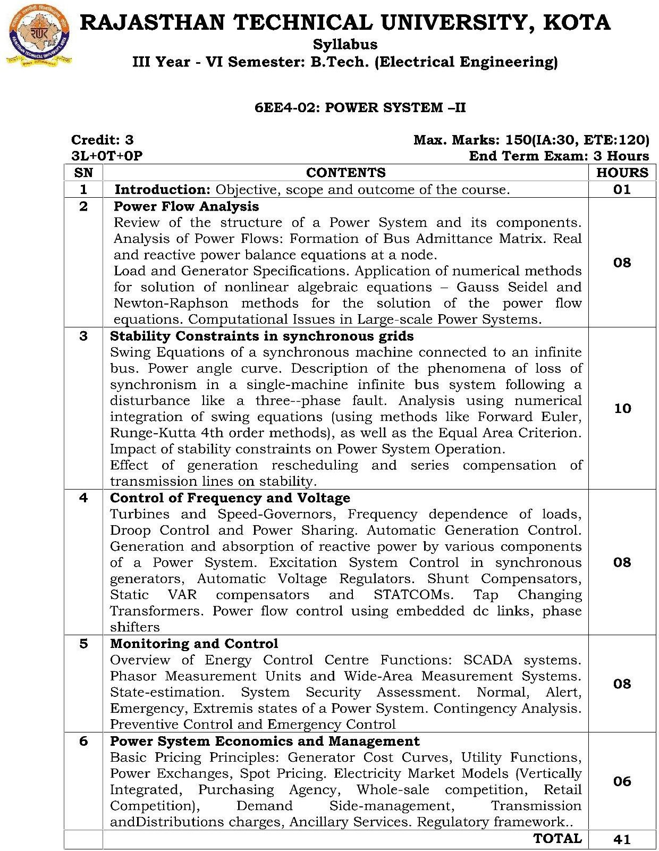

**Course Overview:**

This course familiarizes students with an electric power system is a network of electrical components used to supply, transmit and use electric power. An example of an electric power system is the network that supplies a region's homes and industry with power—for sizable regions, this power system is known as the grid and can be broadly divided into the generators that supply the power, the transmission system that carries the power from the generating centers to the load centers and the distribution system that feeds the power to nearby homes and industries. Smaller power systems are also found in industry, hospitals, commercial buildings, and homes. The majority of these systems rely upon three-phase AC power—the standard for large-scale power transmission and distribution across the modern world. Specialized power systems that do not always rely upon three-phase AC power are found in aircraft, electric rail systems, ocean liners, and automobiles.

### Course Outcome:

|  |  |  |
| --- | --- | --- |
| **CO. NO.** | **Cognitive Level** | **Course Outcome** |
| 1 | Synthesis | Students will be able to discuss primary components of power system planning, planning methodology for optimum power system expansion, various types of generation, transmission and distribution. |
| 2 | Synthesis | Students will be able to show knowledge of forecasting of future load requirements of both demand and energy by deterministic and statistical techniques using forecasting tools. |
| 3 | Analysis | Students will be able to outline and point out methods to mobilize resources to meet the investment requirement for the power sector |
| 4 | Application | Students will be able to use and apply economic appraisal to allocate the resources efficiently and appreciate the investment decisions. |
| 5 | Application | Students will be able to use and apply economic cost curves, Utility functions, Power Exchange and appreciate the investment decisions. |

**Prerequisites:**

1. The prerequisites for this course are fundamentals of basic Power system and its components.
2. Students should be efficient in synchronous machine basics.
3. Students should be familiar with automatic generation control .
4. Monitoring and control: SCADA systems.

### Course Outcome Mapping with Program Outcome:

|  |  |  |  |  |  |  |  |  |  |  |  |  |
| --- | --- | --- | --- | --- | --- | --- | --- | --- | --- | --- | --- | --- |
| **Course Outcome** | **Program Outcomes (PO’s)** | | | | | | | | | | | |
| **CO. NO.** | **Domain Specific (PSO)** | | | | | **Domain Independent (PO)** | | | | | | |
|  | **PO1** | **PO2** | **PO3** | **PO4** | **PO5** | **PO6** | **PO7** | **PO8** | **PO9** | **PO10** | **PO11** | **PO12** |
| CO1 | 1 | 2 | 1 | 2 | 1 | - | - | - | - | - | - | - |
| CO2 | 3 | 2 | 2 | 1 | 1 | - | - | - | - | - | - | - |
| CO3 | 2 | 1 | 2 | 2 | - | - | - | - | - | - | - | - |
| CO4 | 2 | 3 | 2 | 2 | 1 | - | - | - | - | - | - | - |
| CO5 | 1 | 3 | 2 | 2 | 3 | - | - | - | - | - | - | - |
| 1: Slight (Low), 2: Moderate (Medium), 3: Substantial (High) | | | | | | | | | | | | |

**Course Coverage Module Wise:**

|  |  |  |
| --- | --- | --- |
| **Lect. No.** | **Unit** | **Topic** |
| 1 | **1** | **INTRODUCTION:** Objective, Scope and Outcome of The Course. |
| 2 | **2** | **REVIEW OF THE STRUCTURE OF A POWER SYSTEM** and Its  Components. |
| 3 | 2 | Analysis of Power Flows: Formation of Bus Admittance Matrix |
| 4 | 2 | Real and reactive power balance equations at a node. |
| 5 | 2 | Load and Generator Specifications |
| 6 | 2 | Application of numerical methods for solution of nonlinear algebraic equations –  Gauss Seidel and Newton-Raphson methods for the solution of the power flow equations. |
| 7 | 2 | Computational Issues in Large-scale Power Systems. |
| 8 | 2 | Numerical Practice |
| 9 | **3** | **STABILITY CONSTRAINTS:** Synchronous Grids |
| 10 | 3 | Swing Equations of a synchronous machine connected to an infinite bus. Power angle curve. |
| 11 | 3 | Description of the phenomena of loss of synchronism in a single-machine infinite bus system following a disturbance like a three--phase fault. |
| 12 | 3 | Analysis using numerical integration of swing equations (using methods like Forward Euler, Runge-Kutta 4th order methods), as well as the Equal Area  Criterion |
| 13 | 3 | Impact of stability constraints on Power System Operation. |
| 14 | 3 | Effect of generation rescheduling and series compensation of transmission lines on stability. |

|  |  |  |
| --- | --- | --- |
| 15 |  | Numerical Practice |
| 16 | **4** | **CONTROL OF FREQUENCY AND VOLTAGE:** Turbines and Speed- Governors |
| 17 | 4 | Turbines and Speed-Governors |
| 18 | 4 | Frequency dependence of loads, Droop Control and Power Sharing. |
| 19 | 4 | Automatic Generation Control |
| 20 | 4 | Generation and absorption of reactive power by various components of a Power System |
| 21 | 4 | Excitation System Control in synchronous generators, Automatic Voltage Regulators |
| 22 | 4 | Shunt Compensators, Static VAR compensators and STATCOMs |
| 23 | 4 | Tap Changing Transformers |
| 24 | 4 | Power flow control using embedded dc links, phase shifters |
| 25 | **5** | **MONITORING AND CONTROL:** Overview |
| 26 | 5 | Overview of Energy Control Centre Functions |
| 27 | 5 | SCADA systems |
| 28 | 5 | Phasor Measurement Units and Wide-Area Measurement Systems |
| 29 | 5 | State-estimation |
| 30 | 5 | System Security Assessment. |
| 31 | 5 | Normal, Alert, Emergency, Extremis states of a Power System |
| 32 | 5 | Contingency Analysis. Preventive Control and Emergency Control |
| 33 | **6** | **POWER SYSTEM ECONOMICS AND MANAGEMENT:** Overview |
| 34 | 6 | Basic Pricing Principles |
| 35 | 6 | Generator Cost Curves, Utility Functions, Power Exchanges, Spot Pricing |
| 36 | 6 | Electricity Market Models (Vertically Integrated |
| 37 | 6 | Purchasing Agency |
| 38 | 6 | Whole-sale competition |
| 39 | 6 | Retail Competition |
| 40 | 6 | Demand Side-management |
| 41 | 6 | Transmission and Distributions charges |
| 42 | 6 | Ancillary Services |
| 43 | 6 | Regulatory framework |
| 44 |  | Revision to course work. |
| 45 |  | Revision to course work. |

|  |  |  |
| --- | --- | --- |
| 46 |  | Revision to course work. |

**Text/Reference Books:**

1. Kankar Bhattacharya, Math H.J. Boller, JaapE. Daalder, ‘Operation of Restructured Power System’ Klumer Academic Publisher – 2001.
2. Mohammad Shahid ehpour, and Muwaffaq alomoush, - “Restructured electrical Power systems” Marcel Dekker, Inc. 2001.
3. Loi Lei Lai; “Power system Restructuring and Deregulation”, John Wiley & Sons Ltd., England.

### Teaching and Learning resources:

|  |  |
| --- | --- |
| **NPTEL Course Link** | <https://nptel.ac.in/courses/108/106/108106160/> |
| **Quiz** | [https://quizizz.com/admin/quiz/5e5f7c9f780279001db07529/power-system-1-](https://quizizz.com/admin/quiz/5e5f7c9f780279001db07529/power-system-1-topic-1-part-1) [topic-1-part-1](https://quizizz.com/admin/quiz/5e5f7c9f780279001db07529/power-system-1-topic-1-part-1) |
| **Notes** | [http://abs.cu.edu.tr/Dokumanlar/2016/EEE415/206101697_eee415-](http://abs.cu.edu.tr/Dokumanlar/2016/EEE415/206101697_eee415-translinepar.pdf) [translinepar.pdf](http://abs.cu.edu.tr/Dokumanlar/2016/EEE415/206101697_eee415-translinepar.pdf) |

**Assessment Methodology:**

1. Assignments one from each unit.
2. Midterm subjective paper where they have to solve the given problem. (Twice during the semester)
3. Final paper at the end of the semester subjective