Techno India NJR Institute of Technology

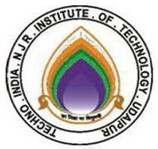

**Course File**

**DISASTER MANAGEMENT (8TT6-60.2)**

Nishit Jain

(Assistant Professor)

Department of C.E.

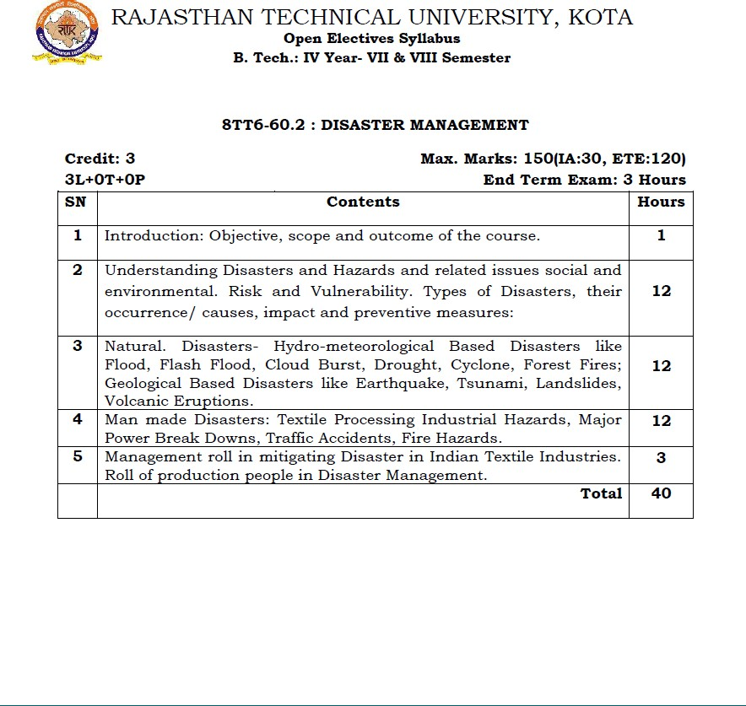

**Course Overview:**

The course is intended to provide a general concept in the dimensions of disasters caused by nature beyond the human control as well as the disasters and environmental hazards induced by human activities with emphasis on disaster preparedness, response and recovery.

The course focuses on natural disasters the problem is addressed in a holistic cross-sectoral and cross- disciplinary manner, including all stages of disaster management cycle: mitigation, preparation, response and recovery. Starting with theory, main definitions and concepts, the course considers other aspects of Disaster Management cycle along with Local National & State policies, to counter disaster, as per act of 2005.

**COURSE OUTCOMES:**

|  |  |  |
| --- | --- | --- |
| **Co No** | **Cognitive Level** | **Course Outcome** |
| 1 | Comprehension | Student will be able to categorize the different types of disaster and their characteristics |
| 2 | Application | Students will be able to make an Evaluation of hazard and vulnerability |
| 3 | Analysis | Students will be able to outline the concept of capacity building and strengthening capacity to reduce disaster risk |
| 4 | Analysis | Students will be able to write Disaster coping strategies, industrial safety plan, safety norms, mass media and disaster management in textile industry. |
| 5 | Application | Students will be able to describe Planning in disaster management, formulating risk reduction plan and to understand act and polices in India |

# Course Outcome Mapping with Program Outcome:

|  |  |  |  |  |  |  |  |  |  |  |  |  |  |  |  |
| --- | --- | --- | --- | --- | --- | --- | --- | --- | --- | --- | --- | --- | --- | --- | --- |
| **Course Outcome** | **PO1** | **PO2** | **PO3** | **PO4** | **PO5** | **PO6** | **PO7** | **PO8** | **PO9** | **PO 10** | **PO 11** | **PO12** | **PSO1** | **PSO2** | **PSO3** |
| **CO660.2.1** | 3 | 1 | 2 | 1 | 1 | 2 | 2 | 1 | 1 | 1 | 1 | 1 | 1 | 1 | 1 |
| **CO660.2.2** | 3 | 2 | 2 | 1 | 1 | 1 | 1 | 1 | 1 | 1 | 1 | 2 | 1 | 1 | 1 |
| **CO660.2.3** | 3 | 1 | 2 | 1 | 1 | 2 | 2 | 1 | 1 | 1 | 1 | 1 | 1 | 1 | 1 |
| **CO660.2.4** | 1 | 1 | 1 | 1 | 1 | 2 | 2 | 1 | 2 | 2 | 1 | 2 | 2 | 1 | 1 |
| **CO660.2.5** | 1 | 1 | 1 | 1 | 1 | 2 | 2 | 1 | 2 | 2 | 1 | 2 | 2 | 1 | 1 |
| **CO660.2(Avg)** | 2.2 | 1.2 | 1.6 | 1 | 1 | 1.8 | 1.8 | 1 | 1.4 | 1.4 | 1 | 1.6 | 1.4 | 1 | 1 |

**Course Coverage Module Wise:**

|  |  |  |
| --- | --- | --- |
| **Lecture No.** | **Unit** | **Topic** |
| 1 | 1 | Introduction: Objective, scope and outcome of the course. |
| 2 | 2 | Understanding Disasters and related issues social and environmental. |
| 3 | 2 | Understanding Hazards and related issues social and environmental. |
| 4 | 2 | Understanding Disasters Cycle. |
| 5 | 2 | Understanding Disasters Cycle. |
| 6 | 2 | Explain the phase of disaster management system. |
| 7 | 2 | Risk and Vulnerability |
| 8 | 2 | Risk and Vulnerability |
| 9 | 2 | Types of Disasters, |
| 10 | 2 | Types of Disasters, |
| 11 | 2 | Study on occurrence of Disaster. |
| 12 | 2 | Study on Impact of Disaster. |

|  |  |  |
| --- | --- | --- |
| 13 | 2 | Study on preventive measures for Disaster. |
| 14 | 3 | Natural. Disasters- Hydro-meteorological Based Disaster. |
| 15 | 3 | Natural. Disasters- Hydro-meteorological Based Disaster. |
| 16 | 3 | Understand flood and related issue. |
| 17 | 3 | Understand Flash flood and related issue. |
| 18 | 3 | Cloud burst causes and preventive measure. |
| 19 | 3 | Understand Drought, causes and preventive measure. |
| 20 | 3 | Understand Cyclone, causes and preventive measure. |
| 21 | 3 | Understand Forest Fires, causes and preventive measure. |
| 22 | 3 | Geological Based Disasters like Earthquake causes and |
|  |  | preventive measure. |
| 23 | 3 | Geological Based Disasters like Tsunami causes and preventive |
|  |  | measure. |
| 24 | 3 | Geological Based Disasters like Land sliding causes and |
|  |  | preventive measure. |
| 25 | 3 | Geological Based Disasters like Volcanic Eruptions causes and |
|  |  | preventive measure. |
| 26 | 4 | Understand Manmade Disasters. |
| 27 | 4 | Manmade Disaster: Causes and Preventing Measures. |
| 28 | 4 | Textile Processing Industrial Hazards |
| 29 | 4 | Textile Processing Industrial Hazards |
| 30 | 4 | Textile Processing Industrial Hazards |
| 31 | 4 | Understand Major Power Break Downs |
| 32 | 4 | Understand Major Power Break Downs |
| 33 | 4 | Understand Major Power Break Downs |
| 34 | 4 | Understand Traffic Accidents, causes and preventive measure. |
| 35 | 4 | Understand Traffic Accidents, causes and preventive measure. |

|  |  |  |
| --- | --- | --- |
| 36 | 4 | Understand Fire Hazards, causes and preventive measure. |
| 37 | 4 | Understand Fire Hazards, causes and preventive measure. |
| 38 | 5 | Management roll in mitigating Disaster in Indian Textile |
|  |  | Industries. Roll of production people in Disaster Management |
| 39 | 5 | Roll of production people in Disaster Management |
| 40 | 5 | Roll of production people in Disaster Management |

**Reference Books:**

1. “Natural Hazards and Disaster Management: Vulnerability and Mitigation” by R B Singh
2. “Disaster Education and Management” by Rajendra Kumar Bhandari
3. “Disaster Management” by R. Subramanian
4. Disaster Management act 2005

**NPTEL Courses:**

1. NPTEL :: Architecture - NOC:Disaster Recovery And Build Back Better
2. NPTEL :: Civil Engineering - Non-natural Hazards - Part-1

3. https://cdn.s3waas.gov.in/s365658fde58ab3c2b6e5132a39fae7cb9/uploads/2018/04/2018041720.pdf

**Teaching and Learning resources:**

Unit 1

INTRODUCTION: Objective, scope and outcome of the course.

* https://youtu.be/OSbSSqNkMW4
* https://publichealthdisasters.eu/objectives-and-learning-outcomes/ DISASTER PREPARADNESS
* https://youtu.be/KwAKjtkpdP4
* https://[www.ifrc.org/disaster-preparedness](http://www.ifrc.org/disaster-preparedness) Unit 2

Natural Disaster

* https://youtu.be/OSbSSqNkMW4
* https://en.wikipedia.org/wiki/Natural_disaster#:~:text=A%20natural%20disaster%20is%20a,storms%2C

%20and%20other%20geologic%20processes Man Made Disaster

* https://youtu.be/NJixgVxTB7I
* https://[www.monroecounty-fl.gov/904/Man-Made-Disaster](http://www.monroecounty-fl.gov/904/Man-Made-Disaster)

Unit 3:

Hazard Assessment:

* https://mmrjournal.biomedcentral.com/articles/10.1186/s40779-015-0059-9
* <http://environmentclearance.nic.in/writereaddata/Online/RiskAssessment/220620160Q65ZGCEAnnexur> e-RiskAssessment.pdf

Unit 4:

Man Made Disasters (Textile Industry) https://reliefweb.int/sites/reliefweb.int/files/resources/54153_23062017wiammtechguideconsultativev.pdf

https://[www.slideshare.net/88azmir/industrial-hazards-and-their-safety-measure-in-textile-industry](http://www.slideshare.net/88azmir/industrial-hazards-and-their-safety-measure-in-textile-industry)

Unit 5:

Coping With Disaster:

* <http://www.cahsd.org/wp-content/uploads/2017/08/Coping-with-Disaster.pdf>
* https://[www.researchgate.net/publication/312893271_Coping_strategies_preparedness_and_emergency_](http://www.researchgate.net/publication/312893271_Coping_strategies_preparedness_and_emergency_) response_of_char-land_peoples_in_Flood_Disaster_A_case_study_in_Kurigram_Bangladesh

Unit 6:

Planning for Disaster Management:

* https://cdn.s3waas.gov.in/s365658fde58ab3c2b6e5132a39fae7cb9/uploads/2018/04/2018041720.pdf

**Assessment Methodology:**

1. Mid-term examination
2. Final exams conducted by the university.

**COURSE LEVEL PROBLEMS (TEST ITEMS):**

|  |  |
| --- | --- |
| **CO.NO.** | **Problem description** |
| **1** | 1. Discuss major issues involved in disaster preparedness, 2. Highlight development perspective to disaster management with focus on disaster management in riverine regions. 3. Write a note on disaster cycle. |
| **2** | 1. Define Total Disaster Risk Management Approach and refer to its pertinence for Disaster Management Cycle. 2. Sustainable management of natural resources is essential to provide livelihood and environmental security’. Discuss. 3. Highlight key environmental concerns pertaining to disasters, |
| **3** | 1. Analyse the important facets of disaster management in mountainous regions 2. Define vulnerability and discuss the process of vulnerability analysis. 3. Examine the role of corporate social responsibility as an emerging avenue in managing disasters |
| **4** | 1. Examine the role of corporate social responsibility as an emerging avenue in managing disasters 2. Define vulnerability and discuss the vulnerability profile of India, 3. Write a note in brief on important disaster management strategies |
| **5** | 1. Discuss the important steps in relief distribution, Explain the different types of damages that occur due to disasters. 2. The relationship between disaster and development depends on the development choices made by the individual, community and the nation’. Discuss. 3. Emergency Operations Centre and Stockpiling practices in disaster management. |

# Assessment Methodology:

## Assignments (online/offline mode)

* 1. Mid-term examination
  2. Final exams conducted by the university

# TECHNO INDIA NJR INSTITUTE OF TECHNOLOGY, UDAIPUR DEPARTMENT OF CIVIL ENGINEERING

## MODEL QUESTION PAPER

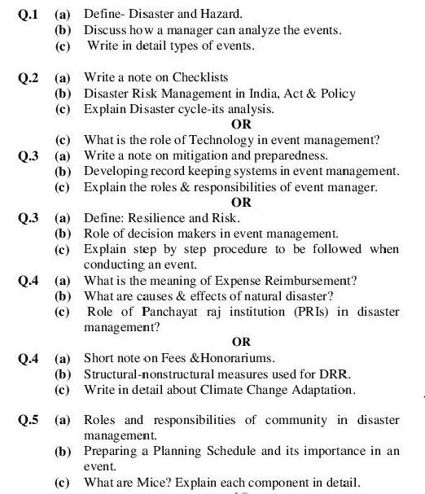**SUBJECT: DISASTER MANAGEMENT SUBJECT CODE: 8TT6-60.2**

# TECHNO INDIA NJR INSTITUTE OF TECHNOLOGY, UDAIPUR DEPARTMENT OF CIVIL ENGINEERING

## MODEL QUESTION PAPER 2

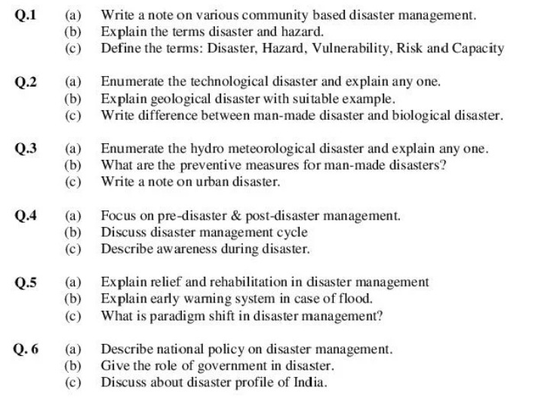**SUBJECT: DISASTER MANAGEMENT SUBJECT CODE: 8TT6-60.2**

**Sample Quiz:**

1. National Institute of Disaster Management was inaugurated on …………
2. September 23, 2002
3. August 14, 2001
4. October 16, 2003
5. August 14, 2004
6. Head office of the National Institute of Disaster Management is situated in India’s city/ state?
7. Kolkata
8. New Delhi
9. Hyderabad
10. Manipur
11. When the situation of hazard arise?
12. When there is the threat of natural calamity
13. When there is a threat to the consequences of the disaster
14. When there is a threat to property and lives from calamities
15. All of the above
16. Which one of the following is not a Natural Disaster?
17. Volcano eruption
18. Flood
19. Blow-out
20. Tsunami
21. Seismic waves cause disaster named as ………
22. Nino
23. Typhoon
24. Tsunami
25. hurricane
26. Rolling effect along the earth’s surface affect produces a wave of an earthquake?
27. L wave
28. P wave
29. S wave
30. None of the above
31. Where International Tsunami information center is located?
32. Honolulu
33. Hyderabad
34. Goa
35. Pondicherry
36. National Disaster Management authority comes under which ministry?
37. Ministry of Pollution
38. Ministry of Environment
39. Ministry of Home Affairs
40. Ministry of Foreign Affairs
41. In which of the following countries, hurricanes are common?
42. India
43. Sri Lanka
44. Australia
45. USA
46. Which is the calm part of a tropical cyclone?
47. Eye
48. Limb
49. Periphery
50. None
51. Where is the Tsunami Warning Center located in India?
52. New Delhi
53. Hyderabad
54. Gujarat
55. Kolkata
56. Tsunami word is derived from which language word.
57. Greek word
58. Indian word
59. French word
60. Japanese word
61. Which option is the perfect answer to the Civil war?
62. Kargil war
63. World war II
64. World war I
65. Syrian War
66. Find the following common factors of wildfire hazards.
67. Volcanic eruption
68. El-Nino
69. Volcanic Lightning and thundering
70. All of the above
71. In North America bush fire is known as
72. Brush fires
73. Wildfire
74. Volcano fire
75. None of the above
76. The two atom bombs in World war II has been dropped on which of the following:-
77. Hiroshima and Nagasaki in Japan
78. Germany
79. Italy
80. Great Britain
81. In which year, a terrorist attack was made on the twin tower of the world trade center in the USA A. 1999

B. 2008

C. 2001

D. 2005

1. In which direction the wind of the tropical cyclone blows in the northern hemisphere.
2. Straight forward
3. Anticlockwise direction
4. Clockwise direction
5. In any direction
6. A deep burn destroys all layers of skin is termed as:-
7. First-degree burn
8. Second-degree burn
9. Third Degree Burn
10. None of these
11. According to the Indian Meteorological Department (IMD), the wind blows at which speed called a storm as ‘Super cyclone”?
12. Above 200 km
13. Above 110 km
14. Above 220 km
15. None of the above
16. The extreme risk zone during a volcanic eruption is…………….
17. At a distance Upto 100 Mtrs
18. At a distance of 100-300 mtrs
19. At a distance of 300mtrs- 3 km
20. None of these
21. Flow of volcanic mud is called as?
22. Magma
23. Lahars
24. Lava
25. None of the above
26. The only active volcano in India is ……………..
27. Volcano Baratang
28. Barren Island volcano
29. Volcano Etna
30. None of the above
31. India’s total flood-prone area is up to……..

A. 30%

B. 20%

C. 12%

D. 10%

1. India’s total cyclone-prone area is ……….

A. 15%

B. 10%

C. 8%

D. 20%

**Previous Year Question Papers**

**TECHNO INDIA NJR INSTITUTE OF TECHNOLOGY, UDAIPUR**

**B. TECH 4th – YEAR (VIII SEM.) – MT-I**

Disaster Management **(8TT6-60.2**)

**Time:** 1.5 Hr **Max. Marks:** 20

**Note:**

1) Attempt any 4 out of 7 question.

2) Each question carries 5 marks

Part- A (20 Marks)

|  |  |
| --- | --- |
| A. | What do you understand by cyclones? Write their classification and impact. |
| B. | Explain the different causes of floods and their consequences on human and animal life. |
| C. | What do you understand by geological based disasters? Explain with examples. |
| D. | Explain the term disasters, write the classification of disasters with examples. |
| E. | Explain the natural drought, what are the methods to combat the drought situation. |
| F. | Explain various phases of the Disaster Management Cycle. |
| G. | Define Hazard |

