- “DESIGN AND ANALYSIS OF 2 STOREY RESIDENTIAL HOUSE”

AMajorProjectReport

SubmittedtotheRajasthanTechnicalUniversity

inpartialfulfillmentofrequirementsfortheawardofdegree

BachelorofTechnology

In

CivilEngineering

By
DIKSHAUDANIYA
19ETCCE015

DEPARTMENTOFCIVIL ENGINEERING
TECHNOINDIANJRINSTITUTEOFTECHNOLOGYUDAIPUR,RAJASTHAN
April 2023

DEPARTMENT OF CIVIL ENGINEERING


TECHNOINDIANJRINSTITUTEOFTECHNOLOGYUDAIPUR,RAJASTHAN2022-23

CERTIFICATE

Thisistocertifythatthereportentitled“Design and Analysis of 2 Storey Residential House”submittedbyDiksha udaniya(19etcce015),toDepartmentofcivilEngineeringinpartialfulfillment of the B.Tech. degree in Civil Engineering is a bonafide record ofthe seminar work carried out by him under our guidance and supervision. This reportinanyformhasnotbeensubmittedtoanyotherUniversityorInstituteforanypurpose.

Mr. Jitendra Choubisa Mr.Nishit Jain
(ProjectGuide) (ProjectCoordinator)
AssistantProfessor AssistantProfessor
Dept.ofCE Dept.ofCE
TechnoIndiaNJRInstitute TechnoIndiaNJRInstitute
ofTechnology ofTechnology
Udaipur,Rajasthan Udaipur,Rajasthan

Rakesh YadavProfessor and HeadDept. OfCE
TechnoIndiaNJRInstituteofTechnologyUdaipur,Rajasthan

DECLARATION

I Diksha Udaniyahereby declare that the major project report Design and Analysis of 2 Storey Residential House, submitted for partial fulfillment of the requirements for the award of degree ofBachelor of Technology of the Rajasthan Technical University, Kota, Rajasthan is abonafideworkdonebymeundersupervisionofMr. Jitendra Choubisa.
This submission represents my ideas in my own words and where ideas or wordsof others have been included; I have adequately and accurately cited and referencedtheoriginalsources.
IalsodeclarethatIhaveadheredtoethicsofacademichonestyandintegrityand have not misrepresented or fabricated any data or idea or fact or source in mysubmission.Iunderstandthatanyviolationoftheabovewillbeacausefordisciplinaryaction by the institute and/or the University and can also evoke penal action from thesourceswhichhavethusnotbeenproperlycitedorfromwhomproperpermissionhasnot been obtained. This report has not been previously formed the basis for the awardofanydegree,diplomaorsimilartitleofanyotherUniversity.

Diksha Udaniya

ABSTRACT

This project consists of ““DESIGN AND ANALYSIS OF 2 STOREY RESIDENTIAL HOUSE””. The design is given special importance to satisfy the various functional and structural requirements. Functional design can promote skill, economy, conveniences, and comforts and can compete needs and priorities. A good front elevation is also given to enhance the appearance of the building. The plan of “house” as per building Bye law. The analysis and design of the various building components are as per IS codal provisions and recommendations. The ultimate aim of the project is to get an economical section for the structural system. Our project deals with the planning of the departmental store building by using Auto cad. The building frame is to be analyzed by using the software ‘STAADPro’ and THREE DIMENSIONAL VIEW of the building using the ‘REVIT ARCHITECTURE’. The structural components are to be designed by limit state methods per the IS code and general specification of codal provision.

ACKNOWLEDGEMENT

I take this opportunity to express my deepest sense of gratitude and sincere thanks toeveryone who helped me to complete this work successfully.I express my sincerethankstoRakesh Yadav,HeadofDepartment,CivilEngineering, Techno India NJR Institute of Technology Udaipur for providing me with all the necessaryfacilitiesandsupport.
I would like to express my sincere gratitude to Mr.Nishit Jain,departmentofCivil Engineering,Techno India NJR Institute of Technology,Udaipur fortheirsupportandco-operation.
IwouldliketoplaceonrecordmysinceregratitudetomyprojectguideMr. Jitendra Choubisa, Assistant Professor, Civil Engineering, Techno India NJRInstituteofTechnologyfortheguidanceandmentorshipthroughoutthecourse.

Finally I thank my family, and friends who contributed to the successfulfulfillmentofthisprojectwork.

DIKSHA UDANIYA
CONTENTS

ABSTRACT i
ACKNOWLEDGEMENT ii
LISTOFFIGURES v
LIST OF SYMBOLS vii
- INTRODUCTION 1
1.1 General ................................ . . .1
1.2 Objective of Project .............................2
1.3 Role of Software . ............... ... . . . . . .2
01. Role of Staad pro . . . . . . . . . . . . . . . . . . . . .. . . . . . 2
02. Role of Revit . . . . . . . . . . . . . . . . . . . . . . . . . . . . 3
03. Role of Enscape . . . . . . . . . . . . . . . . . . . . . . . . . . . 4
- LITERATUREREVIEW 5
2.1 Method of analysis of statistically indeterminate portal frames: .....5
2.2 Methodology....... . . . . . ............. ...7
2.3 Statement of Structure...................... . ..8

- ANALYZE AND DESIGN OF STRUCTURE USING STAAD PRO 10
3.1 Specification.......... ,. . . .. ...............10
3.2 Plan of Structure.................. . . . . . . . 11
3.3 Elevation of Plan ........................... . . 12

3.4 Design of structure ......................... . . 12
3.5 Loadings..................... . . ....... . . 17
3.6 Staad pro result file ......................... . . 21

- DESIGNING AND PLANNING OF STRUCTURE USING REVIT24

4.1 Dimension of plan ...................... . . . . 24
4.2 Floor plan of structure ....................... . . 24
4.3 Elevation of Structure ....................... .. 30
4.4 Rendering of Structure ....................... .. 30

- CONCLUSION 38
- REFRENCES 39

LISTOFFIGURES

FIG. 1…………...PLAN OF STRUCTURE
FIG. 2…………..ELEVATION OF STURCTURE
FIG. 3…………..BEAM DESIGN
FIG. 4…………..BEAM NO 108 SECTION
FIG. 5…………..BENDING(DL)
FIG. 6…………..BENDING(LL)
FIG. 7…………..DEFLECTION IN BEAM NO 108
FIG. 8…………..BENDING IN BEAMS
FIG. 9…………..SHEAR IN BEAMS
FIG. 10…………COLUMN DESIGN(0.23X0.3)
FIG. 11………… COLUMN DESIGN(0.23X0.23)
FIG. 12…………SHEAR IN COLUMN
FIG. 13…………DESIGN OF SLAB
FIG. 14…………LOAD PATTERN DUE TO LL
FIG. 15…………LOAD PATTERN DUE TO DL
FIG. 16…………DEAD LOAD ON STRUCTURE
FIG. 17…………LIVE LOAD ON STRUCTURE
FIG. 18…………FLOOR LOAD ON STRUCTURE
FIG. 19…………1ST LEVEL PLAN
FIG. 20…………2ND LEVEL PLAN
FIG. 21…………3RD LEVEL PLAN
FIG. 22………….4TH LEVEL PLAN
FIG. 23………….5TH LEVEL PLAN
FIG. 24………….SOUTH ELEVATION
FIG. 25………….WEST ELEVATION
FIG. 26………….NORTH ELEVATION
FIG. 27………….EAST ELEVATION
FIG. 28…………3D VIEW
FIG. 29…………RENDER- VIEW 1
FIG. 30…………RENDER- VIEW 2
FIG. 31…………RENDER- VIEW 3

LISTOFSYMBOLS

The following symbols have been used in our project and its meaning is clearly mentioned respective to it:

A -Area
Ast - Area of steel
b - Breadth of beam or shorter dimension of rectangular column
D -Overall depth of beam or slab
DL -Dead load d
1 -effective depth of slab or beam
D - overall depth of beam or slab
Mu,max -moment of resistance factor
Fck -characters tic compressive strength
Fy -characteristic strength of of steel
Ld -devlopment length
LL -live load
Lx -length of shorter side of slab
Ly - length of longer side of slab
B.M. -bending moment
Mu -factored bending moment
Md -design moment
Mf -modification factor
Mx -mid span bending moment along short span
My - mid span bending moment along longer span
M’x -support bending moment along short span
M’y - support bending moment along longer span
pt -percentage of steel
W -total design load
Wd -factored load
Tc max -maximum shear stress in concrete with shear
Tv -shear stress in concrete
Tv -nominal shear stress
ɸ -diameter of bar
Pu -factored axial load
Mu,lim -limiting moment of resistance of a section with out compression reinforcement Mux,Muy -moment about X and Y axis due to design loads
Mux1,Muy1 maximum uniaxial moment capacity for an axial load of pu,bending moment x and Y axis respectively
Ac - area of concrete&
Asc -area of longitudinal reinforcement for column

Chapter1

Introduction

  - . General

Any construction project to begin with starts with the Layout of the building or structure
Followed by Design and Analysis of the structure which is succeeded by cost estimation and planning for the said project. This project involves the design, analysis, planning of a 2 storey residential building.
For completing the project very popular Civil Engineering software’s such asSTAAD Pro V8i, Autodesk Revit, and Enscape has been use.
Building construction is the engineering deals with the construction of building such as residential houses. In a simple building can be define as an enclose space by walls with roof, food, cloth and the basic needs of human beings. In the early ancient times humans lived in caves, over trees or under trees, to protect themselves from wild animals, rain, sun, etc. as the times passed as humans being started living in huts made of timber branches. The shelters of those old have been developed nowadays into beautiful houses. Rich people live in sophisticated condition houses. Buildings are the important indicator of social progress of the county. Every human has desire to own comfortable homes on an average generally one spends his two-third life times in the houses. The security civic sense of the responsibility. These are the few reasons which are responsible that the person do utmost effort and spend hard earned saving in owning houses. Nowadays the house building is major work of the social progress of the county. Daily new techniques are being developed for the construction of houses economically, quickly and fulfilling the requirements of the community engineers and architects do the design work, planning and layout, etc., of the buildings. Draughtsman is responsible for doing the drawing works of building as for the direction of engineers and architects. The draughtsman must know his job and should be able to follow the instruction of the engineer and should be able to draw the required drawing of the building, site plans and layout plans etc., as for the requirements. A building frame consists of number of bays and storey. A multi-storey, multi-paneled frame is a complicated statically intermediate structure. A design of R.C building of G+6 storey frame work is taken up. The building in plan (40*28) consists of columns built monolithically forming a network. The size of building is 40x28m. The number of columns is 85. It is residential complex. The design is made using software on structural analysis design (staad-pro). The building subjected to both the vertical loads as well as horizontal loads. The vertical load consists of dead load of structural components such as beams, columns, slabs etc. and live loads. The horizontal load consists of the wind forces thus building is designed for dead load, live load and wind load as per IS 875. The building is designed as two dimensional vertical frame and analyzed for the maximum and minimum bending moments and shear forces by trial and error methods as per IS 456-2000. The help is taken by software available in institute and the computations of loads, moments and shear forces and obtained from this software.

  - . Objectives of the Project

The objectives of the project are mentioned below:

- Analyzing the building using the software Staad pro vs8i.
- Applying gravity loads and different load combinations as per Indian codal provision.
- Modeling of structure is done in Revit software.
- Rendering of software is done by enscape.

  - . Role of STAAD Pro

STAAD Pro V8i has a very user friendly interface and very useful for designing complex
Structures and analyzing them. STAAD Pro V8i is a design and structural analysis program developed by Research Engineers International, CA. It was acquired by Bentley Systems in 2005. It is one of the most widely used design and structural analysis software’s for concrete, steel and timber design codes.
STAAD pro allows designers and structural engineers to design and analyze virtually any
Type of structure through its very flexible modeling environment, fluent data collection and advanced features.
STAAD pro supports over 70 international codes including IS456:2000 IS800:2007 and over 20 U.S codes in more than 7 languages.
STAAD pro is able to integrate with other Bentley Products such as STAAD. Foundation and ProSteel and OpenSTAAD. It is also able to integrate with other third party applications thus giving a good flexibility to designers working on various software’s.

Using STAAD Pro one can check all the structural parameters in a design such as bending moment analysis, shear force analysis, buckling in a column, loads, deflection thereby helping the structural engineer in designing the structure better.
STAAD pro V8i also has the DESIGN feature which enables engineers to calculate the
Various design data including the reinforcement in case of concrete design. This feature also corrects the designers in case of any mistake and rectifies it. It is also useful in cost estimation as it also gives the various quantities of steel, reinforcement and concrete take off thereby reducing the load of cost estimation from the engineer.

  - Role of Autodesk Revit

Autodesk Revit is building information modeling software tool for architects, landscape architects, structural engineers, mechanical, electrical, and plumbing (MEP) engineers, designers and contractors. The original software was developed by Charles River Software, founded in 1997, renamed Revit Technology Corporation in 2000, and acquired by Autodesk in 2002. The software allows users to design a building and structure and its components in 3D, annotate the model with 2D drafting elements, and access building information from the building model's database.[1] Revit is 4D building information modeling application capable with tools to plan and track various stages in the building's lifecycle, from concept to construction and later maintenance and/or demolition

  - Role of Enscape

Enscape is a commercial real-time rendering and virtual reality plugin. It is mainly used in the architecture, engineering, and construction fields and is developed and maintained by Enscape gmbh, founded in 2013 and based in Karlsruhe, Germany with an office in New York, United States. In 2022, Enscape's developer Enscape gmbh merged WI The main focus of Enscape lies in the calculation of realistic visualizations of architecture with low operating complexity. A real-time method is applied to achieve higher iteration speeds at the planning project by reducing waiting times. The respective CAD model is used, for example, to derive a virtual reality simulation.
Enscape uses openly 4.4[3] and Vulkan and provides photorealistic representations of the underlying CAD models. With the help of a path-tracing procedure[4] and physically based material models, the global illumination[4] can be visualized realistically.th Chaos, developer of competing rendering software V-Ray.[2]

Chapter2

Literature Review

2.1. Method of analysis of statistically indeterminate portal frames:

1. Method of flexibility coefficients.
2. Slope displacements methods (iterative methods)
3. Moment distribution method
4. Kane’s method
5. Cantilever method
6. Portal method
7. Matrix method
8. STAAD Pro

2.1.1. Method of flexibility coefficients:

The method of analysis is comprises reducing the hyper static structure to a determinate structure form by:
Removing the redundant support (or) introducing adequate cuts (or) hinges.

Limitations:It is not applicable for degree of redundancy>3.

2.1.2. Slope displacement equations:

It is advantageous when kinematic indeterminacy <static indeterminacy. This procedure was first formulated by axle bender in 1914 based on the applications of compatibility and equilibrium conditions. The method derives its name from the fact that support slopes and displacements are explicitly comported. Set up simultaneous equations is formed the solution of these parameters and the joint moment in each element or computed from these values.
Limitations:

A solution of simultaneous equations makes methods tedious for manual computations. this method is not recommended for frames larger than too bays and two story’s Iterative methods, These methods involves distributing the known fixed and moments of the structural member to adjacent members at the joints in order satisfy the conditions of compatibility.

Limitations of hardy cross method:

It presents some difficulties when applied to rigid frame especially when the frame is susceptible to side sway. The method cannot be applied to structures with intermediate hinges.

2.1.3. Kani’s method:

This method over comes some of the disadvantages of hardy cross method. Kani’s approach is similar to H.C.M to that extent it also involves repeated distribution of moments at successive joints in frames and continues beams. However there is a major difference in distribution process of two methods. H.C.M distributes only the total joint moment at any stage of iteration.
The most significant feature of kani’s method is that process of iteration is self-corrective. Any error at any stage of iterations corrected in subsequent steps consequently skipping a few steps error at any stage of iteration is corrected in subsequent consequently skipping a few steps of iterations either by over sight of by intention does not lead to error in final end moments.

Advantages:It is used for side way of frames.

Limitations:
The rotational of columns of any storey should be function a single rotation value of same storey.
The beams of storey should not undergo rotation when the column undergoes translation. That is the column should be parallel.
Frames with intermediate hinges cannot be analysis.

2.1.4. Approximate method:

Approximate analysis of hyper static structure provides a simple means of obtaining a quick Solution for preliminary design. It makes some simplifying assumptions regarding Structural behavior so to obtain a rapid solution to complex structures.
The usual process comprises reducing the given indeterminate configuration to a determine structural system by introducing adequate no of hinges. It is possible to sketch the deflected profile of the structure for the given loading and hence by locate the printinflection. Since each point of inflection corresponds to the location of zero moment in the structures. The inflection points can be visualized as hinges for the purpose of analysis. The solution of structures is sundered simple once the inflection points are located. The loading cases are arising in multistoried frames namely horizontal and vertical loading. The analysis carried out separately for these two cases.
Horizontal cases:
The behavior of a structure subjected to horizontal forces depends upon its heights to width ratio among their factor. It is necessary ti differentiate between low rise and high rise frames in this case.

Low rise structures:
Height < width
It is characterized predominately by shear deformation.
High rise buildings
Height > width
It is dominated by bending action

Matrix analysis of frames:

The individual elements of frames are oriented in different directions unlike those of continues beams so their analysis is more complex .never the less the rudimentary flexibility and stiffness methods are applied to frames stiffness method is more useful because its adaptability to computer programming stiffness method is used when degree of redundancy is greater than degree of freedom. However stiffness method is used degree of freedom is greater than degree of redundancy especially for computers.

2.2. Methodology:

2.2.1. Study of IS 875 1987

IS 875 deals with the various load cases that act upon a structure and ways to calculate them. There are various parts of the code that deal with the various load types such as dead load, live load, wind load, snow load and various special loads and load combinations. As the building is situated in Delhi and is not a high rise building, loads such as wind and snow were not considered in the design process.
The Code gives the unit weights of various materials as well as the values of imposed loads that act in various types of structures and parts of these structures.

2.2.2. Analysis and Design using STAAD Pro

Once the layout of the building was approved by the architect the layout was transferred from AutoCAD to STAAD Pro using a DXF file format. Once the layout was transferred, multiple stories were created using the Translational Repeat Tool in Staad Pro. After this member properties were assigned. Next the load cases were generated and applied to the structure.

Once the loads were applied the structure was analyzed and corrections were made to the
Structure for the various errors that were generated while the structure was being analyzed.

After the analysis, we started designing the structure by entering the DESIGN tab in STAAD Pro. All the design parameters were entered and load cases selected. This completes the design of the beam, columns and slabs.
For designing the foundation STAAD foundation program is opened and the structure along with the load cases is transferred. Once this is done the soil conditions and the type of foundation is entered. After this the program analyses and designs the foundation.

2.2.3. Designing of structure in Autodesk Revit:

For engineers, the main part of work before the production itself was designing and then sketching the object.
The project is aimed at creating an intelligent model through designing, analysis, planning using Revit software.

2.3. Statement of project

SALIENT FEATURES:
Utility of building: Residential House
No of stories: 2 Storey
Shape of the building: Rectangular
No of staircases: 1
Type of construction: R.C.C framed structure
Types of walls: Brick wall
GEOMETRIC DETAILS:
Ground floor: 3m
Floor to floor height: 3m.
Height of plinth: 2’
Depth of foundation: 500mm

MATERIALS:
Concrete grade: M25
All steel grades: Fe415 grade
Bearing capacity of soil: 300KN/M2

Chapter3

Analyze and design of structure using STAAD Pro

3.1. SPECIFICATION
Following is the specification that is planned to be provided in this project consisting of
G+4 floors and having RCC roof

1. FOUNDATION:
The foundation for all the main columns in cement concrete 1:4:8,3500x3500mm wide, 600 mm thick and column size of 500x500mm.

3. SUPER STRUCTURE:
All the main walls will be in brick work in C.M 1:5, 230mm thick. All the walls
will be raised up to the roof. The height of the main wall will be 4000mm above floor
level. Parapet walls is 230mm thick and 800mm height.

4. ROOFING:
The roofing will be in RCC 1:2:4 mix, 230mm thick flat slab, plastered with cement
mortar 1:3 and 20mm thick, the weathering coarse will be of brick jelly with lime mortar
of thickness 75mm will be provided over the slab.

5. DOORS AND WINDOWS:
The doors of fully glazed and of size 3000mmx2500mm and 1800x2500mm and
flush door of 1000x 2500 mm, glazed window of size 1800x1500 and fully glazed
ventilator of 1800x600mm size.

6. LINTEL:
All the opening will be provided with 150mm thick RCC 1:2:4 mix lintels.

7. FLOORING:
The floor will be in cement concrete 1:4:8 mix,5” thick, top finished smoothly
with 1:3, 20mm thick plaster for all the rooms.

8. STEPS:
Steps will be in cement concrete 1:2:4 mix having rise of 150mm, thread 250mm.

MEMBER SPECIFICATIONS:
COLUMN – 0.23 x 0.23 and 0.23x 0.30
BEAM -0.3 x0.3
THICKNESS OF SLAB -150mm
HEIGHT OF COLUMN -4.0m
THICKNESS OF WALL -230mm
3.2. PLAN OF STRUCTURE
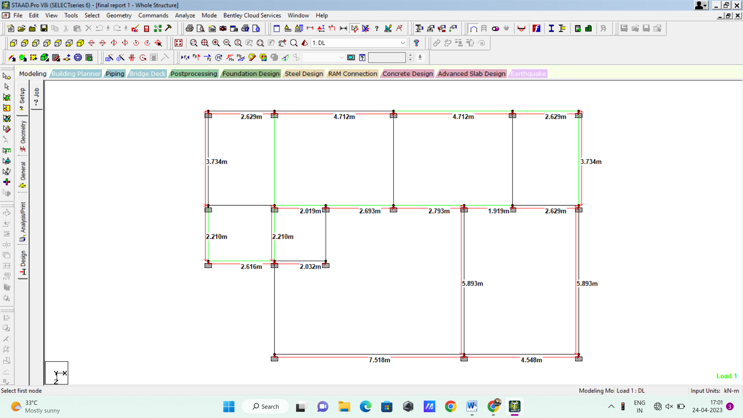
FIG. 1 PLAN OF STRUCTURE

3.3. ELEVATION OF STURCTURE
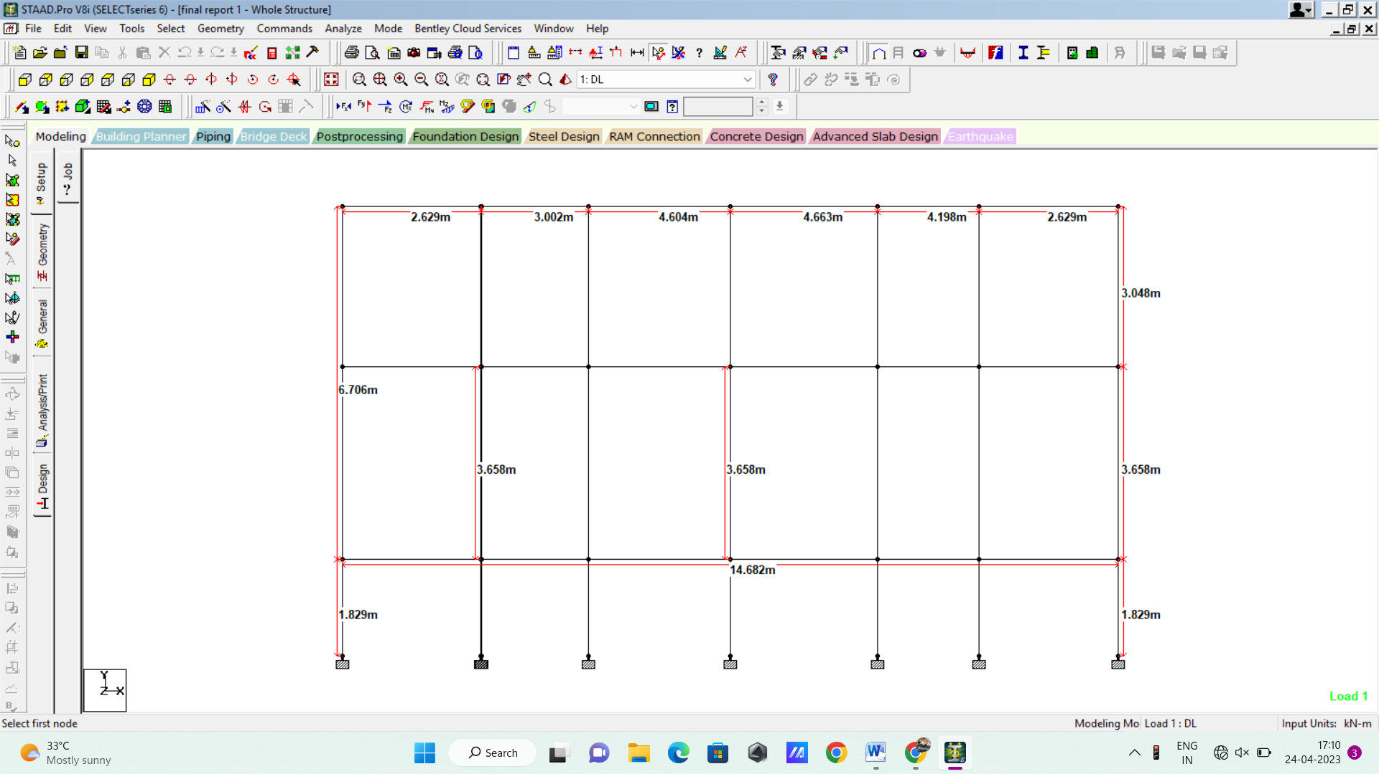

FIG. 2ELEVATION OF STURCTURE
3.4. DESIGN OF STRUCTURE
The entire process of structural planning and design requires not only imagination and conceptual thinking but also sound knowledge of practical aspects, such as recent design codes and bye-laws, backed up by ample experience, institution and judgment. It is emphasized that any structure to be constructed must satisfy the need efficiency for which it is intended and shall be durable for its desired life span. Thus, the design of any structure is categorizes into following two main types:-
- Functional design
- Structural design
1. DESIGN OF BEAM
Beams are designed for flexure, shear and torsion. If required the effect the axial force may be taken into consideration. For all these forces, all active beam loadings are prescanned to identify the critical load cases at different sections of the beams.

A Design for Flexure
Flexural design of beams is performed in two passes. In the first pass, effective depths of the sections are determined with the assumption of single layer of assumed reinforcement and reinforcement requirements are calculated. After the preliminary design, reinforcing bars are chosen from the internal database in single or multiple layers. The entire flexure design is performed again in a second pass taking into account of the changed effective depths of sections calculated on the basis of reinforcement provide after the preliminary design. Final provisions of flexural reinforcements are made then. Efforts have been made to meet the guideline for the curtailment of reinforcements as per IS: 456-2000 (Clause 26.2.3).

Design for Shear
Shear reinforcement is calculated to resist both shear forces and torsional moments. Shear capacity calculation at different sections without the shear reinforcement is based on the actual tensile reinforcement provided by the program. Two-legged stirrups are provided to take care of the balance shear forces acting on these sections.As per Clause 40.5 of IS:456-2000 shear strength of sections (< 2d where d is the effective depth) close to support has been enhanced, subjected to a maximum value of τ_{cmax}.
BEAM DESIGN DETAIL:-
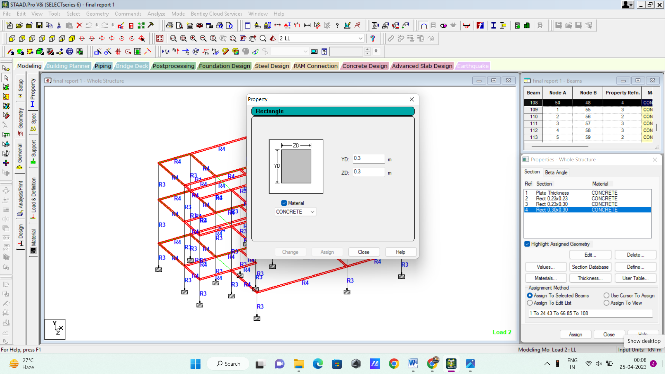

FIG. 3BEAM DESIGN
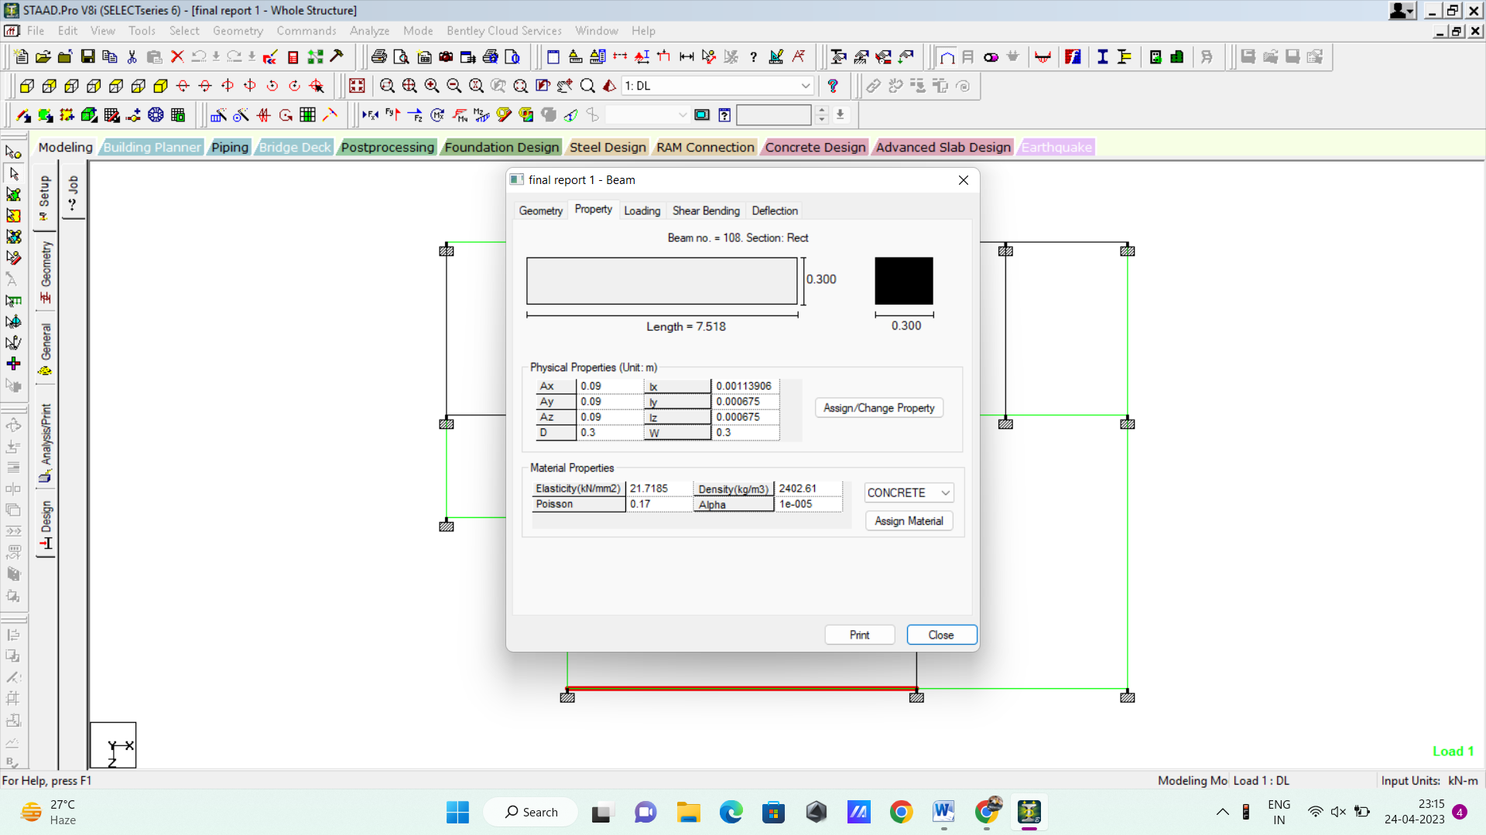
FIG. 4BEAM NO 108 SECTION
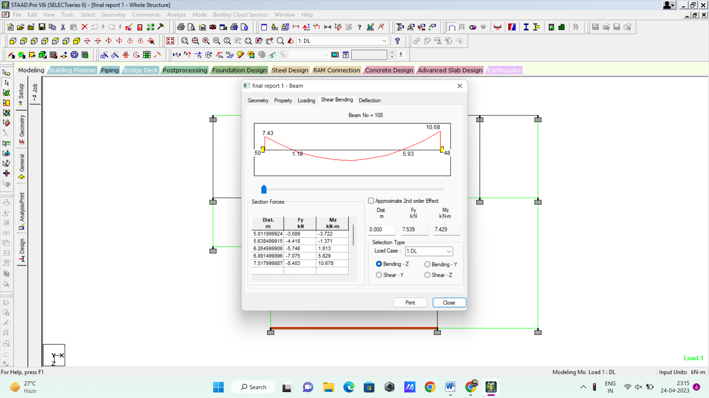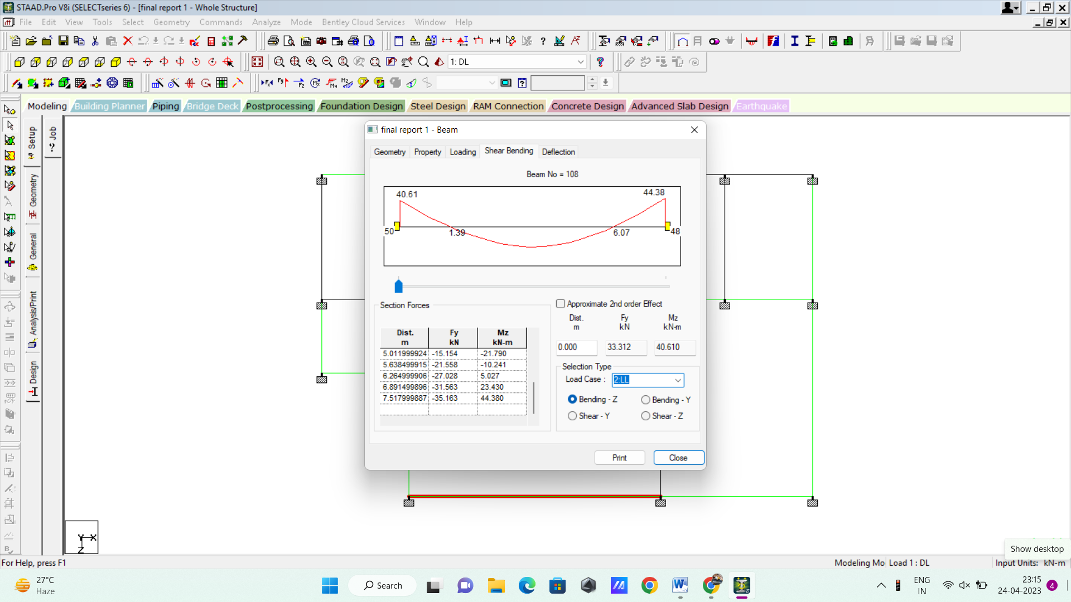
FIG. 5BENDING(DL) FIG. 6BENDING(LL)
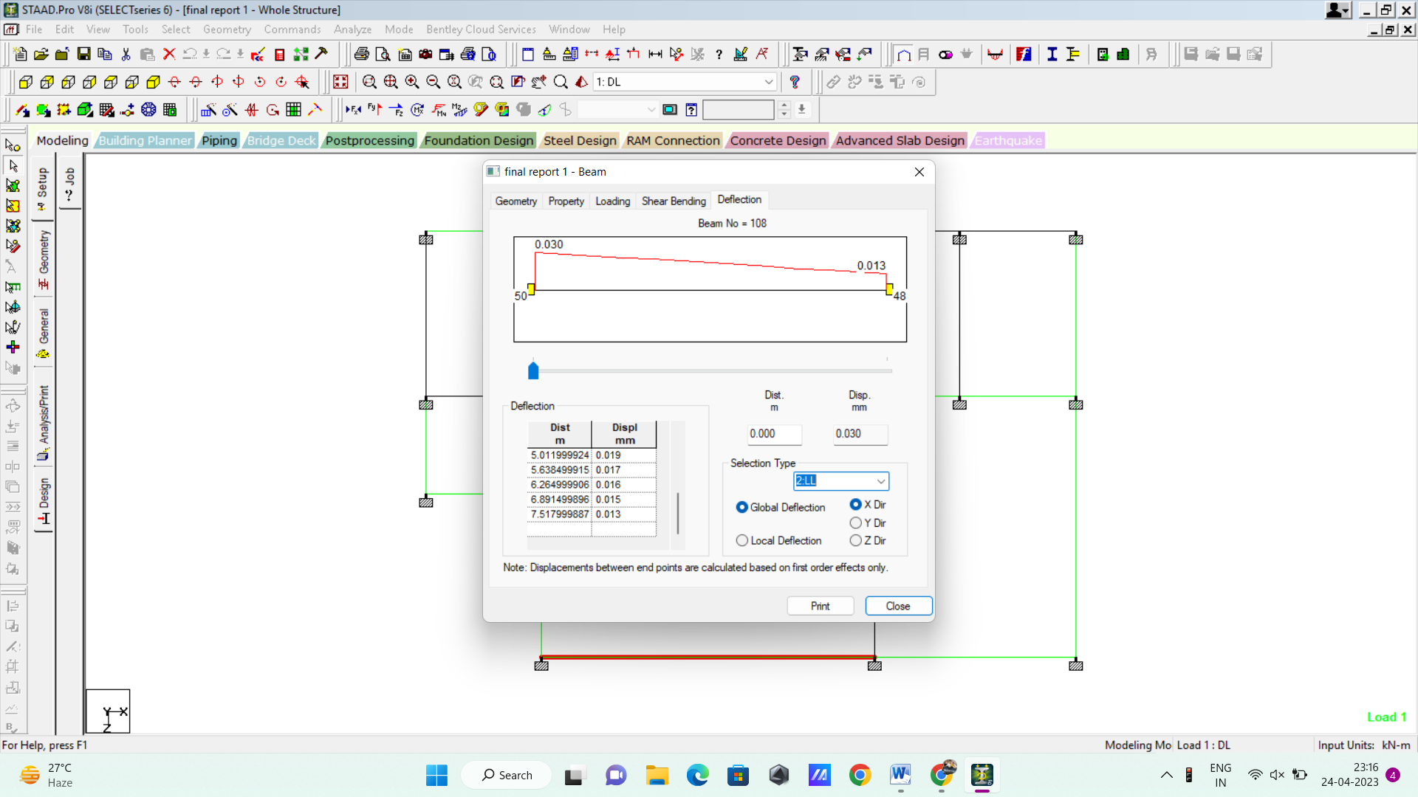

FIG. 7DEFLECTION IN BEAM NO 108
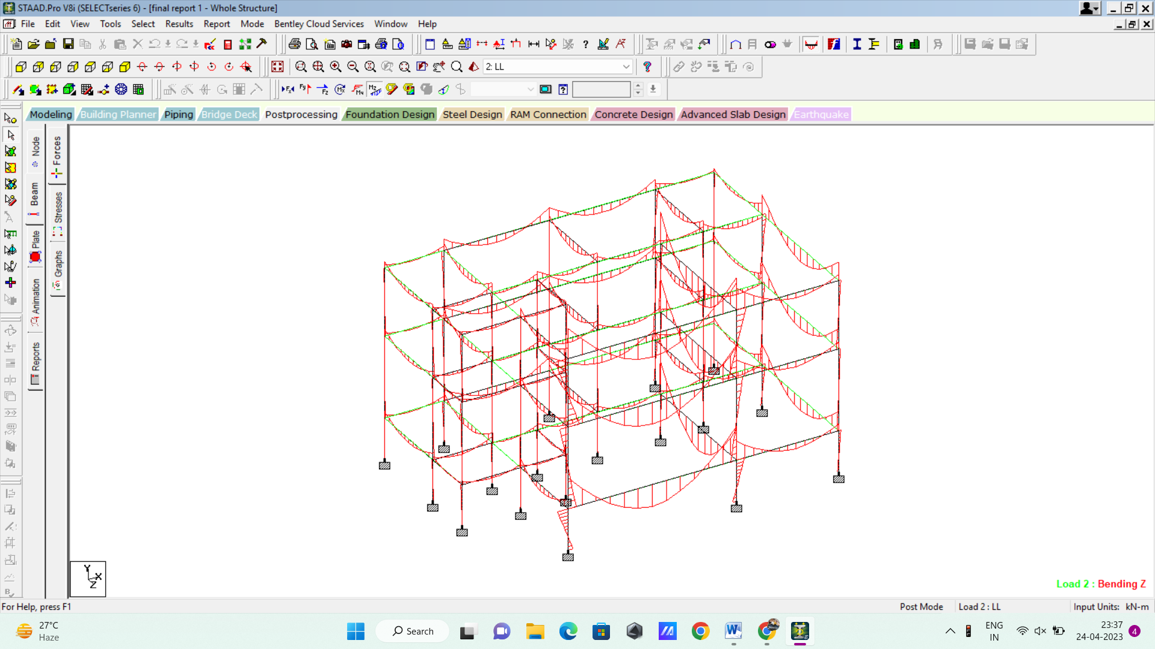
FIG. 8BENDING IN BEAMS
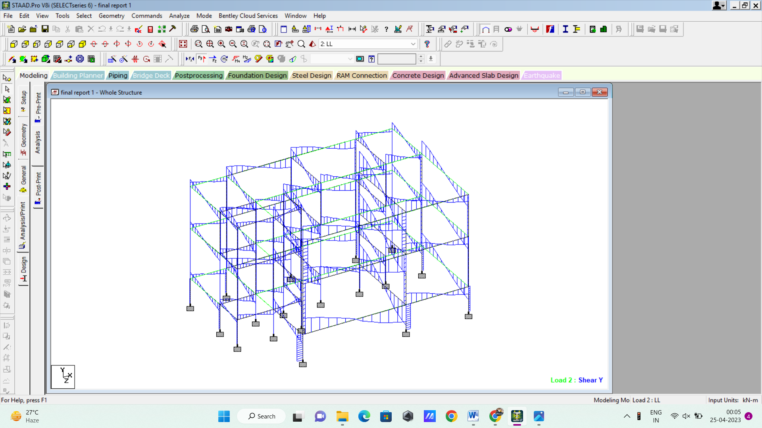
FIG. 9SHEAR IN BEAMS

2. DESIGN OF COLUMNS
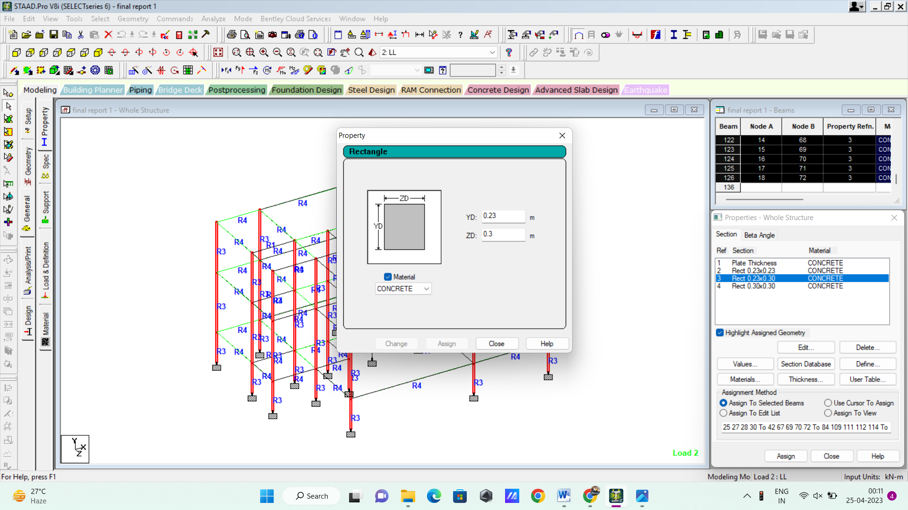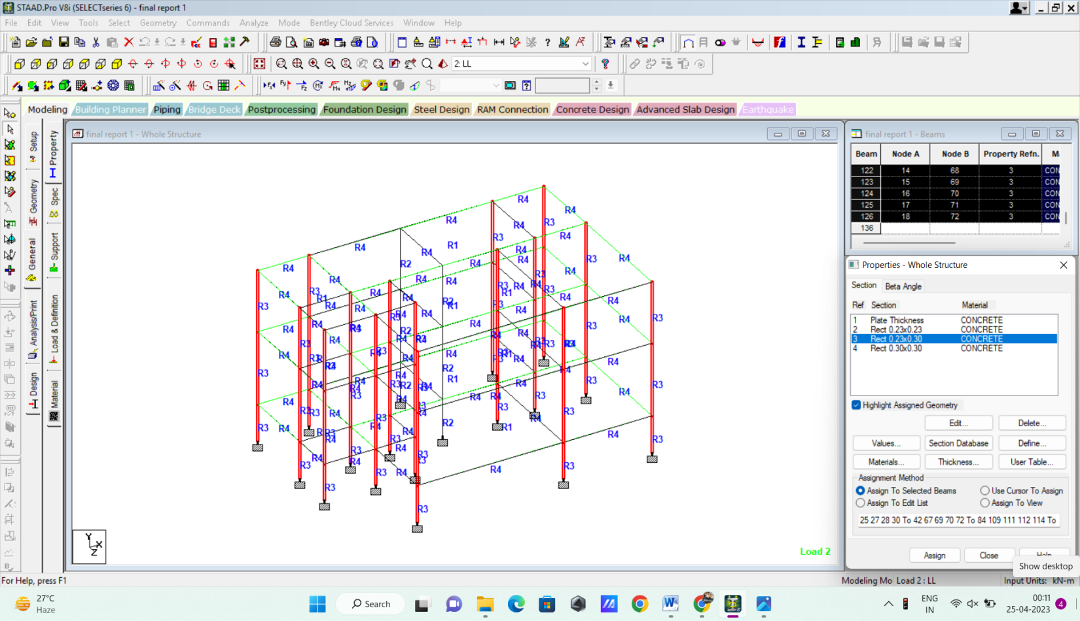
FIG. 10COLUMN DESIGN(0.23X0.3)
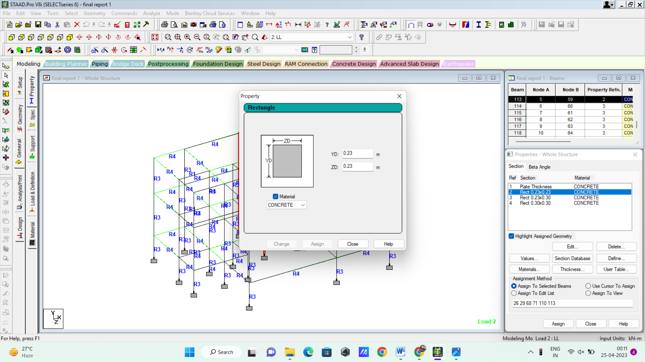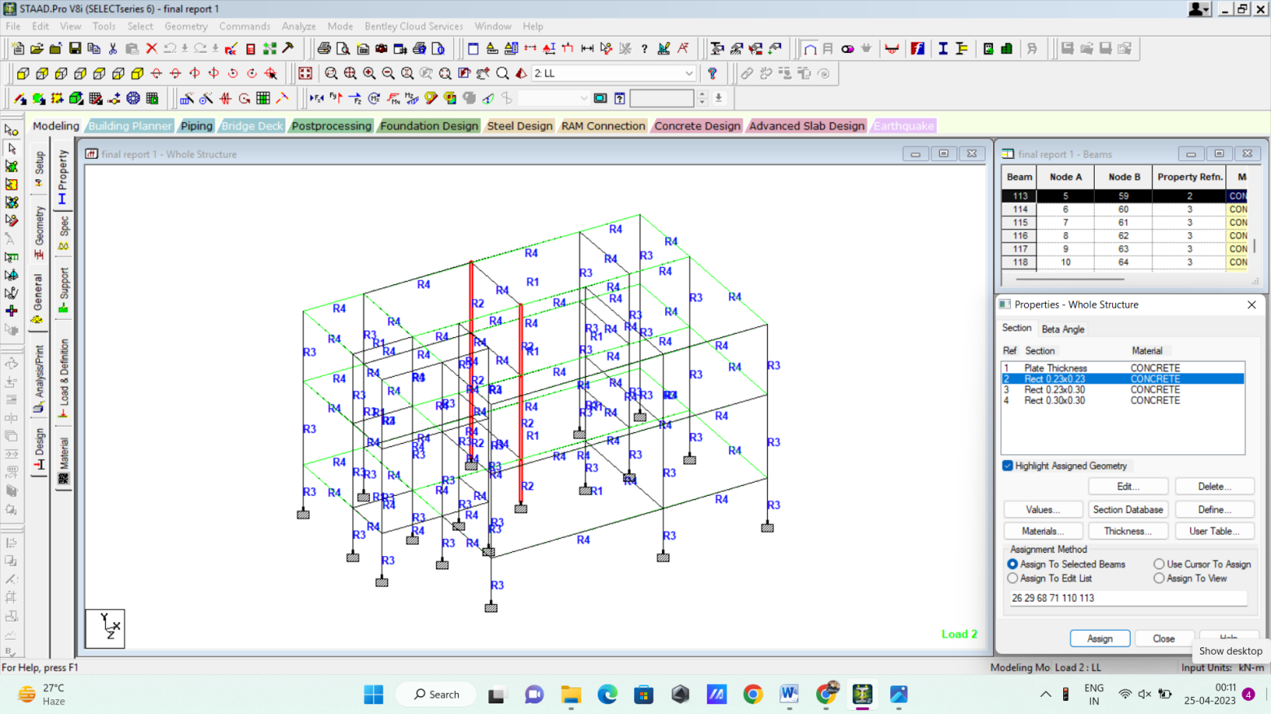
FIG. 11 COLUMN DESIGN(0.23X0.23)
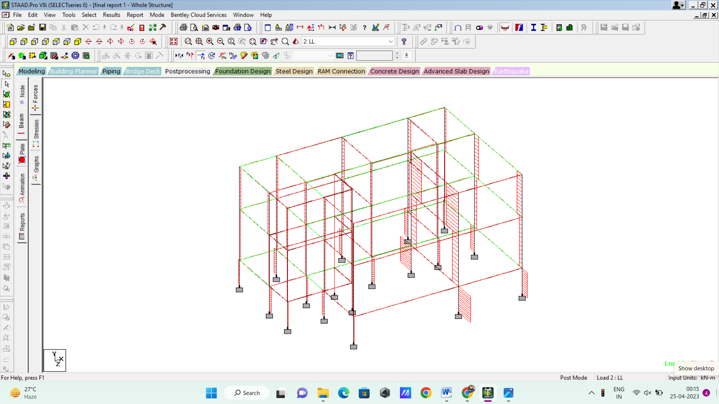
FIG. 12SHEAR IN COLUMN
3. Design of Slab
Slab Thickness:0.15m.
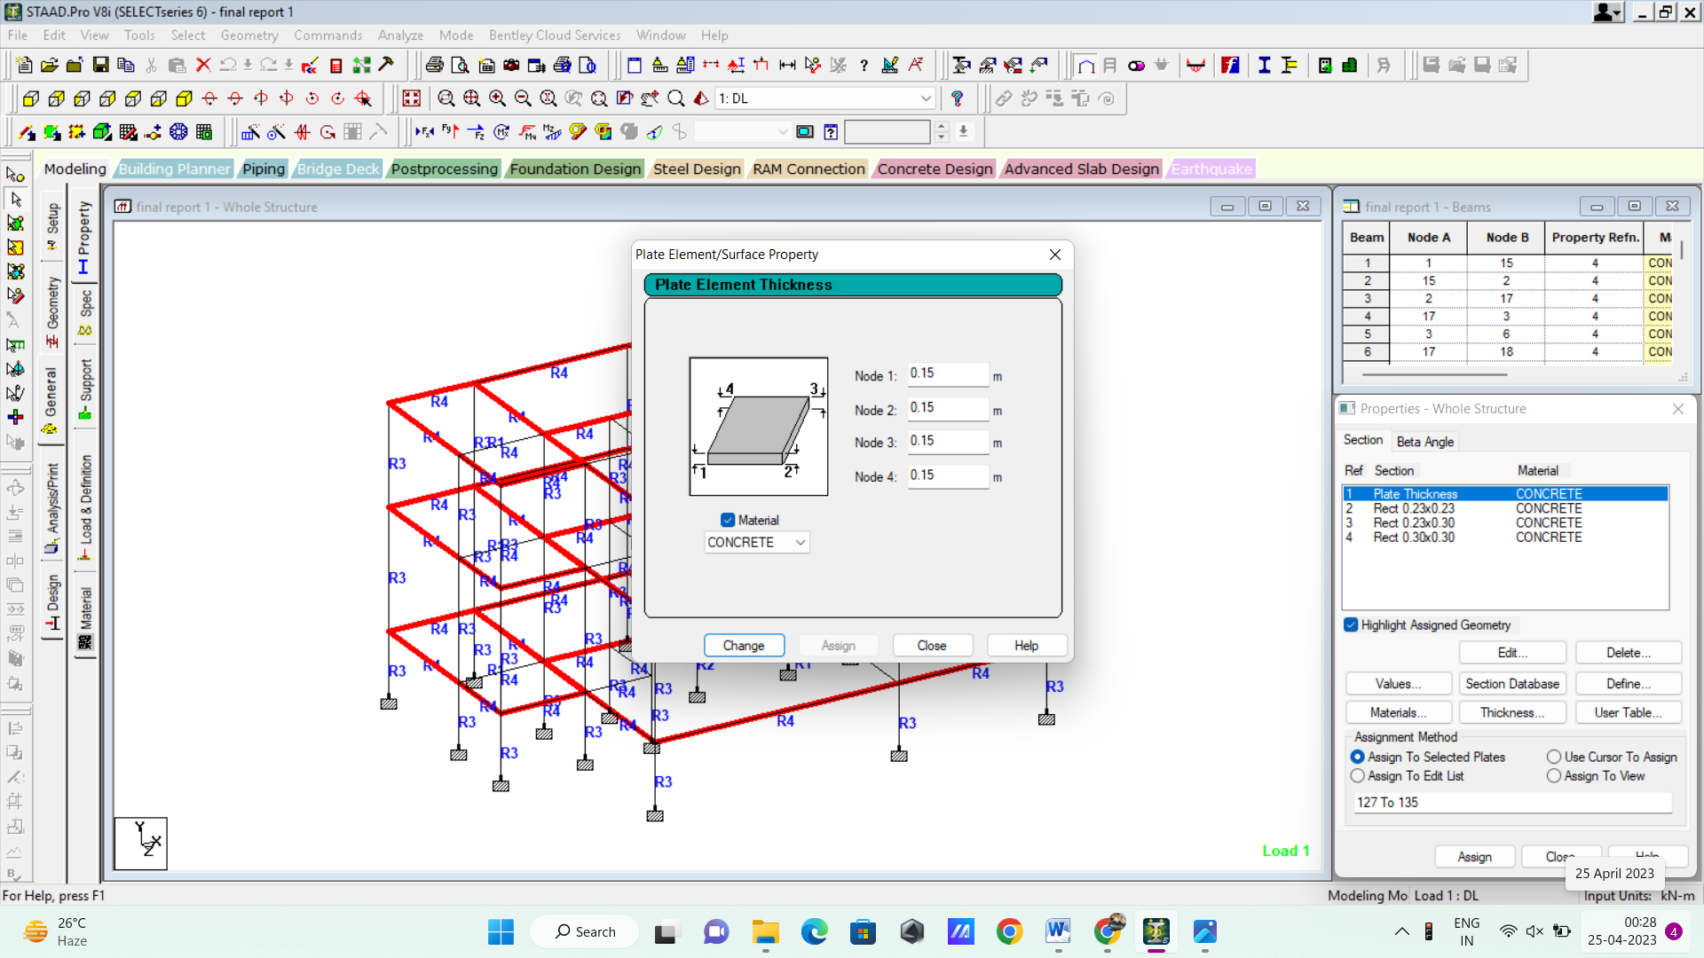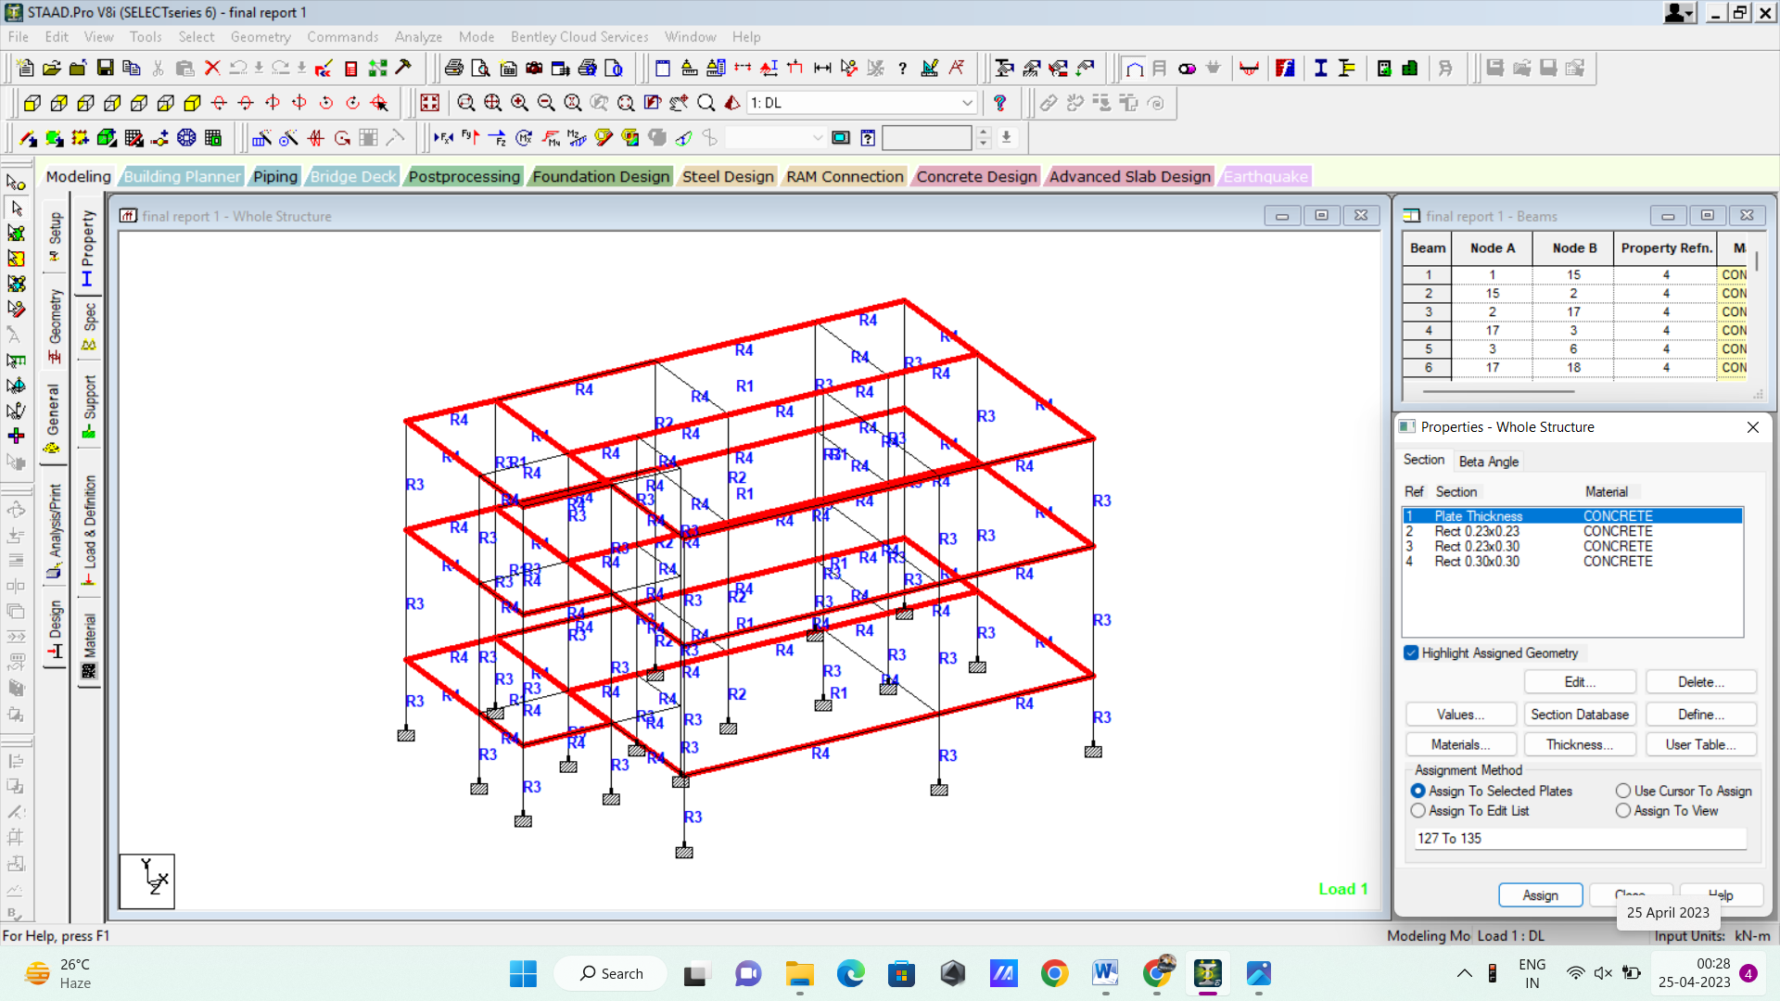
FIG. 13DESIGN OF SLAB

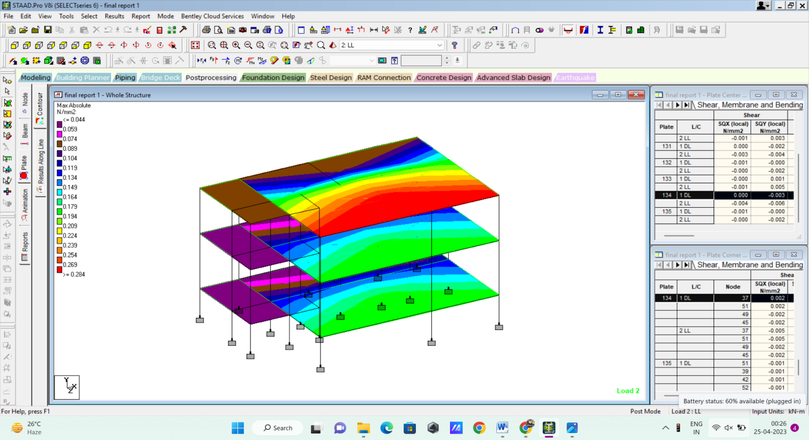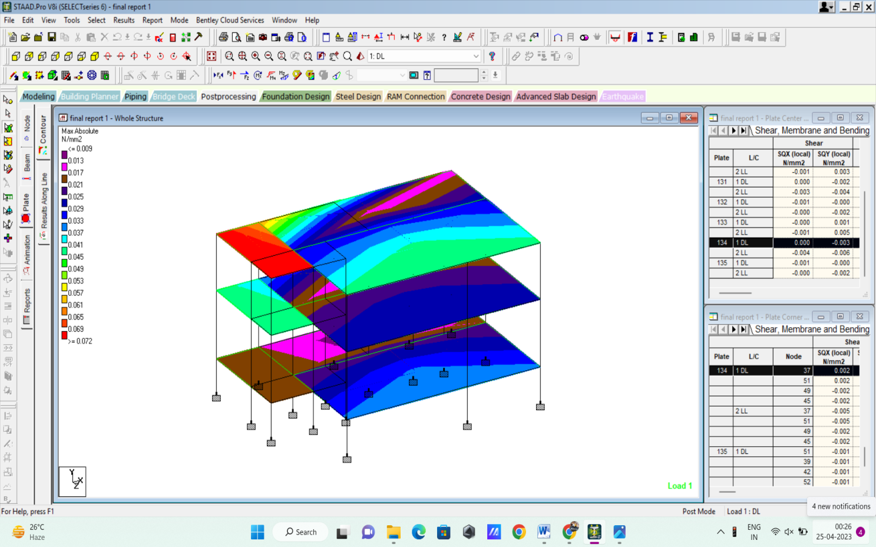
FIG. 14LOAD PATTERN DUE TO LL FIG. 15LOAD PATTERN DUE TO DL
3.5 LOADINGS
3.5.1. Design loads for residential buildings:
General
Loads are a primary consideration in any building design because they define the nature And magnitude of hazards are external forces that a building must resist to provide a reasonable Performance(i.e., safety and serviceability )throughout the structure’s useful life. The anticipated Loads are influenced by a building’s intended use (occupancy and function), configuration (size And shape) and location(climate and site conditions).Ultimately, the type and magnitude of design Loads affect critical decisions such as material collection, construction details and architectural Configuration.
Thus, to optimize the value (i.e., performance versus economy) of the finished product, it is essential to apply design loads realistically. While the buildings considered in this guide are primarily single-family detached and attached dwellings, the principles and concepts related to building loads also apply to other similar types of construction, such as low-rise apartment Buildings. In general, the design loads recommended in this guide are based on applicable Provisions of the ASCE 7 standard-Minimum Design ;loads for buildings and other structures (ASCE,1999).the ASCE 7 standard represents an acceptable practice for building loads in the United states and is recognized in virtually all U.S. building codes. For this reason, the reader is Encouraged to become familiar with the provisions, commentary, and technical references Contained in the ASCE 7 standard. In general structural design of housing has not been treated as a unique engineering discipline or subjected to a special effort to develop better, more efficient Design practices. Therefore, this part of the guide focuses on those aspects of ASCE 7 and other technical resources that are particularly relevant to the determination of design loads For residential structures.
The guide provides supplemental design assistance to address aspects of residential Construction where current practice is either silent or in need of improvement. Residential Buildings methods for determining design loads are complete yet tailored to typical residential Conditions. As with any design function, the designer must ultimately understand and approve the Loads for a given project as well as the overall design methodology, including all its inherent Strengths and weakness.
Since building codes tend to vary in their treatment of design loads the designer should, As a matter of due diligence, identify variances from both local accepted practice and the Applicable code relative to design loads as presented in this guide, even though the variances may Be considered technically sound. Complete design of a home typically requires the evaluation of several different types of materials. Some material specifications use the allowable stress design (ASD) approach while others use load and resistance factor design (LRFD).
- Dead Loads:
Dead loads consist of the permanent construction material loads compressing the roof, floor, wall, and foundation systems, including claddings, finishes and fixed equipment. Dead load is the total load of all of the components of the components of the building that generally do not change over time, such as the steel columns, concrete floors, bricks, roofing material etc. In staad pro assignment of dead load is automatically done by giving the property of the member. In load case we have option called self-weight which automatically calculates weights using the properties of material i.e., density and after assignment of dead load the skeletal structure looks red in color as shown in the figure.
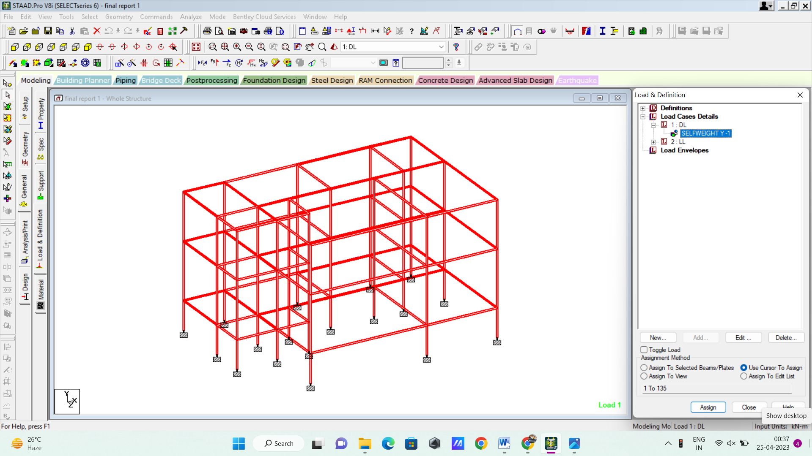
FIG. 16DEAD LOAD ON STRUCTURE
- Live Loads:
Live loads are produced by the use and occupancy of a building. Loads include those from human occupants, furnishings, no fixed equipment, storage, and construction and maintenance activities. As required to adequately define the loading condition, loads are presented in terms of uniform area loads, concentrated loads, and uniform line loads. The uniform and concentrated live loads should not be applied simultaneously n a structural evaluation. Concentrated loads should be applied to a small area or surface consistent with the application and should be located or directed to give the maximum load effect possible in enduse conditions. For example, the stair load of 300 pounds should be applied to the center of the stair tread between supports.
In staad we assign live load in terms of U.D.L .we has to create a load case for live load and select all the beams to carry such load. After the assignment of the live load the structure appears as shown below.
For our structure live load is taken as 25 N/mm for design.
Live loads are calculated as per IS 875 part

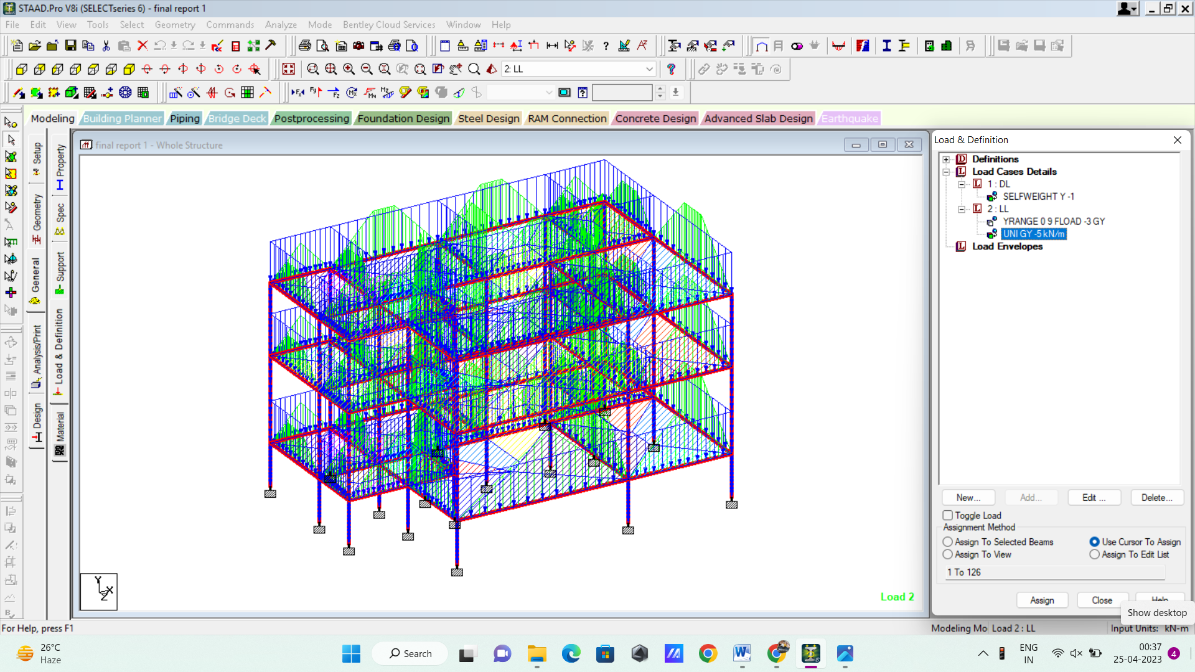

FIG. 17LIVE LOAD ON STRUCTURE
- Floor Load:
Floor load is calculated based on the load on the slabs. Assignment of floor load is done by creating a load case for floor load. After the assignment of floor load our structure looks as shown in the below figure.
The intensity of the floor load taken is: 0.0035 N/mm2
-ve sign indicates that floor load is acting downwards.
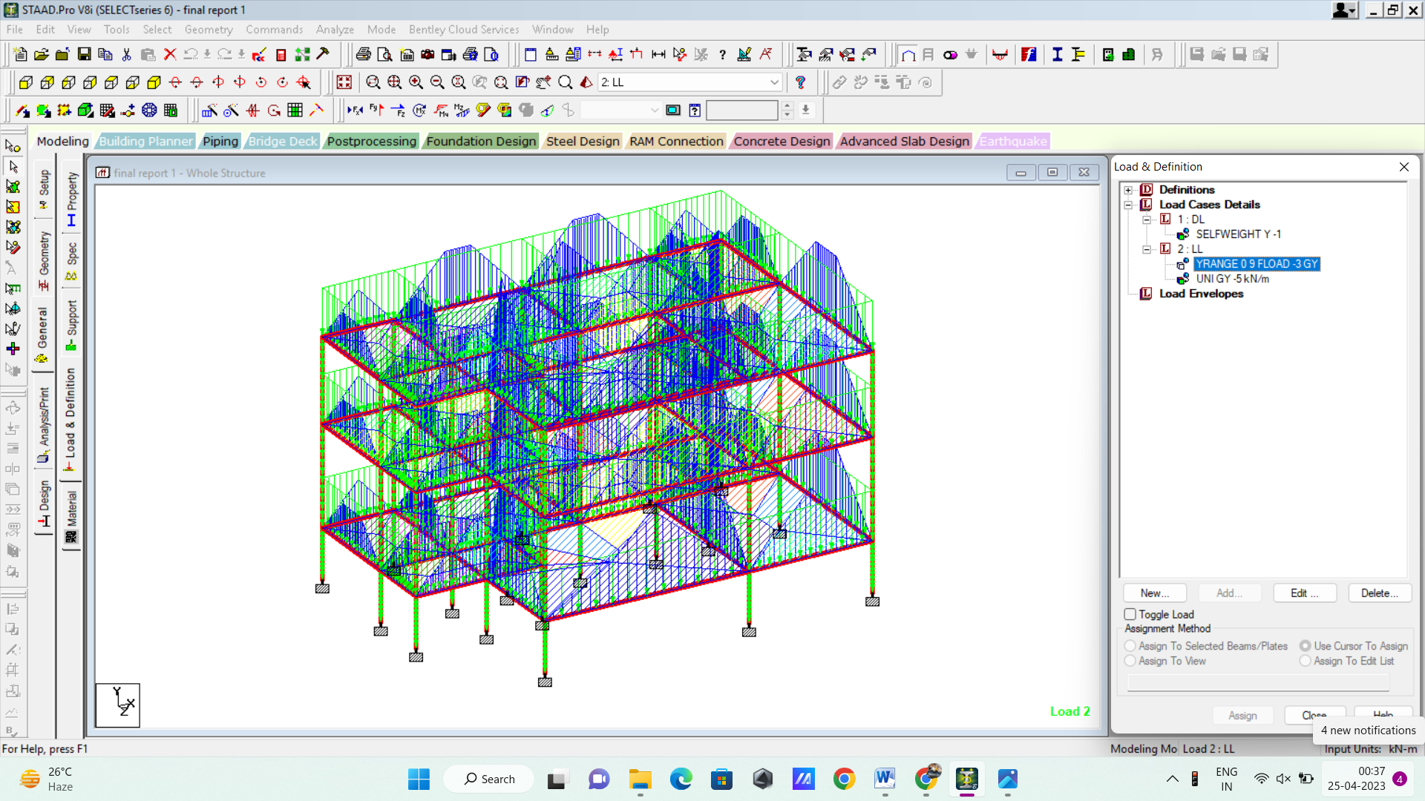

FIG. 18FLOOR LOAD ON STRUCTURE
3.6. Staad Pro Result File:

***TOTAL APPLIED LOAD ( KN METE ) SUMMARY (LOADING 1 )
SUMMATION FORCE-X = 0.00
SUMMATION FORCE-Y = -2177.68
SUMMATION FORCE-Z = 0.00
SUMMATION OF MOMENTS AROUND THE ORIGIN-
MX= 9719.22 MY= 0.00 MZ= -16556.89
***TOTAL REACTION LOAD( KN METE ) SUMMARY (LOADING 1 )
SUMMATION FORCE-X = -0.00
SUMMATION FORCE-Y = 2177.68
SUMMATION FORCE-Z = 0.00

SUMMATION OF MOMENTS AROUND THE ORIGIN-
MX= -9719.22 MY= 0.00 MZ= 16556.89
MAXIMUM DISPLACEMENTS ( CM /RADIANS) (LOADING 1)
MAXIMUMS AT NODE
X = 2.64214E-02 37
Y = -1.21801E-01 42
Z = 2.17172E-02 39
RX= -2.20537E-04 48
RY= -2.21968E-05 40
RZ= -3.57195E-04 40
***TOTAL APPLIED LOAD ( KN METE ) SUMMARY (LOADING 2 )
SUMMATION FORCE-X = 0.00
SUMMATION FORCE-Y = -3223.09
SUMMATION FORCE-Z = 0.00
SUMMATION OF MOMENTS AROUND THE ORIGIN-
MX= 13977.18 MY= 0.00 MZ= -23969.36
***TOTAL REACTION LOAD( KN METE ) SUMMARY (LOADING 2 )
SUMMATION FORCE-X = 0.00
SUMMATION FORCE-Y = 3223.09
SUMMATION FORCE-Z = -0.00
SUMMATION OF MOMENTS AROUND THE ORIGIN-
MX= -13977.18 MY= 0.00 MZ= 23969.36
MAXIMUM DISPLACEMENTS ( CM /RADIANS) (LOADING 2)
MAXIMUMS AT NODE
X = -1.05782E-02 53
Y = -1.18235E-01 48
Z = 2.25134E-02 37
RX= -1.83183E-03 48
RY= 3.05892E-05 46
RZ= -1.53347E-03 50

Chapter4

Designing and Planning of Structure using Revit

4.1. DIMENSION OF PLAN
- Size of plan : 50’ x 45’
- Hall size: 19’4” x 18’
- Living room: 11’9” x 14’11”
- Bedroom 1 size: 23’9” x 12’3”
- Bedroom 2 size: 23’9” x 12’3”
- Kitchen size: 15’3” x 7’3”
- Washroom1 size : 14’11” x 7’3”
This is 2 story residential house with proper architectural concepts. In first floor have 2 master bedrooms, 1 kitchen,, 1 common washrooms and 1 living room and 1 hall. And the 2nd floor, consist 3 master bedroom, 4 balconies, 1 kitchen.
All the dimensions of construction work is mentioned above and in detail plan.
4.2FLOOR PLAN OF STRUCTURE
In architecture and building engineering, a floor plan is a technical drawing to scale, showing a view from above, of the relationships between rooms, spaces, traffic patterns, and other physical features at one level of a structure.
Dimensions are usually drawn between the walls to specify room sizes and wall lengths. Floor plans may also include details of fixtures like sinks, water heaters, furnaces, etc. Floor plans may include notes for construction to specify finishes, construction methods, or symbols for electrical items.

- PURPOSE OF A FLOOR PLAN
- Visual representation –
If you are planning to build your dream home, your Interest board is probably already filled with different ideas and designs. In order to make a dream a reality, you will need a proper plan. That is why house plans are important. Floor plans are there to ensure that your vision will come true.
- Market demands –
On the other hand, if you are planning on selling your property, a floor plan can give you an advantage in a competitive market. A survey by Zillow – consumer housing trends report shows that 80% of buyers will view the home if the listing includes a floor plan. Also in their survey of sellers, 76% of them said that including a floor plan in their listing was a highly important characteristic.
- Permits –
The primary building plan for permits is a site plan, additional plans, as a floor plan may be necessary. If there is a requirement for each room to be drawn and marked, with exact measurements, that means you need a floor plan.
- The perfect layout –
Floor plans are drawn to scale, meaning you will know the exact measurements of the furniture you will need. With the floor plan you will never have a problem with bare or over cramped rooms, because you can make every decision in advance and see how it will look. This can save you time and money.
- 1ST LEVEL PLAN:
In this plan have 2 master bedroom, 1 common toilet, 1 kitchen, 1 stair case and 1 lawn area. This is at 0 level or at ground level, so the all planning is related to 2nd level.

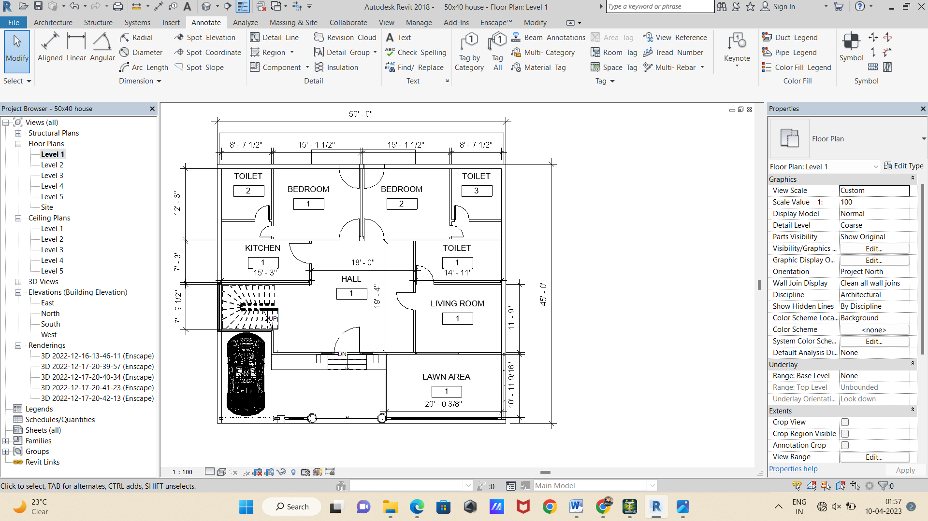
FIG. 191ST LEVEL PLAN
- 2ND LEVEL PLAN:
In this floor have 2 master bedroom, 1 common toilet, 1 kitchen, 1 stair case and 1 lawn area and 5’5” wide backyard. This has 2’ elevation with respect to level 1.

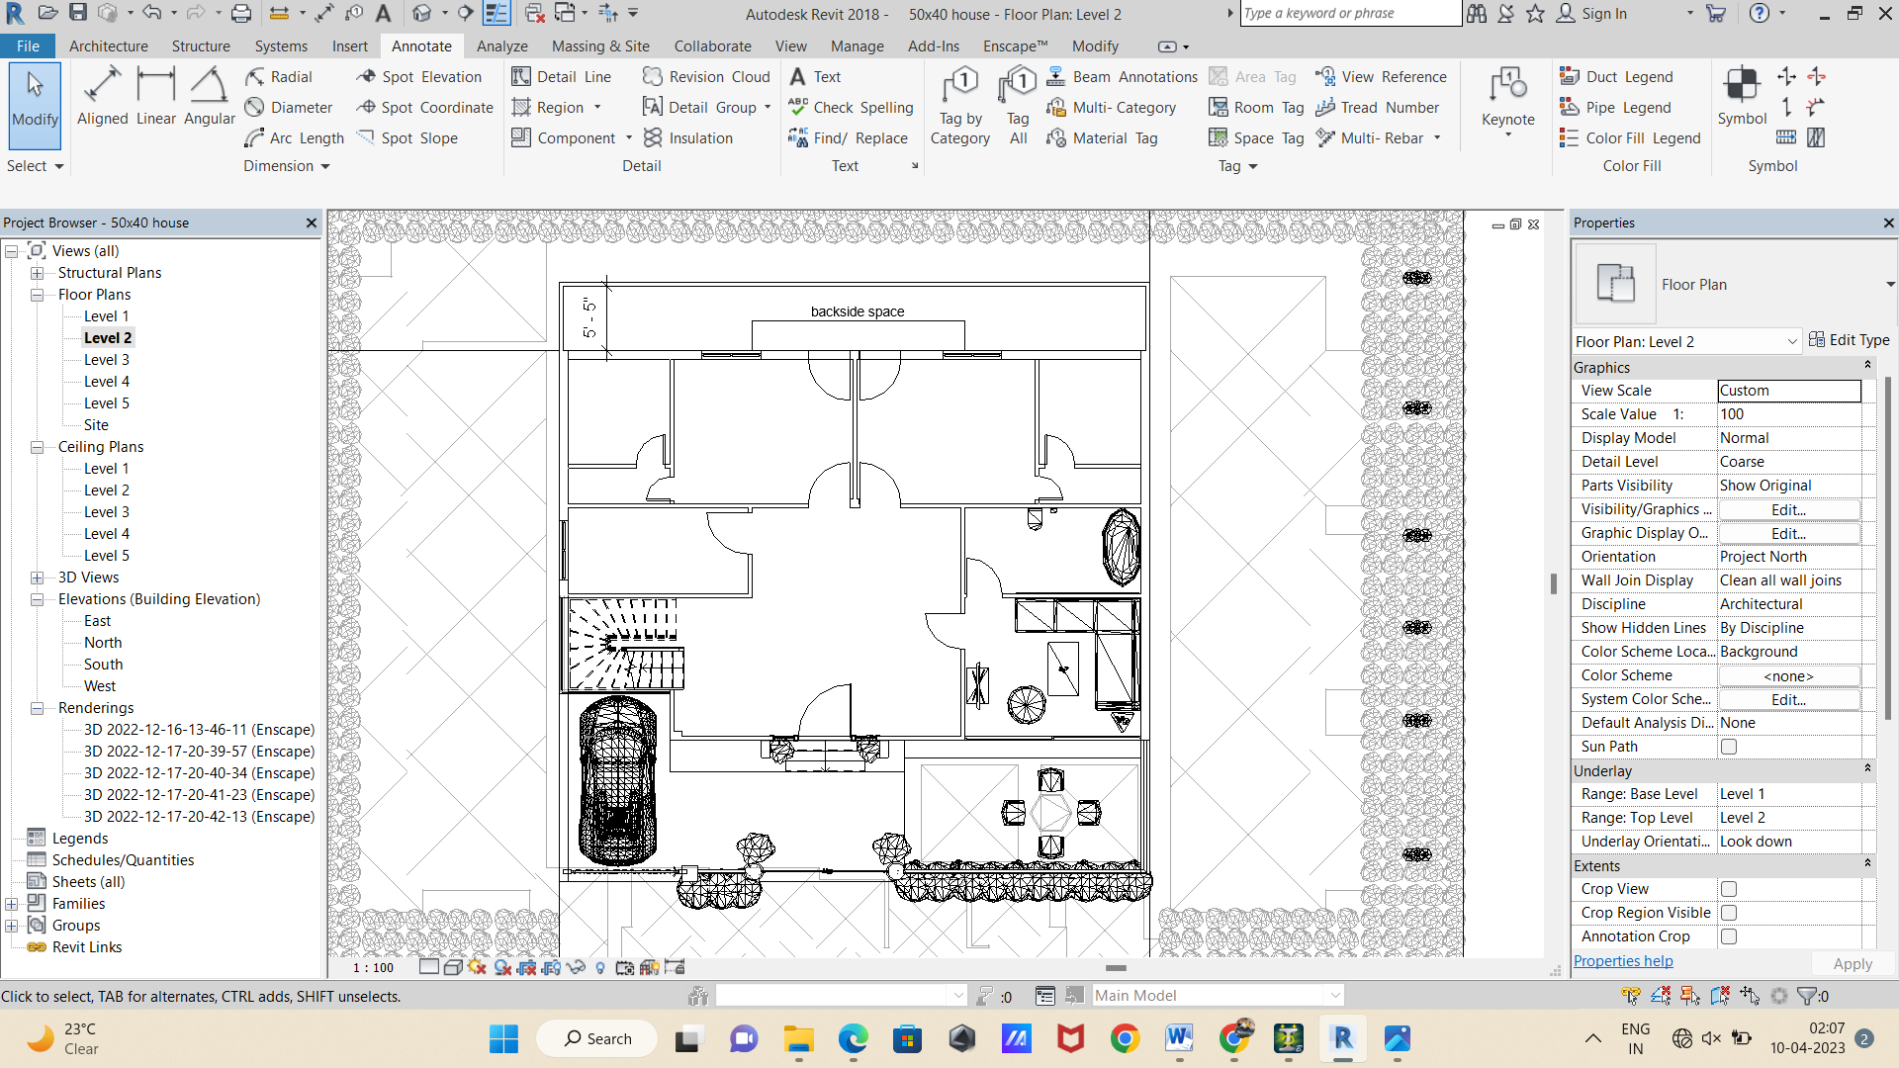

FIG. 20 2ND LEVEL PLAN
- 3RD LEVEL PLAN:
In this plan have 2 back and 2 front balconies, 3 different diffrent sizes master bedroom with attached toilet, 1 kitchen and huge hall and dining area.

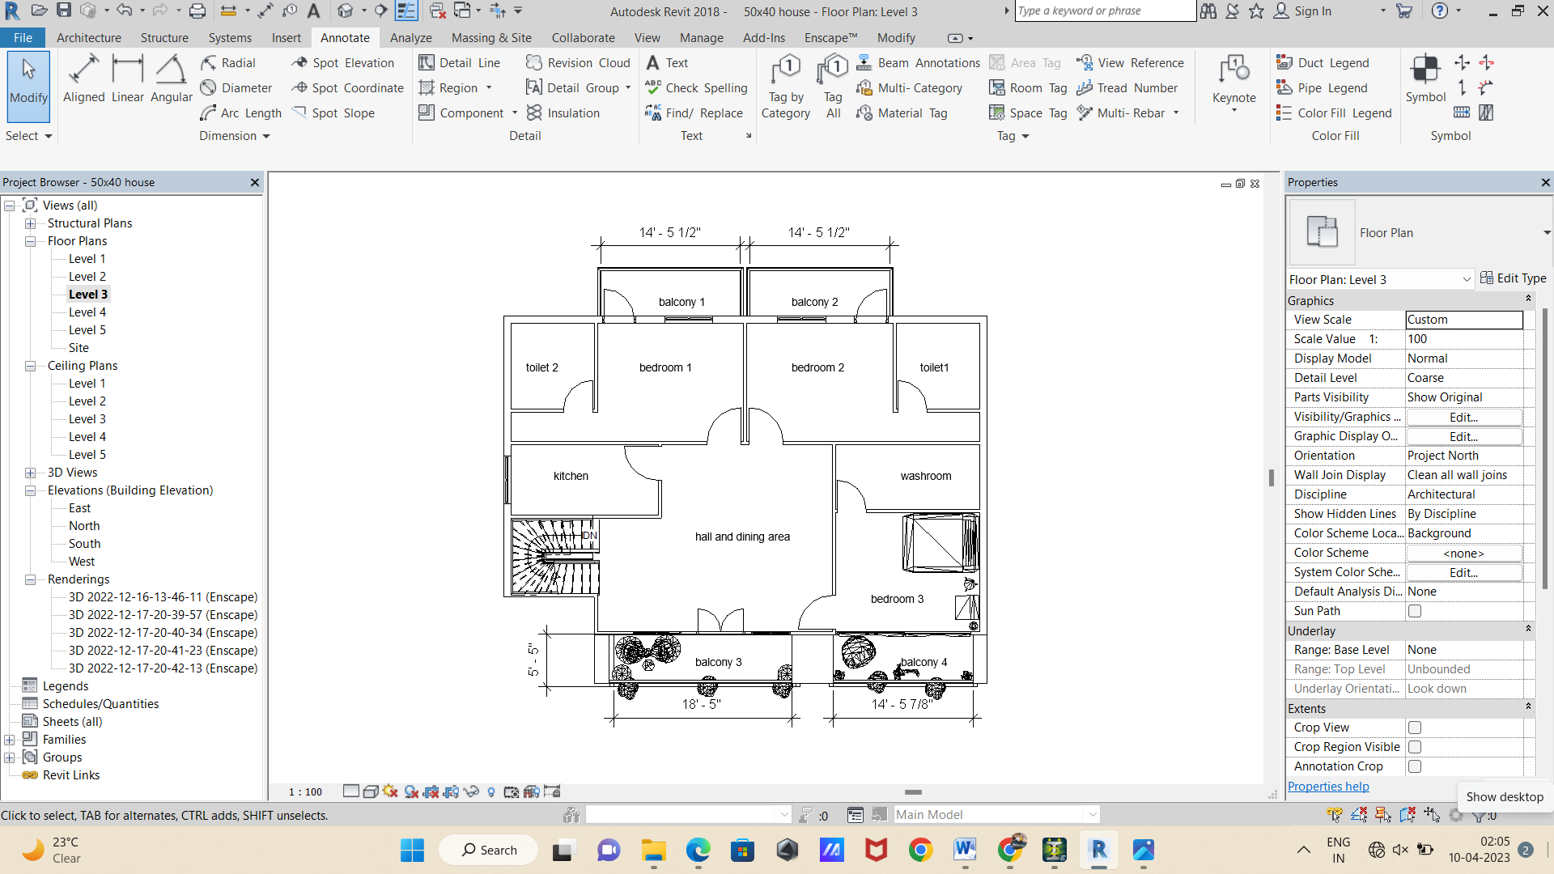
FIG. 21 3RD LEVEL PLAN
- 4TH LEVEL PLAN:
This plan shows the terrace view plan. In this, there are 1 staircase is seen and open terrace are designed.
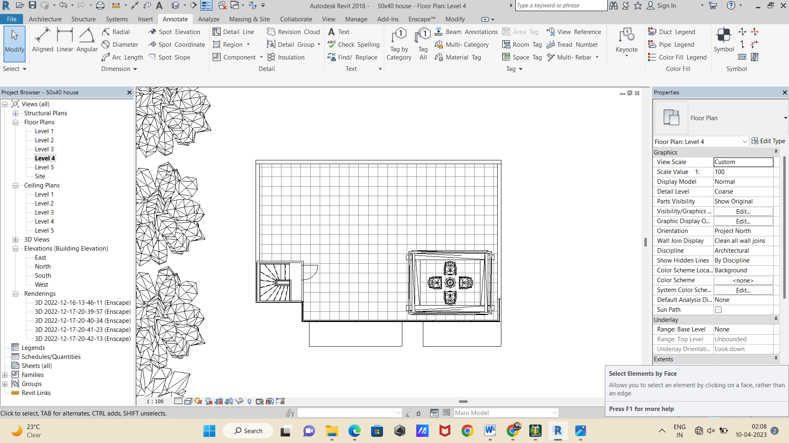
FIG. 22 14TH LEVEL PLAN
- 5TH LEVEL PLAN:In this plan, 1 mumty is designed.
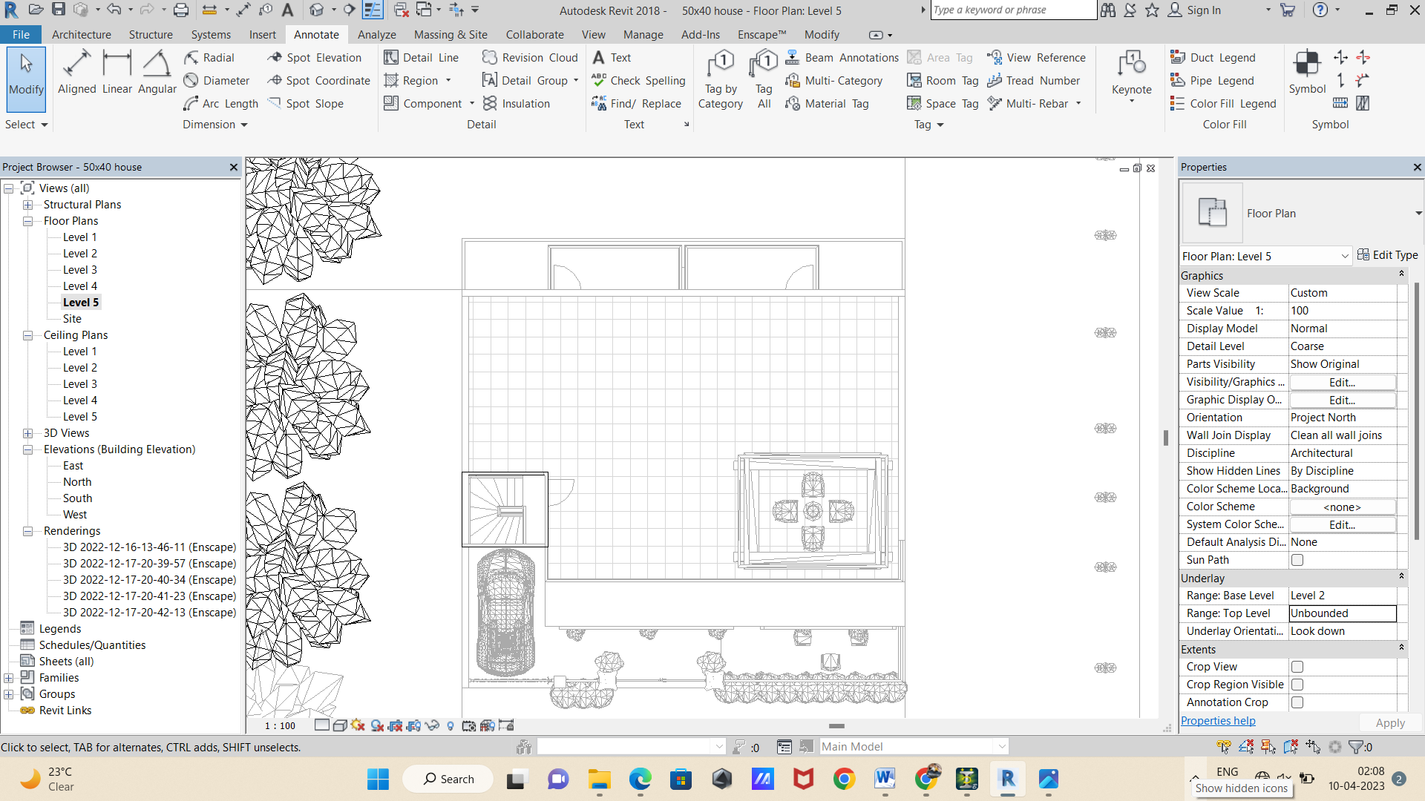
FIG.23 1 5TH LEVEL PLAN

4.3.Elevation of structure in Revit
An elevation plan provides us with an idea about what the finished building will look like. Just as a floor plan or a reflected ceiling plan illustrates how the building's floor or the ceiling will look after completion, the elevation plan shows the structural and architectural details of a building. In the architecture industry, the term 'elevation' refers to an orthographic representation of the exterior sides of any building. In some cases, we use elevation plans to illustrate the interior.
An elevation plan or an elevation drawing is a 2D view of a building or a house seen from one side. In general, the elevation floor plan is a two-dimensional flat visual representation of one facade as it displays the height of key features of the development about a fixed point from the ground level.
Some of the elevation drawings will include:
- The basic outline of the building.
- The outlines for the main door, windows, and garage area (if any).
- The detailed dimension and shape of the required roof area.
- Some important projects like eves and pipes.
- Some of the most accessed elevation plans will include level datums, like the finished ground level and floor positions.
- Dimension of the entire building is noted on the sides.
- Legends, notes, and scale are mentioned at the bottom of the elevation floor plan.
- Any other portion of the building (like a chimney or water tank on the roof) may be visible from a certain projection angle.
- Balcony areas or the exterior walls that are already completed by the builder.
The core purpose of creating an elevation plan is to illustrate what the exterior and interior of an actual building elevation would look like when seen from the front or a particular angle. In addition to this, the elevation plan or elevation drawing serves several other important purposes, like
- Easy Construction: Once you have laid out everything in the elevation drawing, you now know how the entire building or the house will look from the front. It will give you an n-number of chances to make any changes that you deem fit with the right budget and resources.
- Easy Maintenance: If you have created an elevation plan while constructing your house, you will know everything that went into making the front of the building. If your house needs renovation or some maintenance work, you can share it with the builder, who will know the exact place they need to put down their efforts.
- Saves Resources: Another important benefit of creating an elevation floor plan is to save money and time. If you are not happy with the elevation drawing, you will surely not be happy with the final house design. So, instead of wasting your hard-earned money on the building, you can put all of your efforts into creating the right elevation floor plan. Once everyone involved in the project is completely satisfied, you can only begin the construction work.
- Easy Modifications: Changing or modifying the front of the house or any other important interior part is extremely easy with the elevation plan. For instance, with the help of an elevation drawing, you can change the position of windows, modify the height of the chimney, change the locations of the shelves or doors, or more!
- Easy Accessibility: Like any other architectural design, an elevation drawing informs the owner or the builder of any unexpected problem they might face while building the house. For instance, the elevation plan includes the existing walls or trees that might interfere with an overhang.

- SOUTH ELEVATION
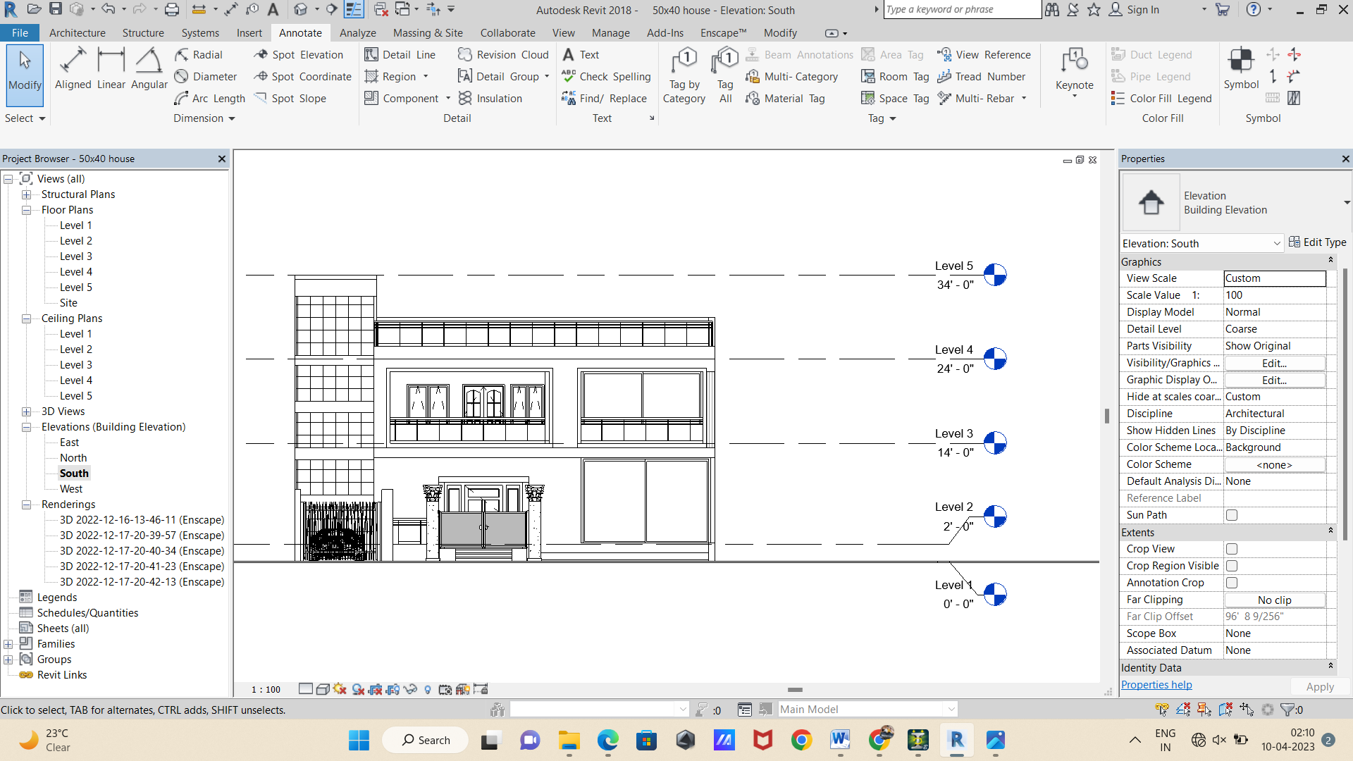
FIG. 24SOUTH ELEVATION

- WEST ELEVATION:
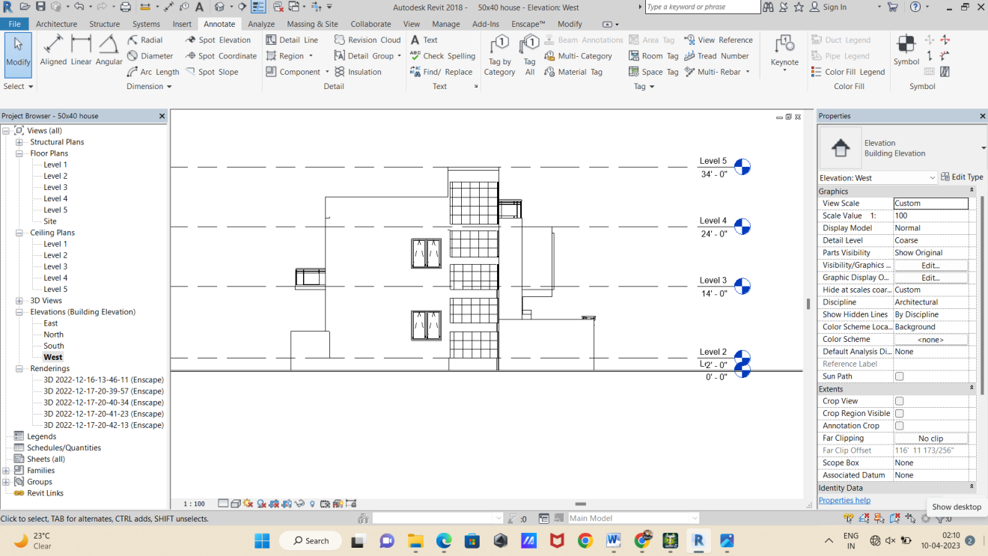
FIG. 25WEST ELEVATION

- NORTH ELEVATION:
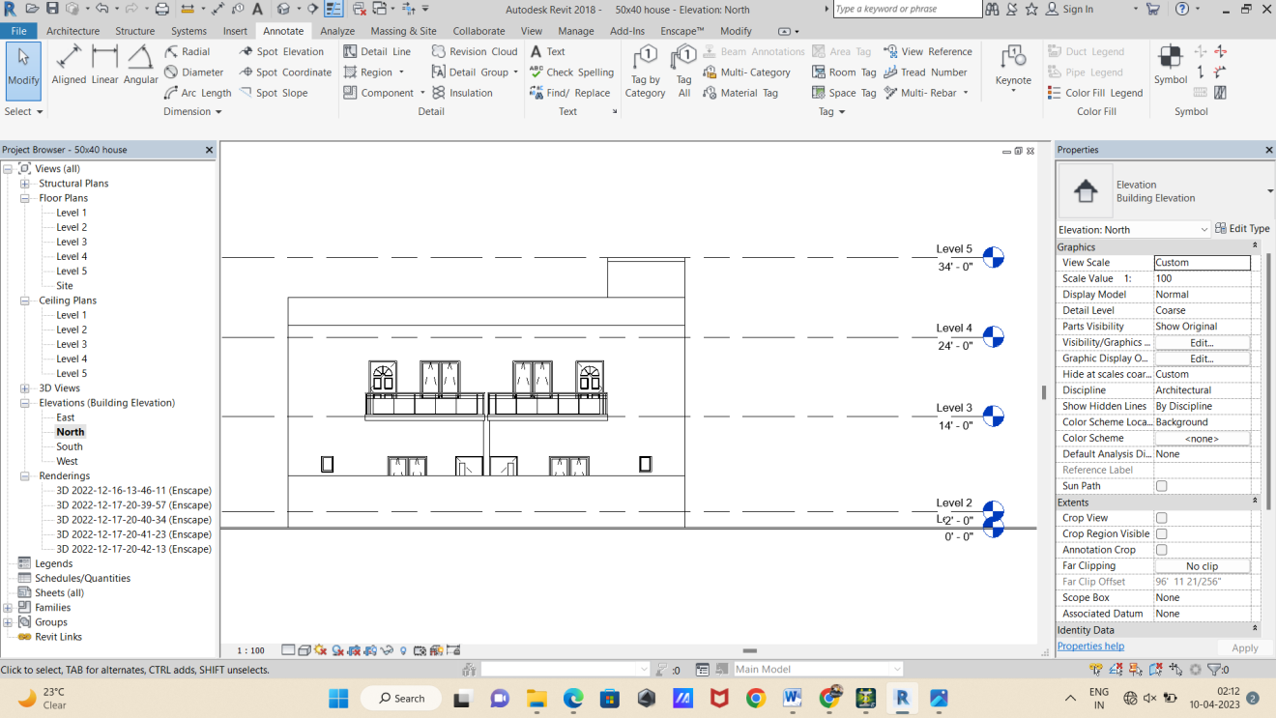
FIG. 26NORTH ELEVATION

- EAST ELEVATION:
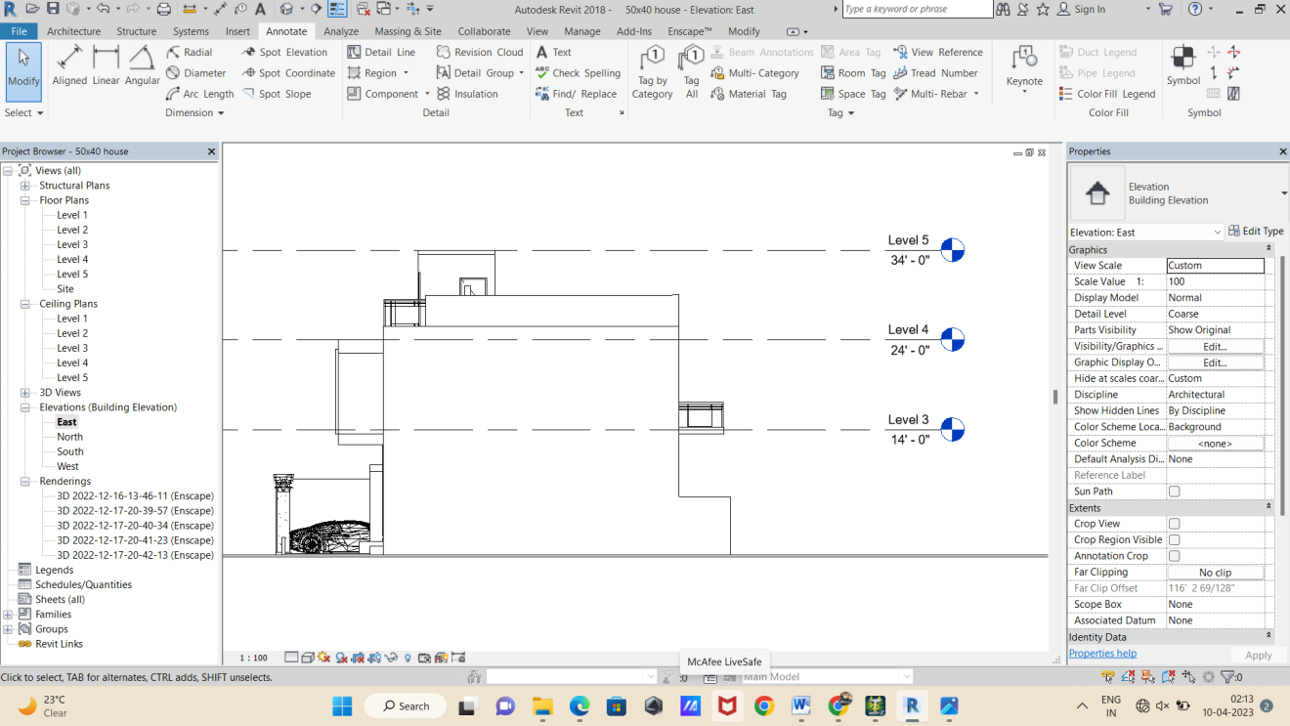
FIG. 27EAST ELEVATION
4.3. 3D VIEW OF STUCTURE:
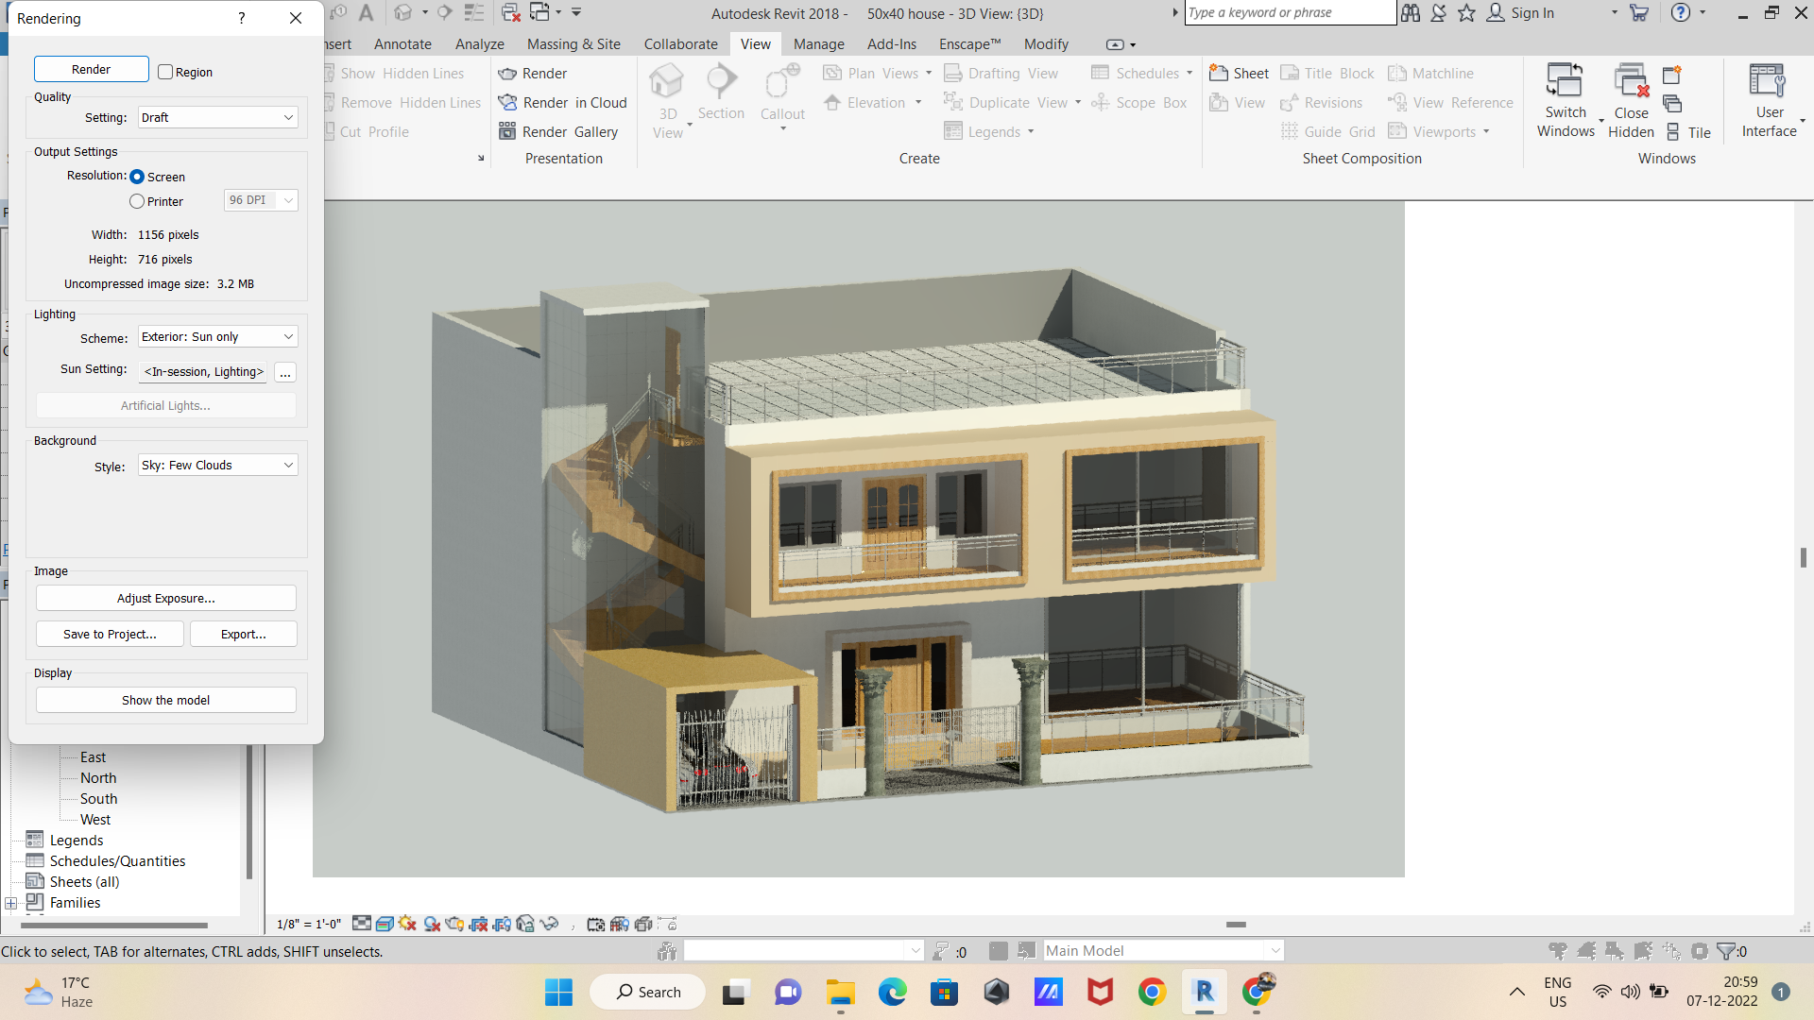
FIG. 283D VIEW
4.4. RENDERING OF STRUCTURE:
The term rendering in most forms of commercial design refers to the act of making an end-product or concept visible to an audience. Depending on the particular sector and business model of the renderer, this may be anything from a two-dimensional animation video to an internal rendering for architectural firms.
Rendering in design sectors such as architecture or engineering is only one part of a toolbox filled with various methods to communicate, illustrate or otherwise emulate ideas and products for potential clients, other professionals in related career sectors, or even simply as proof of concept artwork.
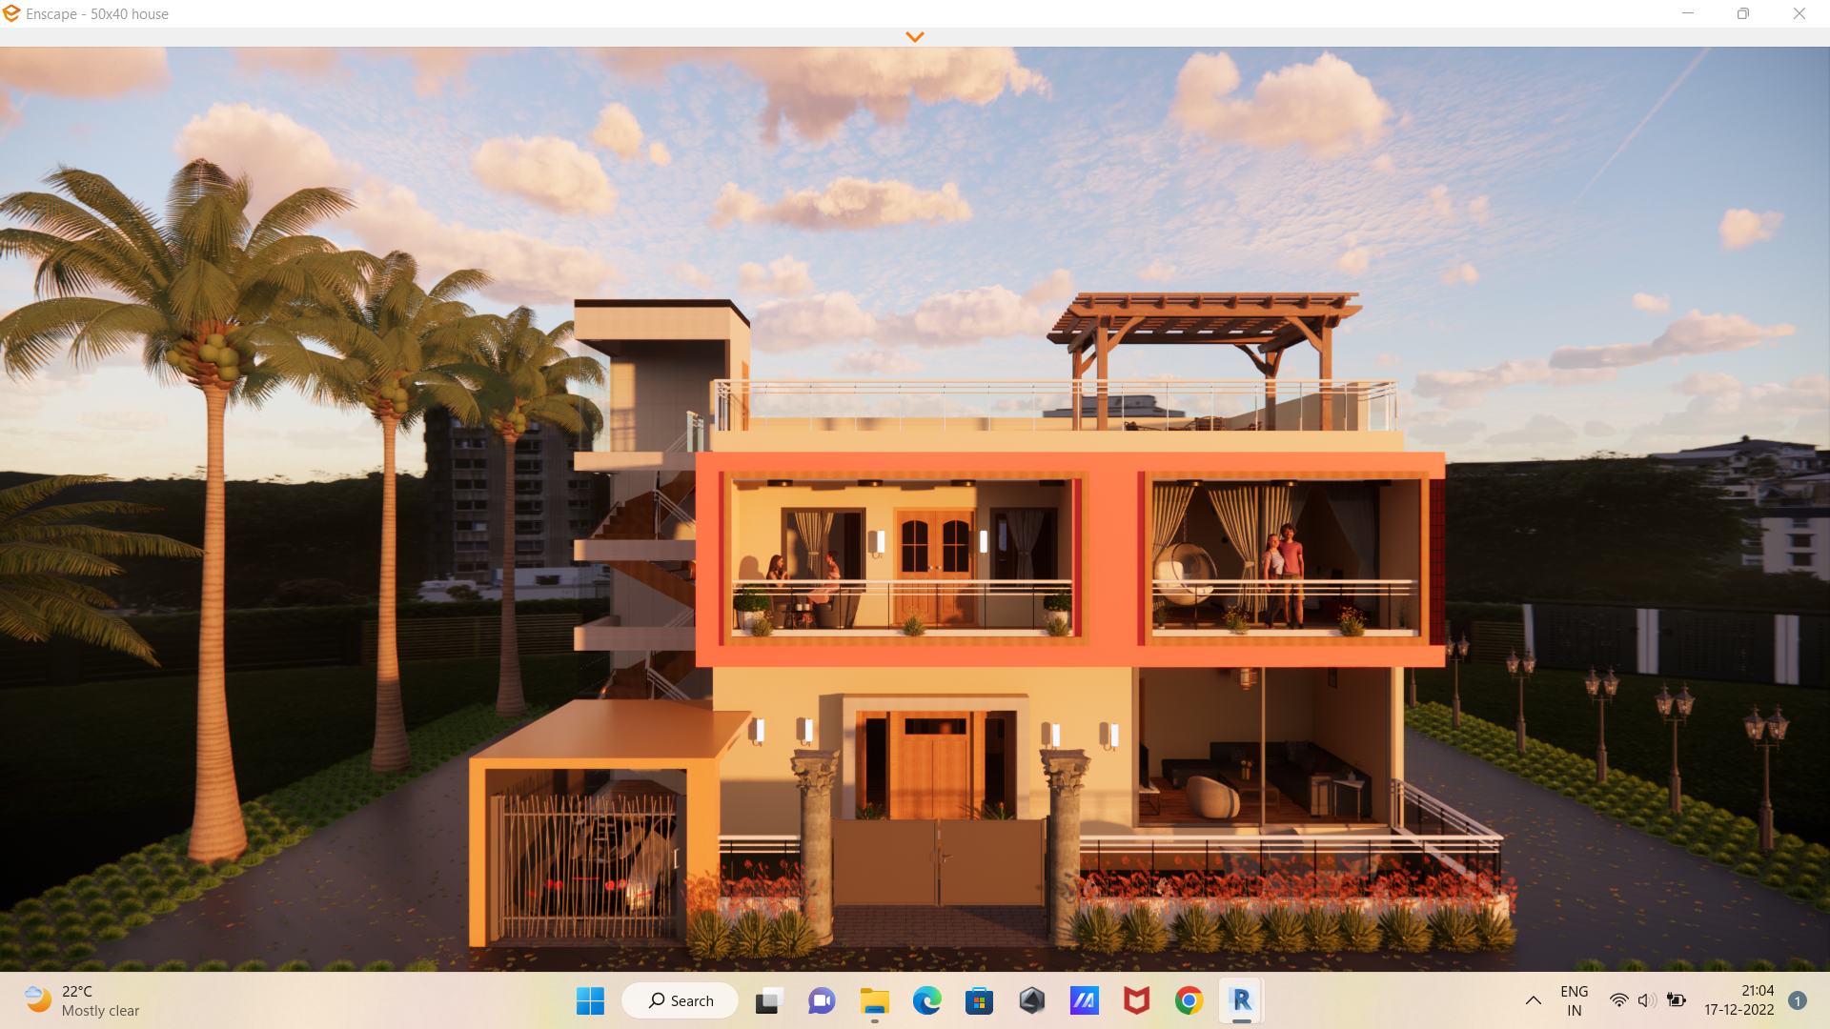
FIG. 29RENDER VIEW 1
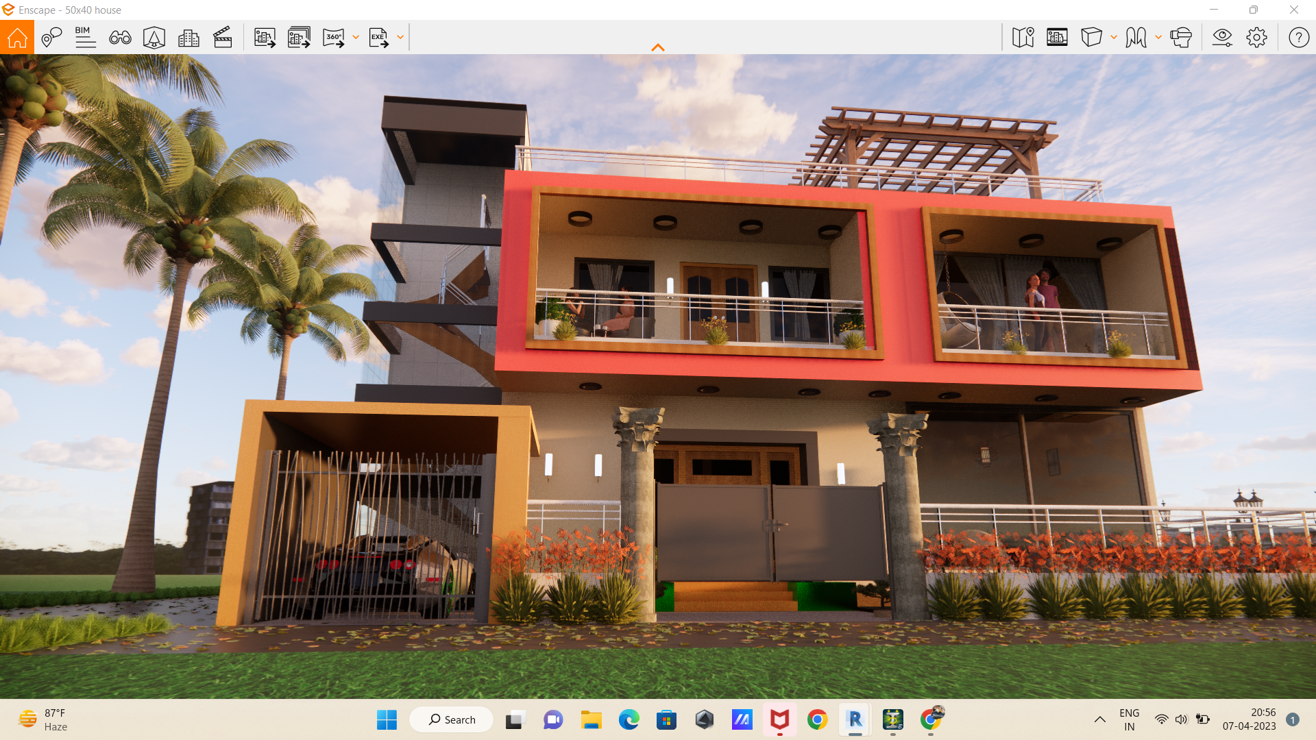
FIG. 30RENDER VIEW 2
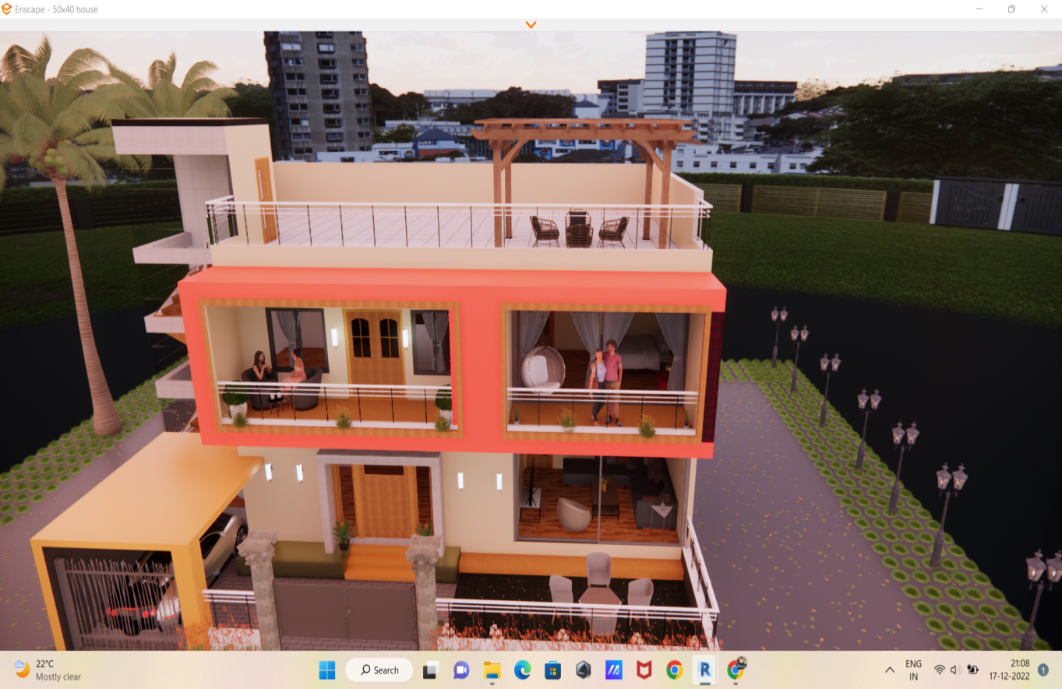
FIG. 31RENDER VIEW 3

Chapter5

Conclusion

- This project gives realistic and accurate families ranging from furniture to lighting fixtures, as well as import existing models from other program. We can get the approximate estimation also. By the application of Revit.
- A clear design and modelling of a residential building with the efficient structural and architectural plans. It provides the overall knowledge of material take off and schedule/ quantities in the model of the building defined in the project.
- 3D realistic view enables us to indicate the family and the components placed within the building model.
- The analysing of structure done in staad pro software.
- It checked in different loading condition also.

Chapter6

References

- IS: 456: 2000
- STAAD PRO MANUAL

