**A**

***PROJECT REPORT***

*on*

**ANONYMOUS ECHO**

*Submitted in partial fulfilment of the requirements for the degree of*

**BACHELOR OF TECHNOLOGY**



Session: - Jan-June 2023

Submitted by

Mustansir Jukker (19ETCCS040)

Sanyam Sharma (19ETCCS059)

Priyanshu Upadhyay (19ETCCS052)

VIII Semester, CSE

Under Guidance of

Mr. Aaditya Maheshwari

Head of Industry Project

Dept. of CSE TINJRIT, Udaipur

**DEPARTMENT OF COMPUTER SCIENCE AND ENGINEERING**

**TECHNO INDIA NJR INSTITUTE OF TECHNOLOGY, UDAIPUR-313001**

**MAY - 2023**

Under Guidance of

Mr. Aaditya Maheshwari

TINJRIT, Udaipur

**A**

***PROJECT REPORT***

*on*

**ANONYMOUS ECHO**

*Submitted in partial fulfilment of the requirements for the degree of*

**BACHELOR OF TECHNOLOGY**



**Session: - Jan-June 2023**

Submitted by

Mustansir Jukker (19ETCCS040)

Sanyam Sharma (19ETCCS059)

Priyanshu Upadhyay (19ETCCS052)

VIII Semester, CSE

Under Guidance of

Mr Aaditya Maheshwari

Head of Industry Project

Dept. of CSE TINJRIT, Udaipur

**DEPARTMENT OF COMPUTER SCIENCE AND ENGINEERING**

**TECHNO INDIA NJR INSTITUTE OF TECHNOLOGY, UDAIPUR-313001**

**MAY - 2023**



Department of Computer Science and Engineering

Techno India NJR Institute of Technology, Udaipur

## Certificate

This is to certify that this Major Project report titled “ANONYMOUS ECHO**”** by Mustansir Jukker, Sanyam Sharma and Priyanshu Upadhyay was successfully carried out in the Department of Computer Science and Engineering, TINJRIT and the report is approved for submission in the partial fulfillment of the requirements for award of degree of Bachelor of Technology in Computer Science and Engineering.

|  |  |
| --- | --- |
| Mr Aaditya Maheshwari | Dr Rimpy Bishnoi |
| Head of Industry Project | Head of Department |
| Dept. of CSE, TINJRIT, Udaipur | Dept. of CSE, TINJRIT, Udaipur |
| Date: —----------------- | Date: —---------------- |



Department of Computer Science and Engineering

Techno India NJR Institute of Technology, Udaipur

## Examiner Certificate

This is to certify that the following students **Mustansir Jukker, Sanyam Sharma and Priyanshu Upadhyay** of final year B.Tech (Computer Science and Engineering), were examined for the project work titled **“*AnonymousEcho*”** during the academic year 2019-2023 at Techno India NJR Institute of Technology, Udaipur.

**Remarks:**

**Date:**

|  |
| --- |
| Signature |
| (**Internal Examiner**)  Name :- ……………………..  Designation :- ……………....  Department :- ……………….  Organisation :- ……………… |

|  |
| --- |
| Signature |
| (**External Examiner**)  Name :- ……………………..  Designation :- ……………....  Department :- ……………….  Organisation :- ……………… |

## Preface

## Welcome to the world of discreet communication and anonymous connections. In a time where privacy concerns are paramount, we are proud to present an innovative solution that prioritizes confidentiality and empowers users to express themselves freely without compromising their identities.

## Our anonymous chatting app, built with the robust combination of Express, React, Socket.IO, and Node.js, offers a secure platform for individuals to engage in real-time conversations while maintaining complete anonymity. Whether you seek an outlet for personal thoughts, want to discuss sensitive topics, or simply crave a space to connect with others without revealing your true identity, this app is tailored to cater to your needs.

## Express, renowned for its flexibility and simplicity, forms the foundation of our server-side application. It ensures seamless handling of incoming requests, robust routing, and efficient middleware integration, guaranteeing a smooth user experience.

## On the client side, we employ React, a powerful JavaScript library, to create a dynamic and interactive interface. React enables us to build a responsive UI that adapts to users' actions and renders real-time updates, enhancing the overall chat experience.

## Facilitating instant, bidirectional communication is Socket.IO, a widely adopted library that enables real-time event-based communication between the client and the server. By leveraging WebSockets, our app enables users to exchange messages instantaneously, maintaining a fluid and engaging chat environment.

## With this anonymous chatting app, we aim to foster a sense of community while respecting and valuing each user's privacy. By removing the constraints of identity, we hope to encourage open conversations, promote genuine connections, and provide a safe haven for sharing thoughts and ideas.

DEPARTMENT OF COMPUTER SCIENCE AND ENGINEERING

TECHNO INDIA NJR INSTITUTE OF TECHNOLOGY, UDAIPUR-313001

## ACKNOWLEDGEMENT

We take this opportunity to record our sincere thanks to all who helped us to successfully complete this work. Firstly, We are grateful to our **supervisor Mr. Aditya Maheshwari** for his invaluable guidance and constant encouragement, support and most importantly for giving us the opportunity to carry out this work.

We would like to express our deepest sense of gratitude and humble regards to our

**Head of Department Dr. Rimpy Bishnoi** for giving invariable encouragement in our endeavors and providing necessary facility for the same. Also a sincere thanks to all faculty members of CSE, TINJRIT for their help in the project directly or indirectly.

Finally, We would like to thank my friends for their support and discussions that have proved very valuable for us. We are indebted to our parents for providing constant support, love and encouragement. We thank them for the sacrifices they made so that we could grow up in a learning environment. They have always stood by us in everything we have done, providing constant support, encouragement and love

**Mustansir Jukker (19ETCCS040)**

**Sanyam Sharma (19ETCCS059)**

**Priyansh Upadhyay (19ETCCS052)**

DEPARTMENT OF COMPUTER SCIENCE AND ENGINEERING

TECHNO INDIA NJR INSTITUTE OF TECHNOLOGY, UDAIPUR-313001

## CONTENTS

**Preface** ……………………………………………………………….……… i

**Contents** ………………………………………………………………………. ii

**List of Figures** ……………………………………………………............………… iii

**List of Tables** ………………………………………………………………………. iv

**Chapter 1** INTRODUCTION…………………………………………................ 1

1.1 Overview of the Application and its Purpose ………….……… 2

1.2 Objectives ………………………………………………………… 3

1.3 Technologies Used ……..……………………………………….. 4

1.4 Features and Functionalities ………………………................... 6

**Chapter 2** SOFTWARE REQUIREMENT SPECIFICATIONS………………… 8

2.1 Introduction ……………………………………..………….……… 9

2.1.1 Purpose ………………………………………………… 9

2.1.2 Scope …………………………………………………… 9

2.1.3 Intended Audience …………………………………….. 9

2.1.4 System Overview .……………………………………… 9

2.2 Functional Requirements ………………………………………… 10

2.2.1 Anonymity ……………………..………………………… 10

2.2.2 Chat Rooms and Groups……………………………….. 10

2.2.3 Real Time Messaging ………………………………….. 10

2.2.4 User Requirement Specifications …………...………… 11

2.3 Non Functional Requirements …………………………………… 12

2.3.1 Security ………………………..………………………… 12

2.3.2 Performance …………………………………………….. 12

2.3.3 User Interface ………..………………………………….. 12

2.3.4 Compatibility …………………………………...………… 12

2.4 Assumptions and Constraints ……..……………………………….. 13

2.6 Development Constraints ..…………………………………………. 13

2.7 Testing Requirements ……..………………………………………… 13

2.7 Documentation Requirements ..…………………………………….. 13

**Chapter 3** SYSTEM ANAYLYSIS AND DESIGN ……………………………… 14

3.1 Introduction ..……………………………………………………………… 15

3.2 Flow Diagram ..…………………………………………………………… 17

**Chapter 4** SCREENSHOTS…………………….. ……………………………… 18

4.1 Home Page ..……………………………………………………………… 19

4.2 Chat Interface ..…………………………………………………………… 20

**Chapter 5** BIBLIOGRAPHY…………………….. ……………………………… 21

### List of Tables

|  |  |  |
| --- | --- | --- |
| **Table No.** | **Table Name** | **Page No.** |
| Table 2.1 | User Requirement Specification | 11 |

### List of Figures

|  |  |  |
| --- | --- | --- |
| **Figure No.** | **Figure Name** | **Page No.** |
| Figure 3.2.1 | Flow Diagram 1 | 17 |
| Figure 3.2.2 | Flow Diagram 2 | 17 |

# CHAPTER - 1

# INTRODUCTION

## Overview of The Application and Its Purpose

Our anonymous chatting app is a secure and user-friendly platform that enables individuals to engage in real-time conversations while maintaining complete anonymity. Built using Express, React, Socket.IO, and Node.js, our app provides a seamless and interactive chatting experience for users seeking privacy and open communication.

The purpose of our anonymous chatting app is to provide a safe and confidential space for individuals to express themselves freely, connect with others, and engage in meaningful conversations without the fear of judgment or exposure. We understand the importance of privacy in today's digital world, where personal information is vulnerable to misuse. Our app aims to address these concerns by offering a platform that respects and prioritizes user anonymity.

Whether you want to discuss sensitive topics, share personal thoughts, seek advice, or simply connect with like-minded individuals without revealing your identity, our app is designed to cater to your needs. We believe in fostering a sense of community and promoting open dialogue, empowering users to express themselves authentically and build connections based on shared interests and ideas.

With our app, you can enjoy real-time, bidirectional communication through a secure and encrypted channel. The user-friendly interface, powered by React, ensures a seamless and responsive chat experience. By leveraging the capabilities of Socket.IO, we enable instant messaging and real-time updates, making conversations engaging and dynamic.

Our app's purpose extends beyond facilitating anonymous communication. We aim to create a supportive and inclusive environment where users can engage in respectful discussions, learn from different perspectives, and broaden their understanding of the world. By removing the barriers of identity, we encourage honest and meaningful connections while preserving user privacy.

Join us on this journey of secure and unfiltered dialogue, where you can freely express yourself, connect with others, and explore a world of limitless conversations. Embrace the freedom to be yourself, without the fear of judgment or exposure. Welcome to our anonymous chatting app, where your privacy and voice are valued above all else.

* 1. **Objectives**

The objectives of our anonymous chatting app are as follows:

* Enable Anonymity: The primary objective of the app is to provide users with a platform where they can engage in conversations while maintaining complete anonymity. Users should have the freedom to express themselves without the fear of their identity being revealed.
* Foster Open Communication: The app aims to create a space that promotes open and honest communication. Users should feel comfortable discussing various topics, sharing opinions, and engaging in meaningful conversations without judgment or prejudice.
* Ensure Privacy and Data Security: User privacy is of utmost importance. The app should implement robust security measures to protect user data and ensure that personal information remains confidential. Encryption and anonymization techniques should be employed to safeguard user identities and messages.
* Encourage User Engagement: The app should encourage active user participation and engagement. Features such as chat rooms, group discussions, and private messaging should be implemented to facilitate interaction between users and promote a sense of community.
* Provide a User-Friendly Interface: The app should have a user-friendly interface that is intuitive and easy to navigate. Users should be able to seamlessly access various features and functionalities, ensuring a positive and hassle-free user experience.
* Real-Time Communication: The app should enable real-time communication, allowing users to send and receive messages instantly. Features such as typing indicators, message notifications, and real-time updates should be implemented to create an interactive and dynamic chatting experience.
* Support Multiple Platforms: The app should be designed to work seamlessly across different platforms, including web browsers, mobile devices, and tablets. This ensures that users can access and use the app conveniently from their preferred devices.
  1. **Technologies Used**

Our anonymous chatting app is built using a combination of modern web technologies to ensure a seamless and secure user experience. The following technologies have been utilized in the development of the app:

* Express.js: Express.js is a fast and minimalist web application framework for Node.js. It is used on the server-side to handle routing, middleware integration, and server setup. Express.js provides a robust and efficient foundation for building scalable and modular server applications.
* React: React is a popular JavaScript library for building user interfaces. It is used on the client-side to create dynamic and responsive user interfaces. React's component-based architecture allows for efficient UI rendering, state management, and event handling, resulting in a smooth and interactive chat experience for users.
* Socket.IO: Socket.IO is a real-time communication library that enables bidirectional communication between the client and server. It facilitates instant messaging and real-time updates by establishing a WebSocket connection between the client and server. Socket.IO ensures efficient and reliable real-time communication, enhancing the responsiveness and interactivity of the app.
* Node.js: Node.js is a server-side JavaScript runtime environment. It provides a non-blocking, event-driven architecture that allows for scalable and high-performance server applications. Node.js is used alongside Express.js to handle server-side logic, database interactions, and other server-related operations in our app.

These technologies have been chosen for their efficiency, scalability, and extensive community support. Express.js and Node.js enable the development of a robust and scalable server-side architecture, while React enhances the client-side user interface with its component-based approach. Socket.IO empowers real-time communication, enabling instant messaging and updates.

Additionally, these technologies offer a wide range of libraries, tools, and community resources that contribute to the development process. They have active developer communities and extensive documentation, making it easier to troubleshoot issues and incorporate best practices.

By leveraging Express.js, React, Socket.IO, and Node.js, we have created a powerful and efficient platform for anonymous chatting that ensures a secure, real-time, and user-friendly experience for our app's users.

* 1. **Features and Functionality**

Our anonymous chatting app offers a range of features and functionalities that enhance user engagement, promote open communication, and ensure a seamless chatting experience. The following are the key features and functionalities of our app:

Anonymity:

The app prioritizes user anonymity, allowing users to chat and interact without revealing their true identities. User profiles are kept anonymous, and conversations are conducted using usernames or aliases. This feature encourages open and honest communication.

Chat Rooms and Groups:

Users can join existing chat rooms or create their own chat groups based on specific topics or interests. This feature enables users to engage in discussions with like-minded individuals and fosters a sense of community within the app.

Real-Time Messaging:

The app facilitates real-time messaging, ensuring that messages are delivered instantly. Users can send and receive messages in real-time, making conversations feel dynamic and interactive. Features like typing indicators and message read receipts enhance the real-time chat experience.

Emojis:

To enhance expressiveness and engagement, the app supports a wide range of emojis. This feature adds visual elements to conversations and enables users to convey emotions and share them seamlessly.

User Profiles and Preferences:

Users can create and customize their profiles with optional information such as profile pictures, short bios, or interests. They can also personalize their preferences, including notification settings, privacy settings, and chat room/group subscriptions.

Responsive Design:

The app is designed to be responsive, adapting to different screen sizes and devices. Whether accessed through a web browser or mobile application, the user interface adjusts seamlessly to provide an optimal viewing and chatting experience.

These features and functionalities work together to create an immersive, secure, and user-friendly anonymous chatting experience. They promote open communication, facilitate meaningful interactions, and empower users to express themselves freely while maintaining anonymity.

# CHAPTER - 2

**SOFTWARE REQUIREMENT SPECIFICATIONS**

**2.1 Introduction**

**2.1.1. Purpose**

The purpose of this Software Requirements Specification (SRS) document is to provide a comprehensive overview of the anonymous chatting app. This document outlines the functional and non-functional requirements, system capabilities, and constraints of the app. It serves as a reference for the development team and stakeholders to ensure a clear understanding of the app's objectives and specifications.

**2.1.2. Scope**

The anonymous chatting app aims to create a platform that enables users to engage in conversations while maintaining complete anonymity. It promotes open communication, facilitates real-time messaging, and provides a secure and user-friendly environment for individuals to express themselves freely. The app includes features such as chat rooms, and private messaging.

**2.1.3. Intended Audience**

The intended audience for this document includes the development team, project stakeholders, designers, testers, and anyone involved in the development and evaluation of the anonymous chatting app. It provides a common understanding of the app's requirements and serves as a basis for development, testing, and project management.

**2.1.4. System Overview**

The anonymous chatting app is a web-based application built using Express.js and React. It leverages Socket.IO for real-time communication between the server and clients. The app allows users to create user profiles, join chat rooms or groups, and engage in messaging. It emphasizes user anonymity, security, and a seamless user experience across multiple devices.

This introduction section provides an overview of the Software Requirements Specification (SRS) document for the anonymous chatting app. It defines the purpose, scope, intended audience, and system overview. The subsequent sections will delve into the specific requirements, functionality, and constraints of the app in more detail.

**2.2 Functional Requirements**

**2.2.1 Anonymity**

* + The app shall ensure that user identities remain anonymous throughout the chat interactions.
  + User profiles and chat messages should only display usernames or aliases without revealing personal information.

**2.2.2 Chat Rooms and Groups**

* + The app shall provide users with the ability to join existing chat rooms or create their own chat groups based on specific topics or interests.
  + Users should be able to view and browse available chat rooms or groups, and join or leave them as desired.

**2.2.3 Real-Time Messaging**

* + The app shall support real-time messaging, ensuring that messages are delivered instantly.
  + Users should be able to send and receive messages in real-time, with features like typing indicators and message read receipts to enhance the real-time chat experience.

**2.2.4 User Requirement Specification**

|  |  |
| --- | --- |
| **Title** | **Description** |
| Chat room creation | The anonymous chatting app allows users to create their own chat rooms based on specific topics or interests, fostering a sense of community and enabling focused discussions. Chat room creation is a key feature that empowers users to initiate conversations and bring like-minded individuals together. |
| Joining a room | Users can join any chat room and can actively engage in conversations with other participants. They can send messages, and respond to ongoing discussions. The chat room becomes a space for exchanging ideas, seeking advice, sharing experiences, and building connections with like-minded individuals. |
| Sending message | Users input their messages in the app's text input or chat box, composing them with text. These messages are then transmitted to the server for processing and distribution. Leveraging real-time messaging technology, the app ensures that messages are instantly delivered to the intended recipients, who receive and display them on their devices in the appropriate chat room. |
| Receiving message | As messages are sent by other users, the app's server relays them to the recipients' devices, where they are received and displayed. The messages are presented in chronological order, with the most recent messages appearing at the bottom of the conversation thread. |

Table 2.1 User Requirement Specification

**2.3 Non-Functional Requirements**

**2.3.1 Security**

* + The app shall implement robust security measures to protect user data and ensure secure communication.
  + User authentication and authorization should be implemented to prevent unauthorized access.

**2.3.2 Performance**

* + The app should be highly responsive and provide a seamless user experience even with a large number of concurrent users.
  + Messages should be delivered and displayed in real-time without significant delays.

**2.3.3 User Interface**

* + The app shall have a user-friendly interface that is intuitive, visually appealing, and easy to navigate.
  + The user interface should adapt to different screen sizes and devices, providing a consistent experience across platforms.

**2.3.4 Compatibility**

* + The app should be compatible with popular web browsers and mobile devices.
  + It should be designed and tested to work on various operating systems and screen resolutions.

**2.4 Assumptions and Constraints**

* + The app assumes that users have access to a reliable internet connection to use the app effectively.
  + The app is constrained by the limitations of the underlying technologies and platforms it is built upon, such as the compatibility of web browsers or the performance capabilities of the user's device.

**2.5 Development Constraints**

* + The app shall be developed using the Express.js framework for the server-side implementation.
  + React shall be used for the client-side user interface development.
  + Socket.IO shall be employed for real-time communication between the server and clients.
  + The development team shall follow best practices for security, code quality, and documentation.

**2.6 Testing Requirements**

* The app shall undergo thorough testing to ensure its functionality, performance, and security.
* Testing activities shall include unit testing, integration testing, and user acceptance testing.
* Test cases and scenarios shall be defined to cover all the identified functional and non-functional requirements.

**2.7 Documentation Requirements**

* The app shall be accompanied by detailed documentation, including installation instructions, user guides, and API documentation.
* Code documentation, such as inline comments and developer guides, shall be provided to facilitate maintenance and future development.

# CHAPTER - 3

**SYSTEM ANALYSIS AND DESIGN**

**3.1 Introduction**

System analysis and design play a vital role in developing the anonymous chatting app, ensuring that it meets the desired objectives and provides a seamless user experience. Here's an overview of the system analysis and design process specific to this app:

1. Requirement Elicitation: The system analysis phase begins by understanding and documenting the specific requirements of the anonymous chatting app. This includes identifying the desired features, functionality, and user interactions. Requirements are gathered through stakeholder interviews, user surveys, and market research to ensure a comprehensive understanding of user needs.

2. Use Case Modeling: Use case diagrams and scenarios are created to illustrate the various interactions and functionalities within the app. This helps in identifying the primary actors (users, administrators) and their respective roles, as well as the main use cases and their relationships. Use case modeling enables a clear visualization of how users will interact with the app and the expected system behavior.

3. System Architecture Design: Based on the requirements and use case modeling, the system architecture is designed. This involves determining the appropriate technologies and frameworks to use, such as Express.js for the server-side implementation and React for the client-side user interface. The system architecture design defines the components, modules, and their interactions, ensuring scalability, reliability, and security.

4. Database Design: The app's data storage requirements are analyzed, and a suitable database design is created. This includes defining the data entities, their relationships, and the database schema. The design ensures efficient storage and retrieval of user profiles, chat room details, messages, and other relevant data.

5. User Interface Design: The user interface (UI) design phase focuses on creating an intuitive and user-friendly interface for the app. UI wireframes and mockups are created to visualize the layout, navigation, and overall look and feel of the app. This stage ensures a cohesive and visually appealing design that enhances the user experience.

6. System Testing and Validation: The designed system is thoroughly tested to ensure that it meets the specified requirements. Testing activities include functional testing, usability testing, performance testing, and security testing. Bugs and issues are identified, addressed, and resolved to deliver a robust and reliable app.

7. Iterative Development: The system analysis and design process is iterative, with feedback from stakeholders and users guiding refinements and improvements. Feedback is collected, analyzed, and incorporated into subsequent iterations, ensuring continuous enhancement of the app's features and functionality.

System analysis and design form the foundation of the anonymous chatting app, ensuring that it is built to meet user requirements, provides an engaging user experience, and incorporates scalable and efficient system architecture. By following a systematic approach, the development team can create a well-designed app that delivers on its objectives and meets user expectations.

**3.2 Flow Diagram**

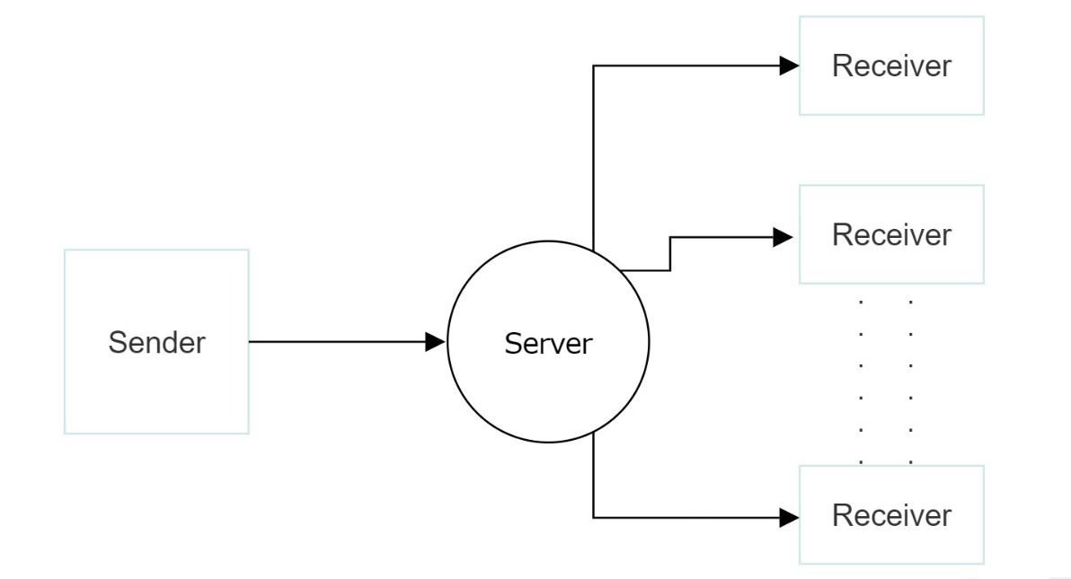

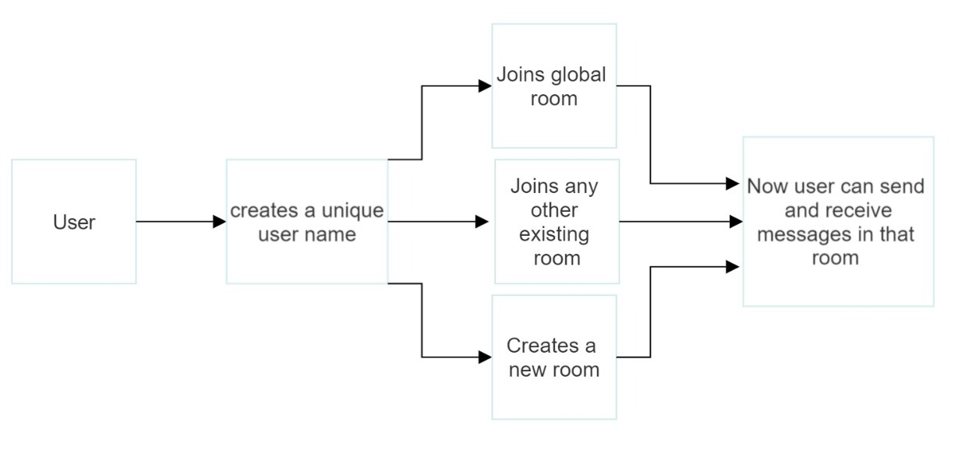

# CHAPTER - 4

**SCREENSHOTS**

**Home Page**

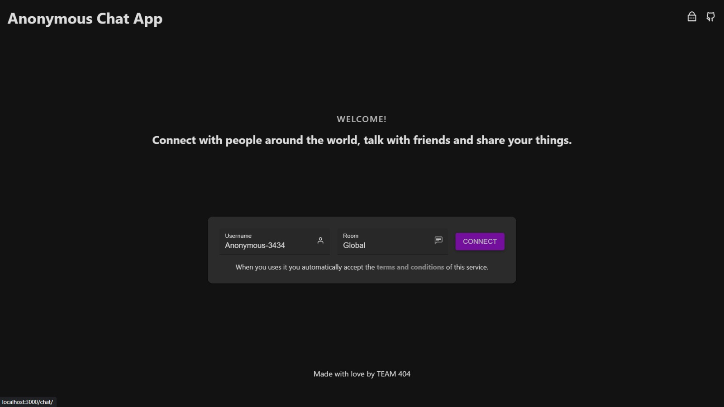

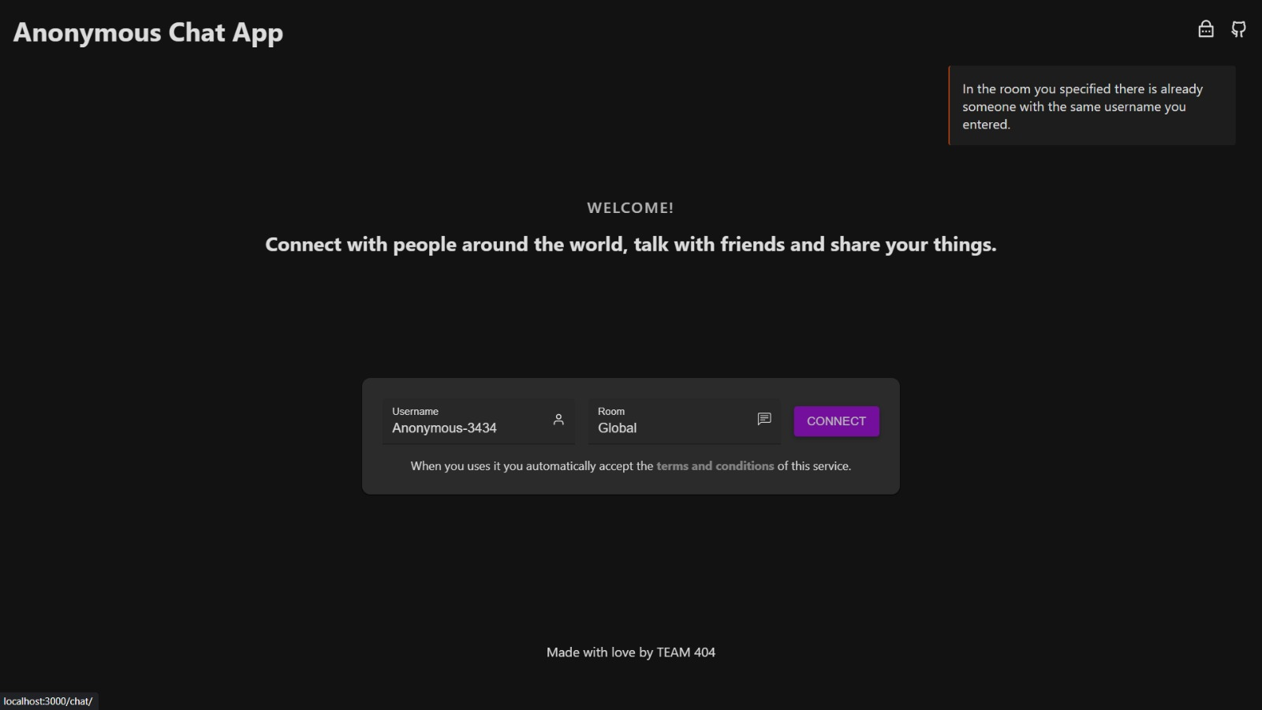

**Chat Interface**

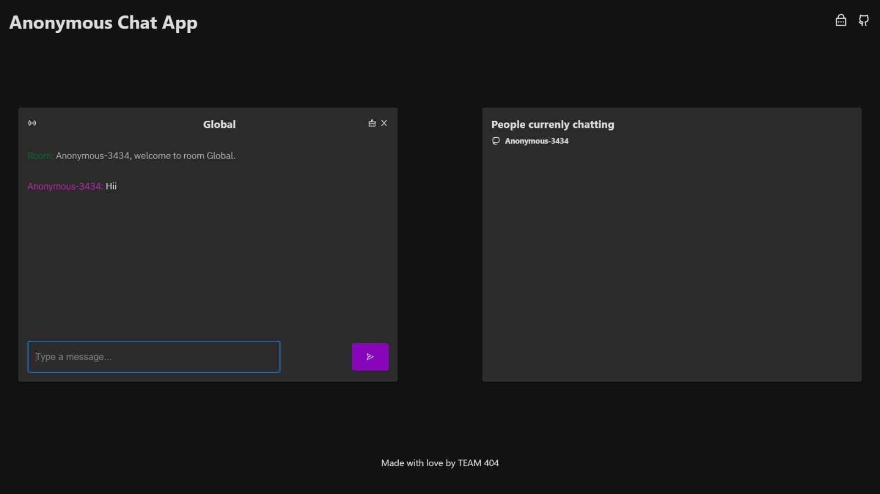

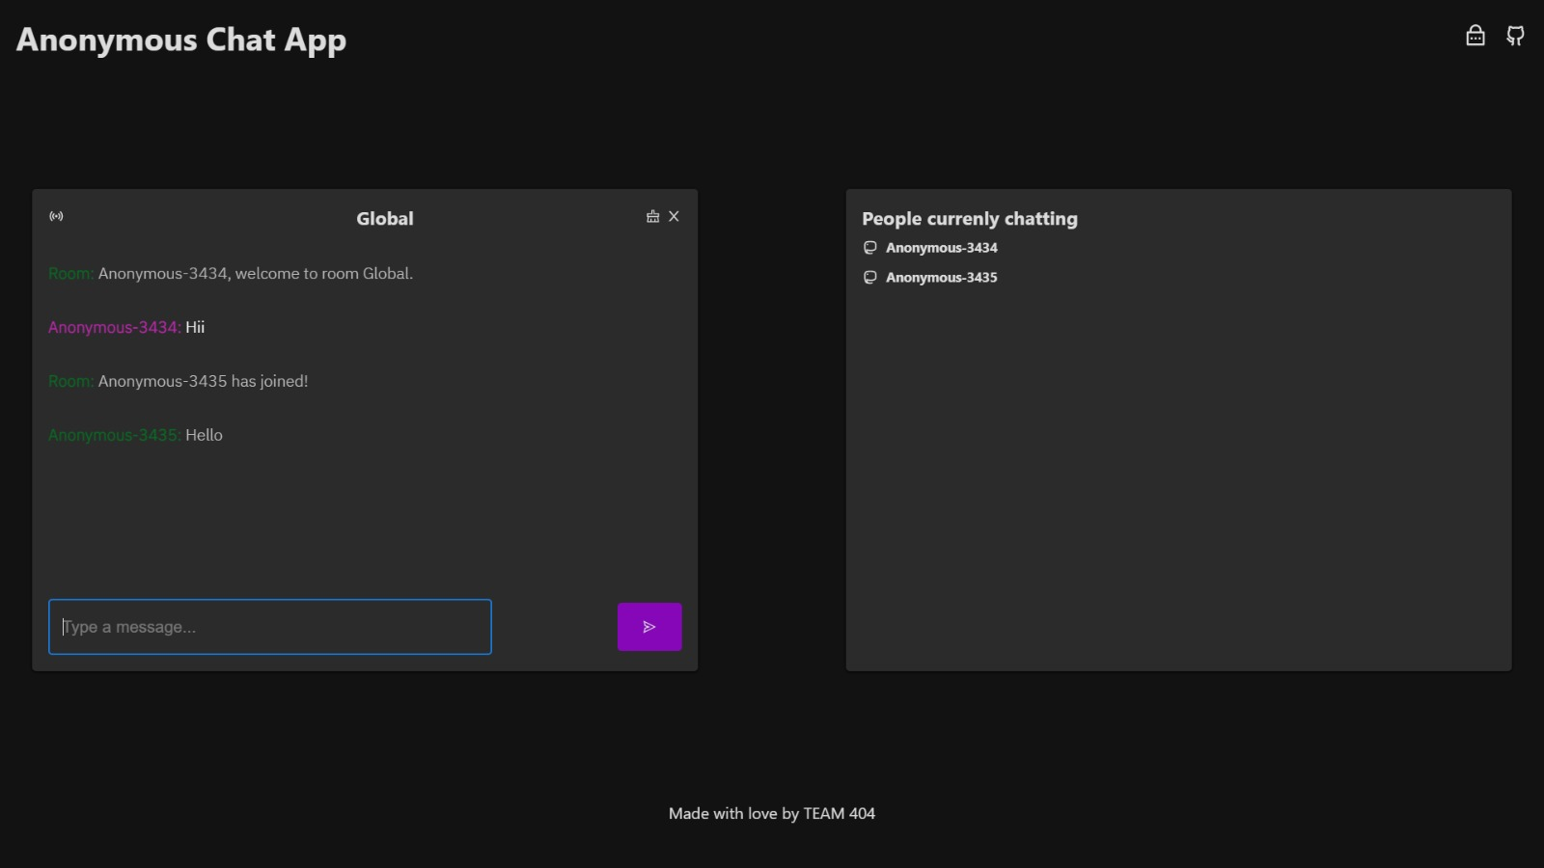

# CHAPTER - 5

**BIBLIOGRAPHY**

* <https://www.w3schools.com/>
* <https://react.dev/>
* <https://nodejs.org/en>
* <https://expressjs.com/>
* <https://socket.io/>