
A

PROJECT REPORT

on

Courier Management System

Submitted in partial fulfilment of the requirements for the degree of

BACHELOR OF TECHNOLOGY

Session: - Jan-June 2023

 |  | Submitted by
Under Guidance of |  | Submitted by
Aaditya Maheshwari Head of |  | Ritika Jain (19etccs053)
Industry Project CSE & Techno |  | Riya Sharma(19etccs054)
India NJR Institute of Technology |  | VIII Sem ,CSE

DEPARTMENT OF COMPUTER SCIENCE AND ENGINEERING TECHNO INDIA NJR INSTITUTE OF TECHNOLOGY, UDAIPUR-313001 MAY - 2023
A

PROJECT REPORT
on

Courier Management System

Submitted in partial fulfilment of the requirements for the degree of

BACHELOR OF TECHNOLOGY


Session: - Jan-June 2023

Under Guidance of
Aaditya Maheshwari
Head of Industry Project

CSE & Techno India NJR

Submitted by

Ritika Jain (19ETCCS053) Riya Sharma (19ETCCS054) VIII semester, CSE

DEPARTMENT OF COMPUTER SCIENCE AND ENGINEERING TECHNO INDIA NJR INSTITUTE OF TECHNOLOGY, UDAIPUR-313001 MAY - 2023



Department of Computer Science and Engineering
Techno India NJR Institute of Technology, Udaipur-313001

Certificate

This is to certify that project work titled "Courier Management System" by Ritika Jain was successfully carried out in the Department of Computer Science and Engineering, TINJRIT and the report is approved for submission in the partial fulfillment of the requirements for award of degree of Bachelor of Technology in Computer Science and Engineering.

Aaditya Maheshwari

Dr. Rimpy Bishnoi

Head of Industry Project

Head of Department

CSE, Techno India NJR Institute of Technology

Dept.

of

CSE

TINJRIT,

Udaipur

Date......................

Date......................

Department of Computer Science and Engineering
Techno India NJR Institute of Technology, Udaipur-313001

Certificate

This is to certify that project work titled "Courier Management System" by Riya Sharma was successfully carried out in the Department of Computer Science and Engineering, TINJRIT and the report is approved for submission in the partial fulfillment of the requirements for award of degree of Bachelor of Technology in Computer Science and Engineering.

Aaditya Maheshwari

Dr. Rimpy Bishnoi

Head of Industry Project

Head of Department

CSE, Techno India NJR Institute of Technology

Dept.

of

CSE

TINJRIT,

Udaipur

Date......................

Date......................

Department of Computer Science and Engineering
Techno India NJR Institute of Technology, Udaipur-313001

Examiner Certificate

This is to certify that the following student

Ritika Jain

of final year B.Tech. (Computer Science and Engineering), was examined for the project work titled

Courier Management System

during the academic year 2022 – 2023 at Techno India NJR Institute of Technology, Udaipur

Remarks:

Date:

Signature

Signature

(Internal Examiner)

(External Examiner)

Name :- ………………………

Name :- ………………………

Designation:- ………………..

Designation:- ………………..

Department: - ……………….

Department: - ……………….

Organization:- ………………

Organization:- ………………

Department of Computer Science and Engineering
Techno India NJR Institute of Technology, Udaipur-313001

Examiner Certificate

This is to certify that the following student

Riya Sharma

of final year B.Tech. (Computer Science and Engineering), was examined for the project work titled

Courier Management System

during the academic year 2022 – 2023 at Techno India NJR Institute of Technology, Udaipur

Remarks:

Date:

Signature

Signature

(Internal Examiner)

(External Examiner)

Name :- ………………………

Name :- ………………………

Designation:- ………………..

Designation:- ………………..

Department: - ……………….

Department: - ……………….

Organization:- ………………

Organization:- ………………

PREFACE

The courier industry is a rapidly growing sector, with the increasing demand for fast and reliable delivery services. With the advent of technology, courier management systems have become an essential tool for businesses that require efficient and effective courier services. A website based on a courier management system can provide a one-stop solution for all courier needs.

We have designed 'Quriarbox' , a website that will offer a range of courier services, including express delivery, same-day delivery, international shipping, and more. The platform will be user-friendly, with a simple interface that allows customers to track their shipments, manage their accounts, and access customer support.

DEPARTMENT OF COMPUTER SCIENCE AND ENGINEERING TECHNO INDIA NJR INSTITUTE OF TECHNOLOGY, UDAIPUR-313001
ACKNOWLEDGMENT

We take this opportunity to record our sincere thanks to all who helped us to successfully complete this work. Firstly, We are grateful to our supervisor Aaditya Maheshwari for his invaluable guidance and constant encouragement, support and most importantly for giving us the opportunity to carry out this work.

We would like to express our deepest sense of gratitude and humble regards to our Head of Department Dr. Rimpy Bishnoi for giving invariable encouragement in our endeavors and providing necessary facility for the same.

Also a sincere thanks to all faculty members of CSE, TINJRIT for their help in the project directly or indirectly. Finally, We would like to thank my friends for their support and discussions that have proved very valuable for us. We are indebted to our parents for providing constant support, love and encouragement.

We thank them for the sacrifices they made so that we could grow up in a learning environment. They have always stood by us in everything we have done, providing constant support, encouragement and love.

Ritika Jain (19etccs053)

Riya Sharma (19etccs054)

DEPARTMENT OF COMPUTER SCIENCE AND ENGINEERING TECHNO INDIA NJR INSTITUTE OF TECHNOLOGY, UDAIPUR-313001

 |  | CONTENTS
1 | Preface ..................................................................................................... |  | 6
2 | Acknowledgement ................................................................................ |  | 7
3 | List of Figures ........................................................................................ |  | 9
 | 3.1 | Definition ................................................................................... | Error! Bookmark not defined.
 | 3.2 | Defined Fields .......................................................................... | Error! Bookmark not defined.
 | 3.3 | Procedure ................................................................................. | Error! Bookmark not defined.
4 | Introduction .......................................................................................... |  | 10
 | 4.1 | Features of Courier Management ........................................................................................ | 10
 | 4.2 | Benefits of Courier Management .......................................................................................... | 10
 | 4.3 | Implementation of Courier Management ............................................................................. | 11
5 | Quriarbox .............................................................................................. |  | 12
6 | Working of the System ...................................................................... |  | 13
7 | Project Planning .................................................................................. |  | 15
8 | System Requirements ....................................................................... |  | 17
9 | Diagrams ............................................................................................... |  | 18
 | 9.1 | Activity Diagram ...................................................................................................................... | 18
 | 9.2 | Entity Relationship Diagram .................................................................................................. | 19
10 | Feasibility Study ................................................................................. |  | 20
11 | System Design ..................................................................................... |  | 21
12 | System Analysis ................................................................................. |  | 25
13 | Implementation And Testing ........................................................... |  | 26
14 | User Screen .......................................................................................... |  | 30

LIST OF FIGURES

1 Diagrams 18

Fig1.1 Activity Diagram for Courier Management 18

Fig1.2 Entity Relationship Diagram 18

2 User Screen 30

Fig2.1 Home Screen 30

Fig2.2 Services Screen 30

Fig2.3 Contact Us Screen 31

Fig2.4 Login Screen 31

Fig2.5 Register Screen 32

Fig2.6 Courier Services Screen 32

INTRODUCTION

Courier Management System is a powerful tool for businesses to manage their delivery operations. It helps businesses to track their orders, manage inventory, and optimize routes for delivery. It also enables businesses to monitor the performance of their delivery staff and ensure timely delivery of orders.

The system is designed to be user-friendly, and it can be easily integrated with existing systems. It can be used to manage multiple courier services, and it provides real-time updates on the status of orders. It also helps businesses to optimize their delivery operations, resulting in cost savings and improved customer satisfaction.

Features of Courier Management System

Courier Management System offers a range of features that enable businesses to manage their delivery operations. It provides real-time updates on the status of orders, and it enables businesses to track their orders and manage inventory. It also helps businesses to optimize routes for delivery, resulting in cost savings and improved customer satisfaction.

The system is user-friendly and can be easily integrated with existing systems. It also offers a range of customization options, allowing businesses to tailor the system to their specific needs. Additionally, it provides detailed analytics and reporting, enabling businesses to monitor the performance of their delivery staff and ensure timely delivery of orders.
Benefits of Courier Management System

Courier Management System provides businesses with a comprehensive solution for managing their delivery operations. It enables businesses to track their orders, manage inventory, and optimize routes for delivery. It also helps businesses to monitor the performance of their delivery staff and ensure timely delivery of orders.

The system helps businesses to save time and money by optimizing their delivery operations. It also helps businesses to improve customer satisfaction by providing real-time updates on the status of orders. The system is user-friendly and can be easily integrated with existing systems, making it an ideal solution for businesses of all sizes.

Implementation of Courier Management System

Courier Management System can be easily implemented in businesses of all sizes. It is designed to be user-friendly and can be easily integrated with existing systems. The system can be used to manage multiple courier services, and it provides real-time updates on the status of orders. Additionally, it helps businesses to optimize their delivery operations, resulting in cost savings and improved customer satisfaction.

Implementing the system requires minimal effort and can be done quickly. It is also cost-effective, and businesses can benefit from the system without incurring significant costs. Additionally, the system can be tailored to the specific needs of businesses, making it an ideal solution for businesses of all sizes.
QURIARBOX

Courier services play a vital role in modern logistics and supply chain management. They offer fast, reliable, and secure transportation options for businesses and individuals alike. While there are challenges associated with courier services, such as cost and environmental impact, the industry is constantly evolving to meet the changing needs of customers.

As technology continues to advance and consumer preferences shift, it will be interesting to see how courier services adapt and innovate in the years to come.

Quriarbox provides a better solution which effective, faster and reliable.

The website will offer a range of features and benefits that make it stand out from other courier management systems. These include real-time tracking, automated notifications, and a user-friendly dashboard that provides a comprehensive overview of all shipments. Customers will also have access to a dedicated customer support team, who are available 24/7 to answer any queries or concerns.

In addition, the website will provide a range of value-added services, such as packaging, insurance, and customs clearance. This ensures that customers can enjoy a hassle-free shipping experience, without worrying about the logistics of their shipment.

WORKING OF THE SYSTEM

Existing courier services operate primarily through an online platform, which enables customers to book, track, and manage their deliveries. Here's a general overview of how these services work:

- Online Booking: Customers visit the courier service's website or use their mobile app to book a shipment. They enter the pickup and delivery addresses, package details (weight, dimensions), and any additional requirements.

- Price Calculation: The courier service's system calculates the price based on various factors such as distance, package weight, dimensions, delivery speed, and any additional services (insurance, signature on delivery, etc.). The customer can view the price and select the desired service level.

- Pickup Arrangement: After confirming the booking, the customer selects a convenient pickup time slot. The courier service assigns a driver to collect the package from the specified pickup location, which could be the customer's home or office.

- Package Collection: On the scheduled pickup date, the assigned driver arrives at the specified location to collect the package. They may scan a barcode or label provided by the customer to ensure accurate tracking and identification.

- Tracking and Notifications: Once the package is picked up, the customer can track its progress through the courier service's website or app. They receive notifications about the shipment's status, including pickup, transit, and delivery updates.

- Sorting and Transportation: The courier service's logistics network involves sorting facilities, where packages are organized based on their destination. The packages are then loaded onto transportation vehicles (vans, trucks, or planes) for efficient delivery.

- Delivery Process: Depending on the service level chosen, the package may undergo various transit points, such as regional hubs or local distribution centers. The courier service optimizes routes and delivery schedules to ensure timely delivery.

- Last-Mile Delivery: The package reaches the local delivery area assigned to a specific delivery driver. The driver follows the optimized route provided by the courier service's app or GPS navigation to deliver the package to the recipient's address.

- Proof of Delivery: The recipient acknowledges the delivery by providing a signature or confirming receipt through the courier service's app or handheld devices carried by the driver. Some services also offer contactless delivery options.

- Customer Support: Throughout the process, customer support is available to address any queries or concerns. Customers can reach out to the courier service via phone, email, or live chat for assistance or updates regarding their shipment.

It's important to note that the exact workings and features may vary among different courier services, as each company may have its own specific procedures and technologies in place.
PROJECT PLANNING

Software project plan can be viewed as the following:

- Within the organisation: How the project is to be implemented? What are various constraints (time, cost, staff)? What is market strategy?

- With respect to the customer: Weekly or timely meetings with the customer with presentation on status reports. Customers feedback is also taken and further modification and developments are done. Project milestones and deliverables are also presented to the customer.

For a successful software project, the following steps can be followed:

- Select a project

o Identifying project’s aims and objectives

- Understanding requirements and specification

oMethods of analysis, design and implementation

oTesting techniques

o Documentation

- Project milestones and deliverables

- Budget allocation

o Exceeding limits within control

- Project Estimates

o

o

o

o

Cost

Time

Size of code

Duration

- Resource Allocation

o

o

Hardware

Software

- Previous relevant project information

oDigital Library

- Risk Management

oRisk avoidance

oRisk detection

SYSTEM REQUIREMENTS

Software Requirement:

- Front end technologies: HTML5, CSS 4.8, React.js (v18.2.0), Next.js (v13.3.1), Tailwind CSS (v3.0).

- Database: MySQL (v8.0.31)

- Web Server: Apache HTTP Server (v 2.2.34)

- Designing tool: Figma

Hardware Requirements:

- Local, development, User acceptance test (UAT) environment

  - RAM - Minimum 8 GB

  - CPU - i5 processor

  - Disk Space- 50 GB

- Product Environment

  - Resource (RAM, CPU, Disk) requirement depends upon user load.
DIAGRAMS

Activity Diagram for Courier Management System
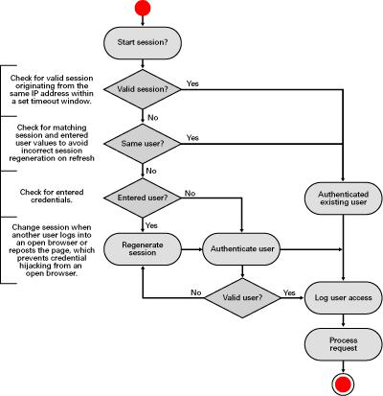

Fig 1.1

Entity Relationship Diagram for Courier Management System
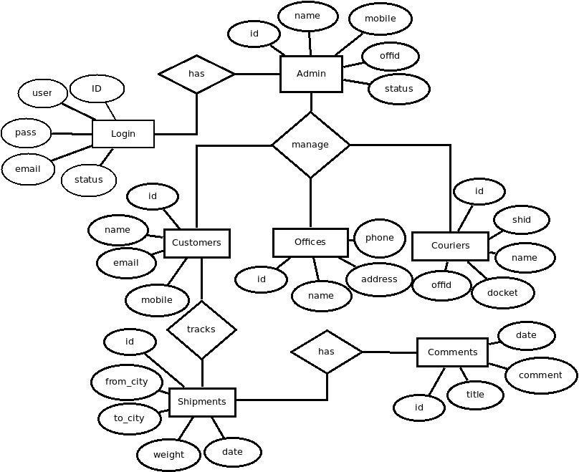

Fig 1.2
FEASIBILITY STUDY

After doing the system study and analyzing all the existing or required functionalities of the system, the next task is to do the feasibility study for the project.

All projects are feasible - given unlimited resources and infinite time.

Feasibility study includes consideration of all the possible ways to provide a solution to the given problem.

The proposed solution should satisfy all the user requirements and should be flexible enough so that future changes can be easily done based on the future upcoming requirements.

- Economical Feasibility

This is a very important aspect to be considered while developing a project. We decided the technology based on minimum possible cost factor. All hardware and software cost has to be borne by the organization.

Overall we have estimated that the benefits the organization is going to receive from the proposed system will surely overcome the initial costs and the later on running cost for system.

- Technical Feasibility

This included the study of function, performance and constraints that may affect the ability to achieve an acceptable system.

For this feasibility study, we studied complete functionality to be provided in the system, as described in the System Requirement Specification (SRS), and checked if everything was possible using Visual Basic 6.0
and MS Access.

- Operational Feasibility

No doubt the proposed system is fully GUI based that is very user friendly and all inputs to be taken all self-explanatory even to a layman. Besides, a proper training has been conducted to let know the essence of the system to the users so that they feel comfortable with new system. As far our study is concerned the clients are comfortable and happy as the system has cut down their loads and doing.
SYSTEM DESIGN

In this phase, a logical system is built which fulfils the given requirements. Design phase of software development deals with transforming the customer’s requirements into a logically working system. Normally, design is performed in the following in the following two steps:

- Primary Design Phase: In this phase, the system is designed at block level. The blocks are created on the basis of analysis done in the problem identification phase. Different blocks are created for different functions emphasis is put on minimising the information flow between blocks. Thus, all activities which require more interaction are kept in one block.

- Secondary Design Phase : In the secondary phase the detailed design of every block is performed.

The general tasks involved in the design process are the following:

- Design various blocks for overall system processes.

- Design smaller, compact and workable modules in each block.

- Design various database structures.

IV. Specify details of programs to achieve desired

functionality.

- Design the form of inputs, and outputs of the system.

VI. Perform documentation of the design.

VII. System reviews.

User Interface Design

User Interface Design is concerned with the dialogue between a user and the computer. It is concerned with everything from starting the system or logging into the system to the eventually presentation of desired inputs and outputs. The overall flow of screens and messages is called a dialogue.

The following steps are various guidelines for User Interface Design:

- The system user should always be aware of what to do next.

- The screen should be formatted so that various types of information, instructions and messages always appear in the same general display area.

- Message, instructions or information should be displayed long enough to allow the system user to read them.

- Use display attributes sparingly.

- Default values for fields and answers to be entered by the user should be specified.

- A user should not be allowed to proceed without correcting an error.

- The system user should never get an operating system message or fatal error.

TESTING

Testing is the process in which the system is run on manually created input so that the system is correctly working as desired or not.

During systems testing, the system is used experimentally to ensure that the software does not fail. In other words, we can say that it will run according to its specifications and in the way users expect. Special test data are input for processing, and the results examined.

A limited number of users may be allowed to use the system so that analyst can see whether they try to use it in unforeseen ways. It is desirable to discover any surprises before the organization implements the system and depends on it.

Testing of a system is generally done in two phases – One is Unit Testing which is done for each module independently on its completion and the other one is System Testing which is done at the end of a project.

VALIDATION CRITERIA

The validation criteria in this project are as follows...

In E-Commerce Portal System also, the user inputs are validated before storing them, and then further for displaying etc. The main validations that are done in E-Commerce Portal System are as follows –

All the screens have a similar look and feel. They all have the almost same color combinations in its background. This provides a better user interface to the users.

- The primary key values cannot be duplicated.

- All the entries in any combo box have been sorted in alphabetical order. This helps a user while selecting a value from the combo box.

IMPORTANCE OF TESTING

During systems testing, the system is used experimentally to ensure that the software does not fail. In other words, we can say that it will run according to its specifications and in the way users expect. Special test data are input for processing, and the results examined.

The importance of system testing is that the system is expected to run according to member’s requirement before delivering it to the customer.

The System is tested on the basis of specification so that it does not fail on user site.
SYSTEM ANALYSIS

The analysis model is a concise, precise abstraction of what the desired system must do, and not how it will be done after the study of the existing system is completed. This basically includes system study and the requirement analysis. Interacting with the clients regarding their requirements and expectations from the system does requirement analysis.

The steps, which are essential for system analysis, are:

- Research and define essential components.

- Analyze current processes and identify gaps.

- Interview users, Trainee, Trainers and other concerned personnel regarding essential components and current processes.

- Write requirements document.

- Define standards for standards, policies, and procedures.

- Review draft requirements document with users, Trainee, Trainers and other concerned personnel.

- Update and expand project plan.
IMPLEMENTATION AND TESTING

Implementation

Detailed Design of Implementation - This phase of the systems development lifecycle refines hardware and software specifications, establishes programming plans, trains users and implements extensive testing procedures, to evaluate design and operating specifications and/or provide the basis for further modification.

Technical Design - This activity builds upon specifications produced during new

system design, adding detailed technical specifications and documentation. Test Specifications and Planning - This activity prepares detailed test

specifications for individual modules and programs, job streams, subsystems, and for the system as a whole.

Programming and Testing - This activity encompasses actual development, writing, and testing of program units or modules.

User Training - This activity encompasses writing user procedure manuals, preparation of user training materials, conducting training programs, and testing procedures.

Acceptance Test -A final procedural review to demonstrate a system and secure user approval before a system becomes operational.

Installation Phase -In this phase the new Computerized system is installed, the conversion to new procedures is fully implemented, and the potential of the new system is explored.

System Installation: The process of starting the actual use of a system and training user personnel in its operation.

Review Phase - This phase evaluates the successes and failures during a systems development project,and to measure the results of a new Computerized Transystem interms of benefits and savings project edat the start of theproject. Development Recap - A review of a project immediately after completion to find successes and potential problems in future work.

Post-Implementation Review - A review, conducted after a new system has been in operation for sometime, to evaluate actual system performance against original expectations and projections for cost benefit improvements. Also identifies maintenance projects to enhance or improve the system.

THE STEPS IN THE SOFTWARE TESTING The steps involved during Unit testing are as follows:

- Preparation of the test cases.

- Preparation of the possible test data with all the validation checks.

- Complete code review of the module.

- Actual testing done manually.

- Modifications done for the errors found during testing.

- Prepared the test result scripts.

The unit testing done included the testing of the following items:

- Functionality of the entire module/forms.

- Validations for user input.

- Checking of the Coding standards to be maintained during coding.

- Testing the module with all the possible test data.

5) Testing of the functionality involving all type of calculations etc.

- Commenting standard in the source files.

After completing the Unit testing of all the modules, the whole

system is integrated with all its dependencies in that module. While System Integration, We integrated the modules one by one and tested the system at each step. This helped in reduction of errors at the time of the system testing. The steps involved during System testing are as follows:

- Integration of all the modules/forms in the system.

- Preparation of the test cases.

- Preparation of the possible test data with all the validation checks.

- Actual testing done manually.

- Recording of all the reproduced errors.

- Modifications done for the errors found during testing.

- Prepared the test result scripts after rectification of the errors.

The System

Testing

done

included

the

testing

of

the

following items:

- Functionality of the entire system as a whole.

- User Interface of the system.

- Testing the dependent modules together with all the possible test data scripts.

- Verification and Validation testing.

- Testing the reports with all its functionality.

After the completion of system testing, the next following phase was the Acceptance Testing. Clients at their end did this and accepted the system with appreciation.

Thus, we reached the final phase of the project delivery.

There are other six tests, which fall under special category. They are described below:

- Peak Load Test: It determines whether the system will handle the volume of activities that occur when the system is at the peak of its processing demand. For example, test the system by activating all terminals at the same time.

- Storage Testing: It determines the capacity of the system to store transaction data on a disk or in other files.

- Performance Time Testing: it determines the length of time system used by the system to process transaction data. This test is conducted prior to implementation to determine how long it takes to get a response to an inquiry, make a backup copy of a file, or send a transmission and get a response.

- Recovery Testing: This testing determines the ability of user to recover data or re-start system after failure. For example, load backup copy of data and resume processing without data or integrity loss.

- Procedure Testing: It determines the clarity of documentation on operation and uses of system by having users do exactly what manuals request. For example, powering down system at the end of week or responding to paper-out light on printer.

- Human Factors Testing: It determines how users will use the system when processing data or preparing reports.
USER SCREEN


Fig 2.1
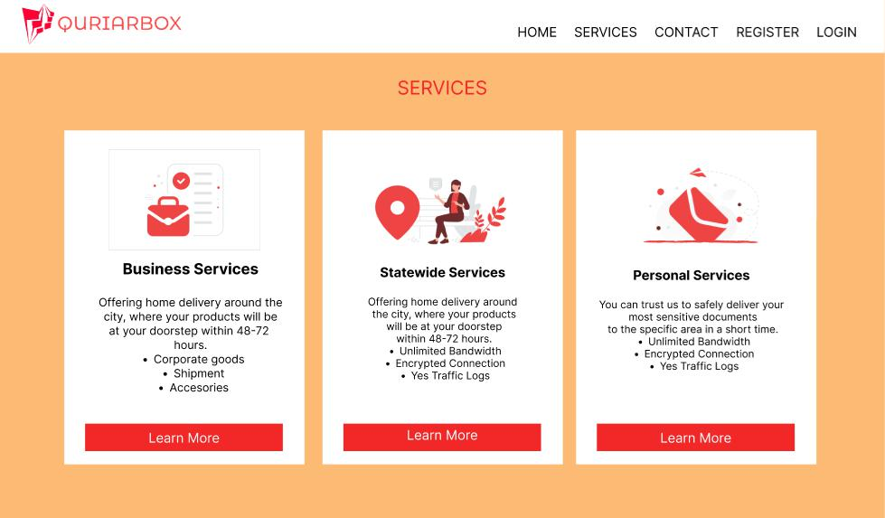

Fig 2.2

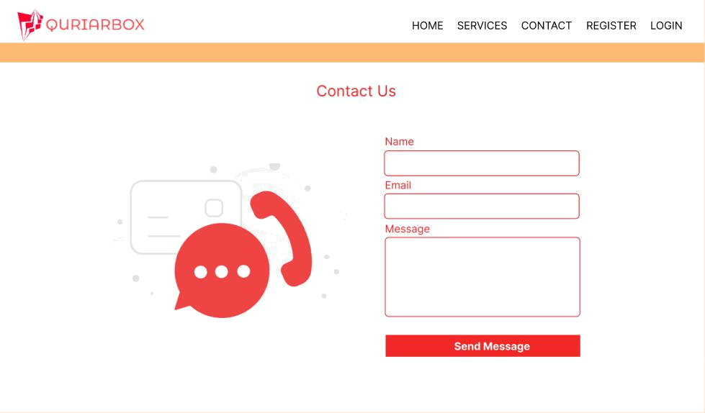

Fig 2.3
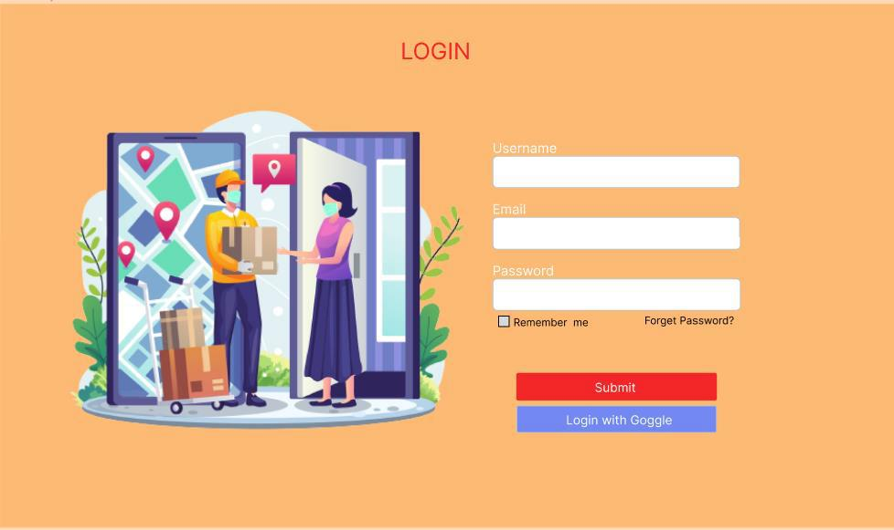

Fig 2.4
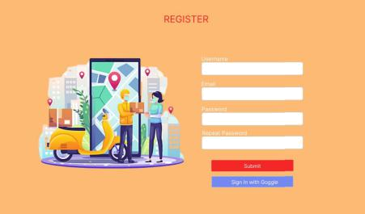

Fig 2.5
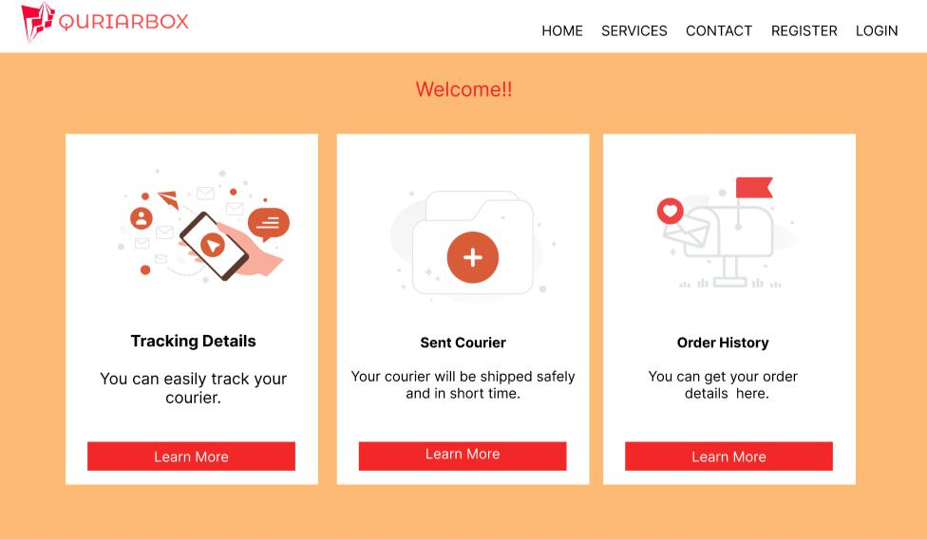

Fig 2.6

