
A

PROJECT REPORT

on

Just For Pets!

Submitted in partial fulfilment of the requirements for the degree of

BACHELOR OF TECHNOLOGY

Session: - Jan-June 2023

Under Guidance of | Submitted by
Mr. Aaditya Maheshwari | Abha Rathore (19ETCCS001)
Head – Industry Projects |  | Lavi Vashishth (19ETCCS033)
 |  | 8th Semester
Department of Computer Science &
 |  | Computer Science & Engineering

DEPARTMENT OF COMPUTER SCIENCE AND ENGINEERING TECHNO INDIA NJR INSTITUTE OF TECHNOLOGY, UDAIPUR-313001 MAY - 2023
A

PROJECT REPORT

on

Just For Pets!

Submitted in partial fulfilment of the requirements for the degree of

BACHELOR OF TECHNOLOGY


Session: - Jan-June 2023

Under Guidance of | Submitted by
Mr. Aaditya Maheshwari | Abha Rathore (19ETCCS001)
Mr. Aaditya Maheshwari | Lavi Vashishth (19ETCCS033)
Head – Industry Projects | Lavi Vashishth (19ETCCS033)
Head – Industry Projects | 8th Semester
Department of Computer Science & | 8th Semester
Department of Computer Science & | Computer Science & Engineering
Engineering | Computer Science & Engineering

DEPARTMENT OF COMPUTER SCIENCE AND ENGINEERING TECHNO INDIA NJR INSTITUTE OF TECHNOLOGY, UDAIPUR-313001 MAY - 2023


Department of Computer Science and Engineering

Techno India NJR Institute of Technology, Udaipur-313001

Certificate

This is to certify that project work titled Just for Pets! by Lavi Vashishth and Abha Rathore was successfully carried out in the Department of Computer Science and Engineering, TINJRIT and the report is approved for submission in the partial fulfillment of the requirements for award of degree of Bachelor of Technology in Computer Science and Engineering.

Mr. Aaditya Maheshwari

Dr. Rimpy Bishnoi

Head – Industry Projects

Head of Department

Department of Computer Science & Engineering

Dept. of CSE TINJRIT, Udaipur

Date......................

Date......................

Department of Computer Science and Engineering

Techno India NJR Institute of Technology, Udaipur-313001

Examiner Certificate

This is to certify that the following student

Lavi Vashishth, Abha Rathore

of final year B.Tech. (Computer Science and Engineering), was examined for the project work titled

Just for Pets!

during the academic year 2022 – 2023 at Techno India NJR Institute of Technology, Udaipur

Remarks:

Date:

Signature

Signature

(Internal Examiner)

(External Examiner)

Name :- ………………………

Name :- ………………………

Designation:- ………………..

Designation:- ………………..

Department: - ……………….

Department: - ……………….

Organization:- ………………

Organization:- ………………

ACKNOWLEDGMENT

We take this opportunity to record our sincere thanks to all who helped us to successfully complete this work. Firstly, We are grateful to our supervisor Mr. Aaditya Maheshwari for his invaluable guidance and constant encouragement, support and most importantly for giving us the opportunity to carry out this work.

We would like to express our deepest sense of gratitude and humble regards to our

Head of Department Dr. Rimpy Bishnoi for giving invariable encouragement in our endeavours and providing necessary facility for the same. Also, a sincere thanks to all faculty members of CSE, TINJRIT for their help in the project directly or indirectly.

Finally, We would like to thank my friends for their support and discussions that have proved very valuable for us. We are indebted to our parents for providing constant support, love and encouragement. We thank them for the sacrifices they made so that we could grow up in a learning environment. They have always stood by us in everything we have done, providing constant support, encouragement and love.

Lavi Vashishth (19ETCCS033)

Abha Rathore (19ETCCS001)

DEPARTMENT OF COMPUTER SCIENCE AND ENGINEERING

TECHNO INDIA NJR INSTITUTE OF TECHNOLOGY, UDAIPUR-313001

i
PREFACE

The main objective of the project is to build a website where the users get to know about various pet events, register for those events and let their pets showcase their skills.

- The design will be both visually attractive to customers, and designed for fast and efficient operations.

- There will be ease in operations for both customers and administrator.

- The website is being developed for the purpose of providing a user-friendly interface to the customers which will reduce the paperwork.

- This website provides us an environment to view and edit the information based on the role of an account.

In Chapter 1, we give an overview of working of the website.

Chapter 2 discusses methodology and planning perspective for the development of website.

Chapter 3 gives the introduction on the React JS library.

Chapter 4. talks about the importance of website components and navigations.

Chapter 5. gives the introduction on the Firebase.

Chapter 6 presents diving into the website components.

Chapter 7 contains the information for data management.

Chapter 8 concludes the above points and the summary of a website.

These chapters will give a brief overview and working of the website including components, navigations, forms, data management, UI design, etc.

DEPARTMENT OF COMPUTER SCIENCE AND ENGINEERING

TECHNO INDIA NJR INSTITUTE OF TECHNOLOGY, UDAIPUR-313001

ii
CONTENTS

Abstract | ………………………………………………………………. | I - ii
Contents | ………………………………………………………………. | iii – iv
List of Figures ……………………………………………………............ |  |  | v
List of Tables ……………………………………………………………. |  |  | vi
Chapter 1 | OVERVIEW…………………………………………... | 1 | - 2
Chapter 2 | METHODOLOGY………………………………………. | 3 | - 6
 | 2.1 Software Requirement Specification (SRS)…………... |  | 5
 | 2.1.1 Role of SRS………………………………………… |  | 6
Chapter 3 | INTRODUCTION TO REACT JS……………………………. | 7 | - 8
Chapter 4 | WEBSITE COMPONENTS AND NAVIGATIONS.………… | 9-10
Chapter 5 | INTRODUCTION TO FIREBASE……………………………. | 11 | - 12
Chapter 6 | DIVING INTO THE COMPONENTS…………………………. | 13 | - 33
 | 6.1. Navbar…………………………………………….……... | 14 | - 18
 | 6.1.1 Admin Login………………………………………… | 16 | - 18
 | 6.2. Image Slider……………………………………...……... | 18 | - 20
 | 6.3. About Section…………………………………….……... | 20 | - 22
 | 6.4 Events Component……………………………….……... | 23 | - 29

iii
 | 6.4.1 Terms & Conditions……………………………… | 25-26
 | 6.4.2 Registration Forms………………………………… | 27-29
 | 6.5. Frequently Asked Questions………………….……... | 30-31
 | 6.6 Footer…………….……………………………….……... | 32-33
Chapter 7 | DATABASE MANAGEMENT………………………………. | 34-38
 | 7.1 JSON Data…………………………………….…………... | 36
 | 7.2 Data Tables…………………………………….…………... | 36-37
 | 7.3 Data Flow Diagram (DFD)…………………….…………... | 38
Chapter 8 | CONCLUSION………….………………………………………. | 39-40
Appendices | ………………...………….………………………………………. | 41-45

iv

LIST OF FIGURES

Fig 6-1 | Website Components………………………………………....... | 14
Fig 6-2 | Navbar Component………………………………………….. | 16
Fig 6-3 | Admin Login……………………………………………………. | 18
Fig 6-4 | Slider Component…………………………………………… | 20
Fig 6-5 | About Component…………………………………………….. | 22
Fig 6-6 | Events Component | 24
Fig 6-6 | ……………………………………………... | 24
Fig 6-7 | Terms and Conditions……………………………………....... | 26
Fig 6-8 | Pet Details Form……………………………………………..... | 28
Fig 6-9 | Owner Details Form ……………….…………………………… | 29
Fig 6-10 | Category Details Form ……………………………………........ | 29
Fig 6-11 | FAQ Component………..……………………………………… | 31
Fig 6-12 | Footer Component……………………………………………... | 33
Fig 7-1 | DFD……………………………………………………………….. | 38

v

LIST OF TABLES

Table 7-1 | User Data Table……………………………………... | 36
Table 7-2 | Events Data Table ………………………………... | 37
Table 7-3 | Forms Data Table …………………………………... | 37
Table 7-4 | FAQ Data Table ……………………………. | 37

vi
CHAPTER 1: OVERVIEW

Pet shows are fun and interactive. There are hundreds of activities for you and your pet. You can meet pets of different breeds (dogs, cats, and many more), see the pet talent demonstrations, participate in contests, and enjoy the company of experts and pet lovers.

But the problem is that people are unaware of the fact that many pet shows are even organized for the pets to showcase their skills or in order to participate in various events of their interests.

On the other hand, most of the times it even happens that the owners are not aware about these kinds of events. Thus, as a result, they tend to miss on keeping a track on these events. So, as to resolve this issue, we have come up with an idea of having a portal that will be based on the pet events being conducted at various places.

The aim of the Pet Show Event Website project is to create an interactive and user-friendly online platform that serves as a comprehensive resource for pet owners, enthusiasts, and participants interested in pet shows and related events. The website will aim to provide the following:

1. Information Hub: The website will serve as a centralized hub for all things related to pet shows, including event schedules, locations, participating categories, and guidelines. It will provide a comprehensive and up-to-date database of upcoming shows, allowing users to easily find and participate in events of their interest.

2. Registration and Participation: The website will offer a seamless registration process for pet owners and participants to sign up for upcoming shows. It will provide a user-friendly interface for submitting necessary details, such as pet information, registration fees, and required documentation. Participants will be able to select their preferred categories and access all the information needed to prepare for the event.

3. Showcase Pet Profiles: The event will provide a platform for pet owners to create profiles for their beloved companions, showcasing their unique attributes, achievements, and photos. This will allow participants to build a community, share experiences, and connect with fellow pet lovers.

- Community Engagement: The website will foster an active and engaged community by incorporating interactive features such as forums, and social media integration. This will encourage

1
pet owners, enthusiasts, and experts to share their experiences, exchange ideas, and connect with like-minded individuals who share a passion for pets and pet shows.

6. Event Updates and Reminders: The website will provide regular updates, news, and reminders about upcoming pet shows, changes in schedules, and important deadlines. Users will have the option to subscribe to email notifications or push alerts to stay informed about the latest developments and ensure they don't miss out on any opportunities.

- Enhanced User Experience: The aim of the website is to provide a seamless and enjoyable user experience for all visitors. This includes easy navigation, clear and concise information, visually appealing design, and responsive functionality across different devices. By prioritizing user experience, the website aims to attract and retain a larger audience, ensuring that pet owners and enthusiasts find value in using the platform.

- Increased Event Participation: The website aims to boost participation in pet shows and related events by providing a centralized platform that facilitates registration, provides comprehensive event details, and engages the community. By simplifying the registration process and offering a user-friendly interface, the website encourages more pet owners to participate in shows, thereby enhancing the overall vibrancy and success of the events.

- Promoting Pet Shows as Educational and Entertainment Events: The aim of the website is to highlight pet shows as not only competitive events but also educational and entertaining experiences. By providing educational resources, showcasing pet profiles, and featuring articles on pet care and training, the website emphasizes the educational aspect of pet shows. Additionally, by promoting the enjoyment and excitement of attending pet shows, the platform aims to attract a wider audience and generate interest in the events.

10. Expansion and Outreach: The website aims to expand the reach of pet shows by transcending geographical limitations. By providing an online platform that can be accessed from anywhere, the website enables pet owners and enthusiasts from different regions to participate in events, access resources, and engage with the community. This expands the visibility and reach of pet shows, fostering a more diverse and inclusive community.

Overall, the Pet Show Event Website project aims to create an inclusive online platform that serves as a one-stop destination for the pet show community, offering valuable information, resources, and a vibrant community space for pet owners, enthusiasts, and participants.

2
CHAPTER 2: METHODOLOGY

The project will be made under some set of principles and practices that will guide us in organizing our project to ensure the optimum performance.

This project will use the Waterfall Model.

It is a traditional approach for the project management. Sometimes called the classic life cycle or the linear sequential model. This model suggests a systematic, sequential approach to software development that begins at the system level and progresses through analysis, design, coding, testing, and support. It is best suited where the requirements are clearly defined.

The process will be as follows –

- A Software Requirement Specification (SRS) will be documented with the description of a website to be developed. It lays out functional and non-functional requirements, and may include a set of use cases that describe user interactions that the website must provide.

- Database design will be made further to store and manipulate the data. This is essential to achieve the goals in working with the database. Then database will be created according to all the relevant and required data.

- Implementation will be the next step in development of a website. It connects two crucial areas –

  - Website design: This will be done using React JS framework.

  - Backend development: This will be done using Firebase.

- Website navigations will handle the flow of a website. It allow users to access the information they want as quickly as possible by presenting an intuitive layout by increasing ease of use.

3
- Functional integrations will take place after the designing gets completed. We will be integrating all the functionalities and features required in the website.

The waterfall model plays several important roles in software development projects. Here are some key roles of the waterfall model:

1. Structured Project Management: The waterfall model provides a structured framework for project management. It breaks down the software development process into distinct phases, allowing for better planning, organization, and allocation of resources. The sequential nature of the model helps in setting clear project milestones and managing dependencies between different phases.

2. Requirement Clarity and Documentation: The waterfall model emphasizes the thorough gathering and documentation of requirements at the beginning of the project. This ensures that all stakeholders have a clear understanding of what the software needs to accomplish.

3. Clear Design and Development Phases: The waterfall model delineates separate design and development phases. This allows the design team to focus on creating a robust system architecture and the developers to concentrate on coding and implementation. The clear separation of these phases promotes specialization, resulting in well-designed and structured software.

4. Risk Mitigation and Predictability: The waterfall model aims to identify and address potential risks early in the project lifecycle. By following a sequential approach, risks associated with requirements, design, and development can be identified and mitigated before moving to the next phase.

5. Documentation and Traceability: The waterfall model emphasizes the importance of documentation at each phase of the development process. This documentation helps in maintaining a clear record of decisions made, design choices, and testing results. It enables traceability, allowing stakeholders to track the progress of the project and understand the rationale behind various design and implementation decisions.

4
6. Regulatory Compliance and Formal Approvals: In certain industries, software development projects need to adhere to strict regulatory requirements. The waterfall model facilitates compliance by providing a framework for formal reviews and approvals at the end of each phase.

While the waterfall model has its strengths in terms of structured planning and documentation, it may not be suitable for projects with evolving or uncertain requirements. The model's rigid nature can make it challenging to accommodate changes and adapt to new insights during the development process. Therefore, it is important to carefully assess the project requirements and constraints before selecting the waterfall model as the preferred approach.

2.1. Software Requirement Specification (SRS)

A software requirements specification (SRS) is a description of a software system to be developed. It lays out functional and non-functional requirements, and may include a set of use cases that describe user interactions that the software must provide.

Software requirements specification establishes the basis for an agreement between customers and contractors or suppliers on what the software product is to do as well as what it is not expected to do. Software requirements specification permits a rigorous assessment of requirements before design can begin and reduces later redesign. It should also provide a realistic basis for estimating product costs, risks, and schedules.

The software requirements specification document enlists enough and necessary requirements that are required for the project development. To derive the requirements we need to have clear and thorough understanding of the products to be developed or being developed. This is achieved and refined with detailed and continuous communications with the project team and customer till the completion of the software.

Using the SRS helps an enterprise confirm that the requirements are fulfilled and helps business leaders make decisions about the lifecycle of their product, such as when to retire a feature.

5
2.1.1 Role Of SRS:

The purpose of the software Requirements specification is to reduce the communication gap between the clients and the developers. Software Requirements Specification is the medium though which the client and user needs are accurately specified. It forms the basis of software development. A good SRS should satisfy all the parties involved in the system.

An SRS forms the basis of an organization’s entire project. It sets out the framework that all the development teams will follow. It provides critical information to all the teams, including development, operations, quality assurance (QA) and maintenance, ensuring the teams are in agreement.

Using the SRS helps an enterprise confirm that the requirements are fulfilled and helps business leaders make decisions about the lifecycle of their product, such as when to retire a feature.

In addition, writing an SRS can help developers reduce the time and effort necessary to meet their goals as well as save money on the cost of development.

6
CHAPTER 3: INTRODUCTION TO REACT JS

Reactjs is an open-source javascript library developed by Facebook that is widely used for building user interfaces (uis) for web applications. It follows a component-based architecture, allowing developers to build reusable UI components that can be combined to create complex and interactive user interfaces. Here are some key features and aspects of reactjs:

- Component-Based Development: reactjs promotes a component-based approach to UI

development. A component represents a self-contained piece of the user interface, encapsulating its own logic and rendering behavior. Components can be easily composed and reused throughout the application, resulting in modular and maintainable code.

- Virtual DOM (Document Object Model): reactjs utilizes a virtual DOM to optimize the rendering

process. The virtual DOM is a lightweight copy of the actual DOM, which reactjs uses to perform efficient updates. When changes occur in the application, reactjs calculates the minimal set of updates needed and applies them to the virtual DOM. This approach minimizes actual DOM manipulation, leading to improved performance.

3. JSX (javascript XML): JSX is an extension to javascript that allows developers to write HTML-like syntax within javascript code. It enables the integration of HTML-like markup directly into React components, making it easier to visualize and understand the structure of the UI. JSX is then transformed into regular javascript using transpilers like Babel.

- Unidirectional Data Flow: reactjs follows a unidirectional data flow pattern, also known as one-way data binding. Data flows from parent components to child components, preventing direct modification of data by child components. This improves predictability and helps maintain a clear flow of data within the application.

- Reusable Components: reactjs promotes the concept of reusable components, which encourages code reusability and modularity. Developers can create components that encapsulate specific functionality and UI elements, making it easier to maintain, update, and test the codebase.

7
- React Hooks: Introduced in React version 16.8, React Hooks provide a way to use state and other React features in functional components. Hooks allow developers to write reusable logic and manage state within functional components, eliminating the need for class components in many cases. This enhances code readability and simplifies component development.

- States: States in reactjs represent the mutable data that can be used to track and manage changes in a component. Each component can have its own state, which is a javascript object containing data that can be modified throughout the component's lifecycle. When the state of a component changes, React automatically re-renders the component to reflect the updated data.

- Refs: Refs in reactjs provide a way to access and manipulate DOM elements or React components directly. Refs are typically used when there is a need to interact with a specific element or component outside of the typical React data flow, such as focusing an input field, triggering animations, or integrating with third-party libraries.

9. Large Ecosystem and Community Support: reactjs has a vast ecosystem of libraries, tools, and community support. It integrates well with other libraries and frameworks, making it versatile and suitable for different development scenarios. The active React community contributes to the development of new tools, provides support, and shares best practices, ensuring continuous improvement and learning opportunities.

- Mobile App Development: React Native, a framework built upon reactjs, allows developers to build native mobile applications using javascript. React Native leverages React's component model to create mobile uis that can be compiled to native code. This enables code sharing between web and mobile platforms, reducing development time and effort.

Reactjs has gained significant popularity in the web development community due to its efficiency, reusability, and performance optimizations. It is widely adopted by both small-scale projects and large-scale applications, making it a powerful tool for building modern and responsive user interfaces.

Overall, reactjs's benefits, including its component-based architecture, performance optimization, cross-platform mobile development capabilities, strong community support, and compatibility, have contributed to its widespread usage and popularity in the web development landscape.

8
CHAPTER 4: WEBSITE COMPONENTS & NAVIGATIONS

In web development, components and navigation are crucial elements for creating a cohesive and user-friendly website. Let's explore each of these concepts:

- Components: Components are self-contained, reusable building blocks that encapsulate a specific functionality or user interface (UI) element. They help structure and organize the website's content, making it easier to manage and maintain. Components can range from simple elements like buttons and forms to more complex ones like headers, footers, cards, and sliders.

By breaking down the website into smaller, modular components, developers can improve code reusability, maintainability, and scalability. Each component typically has its own HTML structure, CSS styles, and javascript logic. Popular javascript libraries and frameworks like reactjs, Vue.js, and Angular provide powerful tools for building and managing components.

- Navigation: Navigation refers to the way users move around and explore different sections or pages

of a website. It includes menus, links, buttons, and other UI elements that allow users to navigate between different parts of the website. Effective navigation is crucial for providing a seamless user experience and ensuring users can easily find the information or functionality they need.

Common types of navigation include:

- Header Navigation: A navigation menu typically placed at the top of the website, providing links to different sections or pages. It often includes the website logo or branding.

- Sidebar Navigation: A vertical or horizontal menu placed on the side of the website, commonly used for navigating through sections or categories.

9
- Footer Navigation: Navigation links placed at the bottom of the website, usually including links to important pages like contact information, terms of service, privacy policy, etc.

- Breadcrumbs: A navigational aid that shows users their current location within the website's hierarchy, usually displayed as a series of clickable links.

- Hamburger Menu: A common mobile navigation pattern that displays a collapsed menu icon (usually three horizontal lines) that expands into a full menu when clicked.

- Tabs and Tabbed Navigation: Tabs allow users to switch between different views or sections within a single page, commonly used for organizing content or settings.

When designing website navigation, it is important to consider factors such as ease of use, accessibility, responsiveness (for mobile devices), and consistency. Clear and intuitive navigation helps users navigate the website effectively and enhances their overall experience.

By combining well-designed components and effective navigation, web developers can create user-friendly websites that are visually appealing, easy to navigate, and provide a seamless browsing experience for visitors.

10
CHAPTER 5: INTRODUCTION TO FIREBASE

Firebase is a comprehensive platform provided by Google that offers a wide range of tools and services for developing and managing web and mobile applications. It provides developers with a cloud-based backend infrastructure, enabling them to focus on building high-quality applications without worrying about server management and infrastructure setup. Firebase encompasses various features, including authentication, real-time database, cloud storage, hosting, cloud functions, and more. Here's a brief introduction to some key components of Firebase:

- Firebase Authentication: Firebase Authentication provides a straightforward way to authenticate users in your application. It supports authentication methods like email/password, social media logins (such as Google, Facebook, Twitter), and third-party identity providers. With Firebase Authentication, you can easily handle user authentication, manage user sessions, and enforce security rules.

- Firebase Realtime Database: Firebase Realtime Database is a nosql cloud-hosted database that allows real-time synchronization of data between clients and servers. It offers real-time data synchronization, enabling instant updates to connected clients whenever data changes. The Realtime Database is a JSON-based database that can be accessed from both frontend and backend, making it ideal for building collaborative, real-time applications.

- Cloud Firestore: Cloud Firestore is a flexible and scalable nosql document database provided by Firebase. It offers more advanced querying capabilities and scalability compared to the Realtime Database. Firestore supports data syncing in real-time and provides offline support for web and mobile applications. It also offers powerful features like document-level security rules and transactions.

- Firebase Cloud Storage: Firebase Cloud Storage is a cloud-based file storage solution that allows developers to securely upload, download, and store user-generated content, such as images, videos,

11
and documents. It provides secure and scalable storage infrastructure, making it easy to handle media assets in your application.

- Firebase Hosting: Firebase Hosting is a fully-managed hosting service that allows you to deploy and serve web applications quickly. It provides a global content delivery network (CDN) that ensures fast and reliable content delivery to users worldwide. Firebase Hosting supports custom domains, SSL certificates, and integrates seamlessly with other Firebase services.

- Firebase Cloud Functions: Firebase Cloud Functions enables developers to deploy serverless functions that respond to events and triggers from Firebase services or HTTP requests. With Cloud Functions, you can run custom server-side code without managing any server infrastructure. It integrates well with other Firebase services and allows you to build serverless architectures for your applications.

These are just a few of the many features and services provided by Firebase. It offers a comprehensive suite of tools that make it easier to develop, deploy, and manage web and mobile applications. Firebase simplifies backend development and enables developers to focus on building great user experiences while benefiting from scalable and reliable cloud infrastructure.

12
CHAPTER 6: DIVING INTO THE COMPONENTS

In React.js, components are the building blocks of a web application's user interface. They are reusable, self-contained units of code that encapsulate the logic and functionality of a specific part of a website or application. Components help in organizing and managing the complexity of a web project by breaking it down into smaller, more manageable pieces.

Here are some reasons why we use components in a website built with React.js:

- Reusability: Components promote code reusability. Once a component is created, it can be used multiple times throughout the application, reducing code duplication and making maintenance and updates easier.

- Modularity: Components enable a modular approach to development. By breaking down the user interface into smaller, independent units, developers can focus on building and testing individual components separately, leading to better code organization and maintainability.

- Separation of Concerns: React components allow separation of concerns between the presentation (UI) and the logic (functionality) of the application. This separation enhances code readability, understandability, and maintainability.

- Component Hierarchy: React components can be nested within each other to form a component hierarchy. This hierarchical structure allows for the composition of complex user interfaces from smaller, reusable components, resulting in a more organized and manageable codebase.

13
- Data Flow: React follows a unidirectional data flow pattern, also known as one-way data binding. This means that data flows from parent components to child components through props (properties). This pattern simplifies the management of data and helps in avoiding data inconsistencies.

- Performance Optimization: React's Virtual DOM and component-based architecture enable efficient rendering. With the Virtual DOM, React compares the changes between the previous and current states of a component, and updates only the necessary parts of the user interface, resulting in better performance.

- Ecosystem and Community: React has a large and active community with a vast ecosystem of libraries, tools, and resources. Using components in React allows developers to leverage this rich ecosystem and benefit from pre-built, customizable components and community support.

By utilizing components in React.js, web developers can create scalable, maintainable, and reusable codebases, leading to faster development cycles, improved code quality, and enhanced user experiences.


Navbar

Image Slider

About Section

Events Section

Frequently
Asked
Questions

Footer

Figure 6-1: Website Components

( Appendix 1 )

( Appendix 2 )

- Navbar:

A Navbar, short for navigation bar, is an essential component in web development that serves as a visual menu or navigation system for a website or web application. It typically appears at the top of a webpage and provides links to different sections or pages within the site.

14

Here are some key reasons why we need a Navbar and the role it plays in a web application:

1. Navigation: The primary role of a Navbar is to help users navigate through a website or application easily. By organizing and displaying links to different pages or sections, users can quickly access the desired content without having to search or dig deep into the site's structure.

- User Experience: A well-designed Navbar improves the overall user experience by providing a clear and intuitive interface. It helps users understand the site's structure, find information quickly, and maintain orientation within the website.

- Consistency: A Navbar contributes to maintaining consistency and visual coherence across a website. By including it on every page, users can easily recognize and access the navigation options, ensuring a seamless and unified experience throughout their journey on the site.

- Branding and Identity: The Navbar often includes the website's logo or brand name, reinforcing the brand identity and creating a consistent visual presence across all pages. It helps users associate the site with its brand and establishes a sense of trust and familiarity.

- Additional Functionality: Besides navigation links, a Navbar can incorporate various additional features and functionalities. It can include dropdown menus, search bars, user login or registration options, social media links, language selection, and more. This allows for enhanced interactivity and user engagement within the site.

With a Navbar, you can achieve the following:

- Provide a clear and accessible navigation structure for users.

- Improve user experience by facilitating easy access to different pages or sections.

15

- Establish a consistent and visually cohesive interface across the website.

- Reinforce brand identity and create a professional impression.

- Integrate additional features and functionalities to enhance user engagement.

Overall, a Navbar plays a crucial role in website navigation, user experience, and maintaining a cohesive visual identity, making it an indispensable component in web development.

Figure 6-2: Navbar Component

( Appendix 3)

1.1. Admin Login:

In React.js, an admin login modal is a user interface component that provides a secure and convenient way for administrators or authorized personnel to access the admin panel or dashboard of a web application. Here's an overview of an admin login modal in React.js:

- Purpose and Functionality: The admin login modal is designed to authenticate and authorize administrators to access restricted areas of a web application. It typically appears as a popup or modal window overlaying the main content of the page, prompting users to enter their credentials.

- User Input and Validation: The admin login modal contains input fields for username or email and password. Users enter their login information, which is then validated against a database or an authentication service to verify their identity and authorization.

- Error Handling and Feedback: The admin login modal handles various error scenarios,

such as incorrect credentials, expired passwords, or account lockouts. It

16
provides feedback to users by displaying error messages or notifications, helping them troubleshoot login issues and take appropriate actions.

- Security Measures: The admin login modal incorporates security measures to protect sensitive information. This may include encryption of passwords, implementation of secure protocols (e.g., HTTPS), and measures to prevent common security vulnerabilities such as cross-site scripting (XSS) or cross-site request forgery (CSRF).

- Authentication and Authorization: Upon successful validation of credentials, the admin login modal triggers the authentication process. It generates an authentication token or sets a session/cookie to maintain the logged-in state of the user across different parts of the application. The token or session is used to authorize access to protected admin features and resources.

- Redirect or Dashboard Access: After successful login, the admin login modal typically redirects the user to the admin dashboard or a specific admin page. This allows administrators to manage settings, users, content, or perform any other administrative tasks based on their roles and permissions.

- Remember Me and Forgot Password Functionality: The admin login modal may include options for "Remember Me" to store login credentials for future convenience. Additionally, it can provide a "Forgot Password" link or functionality to assist users in resetting their passwords if they forget or need to change them.

- Styling and Customization: The admin login modal can be customized to match the overall visual theme and branding of the web application. Styling options such as colors, fonts, and layout can be adjusted to create a cohesive user experience.

When implementing an admin login modal in React.js, you can utilize various libraries or frameworks such as React Bootstrap, Material-UI, or create a custom component using React's state management and event handling capabilities.

17
By incorporating an admin login modal in your React.js application, you can ensure secure access to administrative features and protect sensitive data. It provides a streamlined and intuitive login experience for authorized personnel, facilitating efficient management of the web application's backend functionalities.
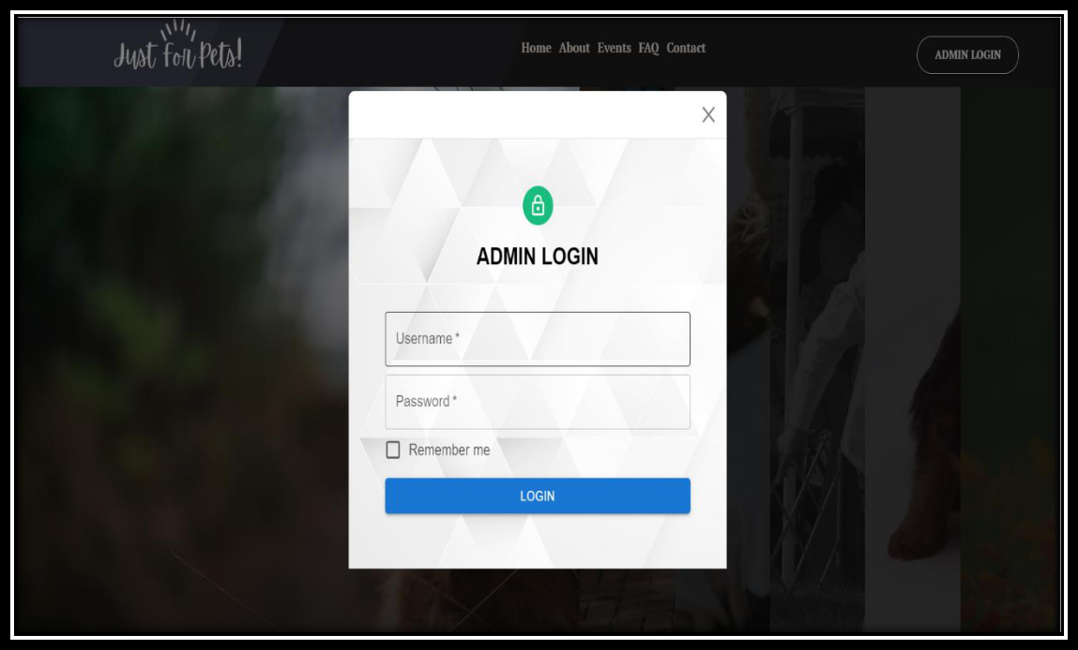

Figure 6-3: Admin Login

- Image Slider:

A home slider, also known as a carousel or image slider, is a popular component used on the homepage of a website to display a rotating set of images or content in a visually appealing and interactive way. It typically occupies a prominent position on the homepage and plays a crucial role in capturing users' attention, conveying key messages, and enhancing the overall user experience.

Here are some key reasons why we need a home slider and the role it plays in a website:

18
- Visual Appeal: A home slider creates an engaging and visually captivating element on the homepage. It allows website owners to showcase their most important or featured content in a dynamic and eye-catching manner, immediately drawing the attention of visitors.

- Message Delivery: The home slider provides a convenient space to convey important messages, promotions, or announcements. By displaying multiple slides, each with its own content or imagery, website owners can effectively communicate different aspects of their business or brand to users in a concise and visually appealing way.

- Highlighting Key Features: With a home slider, website owners can highlight key features, products, or services they offer. By showcasing different elements of their offering in each slide, they can provide users with a quick overview and encourage further exploration of the site.

- Call-to-Action (CTA) Promotion: Home sliders often include call-to-action buttons or links within each slide. This allows website owners to guide users towards desired actions, such as signing up for a newsletter, making a purchase, or exploring specific sections of the site.

- User Engagement: The interactive nature of a home slider encourages user engagement and interaction. Users can manually navigate through the slides or watch them automatically transition, providing an enjoyable and interactive browsing experience.

- Space Optimization: By utilizing a home slider, website owners can make efficient use of limited space on the homepage. Instead of displaying static content or multiple images separately, a slider allows them to showcase multiple items or messages in a compact and organized manner.

- Visual Storytelling: Home sliders can be used to tell a visual story or create a narrative. By presenting a sequence of related images or content, website owners can guide users through a story or journey, capturing their interest and enhancing the overall storytelling experience.

- Dynamic Content Updates: Home sliders can be easily updated with new content or imagery,

allowing website owners to keep their homepage fresh and engaging. This flexibility

19
enables them to showcase seasonal promotions, latest news, or any other time-sensitive information.

By incorporating a home slider into a website, website owners can effectively grab users' attention, deliver key messages, promote important content, and create an engaging and visually appealing user experience. It serves as a powerful tool for showcasing and promoting various aspects of the website and enticing users to explore further.


Figure 6-4: Slider Component

- About Section:

The About section is a crucial component of a website that provides information about the website owner, organization, or brand. It serves as a dedicated space to communicate the background, mission, values, and unique selling points of the entity behind the website. Here's why the About section is essential and the role it plays:

- Establishing Credibility: The About section helps establish credibility and build trust with website visitors. It provides an opportunity to share the history, expertise, and

20

accomplishments of the organization or individuals involved, giving visitors confidence in the website's content, products, or services.

- Introducing the Team or Founder: In the About section, you can introduce the team members or founder behind the website. This humanizes the brand, allowing visitors to connect with the people involved and fostering a sense of familiarity and trust.

- Conveying the Purpose and Mission: The About section enables you to clearly articulate the purpose and mission of the website or organization. It helps visitors understand what the website aims to achieve, the problems it solves, and the value it provides. This can resonate with users who share similar goals or interests.

- Showcasing Expertise and Experience: The About section allows you to highlight your expertise, qualifications, or industry experience. By showcasing relevant achievements, certifications, or accolades, you demonstrate credibility and expertise, positioning yourself as a trusted source of information or a reliable provider of products/services.

- Sharing Unique Differentiators: The About section provides an opportunity to communicate the unique qualities or differentiators of the website, organization, or brand. This could include innovative approaches, core values, commitment to sustainability, or any distinctive factors that set you apart from competitors.

- Engaging Visitors: The About section can engage visitors by presenting engaging and compelling content. This could include storytelling, anecdotes, or multimedia elements such as videos or images to make the section more captivating and memorable.

21
- Enhancing Brand Identity: The About section plays a vital role in shaping your brand identity. It allows you to communicate your brand's tone, values, and personality, helping visitors align themselves with your brand and fostering a sense of brand loyalty.

With the About section, you can:

- Establish credibility and build trust with website visitors.

- Introduce the team or founder behind the website.

- Clearly convey the purpose and mission of the website or organization.

- Showcase expertise, qualifications, or industry experience.

- Communicate unique differentiators or core values.

- Engage visitors with captivating content.

- Encourage connection and interaction with visitors.

- Shape and enhance your brand identity.

Overall, the About section serves as a vital element of a website, allowing you to communicate essential information, build trust, differentiate your brand, and engage visitors on a deeper level.
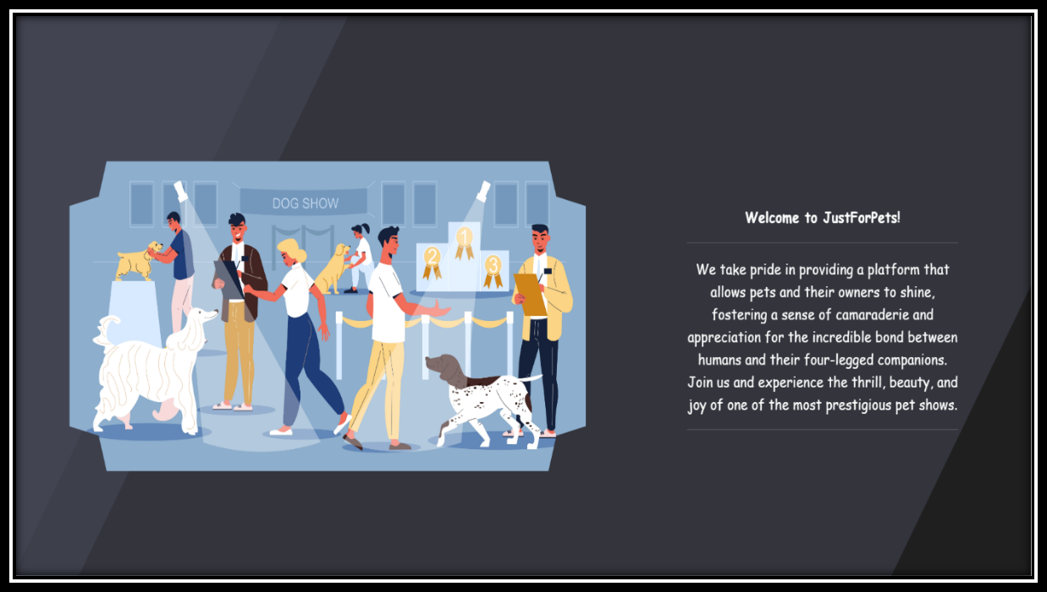

Figure 6-5: About Section

22
- Events Section:

The Event section on a website is a dedicated space to showcase and provide information about upcoming events, conferences, workshops, or any other gatherings organized by the website owner or organization. Here's why the Event section is important and the role it plays:

- Event Promotion: The Event section serves as a platform to promote and advertise upcoming events. It provides visitors with key details such as event dates, locations, schedules, and descriptions, allowing them to learn about and plan their participation.

- Information and Updates: The Event section keeps visitors informed about the latest news, updates, and announcements related to upcoming events. It ensures that attendees have access to all the necessary information, including changes in schedule, guest speakers, ticket availability, and any other relevant updates.

- Engaging and Attracting Participants: The Event section plays a crucial role in engaging and attracting participants to the events. By highlighting the unique features, benefits, and value propositions of each event, you can create interest and generate excitement, encouraging visitors to register and participate.

- Building Anticipation: A well-designed Event section helps build anticipation and creates a buzz around upcoming events. It can include teaser content, sneak peeks, testimonials, or past event highlights, all of which contribute to generating excitement and anticipation among potential attendees.

- Registration and Ticketing: The Event section typically provides a registration or ticketing mechanism, allowing visitors to secure their spots and purchase event tickets directly through the website. This streamlines the registration process and makes it convenient for participants to secure their attendance.

- Networking Opportunities: Events often provide networking opportunities, and the Event section can highlight these aspects. You can showcase guest speakers, panel discussions, or

networking sessions, emphasizing the value of connecting with industry experts and peers.

23
- Post-Event Engagement: The Event section can also extend beyond the event itself by including post-event content, such as recaps, photo galleries, or recorded sessions. This helps maintain engagement and allows participants to relive the event or catch up on content they might have missed.

With the Event section, you can:

- Promote and advertise upcoming events.

- Provide comprehensive event information and updates. - Engage and attract participants to register and attend. - Build anticipation and generate excitement.
- Offer registration and ticketing services.

- Highlight networking opportunities and guest speakers. - Provide post-event content for ongoing engagement.

Overall, the Event section plays a crucial role in effectively promoting and managing events. It serves as a central hub of information and engagement, ensuring that participants have all the necessary details and resources to make the most of their event experience.
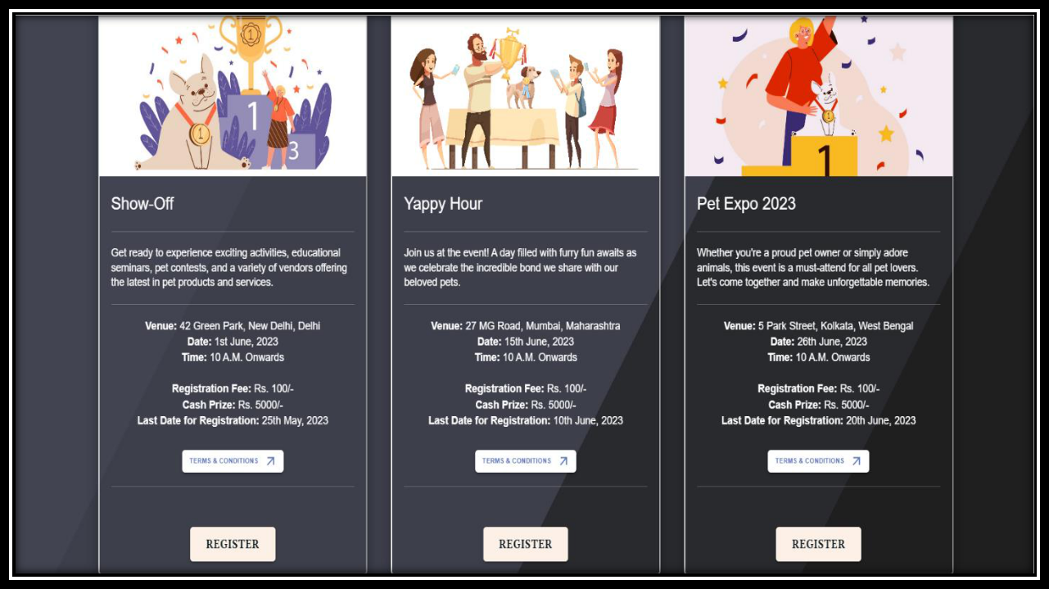

Figure 6-6: Event Component

24
4.1. Terms & Conditions Dialog:

Including Terms and Conditions in the registration form for a pet show website is important for several reasons:

- Legal Protection: Terms and Conditions serve as a legally binding agreement between the website owner and the users participating in the pet show. It outlines the rights, responsibilities, and obligations of both parties, helping protect the interests of the website owner and participants.

- Clear Guidelines: Terms and Conditions provide clear guidelines and rules that participants must adhere to when registering for and participating in the pet show. This ensures that everyone understands the expectations, requirements, and standards set by the organizers, promoting a fair and organized event.

- Liability and Risk Management: By including Terms and Conditions, the website owner can outline liability disclaimers and waivers. This helps protect the organizers from legal claims or damages arising from incidents that may occur during the pet show. It sets the expectations for participants regarding their responsibility for their pets' behavior, health, and safety.

- Consent and Permissions: Terms and Conditions can include provisions related to consent and permissions. This may involve obtaining consent for using participants' photographs or videos taken during the event for promotional purposes or seeking permission to share participants' contact information with sponsors or partners of the pet show.

- Dispute Resolution: Terms and Conditions can include provisions for dispute resolution, outlining the process for resolving any conflicts or issues that may arise between the participants and the website owner. This helps provide a clear path for resolving disputes in a fair and efficient manner.

25
- Communication and Updates: Terms and Conditions can outline how the website owner will communicate with participants regarding any updates, changes, or important information related to the pet show. It ensures that participants receive necessary notifications and updates through the preferred communication channels specified in the Terms and Conditions.

- Participant Agreement: By requiring participants to accept the Terms and Conditions before submitting their registration, it confirms their agreement to abide by the rules and regulations set forth by the website owner. This helps establish a mutual understanding and agreement between the organizers and participants, promoting a positive and compliant participation experience.

Including Terms and Conditions in the registration form for a pet show website helps establish a clear and fair relationship between the website owner and participants. It provides legal protection, sets guidelines and expectations, manages liability and risks, and ensures compliance with privacy and data protection regulations. Ultimately, it contributes to a well-organized and successful pet show experience for all involved parties.
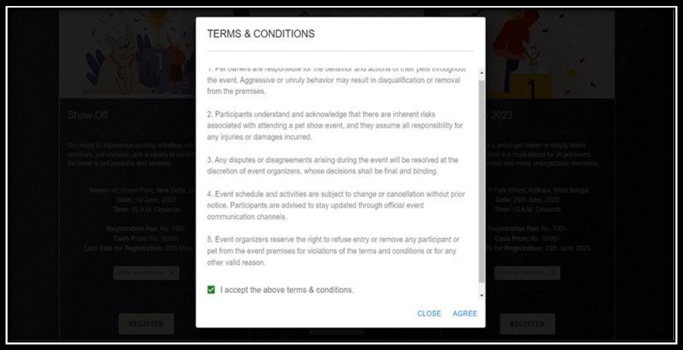

Figure 6-7: Terms & Conditions

26
4.2. Registration Form:

A registration form is an essential component of a pet show website for several important reasons:

- Organized Participation: The registration form allows organizers to gather necessary information from participants in a structured and organized manner. It ensures that all participants provide the required details, such as their name, contact information, pet information, and any additional requirements or preferences.

- Planning and Logistics: The registration form helps organizers effectively plan and manage the pet show. By collecting information about the number of participants, types of pets, and other relevant details, organizers can make informed decisions regarding event logistics, such as venue selection, space allocation, judging criteria, and prize categories.

- Communication and Updates: The registration form serves as a means of communication between organizers and participants. It allows organizers to send important updates, announcements, or reminders regarding the pet show, including schedule changes, entry confirmations, or any additional requirements. This ensures that participants stay informed and engaged throughout the event.

- Participant Database: The information collected through the registration form creates a participant database that organizers can utilize for various purposes. It enables them to maintain a record of participants, their pets, and their preferences, facilitating efficient event management and future communication, such as inviting participants to future events or sharing relevant pet-related information.

- Preparing for Judging and Categories: The registration form helps organizers categorize participants based on their pets' breed, size, age, or other relevant criteria. This information is vital for planning the judging process, creating appropriate categories, and ensuring a fair competition. It helps organizers allocate resources, such as judges or specific requirements, based on the registered participants.

27
- Data Analysis and Reporting: The registration form data can be analyzed to gain insights into participant demographics, popular pet breeds, or other relevant trends. This information can be used for reporting purposes, improving future events, identifying areas of interest, or tailoring marketing efforts to the target audience.

- Compliance and Documentation: By having participants complete a registration form, organizers can ensure compliance with any necessary legal or regulatory requirements. It helps collect consent forms, liability waivers, or any other documents necessary for the pet show. This helps protect the organizers and participants and ensures that everyone is aware of their rights and responsibilities.

In summary, a registration form is crucial for a pet show website as it allows organizers to collect necessary information, communicate with participants, manage logistics, facilitate payments, create participant databases, prepare for judging, analyze data, and ensure compliance. It streamlines the registration process and contributes to the overall success and organization of the pet show.
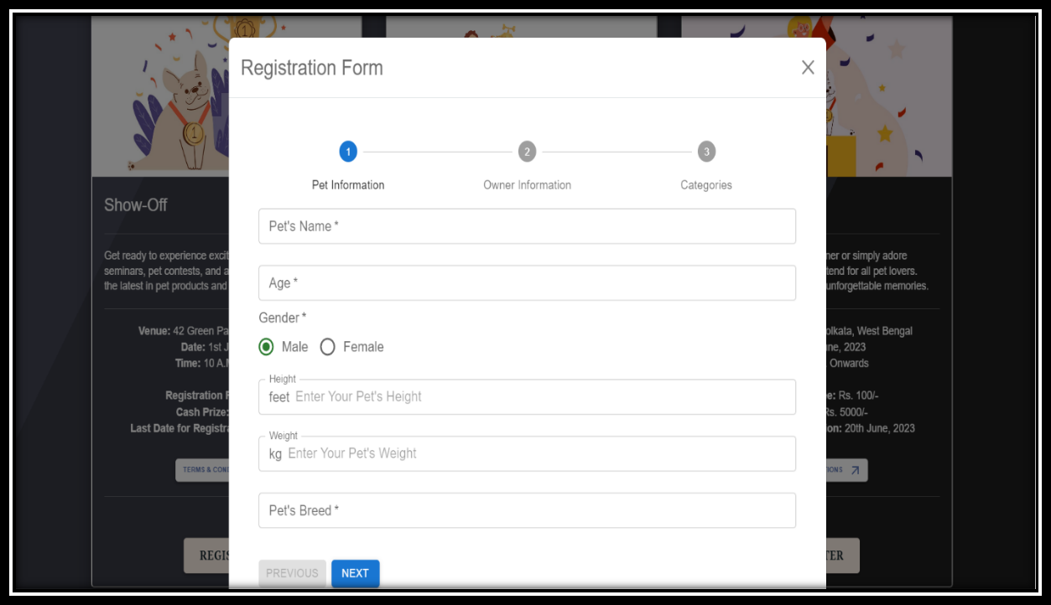

Figure 6-8: Pet Details Form

28
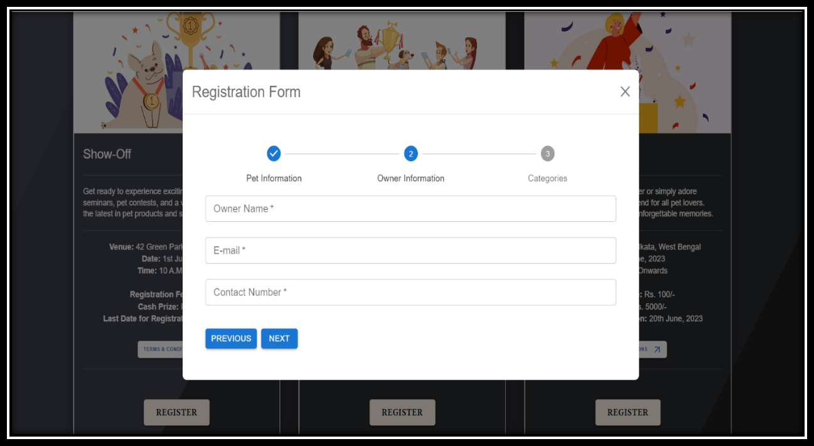

Figure 6-9: Owner Details Form
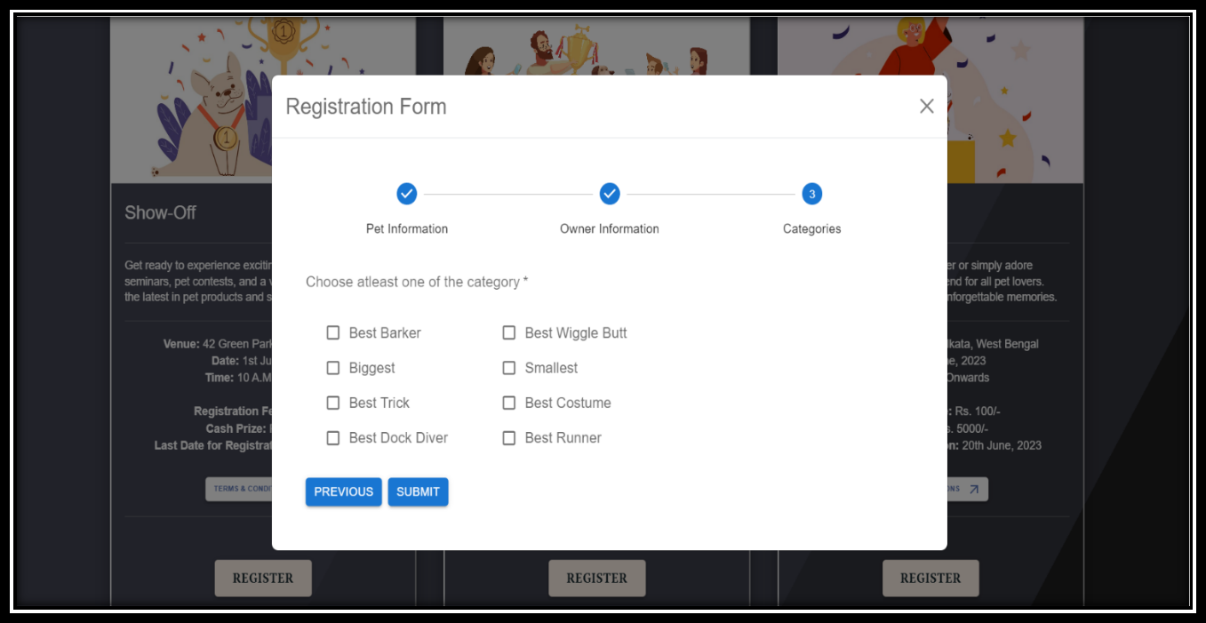

Figure 6-10: Category Details Form

29
5. Frequently Asked Questions:

The FAQ (Frequently Asked Questions) section on a website serves as a valuable resource for visitors by providing answers to common queries and addressing potential concerns they may have. Here's why the FAQ section is important and the role it plays:

- Addressing Common Questions: The FAQ section allows you to proactively address common questions and concerns that visitors may have about your products, services, or website. By providing clear and concise answers, you save both your visitors and your customer support team valuable time.

- Enhancing User Experience: The FAQ section improves the overall user experience by providing easy access to relevant information. Visitors can quickly find answers to their questions without having to navigate through multiple pages or contact customer support, leading to increased satisfaction and a smoother user journey.

- Building Trust and Credibility: An informative and well-structured FAQ section demonstrates that you understand your audience's needs and are committed to addressing their concerns. It builds trust and credibility, reassuring visitors that you have the knowledge and expertise to meet their expectations.

- Reducing Support Requests: By preemptively addressing common questions and concerns in the FAQ section, you can significantly reduce the number of support requests or inquiries. This saves both you and your visitors time and resources, allowing you to focus on more complex or specific support issues.

- Showcasing Product or Service Features: The FAQ section can be utilized to showcase key features, benefits, or unique selling points of your products or services. By framing answers to frequently asked questions around these aspects, you can highlight the value and advantages of what you offer.

  - Providing Clarity and Transparency: The FAQ section allows you to provide clear and

transparent information about your policies, processes, terms and conditions, or any other

30
relevant topics. This promotes transparency, reduces confusion, and ensures that visitors have a clear understanding of your offerings.

With the FAQ section, you can:

- Address common questions and concerns.

- Enhance the user experience by providing quick access to information.

- Build trust and credibility with your audience.

- Reduce support requests and save time.

- Offer self-service solutions for visitors.

- Showcase product or service features and benefits.

- Provide clarity and transparency on policies and processes.

- Benefit from SEO opportunities with relevant keywords.

Overall, the FAQ section plays a vital role in improving user experience, reducing support demands, and providing valuable information to visitors. It serves as a valuable self-service resource that helps address common inquiries, instill confidence, and enhance customer satisfaction.
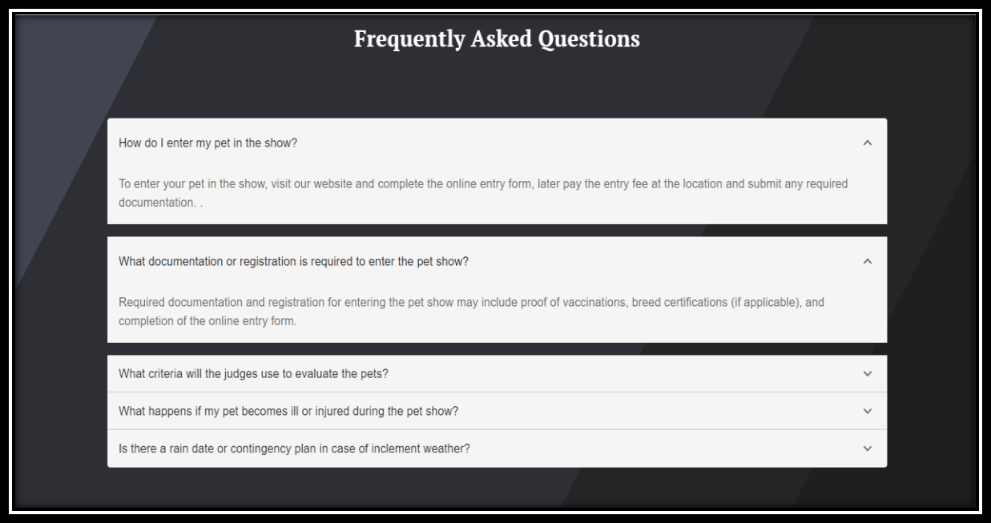

Figure 6-11: FAQ Component

31
6. Footer:

The footer is an essential component of a website that appears at the bottom of each page. It serves multiple purposes and plays a significant role in the overall user experience. Here's why the footer is important and what it can do:

- Navigation and Site Structure: The footer provides an additional navigation option for users. It typically includes links to important pages such as the About Us, Contact, Privacy Policy, Terms of Service, and other relevant sections of the website. This helps users easily navigate to key information without having to scroll back to the top of the page.

- Contact Information: The footer often includes contact details such as the organization's address, phone number, email address, or a contact form. This allows visitors to quickly find and access contact information, making it convenient for them to get in touch or inquire about your products or services.

- Branding and Copyright Information: The footer often showcases branding elements such as the company logo or tagline. It helps reinforce brand recognition and provides a consistent visual identity across all pages of the website. Additionally, the footer usually includes copyright information, indicating ownership and protection of content on the website.

- Social Media Links: The footer can feature social media icons or links to the organization's social media profiles. This encourages visitors to engage with the brand on social platforms, fostering a sense of community and providing an additional channel for communication and promotion.

- Legal and Policy Statements: The footer is an ideal place to include important legal and policy statements, such as privacy policies, terms of service, cookie policies, or disclaimers. Placing these statements in the footer ensures they are easily accessible to users and helps maintain compliance with legal requirements.

- Conversion and Call-to-Action: The footer can incorporate conversion elements and call-to-action buttons or links. This allows you to guide users towards desired actions, such as

32
subscribing to a newsletter, downloading a resource, or making a purchase.

- Design and Aesthetics: The footer contributes to the overall visual appeal and design cohesiveness of the website. It helps balance the page layout, provides a sense of closure, and enhances the user experience by maintaining a consistent design theme throughout the site.

With the footer, you can:

- Provide additional navigation and site structure options.

- Display contact information for easy access.

- Showcase branding elements and copyright information.

- Feature social media links for engagement.

- Enhance the overall design and aesthetics of the website.

In summary, the footer serves as a functional and aesthetic component of a website. It enhances navigation, provides important information, reinforces branding, and contributes to the overall user experience by maintaining consistency and offering additional options for engagement and interaction.
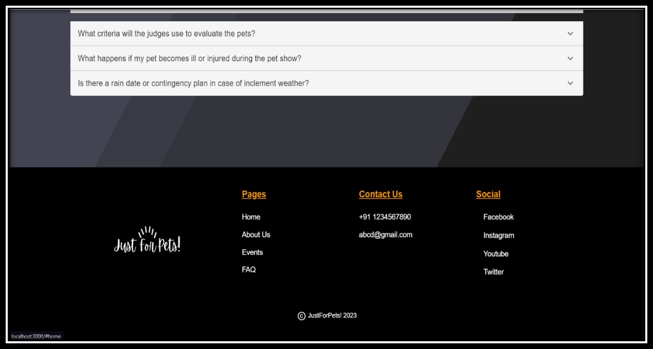

Figure 6-12: Footer Component

33
CHAPTER 7: DATABASE MANAGEMENT

Database management refers to the process of organizing, storing, and manipulating data within a database system. Effective database management is essential for businesses and organizations to efficiently handle and utilize large amounts of data. Here are key aspects and benefits of database management:

- Data Organization: Database management involves structuring data in a logical manner using database management systems (DBMS). This allows for efficient storage, retrieval, and organization of data. Databases use tables, relationships, and indexes to categorize and connect data, ensuring data integrity and eliminating data redundancy.

- Data Storage and Retrieval: Databases provide a structured and centralized storage solution for data. Through database management, data can be stored, accessed, and retrieved easily and quickly. Users can perform queries and retrieve specific information based on various search criteria, saving time and effort compared to manual data handling.

- Data Security: Database management incorporates security measures to protect data from unauthorized access, modifications, or data breaches. Access controls, user authentication, encryption, and data backup strategies are implemented to ensure data confidentiality, integrity, and availability. Regular security updates and audits are conducted to address vulnerabilities and maintain a secure database environment.

- Data Integrity and Consistency: Database management ensures data integrity by enforcing constraints and validation rules. These constraints prevent the entry of invalid or inconsistent data into

the database. Database management systems use transaction processing mechanisms to maintain
34
data consistency and reliability, ensuring that all changes to the database follow atomicity, consistency, isolation, and durability (ACID) properties.

- Data Scalability and Performance: Database management systems are designed to handle large volumes of data and support scalability. They optimize data storage and retrieval processes to deliver fast query responses, even as the database grows in size. Database management includes indexing, query optimization, and performance tuning techniques to enhance database performance and ensure efficient data processing.

- Data Analytics and Decision Making: Database management facilitates data analysis and enables organizations to gain insights from their data. By structuring and organizing data in a database, businesses can perform complex queries, generate reports, and conduct data analysis to make informed decisions. Data-driven decision making becomes more efficient and effective with a well-managed database.

- Data Backup and Recovery: Database management includes regular data backups to ensure data protection and business continuity. Backups provide a means to recover data in the event of data loss, hardware failures, or disasters. Database administrators implement backup and recovery strategies to minimize data loss and maintain the integrity of the database.

- Compliance and Data Governance: Database management involves adhering to regulatory requirements and data governance policies. It ensures that data handling and storage practices comply with relevant regulations, such as data protection laws, industry standards, and privacy regulations. Database management facilitates data auditing, tracking, and reporting to demonstrate compliance and accountability.

35
In summary, database management is crucial for efficient and secure data handling within organizations. It enables data organization, storage, retrieval, security, scalability, performance optimization, analytics, backup, recovery, and compliance. With effective database management, businesses can leverage their data assets to make informed decisions, improve operations, and gain a competitive edge in today's data-driven world.

1. JSON Data:

JSON (JavaScript Object Notation) is a lightweight data interchange format that is commonly used for storing and transmitting structured data. It provides a simple and readable way to represent complex data structures using key-value pairs.

In JavaScript, JSON data can be easily parsed and manipulated using built-in functions. The `JSON.parse()` method is used to convert a JSON string into a JavaScript object, while `JSON.stringify()` is used to convert a JavaScript object into a JSON string.

When working with JSON data, you can map the values from a JSON database to JavaScript code by retrieving the JSON data and accessing the desired properties or values using dot notation or bracket notation.

Mapping JSON database values to JavaScript code allows you to work with the data and utilize it in your application logic. Whether you're retrieving data from an API, reading data from a file, or interacting with a server, the ability to map and manipulate JSON data in JavaScript is crucial for handling and utilizing the information effectively.

2. Data Tables:


User Table

Username

Password

Table 7.2.1: User Data Table

36

Events Table

Name

Description

Venue

Date

Time

Fee

Prize

lastDate

Table 7.2.2: Events Data Table


Form Table

 | Pet Table |  |  |  |  |  |  |  | Categories Table
 | Pet Table |  |  |  | Owner Table |  |  |  | Categories Table
 |  |  |  |  |  |  |  |  | Best Barker
Name
 |  |  |  |  | Name
 |  |  |  |  |  |  |  |  | Best Wiggle Butt
 |  |  |  |  | Email
Age
 |  |  |  |  |  |  |  |  | Biggest
 |  |  |  |  | Contact
 |  |  |  |  |  |  |  |  | Smallest
Gender
 |  |  |  |  |  |  |  |  | Best Trick
Height
 |  |  |  |  |  |  |  |  | Best Costume
 |  |  |  |  |  |  |  |  | Best Dock Diver
Weight
 |  |  |  |  |  |  |  |  | Best Runner
Breed

Table 7.2.3: Form Data Table


FAQ Table

Question

Answer

Table 7.2.4: FAQ Data Table

37
3. Data Flow Diagram (DFD):
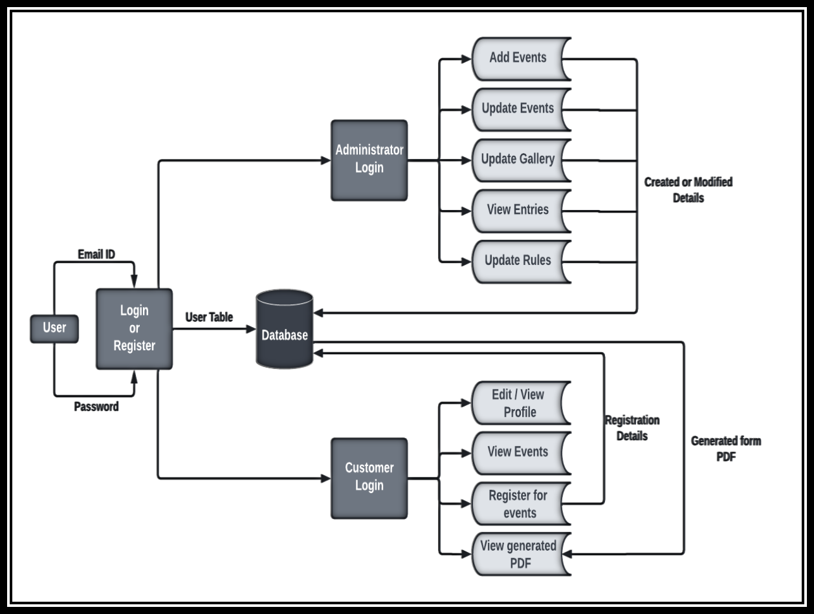

Figure 71: DFD

38
CHAPTER 8: CONCLUSION

The Project entitled “Just for Pets!” Is developed under React JS framework using Firebase for the data handling. It provides the facility to register for upcoming pet shows online. There are various events held and the user can view details and register for the events from the website.

The project will be user-friendly in which user can understand it easily. It will also contain clear navigations by which user can navigate to other sections or pages as he wishes. There are different sections or pages for different operations like view details for pet show, view gallery, register for an upcoming event, view rules for the event, event details, edit and read usage depending upon the account role etc.

The project is used anywhere since it is easy to operate, easy to maintain, highly economical, it has easy working principles which will give nice marketing potential.

In conclusion, the pet show project website is designed to provide a comprehensive platform for organizing and managing a pet show event. The website includes various components and features that contribute to its functionality and effectiveness.

The home slider section on the website allows for visually appealing and engaging content presentation, showcasing key highlights, and attracting the attention of visitors. It serves as a focal point for displaying captivating images and relevant information about the pet show.

The about section provides essential details about the pet show, including its objectives, history, and purpose. It helps create awareness and build credibility among participants and visitors. Additionally, it may include information about the organizing committee, past successful events, and testimonials to establish trust and legitimacy.

39
The event section is a crucial component that outlines the various activities, competitions, and schedules planned for the pet show. It allows participants to access specific event details, rules, and guidelines. Visitors can explore the event calendar, register for specific competitions, and stay updated on any changes or additions to the event schedule.

The FAQ section serves as a valuable resource for addressing common questions and concerns that participants or visitors may have. It provides a convenient way to find answers to frequently asked questions, covering topics such as registration process, judging criteria, pet care, and event logistics. This section helps streamline communication and ensures clarity for all stakeholders involved.

Finally, the footer section offers additional navigation links, contact information, and social media integration. It provides a consistent and accessible way for users to access important pages, connect with the organizers, and stay updated on the latest news and updates related to the pet show.

Overall, the pet show project website effectively fulfills its purpose of promoting the event, facilitating participant registration, providing event information, and enhancing user experience. It offers a user-friendly interface, well-organized content, and seamless functionality, contributing to the success and smooth operation of the pet show.

40
APPENDICES

Appendix 1 – Index.js File

import React from 'react';

import ReactDOM from 'react-dom/client';

import './index.css';

import Navbar from './components/Navbar/Navbar.js';

import reportWebVitals from './reportWebVitals';

import 'bootstrap/dist/css/bootstrap.min.css';

import About from './components/About/About.js'

import Parallax from './components/Parallax/Parallax';

import Slider from './components/Slider/Slider';

import Events from './components/Events/Events';

import Faq from './components/Faq/Faq';

import { Footers } from './components/Footer/Footers';

const root = ReactDOM.createRoot(document.getElementById('root'));

root.render(

<React.StrictMode>

<Navbar />

<Slider />

<About />

<Parallax />

<Events />

<Faq />

<Footers />

<div class="main__bg"></div>

<div class="main__bg layer1"></div>

<div class="main__bg layer2"></div>

</React.StrictMode>

);

- If you want to start measuring performance in your app, pass a function

- to log results (for example: reportWebVitals(console.log))

- or send to an analytics endpoint. Learn more: https://bit.ly/CRA-vitals reportWebVitals();

41
Appendix 2 – Index.css file

body {

margin: 0;

font-family: -apple-system, BlinkMacSystemFont, 'Segoe UI', 'Roboto', 'Oxygen', 'Ubuntu', 'Cantarell', 'Fira Sans', 'Droid Sans', 'Helvetica Neue', sans-serif;

-webkit-font-smoothing: antialiased;

-moz-osx-font-smoothing: grayscale;

}

code {

font-family: source-code-pro, Menlo, Monaco, Consolas, 'Courier New', monospace;

}

.main__bg {

background-image: linear-gradient(-60deg, #000000 50%, #282A3A 50%);

animation: slide 3s ease-in-out infinite alternate;

position: fixed;

top: 0;

bottom: 0;

left: -50%;

right: -50%;

opacity: 0.5;

z-index: -1;

}

.layer1 {

animation-direction: alternate-reverse;

animation-duration: 4s;

}

.layer2 {

animation-duration: 5s;

}

@keyframes slide {

0% {

transform: translateX(-25%);

}

100% {

transform: translateX(25%);

}

}

42
Appendix 3 – Navbar Component

import { Container } from '@mui/system'

import AppBar from '@mui/material/AppBar';

import Toolbar from '@mui/material/Toolbar';

import React from 'react';

import Logo from '../images/logo1.png';

import '../Navbar/Navbar.css'

import Button from '@mui/material/Button';

import Tabs from '@mui/material/Tabs';

import { styled } from '@mui/material';

import AdminLogin from '../AdminLogin/AdminLogin' import { Modal } from 'react-bootstrap'; import { Link } from 'react-scroll';

const LoginButton=styled(Button)({

padding: '8px 23px',

border: '1px solid',

backgroundColor: '#ffffff',

background: 'transparent',

fontSize: 12,

fontWeight: 'bold',

borderRadius: '30px',

fontFamily: 'PT Serif, serif',

'&:hover': {

border: '1px solid',

backgroundColor: '#fdf0e7',

borderColor: '#fdf0e7',

color: '#0F2027',

transition: '1ms'

},

})

const NavTab = styled(Link)({

color: '#fdf0e7',

fontSize: '14px',

padding: '5px',

fontFamily: 'PT Serif, serif',

textDecoration: 'none',

'&:hover': {

cursor: 'pointer',

border: '1px solid',

borderColor: '#ffffff',

borderRadius: '30px',

transition: '1ms',

padding: '5px',

43
color: '#ffffff'

},

})

function Navbar() {

const [modalShow, setModalShow] = React.useState(false);

return (

<Container maxWidth='xl'>

<AppBar position="static" elevation={0}

sx={{

background: 'transparent',

height: '10vh',

marginTop: '1%'

}}>

<Toolbar>

<img className='logo' src={Logo} alt="Just For Pets!" />

<Tabs sx={{ marginLeft: 'auto'}}>

<NavTab

to="home"

smooth={true}

duration={500}

spy={true}

exact="true"

offset={-70}

>

Home

</NavTab>

<NavTab

to="about"

smooth={true}

duration={500}

spy={true}

exact="true"

offset={-70}

>

About

</NavTab>

<NavTab

to="events"

smooth={true}

duration={500}

spy={true}

exact="true"

offset={-70}

>

44
Events

</NavTab>

<NavTab

to="faq"

smooth={true}

duration={500}

spy={true}

exact="true"

offset={-70}

>

FAQ

</NavTab>

<NavTab

to="contact"

smooth={true}

duration={500}

spy={true}

exact="true"

offset={-70}

>

Contact

</NavTab>

</Tabs>

<LoginButton sx={{ marginLeft:'auto'}} variant='contained' onClick={() => setModalShow(true)}>Admin Login</LoginButton>

<Modal

show={modalShow}

onHide={() => setModalShow(false)}

size="md"

aria-labelledby="contained-modal-title-vcenter"

centered

>

<Modal.Header closeButton/>

<Modal.Body className="modal-background">

<AdminLogin />

</Modal.Body>

</Modal>

</Toolbar>

</AppBar>

</Container>

)

}

export default Navbar

45

