A
PROJECT REPORT
on
MOVIE RECOMMENDATION APPLICATION

Submitted in partial fulfilment of the requirements for the degree of
BACHELOR OF TECHNOLOGY



Session: - Jan-June 2023

Under Guidance of
Aaditya Maheshwari
Head of Industry Project
CSE & Techno India NJR
Institute of Technology
Vivek Kumar(19ETCCS082)
Sayyad Sarfraz Ali(19ETCCS062)
Tushar Yadav(19ETCCS073)
Prajjwal Paliwal(19ETCCS048)
VIII semester, CSE

DEPARTMENT OF COMPUTER SCIENCE AND ENGINEERING
TECHNO INDIA NJR INSTITUTE OF TECHNOLOGY, UDAIPUR-313001
MAY - 2023

A
PROJECT REPORT
on
MOVIE RECOMMENDATION APPLICATION

Submitted in partial fulfilment of the requirements for the degree of
BACHELOR OF TECHNOLOGY

Session: - Jan-June 2023

Vivek Kumar(19ETCCS082)
Sayyad Sarfraz Ali(19ETCCS062)
Tushar Yadav(19ETCCS073)
Prajjwal Paliwal(19ETCCS048)
VIII semester, CSE

Under Guidance of
Aaditya Maheshwari
Head of Industry Project
CSE & Techno India NJR

DEPARTMENT OF COMPUTER SCIENCE AND ENGINEERING
TECHNO INDIA NJR INSTITUTE OF TECHNOLOGY, UDAIPUR-313001
MAY - 2023

Department of Computer Science and Engineering
Techno India NJR Institute of Technology, Udaipur-313001

Certificate

This is to certify that project work titled “MOVIE RECOMMENDATION APPLICATION” by Vivek, Prajjwal, Sarfraz and Tushar was successfully carried out in the Department of Computer Science and Engineering, TINJRIT and the report is approved for submission in the partial fulfillment of the requirements for award of degree of Bachelor of Technology in Computer Science and Engineering.

Aaditya Maheshwari Dr. Rimpy Bishnoi
Head of Industry Project Head of Department
CSE TINJRIT, Udaipur CSE TINJRIT, Udaipur Date...................... Date......................

Department of Computer Science and Engineering
Techno India NJR Institute of Technology, Udaipur-313001

Certificate

This is to certify that project work titled “MOVIE RECOMMENDATION APPLICATION” by Sayyad Sarfraz Ali was successfully carried out in the Department of Computer Science and Engineering, TINJRIT and the report is approved for submission in the partial fulfillment of the requirements for award of degree of Bachelor of Technology in Computer Science and Engineering.

Aaditya Maheshwari Dr. Rimpy Bishnoi
Head of Industry Project Head of Department
CSE TINJRIT, Udaipur CSE TINJRIT, Udaipur Date...................... Date......................

Department of Computer Science and Engineering
Techno India NJR Institute of Technology, Udaipur-313001

Certificate

This is to certify that project work titled “MOVIE RECOMMENDATION APPLICATION” by Vivek Kumar was successfully carried out in the Department of Computer Science and Engineering, TINJRIT and the report is approved for submission in the partial fulfilment of the requirements for award of degree of Bachelor of Technology in Computer Science and Engineering.

Aaditya Maheshwari Dr. Rimpy Bishnoi
Head of Industry Project Head of Department
CSE TINJRIT, Udaipur CSE TINJRIT, Udaipur Date...................... Date......................

Department of Computer Science and Engineering
Techno India NJR Institute of Technology, Udaipur-313001

Certificate

This is to certify that project work titled “MOVIE RECOMMENDATION APPLICATION” by Tushar Yadav was successfully carried out in the Department of Computer Science and Engineering, TINJRIT and the report is approved for submission in the partial fulfillment of the requirements for award of degree of Bachelor of Technology in Computer Science and Engineering.

Aaditya Maheshwari Dr. Rimpy Bishnoi
Head of Industry Project Head of Department
CSE TINJRIT, Udaipur CSE TINJRIT, Udaipur Date...................... Date......................

Department of Computer Science and Engineering
Techno India NJR Institute of Technology, Udaipur-313001

Certificate

This is to certify that project work titled “MOVIE RECOMMENDATION APPLICATION ” by Prajjwal Paliwal was successfully carried out in the Department of Computer Science and Engineering, TINJRIT and the report is approved for submission in the partial fulfilment of the requirements for award of degree of Bachelor of Technology in Computer Science and Engineering.

Aaditya Maheshwari Dr. Rimpy Bishnoi
Head of Industry Project Head of Department
CSE TINJRIT, Udaipur CSE TINJRIT, Udaipur Date...................... Date......................

Department of Computer Science and Engineering
Techno India NJR Institute of Technology, Udaipur-313001

Examiner Certificate

This is to certify that the following students
Vivek, Prajjwal, Sarfraz and Tushar
of final year B.Tech. (Computer Science and Engineering), was examined for the project work titled
“MOVIE RECOMMENDATION APPLICATION”
during the academic year 2022 – 2023 at Techno India NJR Institute of Technology, Udaipur

Remarks:
Date:

Signature Signature
(Internal Examiner) (External Examiner)
Name :- ……………………… Name :- ………………………
Designation:- ……………….. Designation:- ………………..
Department: - ………………. Department: - ……………….
Organization:- ……………… Organization:- ………………
Department of Computer Science and Engineering
Techno India NJR Institute of Technology, Udaipur-313001

Examiner Certificate

This is to certify that the following student
Sayyad Sarfraz Ali
of final year B.Tech. (Computer Science and Engineering), was examined for the project work titled
“MOVIE RECOMMENDATION APPLICATION”
during the academic year 2022 – 2023 at Techno India NJR Institute of Technology, Udaipur

Remarks:
Date:

Signature Signature
(Internal Examiner) (External Examiner)
Name :- ……………………… Name :- ………………………
Designation:- ……………….. Designation:- ………………..
Department: - ………………. Department: - ……………….
Organization:- ……………… Organization:- ………………
Department of Computer Science and Engineering
Techno India NJR Institute of Technology, Udaipur-313001

Examiner Certificate

This is to certify that the following student
Vivek Kumar
of final year B.Tech. (Computer Science and Engineering), was examined for the project work titled
“MOVIE RECOMMENDATION APPLICATION”
during the academic year 2022 – 2023 at Techno India NJR Institute of Technology, Udaipur

Remarks:
Date:

Signature Signature
(Internal Examiner) (External Examiner)
Name :- ……………………… Name :- ………………………
Designation:- ……………….. Designation:- ………………..
Department: - ………………. Department: - ……………….
Organization:- ……………… Organization:- ………………
Department of Computer Science and Engineering
Techno India NJR Institute of Technology, Udaipur-313001

Examiner Certificate

This is to certify that the following student
Tushar Yadav
of final year B.Tech. (Computer Science and Engineering), was examined for the project work titled
“MOVIE RECOMMENDATION APPLICATION”
during the academic year 2022 – 2023 at Techno India NJR Institute of Technology, Udaipur

Remarks:
Date:

Signature Signature
(Internal Examiner) (External Examiner)
Name :- ……………………… Name :- ………………………
Designation:- ……………….. Designation:- ………………..
Department: - ………………. Department: - ……………….
Organization:- ……………… Organization:- ………………
Department of Computer Science and Engineering
Techno India NJR Institute of Technology, Udaipur-313001

Examiner Certificate

This is to certify that the following student
Prajjwal Paliwal
of final year B.Tech. (Computer Science and Engineering), was examined for the project work titled
“MOVIE RECOMMENDATION APPLICATION”
during the academic year 2022 – 2023 at Techno India NJR Institute of Technology, Udaipur

Remarks:
Date:

Signature Signature
(Internal Examiner) (External Examiner)
Name :- ……………………… Name :- ………………………
Designation:- ……………….. Designation:- ………………..
Department: - ………………. Department: - ……………….
Organization:- ……………… Organization:- ………………

Preface
Welcome to our revolutionary movie recommendation application! Prepare to be captivated as we dive into the immersive world of cinematic wonders. Our app is designed to be your personal film curator, tailored to your unique tastes and preferences. With a vast database of movies spanning across genres, eras, and cultures, we ensure that every movie recommendation is a masterpiece in its own right. Sit back, relax, and let our cutting-edge algorithms analyze your viewing history, interests, and mood to deliver an exquisite selection of films that will transport you to new realms of entertainment. Get ready to embark on a cinematic journey like never before with our extraordinary movie recommendation application.
In Chapter 1, we embark on an intriguing journey into the heart of our project. We provide a captivating overview, setting the stage for the remarkable innovation and excitement that lies ahead.
Chapter 2 we delves into the critical Software Requirements Specification (SRS), meticulously detailing the functional and non-functional requirements that define the foundation of our software solution.
Chapter 3 we The third chapter delves into the intricate process of system analysis and design. We explore the system's architecture, data models, user interfaces, and workflows, ensuring a well-structured and user-centric software solution.

Chapter 4 gives data dictionary information, Chapter 5 consists of snapshots of the complete project.

Chapter 6 gives testing for the project, Chapter 7 tells about the conclusion and future enhancements of the project. And the final chapter concerns the bibliography.

DEPARTMENT OF COMPUTER SCIENCE AND ENGINEERING TECHNO INDIA NJR INSTITUTE OF TECHNOLOGY, UDAIPUR-313001

ACKNOWLEDGMENT

We take this opportunity to record our sincere thanks to all who helped us to successfully complete this work. Firstly, We are grateful to our supervisor Aaditya Maheshwari for his invaluable guidance and constant encouragement, support and most importantly for giving us the opportunity to carry out this work.
We would like to express our deepest sense of gratitude and humble regards to our
Head of Department Dr. Rimpy Bishnoi for giving invariable encouragement in our endeavors and providing necessary facility for the same. Also a sincere thanks to all faculty members of CSE, TINJRIT for their help in the project directly or indirectly.
Finally, We would like to thank my friends for their support and discussions that have proved very valuable for us. We are indebted to our parents for providing constant support, love and encouragement. We thank them for the sacrifices they made so that we could grow up in a learning environment. They have always stood by us in everything we have done, providing constant support, encouragement and love

Vivek Kumar(19ETCCS082)
Sayyad Sarfraz Ali(19ETCCS062)
Tushar Yadav(19ETCCS073)
Prajjwal Paliwal(19ETCCS048)

DEPARTMENT OF COMPUTER SCIENCE AND ENGINEERING

TECHNO INDIA NJR INSTITUTE OF TECHNOLOGY, UDAIPUR-313001
Contents

CHAPTER 1 1
INTRODUCTION 1
1.4 OVERALL DESCRIPTION 2
1.5 FUNCTIONAL REQUIREMENTS 3
CHAPTER 2 4
SOFTWARE REQUIREMENT SPECIFICATION 4
CHAPTER 3 8
SYSTEM ANALYSIS AND DESIGN 8
CURRENT SYSTEM 8
CHAPTER 4 13
4.2 DATA ELEMENTS 13
4.3 DATA STRUCTURE 13
4.4 TABLE DETAILS 14
CHAPTER 5 17
SCREEN SHOTS 17
5.1 REGISTER USER 17
5.2 LOGIN USER 17
5.3 HOME PAGE 18
5.4 SERIES PAGE 18
5.5 MOVIE PAGE 19
5.6 MOVIE/SERIES LIST 19
ADMIN PAGE 20
5.9 ANALYTICS PAGE 21
5.10 MOVIES PAGE 21
5.11 MOVIES/EDIT 22
5.13 LISTS PAGE 23
5.14 LISTS/EDIT 23
5.15 LISTS/EDIT/CREATE 23
CHAPTER – 6 30
TESTING 30
6.1 TESTING METHODOLOGY 30
6.4 PROGRAM TESTING 32
6.5 STRING TESTING 32
6.6 SYSTEM TESTING 33
6.7 SYSTEM DOCUMENTATION 33
6.8 USER ACCEPTANCE TESTING 33
CONCLUSION AND FUTURE ENHANCEMENTS 34
7.1 LIMITATIONS 34
7.2 FUTURE ENHANCEMENTS 35
7.3 CONCLUSION 36
BIBLIOGRAPHY

LIST OF FIGURES
Fig. 3.6 | Users …………………………………………... | 11
Fig. 3.7 | Movies ………………………………………... | 12

LIST OF TABLES
Table 4.1 | Users …………………………………………... | 36
Table 4.2 | Movies ………………………………………... | 37
Table 4.3 | List ………………………………………... | 38

CHAPTER 1

INTRODUCTION

1.1 INTRODUCTION
The movie recommendation application is designed to help users find movies that align with their individual tastes, interests, and preferences. By leveraging advanced recommendation algorithms, the application aims to provide personalized and relevant movie suggestions, saving users time and effort in searching for movies themselves.
1.2 SCOPE
The scope of this project is very broad in terms of manually suggest movies and series. A few of them are: -
- Genre-based Recommendations: Provide tailored movie suggestions based on user-selected genres, enabling them to explore new movies within their preferred categories.
- User Ratings and Reviews: Allow users to rate and review movies, contributing to an aggregated rating system for accurate recommendations.
- Watchlist and Notifications: Enable users to create a watchlist, receive notifications about new releases, and reminders for upcoming movies of interest.
- Cross-platform Compatibility: Develop a multi-platform app accessible on smartphones, tablets, and web browsers for seamless user experience across devices.
- Advanced Filtering Options: Incorporate filters for criteria like release year, language, runtime, and cast, allowing users to refine their movie recommendations further.

1.3 DOCUMENT OVERVIEW
The remainder of this document is 8 chapters, the first providing an introduction to the project. It lists all the functions performed by the system. The second chapter consists of software requirements specification. The third chapter provides details about system analysis and design. The fourth chapter gives data dictionary information. The fifth chapter consists of snapshots of the complete project. The sixth chapter gives testing for the project. The seventh chapter tells about the conclusion and future enhancements of the project. The final chapter concerns the bibliography.

This document is meant to describe all the features and procedures that were followed while developing the system.

This document specially mentions the details of the project, how it was developed, the primary requirement, as well as various features and functionalities of the project and the procedures followed in achieving these objectives.

1.4 OVERALL DESCRIPTION
The movie recommendation application report aims to provide a comprehensive overview of the development and implementation of a movie recommendation system. The report covers various aspects of the project, including its objectives, system architecture, recommendation algorithms, user interface design, implementation details, testing, and evaluation.
The report begins with an introduction that highlights the significance of developing a movie recommendation application and its potential benefits for users. It sets the context for the project and establishes the motivation behind its development.
The system architecture section presents the high-level architecture of the movie recommendation application. It illustrates the various components and their interactions, providing a clear understanding of how the system functions. This section helps stakeholders visualize the application's structure and flow of data.
Data collection and processing are described, explaining how movie data is gathered from reliable sources and APIs. The methods used to preprocess and clean the data are discussed to ensure its quality and consistency. This section highlights the importance of data preparation for accurate recommendations.
Overall, the movie recommendation application report provides a thorough and structured overview of the project, documenting its objectives, system architecture, recommendation algorithms, user interface design, implementation details, testing, and evaluation. It serves as a comprehensive resource for stakeholders, researchers, and developers interested in movie recommendation systems.

1.5 FUNCTIONAL REQUIREMENTS
Functional Requirements are those that refer to the functionality of the system, i.e., what services it will provide to the user. Nonfunctional (supplementary) requirements pertain to other information needed to produce the correct system and are detailed separately.

1.6 USE CASES

- Admin can do the following functions:
- Login using credentials.
- Register users and Movies.
- View All users and movies data.
- Edit user and movies.
- View movies and documentation uploaded.
- Users can do the following functions:
- Login using credentials.
- Can view the Movies.
- Can chat with customer support.

CHAPTER 2

SOFTWARE REQUIREMENT SPECIFICATION

2.1 ABOUT REACTJS
ReactJS is an open-source JavaScript library that has gained immense popularity for building user interfaces (UIs) for web applications. Developed by Facebook, ReactJS allows developers to create reusable UI components, making the process of building complex and interactive interfaces more manageable and efficient.
One of the key features of ReactJS is its virtual DOM (Document Object Model) implementation. ReactJS uses a virtual representation of the DOM, which is a lightweight copy of the actual DOM. This virtual DOM enables ReactJS to efficiently update and render UI components, reducing the need for manual DOM manipulation and improving performance.
ReactJS follows a declarative approach, where developers define the desired UI state, and React takes care of updating the UI to match that state. This makes it easier to understand and reason about the code, as well as enhance code reusability.
ReactJS also supports component-based architecture, enabling developers to break down the UI into smaller, reusable components. These components can be composed together to build complex UI structures, promoting code modularity and maintainability. Additionally, ReactJS embraces a unidirectional data flow pattern, where data flows in a single direction, making it easier to track and debug application state changes.
Furthermore, ReactJS has a vast ecosystem of libraries and tools, such as Redux for managing application state, React Router for handling navigation, and Axios for making HTTP requests. It also integrates seamlessly with other frameworks and libraries, allowing developers to combine React with technologies like ExpressJS for server-side rendering and data fetching.
2.2 ABOUT EXPRESSJS
ExpressJS is a fast and minimalist web application framework for Node.js. It simplifies the process of building web applications and APIs by providing a set of robust features and tools. With ExpressJS, developers can handle HTTP requests, manage routes, and define middleware functions efficiently.
ExpressJS offers a straightforward and unopinionated approach, allowing developers to have more control over their application's structure and architecture. It provides a flexible routing system that enables developers to define routes for different HTTP methods and handle various request types.
Additionally, ExpressJS supports middleware functions, which can be used for tasks such as parsing request bodies, handling authentication, logging, and error handling. Middleware functions in ExpressJS are executed sequentially, enabling developers to create a pipeline of functions to process requests.
ExpressJS also integrates seamlessly with other Node.js modules and libraries, allowing developers to leverage a wide range of functionalities for tasks like data storage, authentication, and template rendering.
Furthermore, ExpressJS has a large and active community, which means developers have access to extensive documentation, tutorials, and a wide range of third-party middleware and plugins.

2.3 MONGODB ATLAS AND FIREBASE STORAGE
MongoDB Atlas is a cloud-based, fully managed database service that allows developers to store, manage, and scale their MongoDB databases effortlessly. It provides a secure and reliable platform for storing and retrieving data, with features like automated backups, monitoring, and horizontal scaling. With MongoDB Atlas, developers can focus on building their applications without worrying about infrastructure management.

Firebase Storage, on the other hand, is a cloud-based storage solution offered by Google's Firebase platform. It provides developers with an easy and scalable way to store and serve user-generated content, such as images, videos, and documents. Firebase Storage integrates seamlessly with other Firebase services, enabling developers to build robust applications with real-time data synchronization and secure file storage capabilities.

2.4 RESOURCES UTILIZED
- Client side :- React Js
- Web server :- Express Js
- Database :- MongoDB Atlas
- Storage :- Firebase storage

2.5 NON-FUNCTIONAL REQUIREMENTS
There are requirements that are not functional in nature. Specifically, these are the constraints the system must work within. The web site must be compatible with Internet Explorer web browser.
2.6 EXTERNAL INTERFACE SPECIFICATION
None

2.7 HARDWARE SPECIFICATION
2.7.1 CLIENT SIDE:
Internet Explorer: 6.0
Processor: Pentium IV 2.0 and above.
RAM: 512 MB
Hard Disk: 80GB

2.7.2 SERVER SIDE:
Processor: Pentium IV 2.0 and above.
RAM: 1 GB
Disk space: 4GB

2.8 SOFTWARE SPECIFICATION
2.8.1. CLIENT SIDE:
ReactJS
Web Browser
Windows 10
2.8.2. WEB SERVER:
ExpressJS

2.8.2. DATA BASE SERVER:
Mongo DB
FireBase

2.9 HARDWARE AND SOFTWARE REQUIREMENTS :
Processor: Pentium IV 2.0 and above.
Internet Explorer: 6.0
RAM: 512 MB
Hard Disk: 80GB

2.10 SOFTWARE REQUIREMENTS:
1.Microsoft Visual Studio 2019
Microsoft Visual Studio is an integrated development environment (IDE) from Microsoft. It can be used to develop console and graphical user interface applications along with Windows Forms applications, web sites, web applications, and web services in both native codes together with managed code for all platforms supported by Microsoft Windows, Windows Mobile, Windows CE, .NET Framework, .NET Compact Framework and Microsoft Silverlight.

CHAPTER 3

SYSTEM ANALYSIS AND DESIGN

3.1. STUDY & WEAKNESSES OF CURRENT SYSTEM

CURRENT SYSTEM
Our Application offers a vast library of diverse content, including exclusive shows and movies, original productions, and a user-friendly interface, making it a popular choice with a wide range of options for entertainment.

3.2. REQUIREMENTS OF NEW SYSTEM

3.2.1. USER REQUIREMENTS
The User requirements for the new system are to make the system fast, flexible, less prone to errors and reduce expenses and save time.
- Broad Content Library: Users expect a wide range of movies, TV shows, documentaries, and original productions available for streaming.
- Seamless Streaming Experience: Users require a smooth and uninterrupted streaming experience with minimal buffering and high video and audio quality.
- Multiple Device Compatibility: Users should be able to access the streaming platform on various devices such as smartphones, tablets, smart TVs, and web browsers.
- Personalized Recommendations: Users expect personalized recommendations based on their viewing history, ratings, and preferences to discover new content.
- User-Friendly Interface: The streaming platform should have an intuitive and easy-to-navigate interface, allowing users to quickly find and play their desired content.
- Customized Profiles: Users should have the option to create individual profiles with personalized settings, viewing history, and recommendations tailored to their preferences.
- Offline Viewing: Users appreciate the ability to download content for offline viewing, particularly when they are in areas with limited internet connectivity.
- Continuous Updates: Users expect regular updates to the content library, ensuring access to the latest movies, TV shows, and exclusive productions.
- Cross-Platform Syncing: Users should be able to start watching a show or movie on one device and seamlessly continue on another device without losing their progress.
- Subtitles and Accessibility Options: Users require support for subtitles in multiple languages, as well as accessibility features like closed captions and audio descriptions for an inclusive viewing experience.

3.3 FEASIBILITY TIMING
A key part of the preliminary investigation that reviews anticipated costs and benefits and recommends a content of action based on operational, technical, economic, and time factors. The purpose of the study is to determine if the systems request should proceed further.

3.3.1. DOES THE NEW SYSTEM CONTRIBUTE TO THE OVERALL STREAMING PLATFORMS ?
The new system would contribute to the overall objectives of the organization. It would provide a quick, error-free and cost-effective solution to the current process. It would provide a solution to many issues in the current system. As the new system is flexible and scalable it can also be upgraded and extended to meet other complex requirements which may be raised in the future. However, it is up to the organization to upgrade or extend it.
3.3.2. NEW SYSTEM USING CURRENT TECHNOLOGY?
- Content Licensing: Acquire the necessary licenses and rights to stream movies, TV shows, and other content on your platform. This may involve negotiating deals with content creators, production companies, or distributors.
- Content Delivery Infrastructure: Set up a robust infrastructure to handle content delivery. This includes servers, content delivery networks (CDNs), and encoding/transcoding systems to ensure smooth streaming across different devices and network conditions.
- User Authentication and Registration: Implement a user authentication system to allow users to create accounts and log in securely. This ensures that only authorized users can access your OTT platform.
- Content Management System (CMS): Develop a CMS to manage and organize your content library. This system should allow you to categorize content, add metadata, and enable search and filtering capabilities for users to easily discover and access content.
- Video Encoding and Transcoding: Convert video files into suitable formats and bitrates for streaming. This process involves compressing videos to optimize streaming performance while maintaining acceptable video quality.
3.4 FEATURES OF OUR APPLICATION.
The new system has been designed as per the user requirements to fulfil all of them. The new system consists of API for different modules which when consumed gives a full-fledged application. Users can perform basic operations such as create, update, delete, search, and display on the modules.

- Personalized Recommendations: Utilize algorithms and user preferences to provide tailored movie suggestions based on genres, actors, directors, or previously watched movies.
- Ratings and Reviews: Allow users to rate and review movies they have watched, enabling others to make informed decisions based on user feedback.
- Watchlist: Enable users to create a watchlist where they can save movies they are interested in and receive notifications or reminders when those movies become available.
- Social Sharing: Allow users to share their favorite movies, ratings, and reviews on social media platforms, fostering engagement and discussions among friends and followers.
- Filtering and Sorting Options: Provide various filters such as genre, release year, language, and user ratings, allowing users to refine their movie recommendations and search results.

3.5. DATA FLOW DIAGRAM (DFD)

The DFD (also known as bubble chart) is a simple graphical formalism that can be used to represent a system in terms of the input data into the system, various processes carried on these data, and the output data generated by the system.
The main reason the DFD technique is so popular is because of the fact that DFD is an amazingly simple formalism – it is simple to understand and use. A DFD model uses an extremely limited number of primitive symbols to represent the functions performed by a system and the data flow among the functions. Starting with a set of high-level functions that a system performs, a DFD model hierarchy represents various sub-functions.

3.6 DATA FLOW DIAGRAM
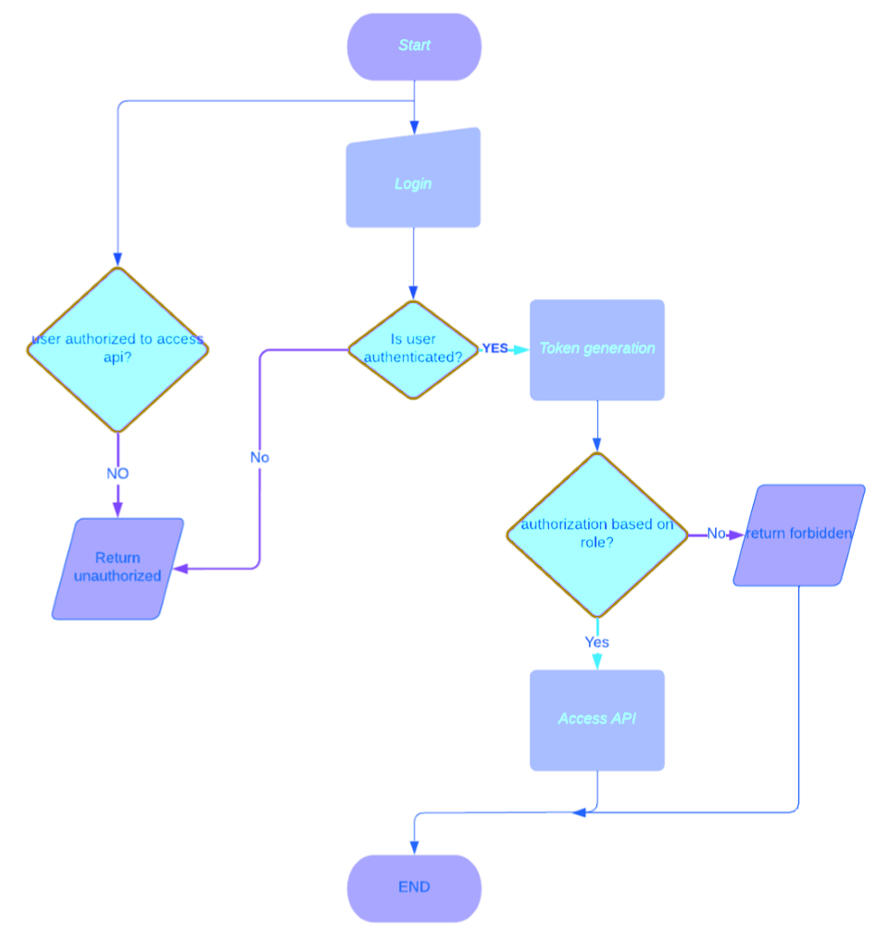

3.7 ER DIAGRAM

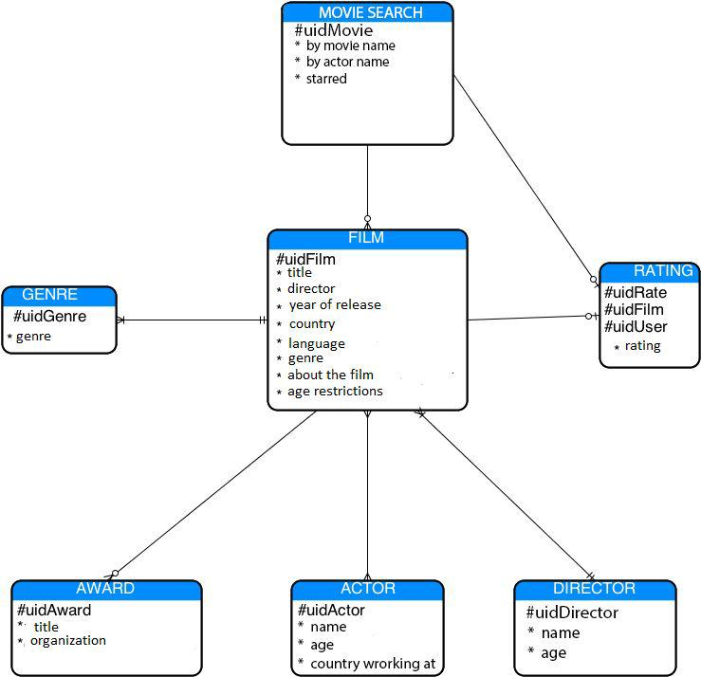

CHAPTER 4
DATA DICTIONARY

4.1 DATA DICTIONARY

A data dictionary is a catalog-a-repository of the elements in a system. As the name suggests, their elements center on data and the way they are structured to meet user requirements and organization needs. In a data dictionary you will find a list of all the elements composing the data flowing through a system. The major elements are data flows, data stores and processes. The data dictionary stores details and descriptions of these elements.
If analysis want to know characters are in a data item by what other names it is referenced in the system, or where it is referenced in the system, or where it is issued in the system, they should be able to find the answers in issued in the system, they should be able to find the answer in properly developed data dictionary. The Dictionary contains two types of description for the data following through the system.

4.2 DATA ELEMENTS
The most fundamental data is the elements. They are building blocks for all other data in the system. Data elements are also alternatively known as fields, data item or elementary item.

4.3 DATA STRUCTURE
A data structure is a set of items that are related to one another and described a component in the system.

4.4 TABLE DETAILS

TABLE 4.1 - USERS

Field Name | Description | Constraints | Data Type
Id | Unique id. | Primary Key | int
Username | Username of the uer. | Null | String
email | Personal mail Id of the User. | Null | String
Password | Password of the User. | Not null | String
ProfilePic | Profile picture of user. | Null | String
isAdmin | If user is admin or not. | Null | Boolean

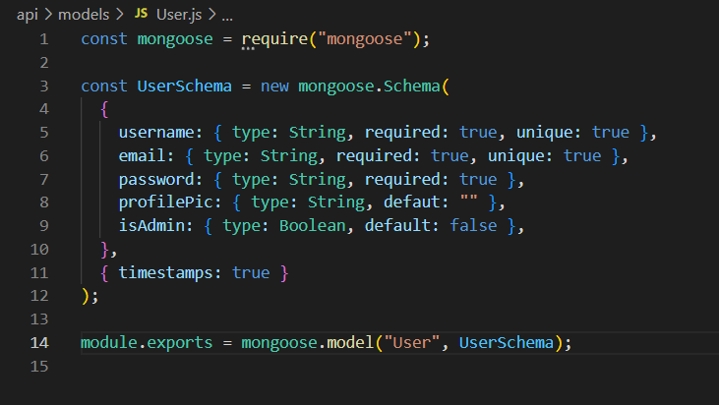

TABLE 4.2. MOVIES

Field Name | Description | Constraints | Data  Type
Id | Unique id. | Primary Key | String
title | Title of movie | Null | String
desc | Description of movie | Null | String
img | Image of movie | Null | String
imgTitle | Title of movie | Null | String
imgSm | Thumbnail of movie | Null | String
trailer | Trailer of movie | Null | String
video | Video clips of movie | Null | String
year | Year of release movie | Null | String
limit | Age limit of movie | Null | Number
genre | Genre of movie | Null | String
isSeries | Movie or Series | Null | Boolean

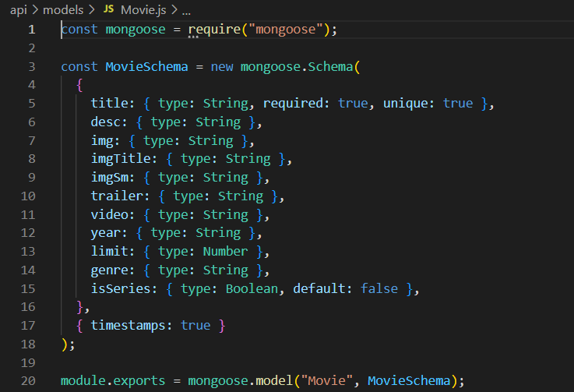

TABLE 4.3 LIST
Field Name | Description | Constraints | Data  Type
Id | Unique id | Primary Key | String
title | Title of movie list | Null | String
type | Movie type or series type | Null | String
genre | Genre of movie list | Null | String
content | Id of the document. | Null | String

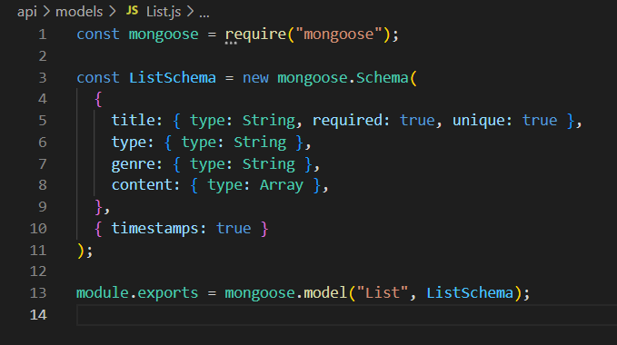

CHAPTER 5

SCREEN SHOTS

5.1 REGISTER USER

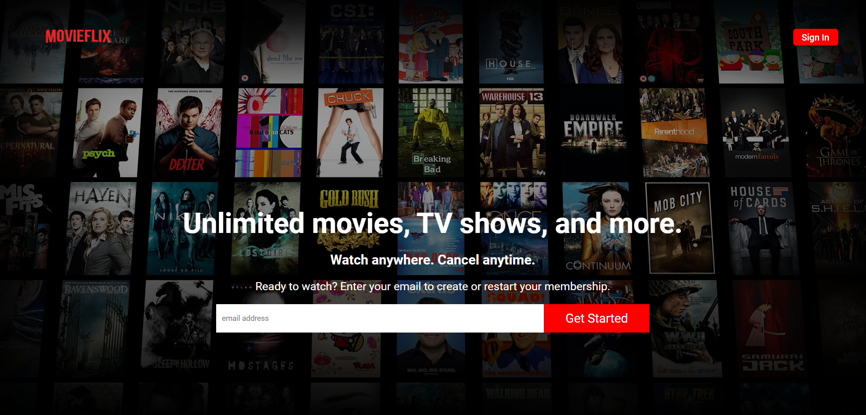

5.2 LOGIN USER

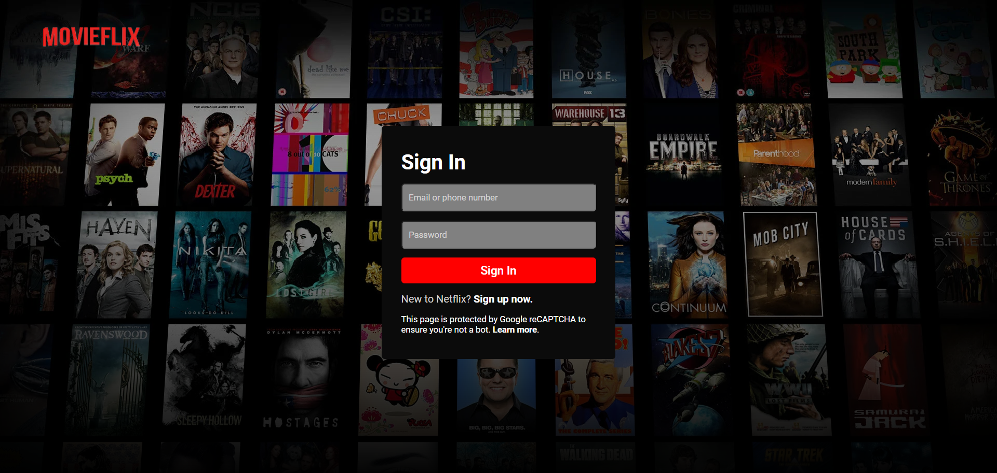

5.3 HOME PAGE

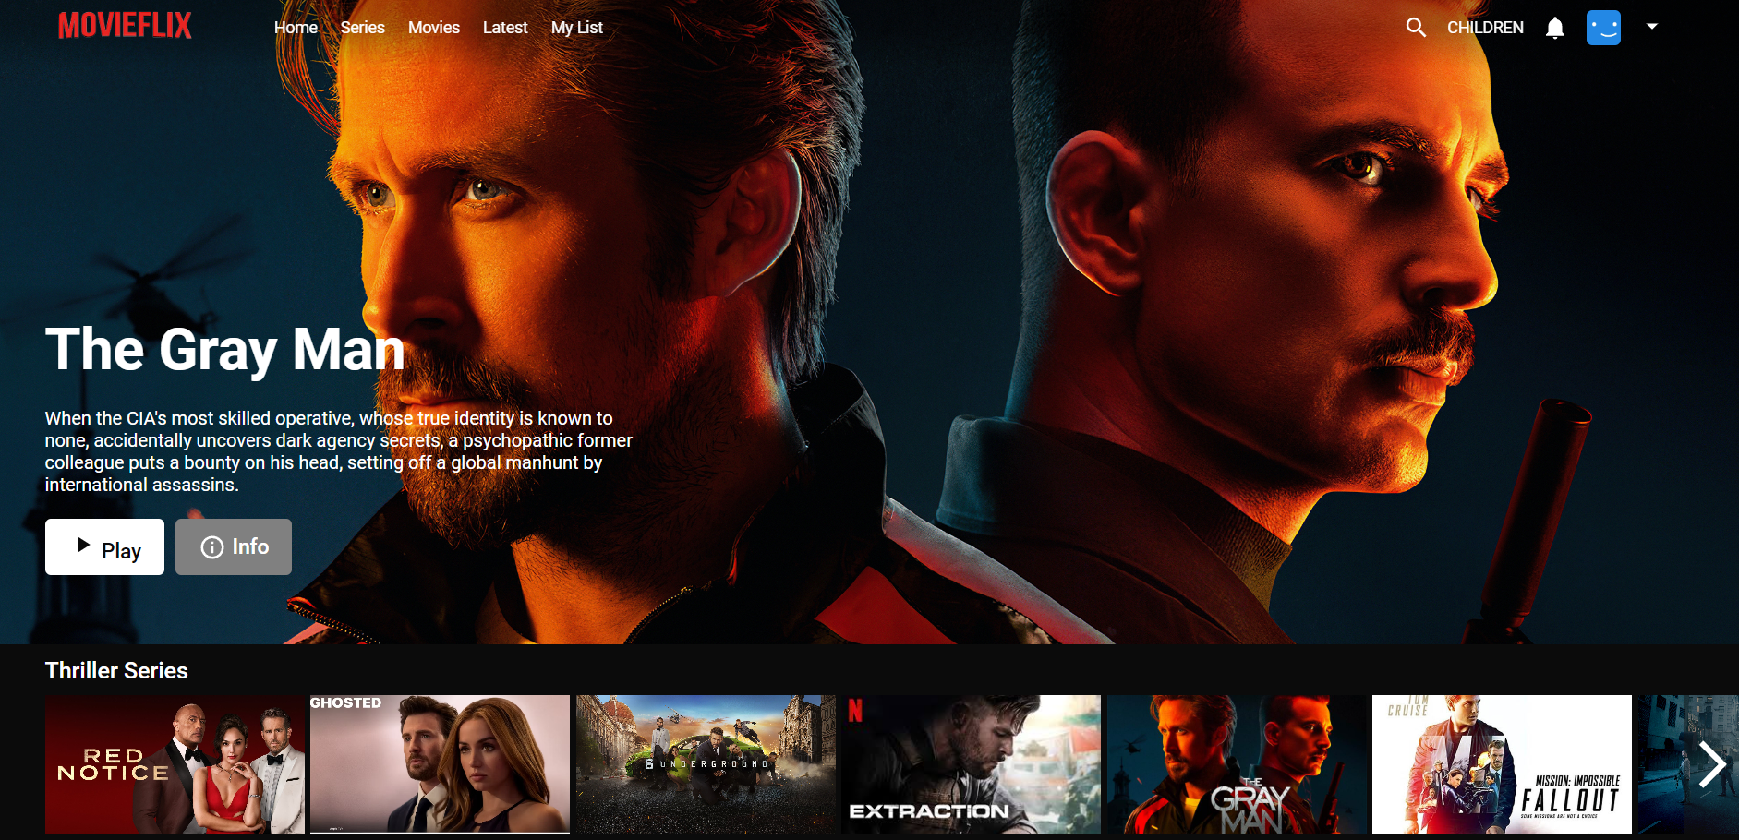

5.4 SERIES PAGE

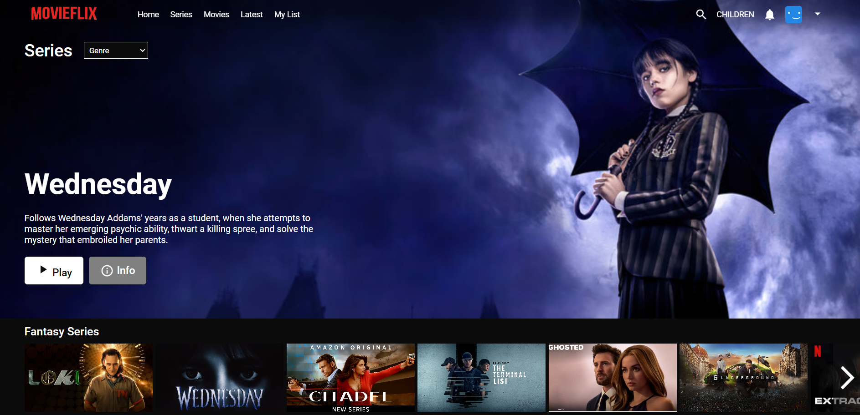

5.5 MOVIE PAGE

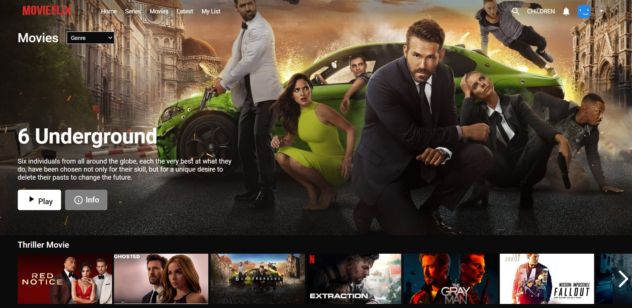

5.6 MOVIE/SERIES LIST

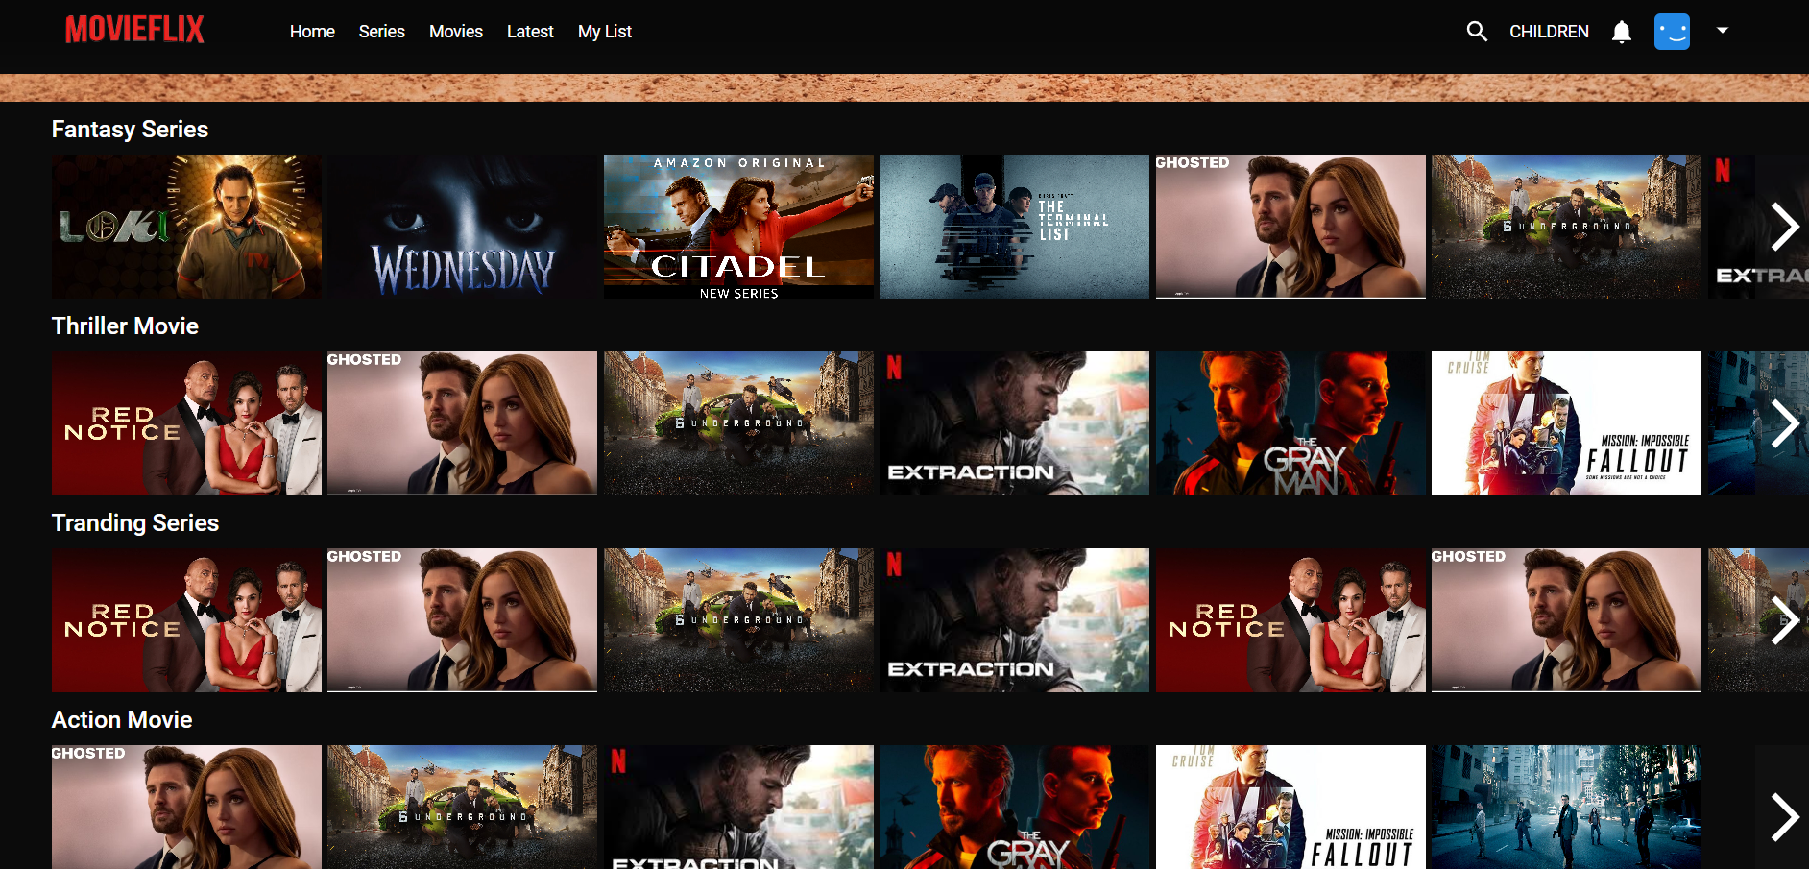

ADMIN PAGE
5.7 ADMIN LOGIN
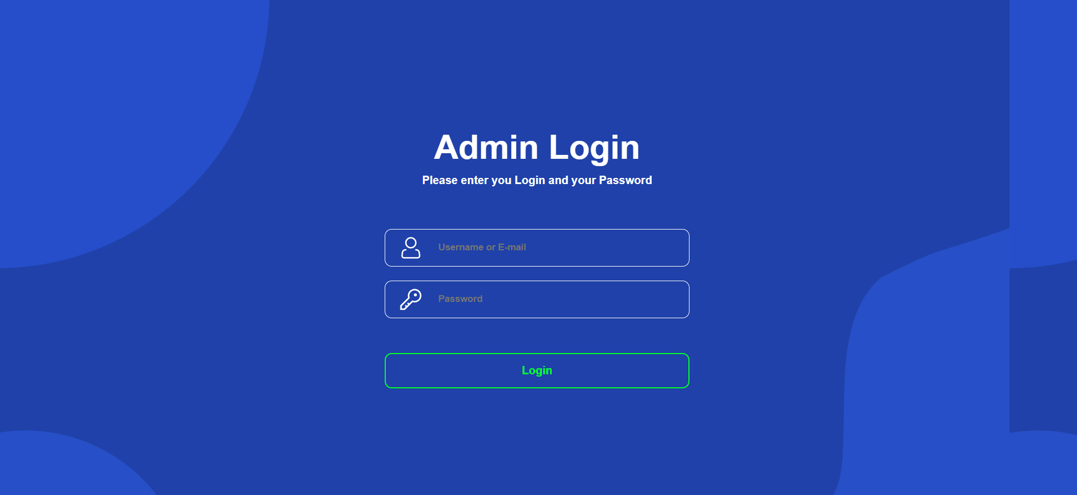
5.8 ADMIN HOME
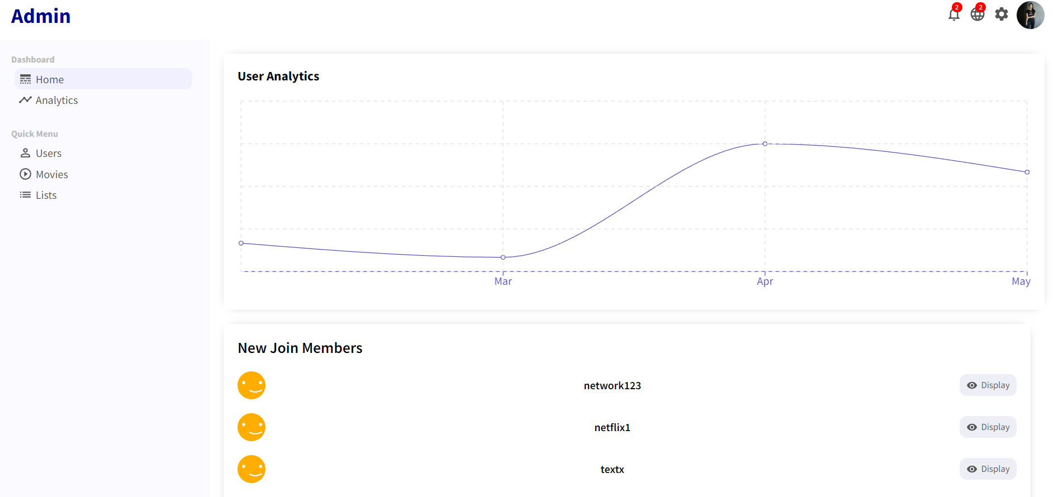

5.9 ANALYTICS PAGE

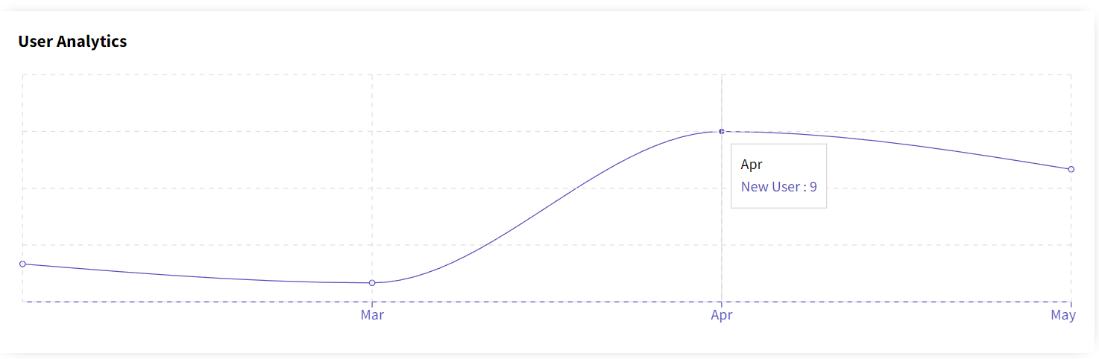

5.10 MOVIES PAGE

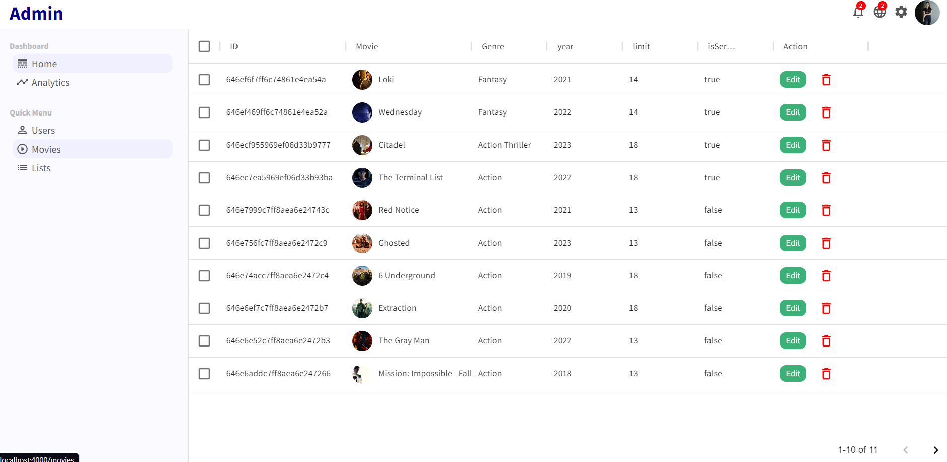

5.11 MOVIES/EDIT
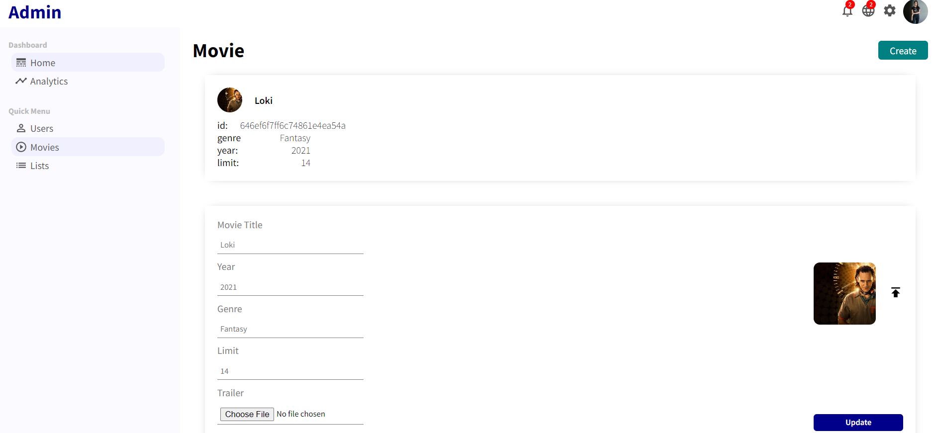

5.12 MOVIES/EDIT/CREATE

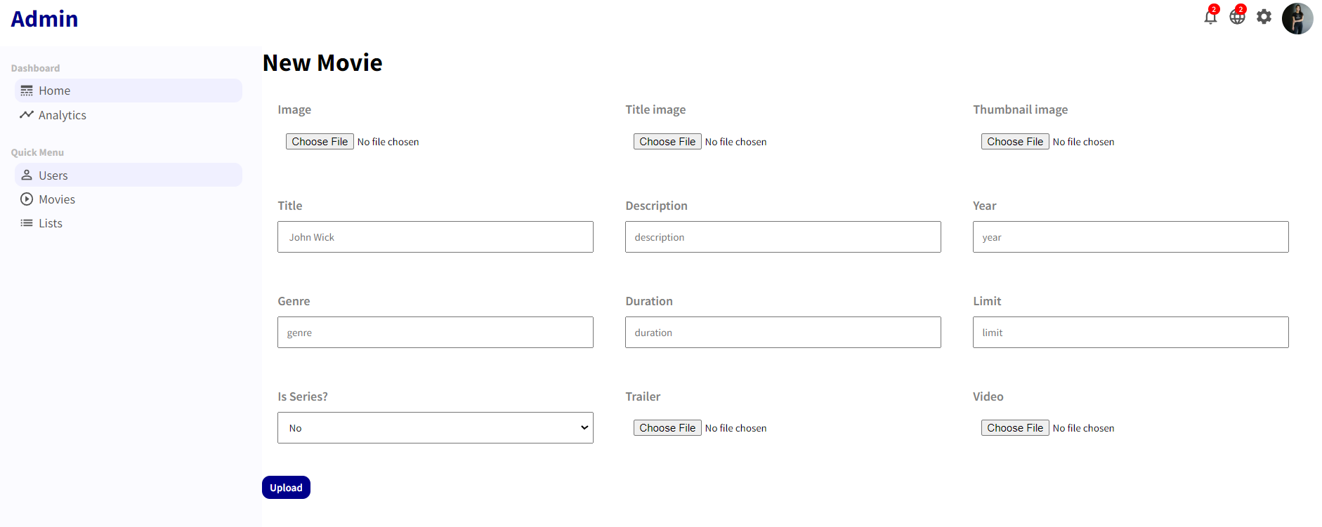

5.13 LISTS PAGE

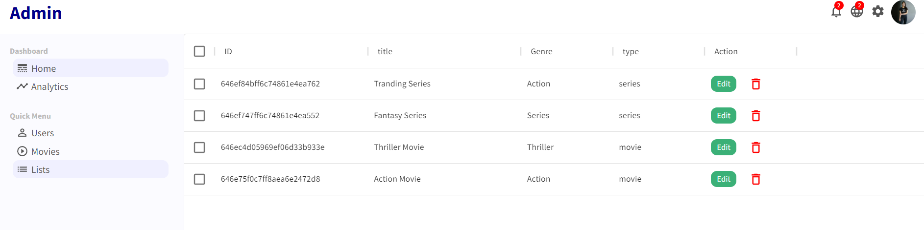

5.14 LISTS/EDIT

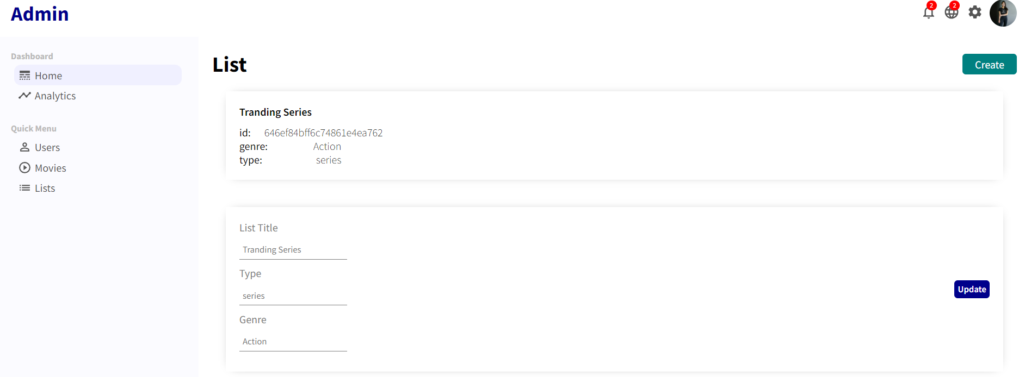

5.15 LISTS/EDIT/CREATE

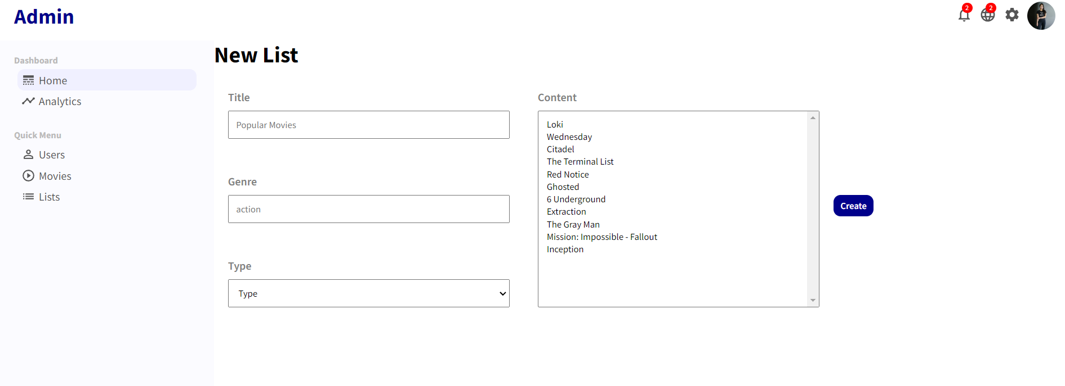

APIS
5.16 REGISTER USER

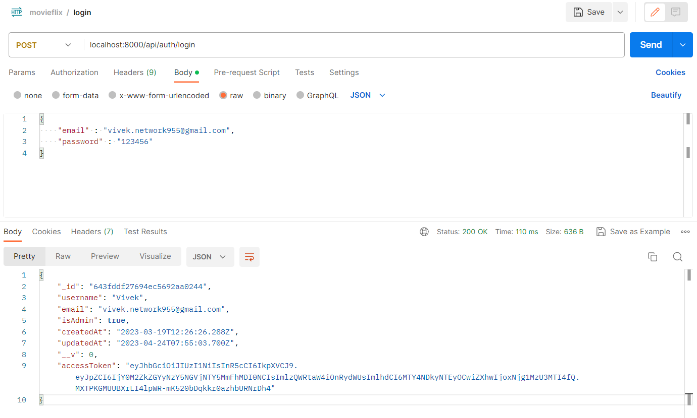
5.17 LOGIN USER

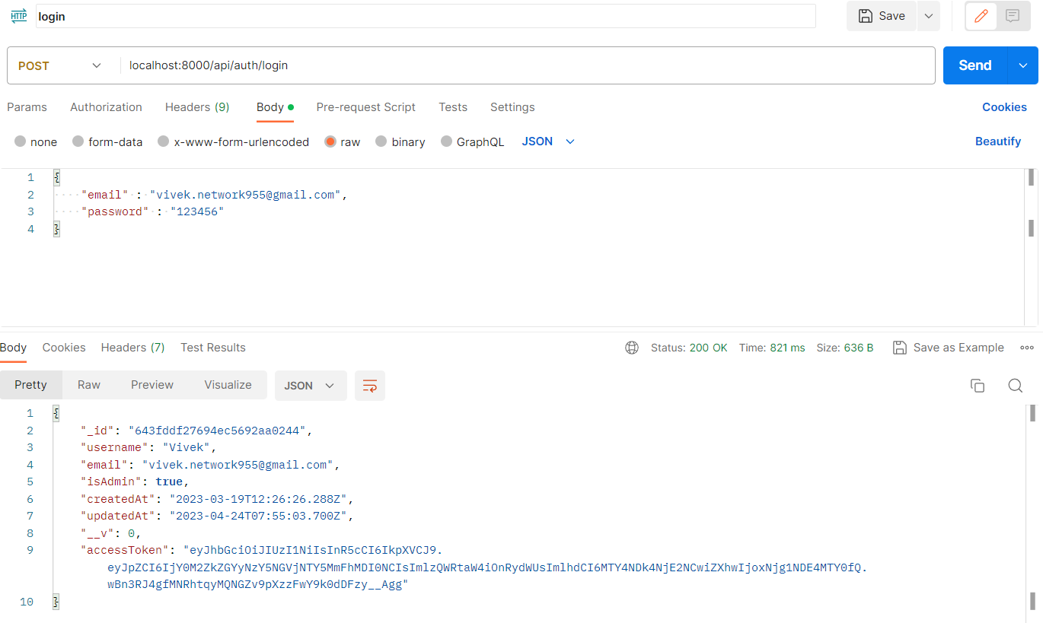
5.18 UPDATE USER

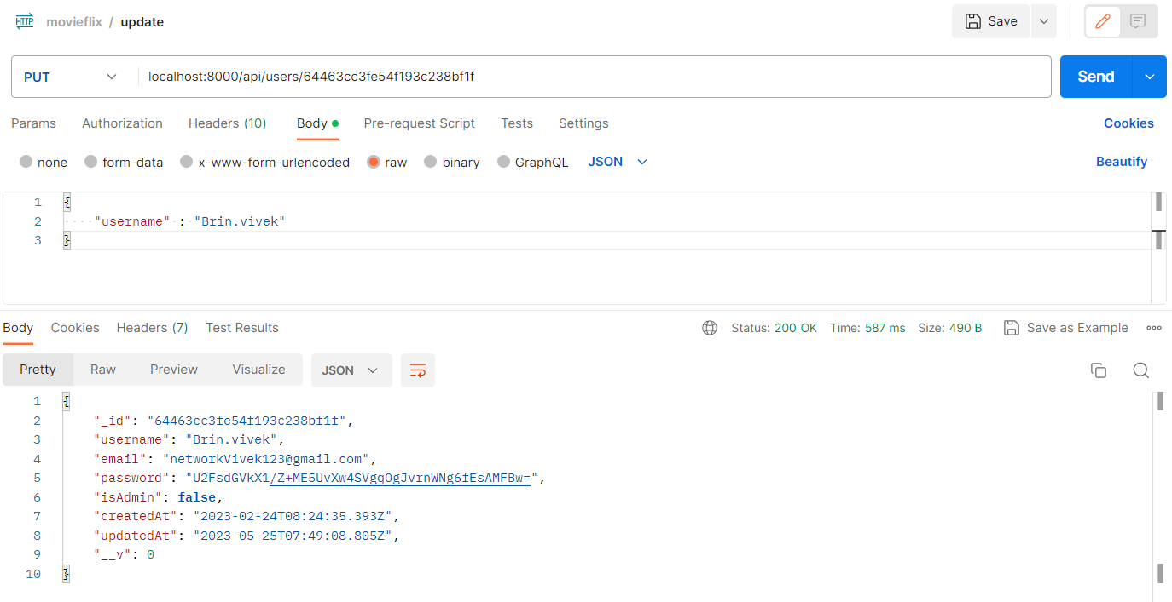
5.19 DELETE USER

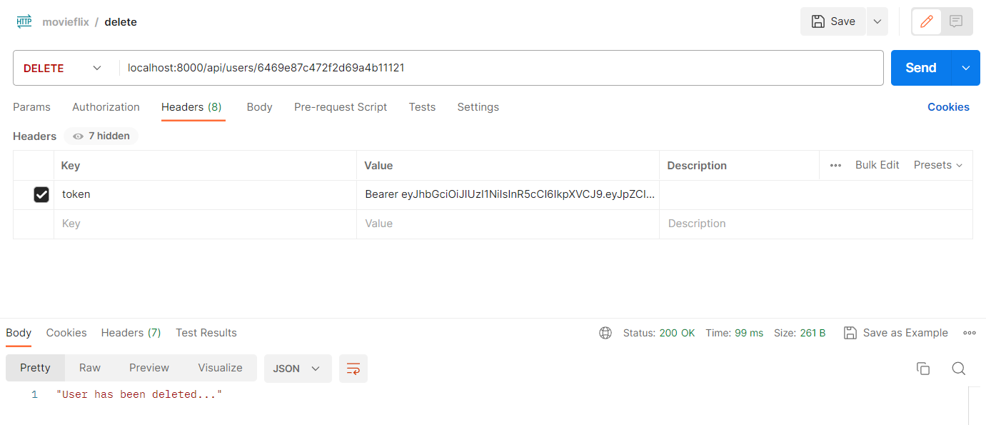

5.20 GET ALL USER

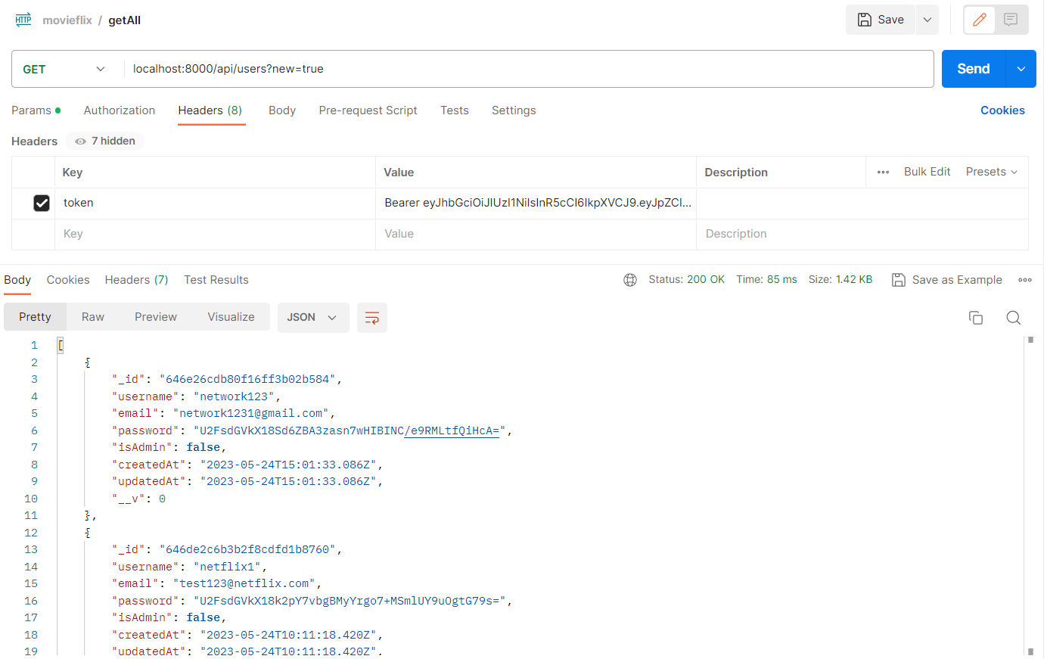
5.21 GET USER

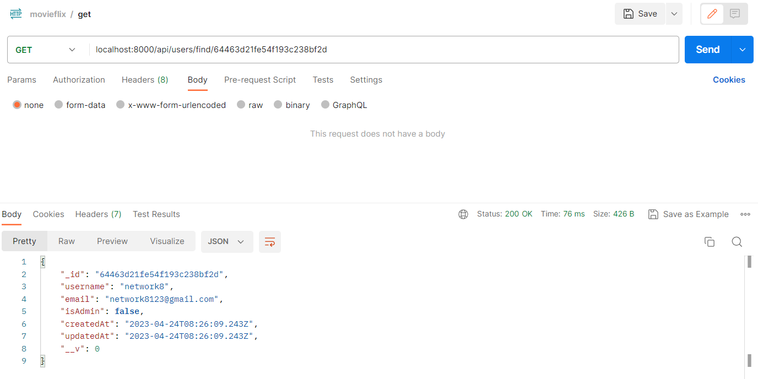

5.22 GET USER STATISTICS

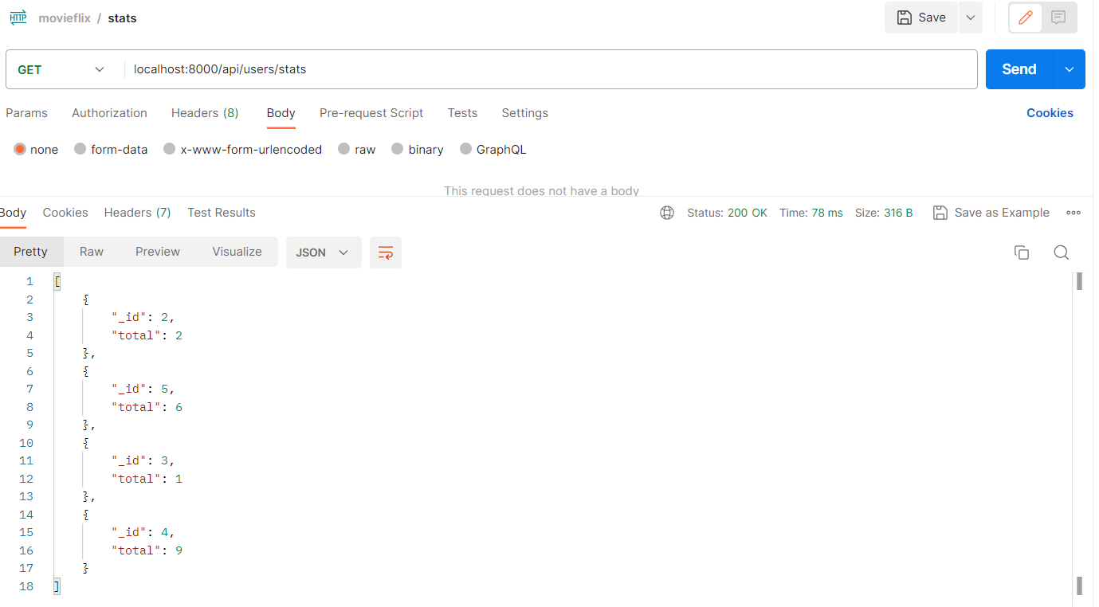
5.23 GET MOVIES

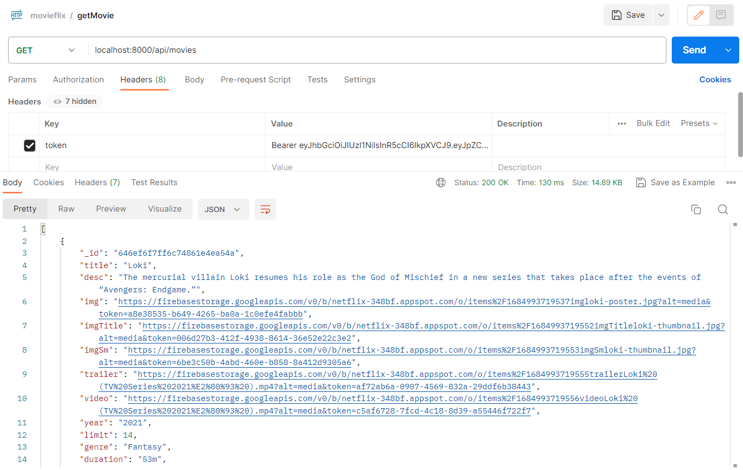

5.24 POST MOVIE

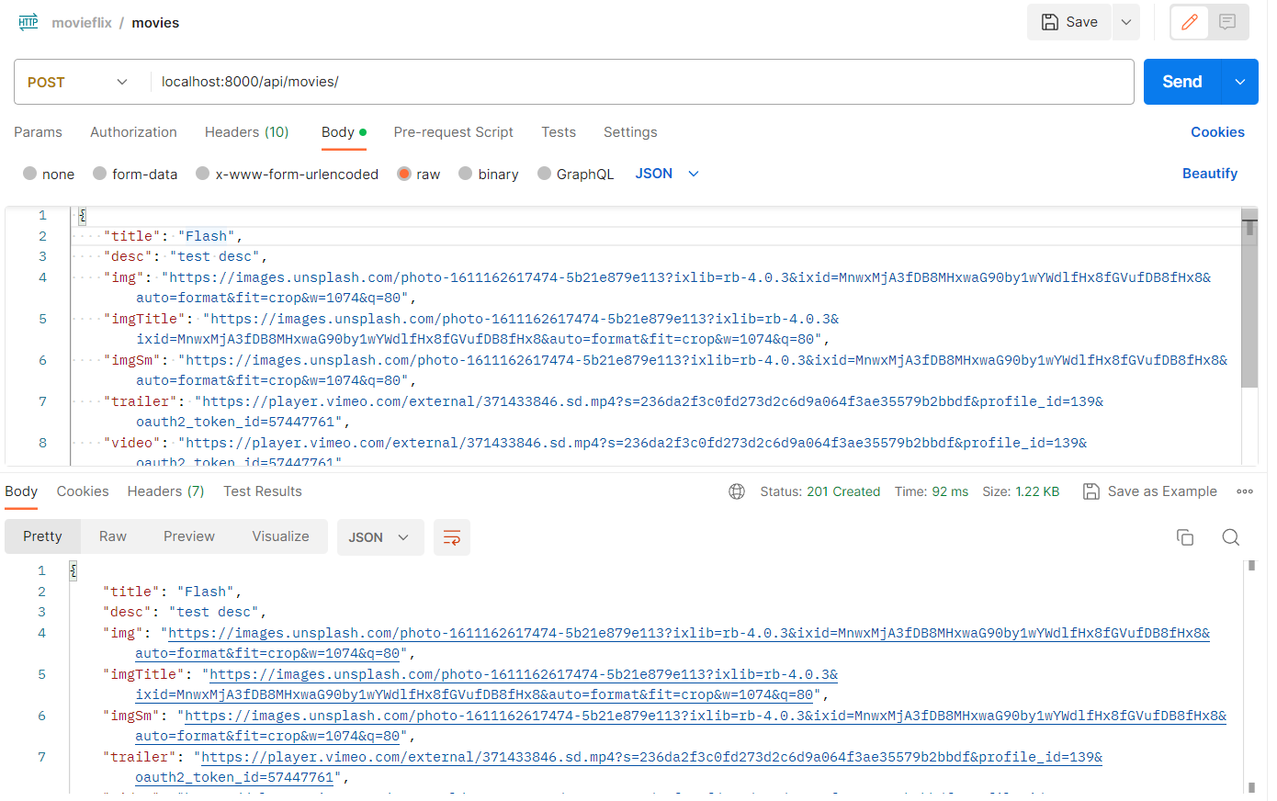
5.25 GET LIST

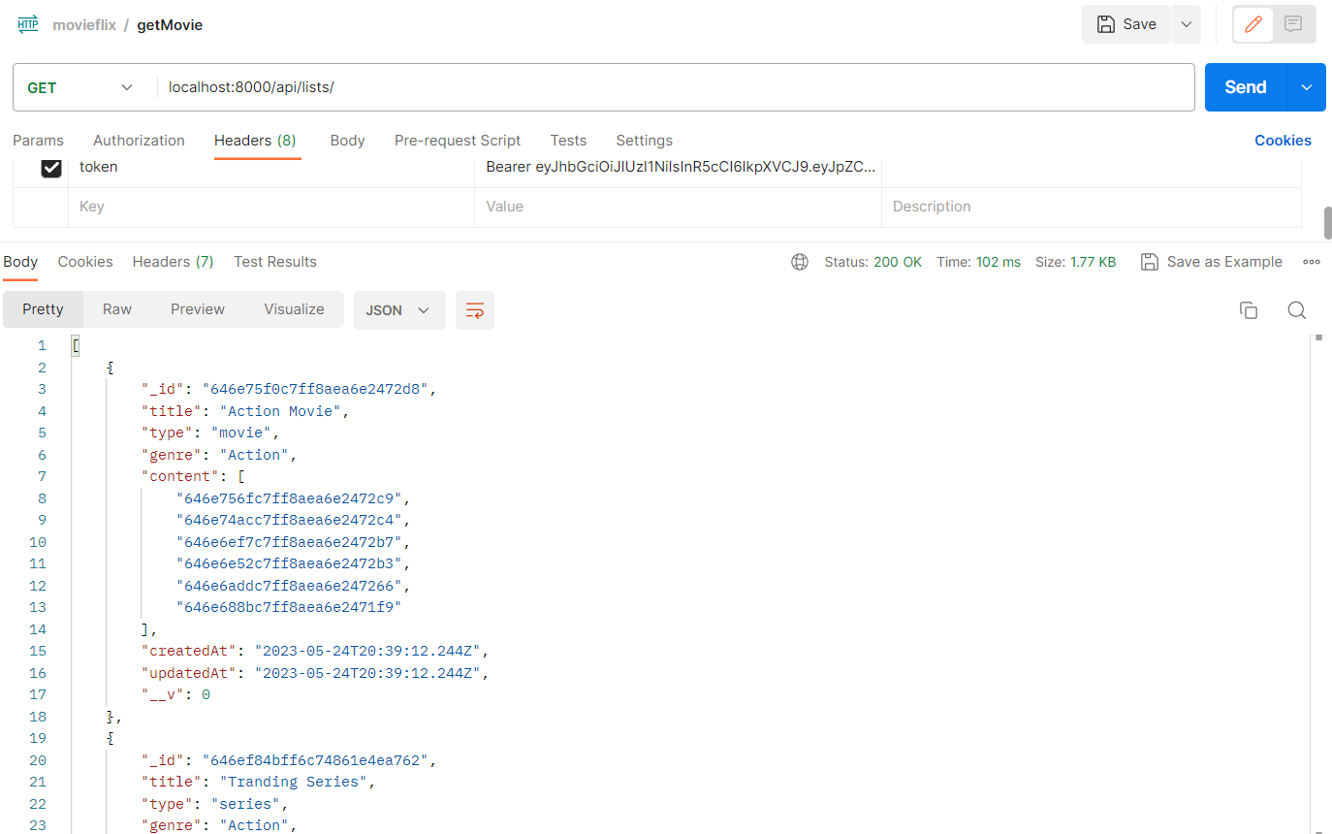

5.26 POST LIST

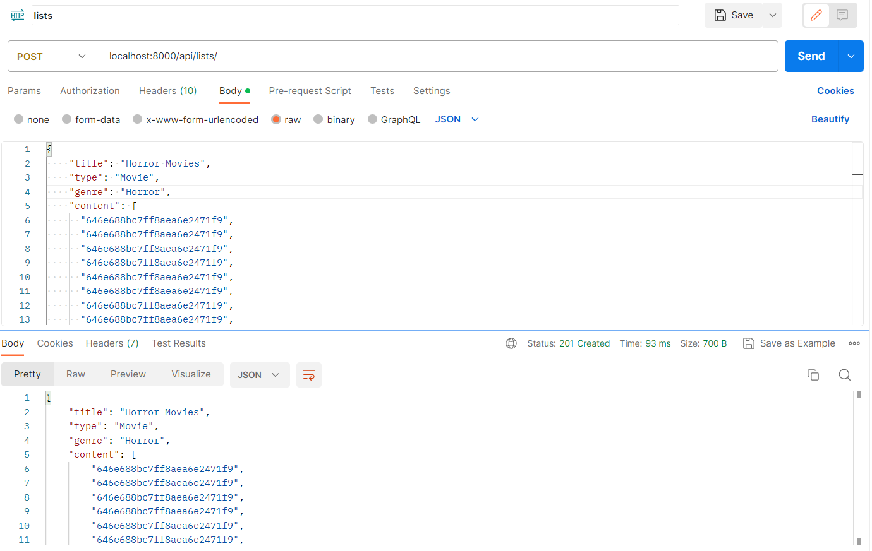

CHAPTER – 6

TESTING

6.1 TESTING METHODOLOGY

Companies rely on software more than ever to provide and manage information with strategic and operational importance and to provide key decision support. Rising customer expectations for fault-free, requirements-exact software have increased awareness of the importance of software testing as a critical activity.
We begin the testing process by developing a comprehensive plan to test the general functionality and specific features on a variety of platform combinations. Strict quality control procedures are used. The process very files that the application meets the requirements specified in the system requirements document and is bug-free. At the end of each testing day, we prepare a summary of completed and failed tests. Applications are not allowed to launch until all identified problems are fixed. A report is prepared at the end of testing to show exactly what was tested and to list the final outcomes.
Our software testing methodology is applied in three distinct phases: unit testing, system testing, and acceptance were testing.
6.2 UNIT TESTING
The programmers conduct unit testing during the development phase. Programmers can test their specific functionality individually or with other units. However, unit testing is designed to test small pieces of functionality rather than the system. This allows the programmers to conduct the first round of testing to eliminate bugs before they reach the testing staff. In unit testing the analyst tests the programs making up a system.
For this reason, unit testing is sometimes called program testing. Unit testing gives stress on the modules independently of one another, to find errors. This helps the tester in detecting errors in coding and logic that are contained within that module alone. The errors resulting from the interaction between modules are initially avoided.
For example, a hotel information system consists of modules to handle reservations; guest checking and checkout; restaurant, room service, and miscellaneous charges; convention activities; and accounts receivable billing. For each, it provides the ability to enter, modify or retrieve data and respond to several types of inquiries or print reports. The test cases needed for unit testing should exercise each condition and option.

Unit testing can be performed from the bottom up, starting with the smallest and lowest-level modules and proceeding one at a time. For each module in bottom-up testing, a short program is used to execute the module and provides the needed data, so that the module is asked to perform the way it will when embedded within the larger system.
6.3 SYSTEM TESTING
The objective of system testing is to ensure that all individual programs are working as expected, that the programs link together to meet the requirements specified and to ensure that the computer system and the associated clerical and other procedures work together.
The initial phase of system testing is the responsibility of the analyst who determines what conditions are to be tested, generates test data, produced a schedule of expected results, runs the tests and compares the computer produced results with the expected results with the expected results.
The analyst may also be involved in procedures testing. When the analyst is satisfied that the system is working properly, he hands it over to the users for testing. The importance of system testing by the user must be stressed. It is the user must verify the system and give permission.
During testing, the system is used experimentally to ensure that the software does not fail, i.e., that it will run according to its specifications and in the way, users expect it to. Special test data is input for processing (test plan) and the results are examined to locate unexpected results.
A limited number of users may also be allowed to use the system so analysts can see whether they try to use it in unexpected ways. It is preferable to find these surprises before the organization implements the system and depends on it. In many organizations, testiness performed by people other than those who write the original programs. Using people who do not know how certain parts were designed or programmed ensures more complete and unbiased testing and more reliable software.
The system is tested as a complete, integrated system. System testing first occurs in the development environment but eventually is conducted in the production environment. Functionality and performance testing are designed to catch bugs in the system, unexpected results, or other ways in which the system does not meet the stated requirements.
The testers create detailed scenarios to test the strength and limits of the system, trying to break it if possible. Editorial reviews not only correct typographical and grammatical errors, but also improve the system’s overall usability by ensuring that on-screen language is clear and helpful to users. Accessibility reviews ensure that the system is accessible to users with disabilities.
System testing consists of the following five steps:
- Program testing
- String testing
- System testing
- System documentation
- User acceptance testing

6.4 PROGRAM TESTING
A program represents the logical elements of a system. For a program to run satisfactorily, it must compile and test data correctly and tie in properly with other programs. It is the responsibility of a programmer to have an error free program. At The time of testing the system, there are two types of errors that should be checked. These errors are syntax and logic.
A syntax error is a program statement that violates one or more rules of the language in which it is written. An improperly defined field dimension or omitted key words are common syntax errors. These errors are shown through error messages generated by the computer. A logic error, on the other hand, deals with incorrect data fields out of range items, and invalid combinations.
Since the logical errors are not detected by compiler, the programmer must examine the output carefully to detect them. When a program is tested, the actual output is compared with the expected output. When there is a discrepancy, the sequence of the instructions must be traced to determine the problem. The process is facilitated by breaking the program down into self-contained portions, each of which can be checked at certain key points.

6.5 STRING TESTING
Programs are invariably related to one another and interact in a total system. Each program is tested to see whether it conforms to related programs in the system. Each part of the system is tested against the entire module with both test and live data before the whole system is ready to be tested.

6.6 SYSTEM TESTING
System testing is designed to uncover weaknesses that were not found in earlier tests. This includes forced system failure and validation of the total system as it will be implemented by its user in the operational environment. Under this testing, generally we
Take low volumes of transactions based on live data. This volume is increased until the maximum level for each transaction type is reached.
The total system is also tested for recovery and fallback after various major failures to ensure that no data is lost during the emergency.
All this is done with the old system still in operation. When we see that the proposed system is successful in the test, the old system is discontinued.

6.7 SYSTEM DOCUMENTATION
All design and test documentation should be well prepared and kept in the library for future reference. The library is the central location for maintenance of the new system.

6.8 USER ACCEPTANCE TESTING
An acceptance test has the objective of selling the user on the validity and reliability of the system. It verifies that the system's procedures operate to system specifications and that the integrity of important data is maintained. Performance of an acceptance test is actually the user's show. User motivation is very important for the successful performance of the system. After that a comprehensive test report is prepared. This report shows the system's tolerance, performance range, error rate and accuracy.

CHAPTER 7

CONCLUSION AND FUTURE ENHANCEMENTS

7.1 LIMITATIONS

While movie recommendation applications can be incredibly useful and efficient in suggesting films to users based on their preferences, they also have some limitations. Here are a few common limitations of movie recommendation applications:

1. Limited data: Movie recommendation applications rely heavily on user data to provide accurate and relevant recommendations. If the application has access to a limited dataset or if the user has not provided enough information or ratings, the recommendations may not be as accurate or diverse.

2. Lack of context: Movie recommendations often focus on individual preferences without considering the social or situational context. For example, a user may enjoy action movies but prefer romantic comedies when watching with their partner. A movie recommendation application may not take such context into account.

3. Narrow focus: Some movie recommendation applications tend to provide recommendations based on similar genres or themes, which can result in a limited range of suggestions. This may lead to a lack of variety and exploration of different movie genres and styles.

4. Limited discovery: While movie recommendation applications aim to suggest films that users are likely to enjoy, they may not prioritize discovering new or lesser-known movies. Users may miss out on hidden gems or films that fall outside their usual preferences.

5. Subjectivity and personal taste: Movie recommendations are subjective by nature, and personal taste can vary greatly among individuals. Recommendations based solely on user preferences or ratings may overlook movies that the user might actually enjoy but has not discovered yet.

7.2 FUTURE ENHANCEMENTS
To address the limitations of movie recommendation applications and enhance their performance in the future, several improvements can be considered:

1. Incorporate contextual information: Movie recommendation systems can be enhanced by considering contextual factors such as the user's current mood, location, social setting, or time of day. This can help provide more personalized and relevant recommendations that align with the user's specific situation.

2. Expand the data sources: Instead of relying solely on user ratings and preferences, movie recommendation applications can incorporate a broader range of data sources. This may include analyzing social media activity, reviews from trusted sources, or leveraging user-generated content such as discussions and comments.

3. Utilize advanced algorithms and machine learning techniques: Applying advanced algorithms, such as deep learning or reinforcement learning, can improve the accuracy and diversity of movie recommendations. These techniques can help capture complex patterns and relationships in user behavior and movie attributes, leading to more precise predictions.

4. Incorporate diversity and serendipity: To encourage exploration and discovery, movie recommendation systems can be designed to provide a mix of recommendations, including both popular and niche films. By incorporating serendipitous suggestions and diversifying the movie choices, users can be exposed to a wider range of cinematic experiences.

5. Real-time updates and dynamic recommendations: Instead of relying on static data, movie recommendation applications can implement real-time updates to account for evolving user preferences and trending movies. By continuously learning from user interactions and adapting recommendations accordingly, the system can provide more up-to-date and engaging suggestions.

7.3 CONCLUSION
In conclusion, while movie recommendation applications have their limitations, there are several potential enhancements that can be implemented to overcome these challenges. By incorporating contextual information, expanding data sources, utilizing advanced algorithms, promoting diversity and serendipity, offering real-time updates, and providing transparency, movie recommendation systems can improve the accuracy, relevance, and user experience. These enhancements can help users discover new movies, cater to their individual preferences, and create a more personalized and engaging movie-watching experience. As technology continues to advance, we can expect movie recommendation applications to become even more sophisticated and effective in providing tailored movie suggestions.

CHAPTER – 8
BIBLIOGRAPHY

8.1 BIBLIOGRAPHY

LIST OF USEFUL WEBSITES
www.msdn.microsoft.com
www.w3schools.com
www.webdevelopersnotes.com

LIST OF USEFUL SOURCES.
Ricci, F., Rokach, L., & Shapira, B. (2015). Introduction to Recommender Systems Handbook. In Recommender Systems Handbook (pp. 1-35). Springer.

Adomavicius, G., & Tuzhilin, A. (2005). Toward the Next Generation of Recommender Systems: A Survey of the State-of-the-Art and Possible Extensions. IEEE Transactions on Knowledge and Data Engineering, 17(6), 734-749.

Herlocker, J. L., Konstan, J. A., Terveen, L. G., & Riedl, J. T. (2004). Evaluating Collaborative Filtering Recommender Systems. ACM Transactions on Information Systems (TOIS), 22(1), 5-53.

Bobadilla, J., Ortega, F., Hernando, A., & Gutiérrez, A. (2013). Recommender Systems Survey. Knowledge-Based Systems, 46, 109-132.

Lam, S. K., Sundaram, H., Schütze, H., & Han, J. (2011). Addressing Cold Start in Recommender Systems: A Semi-supervised Co-training Algorithm. ACM Transactions on Information Systems (TOIS), 29(1), 6.

