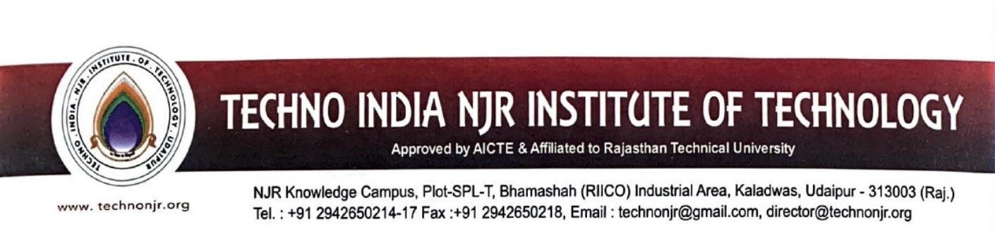

**Date: 30-6-2023**

This is to certify that the following students have attended “**Internship Programme**” in 2022-23 academic sessions.

**List of Student**

|  |  |
| --- | --- |
| **Sr.No.** | **Student Name** |
| 1 | Palash Solanki |
| 2 | Pushkar Dangi |
| 3 | Tanmay Kanthaliya |
| 4 | Pratiksha Sisodiya |
| 5 | Muskaan Ojha |
| 6 | LOKESH BHOI |
| 7 | Lucky Jadia |
| 8 | Dharmendra Choudhary |
| 9 | Nikhil Solanki |
| 10 | Dharmendra Vaishnav |
| 11 | Naresh Meghwal |
| 12 | Mayank Soni |