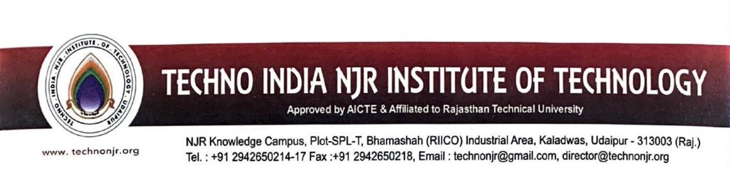

**Date:-18-6-2023**

**To Whomsoever it May Concern**

Techno India NJR Institute of Technology ensures effective Programme curriculum prescribed by Rajasthan Technical University Kota. The detailed syllabus of the courses is available at

**https://iqac.technonjr.org/aqar/2022-23/part-b/1.3.2/**