**A**

***PROJECT REPORT***

*ON*

**COMPANY NETWORK DESIGN AND IMPLEMENTATION**

*Submitted in partial fulfilment of the requirements for the degree of*

**BACHELOR OF TECHNOLOGY**



Session: - Jan-June 2023

Under Guidance of

Mr. Aditya Maheshwari

Asst Professor

CSE Department, TINJR

Submitted by

Shivalika Tak (19etccs064)

Tarannum Parveen (19etccs071)

8th Semester & CS Branch

**DEPARTMENT OF COMPUTER SCIENCE AND ENGINEERING**

**TECHNO INDIA NJR INSTITUTE OF TECHNOLOGY, UDAIPUR-313001**

**MAY – 2023**



Department of Computer Science and Engineering

Techno India NJR Institute of Technology, Udaipur-313001

**Certificate**

This is to certify that project work titled **Company Network Design and Implementation Using Cisco Packet Tracer** by Shivalika Tak and Tarannum Parveen was successfully carried out in the Department of Computer Science and Engineering, TINJRIT and the report is approved for submission in the partial fulfilment of the requirements for award of degree of Bachelor of Technology in Computer Science and Engineering.

Mr. Aaditya Maheshwari Dr. Rimpy Bishnoi

Asst Professor Head of Department

Dept. of CSE TINJRIT, Udaipur Dept. of CSE TINJRIT, Udaipur

Date...................... Date......................



Department of Computer Science and Engineering

Techno India NJR Institute of Technology, Udaipur-313001

**Examiner Certificate**

This is to certify that the following student

**Shivalika Tak and Tarannum Parveen**

of final year B.Tech. (Computer Science and Engineering), was examined for the project work titled

***“*Company *Network Design and Implementation Using Cisco Packet Tracer”***

during the academic year 2022 – 2023 at Techno India NJR Institute of Technology, Udaipur.

**Remarks:**

**Date:**

Signature Signature

(**Internal Examiner**) (**External Examiner**)

Name: - ……………………… Name: - ………………………

Designation: - ……………….. Designation: - ………………..

Department: - ………………. Department: - ……………….

Organization: - ……………… Organization: - ………………

**PREFACE**

Cisco Packet Tracer is Cisco's simulation software. It can be used to create complicated network typologies, as well as to test and simulate abstract networking concepts. The purpose of this project report is to outline the design and implementation of a company network using Cisco Packet Tracer. The network design aims to provide a reliable and secure infrastructure that meets the specific requirements of the organization. This report will cover the network topology, devices used, addressing scheme, and the configuration of essential network services.

In Chapter 1, we give an overview of the computer networking and packet tracer. The chapter concludes with a brief review of the field.

Chapter 2 discusses the devices and technologies used in the project. It is important to understand the technology in order to correctly formulate the problems. In addition, it is important for one to understand, what is doable and what is not! Chapter 2 presents fundamentals of the devices and technologies used in project.

Chapter 3 presents the status of company network, as well as, its design and implementation. We also discuss several other factors such as case study, application requirements and technologies implemented.

DEPARTMENT OF COMPUTER SCIENCE AND ENGINEERING

TECHNO INDIA NJR INSTITUTE OF TECHNOLOGY, UDAIPUR-313001

**ACKNOWLEDGMENT**

We take this opportunity to record our sincere thanks to all who helped us to successfully complete this work. Firstly, we are grateful to our **supervisor Mr. Aaditya Maheshwari Sir** for his invaluable guidance and constant encouragement, support and most importantly for giving us the opportunity to carry out this work.

We would like to express our deepest sense of gratitude and humble regards to our **Head of Department Dr. Rimpy Bishnoi** for giving invariable encouragement in our endeavours and providing necessary facility for the same. Also a sincere thanks to all faculty members of CSE, TINJRIT for their help in the project directly or indirectly.

Finally, we would like to thank my friends for their support and discussions that have proved very valuable for us. We are indebted to our parents for providing constant support, love and encouragement. We thank them for the sacrifices they made so that we could grow up in a learning environment. They have always stood by us in everything we have done, providing constant support, encouragement and love.

**Shivalika Tak (19etccs064)**

**Tarannum Parveen (19etccs071)**

DEPARTMENT OF COMPUTER SCIENCE AND ENGINEERING

TECHNO INDIA NJR INSTITUTE OF TECHNOLOGY, UDAIPUR-313001

**CONTENTS**

|  |  |  |
| --- | --- | --- |
| **Abstract** | ……………………………………………………………. | 4-5 |
| **Contents** | ……………………………………………………………. | 6 |
| **List of Symbols** …………………………………………………........... | | 7 |
| **List of Figures**......................…………………………………………. | | 8 |
| **Chapter 1** | Introduction…………………………………………........ | 9 |
|  | * 1. Computer Network …………………………………. | 9 |
|  | 1.2 Packet Tracer ………………………………………. | 10 |
| **Chapter 2** | Devices and Technologies ……………………………. | 12 |
|  | * 1. Devices ………….................................................... | 12 |
|  | * 1. Technologies………………………………………… | 13 |
| **Chapter 3** | Design and Configuration ……………………………… | 14 |
|  | * 1. Case Study …………………………………………. | 14 |
|  | 3.2 Application Requirements ………………………… | 14 |
|  | 3.3 Technologies Implemented ………………………… | 15 |
|  | 3.4 Network Topology………………………….............. | 16 |
|  | 3.5 IP Addressing....................………………................ | 17 |

3.6Conclusion.............................................................. 18

**LIST OF SYMBOLS**

|  |  |
| --- | --- |
| router.PNG | Router used to for internet service provider |
| multi switch.PNG | Multilayer switch (3650-24PS) |
| switch.PNG | Switch (2960-24TT) |
| pc.PNG | Desktop / computer |
| printer.PNG | Printer |
| laptop.PNG | Laptop |
| tablet.PNG | Tablet |
| server.PNG | Server |
| accessPT.PNG | Access Point |
|  |  |
|  |  |
|  |  |
|  |  |
|  |  |
|  |  |

**LIST OF FIGURES**

|  |  |  |
| --- | --- | --- |
| Fig 1-1 | Computer network………………………………………....... | 9 |
| Fig 1-2 | Packet tracer ..............…………………………………….. | 10 |
| Fig 3-1 | DHCP Configuration.............…………………………….. | 16 |
| Fig 3-2 | Network topology ………………………………………… | 17 |
| Fig 3-3 | IP Addressing for 1st and 2nd floors…………………….. | 17 |
| Fig 3-4 | IP Addressing for 3rd floor ……………………….......... | 18 |
|  |  |  |
|  |  |  |
|  |  |  |
|  |  |  |
|  |  |  |

**INTRODUCTION (CH 1)**

* 1. **Computer Network**

A computer network is a group of computer systems and other hardware computing devices connected through communication channels to enable communication between a wide range of users to share resources. The implementation of a corporate network scenario is completely network based. IT is a secure network that is mostly used in major organizations and other entities to ensure secure connectivity and exchange of their data, information, and the building blocks of computer networks are specialized equipment such as hosts, routers, switches, and access points. A network is created when two or more of these devices are connected to exchange resources via a common convention known as protocols.

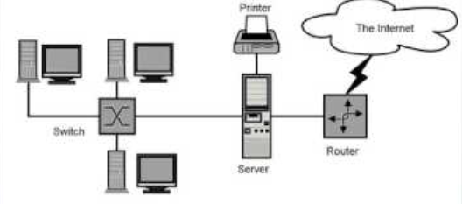

*Figure 1-1 computer network design*

Local Area Network or LAN (Local Area Network) is a type of network that serves a local area and supplies networking capability to a group of computers near each other. A local area network can support as little as two or three users in the home office or several hundred users in the central office of a company. Homeowners and IT managers set up LANs such that network nodes can share services such as printers or network storage.

Many considerations must be considered to design and construct a well-secured network, such as the topology and location of hosts within the network, the choice of hardware and software technologies, and the careful configuration of each component. To ensure the design is done properly, all requirements necessary for the design are first defined before proceeding to the implementation.

Designing and implement a computer network is a time-consuming, complex and intricate task, in which, many divisions of an organization are involved. Usually, factors like physical location to the analysis of user website access are taken into consideration during the design and implementation phase.

The group, as fresh graduates and new employees of NSP Ltd. Company, are required to advise on the Local Area Network requirements of a medium sized company, namely, MSS Ltd. The group is required to cover a network implementation design for MSS LTD, a three-floor medium sized company whose plan involves a LAN network design that would be able to endure any future upgrades. The company consists

of 3 departments: Marketing, sales and general support equipped with workstations. All workstations will have access to the internet, intranet, and the email. The network will consist of dedicated servers and also provide database and data sharing services.

**1.2 Packet Tracer**

Packet Tracer is a cross-platform visual simulation tool designed by Cisco Systems that allows users to create network topologies and imitate modern computer networks. The software allows users to simulate the configuration of Cisco routers and switches using a simulated command line interface. As the name say, this software is built by Cisco and can be used to practice networking related labs virtually. Packet tracer is an excellent tool for having hands-on experience on devices like Cisco Routers, Switches, HUB, and end devices like PC, Laptop, Server, and many more.

Cisco Packet Tracer is available free of charge to all Cisco Networking Academy instructors, students, and alumni. Packet Tracer can be used in training courses and education, or for modelling various scenarios.



*Figure 1-2 Packet tracer*

There are two types of workspaces / modes present in packet tracer:

1. physical mode
2. logical mode

Many of the Packet Tracer activities you encounter in Cisco Networking Academy courses will use Logical mode. A physical network diagram indicates the connection of devices through cables or wireless connections. On the other hand, a logical network diagram indicates data and signal transmission across a network. The purpose of the Physical Workspace is to give a physical dimension to your logical network topology. It gives you a sense of scale and placement (how your network might look in a real environment). Logic models are effective tools to assist in program planning, implementation, management, evaluation, and reporting. They help define a program's intended impact and goals; the sequence of intended effects; which activities are to produce which effect; and where to focus outcome and process evaluations.

**DEVICES AND TECHNOLOGIES (CH-2)**

This chapter gives an overview of the devices and configurations selected for the proposed design.

**2.1 Devices**

According to McQuerry (2008), the devices that transmit and/or receive data through a network segment are network devices. There are various devices used in the implementation of network design in accordance to the requirements.

**2.1.1 Switch**

A switch is used to connect several nodes of a network within multiple segments (Hucaby, 2014). This device works on the 2nd Layer of the OSI Model. Also, this device transmits data to the recipients except for broadcast traffic to devices with unknown ports. This device eliminates the remaining segments of a network from unintended procession of data and is imperative to network security and performance

**2.1.2 Router**

Lucas (2009) stated that routers are interconnection network devices that send and receive packets between networks. This type of network device is based on Layer 3 IP addresses and selects the best path for data transmission in a network. This device, while on the 3rd Layer of the OSI Model, makes network address-based decisions.

**2.1.3 Firewall**

According to Sheth & Thakker (2011), a firewall, is considered as a single device, which imposes the access control policy amongst networks. Firewall, usually a standalone device, is an application software based or network embedded device.

**2.1.4 IP Phone**

IP Telephone, very broadly speaking, is a telephone built to operate with an IP PBX. However, the prevalence of the SIP standard means that the IP PBX of today has invariably develop into a SIP-based PBX. This is excellent news for companies and end-users because it ensures the PBX providers cannot push you to lock in with their proprietary applications or hardware.

**2.1.5 Servers and Hosts**

The host is a node that interacts in a user program, either as a server, a client, or both. The server is a type of host that provides services to other hosts. Usually, a server allows connections from clients who request a service feature .

**2.2 Technologies**

This is known as entities for both material and irrelevant, created by the application of mental and physical effort to obtain some value. In this use, technology applies to instruments and devices that can be used to solve world problems.

**2.2.1 Access Control Lists**

The Access Control List is a policy used in filtering routing protocols, permit or deny traffic flows, and to redirect traffic based on the set policy. Also, this policy or rules is processed from top-to-down until it hits the first match. The access list is then processed only when a condition is met.

**2.2.2 VLAN**

Virtual Local Area Network (VLAN) is a standard of logically segmenting devices on a network that are physically dispersed. This standard allows network design to be flexible. Similarly, VLANs broadcast domain borders on the 2nd layer of the OSI Model. These broadcast Domains are device groups that receive broadcast frames created by devices in the group.

**2.2.3 STP**

The Spanning Tree Protocol (STP) prevents uninvited loops while creating a redundancy path in a network. Multiple active paths in a network are the major cause of loops. These allow duplication of messages while appearing on both ends of a switch. Similarly, this disrupts the forwarding algorithm on a switch and duplicate messages are sent. This protocol allows a LAN with redundancy to manage the loop period of Ethernet frames.

**2.3 Cost Assessment**

It must be considered the cost of physical network design and looking for best alternative design that can meet the budget. Hence, we should analyze the cost of circuit, internetworking devices, hardware, software, network management, test, and maintenance. These could be by two steps: request for proposal and selling the proposal to management

**DESIGN AND CONFIGURATION (CH 3)**

**3.1 Case Study**

A trading floor Support center employs 600 staff. They have recently expanded and as a result, need to move to a new building. A building has been identified but has no network. This means that before they can make to move out, new network service needs to be designed and implemented in the new building. Existing Network comprises of the following elements: The new building is expected to have three floors with two departments in each for example;

1. **First floor-** (Sales and Marketing Department-120 users expected, Human Resource and Logistics Department-120 users expected).
2. **Second floor-** (Finance and Accounts Department-120 users expected, Administrator and Public Relations Department-120 users expected).
3. **Third floor-** (ICT-120 users expected, Server Room-12 devices expected).

**3.2 Application requirements**

* Use Cisco Packet Tracer to design and implement the network solution.
* Use hieratical model providing redundancy at every layer i.e. two routers and two multilayer switches are expected to be used to provide redundancy.
* The network is also expected to connect to at least two ISPs to provide redundancy and each router to the connected to the two ISPs.
* Each department is required to have a wireless network for the users.
* Each department should be in a different VLAN and in different sub network.
* Provided a base network of 172.16.1.0, carry out subnetting to allocate the correct number of IP addresses to each department.
* The company network is connected to the static, public IP addresses (Internet Protocol) 195.136.17.0/30, 195.136.17.4/30, 195.136.17.8/30 and 195.136.17.12/30 connected to the two Internet providers.
* Configure basic device settings such as hostnames, console password, enable password, banner messages, and disable IP domain lookup.
* Devices in all the departments are required to communicate with each other with the respective multilayer switch configured for inter-VLAN routing.
* The Multilayer switches are expected to carry out both routing and switching functionalities thus will be assigned IP addresses.
* All devices in the network are expected to obtain an IP address dynamically from the dedicated DHCP servers located at the server room.
* Devices in the server room are to be allocated IP address statically.
* Use OSPF as the routing protocol to advertise routes both on the routers and multilayer switches.
* Configure SSH in all the routers and layer three switches for remote login.
* Configure port-security for the Finance and Accounts department to allow only one device to connect to a switch port, use sticky method to obtain Mac-address and violation mode shutdown.
* Configure PAT to use the respective outbound router interface IPv4 address, implement the necessary ACL rule.
* Test Communication; ensure everything configured is working as expected.

**3.3 Technologies Implemented**

1. Creating a network topology using Cisco Packet Tracer.
2. Hierarchical Network Design.
3. Connecting Networking devices with correct cabling.
4. Configuring Basic device settings.
5. Creating VLANs and assigning ports VLAN numbers.
6. Subnetting and IP Addressing.
7. Configuring Inter-VLAN Routing on the Multilayer switches (Switch Virtual Interface).
8. Configuring Dedicated DHCP Server device to provide dynamic IP allocation.

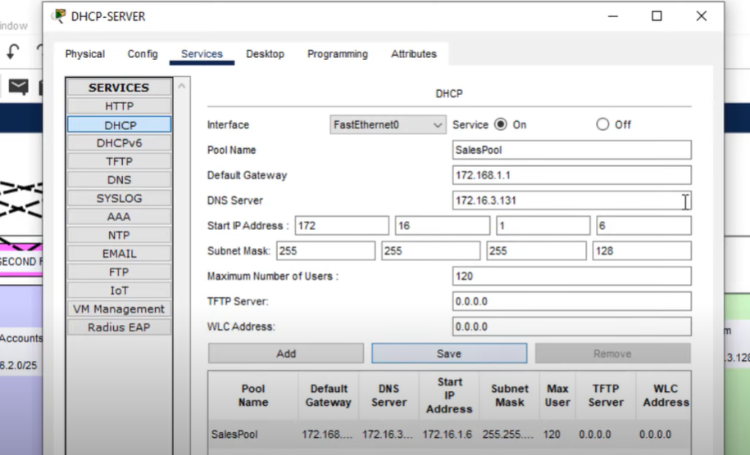

*Figure 3-1 DHCP configuration*

1. Configuring SSH for secure Remote access.
2. Configuring OSPF as the routing protocol.
3. Configuring NAT Overload (Port Address Translation PAT).
4. Configuring standard and extended Access Control Lists ACL.
5. Configuring switch port security or Port-Security on the switches.
6. Configuring WLAN or wireless network (Cisco Access Point).
7. Host Device Configurations.
8. Configuring ISP routers.
9. Test and Verifying Network Communication.

**3.4 Network Topology**

The network topology chosen for this project is a hierarchical design consisting of core, distribution, and access layers. This design provides scalability, redundancy, and better network management. The topology includes the following components:

a. Core Layer: The core layer connects the distribution layers and handles high-speed traffic routing. It consists of high-performance switches or routers to ensure fast and efficient communication between different parts of the network.

b. Distribution Layer: The distribution layer aggregates traffic from multiple access layer switches and performs routing and policy enforcement. It provides connectivity between the core and access layers while ensuring load balancing and fault tolerance.

c. Access Layer: The access layer connects end devices such as computers, printers, and IP phones to the network. It includes access switches that provide local connectivity and power support for devices requiring power.

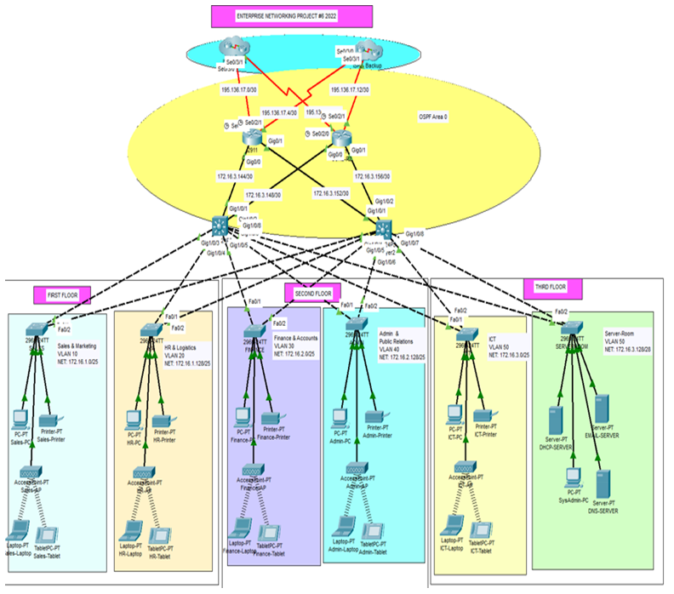

*Figure 3-2 final logical design*

* 1. **IP Addressing Scheme**

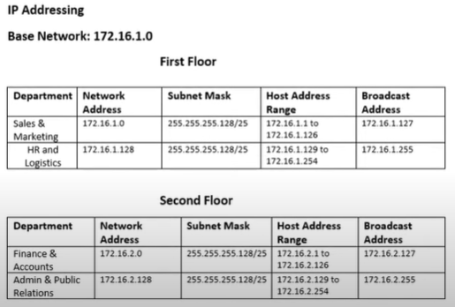

*Figure 3-3 IP Addressing for 1st and 2nd floors*

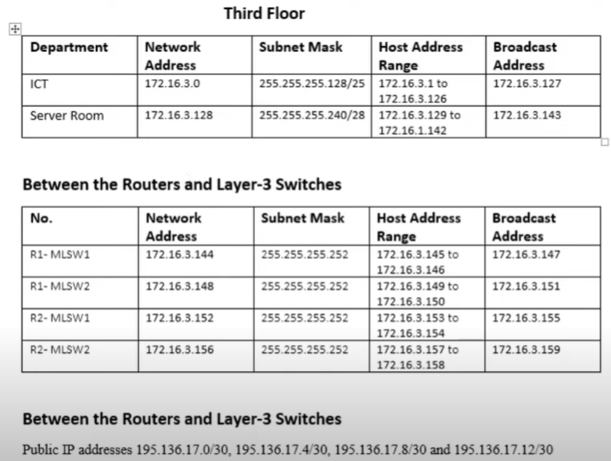

*Figure 3-4 IP Addressing for 3rd floor*

* 1. **Conclusion**

The project began with a thorough assessment of the company’s networking need, including the considerations for scalability, security and performance. During the implementation phase, we carefully configured and integrated various network components, including routers, switches, and access points. We established a well-structured network architecture that supports seamless communication, robust data transfer and secure collaboration across different departments of the company. Using the Cisco packet tracer provided the ability to troubleshoot and test network configuration before deployment. In conclusion the company network design and implementation project using Cisco packet tracer has successfully upgraded the network infrastructure, providing enhanced performance security and scalability. The hierarchical topology, along with the appropriate devices, addressing scheme and network services, ensures efficient and secure communications. Cisco packet tracer proves to be a valuable tool for network design, simulation and testing, allowing a well-planned and reliable network deployment.