**A**

***PROJECT REPORT***

*on*

**“FLIGHT BOOKING MANAGEMENT SYSTEM USING SAP”**

*Submitted in partial fulfilment of the requirements for the degree of*

**BACHELOR OF TECHNOLOGY**



Session: - Jan-June 2023

Submitted by

Divyata Sanadhya (19ETCCS019)

Kritika Kumawat (19ETCCS032)

Mugdha Kumawat (19ETCCS039)

Pranjal Kathait (19ETCCS050)

VIII semester, CSE

Under Guidance of

Aaditya Maheshwari

Head of Industry Project

CSE & Techno India NJR Institute of Technology

**DEPARTMENT OF COMPUTER SCIENCE AND ENGINEERING**

**TECHNO INDIA NJR INSTITUTE OF TECHNOLOGY, UDAIPUR-313001**

**MAY – 2023**

**A**

***PROJECT REPORT***

*on*

**“FLIGHT BOOKING MANAGEMENT SYSTEM USING SAP”**

*Submitted in partial fulfilment of the requirements for the degree of*

**BACHELOR OF TECHNOLOGY**



**Session: - Jan-June 2023**

Under Guidance of

Nooruddin Bohra

ABAP Developer & Consultant

Assistant Manager at Diligent Global

Submitted by

Divyata Sanadhya(19ETCCS019)

Kritika Kumawat(19ETCCS032)

Mugdha Kumawat(19ETCCS039)

Pranjal Kathait(19ETCCS050)

VIII semester, CSE

**DEPARTMENT OF COMPUTER SCIENCE AND ENGINEERING**

**TECHNO INDIA NJR INSTITUTE OF TECHNOLOGY, UDAIPUR-313001**

**MAY – 2023**



Department of Computer Science and Engineering

Techno India NJR Institute of Technology, Udaipur-313001

**Certificate**

This is to certify that project work titled “FLIGHT BOOKING MANAGEMENT SYSTEM USING SAP” by **Divyata Sanadhya** successfully carried out in the Department of Computer Science and Engineering, TINJRIT and the report is approved for submission in the partial fulfillment of the requirements for award of degree of Bachelor of Technology in Computer Science and Engineering.

Aaditya Maheshwari Dr. Rimpy Bishnoi

Head of Industry Project Head of Department

CSE, Techno India NJR Institute of Technology Dept. of CSE TINJRIT, Udaipur

Date...................... Date......................



Department of Computer Science and Engineering

Techno India NJR Institute of Technology, Udaipur-313001

**Certificate**

This is to certify that project work titled “FLIGHT BOOKING MANAGEMENT SYSTEM USING SAP” by **Kritika Kumawat** successfully carried out in the Department of Computer Science and Engineering, TINJRIT and the report is approved for submission in the partial fulfillment of the requirements for award of degree of Bachelor of Technology in Computer Science and Engineering.

Aaditya Maheshwari Dr. Rimpy Bishnoi

Head of Industry Project Head of Department

CSE, Techno India NJR Institute of Technology Dept. of CSE TINJRIT, Udaipur

Date...................... Date......................



Department of Computer Science and Engineering

Techno India NJR Institute of Technology, Udaipur-313001

**Certificate**

This is to certify that project work titled “FLIGHT BOOKING MANAGEMENT SYSTEM USING SAP” by **Mugdha Kumawat** successfully carried out in the Department of Computer Science and Engineering, TINJRIT and the report is approved for submission in the partial fulfillment of the requirements for award of degree of Bachelor of Technology in Computer Science and Engineering.

Aaditya Maheshwari Dr. Rimpy Bishnoi

Head of Industry Project Head of Department

CSE, Techno India NJR Institute of Technology Dept. of CSE TINJRIT, Udaipur

Date...................... Date......................



Department of Computer Science and Engineering

Techno India NJR Institute of Technology, Udaipur-313001

**Certificate**

This is to certify that project work titled “FLIGHT BOOKING MANAGEMENT SYSTEM USING SAP” by **Pranjal Kathait** successfully carried out in the Department of Computer Science and Engineering, TINJRIT and the report is approved for submission in the partial fulfillment of the requirements for award of degree of Bachelor of Technology in Computer Science and Engineering.

Aaditya Maheshwari Dr. Rimpy Bishnoi

Head of Industry Project Head of Department

CSE, Techno India NJR Institute of Technology Dept. of CSE TINJRIT, Udaipur

Date...................... Date......................



Department of Computer Science and Engineering

Techno India NJR Institute of Technology, Udaipur-313001

**Examiner Certificate**

This is to certify that the following student

**Divyata Sanadhya, Kritika Kumawat, Mugdha Kumawat, Pranjal Kathait**

of final year B.Tech. (Computer Science and Engineering), was examined for the project work titled

***“Flight Booking Management System Using SAP”***

during the academic year 2022 – 2023 at Techno India NJR Institute of Technology, Udaipur

**Remarks:**

**Date:**

Signature Signature

(**Internal Examiner**) (**External Examiner**)

Name :- ……………………… Name :- ………………………

Designation:- ……………….. Designation:- ………………..

Department: - ………………. Department: - ……………….

Organization:- ……………… Organization:- ………………

**Preface**

Flight Booking Management system is web-based system that helps in consolidating flight data-flight schedules, seat availability, flight fares and reservations from all airlines with the help of global distribution systems and provides real-time inventory and rates for customers and travel agents to book flight tickets online. We have created this project using **SAP** and added several details in order to generate booking id and create a successful flight booking.

Also we have used Business Application Programming Interface (BAPI) i.e. *'BAPI_FLBOOKING_CREATEFROMDATA'*.

The system allows the airline passengers to search for flights that are available between the two travel cities, namely the “Departure City” and “Arrival City” for a particular departure date. The system gives the list of available flights with certain flight details and allows customer to choose a particular flight suiting his comforts. If the seats are available in a particular flight, then the system allows the passenger to book a seat of his/her choice. Otherwise it asks the user to choose another flight. He can also cancel the current reservations without any problem.

In our project we have added multiple screens for user’s ease. We have also added several validations in our project, in order to check that the information added is correct.

Our project is quite user-friendly in which the user can book a flight with just one click. We have created this considering all the aspects and all the required details to it.

SAP's flight and booking data model exists in every ABAP system.

DEPARTMENT OF COMPUTER SCIENCE AND ENGINEERING

TECHNO INDIA NJR INSTITUTE OF TECHNOLOGY, UDAIPUR-313001

**ACKNOWLEDGMENT**

We take this opportunity to record our sincere thanks to all who helped us to successfully complete this work. Firstly, We are grateful to our **supervisor Nooruddin Bohra** for his invaluable guidance and constant encouragement, support and most importantly for giving us the opportunity to carry out this work.

We would like to express our deepest sense of gratitude and humble regards to our

**Head of Department Dr. Rimpy Bishnoi** for giving invariable encouragement in our endeavours and providing necessary facility for the same. Also a sincere thanks to all faculty members of CSE, TINJRIT for their help in the project directly or indirectly.

Finally, We would like to thank my friends for their support and discussions that have proved very valuable for us. We are indebted to our parents for providing constant support, love and encouragement. We thank them for the sacrifices they made so that we could grow up in a learning environment. They have always stood by us in everything we have done, providing constant support, encouragement and love

**Divyata Sanadhya (19ETCCS019)**

**Kritika Kumawat (19ETCCS032)**

**Mugdha Kumawat (19ETCCS039)**

**Pranjal Kathait (19ETCCS050)**

DEPARTMENT OF COMPUTER SCIENCE AND ENGINEERING

TECHNO INDIA NJR INSTITUTE OF TECHNOLOGY, UDAIPUR-313001

**CONTENTS**

|  |  |  |
| --- | --- | --- |
| **Abstract** | …………………………………….………………………… | i |
| **Contents** | ………………………………………………………………. | ii – iii |
| **List of Figures** …………………………………………………….............. | | iv – v |
| **List of Abbreviations**……………………………………………………… | | vii – viii |
| **Chapter 1** | INTRODUCTION…………………………………………... | 1 |
|  | * 1. SAP………….………………………………………..…. | 2 |
|  | 1.2 ABAP ………………………………..…………………. | 4 |
|  | 1.3 SAP LOGON(HANA) …………………………………. | 6 |
|  | 1.4 ERP ………………………..………………………….... | 8 |
| **Chapter 2** | Process of Flight Booking………………………………….. | 9 |
|  | * 1. 3-Tier Client-Server Architecture………….…………... | 10 |
|  | * 1. Runtime Environment………...………………………… | 11 |
|  | * 1. INCLUDE Program……..……………………………… | 13 |
|  | * 1. Transaction Code………………………………………. | 14 |
|  | 2.4.1 Call Transaction Method………………………… | 15 |
|  | 2.4.2 BAPI……………………………………………… | 16 |
|  | 2.4.3 RFC………………………………………………. | 17 |
|  | 2.4.4 Call Function……………..……………….............. | 17 |
|  | * 1. Generate Booking……………...……………………….. | 20 |
|  |  |  |
|  |  |  |

**LIST OF FIGURES**

|  |  |  |
| --- | --- | --- |
| Fig 1-1 | ABAP…………..…………………………………………....... | 6 |
| Fig 1-2 | Procedure………….………………………………………….. | 6 |
| Fig 1-3 | ABAP Platform……………………………………………….. | 7 |
| Fig 1-4 | SAP Logo……………………………………………………… | 8 |
| Fig 2-1 | 3-Tier Client/Server ………………………………………….. | 9 |
| Fig 2-2 | Run Time Environment………………………………………. | 10 |
| Fig 2-3 | Flight Details………………………………………………....... | 11 |
| Fig 3-1 | Database Connectivity………………………………………..... | 13 |
| Fig 3-2 | Easy Access…………………………………………………… | 13 |
| Fig 3-3 | Data Dictionary-SE11………….…………………………........ | 20 |
| Fig 3-4 | Content of SCARR……..……………………………………… | 22 |
| Fig 3-5 | ABAP Editor…………………………………………………... | 23 |
| Fig 3-6 | Selection Screen……………………………………………….. | 23 |
| Fig 4-1 | Data Flow Diagram……………………………………………. | 30 |
| Fig 4-2 | ER Diagram……………...…………………………………….. | 31 |
| Fig 4-3 | General Block Diagram………………………………………... | 35 |
| Fig 4-4 | Schematic design Flow……………...…………………………. | 36 |

**List of Abbreviations/ Symbols**

|  |  |  |
| --- | --- | --- |
| SAP | | Systems , Application and Products in Data Processing |
| ABAP | | Advanced Business Application Program |
| ERP | | Enterprise Resource Planning |
| CRM | | Customer Relationship Management |
| MM | | Material Management |
| PP | | Production Planning |
| HCM | | Human Capital Management |
| SCM | | Supply Chain Management |
| QM | | Quality Management |
| FI | | Financial Accounting |
| IOB | | Input / Output Block |
| FSCM | | Financial Supply Chain Management |
| BASIS | | Business Application Software Integrated Solution |
|  |  | |
|  |  | |
|  |  | |
|  |  | |
|  |  | |

**CHAPTER 1 : INTRODUCTION**

**1.1. About SAP:**

SAP is one of the world's leading producers of software for the management of business processes, developing solutions that facilitate effective data processing and information flow across organizations.

SAP stands for "Systems Applications and Products in data processing".

SAP, by definition, is also the name of the ERP (Enterprise Resource Planning) software as well as the name of the company. SAP Software is a European multinational, founded in 1972 by Wellenreuther, Hopp, Hector, Plattner, and Tschira. They develop software solutions for managing business operations and customer relationships.

SAP system consists of a number of fully integrated modules, which covers virtually every aspect of business management. [SAP](https://www.guru99.com/sap-training-hub.html) is #1 in the ERP market. As of 2010, SAP has more than 140,000 installations worldwide, over 25 industry-specific business solutions and more than 75,000 customers in 120 countries. Other Competitive products of SAP Software in the market are Oracle, Microsoft Dynamics, etc.

By centralizing data management, SAP software provides multiple business functions with a single view of the truth. This helps companies better manage complex business processes by giving employees of different departments easy access to real-time insights across the enterprise.

**1.2 About ABAP :**

**Advanced Business Application Programming (ABAP).**

ABAP is a multi-paradigm programming language, meaning programmers can utilize procedural, object-oriented, and other programming principles. While it is SAP’s primary programming language, programs written with ABAP can run alongside those based on other programming languages such as Java, JavaScript, and SAPUI5.

ABAP is a programming language that runs in the SAP ABAP runtime environment, created and used by SAP for the development of application programs including:

* Reports
* Module Pool Programming
* Interfaces
* Forms
* Data conversions
* User Exits & BADI

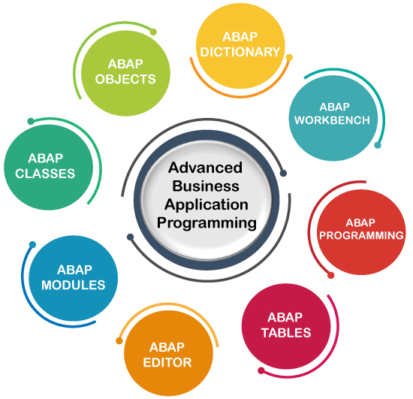

Figure Advanced Business Application Programming

All of R/3’s applications and even parts of its basis system were developed in ABAP.

ABAP is an event-driven programming language. User actions and system events control the execution of an application.

ABAP is also called ABAP/4. The “4” in ABAP/4 stands for “Fourth Generation Language” or 4GL.

ABAP was first introduced by SAP in the 1980s. Throughout the years, various enhancements to the language increased what programmers could do with it. For example, through April 2000 programs could only be created *procedurally*, meaning a program had to follow a set of pre-defined “procedures” to perform a certain task successfully.

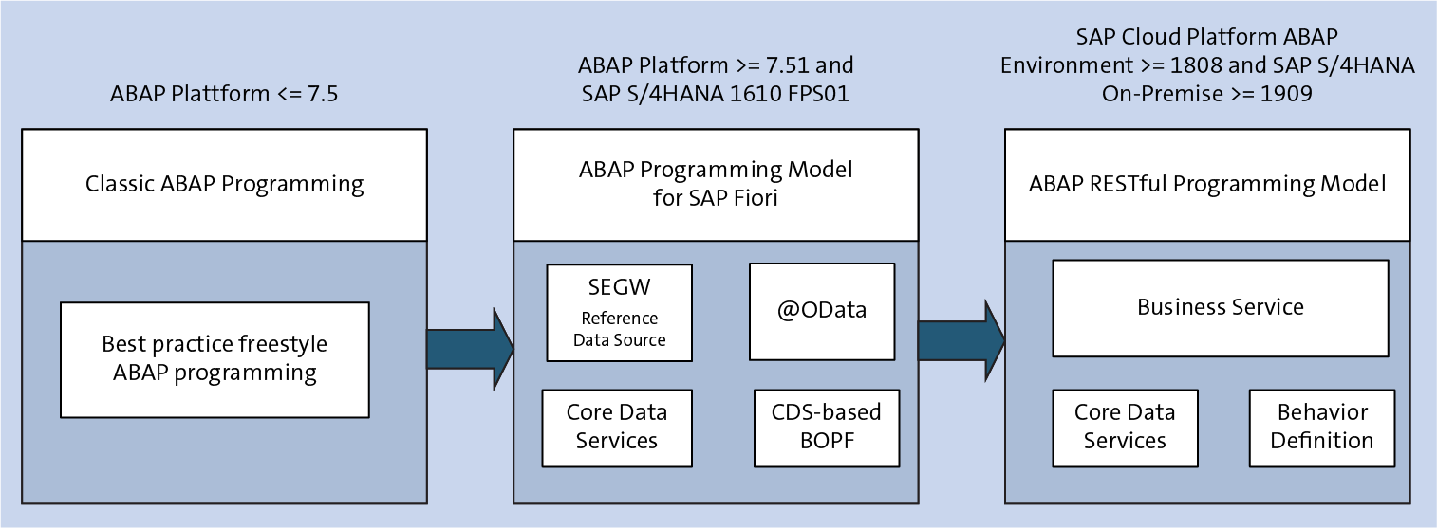

Figure

**1.3 Language Used :**

* **Advanced Business Application Programming (ABAP)**

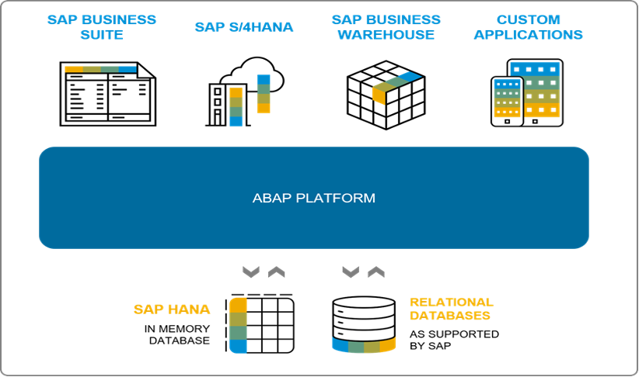

Figure : ABAP Platform

**1.4 Software Used :**

* **SAP LOGON (HANA)**

The SAP Logon is a Windows program, which you use to log on to SAP systems on your Windows PC. It mediates between the SAP system and the SAP GUI user interface. The SAP Logon displays a list of available SAP systems and automatically selects servers with the best current response times.

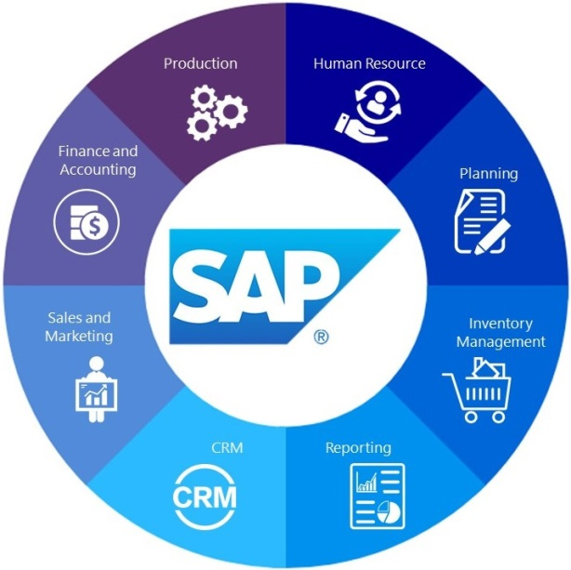

SAP ERP is enterprise resource planning software developed by the company SAP SE. [ERP](https://searcherp.techtarget.com/definition/ERP-enterprise-resource-planning), or enterprise resource planning, software is modular software made to integrate the main functions of an organization's core business processes into a unified system.

An [ERP system](https://www.techtarget.com/searcherp/How-Does-an-ERP-System-Work-Basics-Features-and-Types) consists of software components, called modules, that each focus on an essential business function, such as finance and accounting, HR, production, materials management or customer relationship management ([CRM](https://searchcustomerexperience.techtarget.com/definition/CRM-customer-relationship-management)). Organizations only use the modules they need to run their particular business.

### What is SAP enterprise resource planning (ERP)?

SAP's various ERP products enable its customers to run their business processes, including accounting, sales, production, HR and finance, in an integrated environment, with data from each module stored in a central database. The close integration and common data store ensure that information flows from one SAP ERP component to another without the need for redundant data entry and help enforce financial, process and legal controls.

The most widely installed SAP system, SAP ERP Central Component ([SAP ECC](https://www.techtarget.com/searchsap/definition/SAP-ERP-Central-Component-SAP-ECC)), is an on-premises ERP system that is usually implemented in medium-size and large companies.

At one time, the term "SAP ERP" was synonymous with ECC. Nowadays, it is a catchall for all of SAP's ERP products: ECC, [S/4HANA](https://www.techtarget.com/searchsap/definition/SAP-S-4HANA), Business One and [Business ByDesign](https://www.techtarget.com/searchsap/definition/SAP-Business-ByDesign).

ECC remains SAP's flagship ERP and the basis of the next-generation product, S/4HANA. Its modules are separated into [functional modules](https://www.techtarget.com/searchsap/tip/A-breakdown-of-10-commonly-used-SAP-ECC-components) and technical modules. The functional modules include the following:

* Adavanced Business Application Programme (SAP ABAP)
* Production Planning ([SAP PP](https://www.techtarget.com/searchsap/definition/SAP-Production-Planning))
* Materials Management ([SAP MM](https://www.techtarget.com/searchsap/definition/SAP-Materials-Management-MM))
* Project System ([SAP PS](https://www.techtarget.com/searchsap/definition/SAP-Project-System-PS))
* Sales and Distribution ([SAP SD](https://www.techtarget.com/searchsap/definition/SAP-Sales-and-Distribution-SAP-SD))
* Plant Maintenance ([SAP PM](https://www.techtarget.com/searchsap/definition/SAP-Plant-Maintenance-PM))
* Finance and controlling (SAP FICO)
* Quality Management ([SAP QM](https://www.techtarget.com/searchsap/definition/SAP-Quality-Management-QM))

## CHAPTER 2 : Process of ABAP in SAP kernel

## 2.1. ****3-Tier Architecture of SAP****

We can understand the process of ABAP in SAP by using **3 Tier Architecture of SAP**. Consider the below image:

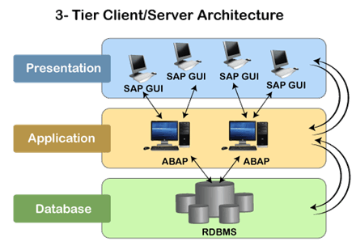

Figure 4: 3 Tier Client- Server Architecture

The ABAP application server is present on the Application layer of the SAP architecture. The application layer is the most important component of the SAP architecture as ABAP programs execute in this layer, and it communicates with both layers.

The application server is responsible for interpreting the ABAP/4 programs. An ABAP program can start on the presentation server, but it can only execute at the application server.

Each ABAP program is stored in the SAP database tables of the database layer, unlike the other C or Java, where programs are stored in other large files.

The SAP database stores program in two forms, which are **source code** and **generated code**. The source code can be viewed and edited by the Workbench editing tools such as **ABAP Editor,** and the generated code is the binary representation of the source code.

**2.2 ABAP Runtime Environment**

ABAP Runtime Environment is a part of SAP kernel, and all the ABAP codes are processed under the control of the runtime environment. Since it is responsible for executing the **ABAP Statements, controlling the flow logic, and responding to an event, so we can compare it** with the **Java virtual machine or JVM.**

**Consider the below image to understand the processing of different processing blocks of an ABAP program:**

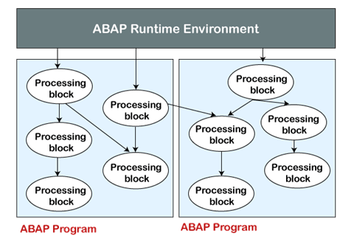

Figure 5 ABAP Runtime Environment

### 2.3 ABAP Programs

### The ABAP programs are executable unit or library that provides reusable code to other programs. These programs are executed on the SAP NetWeaver Application Server.An ABAP program contains several processing blocks that can be occurred in any order within source code.

Each program in ABAP has its type that specifies how that program will run. There are mainly two types of ABAP programs, which are:

* **Executable Programs**: The executable programs can run directly or can start directly by entering the name of the program. These are of two types:
  + **Reports**
  + **Module Pools**
* **Non-executable Programs**: The non-executable programs cannot be run directly. These programs contain the source code that can only be used by the other application programs. These are of following types:
  + **Interface Pools**
  + **Include Programs**
  + **Function Groups**
  + **Subroutine Pools**
  + **Object Classes**
  + **Class Pools**

**2.4 Transactions/Transaction code in ABAP**

The execution of a program in SAP is known as the **transaction**. The SAP system provides a specific four-character code for all the transactions that take place in SAP, and these codes are known as the **transaction codes** or **TCode**.

Any ABAP program can be directly executed by entering the transaction code in the command field of the SAP screen.

In ABAP programming, the transaction can be invoked programmatically by using statements **CALL TRANSACTION** and **LEAVE TO TRANSACTION**. Below is a list of few important TCodes used in ABAP:

|  |  |
| --- | --- |
| **Transaction code** | **Used for** |
| SE11 | ABAP/4 Dictionary |
| SE38 | ABAP Editor/ ABAP program development |
| SE41 | Menu Painter |
| SE51 | Screen Painter |
| SE80 | ABAP Development Workbench |
| SE91 | Maintain Messages |
| ABAPHELP | Keyword Documentation |

**&--------------------------------------------------------------------**

**\*& Module Pool YT013_MP_BOOK**

**&---------------------------------------------------------------------**

**\*&**

**&---------------------------------------------------------------------**

**INCLUDE YT013_MP_BOOK_TOP . " Global Data**

**INCLUDE YT013_MP_BOOK_O01 . " PBO-Modules**

**INCLUDE YT013_MP_BOOK_I01 . " PAI-Modules**

**INCLUDE YT013_MP_BOOK_F01 . " FORM-Routines**

**&---------------------------------------------------------------------**

**\*& Include YT013_MP_BOOK_TOP - Module Pool YT013_MP_BOOK**

**&---------------------------------------------------------------------**

**PROGRAM YT013_MP_BOOK.**

**TABLES : YT013_S_BOOK.**

**DATA: gv_airline TYPE s_carr_id,**

**gv_cdetails TYPE s_conn_id,**

**gv_flight_d TYPE s_date,**

**gv_custom TYPE S_CUSTOMER,**

**gv_class TYPE S_CLASS.**

**DATA : WA_OUTPUT TYPE bapisbonew,**

**bookingid TYPE BAPISBOKEY-bookingid.**

**DATA: itab_return TYPE TABLE OF bapiret2,**

**wa_return TYPE bapiret2.**

**DATA : wa_flight TYPE sflight,**

**flag type i VALUE IS INITIAL.**

**&---------------------------------------------------------------------**

**\*& Include YT013_MP_BOOK_O01**

**&---------------------------------------------------------------------**

**&---------------------------------------------------------------------**

**\*& Module STATUS_9001 OUTPUT**

**&---------------------------------------------------------------------**

**\*&**

**&---------------------------------------------------------------------**

**MODULE status_9001 OUTPUT.**

**SET PF-STATUS 'STATUS'.**

**SET TITLEBAR 'TITLE'.**

**if flag = 1.**

**loop at screen.**

**if screen-name = 'BOOKING'.**

**screen-input = 0.**

**MODIFY SCREEN.**

**endif.**

**endloop.**

**endif.**

**ENDMODULE.**

**&---------------------------------------------------------------------**

**\*& Include YT013_MP_BOOK_I01**

**&---------------------------------------------------------------------**

**&---------------------------------------------------------------------**

**\*& Module USER_COMMAND_9001 INPUT**

**&---------------------------------------------------------------------**

**\* text**

**----------------------------------------------------------------------**

**MODULE user_command_9001 INPUT.**

**CASE sy-ucomm.**

**WHEN 'BACK'.**

**LEAVE TO SCREEN 0.**

**ENDCASE.**

**CASE sy-ucomm.**

**WHEN 'EXIT'.**

**LEAVE TO SCREEN 0.**

**ENDCASE.**

**ENDMODULE.**

**&---------------------------------------------------------------------**

**\*& Module VALIDATION INPUT**

**&---------------------------------------------------------------------**

**\* text**

**----------------------------------------------------------------------**

**MODULE validation INPUT.**

**SELECT SINGLE carrid connid fldate FROM sflight INTO**

**(gv_airline , gv_cdetails , gv_flight_d) WHERE**

**carrid = yt013_s_book-carrid AND**

**connid = yt013_s_book-connid AND**

**fldate = yt013_s_book-fldate.**

**ENDMODULE.**

**&---------------------------------------------------------------------**

**\*& Module VALIDATION2 INPUT**

**&---------------------------------------------------------------------**

**\* text**

**----------------------------------------------------------------------**

**MODULE validation2 INPUT.**

**SELECT SINGLE customid FROM sbook INTO gv_custom WHERE**

**customid = yt013_s_book-customid.**

**SELECT SINGLE class FROM sbook INTO gv_class WHERE**

**class = yt013_s_book-class.**

**ENDMODULE.**

**&---------------------------------------------------------------------**

**\*& Module PROCESS INPUT**

**&---------------------------------------------------------------------**

**\* text**

**----------------------------------------------------------------------**

**MODULE process INPUT.**

**CASE sy-ucomm.**

**WHEN 'ENTER'.**

**SELECT SINGLE name FROM scustom INTO yt013_s_book-passname**

**WHERE id = yt013_s_book-customid.**

**ENDCASE.**

**CASE sy-ucomm.**

**WHEN 'B1'.**

**wa_output-airlineid = yt013_s_book-carrid.**

**wa_output-connectid = yt013_s_book-connid.**

**wa_output-flightdate = yt013_s_book-fldate.**

**wa_output-customerid = yt013_s_book-customid.**

**wa_output-class = yt013_s_book-class.**

**wa_output-counter = yt013_s_book-counter.**

**wa_output-passname = yt013_s_book-passname.**

**CALL FUNCTION 'BAPI_FLBOOKING_CREATEFROMDATA'**

**EXPORTING**

**\* RESERVE_ONLY = ' '**

**booking_data = wa_output**

**\* TEST_RUN = ' '**

**IMPORTING**

**\* AIRLINEID =**

**bookingnumber = bookingid**

**\* TICKET_PRICE =**

**TABLES**

**\* EXTENSION_IN =**

**return = itab_return.**

**IF itab_return IS NOT INITIAL.**

**LOOP AT itab_return INTO wa_return.**

**IF wa_return-type = 'E'.**

**MESSAGE 'Booking Cannot Be Created' TYPE 'E'.**

**ELSEIF wa_return-type = 'S'.**

**CALL FUNCTION 'BAPI_TRANSACTION_COMMIT'**

**EXPORTING**

**wait = 'X'.**

**MESSAGE s000(yt013bookingid) WITH bookingid.**

**ENDIF.**

**ENDLOOP.**

**ENDIF.**

**ENDCASE.**

**ENDMODULE.**

**&---------------------------------------------------------------------**

**\*& Module CANCEL INPUT**

**&---------------------------------------------------------------------**

**\* text**

**----------------------------------------------------------------------**

**MODULE cancel INPUT.**

**CASE sy-ucomm.**

**WHEN 'CANCEL'.**

**CLEAR : yt013_s_book-carrid,**

**yt013_s_book-class,**

**yt013_s_book-connid,**

**yt013_s_book-counter,**

**yt013_s_book-customid,**

**yt013_s_book-fldate,**

**yt013_s_book-passname.**

**ENDCASE.**

**ENDMODULE.**

**&---------------------------------------------------------------------**

**\*& Module CHECK INPUT**

**&---------------------------------------------------------------------**

**\* text**

**----------------------------------------------------------------------**

**MODULE check INPUT.**

**CASE sy-ucomm.**

**WHEN 'CHECK'.**

**flag = 0.**

**select single \***

**from sflight**

**into wa_flight**

**where**

**carrid = yt013_s_book-carrid and**

**connid = yt013_s_book-connid and**

**fldate = yt013_s_book-fldate.**

**CASE yt013_s_book-class.**

**WHEN 'C'.**

**IF wa_flight-seatsocc = wa_flight-seatsmax.**

**flag = 1.**

**ENDIF.**

**WHEN 'Y'.**

**IF wa_flight-seatsocc_b = wa_flight-seatsmax_b.**

**flag = 1.**

**ENDIF.**

**WHEN 'F'.**

**IF wa_flight-seatsocc_f = wa_flight-seatsmax_f.**

**flag = 1.**

**ENDIF.**

**ENDCASE.**

**ENDCASE.**

**ENDMODULE.**

**Output :**

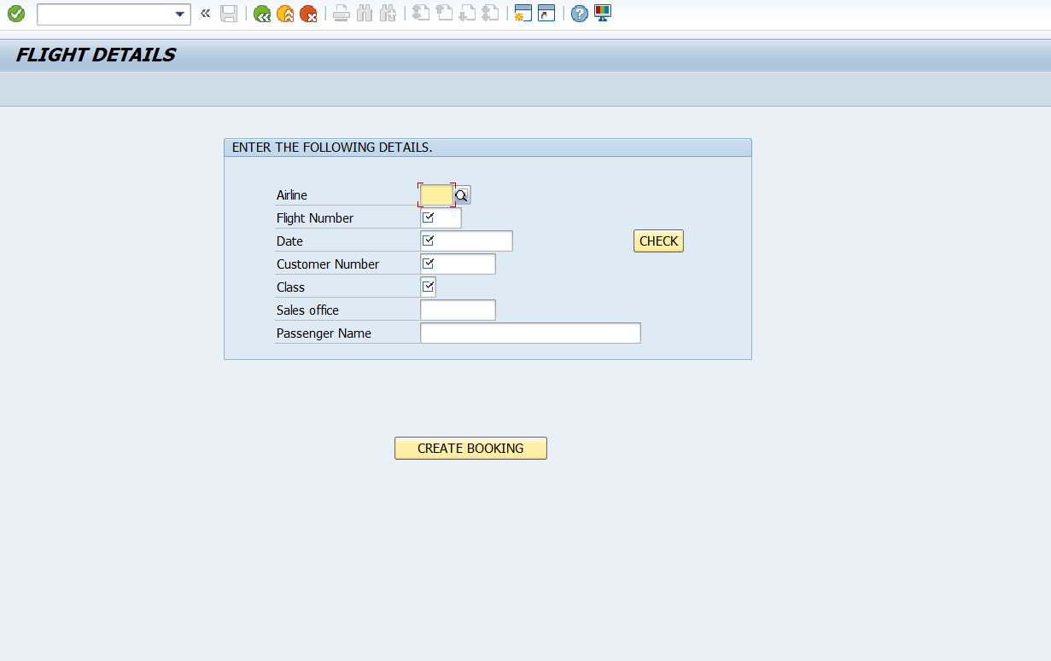

Figure FLIGHT DETAILS

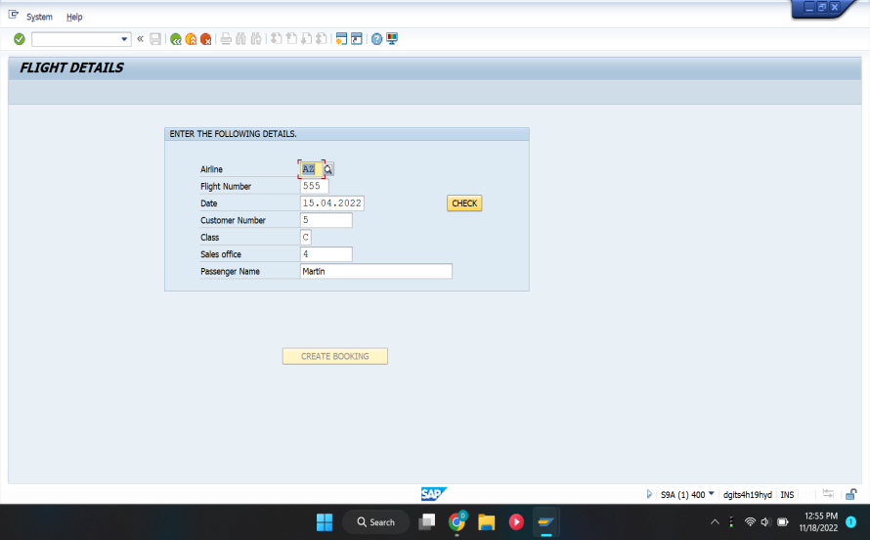

Figure BUTTON DISABLED WHEN FLIGHT IS FULL

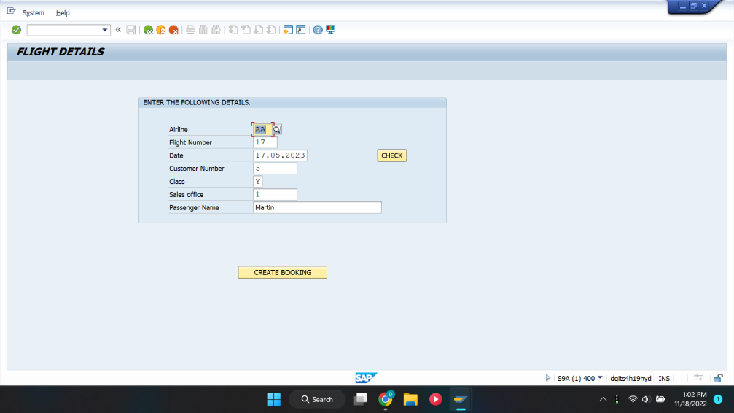

Figure BUTTON ENABLED WHEN BOOKING CAN BE DONE

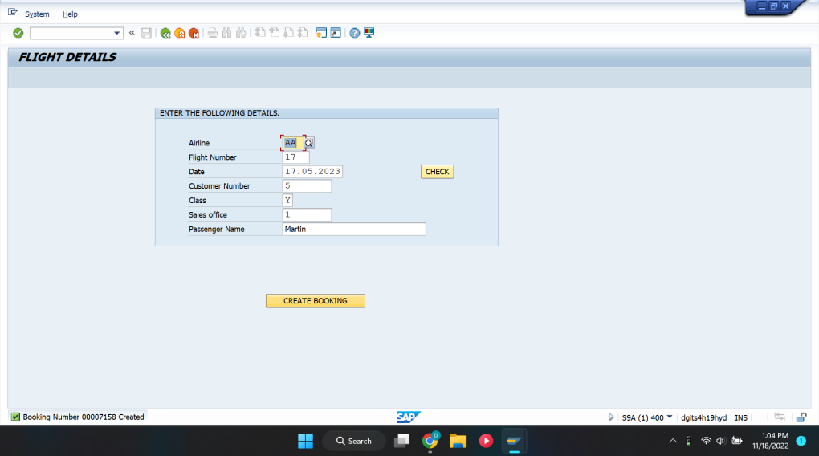

Figure BOOKING ID GENERATED REFLECTING SUCCESSFUL BOOKING

**CHAPTER 3 : DATABASE FUNCTIONALITY**

In this chapter , we are going to explain, SAP's flight and booking data model exists in every ABAP system. It’s used in the ABAP documentation and training provided by SAP. This blog post explains the tables relevant to specific training exercises you may undertake when learning ABAP.

In the ERD shown below, you can see how the flight data tables are set up as provided by SAP. This post won’t cover every table or every field, but you can open the **SAPBC_DATAMODEL** package in Transaction SE80 and find all the flight-related tables.

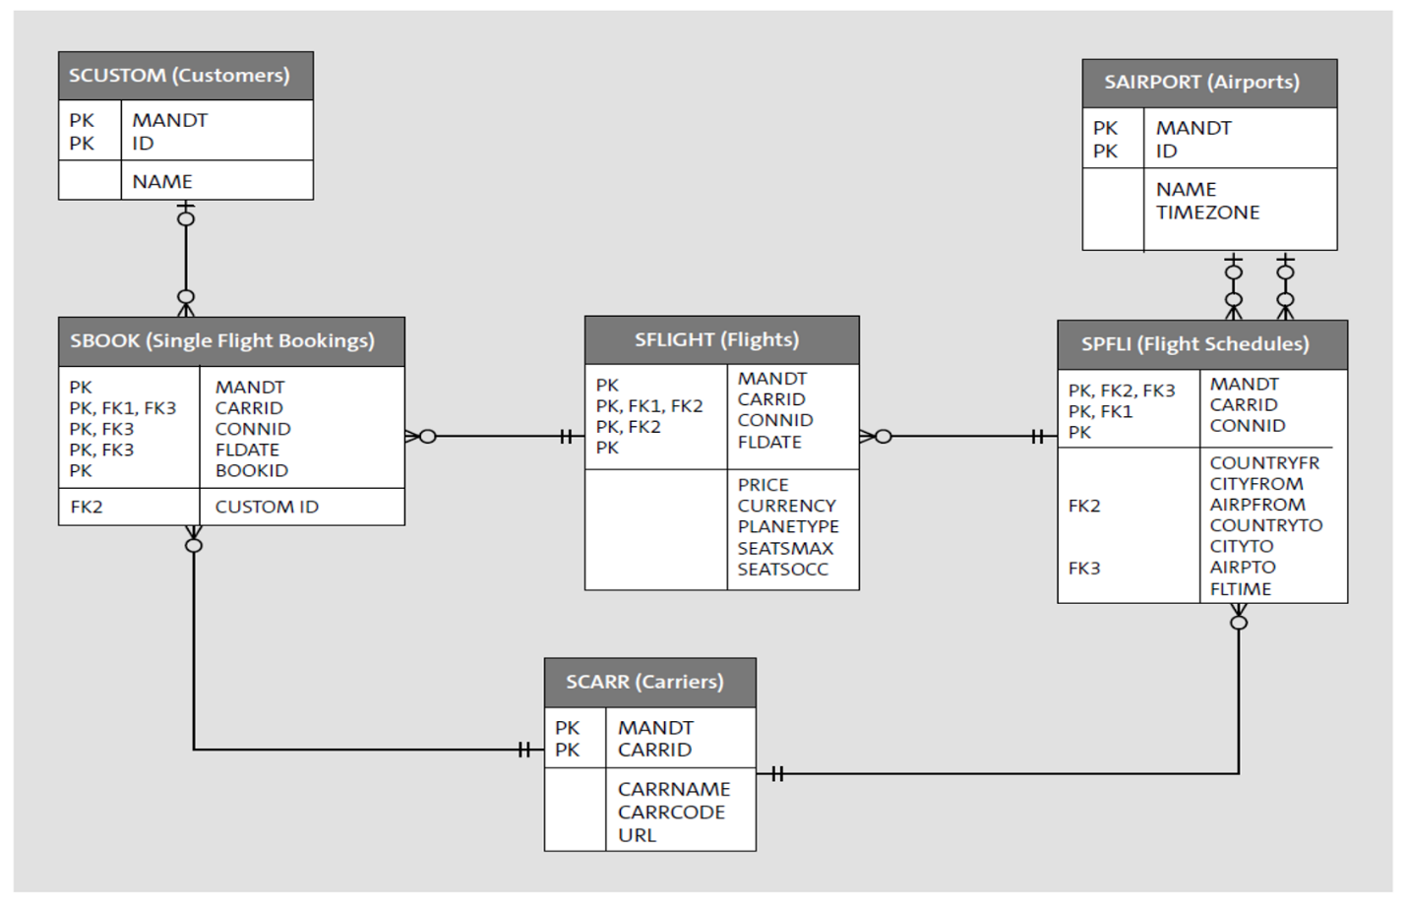

Figure 1 : Database Connectivity

**3.1 The standard tables can be described as follows:**

**3.1.1 Creating Tables**

Database can be created easily using these tables.

* SCUSTOM -

This table stores information about the customers.

* SAIRPORT -

This table stores the airport IDs and information about the airports.

* SCARR -

This table stores all the carriers (airlines).

* SPFLI -

This table stores the flight schedules for each airline—for example, flight 17 for

American Airlines flies to San Francisco from New York and leaves at 11 a.m.

* SFLIGHT -

This table stores the actual flights for a flight schedule—for example, flight 17 for

American Airlines will fly January 12 and will cost $500.

* SBOOK -

This table stores bookings for single flights.

**3.1.2 Creating Database**

You can see that the tables are normalized because the master data tables (such as airports and customers) are all separated out of the tables in which they are referenced multiple times. This means that changes to customer information will take place in table SCUSTOM and not affect the bookings in table SBOOK.

Note that the MANDT field is listed as the first key in every table. This field stores the SAP client number. Client here is the SAP concept that allows the system to separate data within the same database. It is different from a client in the client-server architecture concept.

**3.1.3 Accessing the tables**

1. SE11 (Transaction code for ABAP data dictionary) in the command field (also called input field) of SAP screen.

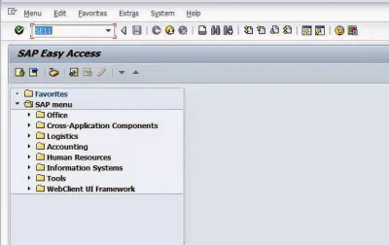

Figure 2 : SAP-Easy Access

1. The following screen opens. You can enter the name of one of the Flight data model table SCARR, say.

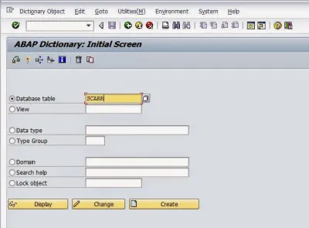

Figure 3 : SE11- ABAP Dictionary

1. Click on display and the screen below with the details of the columns (Fields) follows:

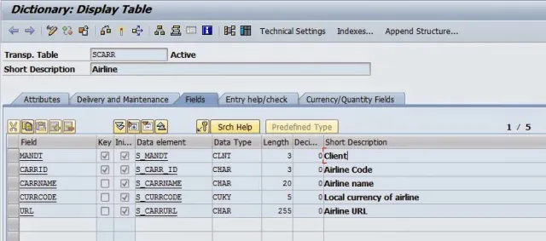

Figure 4 : SE11 – Table SCARR in ABAP Dictionary

1. If you want to see the contents of this table, click on the icon looking like a table structure, highlighted in the below picture with a red circle:

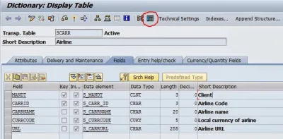

Figure 5 : Table Icon

1. In the next screen, you can enter some criteria e.g Airline code, currency, etc. But for the time being, leave everything blank as it is.

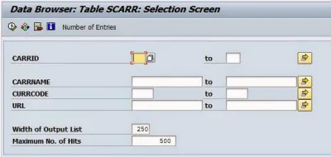

Figure 6 : Data Browser

1. Click on the Execute button in the toolbar highlighted with red circle below. By the way, the area (bar) which contains these buttons like Execute is called the *Application toolbar*.

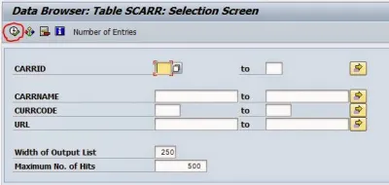

Figure 7 : Execute Button

1. You can see the results (SCARR table entries) below. But if you are unable to see any table entries and get the error message ‘No table entries found for specified key’, it means the tables are empty and SAP flight data system doesn’t contain data in your system. Don’t be discouraged if thats the case. SAP delivers them blank but you can generate data as explained in the next step.

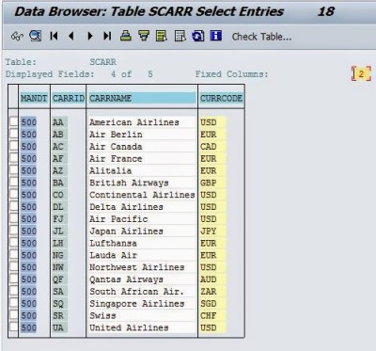

Figure 8 : SE11: Contents of Table SCARR

1. If the table above is blank, all other tables of the Flight data model must be blank too. You can generate data in them by executing SAP provided standard program SAPBC_DATA_GENERATOR. You can do so by using transaction code SE38 (ABAP Editor) in the command field. You will get a screen as below:

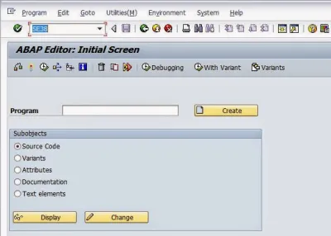

Figure 9 : SE38: ABAP Editor

1. Enter the name of the program **SAPBC_DATA_GENERATOR** in the Program field and click on execute button highlighted in red circle.

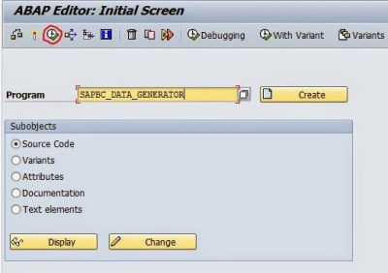

Figure 10 : SE38: Execute program

1. The next screen follows as below:

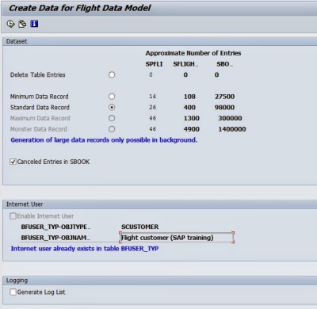

Figure 11 : Selection-screen of Flight Data (Model) Generator program

1. Don’t change anything here and just click on Execute button in the Application toolbar. The program will take some time to execute. Once it executes successfully, you can check the contents of different tables by repeating the steps mentioned above for SE11.
2. If you have executed the above steps correctly, SAP flight data model tables are filled with data. This sample data can be used by your ABAP programs to output results for selected criteria.

**CHAPTER 4 : SIMPLIFIED REPRESENTATION**

**4.1 Data Flow between tables :**

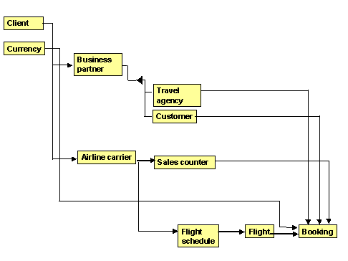

Figure 1 : Data Flow Diagram

The flight model gives a simple description of seat bookings in passenger airplanes by flight customers. The booking can be made either at the sales desk of a carrier or at a travel agency.

A flight booking is based on the individual flight connections described in the flight schedule. There are concrete flights for every flight connection.

**4.2. Assigned Tables in the ABAP Dictionary :**

There is a table in the ABAP Dictionary containing the data of the corresponding entities (versions of the entity type) for each entity type.

The most important tables of the flight model are:

●      T000: Client table

●      SCURX: Currencies (key: currency key)

●      SBUSPART: Business partner (key: client, partner number)

●      STRAVELAG: Travel agencies (key: client, travel agency number)

●      SCUSTOM: Customers (key: client, customer number)

●      SCARR: Carriers (key: client, carrier ID)

●      SCOUNTER: Sales counters (key: client, carrier ID, sales counter number)

●      SPFLI: Flight schedule (key: client, carrier ID, connection number)

●      SFLIGHT: Flights (key: client, carrier ID, connection number, date of flight)

**4.3. Relationship between tables:**

Table SBUSPART contains all the business partners of a carrier. A business partner is identified by a number in this table. The data of the contact person for the business partner is also stored. A business partner can be a travel agency or a customer (for example, a company that frequently books flights directly with the carrier). Different data is required for these two types of business partner. The data for a travel agency is stored in table STRAVELAG and the data for a customer in table SCUSTOM. There is an entry with the same key in either table STRAVELAG or table SCUSTOM for each entry in table SBUSPART.

Table SCARR contains the IDs and names of the carriers. Each carrier has a number of connections. These flight connections are stored in table SPFLI. Table SFLIGHT contains the concrete flight data for each connection. Bookings can be made for each flight in table SFLIGHT. The system enters the bookings made for each flight in table SBOOK.

The carriers have sales counters in the airports. These sales counters lie in table SCOUNTER. The customer number or agency number for which the booking was made is stored in table SBOOK for each booking. If the customer books a flight directly at a counter, the system enters the counter number also in the booking data in table SBOOK.

**4.6 Application And Future Scope Of The Project:**

* We would like to implement our project and tie up with certain airlines and would work upon it for future enhancements satisfying more customer requirements.
* Online feedbacks, help and support for travelers.
* There will be regular vulnerability audits and updates.

**4.7 Reference:**

* **Book:**

• SAP Administration

• IBM SAP Basis

• SAP Basis

* **Websites:**

• SAP - https://blogs.sap.com/2010/05/11/back-to-basis/

• SAP NetWeaver – https://blogs.sap.com/2012/03/13/faq-for-sap-netweaver- admin-sap-basis-careers /

• Create User - https://www.guru99.com/how-to-create-a-user-2.html

• Tutorials Point - <https://www.tutorialspoint.com/sap_basis/sap_basis_user_activities.htmL>

• SAP - https://help.sap.com/