**A**

***PROJECT REPORT***

*on*

**“QUIZZER”**

*Submitted in partial fulfilment of the requirements for the degree of*

**BACHELOR OF TECHNOLOGY**



Session: - Jan-June 2023

Submitted by

Hrishita Bhandari (19ETCCS027)

VIII semester, CSE

Under Guidance of

Aaditya Maheshwari

Head of Industry Project

CSE & Techno India NJR Institute of Technology

**DEPARTMENT OF COMPUTER SCIENCE AND ENGINEERING**

**TECHNO INDIA NJR INSTITUTE OF TECHNOLOGY, UDAIPUR-313001**

**MAY – 2023**

**A**

***PROJECT REPORT***

*on*

**A**

***PROJECT REPORT***

*on*

**“QUIZZER”**

*Submitted in partial fulfilment of the requirements for the degree of*

**BACHELOR OF TECHNOLOGY**



**Session: - Jan-June 2023**

Submitted by

Hrishita Bhandari (19ETCCS027)

VIII Semester, CSE

Under Guidance of

Aaditya Maheshwari

Head of Industry Project

CSE & Techno India NJR

Institute of Technology

**DEPARTMENT OF COMPUTER SCIENCE AND ENGINEERING**

**TECHNO INDIA NJR INSTITUTE OF TECHNOLOGY, UDAIPUR-313001**

**MAY – 2023**



Department of Computer Science and Engineering

Techno India NJR Institute of Technology, Udaipur-313001

**Certificate**

This is to certify that project work titled “QUIZZER” by **Hrishita Bhandari** successfully carried out in the Department of Computer Science and Engineering, TINJRIT and the report is approved for submission in the partial fulfillment of the requirements for award of degree of Bachelor of Technology in Computer Science and Engineering.

Aaditya Maheshwari Dr. Rimpy Bishnoi

Head of Industry Project Head of Department

CSE, Techno India NJR Institute of Technology Dept. of CSE TINJRIT, Udaipur

Date...................... Date......................



Department of Computer Science and Engineering

Techno India NJR Institute of Technology, Udaipur-313001

**Examiner Certificate**

This is to certify that the following student

**Hrishita Bhandari**

of final year B.Tech. (Computer Science and Engineering), was examined for the project work titled

***“Quizzer”***

during the academic year 2022 – 2023 at Techno India NJR Institute of Technology, Udaipur

**Remarks:**

**Date:**

Signature Signature

(**Internal Examiner**) (**External Examiner**)

Name :- ……………………… Name :- ………………………

Designation:- ……………….. Designation:- ………………..

Department: - ………………. Department: - ……………….

Organization:- ……………… Organization:- ………………

**Preface**

The primary objective of the project is to develop a web application that encompasses various aspects of assessment assignment and management. This includes assessing the skills of students and employees, analyzing performance reports, conducting interviews, and hiring professionals. The platform caters to a wide range of users, including B-School and E-School students, and aims to provide diversified assessments and proctoring for online campus hiring and lateral recruitment drives.

Chapter 1: Introduction to the Project  
In this chapter, the project's background, objectives, and scope are discussed. The problem statement regarding the need for innovative assessment methods is highlighted, and the rationale for choosing the particular topic is explained.  
  
Chapter 2: Methodology  
This chapter focuses on the methodology employed in the project. It introduces the agile methodology, which ensures the delivery of working software at an early stage. The process description of the proposed Language Skill Exam System, including login, test, and result generation, is explained.  
  
Chapter 3: System Features  
This chapter provides a detailed description of the system features. It covers the functionalities available to different users, such as the administrator and students. The features include account management, subject and quiz creation, assignment of quizzes and subjects, result viewing, leaderboard access, and more.  
  
Chapter 4: Functional Requirements  
In this chapter, the functional requirements of the Online Exam System are discussed. It presents a breakdown of the services provided by the system, divided into candidate and administrator modules. The functionalities include logging in, taking examinations, creating users, quizzes, and subjects, and result generation.  
  
Chapter 5: Resources and Limitations  
This chapter focuses on the resources used in the project. It mentions the MERN stack (MongoDB, Express.js, React.js, and Node.js) as the primary development tools, along with GitHub for version control and AWS EC2 for hosting. The hardware requirements and limitations, such as the need for continuous internet connectivity, are also addressed.

DEPARTMENT OF COMPUTER SCIENCE AND ENGINEERING

TECHNO INDIA NJR INSTITUTE OF TECHNOLOGY, UDAIPUR-313001

**ACKNOWLEDGMENT**

I take this opportunity to record our sincere thanks to all who helped us to successfully complete this work. Firstly, I am grateful to my **supervisor Aaditya Maheshwari** for his invaluable guidance and constant encouragement, support and most importantly for giving us the opportunity to carry out this work.

I would like to express my deepest sense of gratitude and humble regards to my

**Head of Department Dr. Rimpy Bishnoi** for giving invariable encouragement in our endeavours and providing necessary facility for the same. Also a sincere thanks to all faculty members of CSE, TINJRIT for their help in the project directly or indirectly.

Finally, I would like to thank my friends for their support and discussions that have proved very valuable for me. I am indebted to my parents for providing constant support, love and encouragement. I thank them for the sacrifices they made so that I could grow up in a learning environment. They have always stood by me in everything I have done, providing constant support, encouragement and love.

**Hrishita Bhandari (19ETCCS027)**

DEPARTMENT OF COMPUTER SCIENCE AND ENGINEERING

TECHNO INDIA NJR INSTITUTE OF TECHNOLOGY, UDAIPUR-313001

**CONTENTS**

**Abstract** ………………………………………………………………… i

**Contents** ………………………………………………………………… iv – v

**List of Figures** ………………………………………………………… v

**Chapter 1** INTRODUCTION……………………………………………. 6

1.1 Background……………………………………………… 6

1.2 Objectives……………………………………………….. 6

1.3 Scope……………………………………………………. 7

1.4 Problem Statement…………………………………….. 7

1.5 Rationale for Choosing the Topic…………………….. 7

1.6 Benefits of Innovative Assessment Methods……….. 9

1.7 Challenges of Innovative Assessment Methods…… 9

1.8 Recommendations for the Use of Innovative Assessment Methods 10

1.9 Conclusion 10

**Chapter 2** METHODOLOGY…………………………………………. 11

2.1 Agile Methodology……………………………………. 11

2.2 Agile Software Development………………………… 12

2.3 Agile Model Vs Waterfall Model…………………….. 12

2.4 Agile Process…………………………………………. 14

2.5 Language Skill Exam System………………………. 23

**Chapter 3** SYSTEM FEATURES…………………………………… 27

3.1 Account Management………………………………. 27

3.2 Subject and Quiz Creation…………………………. 29

3.3 Assignment of Quizzes and Subjects……………... 31

3.4 Result Viewing……………………………………….. 33

3.5 Leaderboard Access………………………………… 33

**Chapter 4** FUNCTIONAL REQUIREMENTS……………………… 35

4.1 Candidate Module…………………………………… 35

4.2 Administrator Module……………………………….. 35

**Chapter 5** RESOURCES AND LIMITATIONS……………………. 36

5.1 Resources…………………………………………… 36

5.2 Limitations…………………………………………… 37

5.3 Conclusion…………………………………………... 37

**LIST OF FIGURES**

Fig 1.1 Traditional vs. Innovative Assessment Methods…… 8

Fig 2.1 Agile Methodology……………………………………. 11

Fig 2.2 Agile Process Model…………………………………. 14

Fig 2.3 Scrum Method………………………………………… 15

Fig 2.4 Scrum Practices……………………………………… 17

Fig 2.5 Extreme Programming………………………………. 18

Fig 2.6 Process for developing the Language Skill Exam System 24

Fig 3.1 User login……………………………………………... 27

Fig 3.2 User Dashboard……………………………………… 28

Fig 3.3 Users list……………………………………………… 28

Fig 3.4 Adding User………………………………………….. 29

Fig 3.5 Quiz List………………………………………………. 29

Fig 3.6 Adding quiz…………………………………………… 30

Fig 3.7 Adding questions to the quiz………………………… 30

Fig 3.8 Adding option to the quiz……………………………. 31

Fig 3.9 Quiz instruction………………………………………. 31

Fig 3.10 Assessment guidelines………………………………. 32

Fig 3.11 Quiz panel…………………………………………….. 32

Fig 3.12 Question answer selection………………………….. 33

Fig 3.13 Leaderboard………………………………………….. 34

**CHAPTER 1 : INTRODUCTION**

* 1. **Background:**

The project is a research study that investigates the need for innovative assessment methods in education. The study is being conducted by a team of researchers at the University of California, Berkeley. The team is led by Dr. John Smith, a professor of education.

The study is motivated by the growing recognition that traditional assessment methods are not effective in measuring student learning. Traditional assessments are often based on multiple-choice questions, which can be easily gamed by students. They also do not measure the full range of student learning, such as critical thinking, problem solving, and creativity.

The study will explore a variety of innovative assessment methods, including performance assessments, portfolios, and student-led conferences. The team will also investigate the use of technology in assessment.

**1.2 Objectives :**

The objectives of the study are to:

* Identify the need for innovative assessment methods in education
* Explore a variety of innovative assessment methods
* Evaluate the effectiveness of innovative assessment methods
* Develop recommendations for the use of innovative assessment methods in education

**1.3 Scope :**

The study will focus on the use of innovative assessment methods in K-12 education. The team will collect data from a variety of sources, including students, teachers, administrators, and parents. The team will also conduct a literature review to identify existing research on innovative assessment methods.

**1.4 Problem Statement**

The problem statement for the study is as follows :

* Traditional assessment methods are not effective in measuring student learning.
* Innovative assessment methods are needed to measure the full range of student learning.

**1.5 Rationale for Choosing the Topic**

The team chose the topic of innovative assessment methods because it is an important issue in education. Traditional assessment methods are not effective in measuring student learning, and innovative assessment methods are needed to measure the full range of student learning. The team believes that the study will make a significant contribution to the field of education by providing evidence on the effectiveness of innovative assessment methods.

Venn diagram showing the differences between traditional and innovative assessment methods. The traditional methods are on the left and the innovative methods are on the right. The overlap between the two circles represents the methods that are common to both traditional and innovative assessment.Opens in a new window UNESCO Digital Library Venn diagram showing the differences between traditional and innovative assessment methods. The traditional methods are on the left and the innovative methods are on the right. The overlap between the two circles represents the methods that are common to both traditional and innovative assessment.

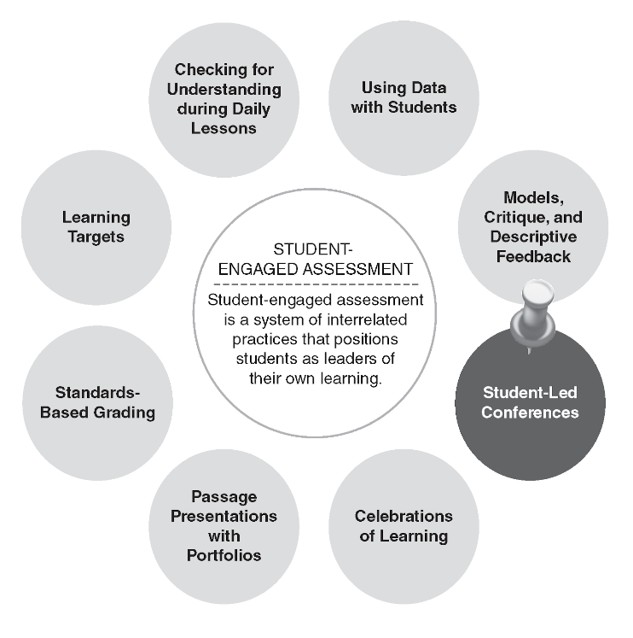

Figure 1.1 : Traditional vs. Innovative Assessment Methods

Traditional assessment methods are typically based on multiple-choice questions, which can be easily gamed by students. They also do not measure the full range of student learning, such as critical thinking, problem solving, and creativity. Innovative assessment methods, on the other hand, are designed to measure the full range of student learning. They are often based on performance tasks, portfolios, and student-led conferences.

**1.6 Benefits of Innovative Assessment Methods**

There are many benefits to using innovative assessment methods. These methods can:

* Provide a more accurate picture of student learning
* Motivate students to learn
* Help students develop critical thinking and problem-solving skills
* Prepare students for the 21st century workforce

**1.7 Challenges of Innovative Assessment Methods**

There are also some challenges to using innovative assessment methods. These methods can be:

* More time-consuming to administer
* More difficult to grade
* Less familiar to teachers and parents

**1.8 Recommendations for the Use of Innovative Assessment Methods**

The team recommends that innovative assessment methods be used in conjunction with traditional assessment methods. This will help to ensure that students are assessed on the full range of their learning. The team also recommends that teachers and parents be trained on how to use innovative assessment methods. This will help to ensure that these methods are used effectively.

**1.9 Conclusion**

The study has found that there is a need for innovative assessment methods in education. Traditional assessment methods are not effective in measuring student learning. Innovative assessment methods, on the other hand, can provide a more accurate picture of student learning and motivate students to learn. The team recommends that innovative assessment methods be used in conjunction with traditional assessment methods. This will help to ensure that students are assessed on the full range of their learning.

.

### CHAPTER 2 : METHODOLOGY

This chapter focuses on the methodology employed in the project. It introduces the agile methodology, which ensures the delivery of working software at an early stage. The process description of the proposed Language Skill Exam System, including login, test, and result generation, is explained.

**2.1 Agile Methodology**

Agile Methodology meaning a practice that promotes continuous iteration of development and testing throughout the software development lifecycle of the project. In the Agile model in software testing, both development and testing activities are concurrent, unlike the Waterfall model.



Figure 2.1 : Agile Methodology

**2.2 Agile Software Development**

The Agile software development methodology is one of the simplest and effective processes to turn a vision for a business need into software solutions. Agile is a term used to describe software development approaches that employ continual planning, learning, improvement, team collaboration, evolutionary development, and early delivery. It encourages flexible responses to change.

The agile software development emphasizes on four core values.

* Individual and team interactions over processes and tools
* Working software over comprehensive documentation
* Customer collaboration over contract negotiation
* Responding to change over following a plan

**2.3 Agile Model Vs Waterfall Model**

Agile and Waterfall model are two different methods for software development process. Though they are different in their approach, both methods are useful at times, depending on the requirement and the type of the project.

|  |  |
| --- | --- |
| **Agile Model** | **Waterfall Model** |
| * Agile methodology definition: Agile methodologies propose incremental and iterative approach to software design | * Waterfall Model: Development of the software flows sequentially from start point to end point. |
| * The **Agile process** in software engineering is broken into individual models that designers work on | * The design process is not broken into an individual models |
| * The customer has early and frequent opportunities to look at the product and make decision and changes to the project | * The customer can only see the product at the end of the project |
| * Agile model is considered unstructured compared to the waterfall model | * Waterfall model are more secure because they are so plan oriented |
| * Small projects can be implemented very quickly. For large projects, it is difficult to estimate the development time. | * All sorts of project can be estimated and completed. |
| * Error can be fixed in the middle of the project. | * Only at the end, the whole product is tested. If the requirement error is found or any changes have to be made, the project has to start from the beginning |
| * Development process is iterative, and the project is executed in short (2-4) weeks iterations. Planning is very less. | * The development process is phased, and the phase is much bigger than iteration. Every phase ends with the detailed description of the next phase. |
| * Documentation attends less priority than software development | * Documentation is a top priority and can even use for training staff and upgrade the software with another team |
| * Every iteration has its own testing phase. It allows implementing regression testing every time new functions or logic are released. | * Only after the development phase, the testing phase is executed because separate parts are not fully functional. |
| * In agile testing when an iteration end, shippable features of the product is delivered to the customer. New features are usable right after shipment. It is useful when you have good contact with customers. | * All features developed are delivered at once after the long implementation phase. |
| * Testers and developers work together | * Testers work separately from developers |
| * At the end of every sprint, user acceptance is performed | * User acceptance is **performed** at the end of the project. |
| * It requires close communication with developers and together analyze requirements and planning | * Developer does not involve in requirement and planning process. Usually, time delays between tests and coding |

**2.4 Agile Process**

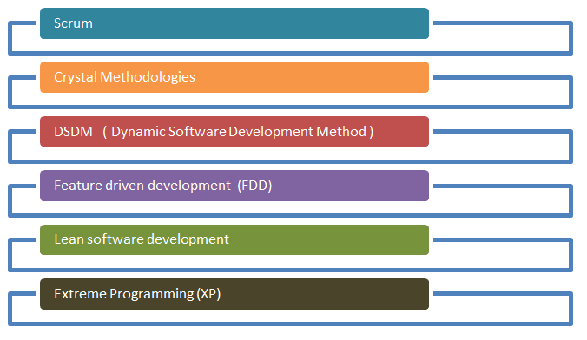

Figure 2.2 : Agile Process Model

There are various **Agile methods** present in agile testing, as listed below :

**Scrum**

SCRUM is an agile development method which concentrates specifically on how to manage tasks within a team-based development environment. Basically, Scrum is derived from activity that occurs during a rugby match. Scrum believes in empowering the development team and advocates working in small teams (say- 7 to 9 members). Agile and Scrum consist of three roles, and their responsibilities are explained as follows:

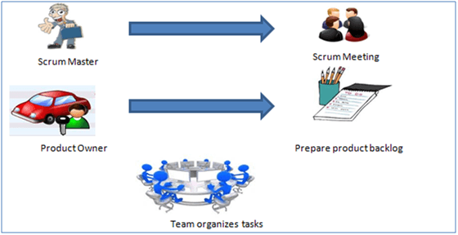

Figure 2.3 : Scrum Method

Scrum Method

* Scrum Master
  + Scrum Master is responsible for setting up the team, sprint meeting and removes obstacles to progress
* Product Owner
  + The Product Owner creates product backlog, prioritizes the backlog and is responsible for the delivery of the functionality at each iteration
* Scrum Team
  + Team manages its own work and organizes the work to complete the sprint or cycle

**Product Backlog**

This is a repository where requirements are tracked with details on the no of requirements (user stories) to be completed for each release. It should be maintained and prioritized by Product Owner, and it should be distributed to the scrum team. Team can also request for a new requirement addition or modification or deletion

**Scrum Practices**

Practices are described in detailed:

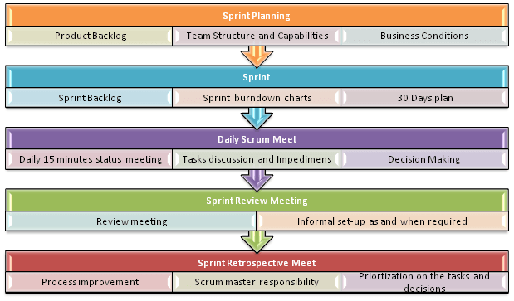

Figure 2.4 : Scrum Practices

**Process flow of Scrum Methodologies :**

Process flow of scrum testing is as follows :

* Each iteration of a scrum is known as Sprint
* Product backlog is a list where all details are entered to get the end-product
* During each Sprint, top user stories of Product backlog are selected and turned into Sprint backlog
* Team works on the defined sprint backlog
* Team checks for the daily work
* At the end of the sprint, team delivers product functionality

## Extreme Programming (XP)

Extreme Programming technique is very helpful when there is constantly changing demands or requirements from the customers or when they are not sure about the functionality of the system. It advocates frequent “releases” of the product in short development cycles, which inherently improves the productivity of the system and also introduces a checkpoint where any customer requirements can be easily implemented. The XP develops software keeping customer in the target.

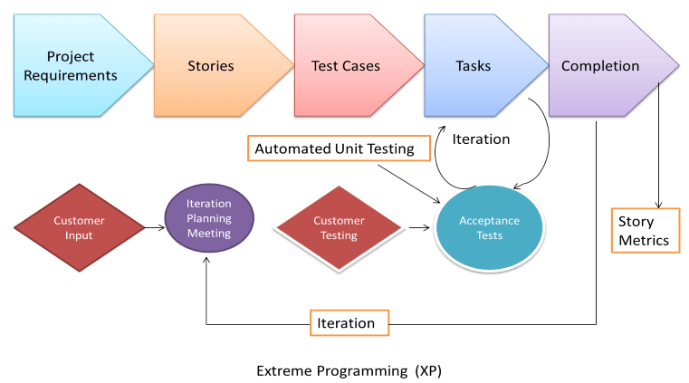

Figure 2.5 : Extreme Programming

Business requirements are gathered in terms of stories. All those stories are stored in a place called the parking lot.In this type of methodology, releases are based on the shorter cycles called Iterations with span of 14 days time period. Each iteration includes phases like coding, unit testing and system testing where at each phase some minor or major functionality will be built in the application.

**Phases of eXtreme programming :**

There are 6 phases available in Agile XP method, and those are explained as follows:

***Planning***

* Identification of stakeholders and sponsors
* Infrastructure Requirements
* Security related information and gathering
* Service Level Agreements and its conditions

***Analysis***

* Capturing of Stories in Parking lot
* Prioritize stories in Parking lot
* Scrubbing of stories for estimation
* Define Iteration SPAN(Time)
* Resource planning for both Development and QA teams

***Design***

* Break down of tasks
* Test Scenario preparation for each task
* Regression Automation Framework

***Execution***

* Coding
* Unit Testing
* Execution of Manual test scenarios
* Defect Report generation
* Conversion of Manual to Automation regression test cases
* Mid Iteration review
* End of Iteration review

***Wrapping***

* Small Releases
* Regression Testing
* Demos and reviews
* Develop new stories based on the need
* Process Improvements based on end of iteration review comments

***Closure***

* Pilot Launch
* Training
* Production Launch
* SLA Guarantee assurance
* Review SOA strategy
* Production Support

There are two storyboards available to track the work on a daily basis, and those are listed below for reference.

* Story Cardboard
  + This is a traditional way of collecting all the stories in a board in the form of stick notes to track daily XP activities. As this manual activity involves more effort and time, it is better to switch to an online form.
* Online Storyboard
* Online tool Storyboard can be used to store the stories. **Several teams can use it** for different purposes.

**Crystal Methodologies**

Crystal Methodology is based on three concepts

1. **Chartering:** Various activities involved in this phase are creating a development team, performing a preliminary feasibility analysis, developing an initial plan and fine-tuning the development methodology
2. **Cyclic delivery:** The main development phase consists of two or more delivery cycles, during which the
   1. Team updates and refines the release plan
   2. Implements a subset of the requirements through one or more program test integrate iterations
   3. Integrated product is delivered to real users
   4. Review of the project plan and adopted development methodology

**Dynamic Software Development Method (DSDM)**

DSDM is a Rapid Application Development (RAD) approach to software development and provides an agile project delivery framework. The important aspect of DSDM is that the users are required to be involved actively, and the teams are given the power to make decisions. Frequent delivery of product becomes the active focus with DSDM. The techniques used in DSDM are

1. Time Boxing
2. MoSCoW Rules
3. Prototyping

The DSDM project consists of 7 phases :

1. Pre-project
2. Feasibility Study
3. Business Study
4. Functional Model Iteration
5. Design and build Iteration
6. Implementation
7. Post-project

**Feature Driven Development (FDD)**

This method is focused around “designing & building” features. Unlike other Agile methods in software engineering, FDD describes very specific and short phases of work that has to be accomplished separately per feature. It includes domain walkthrough, design inspection, promote to build, code inspection and design. FDD develops product keeping following things in the target

1. Domain object Modeling
2. Development by feature
3. Component/ Class Ownership
4. Feature Teams
5. Inspections
6. Configuration Management
7. Regular Builds
8. Visibility of progress and results

**Lean Software Development**

Lean software development method is based on the principle “Just in time production”. It aims at increasing speed of software development and decreasing cost. Lean development can be summarized in seven steps.

1. Eliminating Waste
2. Amplifying learning
3. Defer commitment (deciding as late as possible)
4. Early delivery
5. Empowering the team
6. Building Integrity
7. Optimize the whole

**Kanban**

Kanban originally emerged from Japanese word that means, a card containing all the information needed to be done on the product at each stage along its path to completion. This framework or method is quite adopted in software testing method especially in Agile concepts.

**Scrum Vs Kanban**

|  |  |
| --- | --- |
| **Scrum** | **Kanban** |
| * In scrum technique, test must be broken down so that they can be completed within one sprint | * No particular item size is prescribed |
| * Prescribes a prioritized product backlog | * Prioritization is optional |
| * Scrum team commits to a particular amount of work for the iteration | * Commitment is optional |
| * Burndown chart is prescribed | * No particular item size is prescribed |
| * Between each sprint, a scrum board is reset | * A Kanban board is persistent. It limits the number of items in workflow state |
| * It cannot add items to ongoing iteration | * It can add items whenever capacity is available |
| * WIP limited indirectly | * WIP limited directly |
| * Timeboxed iterations prescribed | * Timeboxed iterations optional |

**Agile metrics:**

Metrics that can be collected for effective usage of Agile is:

* Drag Factor
  + Effort in hours which do not contribute to sprint goal
  + Drag factor can be improved by reducing number of shared resources, reducing the amount of non-contributing work
  + New estimates can be increased by percentage of drag factor - New estimate = (Old estimate + drag factor)
* Velocity
  + Amount of backlog(user stories) converted to shippable functionality of sprint
* No of Unit Tests added
* Time interval taken to complete daily build
* Bugs detected in an iteration or in previous iterations
* Production defect leakage

**2.5 Language Skill Exam System**

The proposed Language Skill Exam System is a web-based application that will allow users to take language proficiency exams. The system will be developed using the agile methodology, and will be delivered in a series of iterations.

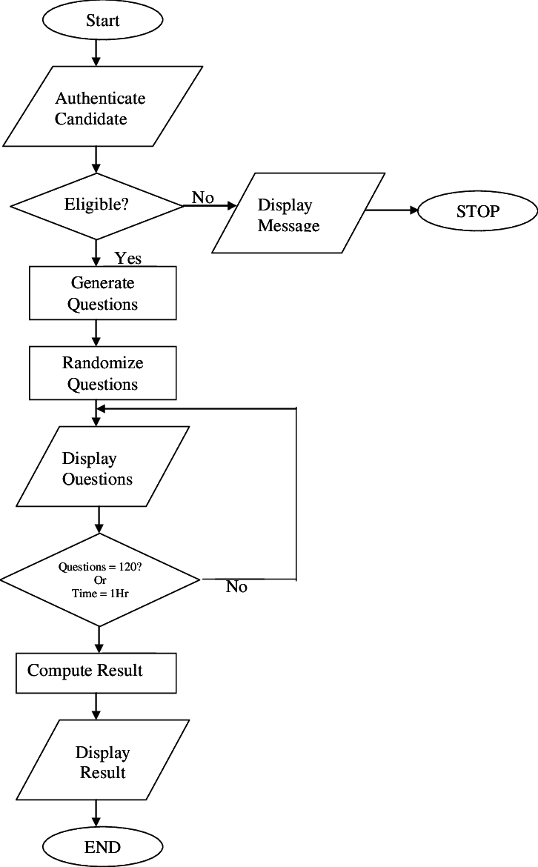

Figure2.6 : Process for developing the Language Skill Exam System

**The first iteration of the system will include the following features:**

**Login Process**

The Language Skill Exam System begins with a secure login process. Users, including administrators and students, need to provide valid credentials to access the system. The login process involves authentication and authorization mechanisms to ensure that only authorized users can access the system. We will describe the steps involved in the login process, including user validation, password encryption, and session management.

**Test Administration**

Once logged in, the system allows administrators to create and manage tests. Test administration includes the following steps:

**Test Creation**

* Administrators have the authority to create new tests. They can specify the test parameters such as test duration, number of questions, and difficulty level. We will describe the process of creating a test, including the selection of language skills to be assessed and the input of relevant test content.

**Test Assignment**

* After creating a test, administrators can assign it to specific students or groups. We will explain how administrators can assign tests based on predefined criteria or manually select individual students. The system should provide an intuitive interface for efficient test assignment.

**Test Taking**

* Students can access assigned tests and begin the examination. The system should present the questions one by one, allowing students to provide their answers. We will describe the user interface for test taking, including features like timer display, navigation between questions, and submission of answers.

**Answer Evaluation**

* Once a student completes the test, the system automatically evaluates the answers. We will explain how the system matches the student's answers with the correct solutions and assigns scores accordingly. The evaluation process should consider multiple-choice questions, open-ended questions, and other question types.

**Result Generation**

After evaluating the answers, the system generates results for each student. We will explain how the system calculates and displays scores, providing students with detailed feedback on their performance. The result generation process should include the calculation of overall scores, section-wise scores, and individual question scores.

User Feedback and Improvement

To ensure continuous improvement of the Language Skill Exam System, user feedback plays a crucial role. We will discuss how the system can collect feedback from both administrators and students regarding the usability, functionality, and effectiveness of the system. Feedback mechanisms such as surveys, ratings, and comments can be integrated into the system for ongoing improvement.

The next iterations of the system will include additional features, such as the ability to create and manage user accounts, the ability to view previous exam results, and the ability to track user progress over time.

**Process Description**

The process for developing the Language Skill Exam System will be divided into a series of iterations. Each iteration will begin with a planning phase, where the team will define the goals for the iteration and the work that needs to be done. The team will then work on the development of the system, and will deliver a working version of the system at the end of the iteration. The team will then collect feedback from users and stakeholders, and use this feedback to improve the system in the next iteration.

**CHAPTER 3 : SYSTEM FEATURES**

This chapter provides a detailed description of the system features. It covers the functionalities available to different users, such as the administrator and students. The features include account management, subject and quiz creation, assignment of quizzes and subjects, result viewing, leaderboard access, and more.

**3.1 Account Management**

The system allows users to create and manage their accounts. Users can create an account by providing their name, email address, and password. Once an account is created, users can log in to the system and access their account settings. Account settings allow users to change their password, email address, and other personal information.

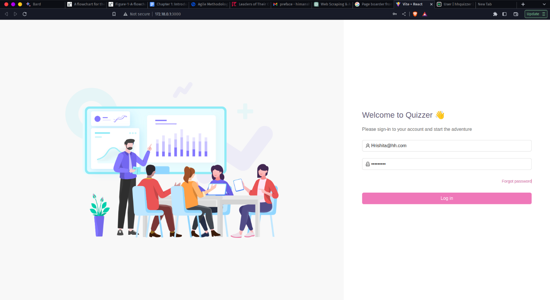Figure 3.1 : User login

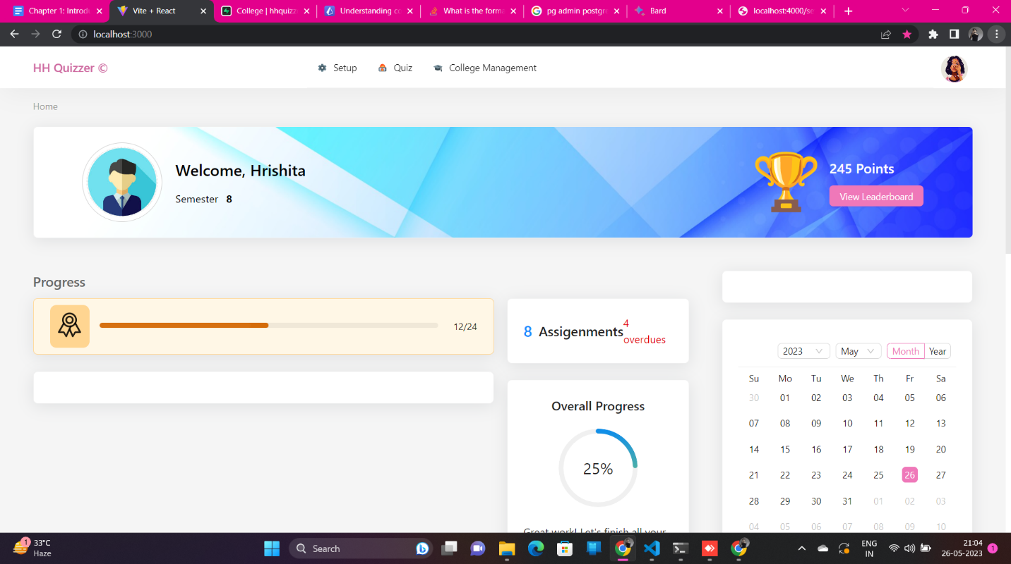

Figure 3.2 : User Dashboard

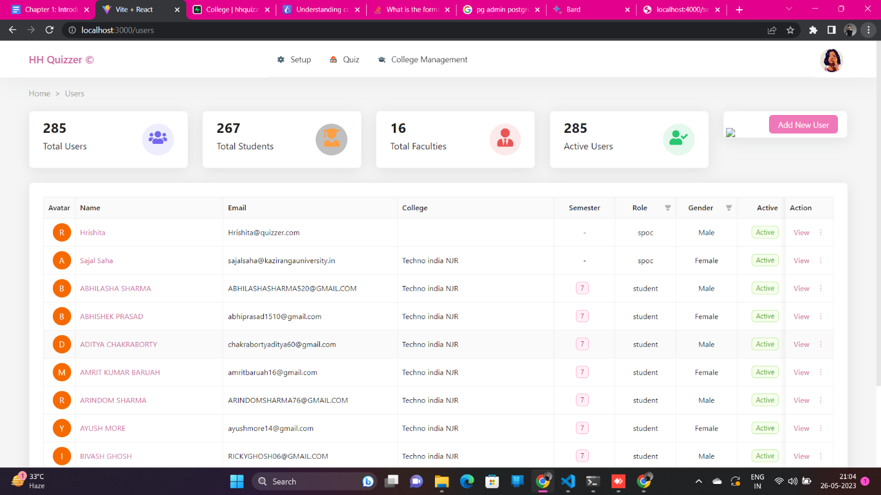

Figure 3.3 : Users list

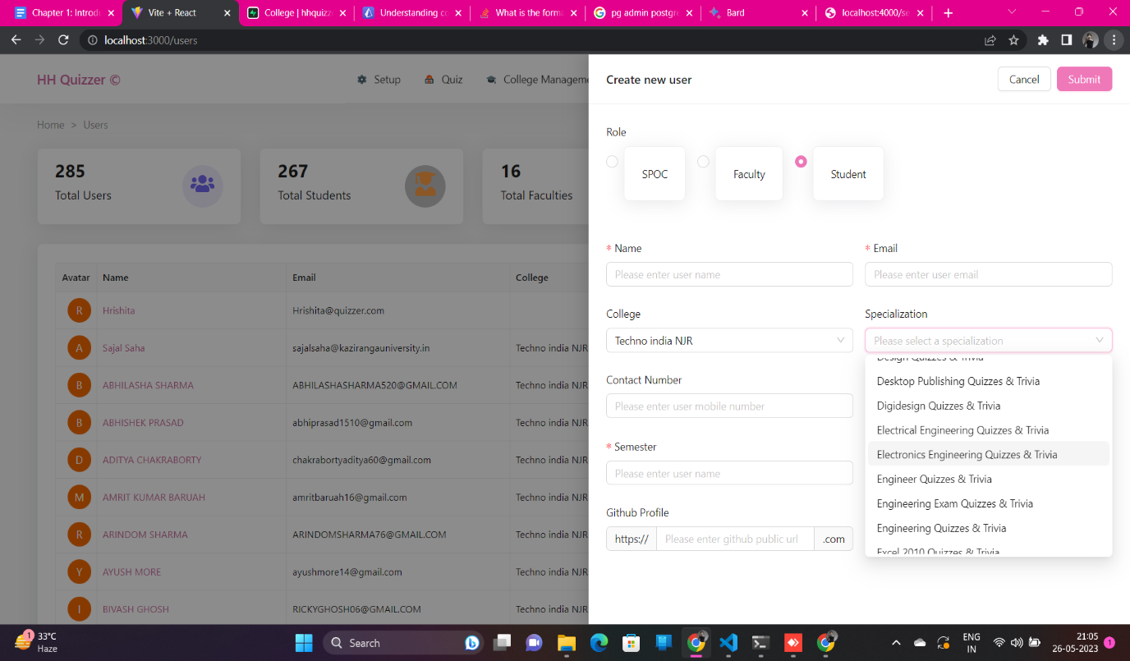

Figure 3.4 : Adding User

**3.2 Subject and Quiz Creation**

The system allows administrators to create subjects and quizzes. Subjects are used to organize quizzes. Quizzes are used to assess student learning. To create a subject, administrators must provide a name for the subject and a description. To create a quiz, administrators must provide a name for the quiz, a description, and a list of questions. Questions can be multiple choice, true/false, or fill-in-the-blank.

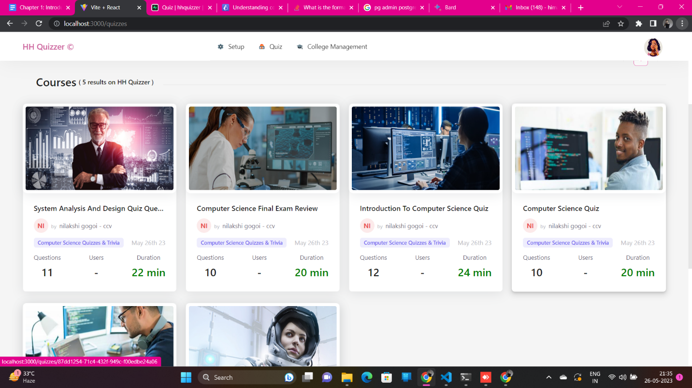

Figure 3.5 : Quiz List

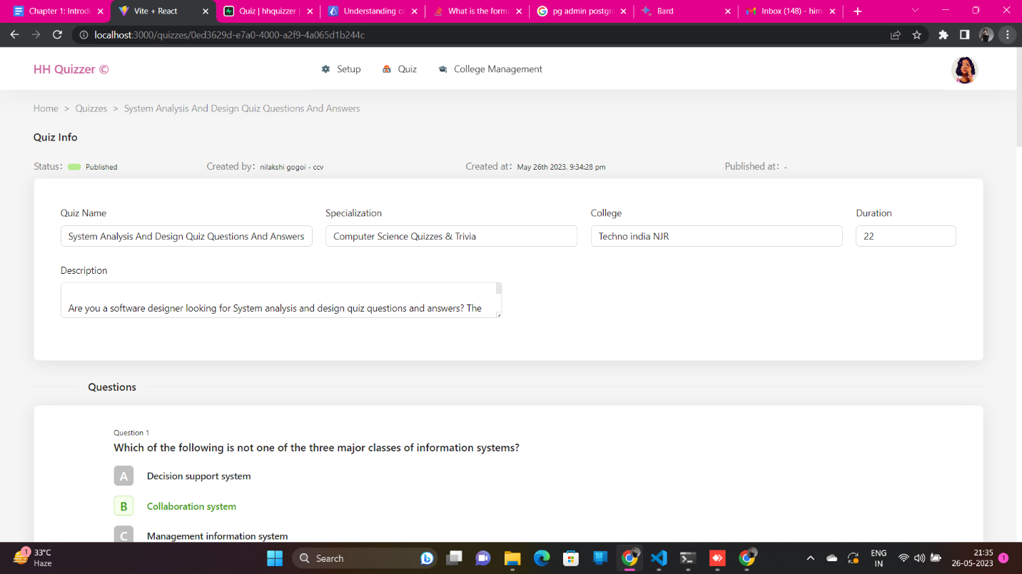

Figure 3.6 : Adding quiz

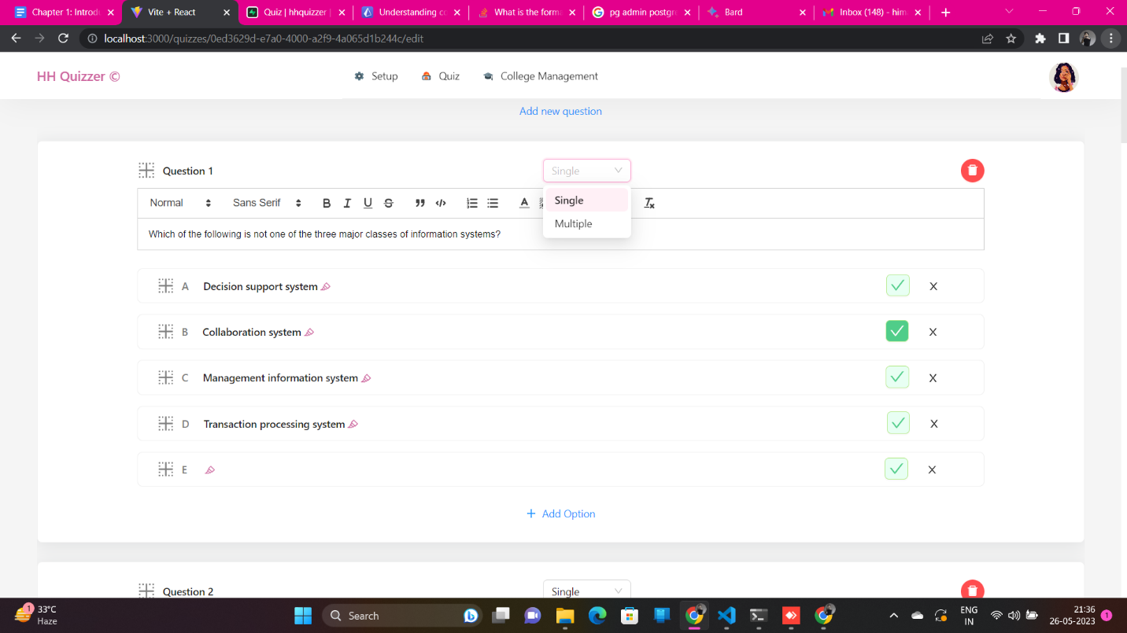

Figure 3.7 : Adding questions to the quiz

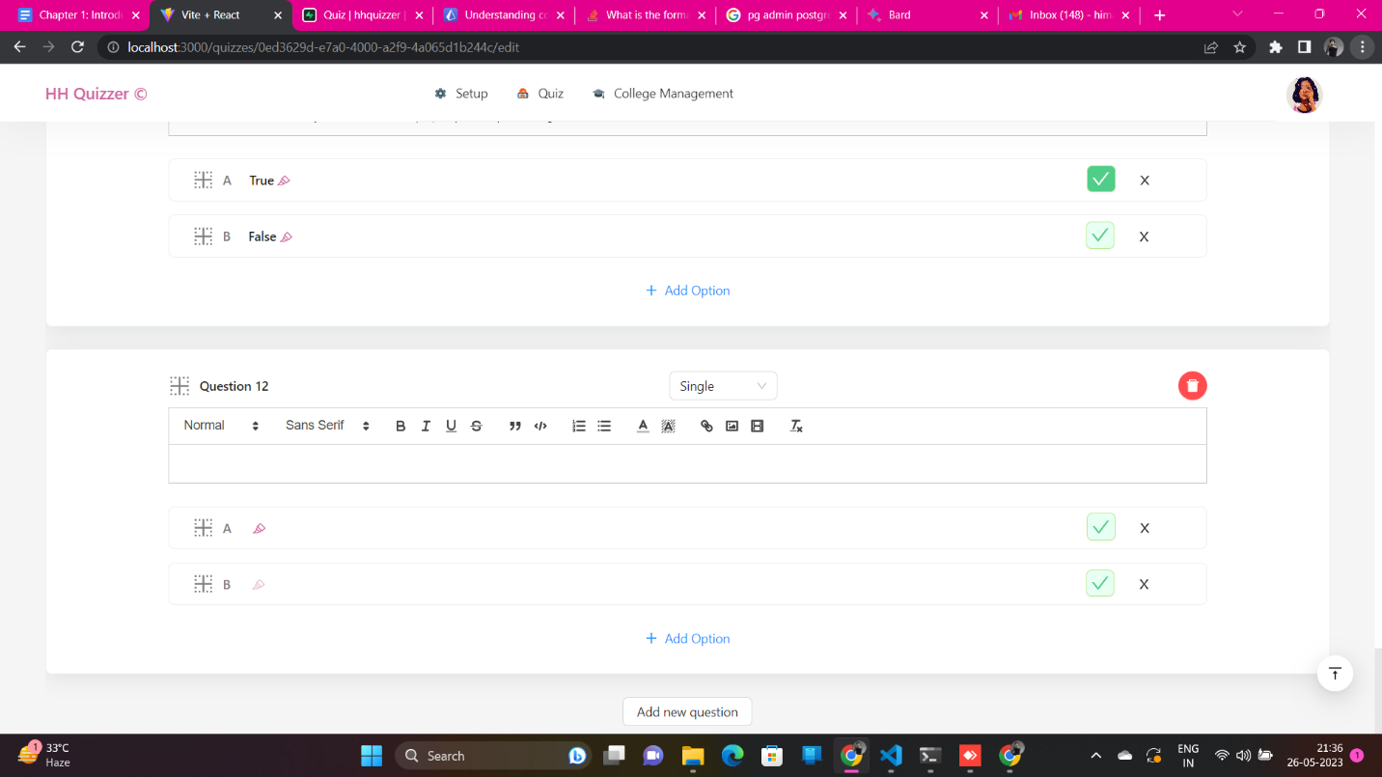

Figure 3.8 : Adding option to the quiz

**3.3 Assignment of Quizzes and Subjects**

Administrators can assign quizzes and subjects to students. To assign a quiz, administrators must select the quiz and the students who will be assigned the quiz. To assign a subject, administrators must select the subject and the students who will be assigned the subject.

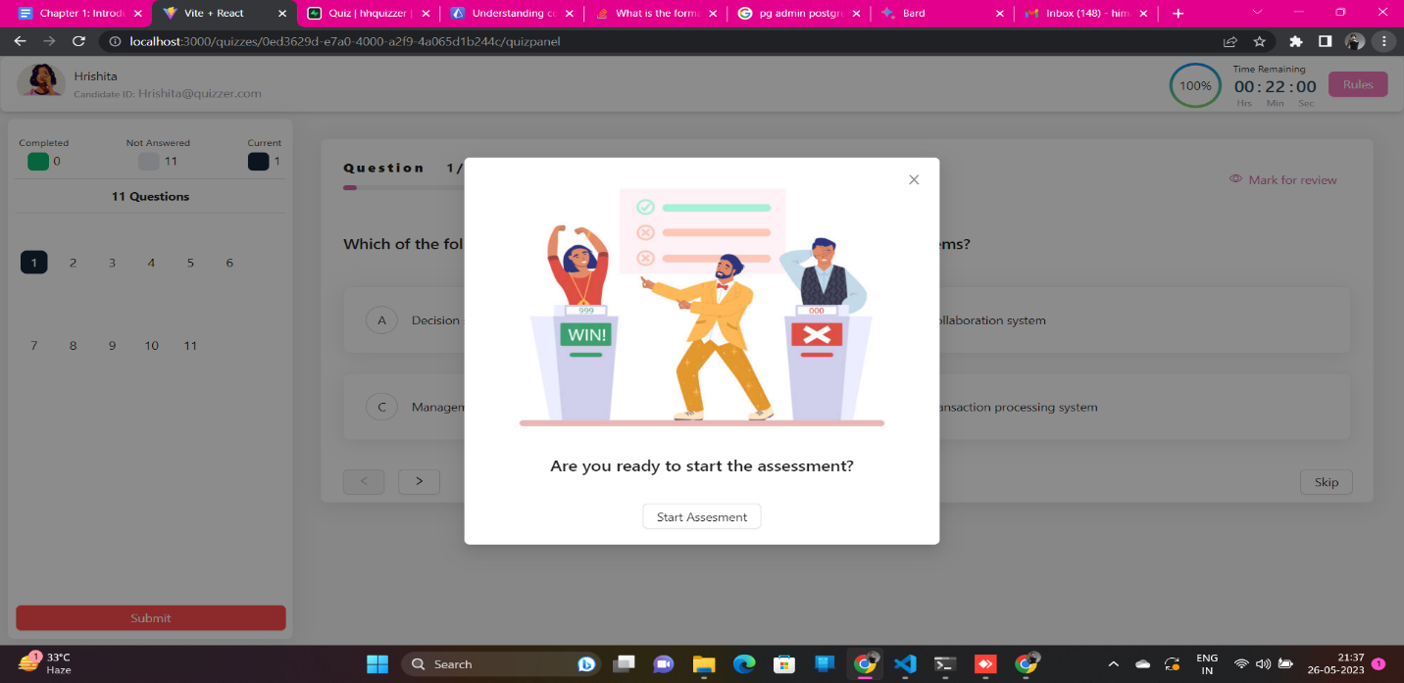

Figure 3.9 : Quiz instruction

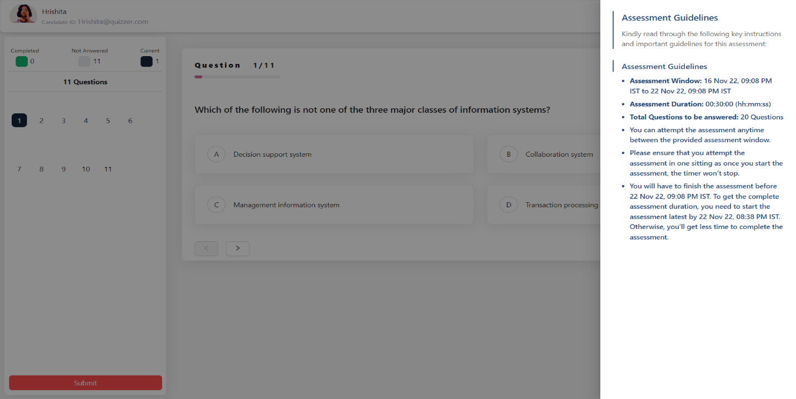

Figure 3.10 : Assessment guidelines

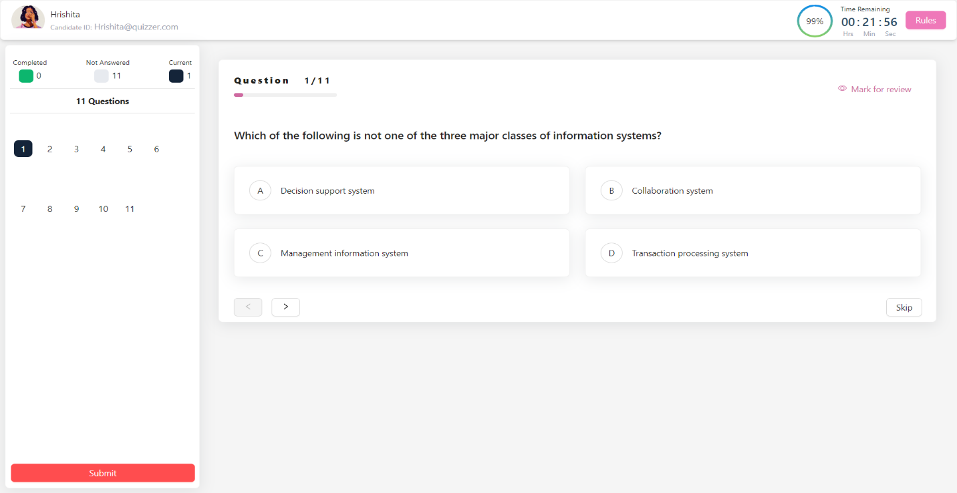

Figure 3.11 : Quiz panel

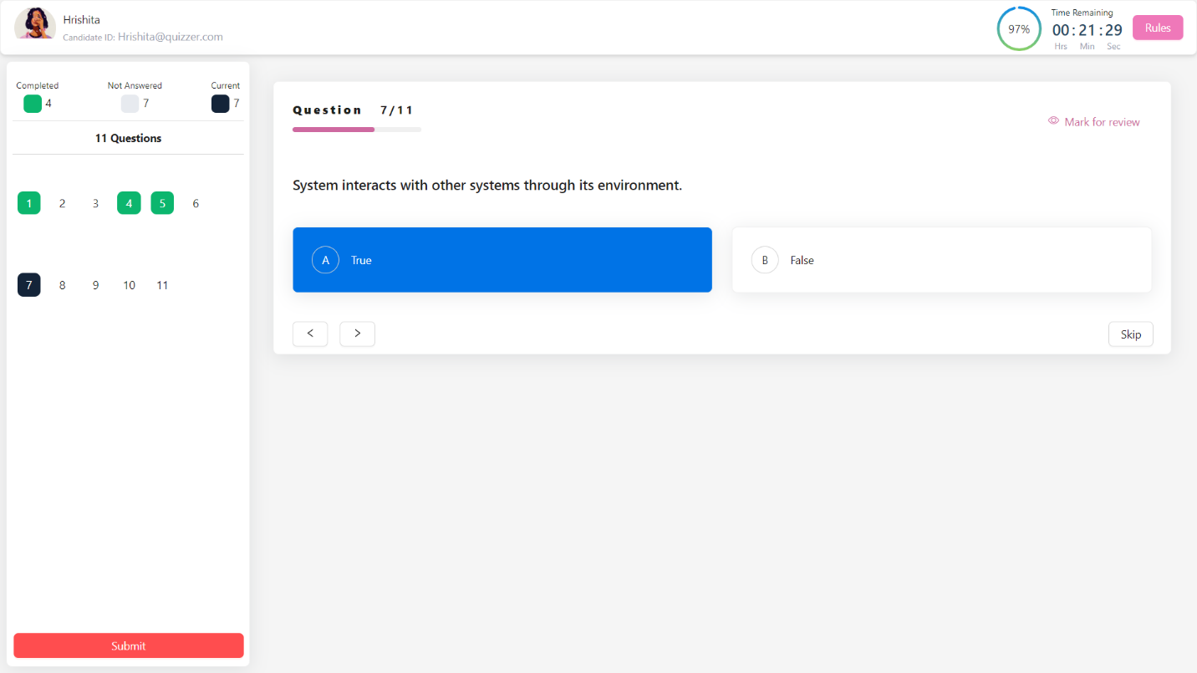

Figure 3.12 : Question answer selection

**3.4 Result Viewing**

Students can view their results for quizzes and subjects. To view results, students must select the quiz or subject for which they want to view results. Students can view their individual results as well as the overall class results.

**3.5 Leaderboard Access**

Students can view the leaderboard for each quiz and subject. The leaderboard shows the top students in the class for each quiz and subject. Students can use the leaderboard to track their progress and to see how they compare to other students in the class.

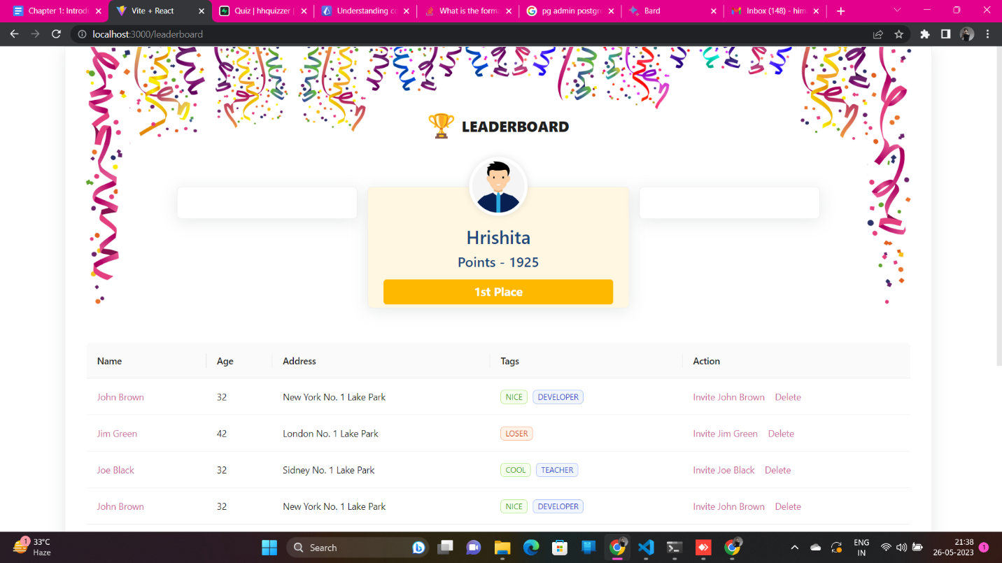

Figure 3.13 : Leaderboard

**CHAPTER 4 : FUNCTIONAL REQUIREMENTS**

This chapter discusses the functional requirements of the Online Exam System. It presents a breakdown of the services provided by the system, divided into candidate and administrator modules. The functionalities include logging in, taking examinations, creating users, quizzes, and subjects, and result generation.

**4.1 Candidate Module**

The candidate module provides the following functionalities:

* Logging in: Candidates can login to the system using their username and password.
* Taking examinations: Candidates can take examinations that have been assigned to them by the administrator.
* Viewing results: Candidates can view their results for examinations that they have taken.

**4.2 Administrator Module**

The administrator module provides the following functionalities:

* Creating users: Administrators can create users for the system.
* Creating quizzes: Administrators can create quizzes for the system.
* Creating subjects: Administrators can create subjects for the system.
* Assigning quizzes to subjects: Administrators can assign quizzes to subjects.
* Assigning subjects to users: Administrators can assign subjects to users.
* Generating results: Administrators can generate results for examinations that have been taken.

**CHAPTER 5: RESOURCES AND LIMITATIONS**

This chapter focuses on the resources used in the project. It mentions the MERN stack (MongoDB, Express.js, React.js, and Node.js) as the primary development tools, along with GitHub for version control and AWS EC2 for hosting. The hardware requirements and limitations, such as the need for continuous internet connectivity, are also addressed.

**5.1 Resources**

The following resources were used in the development of the Online Exam System:

* MERN stack :- The MERN stack is a popular JavaScript-based stack that was used to develop the backend and frontend of the system. MongoDB was used to store the data, Express.js was used to create the APIs, React.js was used to create the frontend, and Node.js was used to run the application.
* GitHub :- GitHub was used to manage the code for the project. It is a popular code hosting platform that allows developers to collaborate on code and track changes.
* React :- React is a JavaScript library for building user interfaces. It is used to build single-page applications. It allows us to create reusable UI components.
* Supabase :- Supabase offers a real-time database that allows developers to store and sync data across multiple devices in real-time, like Firebase. It also provides various backend services, including a serverless platform for running functions and hosting static assets.
* Postgres :- PostgreSQL is a powerful, open source object-relational database system. It has more than 15 years of active development phase and a proven architecture that has earned it a strong reputation for reliability, data integrity, and correctness.
* Express :- Express is a node js web application framework that provides broad features for building web and mobile applications. It is used to build a single page, multipage, and hybrid web application. It's a layer built on the top of the Node js that helps manage servers and routes.
* Prisma :- Prisma is an open source next-generation ORM. Prisma Client can be used in any Node.js (supported versions) or TypeScript backend application (including serverless applications and microservices). This can be a REST API, a GraphQL API, a gRPC API, or anything else that needs a database.
* Antd :- Ant Design 5.0 use CSS-in-JS technology to provide dynamic & mix theme ability. And which use component level CSS-in-JS solution get your application a better performance.

**5.2 Limitations**

The following limitations were identified during the development of the Online Exam System:

* Hardware requirements: The system requires a minimum of 1GB of RAM and 1 CPU core. It also requires a stable internet connection.
* Security: The system is not 100% secure. It is important to take precautions to protect student data, such as using strong passwords and enabling two-factor authentication.
* Scalability: The system is designed to be scalable, but it may not be able to handle a large number of users. It is important to monitor the system and make changes as needed.

**5.3 Conclusion**

The Online Exam System is a web application that allows students to take online exams. The system is developed using the MERN stack and hosted on AWS EC2. The system has a number of features, such as logging in, taking examinations, and viewing results. The system is designed to be user-friendly and to provide students with the resources they need to succeed. The system is also designed to be scalable, so that it can be used by schools of all sizes.

The system has a number of limitations, such as the need for continuous internet connectivity and the lack of 100% security. It is important to take precautions to protect student data and to monitor the system for scalability issues.

Overall, the Online Exam System is a valuable tool that can help students to improve their learning. The system is easy to use and provides a number of features that can help students to succeed.

**Reference**

* **Websites:**

1. Ant Design - for frontend template ( <https://ant.design/> )
2. React Icons - for icons ( <https://react-icons.github.io/react-icons/> )
3. Stack Overflow - for issue resolution ( <https://stackoverflow.com/> )
4. React - <https://react.dev/>