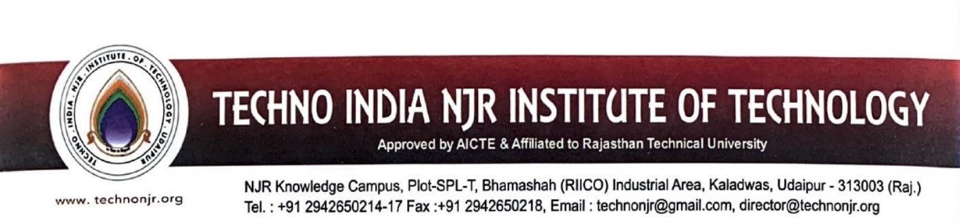

**Date: 11-01-2023**

**TO WHOMSOEVER IT MAY CONCERN**

Techno India NJR Institute of Technology ensures effective Programme curriculum prescribed by Rajasthan Technical University Kota. The detailed syllabus of the courses is available at :

<https://iqac.technonjr.org/aqar/2021-22/part-b/1.3.2/Syllabus%20&%20Scheme/>

