**Techno India NJR Institute of Technology**



**Course File**

**Session 2021-22**

**Engineering Physics (1FY2-02/2FY2-02)**

Vanija Joshi

(Assistant Professor)

**Department of Basic Science**

**Notice: Academic Calendar 2021-2022**

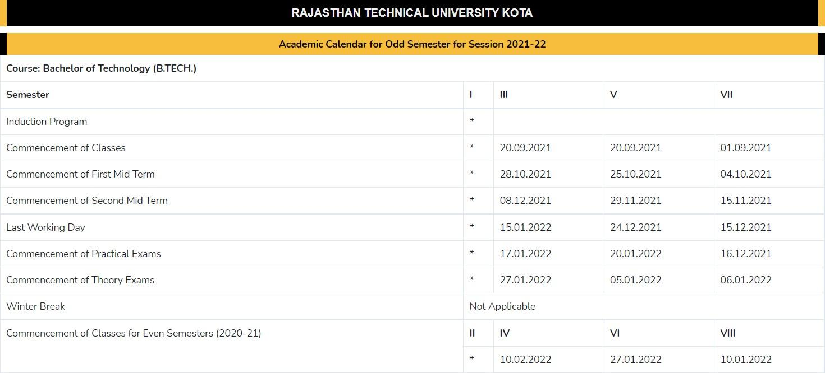

| **Academic Calendar Odd Semester 2021-22** | | | | |
| --- | --- | --- | --- | --- |
| **Particulars** | **B. Tech- I** | **B. Tech- III** | **B. Tech- V** | **B. Tech- VII** |
| Commencement of classes | * | 20-09-2021 | 20-09-2021 | 01-09-2021 |
| Last Working Day | * | 15-01-2022 | 24-12-2021 | 15-12-2021 |
| Course Progression Report-I | * | 20-10-2021 | 20-10-2021 | 20-10-2021 |
| First Mid Term Exam | * | 28-10-2021 | 25-10-2021 | 25-10-2021 |
| Remedial Class-I | * | 08-11-2021 | 08-11-2021 | 08-11-2021 |
| Course Progression Report-II | * | 04-12-2021 | 20-11-2021 | 20-11-2021 |
| Second Mid Term Exam | * | 08-12-2021 | 29-11-2021 | 22-11-2021 |
| Remedial Class-II | * | 16-12-2021 | 09-12-2021 | 09-12-2021 |
| Commencement of Theory Exam | * | 27-01-2022 | 05-01-2022 | 06-01-2022 |
| Commencement of Practical Exam | * | 17-01-2022 | 20-01-2022 | 16-12-2021 |



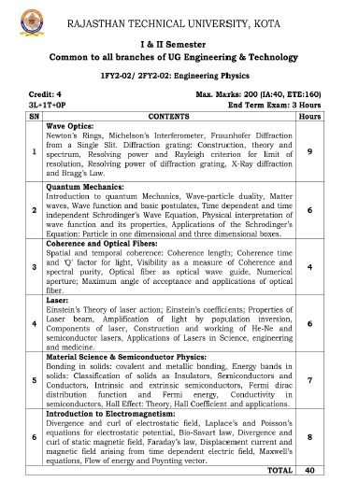

**Course Overview:**

Student will learn fundamentals of physics and how it forms the basis of all engineering and science from this 47-hour course. In this course, student will study the fundamental concepts and application of different physical phenomenon and their theory.

**Course Outcomes:**

| **CO. NO.** | **Cognitive Level** | **Course Outcome** |
| --- | --- | --- |
| 1 | Application | Apply and operate on the concept of interference and diffraction to explain various wave optical phenomena |
| 2 | Knowledge | To describe the concept of quantum mechanics and apply the knowledge to 1D and 3D potential box problem |
| 3 | Analysis | Application of coherence in the source of light and basics of optical fiber: employment of working principle and construction of lasers: demonstration of optical waveguides |
| 4 | Synthesis | Application of physics of semiconductors material and their classifications |
| 5 | Synthesis | Breakdown of electromagnetism with the help of Maxwell’s equations and formulate the electromagnetic energy transformation theorem |

**Prerequisites:**

* Basic mathematics
* Understanding of basic high-school physics
* Able to solve 2nd and 3rd order differential equations
* Aware with the concepts of atomic structure

**Course Coverage Module Wise:**

**Lecture plan based on Unit 1**

| Lecture Sl. No. | Topic |
| --- | --- |
| 1 | Student is able to grasp basic nature of waves and their optical behaviour. |
| 2 | Student becomes familiar with Interference and different types of Interferometers. |
| 3 | Student should be able to identify different patterns of Diffraction. |
| 4 | Student becomes familiar with Diffraction grating and application . |
| 5 | Student is able to grasp concept of Rayleigh criterion. |
| 6 | Student should be able to identify different parts of Spectrum. |
| 7 | Student becomes familiar with Resolving power of optical devices . |
| 8 | Student should be able to understand X-Ray diffraction and bragg’s law. |

**Lecture plan based on Unit 2**

| Lecture Sl. No. | Topic |
| --- | --- |
| 9 | Introduction to Quantum Mechanics. |
| 10 | Student is able to grasp concept of Wave Particle duality. |
| 11 | Student becomes familiar with the concepts of Matter waves and basic postulates . |
| 12 | Student is able to grasp concept of Wave functions . |
| 13 | Student becomes familiar with Properties of Wave functions. |
| 14 | Student is able to grasp concept of Schrodinger’s wave equation. |
| 15 | Student becomes familiar with Applications of Schrodinger’s wave equation. |

**Lecture plan based on Unit 3**

| Lecture Sl. No. | Topic |
| --- | --- |
| 16 | Student is able to grasp concept of Spatial coherence. |
| 17 | Student becomes familiar with Temporal coherence. |
| 18 | Q factor. |
| 19 | Student is able to grasp concept of Visibility. |
| 20 | Student becomes familiar with Optical Waveguides. |
| 21 | Student is able to grasp concept of Optical fibers. |
| 22 | Student becomes familiar with Numerical Aperture. |
| 23 | Student is able to grasp concept of Angle of Acceptance. |
| 24 | Student becomes familiar with Applications of Optical fibers. |

**Lecture plan based on Unit 4**

| Lecture Sl. No. | Topic |
| --- | --- |
| 25 | Student becomes familiar with basic Laser Action. |
| 26 | Student is able to grasp concept of Einstein’s theory of laser action. |
| 27 | Student becomes familiar with Einstein’s coefficients. |
| 28 | Student is able to grasp concept of Properties of Laser beam. |
| 29 | Student becomes familiar with Population inversion. |
| 30 | Student is able to identify Components of Lasers. |
| 31 | Student is able to grasp concept of Laser construction. |
| 32 | Student becomes familiar with He-Ne laser. |
| 33 | Student becomes familiar with Semiconductor Lasers |
| 34 | Applications of lasers. |

**Lecture plan based on Unit 5**

| Lecture Sl. No. | Topic |
| --- | --- |
| 35 | Student is able to grasp concept of Bondings in material, energy bands and classification of solids. |
| 36 | Student becomes familiar with Intrinsic and Extrinsic semiconductors. |
| 37 | Student is able to grasp concept of Fermi Dirac distribution function. |
| 38 | Fermi Energy. |
| 39 | Student is able to grasp concept of Conductivity and factors affecting it. |
| 40 | Hall- effect. |
| 41 | Student is able to grasp concept of Hall-coefficient. |
| 42 | Applications of Semiconductors. |

**Lecture plan based on Unit 6**

| Lecture Sl. No. | Topic |
| --- | --- |
| 43 | Student becomes familiar with Divergence and curl of electrostatic field. |
| 44 | Student is able to grasp concept of Electrostatic potential. |
| 45 | Student is able to grasp concept of Laplace’s equation. |
| 46 | Student is able to grasp concept of Poisson’s equation. |
| 47 | Student becomes familiar with Biot-Savart law. |
| 48 | Student is able to grasp concept of Displacement current. |
| 49 | Student becomes familiar with Time-dependent Electric field. |
| 50 | Student understands Maxwell’s Equations and their vast applications. |
| 51 | Poynting vector. |

**TEXT/REFERENCE BOOKS**

* Essentials of Engineering Physics (RTU), 2nd edition,A S Vasudeva, S. Chand Publishing.
* Engineering Physics, 2nd Edition, Hitendra K Malik, A K Singh, McGraw-Hill Education Publications.

# Optical Physics, 4th Edition, By Ariel Lipson, Stephen G. Lipson, Henry Lipson, Cambridge University Press.

**Teaching and Learning resources:**

**Unit 1**

[**https://drive.google.com/drive/folders/1pB4Lmd0WFj3Sdc566GW3shJd-D6NdsLD?usp=sharing**](https://drive.google.com/drive/folders/1pB4Lmd0WFj3Sdc566GW3shJd-D6NdsLD?usp=sharing)

**Unit 2**

[**https://nptel.ac.in/courses/115/106/115106127/**](https://nptel.ac.in/courses/115/106/115106127/)

**Unit 3**

[**https://nptel.ac.in/courses/115/108/115108127/**](https://nptel.ac.in/courses/115/108/115108127/)

**Unit 4**

[**https://nptel.ac.in/courses/115/102/115102124/**](https://nptel.ac.in/courses/115/102/115102124/)

**Unit 5**

[**https://nptel.ac.in/courses/115/102/115102124/**](https://nptel.ac.in/courses/115/102/115102124/)

**Unit 6**

[**https://youtu.be/bwreHReBH2A**](https://youtu.be/bwreHReBH2A)

**Assessment Methodology:**

1. Quiz on after every module completion.
2. Experiments are performed in laboratory (Once in a week)
3. Assignments one from each unit.
4. Midterm subjective paper. (Twice during the semester)
5. Final paper at the end of the semester is subjective.

**ENGINEERING PHYSICS**

**QUESTION BANK**

**Unit-I**

**Wave Optics**

Q1 (a) Describe the construction and working of Michelson’s interferometer

(b) How will you determine the wavelength difference of two components of a line by Michelson’s interferometer?

(c) Show how Michelson’s interferometer is used to find the wave length of light.

Q2 (a) Explain the formation of Newton’s Rings in reflected light. Prove that the diameters of dark rings are proportional to the square root of natural numbers.

(b) How will you measure wave length of light used in Newton’s ring experiment? Derive the formula used.

(c) What will be effect on Newton’s rings if

(i) A little oil (μ=1.65) is introduced between the lens (μ=1.5) and the glass plates (μ=1.75).

(ii) A plane mirror is placed instead of the glass below the plano-convex lens.

(iii) A plano-convex lens of small radius is used.

Q3 Discuss the phenomenon of Fraunhofer diffraction due to single slit and derive an expression for intensity of diffracted light. Show that the relative intensity of successive maxima are nearly $1:\frac{4}{9π^{2}}:\frac{4}{25π^{2}}:\frac{4}{49π^{2}}$

Q4 (a) What is diffraction grating? Derive an expression for intensity of light diffracted from a plane transmission grating.

(b) Explain the formation of diffraction spectra with a plane transmission grating. How would you use it to determine the wavelength of a monochromatic light?

Q5 (a) Explain Rayleigh’s criteria of resolution.

(b) Show that the resolving power of a diffraction grating depends on (i) No. of ruled lines and (ii) width of ruled space.

(c) Derive an expression for dispersive power of a plane transmission grating.

Q6 What do you understand by diffraction of X-rays from solids and explain Bragg’s law

Q7 (a) Write the difference between Interference and Diffraction.

(b) What is Interference? Write the condition for interference.

(c) How do Michelson’s rings differ from Newton’s rings?

(d) How do circular fringes originate in MI?

(e) What is resolution?

(e) In Newton’s ring experiment, explain why

(i) Central fringe is dark in reflected light?

(ii) Why fringes are circular?

(iii) The rings get closer away from the centre ?

**Unit-II**

**Quantum Mechanics**

Q8 Derive the time dependent and independent Schrodinger’s wave equation.

Q9 Explain why integral of ${\left|Ψ\right|}^{2}$ over all space must be unity. Why normalization of $Ψ$ is imposed on any wave function.

Q10 Write down the Schrodinger’s wave equation for a particle in a box and solve it to derive its Eigen function and Eigen value.

Q11 (a) Write down Schrodinger’s wave equation for a particle of mass ‘m’ trapped in 3D cubical box of length ‘a’. Solve it to get Eigen functions and show that Eigen values are discrete.

(b) Find the energy of the following states:

(i) Non-degenerate

(ii) Doubly degenerate

(iii) Triply degenerate

Q12 Explain the following

1. wave function and its physical interpretation.
2. Normalized wave function
3. Orthogonal wave function
4. properties of a valid wave function
5. Degeneracy
6. Order of degeneracy
7. Non-degenerate states

**Unit-III**

**COHERENCE AND OPTICAL FIBRES**

Q13 What is Coherence? Explain temporal and spatial coherence. Write down the difference between temporal and spatial coherence.

Q14 What is visibility? Show that visibility is a measure of degree of coherence.

Q15 Define Coherence length, coherence time and spectral purity? Derive an expression for coherence length and coherence time in terms of wavelength and frequency.

Q16 How does monochromaticity relate to temporal coherence? Define Q factor for a spectral line.

Q17 How does size of the source relate to spectral coherence? Derive the expression for coherence length of a wave in terms of the line width corresponding to frequency band.

Q18 What is an optical fibre? Describe the construction and working of the optical fibre.

Q19 Give structure of optical fibres. Explain function of each part. Give advantages of optical fibre over copper conducts.

Q20 What do you mean by numerical aperture of an optical fibre? Derive an expression for numerical aperture of a step index optical fibre.

Q21 Explain clearly the propagation of electromagnetic wave inside an optical fibre. Use proper diagram. Derive the expression for the maximum acceptance angle of optical fibre in air.

Q22 Write the applications and characteristics of optical fibres.

**Unit-IV**

**LASER**

Q23 What do you mean by LASER? Explain the essential requirements for producing LASER action.

Q24 What do you understand by spontaneous emission and stimulated emission. Differentiate between the two.

Q25 Obtain a relation between Einstein’s coefficient A and B for spontaneous and stimulated emission.

Q26 Give the reason for the following basic properties of a LASER:

1. High intensity
2. High directionality
3. High monochromaticity
4. High coherence

Q27 What do you mean by active medium, population inversion and optical pumping in reference to LASER action?

Q28 Describe the construction and working of He-Ne LASER. With the help of energy level diagram explain how population inversion is achieved to He-Ne LASER.

Q29 Describe the construction and working of semiconductor LASER also write the various applications of semiconductor LASER.

Q30 Write the difference between Ordinary light and Laser light.

**Unit-V**

**Material Science and Semiconductor physics**

Q31 What do you mean by bonding in solids and explain covalent bonds and metallic bonds.

Q32 Explain the formation of bands in solids. How will you classify solids into conductor, insulator and semiconductor on the basis of the above theory?

Q33 Explain and derive an expression for conductivity in intrinsic and extrinsic semiconductors.

Q34 (a) What is Hall effect and derive an expression for Hall coefficient?

(b) Explain how you will use Hall experiment to distinguish the p-type and n-type semiconductors.

Q35 Write a short note on intrinsic and extrinsic semiconductors.

**Unit-VI**

**Introduction of Electromagnetism**

Q36 Derive the Maxwell’s Equations and discuss their physical significance.

Q37 Deduce the Poynting theorem and explain the physical significance for various terms involved in the expression.

Q38 Explain the following:

1. Divergence of a vector field
2. Curl of a vector field
3. Displacement current
4. Faraday’s law
5. Ampere’s law
6. Modified Ampere’s law
7. Poynting vector
8. Biot-Savart law

Q39 Derive the Poisson’s and Laplace equation’s for electrostatic potential.

………..

**ENGINEERING PHYSICS**

**QUIZ**

Q.1 What is Interference?

Q.2 Give the condition for Diffraction.

Q.3 What is Resolving power?

Q.4 What is Grating element?

Q.5 What is Dispersion.

Q.6 What is De-Broglie Hypothesis?

Q.7 What are the conditions for an acceptable wave function?

Q.8 What is Zero point energy?

Q.9 What is Degeneracy?

Q.10 What is mater wave?

Q.11 On which principle optical fibre works?

Q.12 What is Numerical Appertue?

Q.13 What is the difference between Spatial and Temporal coherence?

Q.14 What is Band Width?

Q.15 What is coherence time?

Q.16 What is LASER?

Q.17 What are threshold conditions for Laser action.

Q.18 Which pumping method is used in He-Ne Laser?

Q.19 What is population inversion?

Q.20 What are the properties of Laser light.

Q.21 What are bonds.

Q.22 In which bonding electrons are shared?

Q.23 What is Hall Effect?

Q.24 Which type of impurities are used in P-type and N-type Semiconductors.

Q.25 What is forbidden energy gap?

Q.26 What is physical significance of curl of a vector?

Q.27 What is difference between Conduction current and Displacement Current?

Q.28 What is Poynting vector?

Q.29 What is Poisson’s Equation?

Q.30 What is Faraday’s law?

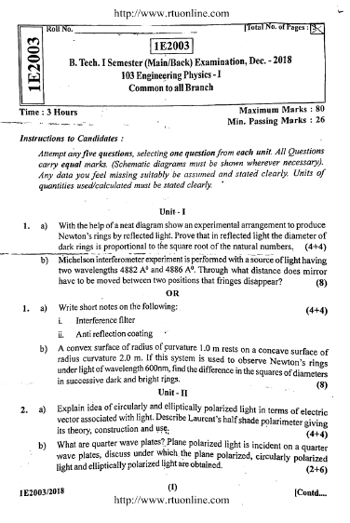 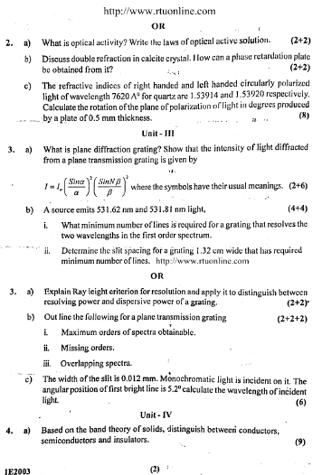 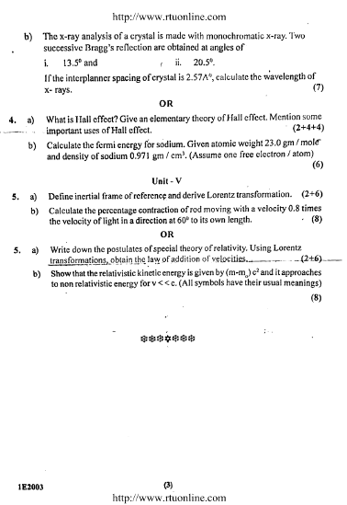 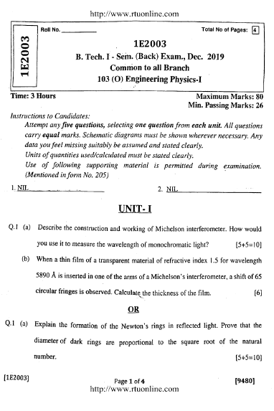 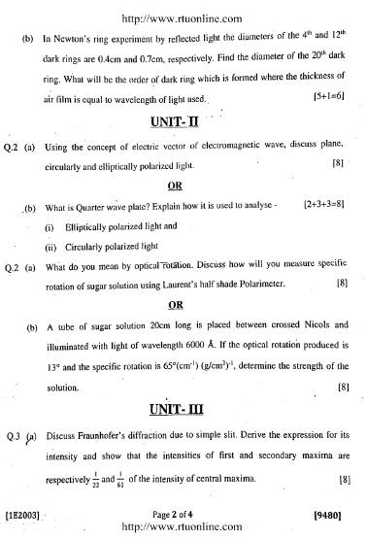 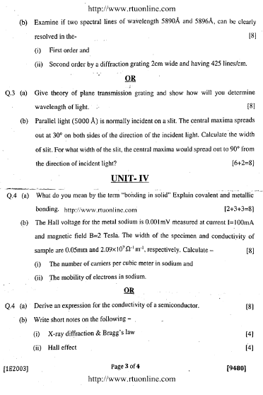

# 

# *Techno India NJR (@TechnoIndiaNJR) | Twitter*

**TECHNO INDIA NJR INSTITUTE OF TECHNOLOGY, UDAIPUR**

**B. TECH 1st – YEAR (I SEM.) – MT-I**

Subject Name: Engineering Physics (**1FY2-02**)

**Time:** 2 Hr **Max. Marks:** 70

**Note:**

1. The paper is divided into 2 parts: Part-A and Part-B.
2. Part-A contains 10 questions and carries 2 mark each.
3. Part-B contains 5 questions. Each question is having two options and carries 10 marks each.

Part- A (20 Marks)

|  | Write the differences the Interference and Diffraction. | CO1 |
| --- | --- | --- |
|  | What is Diffraction Grating? | CO1 |
|  | What is Heidinger’s fringes? | CO1 |
|  | Write Normalization and Orthogonal Conditions? | CO2 |
|  | What is De-Broglie hypothesis? | CO2 |
|  | Explain the term order of degeneracy. | CO2 |
|  | What is wave function? | CO2 |
|  | What is Coherence length and Coherence time? | CO3 |
|  | What is Coherence? | CO3 |
|  | What is Band width? | CO3 |

Part- B (50 Marks)

| 1.Explain the formation of Newton’s Rings in reflected light. Prove that the diameters of dark rings are proportional to the square root of natural numbers | CO1 |
| --- | --- |
| OR | |
| 1. (a) Derive an expression for dispersive power of a plane transmission grating.  (b) In Bragg’s reflection of X-ray, a reflection was found at the glancing angle of 300 with lattice planes of spacing 1.87Å. If this is a second order reflection, then calculate the wavelength of X-ray. | CO1 |

| 2. Discuss the phenomenon of Fraunhofer diffraction due to single slit and derive an expression for intensity of diffracted light. Show that the relative intensity of successive maxima are nearly $1:\frac{4}{9π^{2}}:\frac{4}{25π^{2}}:\frac{4}{49π^{2}}$ | CO1 |
| --- | --- |
| OR | |
| 2. (a) Explain Rayleigh’s criteria of resolution.  (b) A grating has 9600 lines uniformly spaced over a width of 3.00 cm and is illuminated by light from mercury vapour lamp. Find  (i) Dispersion in the third order in the vicinity of green line of wavelength 5460Å.  (ii) Resolving power of grating in fifth order. | CO1 |

| 3. (a) Derive Schrodinger’s time dependent equation.  (b) Find the probability that a particle in a box L wide can be found between x=0 and x=L/n when it is in the nth state. | CO2 |
| --- | --- |
| OR | |
| 3. Obtain Eigen values and normalization wave function for a free particle confined in one-dimensional box of size a. | CO2 |

| 4. (a) Derive an expression for Schrodinger’s time independent equation.  (b) An electron is put in a cubical box of each side 1Å.Calculate the value of its momentum and energy of first excited state. | CO2 |
| --- | --- |
| OR | |
| 4. (a) Explain the following  (i)Normalized wave function  (ii)Orthogonal wave function  (b) A small object of mass 1mg is confined to move between two rigid walls separated by 1cm. Calculate the zero point energy. | CO2 |

| 5. What is an optical fibre. Derive an expression for Acceptance angle and Numerical Aperture of step index optical fibre. | CO3 |
| --- | --- |
| OR | |
| 5. (a) Explain the terms Spatial and Temporal coherence.  (b) What is the coherence length of a source of wavelength 6750 Å with a band width of 0.4 Å? | CO3 |

---------------------

**TECHNO INDIA NJR INSTITUTE OF TECHNOLOGY, UDAIPUR**

**B. TECH 1st – YEAR (I SEM.) – MT-II**

Subject Name: Engineering Physics (**1FY2-02**)

**Time:** 2 Hr **Max. Marks:** 70

**Note:**

1. The paper is divided into 2 parts: Part-A and Part-B.
2. Part-A contains 10 questions and carries 2 mark each.
3. Part-B contains 5 questions. Each question is having two options and carries 10 marks each.

Part- A (20 Marks)

| A. | Define Population Inversion. | CO3 |
| --- | --- | --- |
| B. | What is the basic requirement of a LASER? | CO3 |
| C. | Write the differences between ordinary light and LASER light. | CO3 |
| D. | What is Bond? | CO4 |
| E. | What is Semiconductor? | CO4 |
| F. | Define Fermi Enegy. | CO4 |
| G. | What is Hall coefficient? | CO4 |
| H. | Write Poisson’s and Laplace’s equation. | CO5 |
| I. | What is Displacement current? | CO5 |
| J. | Define Poynting vector. | CO5 |

Part- B (50 Marks)

| 1. (a) Explain the terms Absorption, Stimulated Emission and Spontaneous emission.  (b) A hypothetical atom has two atomic levels spaced by 3eV in energy. Calculate the population ratio in higher energy to lower energy at 50oC. | CO3 |
| --- | --- |
| OR | |
| 1. Explain the construction and working of He-Ne laser. Draw necessary diagram and also write the role of He atoms. | CO3 |

| 2. Describe the construction and working of semiconductor LASER also write the various applications of semiconductor LASER. | CO3 |
| --- | --- |
| OR | |
| 2. Explain the formation of bands in solids. How will you classify solids into conductor, insulator and semiconductor on the basis of the above theory? | CO4 |

| 3. What is Hall effect and derive an expression for Hall coefficient? | CO4 |
| --- | --- |
| OR | |
| 3. What do you mean by bonding in solids and explain covalent bonds and metallic bonds. | CO4 |

| 4. (a) Explain and derive an expression for conductivity in intrinsic and extrinsic semiconductors.  (b) The resistivity of doped Silicon sample is 8.9 × 10-3 Ωm. The Hall coefficient was measured to be 3.6 × 10-4 m3/C. Assuming single carrier conduction, find the mobility and density of charge carriers. | CO4 |
| --- | --- |
| OR | |
| 4. Explain the following:  (i) Gradient of a function  (ii)Divergence of a vector field  (iii)Curl of a vector field  (iv)Biot-Savart law | CO5 |

| 5. Derive the Maxwell’s Equations and discuss their physical significance. | CO5 |
| --- | --- |
| OR | |
| 5. (a) Deduce the Poynting theorem and explain the physical significance for various terms involved in the expression.  (b) An electromagnetic wave in vacuum has electric field amplitude of 220V/m. Calculate the amplitude of the corresponding magnetic field. | CO5 |

---------------------