**Course File**

***Subject Title/Subject Code: Basic Civil Engineering (2FY3-09)***

Semester: I Year: I

|  |  |  |
| --- | --- | --- |
| Name of the Faculty: Mr. Jitendra Choubisa |  | |
|  |  | |
| E-mail id: jitendra.choubisa@technonjr.org |  |

**Class Schedule**

**Total Number of Lectures:** 45

**Course Overview:**

Basic Civil Engineering is an introductory course designed for Bachelor Students pursuing a degree in Engineering. The course provides a broad overview of the fundamentals of Civil Engineering, including the concepts and principals involved in design, construction, and maintenance of civil infrastructure.

Course Objectives includes:

* To introduce students to the field of Civil Engineering and the different sub-disciplines of Civil Engineering.
* To teach students the basic principles of surveying, soil mechanics, mechanics of materials, and structural analysis.
* To develop students' understanding of engineering materials, their properties, and their applications in civil engineering.
* To provide students with an introduction to the principles of engineering design, including the planning, design, and construction of infrastructure projects.
* To develop students' skills in problem-solving and critical thinking in the context of civil engineering problems.

**INDEX - COURSE FILE**

|  |  |  |
| --- | --- | --- |
| **S. No.** | **CONTENT / ITEM NO.** | **PAGE NO.** |
| **Status** |
| 1 | Vision And Mission Of The Institute |  |  |
| 2 | Vision And Mission Of The Department |  |  |
| 3 | Program Educational Objective Of Department (PEO’s) |  |  |
| 4 | Program Outcomes Of Department (PO’s) |  |  |
| 5 | Course Outcome (COs) |  |  |
| 6 | COs mapping with POs and PSOs |  |  |
| 7 | Academic Calendar |  |  |
| 8 | Evaluation Scheme |  |  |
| 9 | Course Syllabus |  |  |
| 10 | Prescribed Books |  |  |
| 11 | Copy Of Time Table |  |  |
| 12 | Course Schedule Plan |  |  |
| 13 | Assignment Sheet (Unit Wise) |  |  |
| 14 | Quiz Questions (One From Each Unit) |  |  |
| 15 | Question Papers Of Mid Term Exam-I |  |  |
| 16 | Marks and Gap Analysis in Mid Term I |  |  |
| 17 | Remedial Action Taken To Remove the Gaps after Mid Term I |  |  |
| 18 | Question Papers Of Mid Term Exam-II |  |  |
| 19 | Gap Analysis in Mid Term II |  |  |
| 20 | Remedial Action Taken To Remove the Gaps after mid Term II |  |  |
| 21 | University Question Paper (Last one year)/ Model Question Paper |  |  |
| 22 | Student Performance Report |  |  |
| 23 | Result Analysis |  |  |

**VISSION & MISSION OF INSTITUTE**

## Vision

Empowering student with recent and emerging technologies to create innovative technical leaders capable of contributing to industrial and societal needs for betterment of mankind across the globe.

## Mission

**M1**: To provide dynamic learning environment to students by providing constant exposure to latest technologies by linking closely with the industries.

**M2**: To establish effective interface with industry to obtain live problems to enhance critical thinking and problem solving skills among students and consultancy projects for faculty.

**M3**: To provide avenues and opportunities to faculty for domain specific trainings and qualification upgradation.

**M4**: To develop ethical leaders with strong communication skills.

**VISION & MISSION OF DEPARTMENT**

**Department Vision**

**To be among top five well known department of Computer Science and Engineering in the state of Rajasthan in placing the students at premier industry.**

**Department Mission**

**M1: To equip students with ability to be innovative and excellence to face the challenges in the digital world.**

**M2: To prepare students with high quality employability skills catering to current trends in industries, problem solving skills, innovative pursuits and ready to face challenges in the domain and allied disciplines.**

**M3: To provide ambience for entrepreneurship and start-ups through incubation center among students.**

**M4: To encourage continuous faculty training on industry-based Development, and Innovation.**

**PROGRAMME EDUCATIONAL OBJECTIVES (PEOs)**

**Technical Proficiency** Graduates will have a strong foundation in core concepts, tools, and technologies relevant to their discipline.

**Career Development** Graduate will be capable of having basic knowledge of diverse career paths in field of Civil Engineering.

**Problem-Solving** Graduates will have a strong math foundation so that they will be proficient problem solvers, capable of identifying, analyzing, and solving complex technical problems using critical thinking and creative approaches.

**Professional Attitude** Graduates will be sensitive to societal and professional environment, possess strong communication skills and will be skilled in working collaboratively within diverse teams adhering to ethical standards and professional practices.

**Learning Environment** To create a learning environment that ensures graduates continue learning throughout their careers, effortlessly adopting new technologies to stay innovative in their chosen fields and remain effective contributors in their chosen field.

**PROGRAM SPECIFIC OUTCOMES (PSO's)**

**PSO1**: Students will be able to design, develop, test, debug, deploy, analyze, troubleshoot, maintain, manage, and ensure security during the complete product lifecycle.

**PSO2**: Student will be able to apply software engineering/information system development skills to solve problems across diverse domains.

**PSO3**: Students will be well-prepared to initiate and oversee innovative startups within their respective sectors.

**PROGRAMME OUTCOMES (POs)**

**A student will develop:**

**PO01. ENGINEERING KNOWLEDGE:** An ability to apply knowledge of Mathematics, Science and Engineering Fundamentals in Electronics and Communication Engineering.

**PO02. PROBLEM ANALYSIS:** ability to analyze and interpret data by designing and conducting experiments. Develop the knowledge of developing algorithms, designing, implementation and testing applications in electronics and communication related areas.

**PO03. DESIGN/ DEVELOPMENT OF SOLUTION:** An ability to Design a system Component or process to meet desired needs within realistic constraints such as economic, environmental, social, political, ethical, health and safety, manufacturability, and sustainability.

**PO04. CONDUCTION OF INVESTIGATION OF COMPLEX PROBLEMS:** Ability to Identify, formulate and solve engineering problems.

**PO05. MODERN TOOL USAGE:** An ability to use the techniques, skills and modern engineering tools necessary for engineering practice.

**PO06. THE ENGINEERING AND SOCIETY:** Broad education necessary to understand the impact of engineering solutions in a global, economic, environmental and societal context.

**PO07. ENVIRONMENT & SUSTAINABILITY:** Understand the impact of professional engineering solution in societal and environmental contexts, and demonstrate the knowledge of, and need of sustainable development.

**PO08. ETHICS:** An ability to understand the professional, social and ethical responsibility.

**PO09. INDIVIDUAL AND TEAM WORK:** Function effectively as an individual, and as a member or leader in diverse teams, and in multidisciplinary settings.

**PO10. COMMUNICATION:** An ability to Communicate effectively in order to succeed in their profession such as, being able to write effective reports and design documentation, make effective presentations.

**PO11. PROJECT MANAGEMENT & FINANCE:** Demonstrate knowledge and understanding of the engineering and management principles and apply these to one’s own work, as a member and leader in team, to manage projects and in multidisciplinary environment.

**PO12. LIFE-LONG LEARNING:** Recognize the need and an ability to engage in life-long learning.

**COURSE OUTCOMES (COs) OF THE SUBJECT**

|  |  |  |
| --- | --- | --- |
| CO No. | Mapping | Statement |
| 1 | Application | Students will be able to write the scope and specialization in civil engineering. |
| 2 | Application | Students will be able to describe the surveying and concepts related to it. |
| 3 | Application | Students will be able to memorize different types of buildings and laws associated with it. |
| 4 | Analyze | Students will be able to interpret different modes of transportation system used. |
| 5 | Remember | Students will be able to define the problems related to environment and concepts its conservation also. |

**COs MAPPING WITH POs AND PSOs**

|  |  |  |  |  |  |  |  |  |  |  |  |  |  |  |  |
| --- | --- | --- | --- | --- | --- | --- | --- | --- | --- | --- | --- | --- | --- | --- | --- |
| **Basic Civil Engineering Year of study: 2022-23** | | | | | | | | | | | | | | | |
| **Course Outcome** | **PO1** | **PO2** | **PO3** | **PO4** | **PO5** | **PO6** | **PO7** | **PO8** | **PO9** | **PO10** | **PO11** | **PO12** | **PSO1** | **PSO2** | **PSO3** |
| **CO1** | 1 | 0 | 0 | 0 | 0 | 2 | 0 | 2 | 2 | 0 | 0 | 0 | 0 | 0 | 0 |
| **CO2** | 3 | 3 | 0 | 0 | 0 | 0 | 0 | 0 | 0 | 0 | 0 | 0 | 0 | 0 | 0 |
| **CO3** | 3 | 3 | 0 | 0 | 0 | 2 | 0 | 0 | 0 | 0 | 0 | 0 | 0 | 0 | 0 |
| **CO4** | 3 | 3 | 0 | 0 | 0 | 2 | 2 | 0 | 0 | 0 | 0 | 0 | 0 | 0 | 0 |
| **CO5** | 3 | 3 | 0 | 0 | 0 | 2 | 2 | 0 | 0 | 0 | 0 | 0 | 0 | 0 | 0 |

**UNIVERSITY ACADEMIC CALENDAR**

Academic Calendar for Even Semester for Session 2022-23

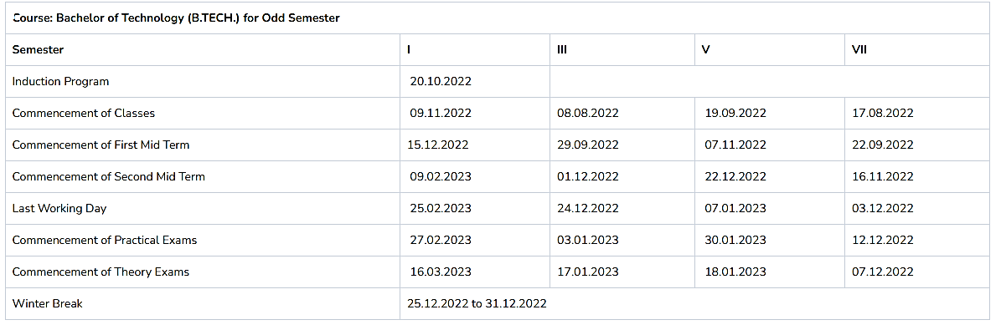

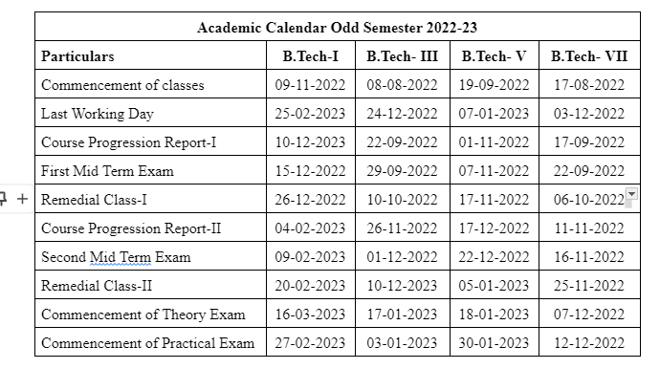

**Evaluation Scheme**

FACULTY DETAILS:

Name of the Faculty : Jitendra Choubisa

Designation : Assistant Professor

Department : Civil Engineering

1. TARGET

a) Percentage Pass: 100 %

b) Percentage I class: 60 %

2. METHOD OF EVALUATION

2.1. Continuous Assessment Examinations (Mid-Term 1, Mid-Term 2)

2.2. Assignments / Seminars

2.3. Mini Projects

2.4. Quiz

2.5. Semester Examination Others___________________________________________________

3. List out any new topic(s) or any innovation you would like to introduce in teaching the subject in this Semester.

1. Take the help of creative tools to stimulate creativity. Include slide presentations, demonstration or forms of visual exercises that will excite the young minds and capture their interest.

Signature of Faculty: **Signature of HOD**

**UNIVERSITY SYLLABUS**

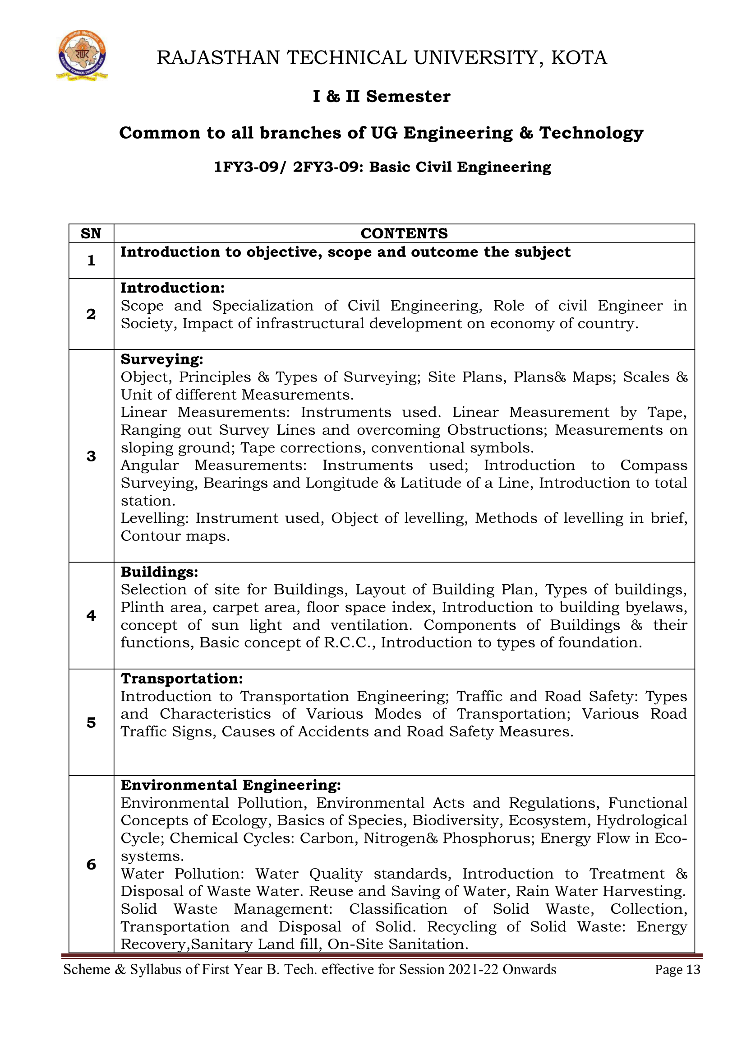

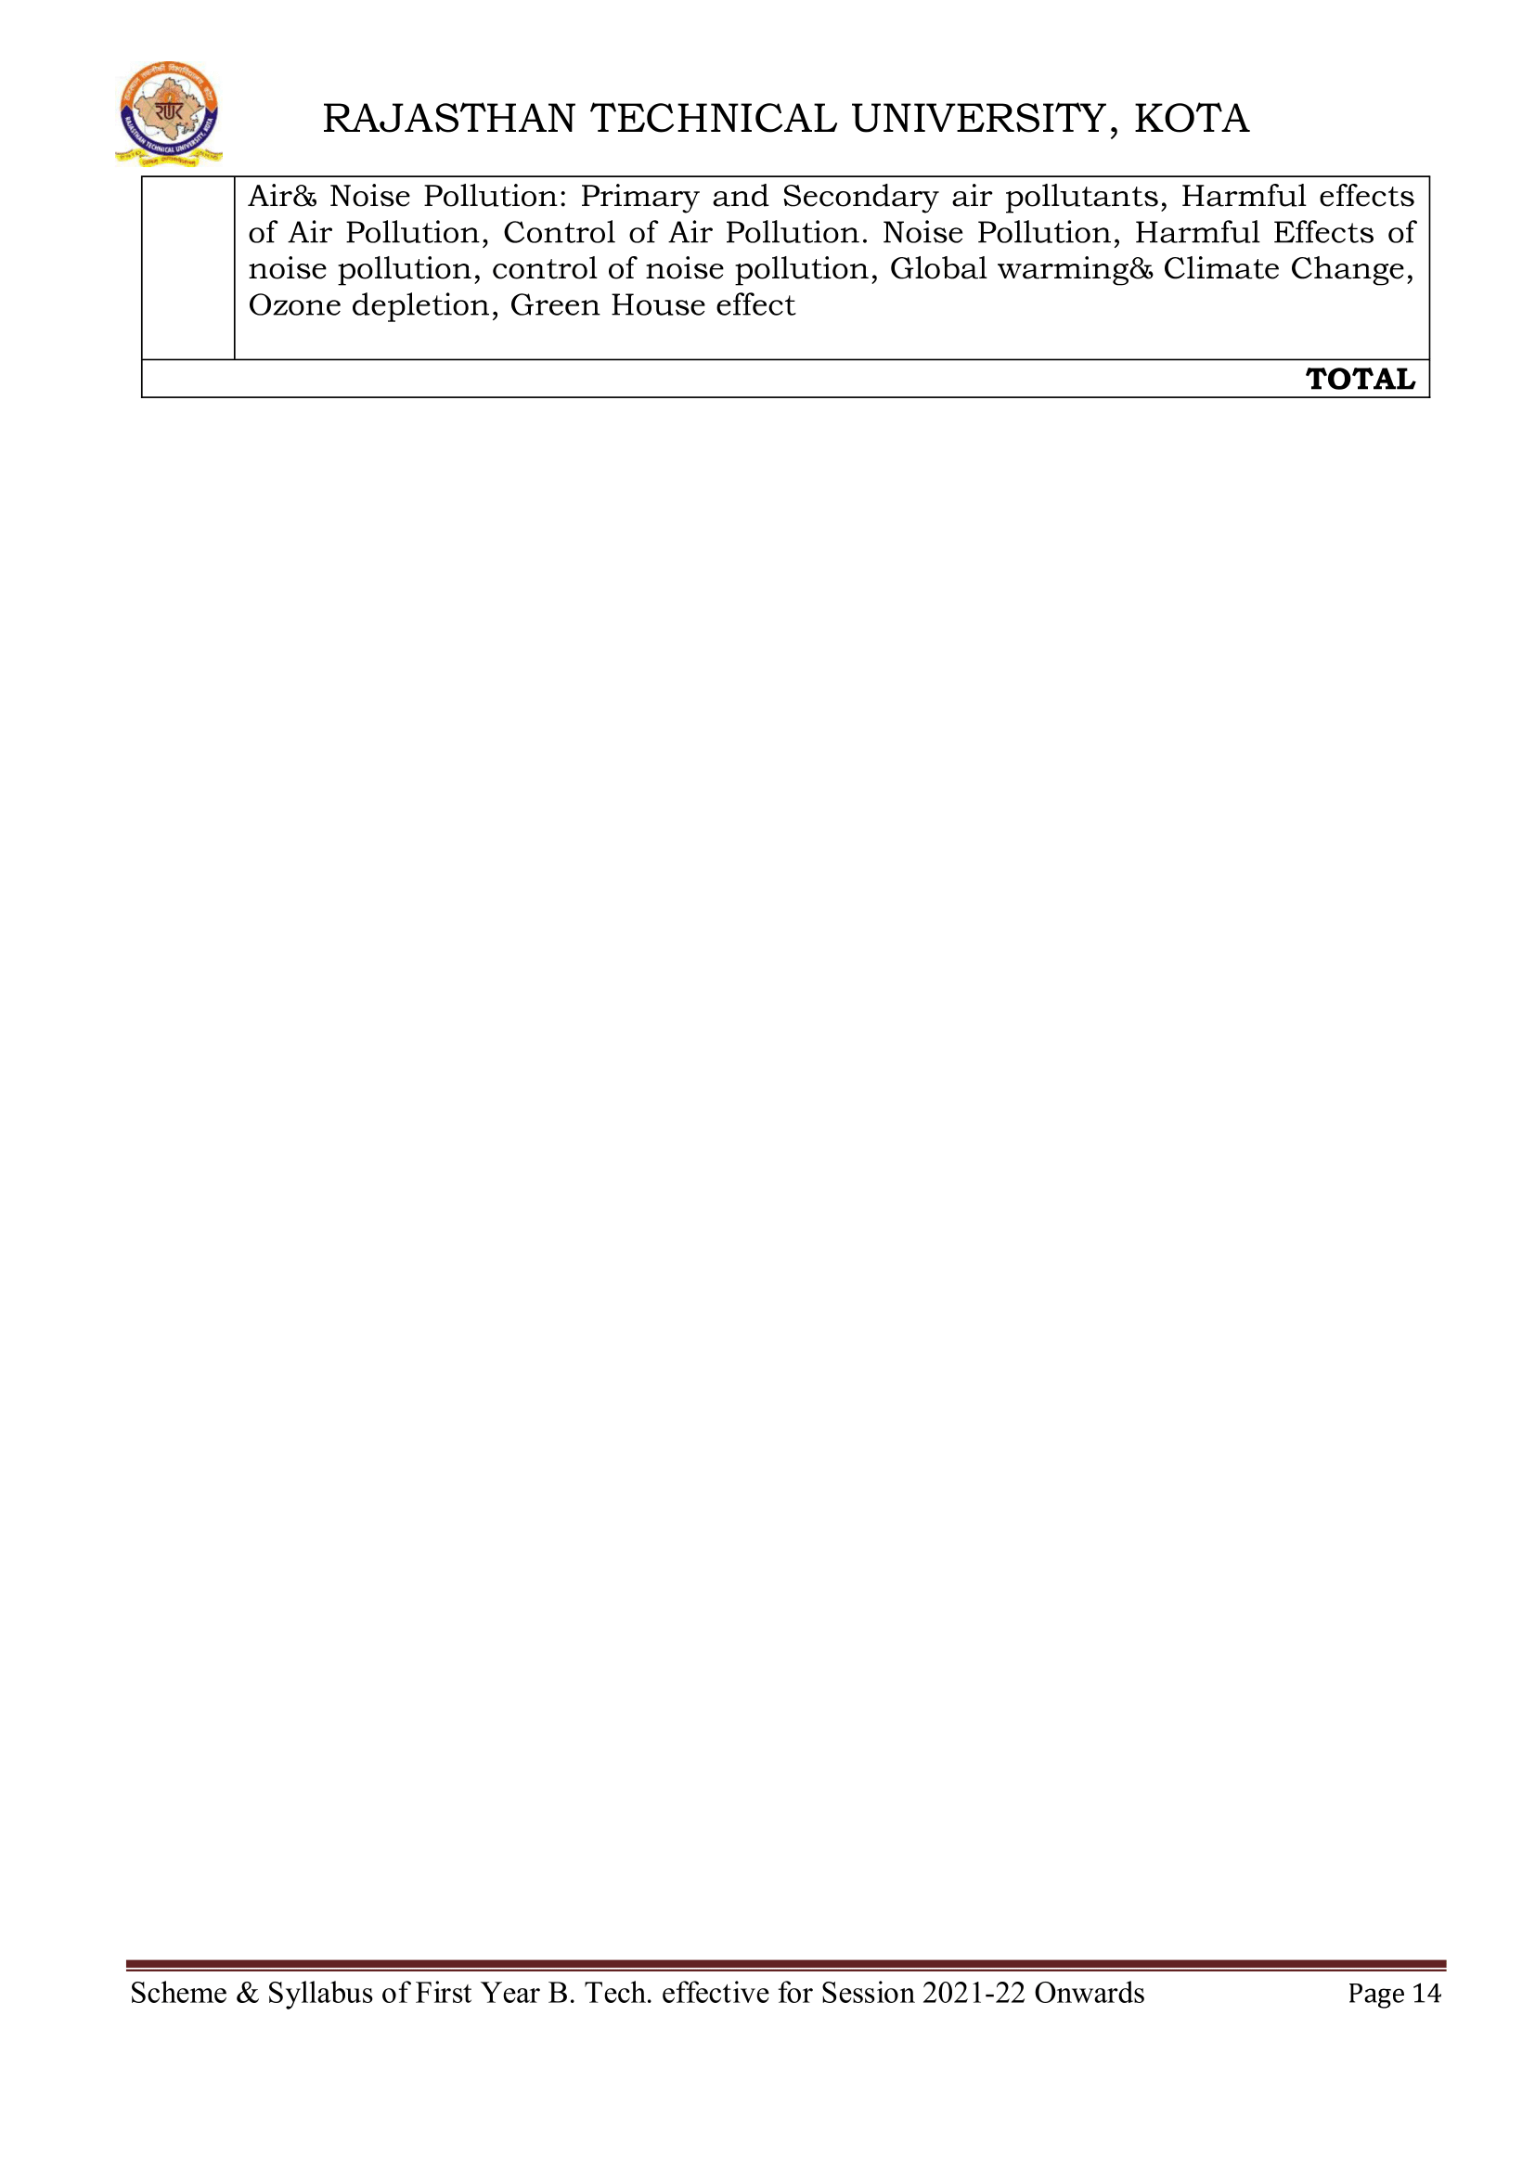

**PRESCRIBED BOOKS**

1. Basic Civil Engineering, Palanichamy, McGraw Hill

2. Basic Civil Engineering, Satheesh Gopi, Pearson Publishers

**WEEKLY TIME TABLE OF THE TEACHER**

First Time Table: with effect from (Date): 10 April 2024

|  |  |  |  |  |  |  |  |
| --- | --- | --- | --- | --- | --- | --- | --- |
| **Day** | **1** | **2** | **3** | **4** | **5** | **6** | **7** |
| Monday |  |  |  |  |  |  |  |
| Tuesday |  |  |  |  |  |  |  |
| Wednesday |  | Basic Civil Eng. |  |  |  |  |  |
| Thursday | Basic Civil Eng. |  |  |  |  |  |  |
| Friday | Basic Civil Eng. |  |  |  |  |  |  |
| Saturday |  | Basic Civil Eng. |  |  |  |  |  |

**COURSE-PLAN**

|  |  |  |  |
| --- | --- | --- | --- |
| **Lect. No.** | **Unit** | **Outcome** | **Teaching Methods/ Teaching Aids** |
|  | 1 | Scope and Specialization of Civil Engineering. | White Board, PPT, |
|  | 1 | Role of civil Engineer in Society. | White Board, PPT, Demonstration |
|  | 1 | Impact of infrastructural development on economy of country. | White Board |
|  | 2 | Object, Principles Of Surveying. | White Board |
|  | 2 | Types of Surveying. | White Board, PPT |
|  | 2 | Site Plans, Plans& Maps. | White Board |
|  | 2 | Scales & Numericals on it. | White Board, PPT |
|  | 2 | Scales & Numericals on it. | White Board |
|  | 2 | Unit of different Measurements. | White Board, PPT, |
|  | 2 | Linear Measurements: Instruments used. | White Board, PPT, Demonstration |
|  | 2 | Linear Measurement by Tape. | White Board |
|  | 2 | Ranging out Survey Lines and overcoming Obstructions. | White Board |
|  | 2 | Measurements on sloping ground; Tape corrections, conventional symbols | White Board, PPT |
|  | 2 | Angular Measurements: Instruments used; Introduction to Compass Surveying. | White Board |
|  | 2 | Bearings and Longitude & Latitude of a Line. | White Board, PPT |
|  | 2 | Introduction to total station. | White Board |
|  | 2 | Levelling: Instrument used, Object of levelling. | White Board, PPT, |
|  | 2 | Methods of levelling in brief, Contour maps. | White Board, Demonstration |
|  | 3 | Buildings: Selection of site for Buildings, Layout of Building Plan. | White Board |
|  | 3 | Types of buildings. | White Board |
|  | 3 | Plinth area, carpet area, floor space index. | White Board, PPT |
|  | 3 | Introduction to building byelaws, concept of sun light and ventilation. | White Board |
|  | 3 | Components of Buildings & their functions. | White Board, PPT |
|  | 3 | Basic concept of R.C.C. | White Board |
|  | 3 | Introduction to types of foundation. | White Board, PPT, |
|  | 4 | Introduction to Transportation Engineering. | White Board, PPT, Demonstration |
|  | 4 | Types and Characteristics of Various Modes of Transportation. | White Board |
|  | 4 | Types and Characteristics of Various Modes of Transportation. | White Board |
|  | 4 | Traffic and Road Safety. | White Board, PPT |
|  | 4 | Various Road Traffic Signs, Causes of Accidents and Road Safety Measures. | White Board |
|  | 5 | Environmental Pollution, Environmental Acts and Regulations. | White Board, PPT |
|  | 5 | Concepts of Ecology, Basics of Species, Biodiversity, Ecosystem, | White Board |
|  | 5 | Hydrological Cycle; Chemical Cycles: Carbon, Nitrogen& Phosphorus; Energy Flow in Ecosystems. | White Board, PPT, |
|  | 5 | Water Pollution: Water Quality standards, Introduction to Treatment. | White Board, PPT, Demonstration |
|  | 5 | Disposal of Waste Water. Reuse and Saving of Water, Rain Water Harvesting. | White Board |
|  | 5 | Solid Waste Management: Classification of Solid Waste, Collection. | White Board |
|  | 5 | Transportation and Disposal of Solid. | White Board, PPT |
|  | 5 | Recycling of Solid Waste: Energy Recovery, Sanitary Land fill, On-Site Sanitation. | White Board |
|  | 5 | Air & Noise Pollution: Primary and Secondary air pollutants, Harmful effects. | White Board, PPT |
|  | 5 | Control of Air Pollution. Noise Pollution. | White Board |
|  | 5 | Harmful Effects of noise pollution, control of noise pollution. | White Board |
|  | 5 | Global warming& Climate Change. | White Board, PPT |
|  | 5 | Ozone depletion, Green House effect. | White Board |
|  | 5 | Air & Noise Pollution: Primary and Secondary air pollutants. | White Board, PPT |
|  | 5 | Harmful effects of Air Pollution, Control of Air Pollution. Noise Pollution. | White Board |

**Signature of Faculty: Signature of HOD**

**Assignment Sheet**

ASSIGNMENT NO. 1

Note: Answer the questions in 100 words

Q.1: Explain the Branches of Civil Engineering?

Q.2: Explain the impact of infrastructural development on the economy of a country.

Q.3: State the roles of civil engineer.

Q.4: Explain what surveying is?

**BASIC CIVIL ENGINEERING (2FY3-09)**

**ASSIGNMENT NO. 2**

Note: Answer the questions in 100 words

Q.1: Explain the principles of surveying?

Q.2: Explain the types of Ranging.

Q.3: State what is Floor Space Index?

Q.4: Write the factors affecting the site selection for a building?

**SAMPLE QUIZ QUESTIONS**

1. What is surveying?

2. What is Levelling?

3. Objective and Uses of Surveying?

4. Methods of Surveying?

a. Triangulation b. Traversing

5. Explain:

a. Topographic Map b. Cadastral Map

c. Engineering Map d. Military Map

e. Contour Map

f. Geological Map

g. Archaeological Map

6. General Principle of Surveying?

7. What is chaining?

8. Instruments used in Chain Surveying?

9. How many links are in 30m Metric Chain? Length of each link?

10. Reciprocal Ranging?

11. What are Corrections?

12. How many ranging rods required for a. Direct Ranging

b. Indirect or Reciprocal Ranging

13. Principle of Chain Surveying?

14. What is well-conditioned triangle?

15. What is Reconnaissance Survey?

16. What is Index Sketch?

17. How to set Perpendicular Offsets?

18. What is Field Book?

19. Principle of Compass Surveying?

20. Explain:

a. True Meridian

b. Magnetic Meridian c. Arbitrary Meridian d. Magnetic Bearing

i. Whole Circle Bearing (WCB)

ii. Quadrantal Bearing (QB)

iii. Reduced Bearing (RB)

e. Fore Bearing

f. Back Bearing

g. Magnetic Declination

h. Dip of the magnetic needle

i. Local Attraction

20. What is traversing?

a. Close Traverse?

b. Open Traverse?

**Mid Term Paper-I**

**TECHNO INDIA NJR INSTITUTE OF TECHNOLOGY, UDAIPUR**

**B. TECH. Ist – YEAR (II SEM.) – MT-I**

Basic Civil Engineering (**2FY309**)

**Time:** 2 Hr **Max. Marks:** 70

**Note:**

1. The paper is divided into 2 parts: Part-A and, Part-B.
2. Part-A contains 10 questions and carries 2 mark each.
3. Part-B contains 5 questions. Each question is having two options and carries 10 marks each.

Part- A (20 Marks)

|  |  |  |
| --- | --- | --- |
|  | Define Structural Engineering & Geotechnical Engineering. | CO1 |
|  | Write Principles of Surveying. | CO1 |
|  | Write types of Bearing System in Compass Surveying. | CO1 |
|  | What is chain used for? | CO1 |
|  | Write the name of angle measuring instrument in Surveying. | CO2 |
|  | Define Scale & Maps. | CO2 |
|  | State what is Floor space index? | CO2 |
|  | Define Floor area. | CO2 |
|  | Write types of Chain. | CO3 |
|  | What do you understand by Fore Bearing and Back Bearing? | CO3 |

Part- B (50 Marks)

|  |  |
| --- | --- |
| 1. Explain the characteristics of Chain used for linear measurement and write its types | CO1 |
| OR | |
| 1. Explain that the growth of economy of a country lies in the development of infrastructure. | CO1 |

|  |  |
| --- | --- |
| 1. Write down the factors affecting for site selection. | CO1 |
| OR | |
| 2. Explain any three branches of civil engineering. | CO1 |

|  |  |
| --- | --- |
| 1. The following readings were taken with a level and 4m leveling staff. The instrument was shifted after 3rd and 6th readings. The readings are 2.665, 3.225, 2.905, 1.85, 0.98, 2.62, 1.585, 0.96, and 0.425. m Enter the above readings in a page of level book and calculate R.L. of points, if the first reading was taken with a staff held on B.M. of 240 m. Use height of instrument method. Apply arithmetic checks. | CO2 |
| OR | |
| 1. The following staff readings were observed successively with a level the instrument is moved by third, sixth and eighth readings. 2.228, 1.606, 0.988, 2.090, 2.864, 1.262, 0.602, 1.982, 1.044, 2.684 m enter the reading in record book and calculate R.L. using height of instrument method if the first reading was taken at a B.M of 432.383m. | CO2 |

|  |  |
| --- | --- |
| 1. The following bearing were observed with a compass. Calculate the interior angles.   **LINES FORE BEARING BACK BEARING**  AB 58° 25’ 238° 25’  BC 121° 40’ 304° 40’  CD 44° 17’ 224° 17’  DE 202° 38’ 22° 38’  EA 305° 5’ 125° 5’ | CO2 |
| OR | |
| 4. The bearing of the sides of a traverse ABCDE are as follows:    Calculate the interior angles of the traverse. | CO2 |

|  |  |
| --- | --- |
| 1. Construct a diagonal scale of 1 cm = 5m and show 38.2 m on it and write steps. | CO3 |
| OR | |
| 5. Convert following WCB Into QB or RB.  35°, 130°, 24°, 290°    Convert following QB or RB to WCB  N70°E, S26°E, N32°W, S42°W | CO3 |

**Marks and Gap Analysis of Mid-Term 1**

|  |  |  |  |  |
| --- | --- | --- | --- | --- |
| S.N. | University Roll No. | Name of Student | Mid-Term 1  MM-32 | Remark  ( Remedial Class need or not – Y/N ) |
|  | 22ETCCS001 | AADARSH SONI | 52 | N |
|  | 22ETCCS002 | ABDUL ATTIF | 67 | N |
|  | 22ETCCS003 | ABHIJEET GARG | 65 | N |
|  | 22ETCCS004 | ADITYA CHHIPA | 67 | N |
|  | 22ETCCS005 | ADITYA GIRI GOSWAMI | 67 | N |
|  | 22ETCCS006 | ADITYA SHARMA | 67 | N |
|  | 22ETCCS007 | AJIT KUMAR | 45 | N |
|  | 22ETCCS008 | AKASH SONI | 67 | N |
|  | 22ETCCS009 | AKSHAT JANGID | 67 | N |
|  | 22ETCCS010 | AKSHAT KUMAR SAINI | 67 | N |
|  | 22ETCCS011 | AKSHI BARGURJAR | 67 | N |
|  | 22ETCCS012 | AKSHIT NALWAYA | 61 | N |
|  | 22ETCCS013 | AKSHITA KUMAWAT | 67 | N |
|  | 22ETCCS014 | AKSHITA PANCHAL | 67 | N |
|  | 22ETCCS015 | ALI ASGAR ORA WALA | 56 | N |
|  | 22ETCCS016 | AMIT PAL | 0 | Y |
|  | 22ETCCS017 | ANGHA VARANGAONKAR | 67 | N |
|  | 22ETCCS018 | ANKIT DHANAWAT | 67 | N |
|  | 22ETCCS019 | ANSHIKA JAIN | 54 | N |
|  | 22ETCCS020 | ARCHIT JAIN | 67 | N |
|  | 22ETCCS021 | ARIN UPADHAYAY | 56 | N |
|  | 22ETCCS022 | ARUSH MENARIA | 67 | N |
|  | 22ETCCS023 | ARYAN TALWAR | 67 | N |
|  | 22ETCCS024 | AVIKA SURANA | 67 | N |
|  | 22ETCCS025 | BHAWANA KUMARI | 54 | N |
|  | 22ETCCS026 | BHUMI JAIN | 67 | N |
|  | 22ETCCS027 | BHUWAN SUTHAR | 45 | N |
|  | 22ETCCS028 | CHETAN NAGDA | 34 | Y |
|  | 22ETCCS029 | CHIRAG SHARMA | 47 | N |
|  | 22ETCCS030 | MSCIA SHARMMA | 67 | N |
|  | 22ETCCS031 | DAIVIK SHARMA | 51 | N |
|  | 22ETCCS032 | DAKSH JAIN | 54 | N |
|  | 22ETCCS033 | DAKSH MENARIA | 34 | Y |
|  | 22ETCCS034 | DEV PARAKH | 54 | N |
|  | 22ETCCS035 | DHANESH JOSHI | 54 | N |
|  | 22ETCCS036 | DHEERAJ SINGH THAPA | 63 | N |
|  | 22ETCCS037 | DHWANI KHUSHLANI | 54 | N |
|  | 22ETCCS038 | DIKSHIT DARJI | 61 | N |
|  | 22ETCCS039 | MSDIKSHITA SHARMA | 67 | N |
|  | 22ETCCS040 | DIVYA BAGORA | 54 | N |
|  | 22ETCCS041 | DIVYANSHU SHARMA | 43 | N |
|  | 22ETCCS042 | DIVYASHAKTI PAL | 67 | N |
|  | 22ETCCS043 | DIYA JAIN | 54 | N |
|  | 22ETCCS044 | DIYA PALIWAL | 67 | N |
|  | 22ETCCS045 | FALGUN CHOUDHARY | 67 | N |
|  | 22ETCCS046 | GARGI SHARMA | 67 | N |
|  | 22ETCCS047 | GARV BAKLIWAL | 56 | N |
|  | 22ETCCS048 | GARVIT NANDAWAT | 61 | N |
|  | 22ETCCS049 | GAURAV JAIN | 63 | N |
|  | 22ETCCS050 | GAURAVI NEGI | 67 | N |
|  | 22ETCCS051 | GAURI SUTHAR | 67 | N |
|  | 22ETCCS053 | GOURAV POKHARNA | 41 | N |
|  | 22ETCCS054 | HARDIK BATWAL | 67 | N |
|  | 22ETCCS055 | HARSH DANGI | 54 | N |
|  | 22ETCCS056 | HARSH KAWADIA | 54 | N |
|  | 22ETCCS057 | HARSH TAMBOLI | 67 | N |
|  | 22ETCCS058 | HARSHAL JAIN | 65 | N |
|  | 22ETCCS059 | HARSHIT POKHARNA | 67 | N |
|  | 22ETCCS060 | HARSHVARDHAN SINGH CHAUHAN | 47 | N |
|  | 22ETCCS061 | HARSHVARDHAN SINGH KITAWAT | 67 | N |
|  | 22ETCCS062 | HEMANT AHUJA | 67 | N |
|  | 22ETCCS064 | HIMANK LOHAR | 67 | N |
|  | 22ETCCS065 | HIMANSHI PRAJAPATI | 67 | N |
|  | 22ETCCS066 | HIMANSHU KALAL | 67 | N |
|  | 22ETCCS067 | HONHAR RAWAL | 45 | N |
|  | 22ETCCS068 | HUSAIN BOHRA TIDIWALA | 54 | N |
|  | 22ETCCS069 | JAINISH JAIN | 35 | Y |
|  | 22ETCCS070 | JAYESH JOSHI | 0 | Y |
|  | 22ETCCS071 | JAYESH MANDAWAT | 44 | N |
|  | 22ETCCS072 | JINENDRA SINGH DODIYA | 33 | Y |
|  | 22ETCCS073 | KANIKA GUPTA | 50 | N |
|  | 22ETCCS074 | KANISHK GUPTA | 54 | N |
|  | 22ETCCS075 | KAPIL KALAL | 52 | N |
|  | 22ETCCS076 | KARAN SWAMI | 56 | N |
|  | 22ETCCS077 | KARTIK JAIN | 54 | N |
|  | 22ETCCS078 | KARTIK KRISHNA KALE | 45 | N |
|  | 22ETCCS079 | KAVYA PALIWAL | 58 | N |
|  | 22ETCCS080 | KETAN OJHA | 54 | N |
|  | 22ETCCS081 | KHUSH JAIN | 67 | N |
|  | 22ETCCS082 | KHUSHI SHARMA | 54 | N |
|  | 22ETCCS083 | KIRTAN TAMBOLI | 67 | N |
|  | 22ETCCS085 | KONPAL SHARMA | 54 | N |
|  | 22ETCCS086 | KRITI PATWA | 54 | N |
|  | 22ETCCS087 | KUSH PARSAI | 67 | N |
|  | 22ETCCS088 | KUSHAL MEENA | 65 | N |
|  | 22ETCCS089 | LAKSHIT PALIWAL | 54 | N |
|  | 22ETCCS090 | LAKSHY JAIN | 63 | N |
|  | 22ETCCS091 | LAKSHYARAJ CHOUDHARY | 67 | N |
|  | 22ETCCS092 | LAL SINGH JHALA | 41 | N |
|  | 22ETCCS093 | LUCKY LOHAR | 63 | N |
|  | 22ETCCS094 | MAHATV BHATNAGAR | 65 | N |
|  | 22ETCCS095 | MAHENDRA SINGH SISODIYA | 65 | N |
|  | 22ETCCS096 | MSMAHIMA CHOUHAN | 54 | N |
|  | 22ETCCS097 | MAHIPAL SINGH JHALA | 67 | N |
|  | 22ETCCS098 | MAHIRAJ SINGH SANKHLA | 0 | Y |
|  | 22ETCCS099 | MANAS PARWANI | 54 | N |
|  | 22ETCCS100 | MANASVI SHARMA | 67 | N |
|  | 22ETCCS101 | MANASWINI SHARMA | 54 | N |
|  | 22ETCCS102 | MANSI DUBE | 67 | N |
|  | 22ETCCS103 | MAYANK KASERA | 36 | N |
|  | 22ETCCS104 | MAYANK TRIVEDI | 45 | N |
|  | 22ETCCS105 | MEDHAVI KAUSHIK | 67 | N |
|  | 22ETCCS106 | MEETRAJ SINGH | 54 | N |
|  | 22ETCCS107 | MITALI PALIWAL | 67 | N |
|  | 22ETCCS108 | MITVESH AMETA | 41 | N |
|  | 22ETCCS109 | MOHAMMED YASAR | 50 | N |
|  | 22ETCCS110 | MOHIT KALAL | 50 | N |
|  | 22ETCCS111 | MOHIT KUMAWAT | 54 | N |
|  | 22ETCCS112 | MONIL SETH | 67 | N |
|  | 22ETCCS113 | NAKUL PANDYA | 54 | N |
|  | 22ETCCS114 | NEERAJ DANGI | 56 | N |
|  | 22ETCCS115 | NIKHIL RAJ MALI | 67 | N |
|  | 22ETCCS116 | NIMISHKA CHAUHAN | 58 | N |
|  | 22ETCCS117 | NISHANT MENARIA | 54 | N |
|  | 22ETCCS118 | MSPALAK KUMAWAT | 67 | N |
|  | 22ETCCS119 | PARSHVI HARKAWAT | 54 | N |
|  | 22ETCCS120 | PRAGYA BUJ | 67 | N |
|  | 22ETCCS121 | PRATIBHA SINGH | 67 | N |
|  | 22ETCCS122 | PRINCE DANGI | 45 | N |
|  | 22ETCCS123 | PRIYANSH JAIN | 67 | N |
|  | 22ETCCS124 | PURVAM CHATURVEDI | 67 | N |
|  | 22ETCCS125 | PUSHKAR GAMETI | 65 | N |
|  | 22ETCCS126 | PUSHPENDRA MENARIA | 67 | N |
|  | 22ETCCS127 | QAIDJOHAR JUKKER | 54 | N |
|  | 22ETCCS128 | RAGHAVENDRA BAHETI | 67 | N |
|  | 22ETCCS129 | RAJ LAXKAR | 49 | N |
|  | 22ETCCS130 | RAJ SHRIMALI | 65 | N |
|  | 22ETCCS131 | RAM MUNDRA | 54 | N |
|  | 22ETCCS132 | RAMMITH K R | 47 | N |
|  | 22ETCCS133 | RANITH BISWAS | 33 | Y |
|  | 22ETCCS134 | RANJIT SINGH SHAKTAWAT | 54 | N |
|  | 22ETCCS135 | MSRAUNAK TAK | 67 | N |
|  | 22ETCCS136 | RAVI JOSHI | 51 | N |
|  | 22ETCCS137 | RAVI MENARIYA | 54 | N |
|  | 22ETCCS138 | RITIK SHARMA | 65 | N |
|  | 22ETCCS139 | RITISHA SEN | 54 | N |
|  | 22ETCCS140 | ROHIT AGARWAL | 67 | N |
|  | 22ETCCS141 | ROSHAN SHARMA | 56 | N |
|  | 22ETCCS142 | ROSHNI MENARIA | 67 | N |
|  | 22ETCCS143 | RUDRA PUROHIT | 54 | N |
|  | 22ETCCS144 | RUDRAVEER SINGH PANWAR | 49 | N |
|  | 22ETCCS145 | SHAAN SANADHYA | 54 | N |
|  | 22ETCCS146 | SHACHI JAIN | 54 | N |
|  | 22ETCCS147 | SHAURYA KUNDAR | 67 | N |
|  | 22ETCCS148 | SHOURYA BORDIA | 47 | N |
|  | 22ETCCS149 | SHUBHAM YADAV | 44 | N |
|  | 22ETCCS150 | SIDDHARTH KUMAR SINGH | 67 | N |
|  | 22ETCCS151 | SIDDHARTH MENARIA | 51 | N |
|  | 22ETCCS152 | SRAJAN MENARIA | 50 | N |
|  | 22ETCCS154 | SUMIT DANGI | 45 | N |
|  | 22ETCCS155 | SURBHI TAILOR | 56 | N |
|  | 22ETCCS156 | SURYANSH MADHUKAR | 51 | N |
|  | 22ETCCS157 | TALENT JAIN | 65 | N |
|  | 22ETCCS158 | TANISHK VYAS | 54 | N |
|  | 22ETCCS159 | TANVI SHARMA | 65 | N |
|  | 22ETCCS160 | TOHEED AKHTAR | 58 | N |
|  | 22ETCCS161 | TUSHAR PRAJAPAT | 36 | N |
|  | 22ETCCS162 | TUSHAR SINGH RAWAT | 54 | N |
|  | 22ETCCS163 | UJJWAL SINGH CHOUHAN | 49 | N |
|  | 22ETCCS164 | USHIT SHARMA | 42 | N |
|  | 22ETCCS165 | UTKARSH BAJPAI | 56 | N |
|  | 22ETCCS166 | VAIBHAV GOYAL | 67 | N |
|  | 22ETCCS167 | VANSH BHATNAGAR | 67 | N |
|  | 22ETCCS168 | VINAY VADERA | 54 | N |
|  | 22ETCCS169 | VINITA MENARIA | 54 | N |
|  | 22ETCCS170 | VISHAL MENARIYA | 67 | N |
|  | 22ETCCS171 | VISHAL SINGH RAO | 63 | N |
|  | 22ETCCS172 | VIVEK SHARMA | 54 | N |
|  | 22ETCCS173 | VIVEK SHRIMALI | 65 | N |
|  | 22ETCCS174 | YANA OZHA | 67 | N |
|  | 22ETCCS175 | YASH VAGHELA | 54 | N |
|  | 22ETCCE001 | ANKIT KUMAR | 67 | N |
|  | 22ETCCE002 | ARMAAN CHAUHAN | 34 | Y |
|  | 22ETCCE003 | AYUSH SINGH JHALA | 36 | N |
|  | 22ETCCE004 | PARADHI NINAMA | 54 | N |
|  | 22ETCCE005 | PRAVEEN DANGI | 67 | N |
|  | 22ETCCE006 | ROSHNI TABIYAR | 54 | N |
|  | 22ETCEC001 | AZIZ BOHRA | 0 | Y |
|  | 22ETCEC002 | GAURAV SHARMA | 67 | N |
|  | 22ETCEC003 | KARAN SUTHAR | 45 | N |
|  | 22ETCEC004 | KEVALI ASHOK KANAGALE | 54 | N |
|  | 22ETCEC005 | MSKRITIKA SAINI | 35 | Y |
|  | 22ETCEC006 | LAKSHYA BHAVSAR | 67 | N |
|  | 22ETCEC007 | NILESH SUTHAR | 42 | N |
|  | 22ETCEC008 | PIYUSH CHORDIYA | 67 | N |
|  | 22ETCEC009 | PLAKSHA PRIYA | 54 | N |
|  | 22ETCEC010 | MSVAISHALI PUJARI | 47 | N |
|  | 22ETCEC011 | MSVIDHI SONI | 0 | Y |
|  | 22ETCEC012 | VINAYAK MEGHWAL | 61 | N |
|  | 22ETCEC013 | VIPIN JAIN | 52 | N |
|  | 22ETCEC014 | VISHNU SUTHAR | 31 | Y |
|  | 22ETCEC015 | VISHWAS PRAJAPAT | 67 | N |
|  | 22ETCME001 | ADITYA VAGERWAL | 44 | N |
|  | 22ETCME003 | MAHEEP PALIWAL | 67 | N |
|  | 22ETCME005 | PAWAN JAIN | 54 | N |
|  | 22ETCME006 | PRAHLAD SINGH | 67 | N |
|  | 22ETCME007 | VAIBHAV PUROHIT | 54 | N |
|  | 22ETCME008 | VINAY PRATAP SINGH PANWAR | 28 | Y |
|  | 22ETCME009 | VINEET SHARMA | 44 | N |

**Signature of Faculty: Signature of HOD**

**Remedial Action Taken to Remove the Gaps (After Mid- Term 1)**

|  |  |  |  |  |  |
| --- | --- | --- | --- | --- | --- |
| S.no. | University Roll no. | Name of Student | Topics to be discussed in Remedial Class | Schedule Date of Remedial Class | Outcome  Achieved |
|  | 22ETCCS016 | AMIT PAL | Impact of infrastructural development,  Components of Buildings & their functions, | 8-9 AM on every Wednesday  Effective from: 05/06/23 |  |
|  | 22ETCCS028 | CHETAN NAGDA |
|  | 22ETCCS033 | DAKSH MENARIA |
|  | 22ETCCS069 | JAINISH JAIN |
|  | 22ETCCS070 | JAYESH JOSHI |
|  | 22ETCCS072 | JINENDRA SINGH DODIYA |
|  | 22ETCCS098 | MAHIRAJ SINGH SANKHLA |
|  | 22ETCCS133 | RANITH BISWAS |
|  | 22ETCCE002 | ARMAAN CHAUHAN |
|  | 22ETCEC001 | AZIZ BOHRA |
|  | 22ETCEC005 | MSKRITIKA SAINI |
|  | 22ETCEC011 | MSVIDHI SONI |
|  | 22ETCEC014 | VISHNU SUTHAR |
|  | 22ETCME008 | VINAY PRATAP SINGH PANWAR |

**Signature of Faculty: Signature of HOD**

**Mid Term Paper-II**

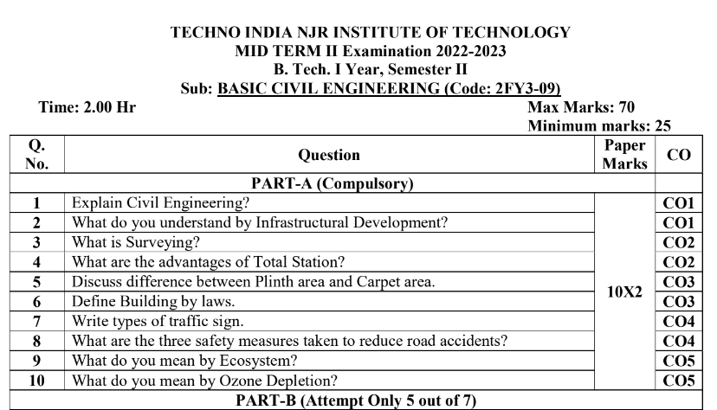

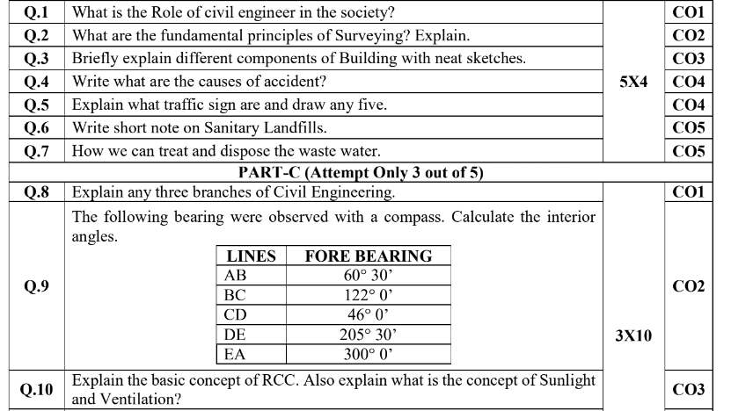

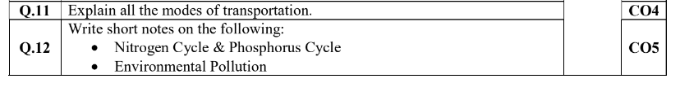

**Mid Term Exam – II**

**Marks and Gap Analysis of Mid-Term II**

|  |  |  |  |  |
| --- | --- | --- | --- | --- |
| S.No. | University Roll No. | Name of Student | Mid-Term 2  MM-32 | Remark  ( Remedial Class need or not – Y/N ) |
|  | 22ETCCS001 | AADARSH SONI | 51 | N |
|  | 22ETCCS002 | ABDUL ATTIF | 66 | N |
|  | 22ETCCS003 | ABHIJEET GARG | 64 | N |
|  | 22ETCCS004 | ADITYA CHHIPA | 66 | N |
|  | 22ETCCS005 | ADITYA GIRI GOSWAMI | 66 | N |
|  | 22ETCCS006 | ADITYA SHARMA | 66 | N |
|  | 22ETCCS007 | AJIT KUMAR | 44 | N |
|  | 22ETCCS008 | AKASH SONI | 66 | N |
|  | 22ETCCS009 | AKSHAT JANGID | 66 | N |
|  | 22ETCCS010 | AKSHAT KUMAR SAINI | 66 | N |
|  | 22ETCCS011 | AKSHI BARGURJAR | 66 | N |
|  | 22ETCCS012 | AKSHIT NALWAYA | 60 | N |
|  | 22ETCCS013 | AKSHITA KUMAWAT | 66 | N |
|  | 22ETCCS014 | AKSHITA PANCHAL | 66 | N |
|  | 22ETCCS015 | ALI ASGAR ORA WALA | 55 | N |
|  | 22ETCCS016 | AMIT PAL | 0 | Y |
|  | 22ETCCS017 | ANGHA VARANGAONKAR | 66 | N |
|  | 22ETCCS018 | ANKIT DHANAWAT | 66 | N |
|  | 22ETCCS019 | ANSHIKA JAIN | 66 | N |
|  | 22ETCCS020 | ARCHIT JAIN | 66 | N |
|  | 22ETCCS021 | ARIN UPADHAYAY | 55 | N |
|  | 22ETCCS022 | ARUSH MENARIA | 66 | N |
|  | 22ETCCS023 | ARYAN TALWAR | 66 | N |
|  | 22ETCCS024 | AVIKA SURANA | 66 | N |
|  | 22ETCCS025 | BHAWANA KUMARI | 66 | N |
|  | 22ETCCS026 | BHUMI JAIN | 66 | N |
|  | 22ETCCS027 | BHUWAN SUTHAR | 44 | N |
|  | 22ETCCS028 | CHETAN NAGDA | 33 | Y |
|  | 22ETCCS029 | CHIRAG SHARMA | 46 | N |
|  | 22ETCCS030 | MSCIA SHARMMA | 66 | N |
|  | 22ETCCS031 | DAIVIK SHARMA | 62 | N |
|  | 22ETCCS032 | DAKSH JAIN | 66 | N |
|  | 22ETCCS033 | DAKSH MENARIA | 33 | Y |
|  | 22ETCCS034 | DEV PARAKH | 66 | N |
|  | 22ETCCS035 | DHANESH JOSHI | 66 | N |
|  | 22ETCCS036 | DHEERAJ SINGH THAPA | 62 | N |
|  | 22ETCCS037 | DHWANI KHUSHLANI | 66 | N |
|  | 22ETCCS038 | DIKSHIT DARJI | 60 | N |
|  | 22ETCCS039 | MSDIKSHITA SHARMA | 66 | N |
|  | 22ETCCS040 | DIVYA BAGORA | 66 | N |
|  | 22ETCCS041 | DIVYANSHU SHARMA | 42 | N |
|  | 22ETCCS042 | DIVYASHAKTI PAL | 66 | N |
|  | 22ETCCS043 | DIYA JAIN | 66 | N |
|  | 22ETCCS044 | DIYA PALIWAL | 66 | N |
|  | 22ETCCS045 | FALGUN CHOUDHARY | 66 | N |
|  | 22ETCCS046 | GARGI SHARMA | 66 | N |
|  | 22ETCCS047 | GARV BAKLIWAL | 55 | N |
|  | 22ETCCS048 | GARVIT NANDAWAT | 60 | N |
|  | 22ETCCS049 | GAURAV JAIN | 62 | N |
|  | 22ETCCS050 | GAURAVI NEGI | 66 | N |
|  | 22ETCCS051 | GAURI SUTHAR | 66 | N |
|  | 22ETCCS053 | GOURAV POKHARNA | 40 | N |
|  | 22ETCCS054 | HARDIK BATWAL | 66 | N |
|  | 22ETCCS055 | HARSH DANGI | 66 | N |
|  | 22ETCCS056 | HARSH KAWADIA | 66 | N |
|  | 22ETCCS057 | HARSH TAMBOLI | 66 | N |
|  | 22ETCCS058 | HARSHAL JAIN | 64 | N |
|  | 22ETCCS059 | HARSHIT POKHARNA | 66 | N |
|  | 22ETCCS060 | HARSHVARDHAN SINGH CHAUHAN | 46 | N |
|  | 22ETCCS061 | HARSHVARDHAN SINGH KITAWAT | 66 | N |
|  | 22ETCCS062 | HEMANT AHUJA | 66 | N |
|  | 22ETCCS064 | HIMANK LOHAR | 66 | N |
|  | 22ETCCS065 | HIMANSHI PRAJAPATI | 66 | N |
|  | 22ETCCS066 | HIMANSHU KALAL | 66 | N |
|  | 22ETCCS067 | HONHAR RAWAL | 44 | N |
|  | 22ETCCS068 | HUSAIN BOHRA TIDIWALA | 66 | N |
|  | 22ETCCS069 | JAINISH JAIN | 42 | N |
|  | 22ETCCS070 | JAYESH JOSHI | 66 | N |
|  | 22ETCCS071 | JAYESH MANDAWAT | 53 | N |
|  | 22ETCCS072 | JINENDRA SINGH DODIYA | 40 | N |
|  | 22ETCCS073 | KANIKA GUPTA | 49 | N |
|  | 22ETCCS074 | KANISHK GUPTA | 66 | N |
|  | 22ETCCS075 | KAPIL KALAL | 64 | N |
|  | 22ETCCS076 | KARAN SWAMI | 55 | N |
|  | 22ETCCS077 | KARTIK JAIN | 66 | N |
|  | 22ETCCS078 | KARTIK KRISHNA KALE | 55 | N |
|  | 22ETCCS079 | KAVYA PALIWAL | 57 | N |
|  | 22ETCCS080 | KETAN OJHA | 66 | N |
|  | 22ETCCS081 | KHUSH JAIN | 66 | N |
|  | 22ETCCS082 | KHUSHI SHARMA | 66 | N |
|  | 22ETCCS083 | KIRTAN TAMBOLI | 66 | N |
|  | 22ETCCS085 | KONPAL SHARMA | 66 | N |
|  | 22ETCCS086 | KRITI PATWA | 66 | N |
|  | 22ETCCS087 | KUSH PARSAI | 66 | N |
|  | 22ETCCS088 | KUSHAL MEENA | 64 | N |
|  | 22ETCCS089 | LAKSHIT PALIWAL | 66 | N |
|  | 22ETCCS090 | LAKSHY JAIN | 62 | N |
|  | 22ETCCS091 | LAKSHYARAJ CHOUDHARY | 66 | N |
|  | 22ETCCS092 | LAL SINGH JHALA | 40 | N |
|  | 22ETCCS093 | LUCKY LOHAR | 62 | N |
|  | 22ETCCS094 | MAHATV BHATNAGAR | 64 | N |
|  | 22ETCCS095 | MAHENDRA SINGH SISODIYA | 64 | N |
|  | 22ETCCS096 | MSMAHIMA CHOUHAN | 66 | N |
|  | 22ETCCS097 | MAHIPAL SINGH JHALA | 66 | N |
|  | 22ETCCS098 | MAHIRAJ SINGH SANKHLA | 40 | N |
|  | 22ETCCS099 | MANAS PARWANI | 66 | N |
|  | 22ETCCS100 | MANASVI SHARMA | 66 | N |
|  | 22ETCCS101 | MANASWINI SHARMA | 66 | N |
|  | 22ETCCS102 | MANSI DUBE | 66 | N |
|  | 22ETCCS103 | MAYANK KASERA | 35 | Y |
|  | 22ETCCS104 | MAYANK TRIVEDI | 44 | N |
|  | 22ETCCS105 | MEDHAVI KAUSHIK | 66 | N |
|  | 22ETCCS106 | MEETRAJ SINGH | 66 | N |
|  | 22ETCCS107 | MITALI PALIWAL | 66 | N |
|  | 22ETCCS108 | MITVESH AMETA | 40 | N |
|  | 22ETCCS109 | MOHAMMED YASAR | 49 | N |
|  | 22ETCCS110 | MOHIT KALAL | 49 | N |
|  | 22ETCCS111 | MOHIT KUMAWAT | 66 | N |
|  | 22ETCCS112 | MONIL SETH | 66 | N |
|  | 22ETCCS113 | NAKUL PANDYA | 66 | N |
|  | 22ETCCS114 | NEERAJ DANGI | 55 | N |
|  | 22ETCCS115 | NIKHIL RAJ MALI | 66 | N |
|  | 22ETCCS116 | NIMISHKA CHAUHAN | 57 | N |
|  | 22ETCCS117 | NISHANT MENARIA | 66 | N |
|  | 22ETCCS118 | MSPALAK KUMAWAT | 66 | N |
|  | 22ETCCS119 | PARSHVI HARKAWAT | 66 | N |
|  | 22ETCCS120 | PRAGYA BUJ | 66 | N |
|  | 22ETCCS121 | PRATIBHA SINGH | 66 | N |
|  | 22ETCCS122 | PRINCE DANGI | 44 | N |
|  | 22ETCCS123 | PRIYANSH JAIN | 66 | N |
|  | 22ETCCS124 | PURVAM CHATURVEDI | 66 | N |
|  | 22ETCCS125 | PUSHKAR GAMETI | 64 | N |
|  | 22ETCCS126 | PUSHPENDRA MENARIA | 66 | N |
|  | 22ETCCS127 | QAIDJOHAR JUKKER | 66 | N |
|  | 22ETCCS128 | RAGHAVENDRA BAHETI | 66 | N |
|  | 22ETCCS129 | RAJ LAXKAR | 60 | N |
|  | 22ETCCS130 | RAJ SHRIMALI | 64 | N |
|  | 22ETCCS131 | RAM MUNDRA | 66 | N |
|  | 22ETCCS132 | RAMMITH K R | 46 | N |
|  | 22ETCCS133 | RANITH BISWAS | 40 | N |
|  | 22ETCCS134 | RANJIT SINGH SHAKTAWAT | 66 | N |
|  | 22ETCCS135 | MSRAUNAK TAK | 66 | N |
|  | 22ETCCS136 | RAVI JOSHI | 62 | N |
|  | 22ETCCS137 | RAVI MENARIYA | 66 | N |
|  | 22ETCCS138 | RITIK SHARMA | 64 | N |
|  | 22ETCCS139 | RITISHA SEN | 66 | N |
|  | 22ETCCS140 | ROHIT AGARWAL | 66 | N |
|  | 22ETCCS141 | ROSHAN SHARMA | 55 | N |
|  | 22ETCCS142 | ROSHNI MENARIA | 66 | N |
|  | 22ETCCS143 | RUDRA PUROHIT | 66 | N |
|  | 22ETCCS144 | RUDRAVEER SINGH PANWAR | 60 | N |
|  | 22ETCCS145 | SHAAN SANADHYA | 66 | N |
|  | 22ETCCS146 | SHACHI JAIN | 66 | N |
|  | 22ETCCS147 | SHAURYA KUNDAR | 66 | N |
|  | 22ETCCS148 | SHOURYA BORDIA | 57 | N |
|  | 22ETCCS149 | SHUBHAM YADAV | 53 | N |
|  | 22ETCCS150 | SIDDHARTH KUMAR SINGH | 66 | N |
|  | 22ETCCS151 | SIDDHARTH MENARIA | 62 | N |
|  | 22ETCCS152 | SRAJAN MENARIA | 49 | N |
|  | 22ETCCS154 | SUMIT DANGI | 55 | N |
|  | 22ETCCS155 | SURBHI TAILOR | 55 | N |
|  | 22ETCCS156 | SURYANSH MADHUKAR | 62 | N |
|  | 22ETCCS157 | TALENT JAIN | 64 | N |
|  | 22ETCCS158 | TANISHK VYAS | 66 | N |
|  | 22ETCCS159 | TANVI SHARMA | 64 | N |
|  | 22ETCCS160 | TOHEED AKHTAR | 57 | N |
|  | 22ETCCS161 | TUSHAR PRAJAPAT | 35 | Y |
|  | 22ETCCS162 | TUSHAR SINGH RAWAT | 53 | N |
|  | 22ETCCS163 | UJJWAL SINGH CHOUHAN | 60 | N |
|  | 22ETCCS164 | USHIT SHARMA | 51 | N |
|  | 22ETCCS165 | UTKARSH BAJPAI | 55 | N |
|  | 22ETCCS166 | VAIBHAV GOYAL | 66 | N |
|  | 22ETCCS167 | VANSH BHATNAGAR | 66 | N |
|  | 22ETCCS168 | VINAY VADERA | 53 | N |
|  | 22ETCCS169 | VINITA MENARIA | 66 | N |
|  | 22ETCCS170 | VISHAL MENARIYA | 66 | N |
|  | 22ETCCS171 | VISHAL SINGH RAO | 62 | N |
|  | 22ETCCS172 | VIVEK SHARMA | 66 | N |
|  | 22ETCCS173 | VIVEK SHRIMALI | 64 | N |
|  | 22ETCCS174 | YANA OZHA | 66 | N |
|  | 22ETCCS175 | YASH VAGHELA | 66 | N |
|  | 22ETCCE001 | ANKIT KUMAR | 66 | N |
|  | 22ETCCE002 | ARMAAN CHAUHAN | 33 | Y |
|  | 22ETCCE003 | AYUSH SINGH JHALA | 35 | Y |
|  | 22ETCCE004 | PARADHI NINAMA | 66 | N |
|  | 22ETCCE005 | PRAVEEN DANGI | 66 | N |
|  | 22ETCCE006 | ROSHNI TABIYAR | 66 | N |
|  | 22ETCEC001 | AZIZ BOHRA | 44 | N |
|  | 22ETCEC002 | GAURAV SHARMA | 66 | N |
|  | 22ETCEC003 | KARAN SUTHAR | 44 | N |
|  | 22ETCEC004 | KEVALI ASHOK KANAGALE | 66 | N |
|  | 22ETCEC005 | MSKRITIKA SAINI | 42 | N |
|  | 22ETCEC006 | LAKSHYA BHAVSAR | 66 | N |
|  | 22ETCEC007 | NILESH SUTHAR | 51 | N |
|  | 22ETCEC008 | PIYUSH CHORDIYA | 66 | N |
|  | 22ETCEC009 | PLAKSHA PRIYA | 66 | N |
|  | 22ETCEC010 | MSVAISHALI PUJARI | 46 | N |
|  | 22ETCEC011 | MSVIDHI SONI | 66 | N |
|  | 22ETCEC012 | VINAYAK MEGHWAL | 60 | N |
|  | 22ETCEC013 | VIPIN JAIN | 64 | N |
|  | 22ETCEC014 | VISHNU SUTHAR | 37 | N |
|  | 22ETCEC015 | VISHWAS PRAJAPAT | 66 | N |
|  | 22ETCME001 | ADITYA VAGERWAL | 53 | N |
|  | 22ETCME003 | MAHEEP PALIWAL | 66 | N |
|  | 22ETCME005 | PAWAN JAIN | 66 | N |
|  | 22ETCME006 | PRAHLAD SINGH | 66 | N |
|  | 22ETCME007 | VAIBHAV PUROHIT | 66 | N |
|  | 22ETCME008 | VINAY PRATAP SINGH PANWAR | 33 | Y |
|  | 22ETCME009 | VINEET SHARMA | 53 | N |

**Signature of Faculty: Signature of HOD**

**Remedial Action Taken to Remove the Gaps (After Mid- Term II)**

|  |  |  |  |  |  |
| --- | --- | --- | --- | --- | --- |
| S.no. | University Roll no. | Name of Student | Topics to be discussed in Remedial Class | Schedule Date of Remedial Class | Outcome  Achieved |
|  | 22ETCCS016 | AMIT PAL | Principles and Types of Surveying,  Bearings and Longitude & Latitude of a Line,  Objectives of levelling,  Environmental engineering | 2-4 PM on every Wednesday  Effective from: 12/07/23 |  |
|  | 22ETCCS028 | CHETAN NAGDA |
|  | 22ETCCS033 | DAKSH MENARIA |
|  | 22ETCCS103 | MAYANK KASERA |
|  | 22ETCCS161 | TUSHAR PRAJAPAT |
|  | 22ETCCE002 | ARMAAN CHAUHAN |
|  | 22ETCCE003 | AYUSH SINGH JHALA |
|  | 22ETCME008 | VINAY PRATAP SINGH PANWAR |

**Signature of Faculty: Signature of HOD**

**University Question Paper**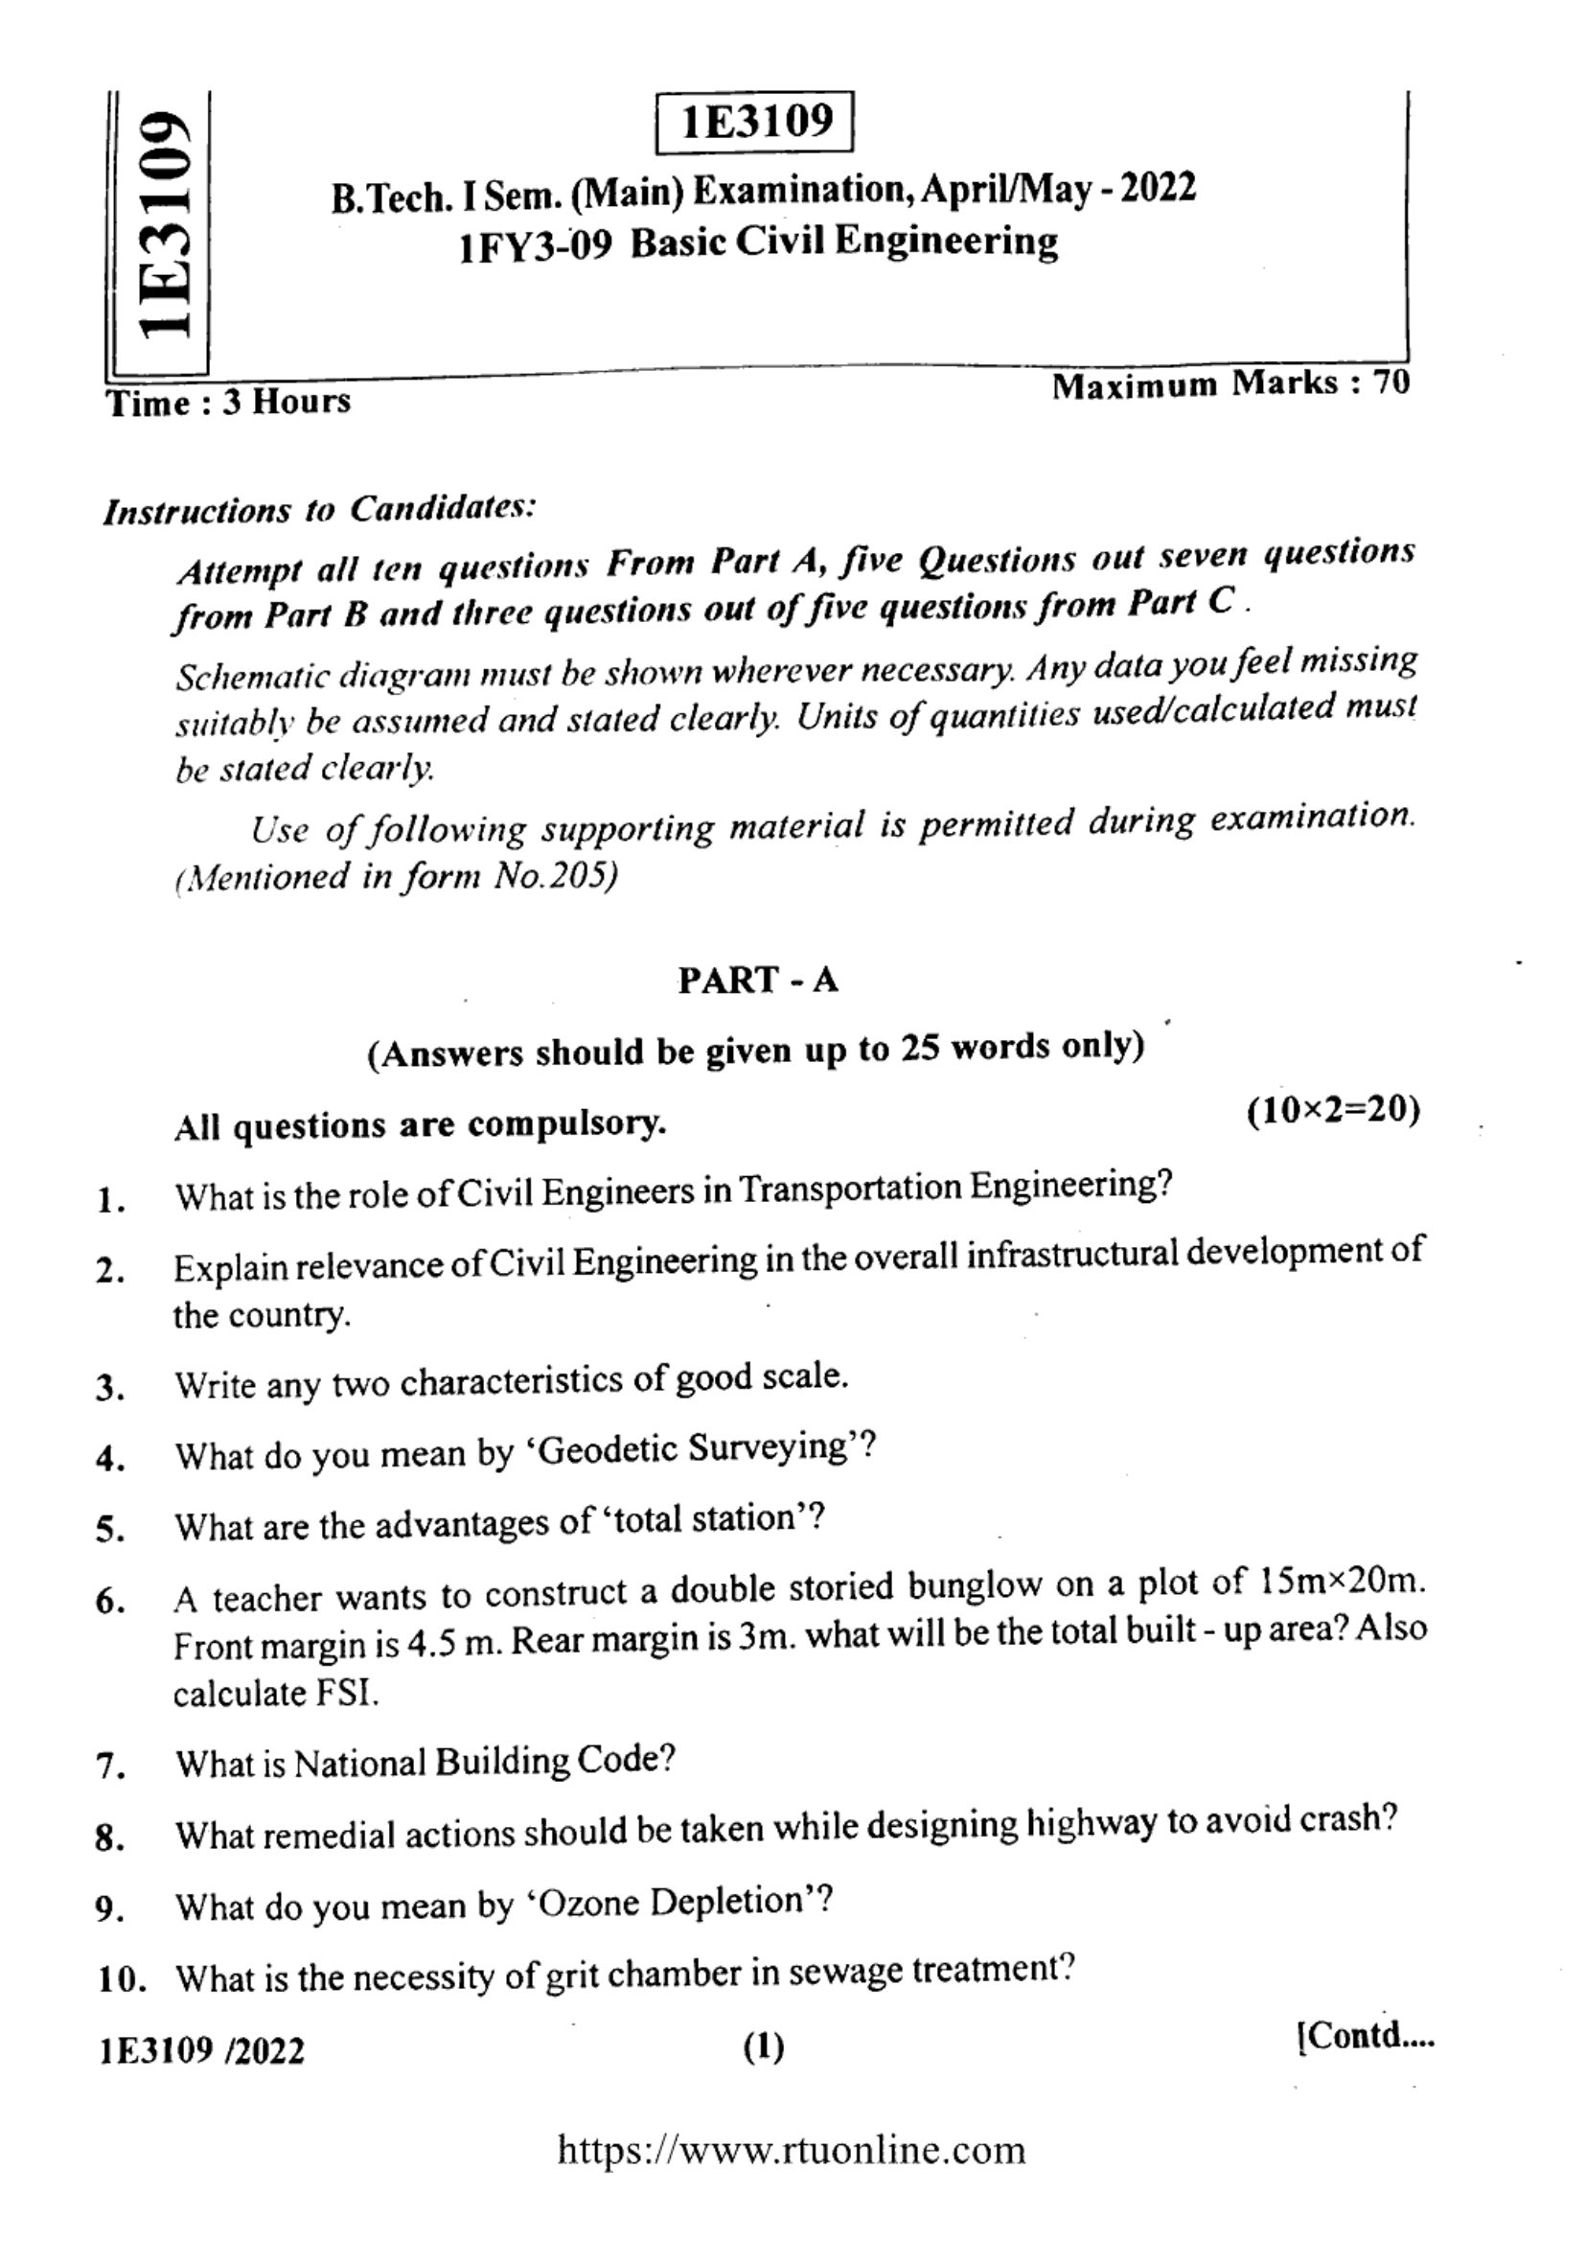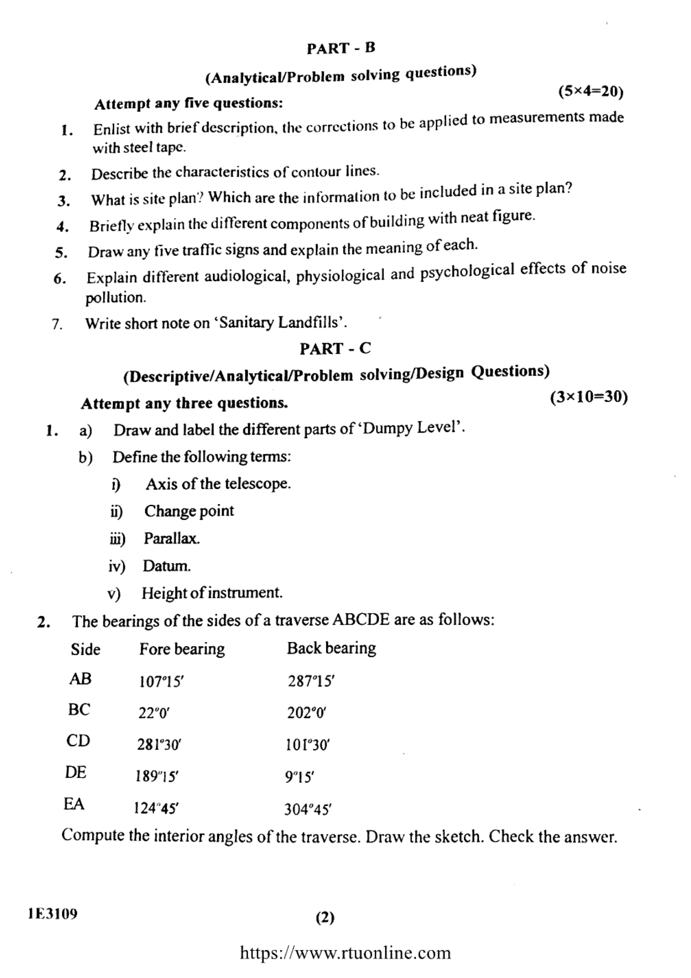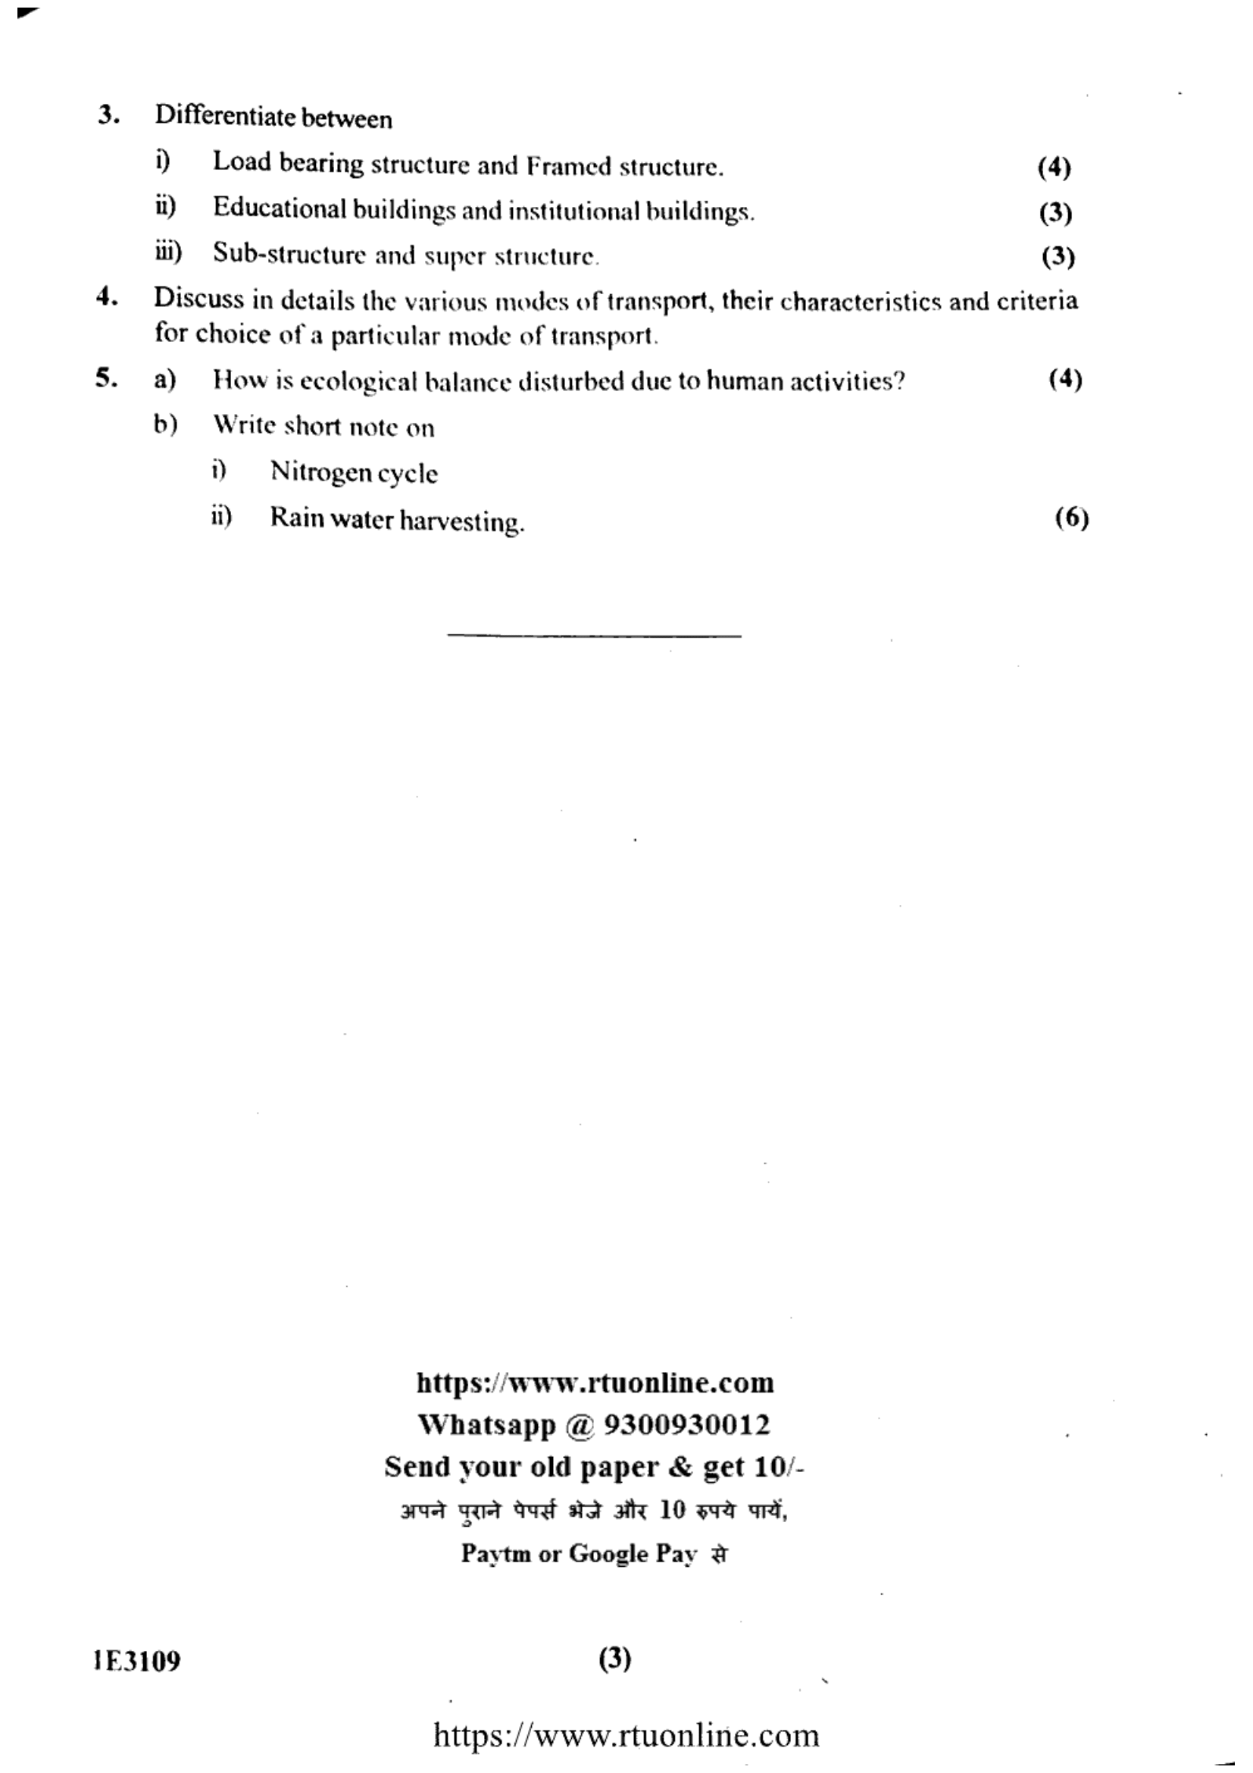

**STUDENT PERFORMANCE REPORT**

|  |  |  |  |  |
| --- | --- | --- | --- | --- |
| Roll no. | Name | Mid term I | Mid term II | Average |
| 22ETCCS001 | AADARSH SONI | 30 | 31 | 31 |
| 22ETCCS002 | ABDUL ATTIF | 36 | 37 | 37 |
| 22ETCCS003 | ABHIJEET GARG | 49 | 50 | 50 |
| 22ETCCS004 | ADITYA CHHIPA | 58 | 59 | 59 |
| 22ETCCS005 | ADITYA GIRI GOSWAMI | 59 | 60 | 60 |
| 22ETCCS006 | ADITYA SHARMA | 56 | 57 | 57 |
| 22ETCCS007 | AJIT KUMAR | 26 | 27 | 27 |
| 22ETCCS008 | AKASH SONI | 61 | 62 | 62 |
| 22ETCCS009 | AKSHAT JANGID | 55 | 56 | 56 |
| 22ETCCS010 | AKSHAT KUMAR SAINI | 38 | 39 | 39 |
| 22ETCCS011 | AKSHI BARGURJAR | 43 | 44 | 44 |
| 22ETCCS012 | AKSHIT NALWAYA | 43 | 44 | 44 |
| 22ETCCS013 | AKSHITA KUMAWAT | 64 | 0 | 32 |
| 22ETCCS014 | AKSHITA PANCHAL | 56 | 57 | 57 |
| 22ETCCS015 | ALI ASGAR ORA WALA | 22 | 23 | 23 |
| 22ETCCS016 | AMIT PAL | 0 | 0 | 0 |
| 22ETCCS017 | ANGHA VARANGAONKAR | 51 | 52 | 52 |
| 22ETCCS018 | ANKIT DHANAWAT | 46 | 47 | 47 |
| 22ETCCS019 | ANSHIKA JAIN | 68 | 69 | 69 |
| 22ETCCS020 | ARCHIT JAIN | 48 | 49 | 49 |
| 22ETCCS021 | ARIN UPADHAYAY | 37 | 38 | 38 |
| 22ETCCS022 | ARUSH MENARIA | 64 | 65 | 65 |
| 22ETCCS023 | ARYAN TALWAR | 58 | 59 | 59 |
| 22ETCCS024 | AVIKA SURANA | 62 | 63 | 63 |
| 22ETCCS025 | BHAWANA KUMARI | 62 | 63 | 63 |
| 22ETCCS026 | BHUMI JAIN | 59 | 60 | 60 |
| 22ETCCS027 | BHUWAN SUTHAR | 27 | 0 | 14 |
| 22ETCCS028 | CHETAN NAGDA | 18 | 0 | 9 |
| 22ETCCS029 | CHIRAG SHARMA | 33 | 0 | 17 |
| 22ETCCS030 | MSCIA SHARMMA | 51 | 52 | 52 |
| 22ETCCS031 | DAIVIK SHARMA | 38 | 39 | 39 |
| 22ETCCS032 | DAKSH JAIN | 64 | 65 | 65 |
| 22ETCCS033 | DAKSH MENARIA | 2 | 0 | 1 |
| 22ETCCS034 | DEV PARAKH | 54 | 55 | 55 |
| 22ETCCS035 | DHANESH JOSHI | 66 | 67 | 67 |
| 22ETCCS036 | DHEERAJ SINGH THAPA | 40 | 41 | 41 |
| 22ETCCS037 | DHWANI KHUSHLANI | 66 | 67 | 67 |
| 22ETCCS038 | DIKSHIT DARJI | 44 | 45 | 45 |
| 22ETCCS039 | MSDIKSHITA SHARMA | 64 | 65 | 65 |
| 22ETCCS040 | DIVYA BAGORA | 67 | 68 | 68 |
| 22ETCCS041 | DIVYANSHU SHARMA | 26 | 27 | 27 |
| 22ETCCS042 | DIVYASHAKTI PAL | 45 | 46 | 46 |
| 22ETCCS043 | DIYA JAIN | 53 | 54 | 54 |
| 22ETCCS044 | DIYA PALIWAL | 49 | 50 | 50 |
| 22ETCCS045 | FALGUN CHOUDHARY | 61 | 62 | 62 |
| 22ETCCS046 | GARGI SHARMA | 36 | 37 | 37 |
| 22ETCCS047 | GARV BAKLIWAL | 42 | 43 | 43 |
| 22ETCCS048 | GARVIT NANDAWAT | 41 | 42 | 42 |
| 22ETCCS049 | GAURAV JAIN | 53 | 54 | 54 |
| 22ETCCS050 | GAURAVI NEGI | 37 | 38 | 38 |
| 22ETCCS051 | GAURI SUTHAR | 62 | 63 | 63 |
| 22ETCCS053 | GOURAV POKHARNA | 2 | 3 | 3 |
| 22ETCCS054 | HARDIK BATWAL | 57 | 58 | 58 |
| 22ETCCS055 | HARSH DANGI | 42 | 43 | 43 |
| 22ETCCS056 | HARSH KAWADIA | 58 | 59 | 59 |
| 22ETCCS057 | HARSH TAMBOLI | 42 | 43 | 43 |
| 22ETCCS058 | HARSHAL JAIN | 46 | 47 | 47 |
| 22ETCCS059 | HARSHIT POKHARNA | 56 | 57 | 57 |
| 22ETCCS060 | HARSHVARDHAN SINGH CHAUHAN | 25 | 26 | 26 |
| 22ETCCS061 | HARSHVARDHAN SINGH KITAWAT | 30 | 31 | 31 |
| 22ETCCS062 | HEMANT AHUJA | 48 | 49 | 49 |
| 22ETCCS064 | HIMANK LOHAR | 33 | 34 | 34 |
| 22ETCCS065 | HIMANSHI PRAJAPATI | 66 | 67 | 67 |
| 22ETCCS066 | HIMANSHU KALAL | 38 | 39 | 39 |
| 22ETCCS067 | HONHAR RAWAL | 15 | 16 | 16 |
| 22ETCCS068 | HUSAIN BOHRA TIDIWALA | 52 | 0 | 26 |
| 22ETCCS069 | JAINISH JAIN | 20 | 21 | 21 |
| 22ETCCS070 | JAYESH JOSHI | 0 | 0 | 0 |
| 22ETCCS071 | JAYESH MANDAWAT | 27 | 28 | 28 |
| 22ETCCS072 | JINENDRA SINGH DODIYA | 17 | 18 | 18 |
| 22ETCCS073 | KANIKA GUPTA | 30 | 31 | 31 |
| 22ETCCS074 | KANISHK GUPTA | 58 | 59 | 59 |
| 22ETCCS075 | KAPIL KALAL | 51 | 52 | 52 |
| 22ETCCS076 | KARAN SWAMI | 36 | 0 | 18 |
| 22ETCCS077 | KARTIK JAIN | 62 | 63 | 63 |
| 22ETCCS078 | KARTIK KRISHNA KALE | 43 | 0 | 22 |
| 22ETCCS079 | KAVYA PALIWAL | 31 | 32 | 32 |
| 22ETCCS080 | KETAN OJHA | 55 | 56 | 56 |
| 22ETCCS081 | KHUSH JAIN | 66 | 67 | 67 |
| 22ETCCS082 | KHUSHI SHARMA | 57 | 0 | 29 |
| 22ETCCS083 | KIRTAN TAMBOLI | 60 | 0 | 30 |
| 22ETCCS085 | KONPAL SHARMA | 68 | 69 | 69 |
| 22ETCCS086 | KRITI PATWA | 69 | 70 | 70 |
| 22ETCCS087 | KUSH PARSAI | 54 | 55 | 55 |
| 22ETCCS088 | KUSHAL MEENA | 45 | 46 | 46 |
| 22ETCCS089 | LAKSHIT PALIWAL | 25 | 26 | 26 |
| 22ETCCS090 | LAKSHY JAIN | 45 | 46 | 46 |
| 22ETCCS091 | LAKSHYARAJ CHOUDHARY | 50 | 51 | 51 |
| 22ETCCS092 | LAL SINGH JHALA | 25 | 26 | 26 |
| 22ETCCS093 | LUCKY LOHAR | 35 | 36 | 36 |
| 22ETCCS094 | MAHATV BHATNAGAR | 42 | 43 | 43 |
| 22ETCCS095 | MAHENDRA SINGH SISODIYA | 49 | 50 | 50 |
| 22ETCCS096 | MSMAHIMA CHOUHAN | 50 | 51 | 51 |
| 22ETCCS097 | MAHIPAL SINGH JHALA | 56 | 57 | 57 |
| 22ETCCS098 | MAHIRAJ SINGH SANKHLA | 0 | 0 | 0 |
| 22ETCCS099 | MANAS PARWANI | 44 | 45 | 45 |
| 22ETCCS100 | MANASVI SHARMA | 46 | 47 | 47 |
| 22ETCCS101 | MANASWINI SHARMA | 31 | 32 | 32 |
| 22ETCCS102 | MANSI DUBE | 69 | 70 | 70 |
| 22ETCCS103 | MAYANK KASERA | 1 | 2 | 2 |
| 22ETCCS104 | MAYANK TRIVEDI | 16 | 17 | 17 |
| 22ETCCS105 | MEDHAVI KAUSHIK | 55 | 56 | 56 |
| 22ETCCS106 | MEETRAJ SINGH | 34 | 35 | 35 |
| 22ETCCS107 | MITALI PALIWAL | 36 | 37 | 37 |
| 22ETCCS108 | MITVESH AMETA | 15 | 16 | 16 |
| 22ETCCS109 | MOHAMMED YASAR | 38 | 39 | 39 |
| 22ETCCS110 | MOHIT KALAL | 28 | 29 | 29 |
| 22ETCCS111 | MOHIT KUMAWAT | 30 | 31 | 31 |
| 22ETCCS112 | MONIL SETH | 57 | 58 | 58 |
| 22ETCCS113 | NAKUL PANDYA | 30 | 31 | 31 |
| 22ETCCS114 | NEERAJ DANGI | 25 | 26 | 26 |
| 22ETCCS115 | NIKHIL RAJ MALI | 44 | 45 | 45 |
| 22ETCCS116 | NIMISHKA CHAUHAN | 35 | 36 | 36 |
| 22ETCCS117 | NISHANT MENARIA | 61 | 62 | 62 |
| 22ETCCS118 | MSPALAK KUMAWAT | 43 | 44 | 44 |
| 22ETCCS119 | PARSHVI HARKAWAT | 55 | 56 | 56 |
| 22ETCCS120 | PRAGYA BUJ | 58 | 0 | 29 |
| 22ETCCS121 | PRATIBHA SINGH | 64 | 65 | 65 |
| 22ETCCS122 | PRINCE DANGI | 6 | 7 | 7 |
| 22ETCCS123 | PRIYANSH JAIN | 63 | 64 | 64 |
| 22ETCCS124 | PURVAM CHATURVEDI | 44 | 45 | 45 |
| 22ETCCS125 | PUSHKAR GAMETI | 44 | 45 | 45 |
| 22ETCCS126 | PUSHPENDRA MENARIA | 62 | 63 | 63 |
| 22ETCCS127 | QAIDJOHAR JUKKER | 66 | 0 | 33 |
| 22ETCCS128 | RAGHAVENDRA BAHETI | 50 | 51 | 51 |
| 22ETCCS129 | RAJ LAXKAR | 0 | 1 | 1 |
| 22ETCCS130 | RAJ SHRIMALI | 52 | 53 | 53 |
| 22ETCCS131 | RAM MUNDRA | 52 | 53 | 53 |
| 22ETCCS132 | RAMMITH K R | 32 | 33 | 33 |
| 22ETCCS133 | RANITH BISWAS | 12 | 13 | 13 |
| 22ETCCS134 | RANJIT SINGH SHAKTAWAT | 44 | 45 | 45 |
| 22ETCCS135 | MSRAUNAK TAK | 59 | 60 | 60 |
| 22ETCCS136 | RAVI JOSHI | 33 | 34 | 34 |
| 22ETCCS137 | RAVI MENARIYA | 65 | 66 | 66 |
| 22ETCCS138 | RITIK SHARMA | 27 | 28 | 28 |
| 22ETCCS139 | RITISHA SEN | 63 | 64 | 64 |
| 22ETCCS140 | ROHIT AGARWAL | 69 | 0 | 35 |
| 22ETCCS141 | ROSHAN SHARMA | 23 | 24 | 24 |
| 22ETCCS142 | ROSHNI MENARIA | 46 | 47 | 47 |
| 22ETCCS143 | RUDRA PUROHIT | 27 | 28 | 28 |
| 22ETCCS144 | RUDRAVEER SINGH PANWAR | 44 | 45 | 45 |
| 22ETCCS145 | SHAAN SANADHYA | 51 | 52 | 52 |
| 22ETCCS146 | SHACHI JAIN | 38 | 39 | 39 |
| 22ETCCS147 | SHAURYA KUNDAR | 57 | 58 | 58 |
| 22ETCCS148 | SHOURYA BORDIA | 42 | 43 | 43 |
| 22ETCCS149 | SHUBHAM YADAV | 32 | 33 | 33 |
| 22ETCCS150 | SIDDHARTH KUMAR SINGH | 48 | 49 | 49 |
| 22ETCCS151 | SIDDHARTH MENARIA | 26 | 27 | 27 |
| 22ETCCS152 | SRAJAN MENARIA | 19 | 20 | 20 |
| 22ETCCS154 | SUMIT DANGI | 37 | 38 | 38 |
| 22ETCCS155 | SURBHI TAILOR | 39 | 40 | 40 |
| 22ETCCS156 | SURYANSH MADHUKAR | 46 | 47 | 47 |
| 22ETCCS157 | TALENT JAIN | 47 | 48 | 48 |
| 22ETCCS158 | TANISHK VYAS | 52 | 53 | 53 |
| 22ETCCS159 | TANVI SHARMA | 45 | 46 | 46 |
| 22ETCCS160 | TOHEED AKHTAR | 38 | 0 | 19 |
| 22ETCCS161 | TUSHAR PRAJAPAT | 20 | 21 | 21 |
| 22ETCCS162 | TUSHAR SINGH RAWAT | 37 | 38 | 38 |
| 22ETCCS163 | UJJWAL SINGH CHOUHAN | 20 | 21 | 21 |
| 22ETCCS164 | USHIT SHARMA | 33 | 34 | 34 |
| 22ETCCS165 | UTKARSH BAJPAI | 38 | 39 | 39 |
| 22ETCCS166 | VAIBHAV GOYAL | 68 | 69 | 69 |
| 22ETCCS167 | VANSH BHATNAGAR | 52 | 53 | 53 |
| 22ETCCS168 | VINAY VADERA | 17 | 18 | 18 |
| 22ETCCS169 | VINITA MENARIA | 61 | 62 | 62 |
| 22ETCCS170 | VISHAL MENARIYA | 52 | 53 | 53 |
| 22ETCCS171 | VISHAL SINGH RAO | 45 | 0 | 23 |
| 22ETCCS172 | VIVEK SHARMA | 61 | 62 | 62 |
| 22ETCCS173 | VIVEK SHRIMALI | 48 | 49 | 49 |
| 22ETCCS174 | YANA OZHA | 60 | 61 | 61 |
| 22ETCCS175 | YASH VAGHELA | 52 | 53 | 53 |
| 22ETCCE001 | ANKIT KUMAR | 41 | 42 | 42 |
| 22ETCCE002 | ARMAAN CHAUHAN | 0 | 0 | 0 |
| 22ETCCE003 | AYUSH SINGH JHALA | 9 | 10 | 10 |
| 22ETCCE004 | PARADHI NINAMA | 36 | 37 | 37 |
| 22ETCCE005 | PRAVEEN DANGI | 40 | 41 | 41 |
| 22ETCCE006 | ROSHNI TABIYAR | 56 | 57 | 57 |
| 22ETCEC001 | AZIZ BOHRA | 0 | 0 | 0 |
| 22ETCEC002 | GAURAV SHARMA | 53 | 0 | 27 |
| 22ETCEC003 | KARAN SUTHAR | 17 | 18 | 18 |
| 22ETCEC004 | KEVALI ASHOK KANAGALE | 47 | 48 | 48 |
| 22ETCEC005 | MSKRITIKA SAINI | 27 | 28 | 28 |
| 22ETCEC006 | LAKSHYA BHAVSAR | 48 | 49 | 49 |
| 22ETCEC007 | NILESH SUTHAR | 28 | 29 | 29 |
| 22ETCEC008 | PIYUSH CHORDIYA | 44 | 45 | 45 |
| 22ETCEC009 | PLAKSHA PRIYA | 55 | 56 | 56 |
| 22ETCEC010 | MSVAISHALI PUJARI | 28 | 0 | 14 |
| 22ETCEC011 | MS. VIDHI SONI | 0 | 0 | 0 |
| 22ETCEC012 | VINAYAK MEGHWAL | 24 | 25 | 25 |
| 22ETCEC013 | VIPIN JAIN | 15 | 16 | 16 |
| 22ETCEC014 | VISHNU SUTHAR | 3 | 4 | 4 |
| 22ETCEC015 | VISHWAS PRAJAPAT | 65 | 66 | 66 |
| 22ETCME001 | ADITYA VAGERWAL | 32 | 33 | 33 |
| 22ETCME003 | MAHEEP PALIWAL | 56 | 57 | 57 |
| 22ETCME005 | PAWAN JAIN | 43 | 44 | 44 |
| 22ETCME006 | PRAHLAD SINGH | 55 | 56 | 56 |
| 22ETCME007 | VAIBHAV PUROHIT | 57 | 58 | 58 |
| 22ETCME008 | VINAY PRATAP SINGH PANWAR | 7 | 8 | 8 |
| 22ETCME009 | VINEET SHARMA | 23 | 24 | 24 |

**Signature of Faculty: Signature of HOD**

**RESULT ANALYSIS**

|  |  |  |  |  |  |
| --- | --- | --- | --- | --- | --- |
| **S.NO.** | **RTU ROLL NUMBER** | **NAME OF STUDENT** | **END TERM MARKS** | **SESSIONAL MARKS** | **TOTAL** |
| **MAX. MARKS** | **70** | **30** | **100** |
| **Set Target Level** | | | **60%** | **75%** |  |
|  | 22ETCCS001 | AADARSH SONI | 34 | 23 | 57 |
|  | 22ETCCS002 | ABDUL ATTIF | 45 | 30 | 75 |
|  | 22ETCCS003 | ABHIJEET GARG | 35 | 29 | 64 |
|  | 22ETCCS004 | ADITYA CHHIPA | 45 | 30 | 75 |
|  | 22ETCCS005 | ADITYA GIRI GOSWAMI | 33 | 30 | 63 |
|  | 22ETCCS006 | ADITYA SHARMA | 35 | 30 | 65 |
|  | 22ETCCS007 | AJIT KUMAR | 20 | 20 | 40 |
|  | 22ETCCS008 | AKASH SONI | 51 | 30 | 81 |
|  | 22ETCCS009 | AKSHAT JANGID | 35 | 30 | 65 |
|  | 22ETCCS010 | AKSHAT KUMAR SAINI | 41 | 30 | 71 |
|  | 22ETCCS011 | AKSHI BARGURJAR | 43 | 30 | 73 |
|  | 22ETCCS012 | AKSHIT NALWAYA | 35 | 27 | 62 |
|  | 22ETCCS013 | AKSHITA KUMAWAT | 35 | 30 | 65 |
|  | 22ETCCS014 | AKSHITA PANCHAL | 52 | 30 | 82 |
|  | 22ETCCS015 | ALI ASGAR ORA WALA | 27 | 25 | 52 |
|  | 22ETCCS016 | AMIT PAL | AB | AB | AB |
|  | 22ETCCS017 | ANGHA VARANGAONKAR | 43 | 30 | 73 |
|  | 22ETCCS018 | ANKIT DHANAWAT | 33 | 30 | 63 |
|  | 22ETCCS019 | ANSHIKA JAIN | 49 | 30 | 79 |
|  | 22ETCCS020 | ARCHIT JAIN | 38 | 30 | 68 |
|  | 22ETCCS021 | ARIN UPADHAYAY | 41 | 25 | 66 |
|  | 22ETCCS022 | ARUSH MENARIA | 48 | 30 | 78 |
|  | 22ETCCS023 | ARYAN TALWAR | 59 | 30 | 89 |
|  | 22ETCCS024 | AVIKA SURANA | 43 | 30 | 73 |
|  | 22ETCCS025 | BHAWANA KUMARI | 56 | 30 | 86 |
|  | 22ETCCS026 | BHUMI JAIN | 63 | 30 | 93 |
|  | 22ETCCS027 | BHUWAN SUTHAR | 49 | 20 | 69 |
|  | 22ETCCS028 | CHETAN NAGDA | 40 | 15 | 55 |
|  | 22ETCCS029 | CHIRAG SHARMA | 40 | 21 | 61 |
|  | 22ETCCS030 | MSCIA SHARMMA | 41 | 30 | 71 |
|  | 22ETCCS031 | DAIVIK SHARMA | 39 | 28 | 67 |
|  | 22ETCCS032 | DAKSH JAIN | 47 | 30 | 77 |
|  | 22ETCCS033 | DAKSH MENARIA | 41 | 15 | 56 |
|  | 22ETCCS034 | DEV PARAKH | 41 | 30 | 71 |
|  | 22ETCCS035 | DHANESH JOSHI | 50 | 30 | 80 |
|  | 22ETCCS036 | DHEERAJ SINGH THAPA | 38 | 28 | 66 |
|  | 22ETCCS037 | DHWANI KHUSHLANI | 47 | 30 | 77 |
|  | 22ETCCS038 | DIKSHIT DARJI | 40 | 27 | 67 |
|  | 22ETCCS039 | MSDIKSHITA SHARMA | 38 | 30 | 68 |
|  | 22ETCCS040 | DIVYA BAGORA | 36 | 30 | 66 |
|  | 22ETCCS041 | DIVYANSHU SHARMA | 50 | 19 | 69 |
|  | 22ETCCS042 | DIVYASHAKTI PAL | 42 | 30 | 72 |
|  | 22ETCCS043 | DIYA JAIN | 48 | 30 | 78 |
|  | 22ETCCS044 | DIYA PALIWAL | 49 | 30 | 79 |
|  | 22ETCCS045 | FALGUN CHOUDHARY | 40 | 30 | 70 |
|  | 22ETCCS046 | GARGI SHARMA | 52 | 30 | 82 |
|  | 22ETCCS047 | GARV BAKLIWAL | 52 | 25 | 77 |
|  | 22ETCCS048 | GARVIT NANDAWAT | 46 | 27 | 73 |
|  | 22ETCCS049 | GAURAV JAIN | 27 | 28 | 55 |
|  | 22ETCCS050 | GAURAVI NEGI | 34 | 30 | 64 |
|  | 22ETCCS051 | GAURI SUTHAR | 39 | 30 | 69 |
|  | 22ETCCS053 | GOURAV POKHARNA | 42 | 18 | 60 |
|  | 22ETCCS054 | HARDIK BATWAL | 38 | 30 | 68 |
|  | 22ETCCS055 | HARSH DANGI | 43 | 30 | 73 |
|  | 22ETCCS056 | HARSH KAWADIA | 43 | 30 | 73 |
|  | 22ETCCS057 | HARSH TAMBOLI | 36 | 30 | 66 |
|  | 22ETCCS058 | HARSHAL JAIN | 47 | 29 | 76 |
|  | 22ETCCS059 | HARSHIT POKHARNA | 37 | 30 | 67 |
|  | 22ETCCS060 | HARSHVARDHAN SINGH CHAUHAN | 45 | 21 | 66 |
|  | 22ETCCS061 | HARSHVARDHAN SINGH KITAWAT | 30 | 30 | 60 |
|  | 22ETCCS062 | HEMANT AHUJA | 32 | 30 | 62 |
|  | 22ETCCS064 | HIMANK LOHAR | 50 | 30 | 80 |
|  | 22ETCCS065 | HIMANSHI PRAJAPATI | 43 | 30 | 73 |
|  | 22ETCCS066 | HIMANSHU KALAL | 36 | 30 | 66 |
|  | 22ETCCS067 | HONHAR RAWAL | 26 | 20 | 46 |
|  | 22ETCCS068 | HUSAIN BOHRA TIDIWALA | 33 | 30 | 63 |
|  | 22ETCCS069 | JAINISH JAIN | 27 | 19 | 46 |
|  | 22ETCCS070 | JAYESH JOSHI | 37 | 30 | 67 |
|  | 22ETCCS071 | JAYESH MANDAWAT | 34 | 24 | 58 |
|  | 22ETCCS072 | JINENDRA SINGH DODIYA | 22 | 18 | 40 |
|  | 22ETCCS073 | KANIKA GUPTA | 29 | 22 | 51 |
|  | 22ETCCS074 | KANISHK GUPTA | 35 | 30 | 65 |
|  | 22ETCCS075 | KAPIL KALAL | 28 | 29 | 57 |
|  | 22ETCCS076 | KARAN SWAMI | 37 | 25 | 62 |
|  | 22ETCCS077 | KARTIK JAIN | 44 | 30 | 74 |
|  | 22ETCCS078 | KARTIK KRISHNA KALE | 50 | 25 | 75 |
|  | 22ETCCS079 | KAVYA PALIWAL | 30 | 26 | 56 |
|  | 22ETCCS080 | KETAN OJHA | 35 | 30 | 65 |
|  | 22ETCCS081 | KHUSH JAIN | 54 | 30 | 84 |
|  | 22ETCCS082 | KHUSHI SHARMA | 41 | 30 | 71 |
|  | 22ETCCS083 | KIRTAN TAMBOLI | 41 | 30 | 71 |
|  | 22ETCCS085 | KONPAL SHARMA | 45 | 30 | 75 |
|  | 22ETCCS086 | KRITI PATWA | 51 | 30 | 81 |
|  | 22ETCCS087 | KUSH PARSAI | 46 | 30 | 76 |
|  | 22ETCCS088 | KUSHAL MEENA | 23 | 29 | 52 |
|  | 22ETCCS089 | LAKSHIT PALIWAL | 42 | 30 | 72 |
|  | 22ETCCS090 | LAKSHY JAIN | 33 | 28 | 61 |
|  | 22ETCCS091 | LAKSHYARAJ CHOUDHARY | 32 | 30 | 62 |
|  | 22ETCCS092 | LAL SINGH JHALA | 44 | 18 | 62 |
|  | 22ETCCS093 | LUCKY LOHAR | 36 | 28 | 64 |
|  | 22ETCCS094 | MAHATV BHATNAGAR | 19 | 29 | 48 |
|  | 22ETCCS095 | MAHENDRA SINGH SISODIYA | 49 | 29 | 78 |
|  | 22ETCCS096 | MSMAHIMA CHOUHAN | 41 | 30 | 71 |
|  | 22ETCCS097 | MAHIPAL SINGH JHALA | 49 | 30 | 79 |
|  | 22ETCCS098 | MAHIRAJ SINGH SANKHLA | 29 | 18 | 47 |
|  | 22ETCCS099 | MANAS PARWANI | 39 | 30 | 69 |
|  | 22ETCCS100 | MANASVI SHARMA | 37 | 30 | 67 |
|  | 22ETCCS101 | MANASWINI SHARMA | 25 | 30 | 55 |
|  | 22ETCCS102 | MANSI DUBE | 43 | 30 | 73 |
|  | 22ETCCS103 | MAYANK KASERA | 22 | 16 | 38 |
|  | 22ETCCS104 | MAYANK TRIVEDI | 36 | 20 | 56 |
|  | 22ETCCS105 | MEDHAVI KAUSHIK | 47 | 30 | 77 |
|  | 22ETCCS106 | MEETRAJ SINGH | 52 | 30 | 82 |
|  | 22ETCCS107 | MITALI PALIWAL | 41 | 30 | 71 |
|  | 22ETCCS108 | MITVESH AMETA | 38 | 18 | 56 |
|  | 22ETCCS109 | MOHAMMED YASAR | 31 | 22 | 53 |
|  | 22ETCCS110 | MOHIT KALAL | 36 | 22 | 58 |
|  | 22ETCCS111 | MOHIT KUMAWAT | 39 | 30 | 69 |
|  | 22ETCCS112 | MONIL SETH | 64 | 30 | 94 |
|  | 22ETCCS113 | NAKUL PANDYA | 31 | 30 | 61 |
|  | 22ETCCS114 | NEERAJ DANGI | 45 | 25 | 70 |
|  | 22ETCCS115 | NIKHIL RAJ MALI | 40 | 30 | 70 |
|  | 22ETCCS116 | NIMISHKA CHAUHAN | 36 | 26 | 62 |
|  | 22ETCCS117 | NISHANT MENARIA | 30 | 30 | 60 |
|  | 22ETCCS118 | MSPALAK KUMAWAT | 36 | 30 | 66 |
|  | 22ETCCS119 | PARSHVI HARKAWAT | 56 | 30 | 86 |
|  | 22ETCCS120 | PRAGYA BUJ | 36 | 30 | 66 |
|  | 22ETCCS121 | PRATIBHA SINGH | 49 | 30 | 79 |
|  | 22ETCCS122 | PRINCE DANGI | 33 | 20 | 53 |
|  | 22ETCCS123 | PRIYANSH JAIN | 39 | 30 | 69 |
|  | 22ETCCS124 | PURVAM CHATURVEDI | 34 | 30 | 64 |
|  | 22ETCCS125 | PUSHKAR GAMETI | 56 | 29 | 85 |
|  | 22ETCCS126 | PUSHPENDRA MENARIA | 49 | 30 | 79 |
|  | 22ETCCS127 | QAIDJOHAR JUKKER | 33 | 30 | 63 |
|  | 22ETCCS128 | RAGHAVENDRA BAHETI | 32 | 30 | 62 |
|  | 22ETCCS129 | RAJ LAXKAR | 34 | 27 | 61 |
|  | 22ETCCS130 | RAJ SHRIMALI | 38 | 29 | 67 |
|  | 22ETCCS131 | RAM MUNDRA | 36 | 30 | 66 |
|  | 22ETCCS132 | RAMMITH K R | 43 | 21 | 64 |
|  | 22ETCCS133 | RANITH BISWAS | 31 | 18 | 49 |
|  | 22ETCCS134 | RANJIT SINGH SHAKTAWAT | 32 | 30 | 62 |
|  | 22ETCCS135 | MSRAUNAK TAK | 50 | 30 | 80 |
|  | 22ETCCS136 | RAVI JOSHI | 39 | 28 | 67 |
|  | 22ETCCS137 | RAVI MENARIYA | 40 | 30 | 70 |
|  | 22ETCCS138 | RITIK SHARMA | 45 | 29 | 74 |
|  | 22ETCCS139 | RITISHA SEN | 42 | 30 | 72 |
|  | 22ETCCS140 | ROHIT AGARWAL | 33 | 30 | 63 |
|  | 22ETCCS141 | ROSHAN SHARMA | 39 | 25 | 64 |
|  | 22ETCCS142 | ROSHNI MENARIA | 32 | 30 | 62 |
|  | 22ETCCS143 | RUDRA PUROHIT | 32 | 30 | 62 |
|  | 22ETCCS144 | RUDRAVEER SINGH PANWAR | 35 | 27 | 62 |
|  | 22ETCCS145 | SHAAN SANADHYA | 39 | 30 | 69 |
|  | 22ETCCS146 | SHACHI JAIN | 43 | 30 | 73 |
|  | 22ETCCS147 | SHAURYA KUNDAR | 38 | 30 | 68 |
|  | 22ETCCS148 | SHOURYA BORDIA | 24 | 26 | 50 |
|  | 22ETCCS149 | SHUBHAM YADAV | 54 | 24 | 78 |
|  | 22ETCCS150 | SIDDHARTH KUMAR SINGH | 39 | 30 | 69 |
|  | 22ETCCS151 | SIDDHARTH MENARIA | 51 | 28 | 79 |
|  | 22ETCCS152 | SRAJAN MENARIA | 35 | 22 | 57 |
|  | 22ETCCS154 | SUMIT DANGI | 44 | 25 | 69 |
|  | 22ETCCS155 | SURBHI TAILOR | 36 | 25 | 61 |
|  | 22ETCCS156 | SURYANSH MADHUKAR | 39 | 28 | 67 |
|  | 22ETCCS157 | TALENT JAIN | - | 29 | #VALUE! |
|  | 22ETCCS158 | TANISHK VYAS | 34 | 30 | 64 |
|  | 22ETCCS159 | TANVI SHARMA | 35 | 29 | 64 |
|  | 22ETCCS160 | TOHEED AKHTAR | 47 | 26 | 73 |
|  | 22ETCCS161 | TUSHAR PRAJAPAT | 32 | 16 | 48 |
|  | 22ETCCS162 | TUSHAR SINGH RAWAT | 34 | 24 | 58 |
|  | 22ETCCS163 | UJJWAL SINGH CHOUHAN | 40 | 27 | 67 |
|  | 22ETCCS164 | USHIT SHARMA | 18 | 23 | 41 |
|  | 22ETCCS165 | UTKARSH BAJPAI | 29 | 25 | 54 |
|  | 22ETCCS166 | VAIBHAV GOYAL | 36 | 30 | 66 |
|  | 22ETCCS167 | VANSH BHATNAGAR | 36 | 30 | 66 |
|  | 22ETCCS168 | VINAY VADERA | 28 | 24 | 52 |
|  | 22ETCCS169 | VINITA MENARIA | 60 | 30 | 90 |
|  | 22ETCCS170 | VISHAL MENARIYA | 46 | 30 | 76 |
|  | 22ETCCS171 | VISHAL SINGH RAO | 46 | 28 | 74 |
|  | 22ETCCS172 | VIVEK SHARMA | 40 | 30 | 70 |
|  | 22ETCCS173 | VIVEK SHRIMALI | 38 | 29 | 67 |
|  | 22ETCCS174 | YANA OZHA | 30 | 30 | 60 |
|  | 22ETCCS175 | YASH VAGHELA | 27 | 30 | 57 |
|  | 22ETCCE001 | ANKIT KUMAR | 34 | 30 | 64 |
|  | 22ETCCE002 | ARMAAN CHAUHAN | 6 | 15 | 21 |
|  | 22ETCCE003 | AYUSH SINGH JHALA | 25 | 16 | 41 |
|  | 22ETCCE004 | PARADHI NINAMA | 37 | 30 | 67 |
|  | 22ETCCE005 | PRAVEEN DANGI | 40 | 30 | 70 |
|  | 22ETCCE006 | ROSHNI TABIYAR | 43 | 30 | 73 |
|  | 22ETCEC001 | AZIZ BOHRA | 26 | 20 | 46 |
|  | 22ETCEC002 | GAURAV SHARMA | 36 | 30 | 66 |
|  | 22ETCEC003 | KARAN SUTHAR | 28 | 20 | 48 |
|  | 22ETCEC004 | KEVALI ASHOK KANAGALE | 52 | 30 | 82 |
|  | 22ETCEC005 | MSKRITIKA SAINI | 31 | 19 | 50 |
|  | 22ETCEC006 | LAKSHYA BHAVSAR | 40 | 30 | 70 |
|  | 22ETCEC007 | NILESH SUTHAR | 27 | 23 | 50 |
|  | 22ETCEC008 | PIYUSH CHORDIYA | 14 | 30 | 44 |
|  | 22ETCEC009 | PLAKSHA PRIYA | 25 | 30 | 55 |
|  | 22ETCEC010 | MSVAISHALI PUJARI | 33 | 21 | 54 |
|  | 22ETCEC011 | MSVIDHI SONI | 45 | 30 | 75 |
|  | 22ETCEC012 | VINAYAK MEGHWAL | 23 | 27 | 50 |
|  | 22ETCEC013 | VIPIN JAIN | 34 | 29 | 63 |
|  | 22ETCEC014 | VISHNU SUTHAR | 29 | 17 | 46 |
|  | 22ETCEC015 | VISHWAS PRAJAPAT | 52 | 30 | 82 |
|  | 22ETCME001 | ADITYA VAGERWAL | 34 | 24 | 58 |
|  | 22ETCME003 | MAHEEP PALIWAL | 37 | 30 | 67 |
|  | 22ETCME005 | PAWAN JAIN | 28 | 30 | 58 |
|  | 22ETCME006 | PRAHLAD SINGH | 38 | 30 | 68 |
|  | 22ETCME007 | VAIBHAV PUROHIT | 48 | 30 | 78 |
|  | 22ETCME008 | VINAY PRATAP SINGH PANWAR | 34 | 15 | 49 |
|  | 22ETCME009 | VINEET SHARMA | 40 | 24 | 64 |

|  |  |  |  |  |
| --- | --- | --- | --- | --- |
| TOTAL | PASS | FAIL | ABSENT | PASS % |
| 199 | 197 | 1 | 1 | 98.98 |

**Indirect Assessment:**

**Overall Teacher Self-Assessment (at the completion of course) in terms of course objective and outcomes**

**Course Objectives:**

To understand the fundamental concepts of compilers.

To learn about lexical analysis, syntax analysis, and semantic analysis.

To implement compiler components and tools.

To apply compiler design principles to practical projects.

**Course Outcomes**:

Students can explain the theory and principles of compiler design.

Students can perform lexical analysis and syntax analysis of a given programming language.

Students can implement a basic compiler that generates intermediate code.

Students can apply their knowledge to complete a compiler project.

**Methodology to identify bright student**

Considered a range of criteria, including academic performance, creativity, critical thinking, problem-solving skills, and enthusiasm for learning. Bright students often excel in multiple areas. Observed how students perform in the classroom. In terms of active participation, engagement in discussions, leadership, and the ability to grasp complex concepts.

**Efforts to keep students engaged**

1. Active Learning:
   * Incorporate active learning strategies, such as group discussions, problem-solving activities, and hands-on projects. Active participation keeps students engaged and encourages critical thinking.
2. Varied Teaching Methods:
   * Use a variety of teaching methods, including lectures, group work, multimedia presentations, and interactive activities to cater to different learning preferences.
3. Technology Integration:
   * Leverage technology, such as online platforms, educational apps, and interactive software, to make lessons more engaging and interactive.

**Methodology to identify weak student**

Considered a range of criteria, including classroom observation, formative assessment, summative assessment, assignment review e.t.c. Weak students are struggling students with sensitivity and a desire to support their learning. Some measures, such as additional tutoring, personalized assignments, or alternative assessment methods, to help students succeed.

**Targeted inventions for weak student**

**1. Additional Resources**

Offer supplementary learning materials, such as textbooks, online resources, or multimedia content, to provide alternative explanations and reinforce key concepts.

**2. Remedial classes**

Establish a tutoring program where students can receive extra help from teachers.

**3. Flipped classroom**

Students are assigned pre-class learning materials, often in the form of videos, readings, or online modules, to cover the foundational concepts before coming to class.

Some additional resources or links for student to improve their understanding for topic:

Teaching and Learning resources unit-wise:

**Unit-1**

**Tutorials**

1. <https://youtu.be/O43-WxCsZxY>

2. <https://www.youtube.com/@jituchoubisa5579/videos>

3. <https://www.youtube.com/watch?v=GNMfnwFfYHM>

**NPTEL Course:**

https://nptel.ac.in/courses/105106201

**Unit-2**

**Tutorial:**

1. <https://www.youtube.com/watch?v=1TdkNBw42fw>

2. <https://www.youtube.com/watch?v=SPCewaAfqPA>

3. <https://www.youtube.com/watch?v=ZGx37X7KXvc>

**NPTEL Course:**

https://nptel.ac.in/courses/105106201

**Unit-3**

**Tutorials:**

1. <https://www.youtube.com/watch?v=ecTk6szWBkg>

2. <https://www.youtube.com/watch?v=CSr_vlG_lnM>

**NPTEL Course:**

https://nptel.ac.in/courses/105106201

**Unit-4**

**Tutorials:**

1. <https://www.youtube.com/watch?v=IYZA06kRktw>

2. <https://www.youtube.com/watch?v=Y7Q9kbutKPQ>

**NPTEL Course:**

https://nptel.ac.in/courses/105106201

**Unit-V**

**Tutorials:**

1. <https://www.youtube.com/watch?v=P4NsZLNGJ7w>

2. <https://www.youtube.com/watch?v=cZP9n2jlPB4>

3. <https://www.youtube.com/watch?v=YzUb5EICy9w>

**NPTEL Course:**

https://nptel.ac.in/courses/105106201