**Techno India NJR Institute of Technology**



B.Tech. III Semester

**Course File**

**CIVIL ENGINEERING MATERIALS LAB(3CE4-24)**

Rakesh Yadav

(Assistant Professor)

**Department of CE**

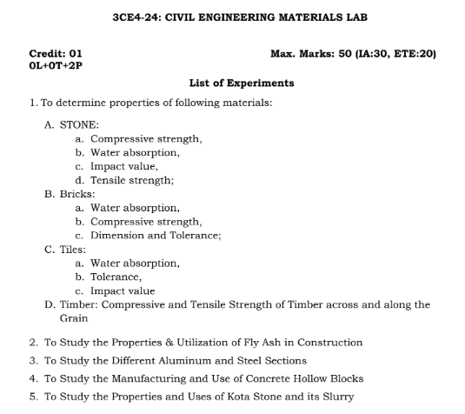

**Course Overview:**

Study the nature and performance of civil engineering materials and evaluation of their physical and mechanical properties. This course focuses on materials used in construction and maintenance of building and infrastructure such as ferrous and non ferrous metals, aggregates, Portland cement, concrete, masonry, asphalt and asphalt mixtures, wood and composites. Emphasis will be placed on selection criteria, design, applications and proper use of these materials. The objective of this course is to understand the nature, characteristics, performance, and behavior of civil engineering materials used in buildings and infrastructure and to evaluate their physical and mechanical properties. Students will learn how to select materials based on their properties and their proper use for a particular facility under prevailing environmental conditions.

**Course Outcomes:**

|  |  |  |
| --- | --- | --- |
| **CO.NO.** | **Mapping** | **Course Outcome** |
| 1 | **Understanding** | Explain about fly ash, different stones, different glasses, aluminum and steel sections. |
| 2 | **Remembering** | To memorize the various properties of cement. |
| 3 | **Understanding** | Student can distinguish the various building materials by visual inspection. |
| 4 | **Understanding** | Identify the properties and utilization of fly ash, glass, timber, kota stone, aluminum and steel sections. |
| 5 | **Understanding** | Understand the manufacturing and use of concrete hollow block |

**Prerequisites:**

1. Fundamentals knowledge of chemistry.
2. Fundamentals knowledge of science.
3. Fundamentals knowledge of civil engineering.

**Course Coverage Module Wise:**

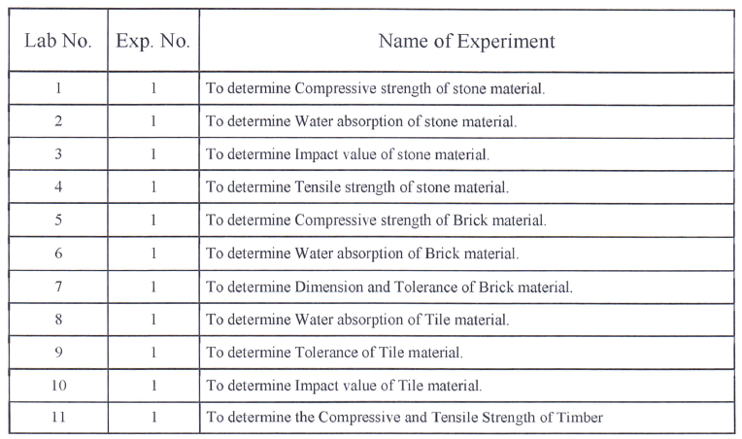

**FacultyLab ManualLink:**

<https://drive.google.com/file/d/19_r2yi18wx--9spIYiDXTTYkAUqbDgVS/view?usp=share_link>

**VivaQUIZLink**

1. <https://www.indiabix.com/civil-engineering/building-materials/>
2. <https://quizizz.com/admin/quiz/5fcd823d41c265001b3d3de7/civil-engineering-material>
3. <https://www.objectivebooks.com/2016/04/building-materials-and-construction.html>
4. <https://www.examveda.com/civil-engineering/practice-mcq-question-on-building-materials/>

**AssessmentMethodology:**

1. Practical exam.
2. Internal exams and Viva Conduct.
3. Final Exam (practical paper) at the end of the semester.

### **Experiment No: 1** Date:

**Title: Shape and size of supplied brick**

**Objective:**To determine the shape and size of the supplied brick.

**Apparatus:**Scale

**Material required:** Bricks

**Procedure:**

* + 1. 20 bricks are taken randomly from a stack. The bricks should be rectangular in shape with sharp edges and smooth surface.
    2. Dimension i.e. length, breadth, & height of the bricks are measured by scale and recorded.
    3. For good quality bricks, the dimension of 20 bricks should be within the following limits.

Length 3680mm to 3920mm

Width 1740 mm to 1860mm

Height1 740mm to1860mm

### Observation:

|  |  |  |  |
| --- | --- | --- | --- |
| SLNO | Length(mm) | Breath(mm) | Height(mm) |
| 1 |  |  |  |
| 2 |  |  |  |
| 3 |  |  |  |
| 4 |  |  |  |
| 5 |  |  |  |
| 6 |  |  |  |
| 7 |  |  |  |
| 8 |  |  |  |
| 9 |  |  |  |
| 10 |  |  |  |
| 11 |  |  |  |
| 12 |  |  |  |
| 13 |  |  |  |
| 14 |  |  |  |
| 15 |  |  |  |
| 16 |  |  |  |
| 17 |  |  |  |
| 18 |  |  |  |
| 19 |  |  |  |
| 20 |  |  |  |

|  |  |  |
| --- | --- | --- |
| **Calculation:** |  |  |
| Sum of the length of 20 bricks | = | mm |
| Sum of the breadth of 20 bricks | = | mm |
| Sum of the height of 20 bricks | = | mm |
| **Conclusion/Result :** |  |  |

**Experiment No:2 Date:**

**Title: Water absorption of brick**

**Objective:** To determines water absorption of brick.

### **Apparatus**:

1. Dry bricks
2. Weighing machine

**Material required:** Bricks

**Theory:** Brick for external use must be capable of preventing rain water from passing throughthem to the inside of walls of reasonable thickness. A good brick should absorb water maximum1/7th of the weight of the brick.

### **Procedure**:

* 1. 20 bricks are taken randomly from a stack.
  2. The bricks are put in an oven at a temperature of 105 0C for drying.

1. Bricks are weighed in a digital weighing machine and is record asW1
2. The bricks are immersed in water at room temperature for 24 hours.
3. After 24 hours immersion, the bricks are taken out of water and wiped with a damp cloth for 3 minutes.
4. The bricks are weight again and recorded as W2.
5. Calculate water absorption of brick

### Observation:

|  |  |  |  |  |
| --- | --- | --- | --- | --- |
| SlNo | WeightW1(Kg) | WeightW2(Kg) | Water absorption in % | Remarks |
| 1 |  |  |  |  |
| 2 |  |  |  |  |
| 3 |  |  |  |  |

**Conclusion/Result:** Water absorption in % is calculated as................................

### **Experiment No:3** **Date**:

**Title: Compressive Strength of Bricks**

**Objective:** To determine the compressive strength of bricks.

**Apparatus:** Compressive strength testing machine

**Material required:** Bricks, Water, Sand, Cement, Trowel

**Theory:** Bricks are mostly subjected to compression and tension. The usual crushing strength of common hand moulded well burnt bricks is about 5 to 10 N/mm2 (50 to 100/kg/cm2) varyingaccording to the nature of preparation of the clay. Pressed and machine moulded bricks made of thoroughly pugged clay are stronger than common hand moulded bricks from carelessly preparedclay.

### **Procedure**:

1. Eight bricks are taken for the compressive strength testing.
2. The bricks are then immersed in water at room temperature for24 hours.
3. Then these are taken out of water and surplus water on the surfaces is wiped off with a moist cloth.
4. The frog of the bricks is flushed level with cement mortar (1:3)
5. The bricks are stored under damp jute bags for 24 hours followed by its immersion in water at room temperature for three days.
6. The bricks are placed in the compression testing machine with flat faces horizontal and mortar filled face being upwards.
7. Load is applied at a uniform rate of14N/ m2 per minute till failure.

### **Observation**:

|  |  |  |  |  |
| --- | --- | --- | --- | --- |
| Sl No | Load at Failure(N) | Average area of back faces(mm2) | CompressiveStrength.(N/mm2) | Remarks |
| 1 |  |  |  |  |
| 2 |  |  |  |  |
| 3 |  |  |  |  |
| 4 |  |  |  |  |
| 5 |  |  |  |  |

**Conclusion/Result:** Average strength of bricks

### **ExperimentNo:4** **Date**:

**Title: Utilization of fly ash in construction**

**Objective:** Utilization of Fly Ashin Construction

Introduction

These days, concrete has become main building material with more than 10 billion tons produced annually in construction industry. The important characters of concrete compare to other materials are excellent strength, easy to molded in any form, an engineered material that can meet almost any desired specification, adaptable, quite incombustible, afford- able, and easily obtained. Higher demand for construction materials has been rising to sustain the fast-growing global population. As a result, there is continual depletion of raw materials and natural sources and leading to increase the construction material cost. To this effect, engineers are faced with the challenge of resolving this potential sustainability problem.

The current global trends are focused on recovery of usable materials from waste as well as utilization of waste as raw materials whenever feasible in construction. Fly ash is a waste product from the combustion of pulverized coal in electricity power plants that faces an increasing production required large area for disposal. In year 2016, Malaysia produce about 6.8 million tonnes of fly ash. The fly ash is deposited either in a dry landfill over a vast area of land which is not possible in urban areas or deposited in an ash pond which also has its shortcomings. Dispose tonnes of waste in without any treatment would cause land pollution, water pollution, air pollution as well as destruction to flora and fauna. . Fly ash has been successfully used in concrete industry since over 50 years but its application is still limited due to lack of understanding of the characteristics of fly ash itself and the properties of concrete containing fly ash.

# Fly Ash Generation and Environmental Issue

Fly ash can be defined as a waste residue that is released from coal combustion process in electric power stations. Fly ash is the unburned residue that is carried away from the burning zone in the boiler by the flue gases and then collected by either mechanical or electrostatic separators Malaysia started the development of coal-fired electric power station in year 1987 and currently there are six coal fired electric power station in Malaysia.Those electric power station produce about 6.8 million tonnes of fly ash. According to statistics, fly ash rate of production is clearly far outweighs consumption due to increased amounts of energy being generated by coal-fired power plants and widely available across the globe as shown in Table.

**Table1.** Fly ash production in different countries

|  |  |  |  |
| --- | --- | --- | --- |
| **Country** | **Amount ofProduction**  **(milliontons/year)** | **Country** | **Amount ofProduction**  **(milliontons/year)** |
| India | 112 | Malaysia | 6.8 |
| China | 100 | Canada | 6 |
| USA | 75 | France | 3 |
| Germany | 40 | Denmark | 2 |
| UK | 15 | Italy | 2 |
| Australia | 10 | Netherland | 2 |

Fly ash contains silica, alumina, ferric oxide and other oxides material that might turn fly ash into hazardous material. These hazardous materials is contributing factor in air, water and soil pollution that lead to human health problems and various geo-environmental issue. These bad situations will interrupt the entire ecological cycles if not properly disposed, therefore good waste management practice needed to sustain a healthy environment. Fly ash emissions from coal combustion units show a wide range of composition with present of elements below atomic number 92 and considered as major source of air pollution. The ultrafine particle of fly ash will behave like cumulative poisons after remain for long periods of time when reaches the respiratory region. As a result, several physiological disorders and other related health problems such as respiratory problem, cancer, anaemia, hepatic disorder, gastroenteritis and dermatitis will arise. Several studies on the present ground showed that wet disposal of this waste causes migration of metal into the soil. The populations located near the fly ash dumping area facing surface water pollution and underground water pollution. However, the surface water pollution is more critical than the underground water pollution. The surface water pollution decreases the fish population and other aquatic organisms due to heavy metal material and organic matter content contained in the water. The surface water contamination also causes skin diseases, diarrhoea and death due to bathing and drinking of water from the contamination river.

Properties of Fly Ash

Physical and chemical characteristics of fly ash is important, as these characteristics influence its subsequent use and disposal. Those characteristics of fly ash is depend on the type of coal used, the combustion condition and temperature at which the coal was fired, the collector setup, the air fuel ratio and other factors. Few generalizations were made in particle size distribution, morphology, surface area, hydraulic conductivity or permeability and density of the fly ash. Fly ash consists of predominantly fine particles ranging from grey to tan to reddish brownwith an average size of particles is 20μm and the bulk density ranging from 0.54g/cm3 to 0.86 g/cm3. 70% to 90% of the particle were solid glassy spheres, while the balance containing Quartz, Mullite, Hematite and Magnetite and a small portion of unburned Carbon as shown in Figure 1

American Society for Testing and Materials (C618 − 12a), classifies fly ash into two classes, Class C and Class F. Typically fly ash contains significant amount of Silicon Dioxide (SiO2), Aluminium Oxide (Al2O3) and Calcium Oxide (CaO) and the class divides based on its chemical composition and source of origin. Class F fly ash produced by burning anthracite or bituminous coal and only has pozzolanic properties while Class C fly ash produced by burning lignite or sub-bituminous coal and has both pozzolanic and cementitious properties.The main 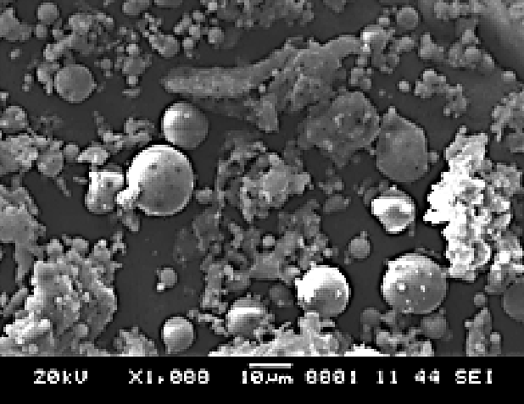difference between these two classes is the amount of calcium, silica, alumina, and iron content. Class F fly ash, contains less than 10% CaO and minimum SiO2 +Al2O3 +Fe2O3 content of 70%, whereas Class C fly ash, contains more than 20% CaO and minimum SiO2 +Al2O3 +Fe2O3 content of 50% .

Figure 1. Morphology of Fly Ash [20].

Utilization of Fly Ash

In last 30 years, many researches has been carry out in aim to increase the utilization of fly ash in various sectors since it is not considered as hazardous waste . Figure 2 shows many countries across the globe utilize this residue waste and turn it into useful product as an alternative to another industrial resource, process or application. The utilization of fly ash can be categorized into three classes of application, low, medium and high technology application.

Fly ash suitable to be used as raw material in many different industries and construction because it is oxide-rich material. Currently, the fly ash was successfully use in improving the construction material and excellent to be used in agriculture sector to enhance the soil properties too. The fly ash also can be utilized in brick manufacturing, ceramics manufacturing, road construction, concrete production and other activities as shown in Figure 3. The most important areas of fly ash utilization is a concrete production, either in conventional concrete or geopolymer concrete. Many researches have been done to find use of fly ash in cement, concrete, and other cementitious composites.

### **ExperimentNo:5** **Date**:

**Title: Utilization of fly ash in construction**

HOLLOW CONCRETEBLOCKS

Objective: To study the use & manufacturing of hollow concrete block

## INTRODUCTION

Shelter is one of the three basic requirements of human being. Initially ancient man started living in caves excavated below ground level on near the hill ends. Thereafter, they started constructing walls from mud, and in due course of time, the developed the techniques of burnt clay brick masonry to form the structural part of the shelter.

As building development throughout the world continues, the desire to construct cheaper structures onsites that are more difficult to build on, in shorter periods of time, all while providing improved performance will always be desirable in order to maximize both product economy and quality. As such, the construction industry is constantly searching for ways to improve their product. One means to this end is, rather than relying on improving construction implementation mechanisms such as scheduling, installation techniques, and quality control, is focusing on the industry’s improved knowledge and development of material sand their behavior.

The hollow blocks are made of cement, stone chips, stone dust and sand are not only cheaper than bricks but have other specialities as well. These block shave more tensile strength, the walls constructed from these blocks act as thermal insulaters because of their hollowness.

## MARKET DEMAND

As the construction activity is growing day by day, there isa good demand for hollow blocks. These blocks find wide applicability and construction cost is largely reduced. It requires mainly by Govt. Departments and industries.

As the construction activity is growing day by day, there is a good demand for hollow and cement concrete bricks. These blocks find wide applicability and construction cost is largely reduced. It is also observed that there is good demand for housing activity among tribals.

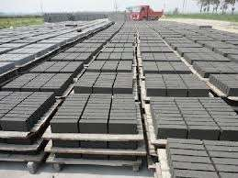

**Fig.1 Placing Hollow Concrete Blocks**

## MANUFACTURING PROCESS

Cement concrete block scan be solid (dense)or hollow. Besides different sizes and designs can be given to the blocks. The blocks are made in the sizes of 12x8x4"; 12x8x3"; 12x8x6", etc. Firstly cement, stone chips, sand, etc are mixed in the ratio of 1:6 or1:12.This mixture is put in vibrator machine. This is then poured into the desired size mould. After 24 hours of drying, the blocks are put in water tank for curing. The process of curing continues for two to three weeks to give the blocks compression strength. The blocks are used in construction process after drying.

It is easy to make a concrete block. The successful block yard must however make blocks of uniform quality and sell them at a price high enough to cover costs and make a reasonable profit.

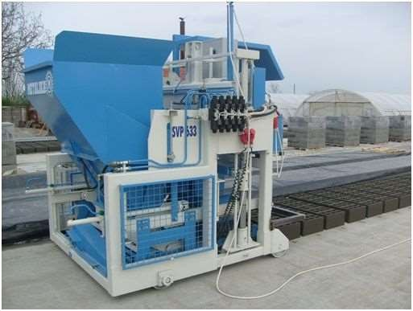

## Fig.2 Movable Concrete Automatic Machine

1. **SIZE**

The site should be big enough for aggregate stock piles, cement storage, production (labor stationary machine), block stacking, staff facilities, an office and on-site access.

Provided concrete masonry units complying with requirements indicated below for size are manufactured to specified face dimensions within tolerances specified in applicable referenced ASTM specification. A. Manufacture concrete masonry units specified dimensions of 3/8 inch less than nominal widths by nominal heights by nominal lengths.

Provide special shapes where indicated and as follows:

1. For Lintels, corners, jambs, sash, control joints, headers, bonding and other special conditions
2. Square-edged units for outside corners except where bullnose units are indicated.

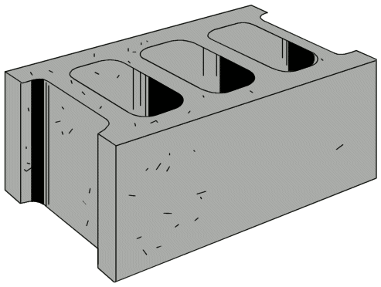

**Fig.3 Hollow Concrete Block**

Materials for block making

## Cement

Cement should comply with SANS 50197-1. Strength class should be 42,5 N or higher because the concrete must develop strength as rapidly as possible. Note that it is illegal to sell common cement in South Africa without a regulatory Letter of Authority (LOA) number which indicates compliance with SANS50197-1 or EN197-1.

## Aggregates

Sand and stone are fragments of rock and differ only in size. Sand particles will pass through a sieve with 4,75-mm square openings. Stone particles will not because they are too large. It can be seen that strength depends on a number of interrelated factors. It is therefore not possible to design a mix in a laboratory. Instead, a trial-and-error process, using the equipment of the block yard, is followed. This process aims to arrive at the best combination of aggregates and the right aggregate:cement ratio.

* 1. **Aggregate:cement ratio**

Try 6:1, 8:1 and 10:1 by loose volumes (230, 300 and 380-*l* of aggregate respectively per 50-kg bag of cement).

## Production

To minimize breakages in cold weather, increase the cement content of the mix or the curing period before moving blocks.

## Mixing

Hand mixing with the use of shovels should be done on a level concrete slab or steel plate. First spread the sand out 50 to 100 mm thick. Then distribute the cement, and stone if any, evenly over the sand. Mix aggregate and cement until the color is uniform.

Spread the mixture out, sprinkle water over the surface and mix. Continue with this process until the right amount of water has been mixed in. For machine mixing, first mix aggregate and cement then add water gradually while mixing until water content is correct.

## Moulding

The mould of a powered machine should be filled until approximately six to eight cycles of compaction are required to bring the compacting head to its stops. Too little or poor compaction should be avoided as it results in greatly reduced strengths.

Demoulding or removal of the mould should be done carefully so that the fresh blocks are not damaged. Fresh blocks should be protected from rain (with plastic sheets or any suitable covering) and from the drying effects of the sun and wind until curing starts.

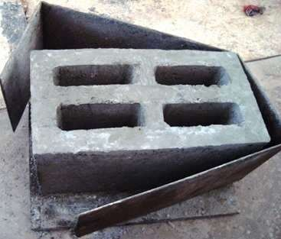.

**Fig.4BlockMould**

In some cases it may be necessary to protect blocks from frost damage. Covering with plastic sheeting with the edges held down is normally sufficient.

To minimize breakages in cold weather it may be necessary to increase the cement content of the mix, or the curing period before moving blocks.

## Curing

In order to maximize the efficiency of the curing process of concrete for precast applications, a general understanding of the hydration reaction is necessary. When combined with water, Portland cement undergoes a chemical reaction known as hydration, the process responsible for the hardening of concrete. This process can be divided into three distinct stages.

Stage one of the curing process begins immediately upon the addition of water to the cement and aggregate that makeup the dry concrete mix, and lasts until the onset of initial set, as determined by ASTMC403. Some manufacturers designate the end of this phase as being coincidental with the achievement of a compressive strength of 500psi (Corcoran,2004). During stage one, the chemical reaction between the Portland cement and the water begins; however, the

Development of measurable compressive strength gain is minimal. Depending on the particular mix design characteristics, this stage usually lasts for 3-4hours.

* + - High-Pressure Steam Curing (Autoclaving).
    - Low-Pressure Steam Curing.
    - Electrical Resistance Curing.
    - Conduction/Convection Used for Accelerated Curing.

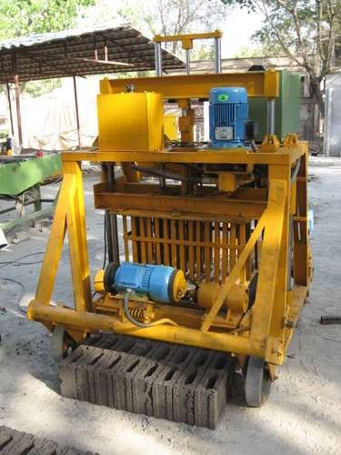

**Fig.5ConcreteBlockMachine**

## ADVANTAGES OF HOLLOW CONCRETE BLOCKS.

Highly Durable: The good concrete compacted by high pressure and vibration gives substantial strength to the block. Proper curing increase compressive strength of the blocks.

## Structural Advantages

In this construction system, structurally, each wall and slab behaves as a shear wall and a diaphragm respectively, reducing the vulnerability of disastrous damage to the structure/building, during the natural hazards.

# Properties

## Thermal properties

Concrete blocks have an excellent thermal property, comparable to other masonry blocks. The cavities in the blocks provide better thermal protection and also do not need external or internal plastering. The performance of these blocks increases with the increase in the number of hollow cores, which may or may not be filled in with some insulating materials.

## Sound insulation

Concrete blocks provide an acceptable degree of sound insulation.

## Fire and vermin resistance

Concrete blocks will not burn. They are readily incorporated into fire resistant rated construction. It has no problems of vermin attacks or infestation.

## Durability and moisture resistance

They are very popular as a long lasting, low maintenance masonry unit, with good compressive strengths. They have a general life’s span of about 60yrs although may extend up to 80yrs or more. They are robust and durable even if wetted. If water absorption is less than 10% of weight of block, after just 24hrs, and may need a weather proof coating to keep the moisture out.

## Applicability

Concrete blocks have various types like; solid, hollow, paving, tree-guard blocks, and each of them are available in various shapes and sizes. This vast range of products offers a large market for application.

* In load bearing structures-low rise residential and office buildings, bungalows, shelter units for rural housing, highway constructions, institutional buildings, godowns and warehouses etc
* Inframe structures–High rise residential apartments, office buildings, market complexes, hospitals and hotels etc
* As ground laying units– interlocking paving blocks for roadside walkways, garden pathways, curbstones, exhibition grounds, fuel pumping stations, movement corridors, high traffic movement areas like: bus and train stations etc.
* Specific usage areas: treeguard blocks for road side and garden tree plantations.

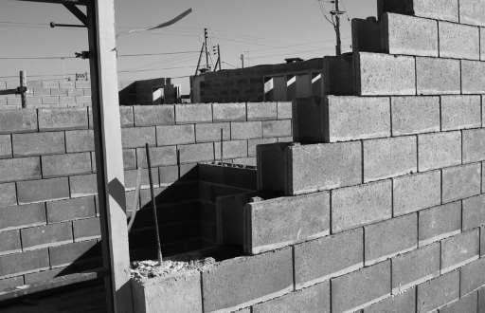

**Fig.6 HollowConcreteBlockWall**

## Strength

Quality of blocks should be controlled so that strengths are adequate (to avoid breakages and rejection by customers) and mixes are as economical as possible. Ideally, blocks should be regularly tested for strength and mixes and production processes modified if necessary.

If testing is impracticable or unaffordable, block strength should be continually assessed by noting whether corners and edges, or even whole blocks, tend to break in handling.

Strength can also be assessed by knocking two mature bricks together.

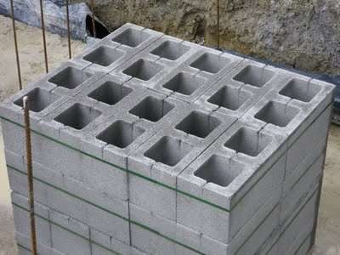

**Fig.7 BlockforLoadStructure**

## CONCLUSIONS

The hollow concrete blocks of sizes 400 x 200 x 200 mm made with the concrete grade 1:3:6 proportion gives the average compressive strength of 11.25 kg/cm2 considering the gross area. Considering the net crosssectional area the hollow concrete blocks of size 400 x 200 x 200 mm made with the concrete grade 1:3:6 proportion gives the average compressive strength of 22kg/cm2. The hollow concrete blocks of size 200 x 200 x 200 mm madewiththeconcretegrade1:3:6 proportion gives the average compressive strength of 45 kg/cm2 considering the gross area and 87.8kg/cm2 considering the net crosssectional area.

The Blocks manufactured in this experimental program with granite fine particles as an additive ensures effective packing and large dispersion of cement particles which resulted in a good degree of surface finish and edges.

It is evident from the results obtained that the compressive strength and the performance of the Hollow concrete blocks can be increased with proper compaction techniques. When compared to compaction with machine vibration the blocks manufactured with uniform hand compaction gives higher compressive strength.

It is seen from the experimental data the optimum replacement of fine aggregates by granite fines is 25% and further increase in granite fines reduces the strength of Hollow concrete blocks.

**TECHNO INDIA NJR INSTITUTE OF TECHNOLOGY UDAIPUR**

**Civil Engineering**

**B. TECH II– YEAR (III Sem)**

**SUBJECT:CIVIL ENGINEERING MATERIALS LAB (3CE4-24)**

**Viva**

1. **The rocks which are formed due to cooling of magma at a considerable depth from earth's surface are called**
2. **advantage of plywood?**
3. **Excess of alumina in brick earth makes the brick?**
4. **The constituent of cement which is responsible for all the undesirable properties of cement is called?**
5. **The basic purpose of a retarder in concrete is?**
6. **Clay and silt content in a good brick earth must be at least?**
7. **the purest form of iron?**
8. **The principal constituent of brick used as building materials are:**
9. .**In absorption test on brick, how many hours it has to be soaked in cold water?**
10. **What is the loading rate used in compressive strength test?**
11. **How is the hardness of brick tested?**
12. **What is the maximum permissible tolerance for length and width respectively?**
13. **What should be observed ideally when two bricks are struck together?**
14. **How is the structure of brick tested**
15. **What should be observed ideally when two bricks are struck together**

**TECHNO INDIA NJR INSTITUTE OF TECHNOLOGY UDAIPUR**

**Civil Engineering**

**B. TECH II– YEAR (III Sem)**

**SUBJECT:CIVIL ENGINEERING MATERIALS LAB (3CE4-24)**

**Quiz**

1. In absorption test on brick, how many hours it has to be soaked in cold water?  
   a) 19 hours  
   b) 5 hours  
   c) 6 hours  
   d) 24 hours
2. What is the loading rate used in compressive strength test?  
   a) 14 N/mm2 per hour  
   b) 14 N/mm2 per minute  
   c) 20 N/mm2 per minute  
   d) 40 N/mm2 per hour
3. Which of the following is/are basic building materials?  
   a) Wood  
   b) Cement  
   c) Brick  
   d) All of the mentioned
4. . Which of the following is not a type of Inorganic building materials?  
   a) Mud  
   b) Gypsum  
   c) Wood  
   d) Lime
5. Why building materials are required?  
   a) Building material signifies bonding between the construction materials  
   b) Building material signifies structural existence  
   c) Both a & b  
   d) All of the mentioned
6. Which of the following line is usually parallel to the plot boundaries and laid down in each case by the Authority, beyond which nothing can be constructed towards the site boundaries?  
   a) Property line  
   b) Building line  
   c) Plot line  
   d) Control line
7. . Which of the following is not a classification of rocks from which building stones are obtained?  
   a) Geological classification  
   b) Biological classification  
   c) Physical classification  
   d) Chemical classification
8. In which of the following rocks, clay predominates?  
   a) Argillaceous rocks  
   b) Calcareous rocks  
   c) Silicious rocks  
   d) Volcanic rocks
9. Augite forms crystals of ________ shape.  
   a) Square  
   b) Circular  
   c) Hexagonal  
   d) Octagonal
10. Smith’s test is used to find out ____________  
    a) The toughness of a stone  
    b) Compressive strength of a stone  
    c) Presence of soluble material in a sample of stone  
    d) Rate of wear of stones
11. Crushing strength should be greater than ___________ for a good structural stone.  
    a) 10 kg per cm2  
    b) 100 kg per cm2  
    c) 1000 kg per cm2  
    d) 10,000 kg per cm
12. Dolomite is a bicarbonate of _________ and ___________  
    a) Magnesium and aluminium  
    b) Calcium and aluminium  
    c) Magnesium and calcium  
    d) Sodium and aluminium
13. For a stone to be used in road work, coefficient of hardness should be greater than ___________  
    a) 7  
    b) 10  
    c) 15  
    d) 17
14. Quartz sand is an example of polymineralic rock while granite is an example of a monomineralic rock.  
    a) True  
    b) False

**Answers:**

|  |  |  |  |  |  |  |
| --- | --- | --- | --- | --- | --- | --- |
| **1 – B** | **2-C** | **3 – D** | **4 - -B** | **5 - A** | **6 - D** | **7 - D** |
| **8 - D** | **9 - A** | **10 - B** | **11 - D** | **12 - B** | **13 - B** | **14 - B** |