Techno India NJR Institute of Technology



Building Drawing Lab (4CE4-23)

Nishit Jain (Associate Professor) **Department of CE**

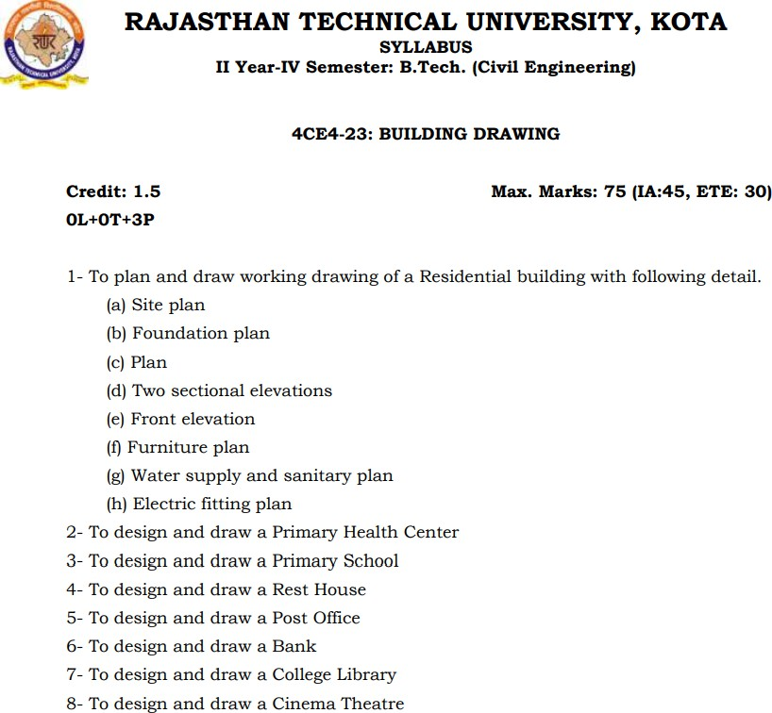

# Course Overview:

Drawing is the language of Engineers and Architects. Building Planning and Drawing is the foundation subject for Civil Engineering students. reader is empowered with an in-depth knowledge in the subject of Building Planning and Drawing. The entire subject is canvassed in the chapters like: Fundamentals of Building Drawing; Fundamentals of Buildings; Site Selection for Residential Buildings; Climate and Its Influence on Building Planning; Orientation of Buildings; Principles of Planning Of Buildings; Building Bye-Laws; Planning of Residential Buildings; Planning of Public Buildings; Different Methods of Construction; Prefabricated Construction; Economical Measures in Building Construction; Green Buildings; Anthropometric Studies; Intelligent Buildings; Construction Management Techniques; Basic Concepts of the Building Elements; Nomenclature of Building Planning and Construction; Standard Guidelines for Building Drawing; Guidelines for Planning and Drawing of Residential Building; Drafting Materials and their Utilization; Conventional Signs and B.I.S. Code Colours; A Few Facts of the Vaastu Sastra; Perspective Drawings; Computer Aided Building Drawings; Typical Building Drawings; Question Bank. The Appendix gives University Examination Questions

# Course Outcomes:

|  |  |  |
| --- | --- | --- |
| **CO.NO.** | **Cognitive Level** | **Course Outcome** |
| 1 | Analyzing | Learner can sketch, plan and do drawing of residential building with details of site plan, foundation plan, furniture plan, water supply and sanitary plan |
| 2 | Analyzing | Learner can sketch, plan and do drawing of institutional building with details of site plan, foundation plan, furniture plan |
| 3 | Applying | Learner can sketch and do the drawing of commercial building with details of site plan, foundation plan, furniture plan |
| 4 | Analyzing | Draw the details of parts of buildings. |
| 5 | Applying | State the scope and provisions for building components and services. |

**Prerequisites:**

**1.**Fundamentals Knowledge of Different types of Civil Engineering Drawings.

**Course Outcome Mapping with Program Outcome:**

|  |  |  |  |  |  |  |  |  |  |  |  |  |  |  |  |
| --- | --- | --- | --- | --- | --- | --- | --- | --- | --- | --- | --- | --- | --- | --- | --- |
| **Course Outcome** | **PO 1** | **PO 2** | **PO 3** | **PO 4** | **PO 5** | **PO 6** | **PO 7** | **PO 8** | **PO 9** | **PO1 0** | **PO1 1** | **PO1 2** | **PS O1** | **PS O2** | **PS O3** |
| CO249.1 | 3 | 2 | 2 | 2 | 2 | 2 | 2 | 1 | 2 | 1 | 1 | 1 | 2 | 2 | 2 |
| CO249.2 | 2 | 2 | 2 | 2 | 1 | 2 | 2 | 1 | 2 | 1 | 2 | 1 | 2 | 2 | 2 |
| CO249.3 | 3 | 2 | 2 | 2 | 2 | 2 | 2 | 1 | 2 | 1 | 1 | 1 | 2 | 2 | 2 |
| CO249.4 | 2 | 2 | 1 | 2 | 2 | 2 | 3 | 1 | 2 | 1 | 1 | 2 | 3 | 2 | 2 |
| CO249.5 | 2 | 1 | 1 | 1 | 2 | 2 | 1 | 1 | 2 | 1 | 1 | 2 | 3 | 2 | 2 |
| CO249  (AVG) | 2.4 | 1.8 | 1.6 | 1.8 | 1.8 | 2 | 2 | 1 | 2 | 1 | 1.2 | 1.4 | 2.4 | 2 | 2 |

**Course Coverage Module Wise:**

|  |  |
| --- | --- |
| 1 | To plan and draw working drawing of a Residential building with following detail. |
| a | Site plan |
| b | Foundation plan |
| c | Plan |
| d | Two sectional elevations |
| e | Front elevation |
| f | Furniture plan |
| g | Water supply and sanitary plan |
| h | Electric fitting plan |
| 2 | To design and draw a Primary Health Center |
| 3 | To design and draw a Primary School |
| 4 | To design and draw a Rest House |
| 5 | To design and draw a Post Office |
| 6 | To design and draw a Bank |
| 7 | To design and draw a College Library |
| 8 | To design and draw a Cinema Theatre |

**Faculty Lab Manual Link**

[1. https://r.search.yahoo.com/_ylt=AwrxwXoUrKxh4ikAHwC7HAx.;_ylu=Y29sbwNzZzMEcG9zAzEEdnRpZAMEc2VjA3Ny/RV=2/RE=1638734997/RO=10/RU=https%3a%2f%2famrita.edu.in%2fsites%2fdefault%2ffiles%2fCE%25208211%2520Computer%2520Aided](https://r.search.yahoo.com/_ylt%3DAwrxwXoUrKxh4ikAHwC7HAx.%3B_ylu%3DY29sbwNzZzMEcG9zAzEEdnRpZAMEc2VjA3Ny/RV%3D2/RE%3D1638734997/RO%3D10/RU%3Dhttps%3a%2f%2famrita.edu.in%2fsites%2fdefault%2ffiles%2fCE%25208211%2520Computer%2520Aided%2520Building%2520Drawing%2520Lab%2520Manual_0.pdf/RK%3D2/RS%3DRu1cHXxZLtDjqo3YvwrmZkk31So-)

[%2520Building%2520Drawing%2520Lab%2520Manual_0.pdf/RK=2/RS=Ru1cHXxZLt](https://r.search.yahoo.com/_ylt%3DAwrxwXoUrKxh4ikAHwC7HAx.%3B_ylu%3DY29sbwNzZzMEcG9zAzEEdnRpZAMEc2VjA3Ny/RV%3D2/RE%3D1638734997/RO%3D10/RU%3Dhttps%3a%2f%2famrita.edu.in%2fsites%2fdefault%2ffiles%2fCE%25208211%2520Computer%2520Aided%2520Building%2520Drawing%2520Lab%2520Manual_0.pdf/RK%3D2/RS%3DRu1cHXxZLtDjqo3YvwrmZkk31So-)

[Djqo3YvwrmZkk31So-](https://r.search.yahoo.com/_ylt%3DAwrxwXoUrKxh4ikAHwC7HAx.%3B_ylu%3DY29sbwNzZzMEcG9zAzEEdnRpZAMEc2VjA3Ny/RV%3D2/RE%3D1638734997/RO%3D10/RU%3Dhttps%3a%2f%2famrita.edu.in%2fsites%2fdefault%2ffiles%2fCE%25208211%2520Computer%2520Aided%2520Building%2520Drawing%2520Lab%2520Manual_0.pdf/RK%3D2/RS%3DRu1cHXxZLtDjqo3YvwrmZkk31So-)

**Assessment Methodology:**

1. Practical exam using Hand drawing
2. Internal exams and Viva Conduct.
3. Final Exam (practical paper) at the end of the semester.

# GENERAL BUILDING REQUIREMENTS AND SERVICES

**General**

This part sets out the standard space requirements of various parts of a building (for all types of buildings – low/ high rise).

## Table4.1Occupant Load

|  |  |  |
| --- | --- | --- |
| **Sl. No.** | **Type of Occupancy** | **Occupant Load per 100sqm.of Plinth or Covered Area** |
| 1 | Residential | 8.0 |
| 2 | Educational | 25.0 |
| 3 | Institutional | 6.60 |
| 4 | Assembly |  |
| With fixed or loose seats and dance floor | 166.6 |
| Without seating facilities including dining rooms | 66.6 |
| 5 | Mercantile |  |
| Street floor and sales basement | 33.3 |
| Upper sale floor | 16.6 |
| 6 | Business and industrial | 10.0 |
| 7 | Storage | 3.3 |
| 8 | Hazardous | 10.0 |

*\* The occupant load in dormitory portions of homes for the aged, orphanages or mental hospitals etc. where sleeping accommodation is provided shall be calculated at not less than 13.3 persons per 100 sq.m.*

*\*\* The plinth or covered area shall include, in addition to the main assembly room or space, any occupied connecting room or space in the same storey or in the storeys above or below where entrance is common to such rooms and space and the area available for use by the occupants of the assembly place. No deduction shall be made in the plinth/covered area for corridors, closets and other sub-divisions; that area shall include all space serving the particular assembly occupancy.*

## Requirements for Parts of Buildings Plinth

**Main Buildings**

The plinth or any part of a building or outhouse shall be so located with respect to the surroundinggroundlevelthatadequatedrainageofthesiteisassured.Theheightofthe plinth shall be not less than 450 mm from the surrounding ground level.

## Interior Courtyards and Covered Parking

Every interior courtyard shall be raised at least 150 mm above the determining ground level and shall be satisfactorily drained.

## Habitable Rooms

**Height**

The height of all rooms for human habitation shall not be less than 2.75 m measured from the surface of the floor to the lowest point of the ceiling (bottom of slab) provided that the minimum clear headway under any beam shall not be less than 2.4 m. In the case of pitched roof, the average height of rooms shall not be less than 2.75 m. The minimum clear head room under a beam, folded plates or eaves shall be 2.4 m. In the case of air-conditioned rooms, a height of not less than 2.4 m measured from the surface of the floor to the lowest point of air- conditioning duct or the false ceiling shall be provided.

The requirements of clause apply to residential, business and mercantile buildings. For educational and industrial buildings, the following minimum requirements apply:

## Minimum height requirement for educational and industrial buildings

|  |  |  |
| --- | --- | --- |
| **Sl. No** | **Types of building** | **Ceiling height** |
| 1 | Educational Buildings | Ceiling height 3.6m for all regions; in cold regions, 3 m |
| 2 | Industrial Buildings | Ceiling height 3.6m, except when air-conditioned, 3m (*Factory Act*  1948 and Rules there in shall govern such heights, where  applicable). |

Size

The area of habitable room shall not be less than 9.5 m2, where there is only one room with a minimum width of 2.4 m. Where there are two rooms, one of these shall not be less than 9.5 m2 and the other not less than 7.5 m2, with a minimum width of 2.1 m.

## Kitchen Height

The height of a kitchen measured from the surface of the floor to the lowest point in the

Ceiling (bottom of slab) shall not be less than 2.75m, except for the portion to accommodate floor trap of the upper floor.

## Size

The area of a kitchen where separate dining area is provided shall be not less than5.0 m2 with a minimum width of 1.8 m. Where there is a separate store, the area of the kitchen may be reduced to 4.5 m2. A kitchen, which is intended for use as a dining area also, shall have a floor area of not less than 7.5 m2 with a minimum width of 2.1 m.

## Other Requirements

Every room to be used as kitchen shall have:

1. unless separately provided in a pantry, means for the washing of kitchen utensils which shall lead directly or through a sink to a grated and trapped connection to the waste pipe;
2. an impermeable floor;
3. a flue, if found necessary; and
4. a window or ventilator or opening of size not less than as specified in clause 4.31.1 subject to increase in area of opening in accordance with Note 3.

## Bathrooms and Water-Closets

**Height**

The height of a bathroom or water-closet measured from the surface of the floor to the lowest point in the ceiling (bottom of slab) shall not be less than 2.1 m.

## Size

The area of a bathroom shall not be less than 1.8 m2 with a minimum width of 1.2 m. The floor area of water-closet shall be 1.1 m2 with a minimum width of 0.9 m. If bath and water-closet are combined, its floor area shall not be less than 2.8 m2 with a minimum width of 1.2 m.

## Other Requirements

Every bathroom or water-closet shall:

1. be so situated that at least one of its walls shall open to external air;
2. not be directly over or under any room other than another water- closet, washing place, bath or terrace, unless it has a water-tight floor;
3. have the platform or seat made of water-tight non-absorbent material;
4. be enclosed by walls or partitions and the surface of every such wall or partition shall be finished with a smooth impervious material to a height of not less than 1 m above the floor of such a room;
5. be provided with an impervious floor covering, sloping towards the drain with a suitable grade and not towards VERANDAH or any other room; and
6. have a window or ventilator, opening to a shaft or open space, of area not less than

0.3m2 with side not less than 0.3m.

No room containing water-closets shall be used for any purpose except as a lavatory and no such room shall open directly into any kitchen or cooking space by a door, window or other opening. Every room containing water-closet shall have a door completely closing the entrance to it**.**

Ledge or Loft

## Height

The minimum head-room of ledge or loft shall be 2.2m.The maximum height of loft shall be 1.5 m.

## Size

A ledge or loft in a habitable room shall not cover more than 25 percent of the area of the floor on which it is constructed and shall not interfere with the ventilation of the room under any circumstances.

# Mezzanine Floor

## Height

It shall have a minimum height of 2.2 m.

## Size

The minimum size of the mezzanine floor, if it is to be used as a living room, shall not be less than 9.5 m2.

The aggregate area of such mezzanine floor in a building shall in no case exceed one-third the plinth area of the building.

# Other Requirements

A mezzanine floor may be permitted over a room or a compartment provided:

1. itconformtothestandardoflivingroomsasregardslightingandventilationincase the size of mezzanine floor is 9.5 m2 or more (see 4.31.1);
2. it is so constructed as not to interfere under any circumstances with the ventilation of the space over and under it;
3. such mezzanine floor is not sub-divided into smaller compartments;
4. such mezzanine floor or any part of it shall not be used as a kitchen; and
5. in no cases hall a mezzanine floor be closed so as to make it liable to be converted into unventilated compartments.

# Store Room

## Height

The height of a store room shall be not less than2.2 m.

## Size

The size of a store room, where provided in a residential building, shall be not less than 3 m2.

# Garage

## Height

The height of a garage shall be not less than 2.4 m.

## Size

The size of garages shall be as below:

1. Private Garage- 3.0m×6.0m, minimum; and
2. Public Garage- Based on the number of vehicles parked by ECU.(Appendix‘A-1’)

# Boundary Wall

The requirements of the boundary wall shall be as follows:

1. Except with the special permission of the Authority, the maximum height of the compound wall shall be 1.5m above the centre line of the front street. Compound wall up to 2.4 m height may be permitted if the top 0.9 m is of open type construction of a design to be approved by the Authority.
2. In the case of a corner plot, the height of the boundary wall shall be restricted to

0.75 m for a length of 10 m on the front and side of the inter-sections and the balance height of

0.75 m if required in accordance with (a) may be made up of open type construction (through railings) and of design to be approved by the Authority.

However, the provisions of (a) and (b) are not applicable to boundary walls of jails. In industrial buildings, electric sub-stations, transformer stations, institutional buildings like senatorial, hospitals, industrial buildings like workshops, factories and educational buildings like schools, colleges, including hostels, and other uses of public utility undertakings and strategically sensitive buildings, a height upto 2.4 m may be permitted by the Authority.

## Septic Tanks

Where a septic tank is used for sewage disposal, the location, design and construction of septic tank shall conform to requirements of Part 9 ‘Plumbing Services, Section 1 Water Supply, Drainage and Sanitation (Including Solid Waste Management)’of NBC, 2005.

## Location of the Septic Tanks and Sub surface Absorption Systems

A sub-soil dispersion system shall not be closer than 18 m from any source of drinking water, such as well, to mitigate the possibility of bacterial pollution of subsurface water. It shall also be as far removed from the nearest habitable building as economically feasible but not closer than 6 m, to avoid damage to the structures.

## Requirements

1. *Dimensions of septic tanks* - Septic tanks shall have a minimum width of 750 mm, a minimum depth of 1 m below the water level and a minimum liquid capacity of 1 m3.The length of tanks shall be 2 to 4 times the width;
2. Septic tanks may be constructed of brickwork, stone masonry, concrete or other suitable materials as approved by the Authority;
3. Under no circumstances shall effluent from a septic tank be allowed into an open channel drain or body of water without adequate treatment;
4. The minimum nominal diameter of the pipe shall be 100 mm. Further, at junctions of pipes in manholes, direction of flow from a branch connection shall not make an angle exceeding 45° with the direction of flow in the main pipe;
5. The gradients of land drains, under-drainage as well as the bottom of dispersion trenches and soak ways shall be between 1:300 and 1:400;
6. Every septic tank shall be provided with ventilating pipe of at least 50 mm diameter. The top of the pipe shall be provided with a suitable cage of mosquito- proof wire mesh. The ventilating pipe shall extend to a height which would cause no smell nuisance to any building in the area. Generally, the ventilating pipe may extend to a height of about 2 m, whentheseptictankisatleast15mawayfromthe nearest building and to a height of 2 m above the top of the building when it is located closer than 15 m;
7. When the disposal of septic tank effluent is to a seepage pit, the seepage pit may be of any suitable shape with the least cross sectional dimension of 0.90 m and not less than 1.00 m in depth below the invert level of the inlet pipe. The pit may be lined with stone, brick or concrete blocks with dry open joints which should be backed with at least 75 mm of clean coarse aggregate. The lining above the inlet level should be finished with mortar. In the case of pits of large dimensions, the top portion maybe narrowed to reduce the size of the RCC cover slabs. Where no lining is used, specially near trees, the entire pit should be filled with loose stones. A masonry ring may be constructed at the top of the pit to prevent damage by flooding of the pit by surface runoff. The inlet pipe may be taken down a depth of 0.90m from the top as an anti-mosquito measure; and
8. When the disposal of the septic tank effluent is to a dispersion trench, the dispersion trench shall be 0.50 m to 1.00 m deep and 0.30 m to 1.00 m wide excavated to a slight gradient and shall be provided with 150 mm to 250 mm of washed gravel or crushed stones. Open jointed pipes placed inside the trench shall be made of unglazed earthen ware clay or concrete and shall have a minimum internal diameter of 75mm to

100 mm. Each dispersion trench shall not be longer than 30 m and trenches shall not be placed closer than 1.8 m.

# Stairs

The minimum clear width, minimum tread width and maximum riser of staircases for buildings shall be as given as below (*see also* Part 4 ‘Fire and Life Safety of NBC 2005).

## Minimum width

The minimum width of staircase shall be as follows:

|  |  |  |
| --- | --- | --- |
| A | Residential buildings(dwellings)NOTE  —For row housing with 2 storeys, the min. width of shall be 0.75 | 1.0 m |
| B | Residential hotel buildings | 1.5 m |
| C | Assembly buildings like auditoria, theatres and cinemas | 2.0 m |
| D | Educational building | 1.5 m |
| E | Institutional buildings | 2.0 m |
| F | All other buildings | 1.5 m |

## Minimum tread

The minimum width of tread without nosing shall be 250mm for residential buildings. The minimum width of tread for other buildings shall be 300 mm.

## Maximum riser

The maximum height of riser shall be 190mm for residential buildings and 150mm for other buildings and these shall be limited to 12 per flight.

The minimum head-room in a passage under the landing of a staircase shall be 2.2

m. The minimum clear head-room in any staircase shall be 2.2 m.

## Exit Requirements

All aspects of exit requirements for corridors, doors, stair cases, ramps, etc in respect of widths, travel distance shall be as per Part 4 ‘Fire and Life Safety’ of NBC,2005.

# Roofs

The roof of a building shall be so designed and constructed as to effectively drain water by means of sufficient rain-water pipes of adequate size, wherever required, so arranged, jointed and fixed as to ensure that the rain-water is carried away from the building without causing dampness in any part of the walls, roof or foundations of the building or an adjacent building.

* The Authority may require rain-water pipes to be connected to a drain or sewer to a covered channel formed beneath the public footpath to connect the rainwater rain water pipe to the road gutter or in any other approved manner.
* Rain-water pipes shall be affixed to the outside of the external walls of the building or in recesses or chases cut or formed in such external walls or in such other manner as may be approved by the Authority.
* It is desirable to conserve rain water using suitable rain water harvesting techniques including by roof water collection. In this context, reference may be made to Part 9 ‘Plumbing Services, Section 1 Water Supply, Drainage and Sanitation (Including Solid Waste Management)’ of NBC, 2005.

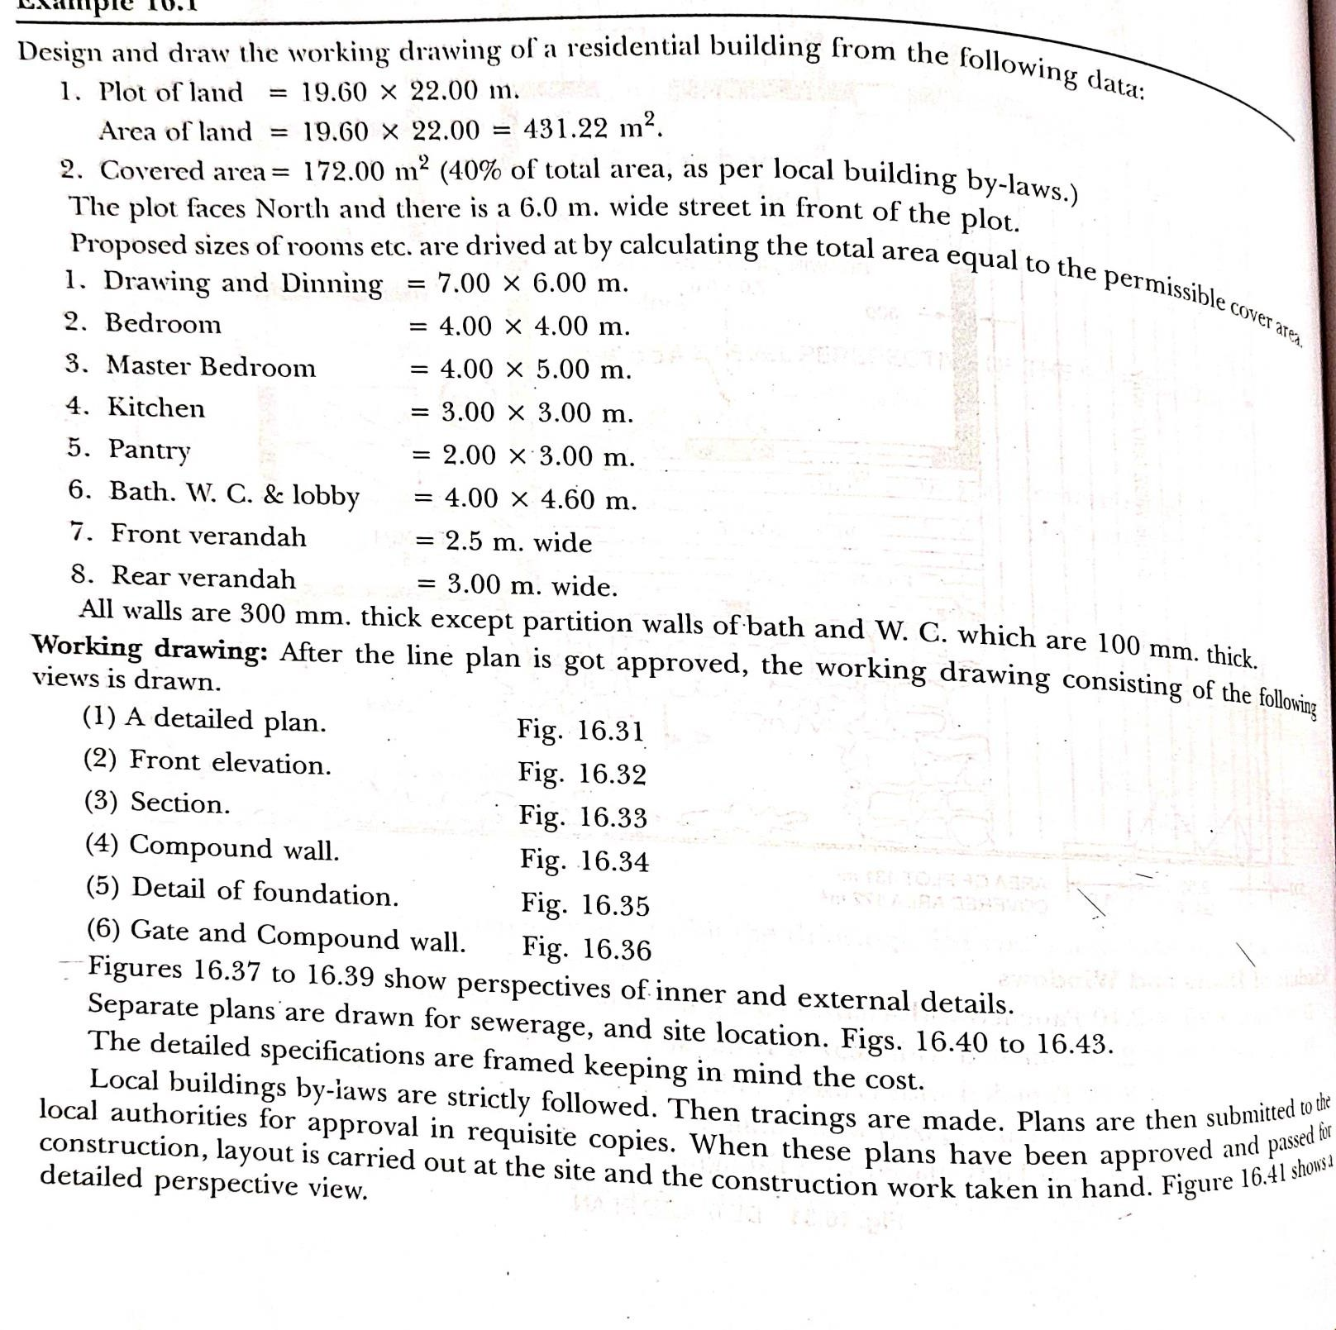

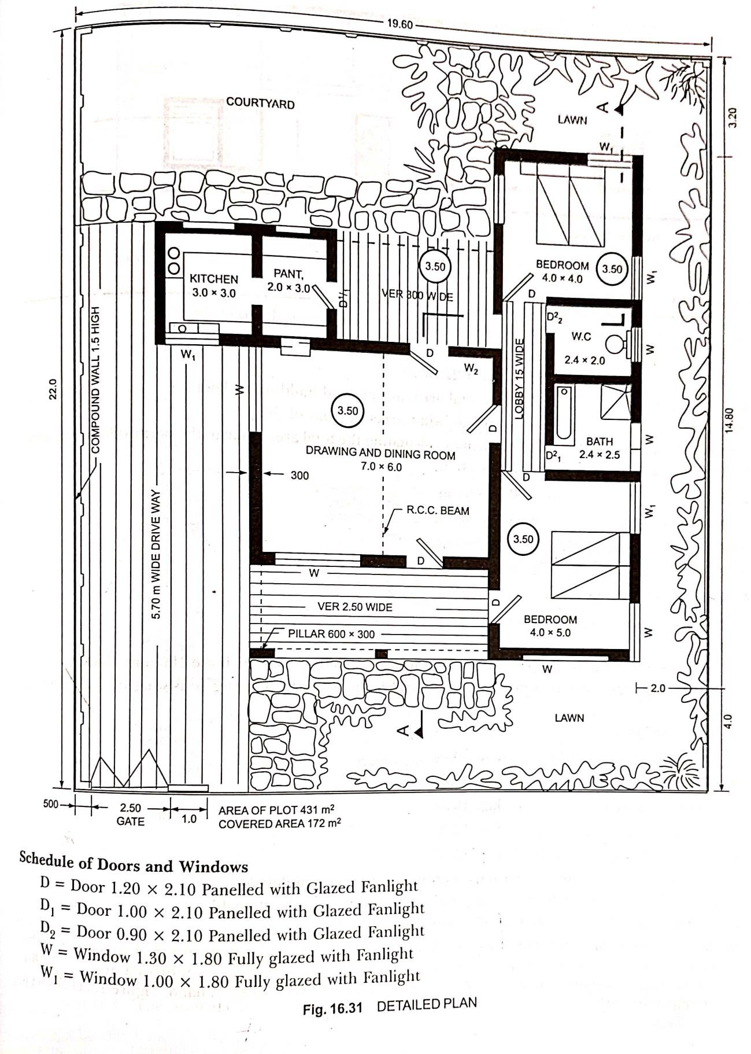

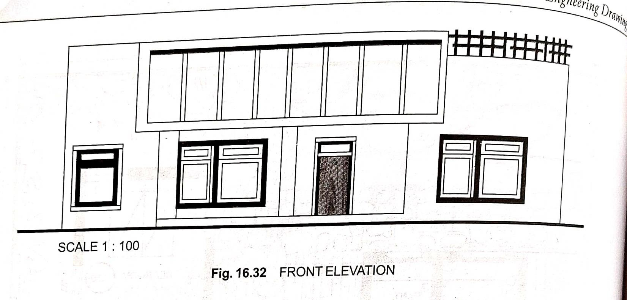

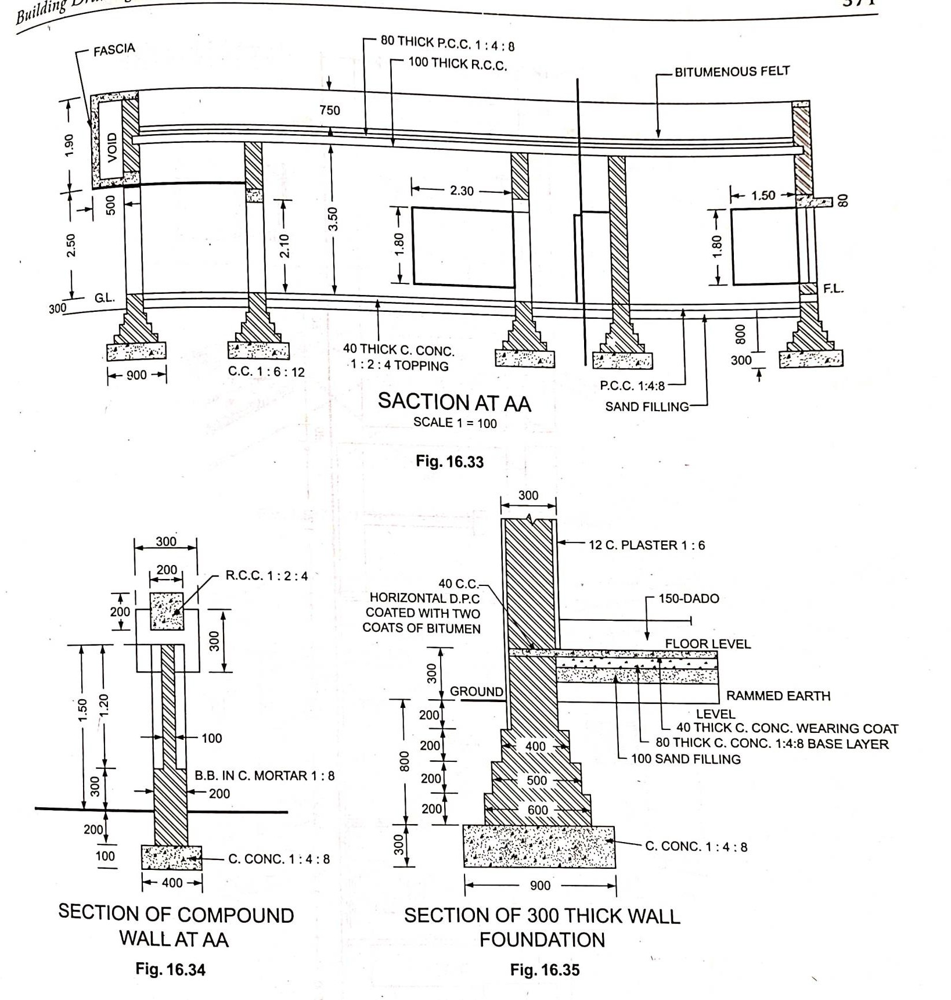

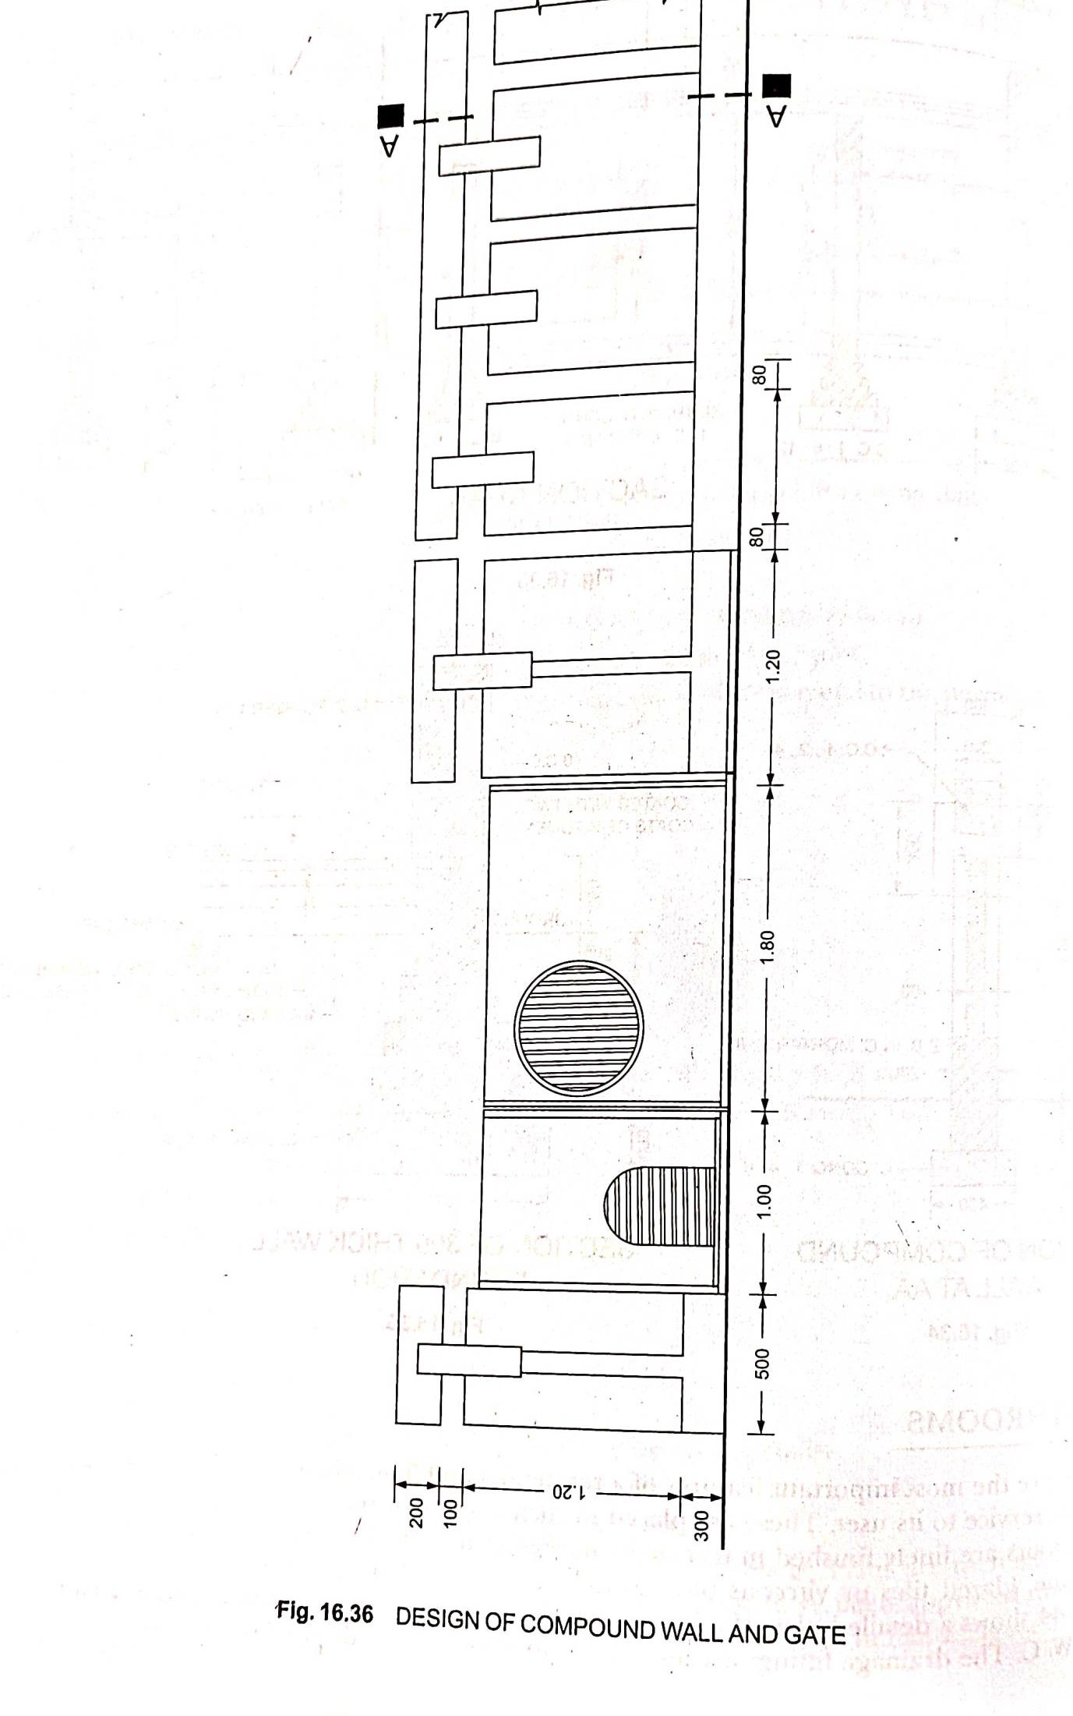

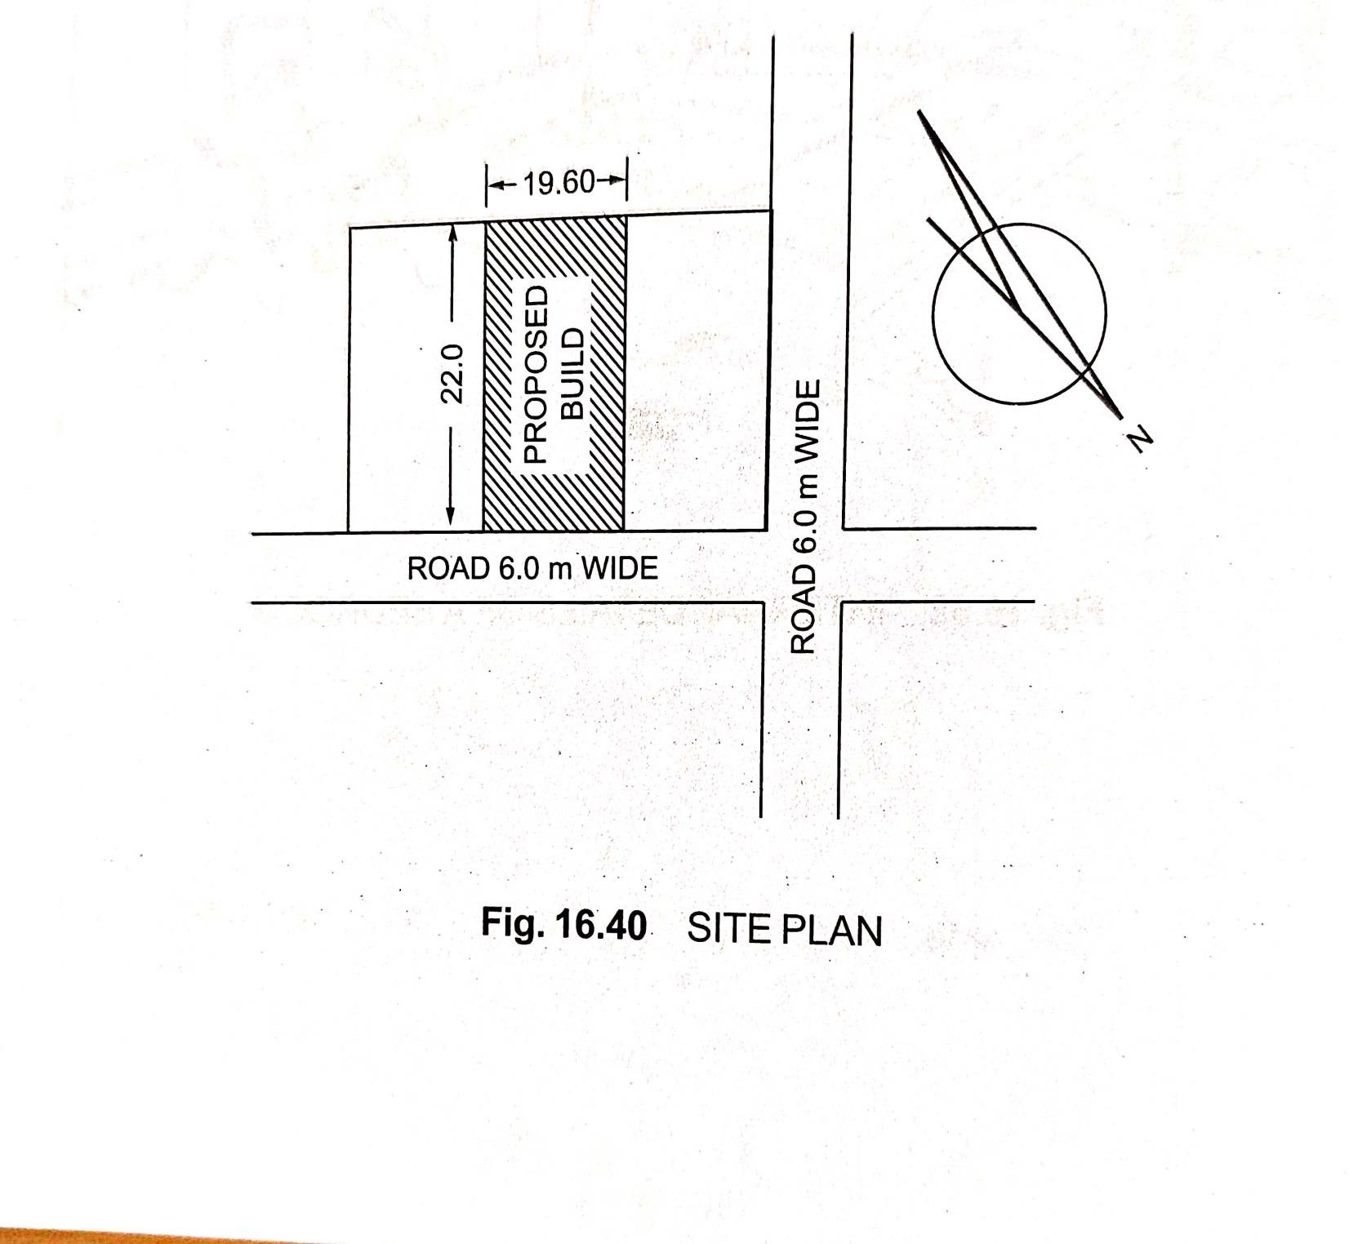

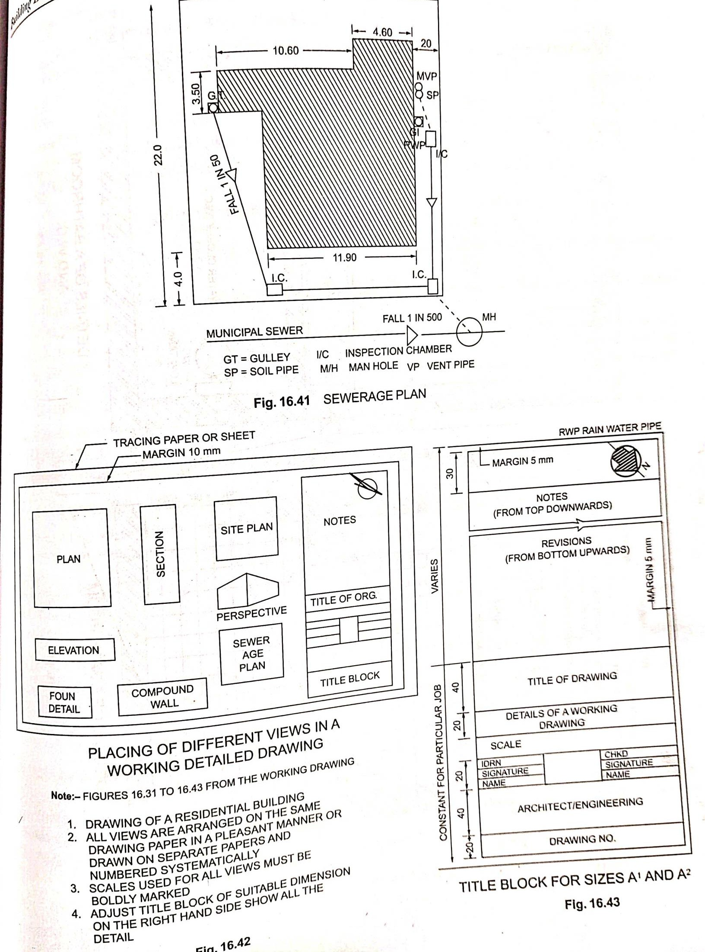

**To design and draw a Primary Health Center**

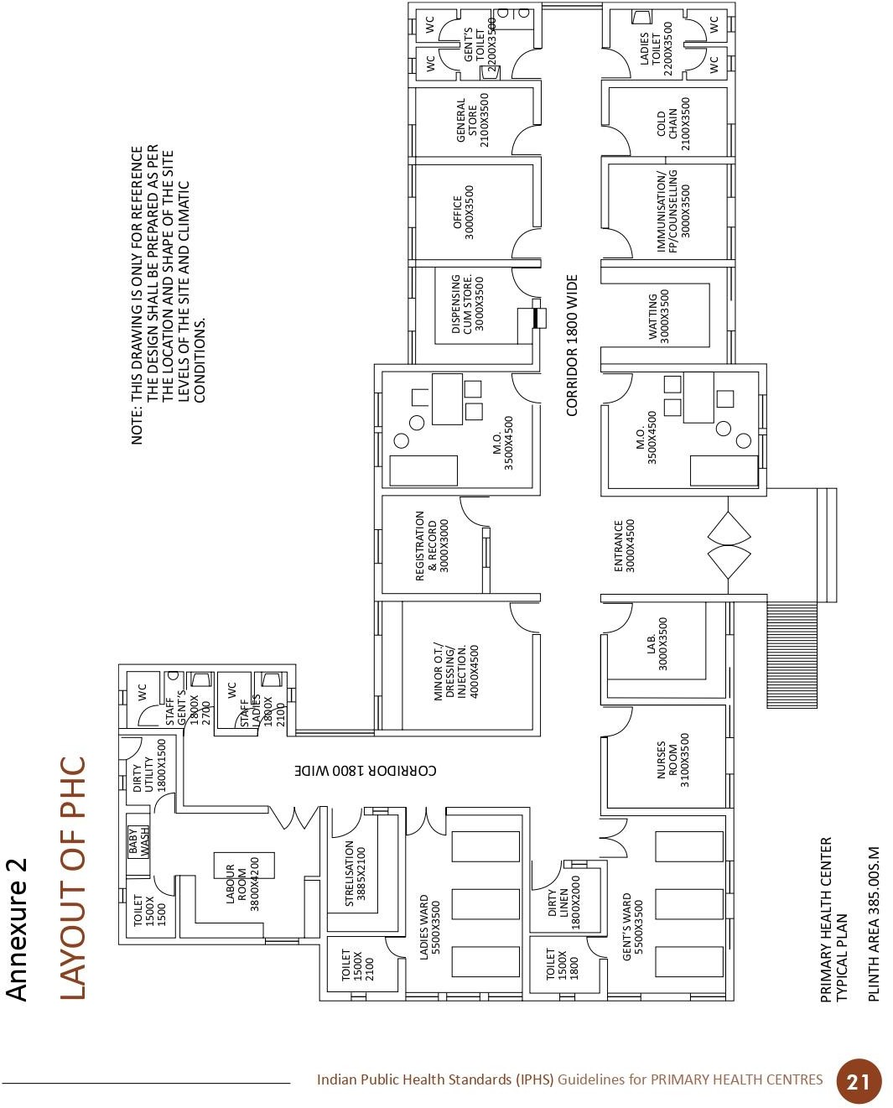

**To design and draw a Primary School**

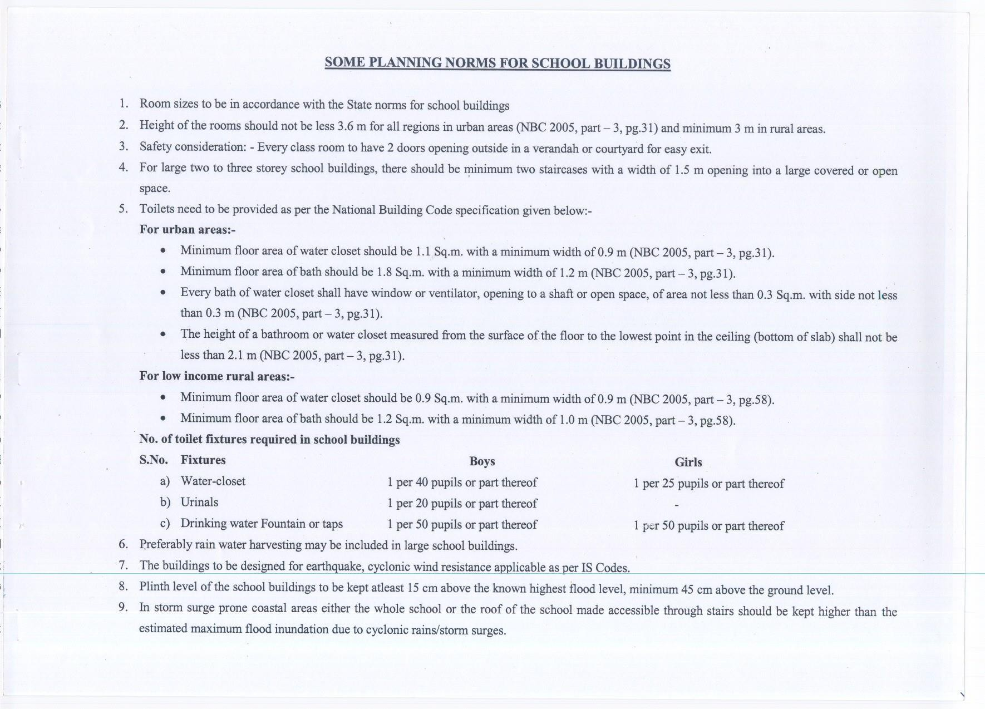

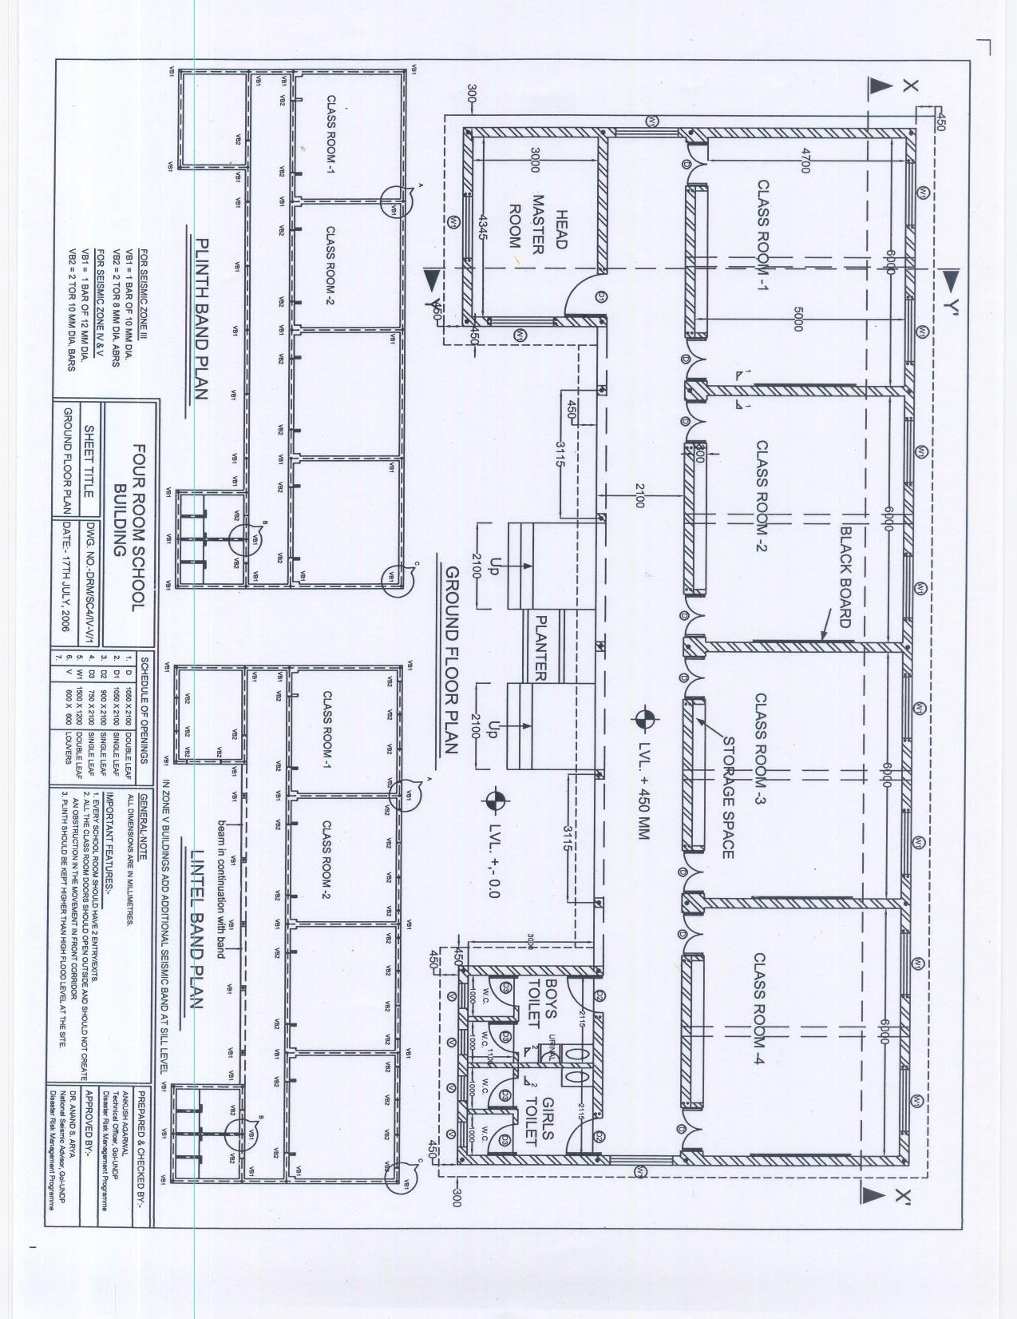

**To design and draw a Rest House**

At first thought, the guest house serves one purpose; to comfortably and efficiently house any guests visiting the property. Often adjacent to the main property, the guest house is a structure built specifically to feel just-isolated-enough that the guest(s) is part of the home but disconnected in a way that they’ll experience ample privacy. Typically, a guest house will have, if not most, all the functionality of an actual home; running water, electricity, bathroom, living room, bedroom, and a kitchen. An accessory could be a washer and dryer machine, although many guest houses include these as well.

Yet, beyond being a structure designed for visitors, guest houses or granny flats are the perfect home improvements that add major value. For one, if designed correctly (we’ll go into this), a guest house can add value to your home. It should be common sensical that the same sized home with a guest house would be more valuable than one without. Still, homeowners don’t tend to regard guest houses in this light, as it can be hard to view them as an investment on the property in its entirety.

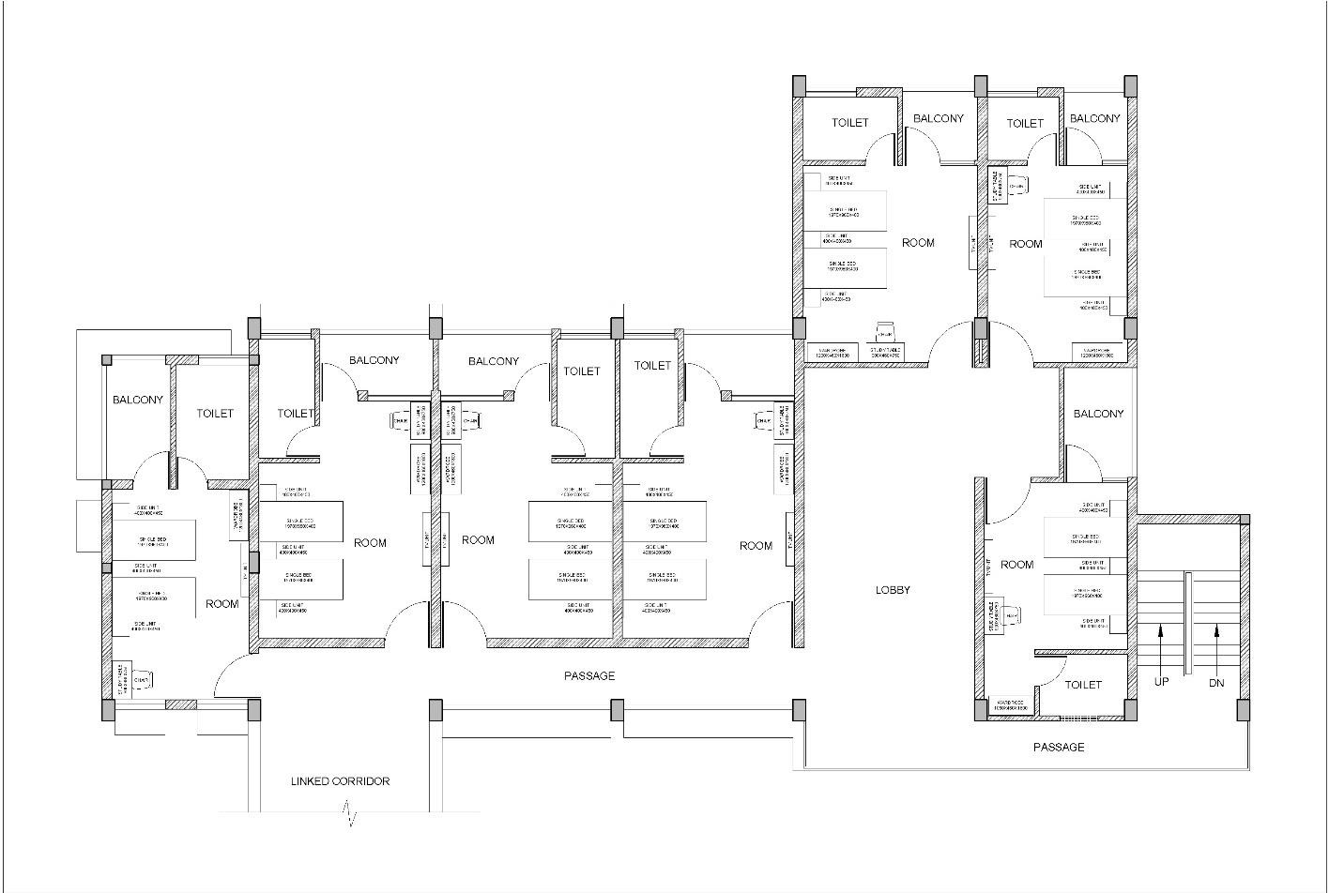

**To design and draw a Post Office**

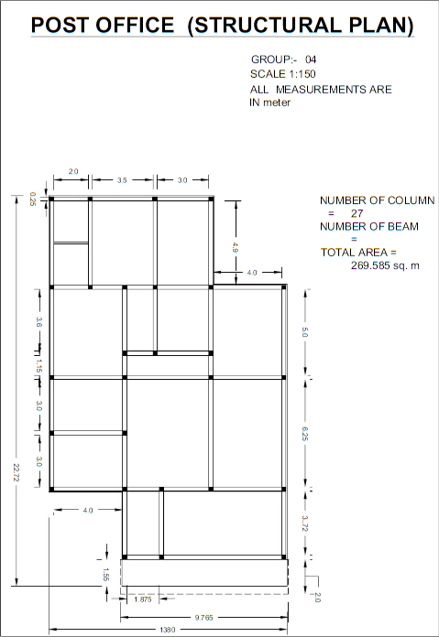

**To design and draw a Bank**

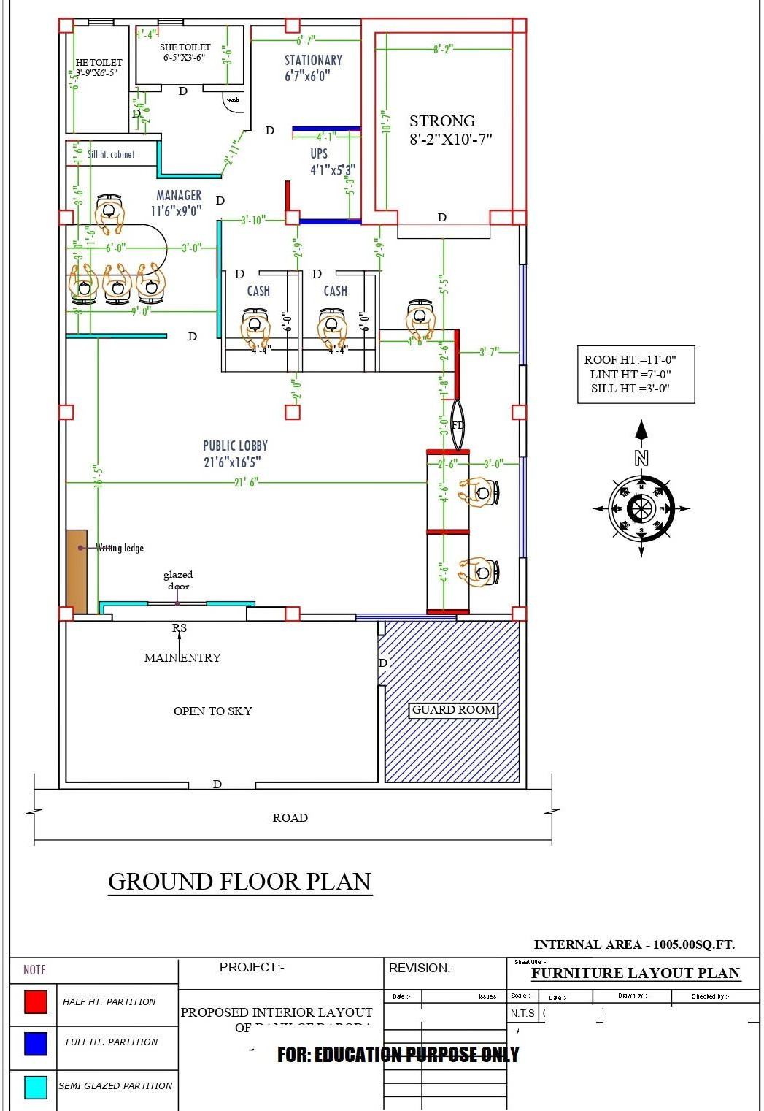

**To design and draw a College Library**

Library activity is a specialised activity and it should be designed so as to carry out this activity efficiently in a congenial environment. The library design should be based upon and correlated with the functions and services of the library. Just as a temple, a church, or a hospital has a distinctive architecture-both internal and external- the libraryis also a specialised institution, and its individuality should be reflected in its architecture. But above all its design should aim at bringing about economy in administration and optimise its operation. For the sake of economy the stack areas may have low ceilings (2.5 m), compared to the other areas (3.75 in). For effect, the lobby may have higher ceiling. Above all, library requires floor stronger than other office buildings to withstand load of stocks. While planning and execution of plan for a library building, it should be ensured that load bearing capacity of floor (1500 kg/sq m), floor height(not less than 8 ft), avoiding interior load bearing walls; quiet comfortable and attracting reading rooms, simplicity, efficiency, economy, comfort, flexibility and functional usefulness of the building are as per standards. The preliminary considerations should lead to a proper written proposal/programme and that in term should 'get translated into working drawings and specifications for the requisite building.

Mainly the following four broad areas along with their allied and sub-areas are identified as common service areas in a library:

1. Circulation area, which includes:
   * Stack rooms or halls
   * Charging Desk
   * Public Catalogue/s
2. Reader Activity Area, which includes:
   * Reading room/s
   * Microform reading room
   * Study carrels
3. Staff Activity Area, which includes:
   * Acquisition section
   * Technical section
   * Reference section
4. Other Areas, which include:
   * Senior professionals rooms
   * Space for library staff
   * Seminar room
   * Binding section

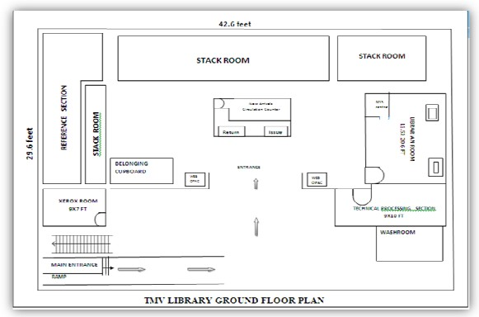

# To design and draw a Cinema Theatre

The proposed floor plan must have:

1. Booth configuration drawn to scale, including base dimensions, heights and locations.
2. Aisle locations and dimensions must be a minimum of four(4) feet wide.
3. Location and dimensions of all fixtures including, but not limited to, stages risers, registration areas, lounge areas, entertainment areas, etc.
4. Location of all exits.
5. Location of all permanent and temporary concession and novelty stands.
6. Location of all fire safety devices including extinguisher and alarm stations.
7. Location of all primary entrances.
8. Locations and dimensions of all service desks, including space allocations for service desks operated by the theater.
9. Location and dimensions of service contractor storage areas**.**

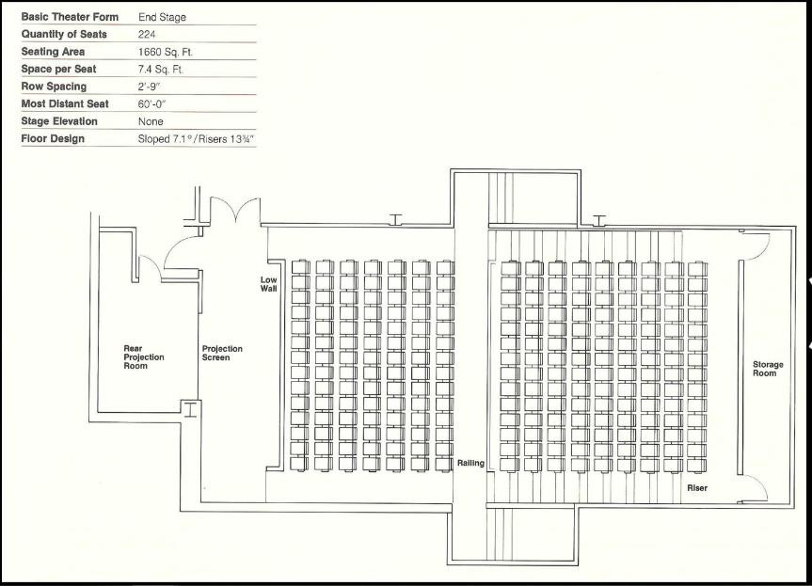

# QUIZ

1. In a building, to provide ultimate comfort to occupants can be used.
   1. AC
   2. HVAC
   3. Ventilators
   4. HAC
2. The slope of a ramp should not be more than:
   1. 1 in 35
   2. 1 in 20
   3. 1 in 15
   4. 1 in 10
3. How many types of ventilation are there?

a)3

b) 4

c)2

d) 5

1. A fire detector cannot detect:
   1. Radiation
   2. Heat
   3. Light
   4. Smoke
2. A is a set of rules that specify the standards for constructed objects such as buildings and non-building structures.
   1. Building code
   2. Building bye-laws
   3. IS code
   4. Procedure
3. Which is not included in building codes?
   1. Mechanical integrity
   2. Safety
   3. Providing employment
   4. Structural integrity
4. Which is not a objectives of Building Byelaws?
   1. Allows disciplined and systematic growth of buildings and towns and prevent haphazard development
   2. Protect safety of public against fire, noise, health hazards and structural failures
   3. They provide health, safety and comfort to the people who live in buildings
   4. Renovation of old buildings without any charge by the government
5. Combining two or more plots as a single plot is called
   1. Amalgamation
   2. Frontage
   3. Bifurcation
   4. Building set back
6. Which is not a Building Bye-Laws Characteristic?
   1. The rules must be specific, clear and the language of rules should be grammatically correct
   2. Terms used should be defined clearly so that there must be one and only one meaning of the term
   3. Due to some special conditions and requirements, some bye-laws differ from the bye-laws of other places
   4. No modification is allowed if required
7. Which of the following is not a zone?
   1. Residential
   2. Commercial
   3. Industrial
   4. Electrical
8. Which is not a type of building?
   1. Educational Building
   2. Mercantile Building
   3. Institutional Building
   4. Domestic building
9. Line up to which the plinth of a building adjoining a street may be law-fully extended is called?
   1. Building line
   2. Building boundary
   3. Building extend
   4. Building plan
10. Door opening is not counted in the lighting and ventilation of the building.
    1. True
    2. False
11. Carpet Area does not include the thickness of the inner walls.
    1. True
    2. False
12. Fire safety is the set of practices intended to reduce the destruction caused by fire.
    1. True
    2. False
13. For industrial unit having area more than 0.8 hectare, and 5% area can be used as a general parking.
    1. True
    2. False
14. When drawings are drawn smaller than the actual size of the objects the scale used is said to be
    1. Enlarging scale
    2. Reducing scale
    3. Small scale
    4. Decreasing scale
15. The ratio of the length of the drawing of the object to the actual length of the object is called
    1. Resulting fraction
    2. Representative figure
    3. Representative fraction
    4. Representative index
16. The scale of chords is used to measure
    1. Chords
    2. Lines
    3. Angles
    4. Diameter
17. A room of 1728 m3 volume is shown as 216 cm3 volume on a drawing sheet. What is the R.F?
    1. 1/20
    2. 1/200
    3. 1/250
    4. 1/186
18. Which grade of pencil is used for drawing arrow heads?
    1. 2H
    2. 2B
    3. 7H
    4. H
19. A is a set of rules that specify the standards for constructed objects such as buildings and non-building structures.
    1. Building code
    2. Building bye-laws
    3. IS code
    4. Procedure
20. Which is not included in building codes?
    1. Mechanical integrity
    2. Safety
    3. Providing employment
    4. Structural integrity
21. Which is not a objectives of Building Bye laws?
    1. Allows disciplined and systematic growth of buildings and towns and prevent haphazard development
    2. Protect safety of public against fire, noise, health hazards and structural failures
    3. They provide health, safety and comfort to the people who live in buildings
    4. Renovation of old buildings without any charge by the government
22. Combining two or more plots as a single plot is called
    1. Amalgamation
    2. Frontage
    3. Bifurcation
    4. Building set back

## Solution

1.b,2.c,3.a.4.c,5.a,6.c,7.d,8.a,9.d,10.d,11.d,12.a,13.a,14.a,15.a,16.a17.b,18.c,19.c,

1. b,21.a, 22.a, 23.c, 24.d, 25.a

# Viva Questions

* 1. What is circulation in planning of residential building?
  2. What do you understand by Vastu?
  3. What is the use of bubble diagram?
  4. Name2NBCprovisionforschool building.
  5. What do you understand by FAR?
  6. Mention3factors to be considered for planning of residential building.
  7. What is a flush door?
  8. Define ventilation.
  9. Name5differenttypes of sources of indoor lighting.
  10. What do you understand by acoustic of building?
  11. What are the factors affecting the selection of site, Explain
  12. What is meant by sun shading devices?
  13. By what different methods we can achieve the passive solar cooling?
  14. Explain acoustic comfort.
  15. Discuss the uses of sun-path diagram
  16. What is passive solar cooling?
  17. What are building bye-laws.