# Techno India NJR Institute of Technology



B.Tech IV Semester

# Course File

CONCRETE LAB (4CE4-25)

Session 2022-23

**Prachi Singhal**

(Assistant Professor)

**Department of CE**

**RAJASTHAN TECHNICAL UNIVERSITY, KOTA SYLLABUS**

**II Year-IV Semester: B.Tech (Civil Engineering)**

**4CE4-25: CONCRETE LAB**

**Credit: 1.5 Max. Marks: 100**

**(IA: 60, ETE: 40) 0L+0T+3P**

1. To determine the fineness of Cement by Blaine's air permeability test.
2. To determine the flexural strength of Concrete.
3. To determine Soundness of cement by Le-chatelier apparatus.
4. To determine the specific gravity of fine aggregate (sand) by Pycnometer.
5. To determine the bulking of fine aggregate and to draw curve between water content and bulking.
6. Sieve analysis of coarse aggregates and fine aggregates.
7. To determine the workability of given concrete mix by slump test.
8. To determine the optimum dose of super plastsizers by Flow table test.
9. To design concrete mix of M-20 grade in accordance with I S 10262.
10. To design concrete mix of M-40 grade with super plasticizer in accordance with I S 10262.
11. To determine the Permeability of Concrete.
12. Study of Core cutter, UPV & Rebound Hammer equipment.

## Course Overview:

The primary focus of this lab is on additional cementing materials used in the production of concrete. This lab activity broadly includes the investigation of the qualities of concrete's component parts, the formulation of the concrete mix, the manufacture of concrete, and various concreting procedures. The training also gives the correct attention to the study of aggregate and water properties. Another crucial element of the training is the concrete production process and concreting procedures. The course covers admixtures, which are substances added to concrete to change its properties, in addition to studying special purpose concretes. This will include Le- chatelier Blaine's air permeability, bulking of fine aggregate Pycnometer etc.

## Course Outcomes:

|  |  |  |
| --- | --- | --- |
| **CO.NO.** | **Cognitive Level** | **Course Outcome** |
| 1 | **Analyzing** | To determine the different properties of building materials like  cement, concrete, aggregates through practical(s). |
| 2 | **Analyzing** | To design concrete mix (M-20 and M-40) in lab. |
| 3 | **Understanding** | Learner can state what a Non Destructive testing is. |
| 4 | **Analyzing** | Test the properties of fresh concrete mix. |
| 5 | **Analyzing** | Design concrete mix for various grades of concrete according to IS  recommendations with and without admixture. |

**Prerequisites:**

* 1. Fundamentals knowledge of Concrete technologies & materials

**Course Outcome Mapping with Program Outcome:**

|  |  |  |  |  |  |  |  |  |  |  |  |  |  |  |  |
| --- | --- | --- | --- | --- | --- | --- | --- | --- | --- | --- | --- | --- | --- | --- | --- |
| **Course Outcome** | **PO 1** | **PO 2** | **PO 3** | **PO 4** | **PO 5** | **PO 6** | **PO 7** | **PO 8** | **PO 9** | **PO1 0** | **PO1 1** | **PO1 2** | **PSO 1** | **PSO 2** | **PSO 3** |
| CO2410.1 | 3 | 1 | 2 | 1 | 1 | 2 | 2 | 1 | 1 | 1 | 1 | 1 | 2 | 1 | 1 |
| CO2410.2 | 3 | 2 | 2 | 1 | 1 | 1 | 1 | 1 | 1 | 1 | 1 | 2 | 2 | 1 | 1 |
| CO2410.3 | 3 | 1 | 2 | 1 | 1 | 2 | 2 | 1 | 1 | 1 | 1 | 1 | 2 | 1 | 1 |
| CO2410.4 | 3 | 3 | 3 | 3 | 2 | 2 | 2 | 1 | 1 | 1 | 1 | 2 | 2 | 1 | 1 |
| CO2410.5 | 3 | 1 | 2 | 1 | 1 | 2 | 1 | 1 | 1 | 1 | 1 | 1 | 2 | 1 | 1 |
| CO2410 (AVG) | 3 | 1.6 | 2.2 | 1.4 | 1.2 | 1.8 | 1.6 | 1 | 1 | 1 | 1 | 1.4 | 2 | 1 | 1 |

**Course Coverage Module Wise:**

|  |  |
| --- | --- |
| **S. No.** | **Topic** |
| 1 | To determine the fineness of Cement by Blaine's air permeability test. |
| 2 | To determine the flexural strength of Concrete. |
| 3 | To determine Soundness of cement by Le-chatelier apparatus. |
| 4 | To determine the specific gravity of fine aggregate (sand) by Pycnometer. |
| 5 | To determine the bulking of fine aggregate and to draw curve between water  content and bulking. |
| 6 | Sieve analysis of coarse aggregates and fine aggregates. |
| 7 | To determine the workability of given concrete mix by slump test. |
| 8 | To determine the optimum dose of super plastsizers by Flow table test. |
| 9 | To design concrete mix of M-20 grade in accordance with I S 10262. |
| 10 | To design concrete mix of M-40 grade with super plasticizer in accordance with I  S 10262. |
| 11 | To determine the Permeability of Concrete. |
| 12 | Study of Core cutter, UPV & Rebound Hammer equipment. |

**Faculty Lab Manual Link**

https://drive.google.com/file/d/1a04IvvwsJraXmjFTVtEr2REuAmZAaXXb/view?usp=share_link

**Viva QUIZ Link**

1. https://drive.google.com/file/d/1a04IvvwsJraXmjFTVtEr2REuAmZAaXXb/view?usp

=share_link

## Assessment Methodology:

1. Practical exam using Advance Surveying Lab software.
2. Internal exams and Viva Conduct.
3. Final Exam (practical paper) at the end of the semester.

# EXPERIMENT NO: 01

**INTRODUCTION TO CONCRETE TECHNOLOGY LABORATORY**

# Definition

In its simplest form, concrete is a mixture of paste and aggregates (rocks). The paste, composed essentially of portland cement and water, coats the surface of the fine (small) and coarse (larger) aggregates. Through a series of chemical reactions called hydration, the paste hardens and gains strength to form the rock-like mass known as concrete. Within this process lies the key to a remarkable trait of concrete: it's plastic and malleable when newly mixed, strong and durable when hardened. These qualities explain why one material, concrete, can build skyscrapers, bridges, sidewalks and superhighways, houses and dams.

# Concrete in practice:

Concrete is a composite with properties that change with time. During service, the quality of concrete provided by initial curing can be improved by subsequent wetting as in the cases of foundations or water retaining structures. However, concrete can also deteriorate with time due to physical and chemical attacks. Structures are often removed when they become unsafe or uneconomical. Lack of durability has become a major concern in construction for the past 20 to 30 years.

In some developed countries, it is not uncommon to find large amount of resources, such as 30 to 50% of total infrastructure budget, applied to repair and maintenance of existing structures. As a result, many government and private developers are looking into lifecycle costs rather than first cost of construction. Durability of concrete depends on many factors including its physical and chemical properties, the service environment and design life. As such, durability is not a fundamental property.

One concrete that performs satisfactory in a severe environment may deteriorate prematurely in another situation where it is consider as moderate. This is mainly due to the differences in the failure mechanism from various exposure conditions. Physical properties of concrete are often discussed in term of permeation the movement of aggressive agents into and out of concrete. Chemical properties refer to the quantity and type of hydration products, mainly calcium silicate hydrate, calcium aluminate hydrate, and calcium hydroxide of the set cement. Reactions of penetrating agents with these hydrates produce products that can be inert, highly soluble, or expansive. It is the nature of these reaction products that control the severity of chemical attack. Physical damage to concrete can occur due to expansion or contraction under loading.

# Course objectives

The objective of concrete laboratory is to determine the physical properties of building construction materials like cement, fine and coarse aggregate.

The tests include determination of specific gravity, fineness, normal consistency, setting times, workability and soundness of cement, fineness modulus of fine and coarse aggregate, strength of cement mortar, cement concrete. Students can design the mix, make the specimens and test the same for their respective strengths.

# EXPERIMENT NO: 02

# FINENESS OF CEMENT

**Theory**:

# The fineness of cement has an important bearing on the rate of hydration and hence on the rate of gain of strength and also on the rate of evolution of heat. Finer cement offers a greater surface area for hydration and hence the faster and greater the development of strength. Increase in fineness of cement is also found to increase the drying shrinkage of concrete. Fineness of cement is tested either by sieving or by determination of specific surface by air-permeability apparatus. Specific surface is the total surface area of all the particles in one gram of cement.

**Aim:**

To determine the fineness of the given sample of cement by sieving.

**Apparatus:**

IS-90 micron sieve conforming to IS: 460-1965, standard balance, weights, and brush.

# Procedure:

Weigh accurately 100 g of cement and place it on a standard 90 micron IS sieve. Break down any air-set lumps in the cement sample with fingers.

Continuously sieve the sample giving circular and vertical motion for a period of 15 minutes. Weigh the residue left after 15 minutes of sieving.

# Limits:

As per IS code the percentage residue should not exceed 10%.

# Result:

The fineness of a given sample of cement is %

# Viva Voce:

1. What is size of the sieve that is used in fineness test?
2. What is the necessity to do the fineness test?
3. What is the specific limit of fineness test?

# EXPERIMENT NO: 03 NORMAL CONSISTENCY OF CEMENT

**Theory and Scope:**

Vicat plunger to penetrate to appoint 5 to 7 mm from the bottom of the vicat mould in this test. It is expressed as amount of water as a percentage [by weight] of dry cement. Standard consistency is also called normal consistency.

A certain minimum quantity of water is required to be mixed with cement so as to complete chemical reaction between water and cement less water than this quantity required wood not complete chemical reaction thus resulting in reaction strength and more water increases water cement ratio and it reduces the strength. So correct proportion of w/c is required.

# Aim:

To determine the percentage of water required for preparing cement paste of standard consistency, used for other tests.

# Apparatus:

Vicat apparatus with plunger, I.S. Sieve No. 9, measuring jar, weighing balance

# Procedure:

The vicat apparatus consists of a D- frame with movable rod. An indicator is attached to the movable rod, which gives the penetration on a vertical scale.

A plunger of 10 mm diameter, 50 mm long is attached to the movable rod to find out normal consistency of cement.

Take 300 gm of cement sieved through I.S. Sieve No. 9 and add 30% by weight (90 ml) water to it. Mix water and cement on a non-porous surface thoroughly with in 3 to 4 minutes.

The cement paste is filled in the vicat mould and top surface is leveled with a trowel. The filled up mould shall be placed along with its bottom non- porous plate on the base plate of the vicat apparatus centrally below the movable rod. The plunger is quickly released into the paste. The settlement of plunger is noted. If the penetration is between 33 mm to35 mm from top (or) 5 mm to 7 mm from the bottom, the water added is correct. If the penetration is less than required, the process is repeated with different percentages ofwater till the desired penetration is obtained.

# Observation and Calculation:

|  |  |  |  |
| --- | --- | --- | --- |
| **S.No.** | **Amount of water mixed** | **Penetration of Plunger from top** | **Remark** |
|  |  |  |  |

**Result:**

The normal consistency of cement =

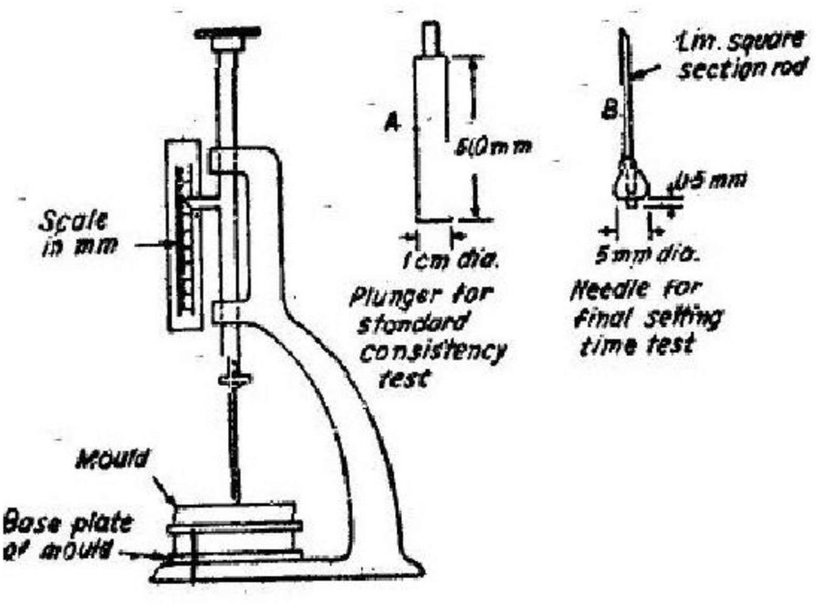

## Vicat Apparatus

**Viva Voce:**

1. What is normal or standard consistency of a cement paste?
2. What are the factors affecting the result of the test?
3. What do you understand by the term flash setting?

# Reference:

1. Indian Standard Methods of Physical Tests for cements IS: 4031, Indian Standards Institution.
2. Indian Standard Specifications for ordinary and low heat Portland cement IS: 269, Indian Standards Institution.
3. Neville. A. M, Properties of concrete, 3rd edition, Pitman publishing company, 1981.

# EXPERIMENT NO: 4

**INITIAL AND FINAL SETTING TIMES OF CEMENT**

# Theory and Scope:

Setting means becoming finer and harder, changing from semi liquid state to plastic state and form plastic state to solid state. Mortar or concrete when mixed is in semi liquid state.

The chemical action between cement and water starts, and the mixture goes into plastic state.

Initial setting time is that time period between the time water is added to cement and time at which 1 mm square section needle fails to penetrate the cement paste, placed in the Vicat mould 5 mm to 7 mm from the bottom of the mould.



Final setting time is that time period between the time water is added to cement and the time at which 1 mm needle makes an impression on the paste in the mould but 5 mm attachment does not make any impression.

# Aim:

To determine the initial and final setting times for the given sample of cement.

# Apparatus:

Vicat apparatus with mould, I.S. sieve No. 9, Initial and final setting time needles, measuring jar,weighing balance, etc.

# Procedure:

Preparation of Test Block:

Prepare a neat cement paste by gauging 300 grams of cement with 0.85 times the water required to give a paste of standard consistency.

Potable or distilled water shall be used in preparing the paste. The paste shall be gauged in the manner and under the conditions

prescribed indetermination of consistency of standard cement paste. Start a stop-watch at the instant when water is added to the cement.

Fill the mould with the cement paste gauged as above the mould resting on a non porous plate.

Fill the mould completely and smooth off the surface of the paste making it level with the top of the mould. The cement block thus prepared in the mould is the test block.

# DETERMINATION OF INITIAL SETTING TIME:

Place the test blocks confined in the mould and rest it on the non- porous plate, under the rod bearing initial setting needle, lower the needle gently in contact with the surface of the test block and quickly release, allowing it to penetrate into the test block.

In the beginning, the needle will completely pierce the test block.

Repeat this procedure until the needle, when brought in contact with the test block and released as described above, fails to pierce the block to a point 5 to 7 mm measured from the bottom of the mould shall be the initial setting time.

# DETERMINATION OF FINAL SETTING TIME:

Replace the needle of the Vicat apparatus by the needle with an annular attachment.

The cement shall be considered as finally set when, upon applying the needle gently to the surface of the test block, the needle makes an impression there on, while the attachment fails to do so.

The period elapsed between the time when water is added to the cement and the time at which the needle makes an impression on the surface of test block while the attachment fails to do so shall be the final setting time.

# PRECAUTIONS:

Clean appliances shall be used for gauging.

All the apparatus shall be freefrom vibration during the test.

The temperature of water and that of the test room, at the time of gauging shall be 27 C +2 C. Care shall be taken to keep the needle straight.

**Result:**

1. Initial setting time of cement=

2. Final setting time of cement=

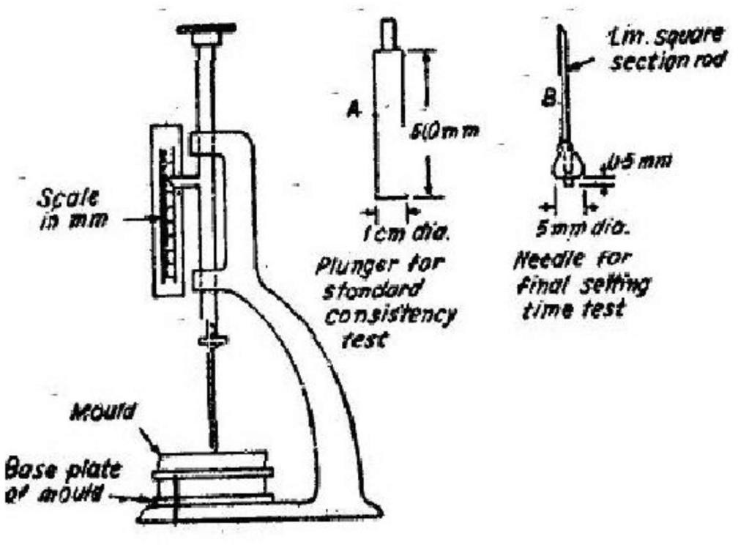

# Vicat Apparatus

**Viva Voce:**

1. What is Initial setting time of cement?
2. What is Final setting time of cement?
3. Explain why you are performing this experiment?

# Reference:

1. Indian Standard Methods of Physical Tests for cements IS: 4031, Indian Standards Institution.
2. Indian Standard Specifications for ordinary and low heat Portland cement IS: 269, Indian Standards Institution.

# EXPERIMENT NO: 05

**SPECIFIC GRAVITY OF CEMENT**

**Theory and Scope:**

Specific gravity is defined as the ratio between weight of a given volume of material and weight of an equal volume of water. To determine the specific gravity of cement, kerosene is used which does not react with cement.

**Aim:**

To determine the specific gravity of cement using Specific gravity bottle.

**Apparatus:**

Specific gravity bottle, 100ml, capacity balance capable of weighing accurately upto0.1gms.

# Procedure:

Clean and dry the specific gravity bottle and weigh it with the stopper (W1).

Fill the specific gravity bottle with cement sample at least half of the bottle and weigh with stopper (W2).

Fill the specific gravity bottle containing the cement, with kerosene (free of water) placing the stopper and weigh it (W3).

While doing the above do not allow any air bubbles to remain in the specific gravity bottle.

After weighing the bottle, the bottle shall be cleaned and dried again. Then fill it with fresh kerosene and weigh it with stopper (W4).

Remove the kerosene from the bottle and fill it with full of water and weigh it with stopper (W5).

All the above weighing should be done at the room temperature of 27 0C + 10C.

# Observations:

|  |  |  |  |
| --- | --- | --- | --- |
| **Description of item** | **Trial 1** | **Trial 2** | **Trial 3** |
| Weight of empty bottle W1 g |  |  |  |
| Weight of bottle + Cement W2 g |  |  |  |
| Weight of bottle + Cement + Kerosene W3 g |  |  |  |
| Weight of bottle + Full Kerosene  W4 g |  |  |  |
| Weight of bottle + Full Water W5 g |  |  |  |

Specific gravity of Kerosene Sk = W4 - W1 / W5 - W1

Specific gravity of Cement Sc = (W2 - W1)* (W4 - W1) / ((W4 - W1)-(W3-W2))*(W5 - W1)

Specific Gravity of cement =



**Note:** Specific Gravity of kerosene =0.79

# Precautions:

1. Only kerosene which is free of water shall be used.
2. At time of weighing the temperature of the apparatus will not be allowed to exceed the specified temperature.
3. All air bubbles shall be eliminated in filling the apparatus and inserting the stopper.
4. Weighing shall be done quickly after filling the apparatus and shall be accurate to 0.1 mg.
5. Precautions shall be taken to prevent expansion and overflow of the contents resulting from the heat of the hand when wiping the surface of the apparatus.

**Result:**

Specific Gravity of Cement=

# Viva Voce:

1. What is Specific Gravity of cement?
2. Explain why you are performing this experiment?

# EXPERIMENT NO: 6

# COMPRESSIVE STRENGTH OF CEMENT

**Theory and Scope:**

The compressive strength of cement mortar is determined strength of cement mortar is determined in order to verify whether the cement conforms to IS specification **(IS: 269-1976)** and whether it will be able to develop the required compressive strength of concrete. According **to IS: 269-1976**, the ultimate compressive strength of cubes of cement sand mortar of the ratio 1:3, containing (P/4+3.0) percent of water should be as.

# Aim:

To determine the compressive strength of 1:3 Cement sand mortar cubes after 3 days and 7 days curing.

# Apparatus:

Universal Testing Machine or Compression Testing Machine, cube moulds, vibrating machine, crucible for mixing cement and sand measuring cylinder, trowels, non-porous plate and balance with weight box.

# Procedure:

Calculate the material required. The material for each cube shall be mixed separately and the quantities of cement and standard sand shall be as follows:

Cement = 200 gm.

Standard Sand = 600 gm.

Water = (P/4+3.0) percent = 84 gm.

The time of mixing (gauging) in any event shall not be less than 3 minutes and if the time taken to obtain a uniform colour exceeds 4 minutes the mixture shall be rejected and the operation is repeated with a fresh quantity of cement, sand and water.

Place the assembled mould on the table of the vibrating machine and firmly hold it in the vibrating machine and firmly hold it in position by means of suitable clamps. Securely attach the hopper at the top of the mould to facilitate filling and this hopper shall not be removed until completion of the vibration period.

Immediately after mixing the mortar as explained above, fill the entire quantity of mortar in the hopper of the cube mould and compact by vibration. The period of vibration shall be 2 minutes at the specified speed of 12000+400 cycles per minute.

Remove the mould from the machine and keep it at a temperature of 27+ 20C in an atmosphere of at least 90 percent relative humidity for 24 hours after completion of vibrations.

The cubes are removed from the mould and immediately submerge it in clean and fresh water and keep there until taken out just prior to breaking. The water is which the cubes are submerged shall be renewed after every 7 days and be maintained at a temperature of 27+ 20C, keep the cubes wet till they are placed in machine for testing.

Test the specimens at the required periods, test three cubes at the periods mentioned below, the periods being reckoned from the completion of vibration. The compressive strength shall be the average of the strengths of the three cubes for each period.

* 1. Ordinary Portland Cement: 3 and 7days.
  2. Rapid Hardening Portland Cement: 1 and 3 days.
  3. Low Heat Portland Cement: 3, 7 and 28 days.

The cubes shall be tested on their sides, the load being applied at the rate of 35 N/mm2/ minute.

# Observation and Calculations:

# Ordinary Portland cement

|  |  |  |  |  |
| --- | --- | --- | --- | --- |
| **S.No.** | **3-day strength** | | **7-day strength** | |
| **Load in KN** | **Strength in N/mm2** | **Load in KN** | **Strength in N/mm2** |
| **1** |  |  |  |  |
| **2** |  |  |  |  |
| **3** |  |  |  |  |
| **Average** |  |  |  |  |

**Result:**

Compressive strength of Cement=

# Viva Voce:

1. What you understand by term ultimate strength of cement?
2. What precautions do you take during determination of compressive strength?
3. What is the significance of this test?

# References:

1. Neville A.M, properties of concrete, 3rdEdn. Pitman Publishing Company, 1981.
2. Gambhir .M.L, Concrete Manual, 4thEdn.,DhanpatRai Sons, Delhi

# EXPERIMENT NO: 7

**SOUNDNESS OF CEMENT**

**Theory and Scope:**

Unsoundness of cement means, that the cement having excess lime, magnesium sulphates, etc. due to excess of these items there will be volume changes and large expansions, there by reduces the durability of the structures.

**Aim**:

To find out the soundness of cement.

**Apparatus**:

Le-Chatelier Apparatus Cement, Water , Glass plate.

# Procedure:

The cement is gauged with 0.78 times the water required for standard consistency (0.78P)in a standard manner and filled in to the Le- Chatelier mould kept on the glass plate.

The mould is covered on the top with another glass plate.

The whole assembly is immersed in water at temperature of 27oC to 32oC and kept there for 24 hrs.

Measure the distance between the indicator points.

Submerge the mould again in water, heat the water up to boiling point in 30 minutes and keep it boiling for 3 hrs.

Remove the mould from hot water and allow it to cool and measure the distance between the indicator points.

The distance between these two measurements gives the expansion of cement. This must not exceed 10mm for OPC, RHC, LHC, etc.

If the expansion is more than 10mm, the cement is unsound.

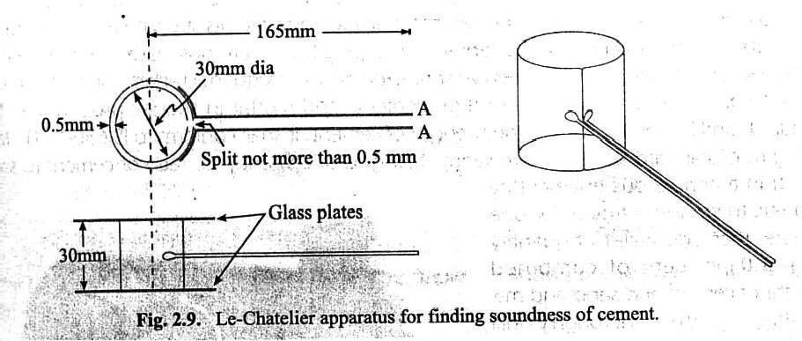

Soundness of given cement =

# Result:

**Viva Voce:**

* 1. What is the significance of this test?
  2. What is the specific limit of soundness test?

# Reference:

1. Indian Standard Methods of Physical Tests for cements IS: 4031, Indian Standards Institution.
2. Indian Standard Specifications for ordinary and low heat Portland cement IS: 269, Indian Standards Institution.
3. Neville. A. M, Properties of concrete, 3rd edition, Pitman publishing company, 1981.

# EXPERIMENT NO.8

**FINENESS MODULUS OF FINE AGGREGATE AND COARSE AGGREGATE**

# Theory:

Fineness modulus is a numerical index used to know the mean size of particle in the total Quantity of aggregate. Fineness modulus is to grade the given aggregate for most economical mix and workability with less assumption of cement lower FM gives uneconomical mix and higher FM gives harsh mix. It is defined the average cumulative % retained by 100 was known as fineness modulus

**Aim:**

To determine the fineness of modulus of fine aggregate and coarse aggregate.

**Apparatus:**

Indian standard test sieves set, weighting balance, sieves shaker pan, tray.

**Procedure:**

Arrange the test services with larger openings at top and smaller openings at bottom and finally below all keep a pan

Take 1 kg of sand in to a tray and break the lumps, if any in case of fine aggregate and1kg of samples in the case of coarse aggregate and mixed aggregate.

Keep the sample in the top sieve and keep the total set in the top sieve and keep the total Set in the shaker. Continue sieving for a period not less than 10 minutes.

Weigh the material retained on each sieve property.

# Precautions:

Sample should be taken by quartering.

Careful sieving must be done to prevent any spilling of Aggregate

**Graph**:

Draw a graph between IS sieve size (in log scale) and %passing. Specification: The following limits may be taken as guidance.

Fine sand : F.M 2.2 2.6

Medium sand : F~~.M~~ 2.62.9

Coarse sand : F.M 2.9 3.2

# Observations:

Weight of sample for fine aggregate=

Weight of sample for coarse aggregate=

# Observation:

# Fine aggregate:

|  |  |  |  |  |  |
| --- | --- | --- | --- | --- | --- |
| **S.no.** | **IS sieve size** | **Wt. retained Gm** | **% retained** | **% passing** | **Cumulative**  **%**  **Retained** |
| 1 | 4.75mm |  |  |  |  |
| 2 | 2.36mm |  |  |  |  |
| 3 | 1.18mm |  |  |  |  |
| 4 |  |  |  |  |  |
| 5 |  |  |  |  |  |
| 6 |  |  |  |  |  |

**Coarse aggregates:**

|  |  |  |  |  |  |
| --- | --- | --- | --- | --- | --- |
| **S.no.** | **IS sieve size** | **Wt. retained Gm** | **% retained** | **% passing** | **Cumulative**  **%**  **Retained** |
| 1 | 80mm |  |  |  |  |
| 2 | 40mm |  |  |  |  |
| 3 | 20mm |  |  |  |  |
| 4 | 10mm |  |  |  |  |
| 5 | 4.75mm |  |  |  |  |
| 6 | 2.36mm |  |  |  |  |
| 7 | 1.18mm |  |  |  |  |
| 8 | 600 µ |  |  |  |  |
| 9 | 300 µ |  |  |  |  |
| 10 | 150 µ |  |  |  |  |

# Result:

Fineness modulus of fine aggregate=

Fineness modulus of coarse aggregate=

# Viva Voce:

* 1. What is the significance of this test?
  2. What are the sieve sizes using to find out fineness modulus test?

# EXPERIMENT NO: 9

**BULKING OF SAND**

# Theory and Scope:

The volume of fine aggregate may increase by 1% to 5% due to presence of moisture.

This property of increase in volume of fine aggregate due to moisture is called bulking.

**Aim**:

To find out the bulking factor of fine aggregate.

# Apparatus:

Container, Sand, Water, Mixing Pan.

# Procedure:

Take about 6 liters of dry compacted sand and weigh it and dump it into a mixing pan.

Add a certain known percentage of water by weight of dry sand.

Mix rapidly and thoroughly till a uniform colour is obtained and fill the container withthe wet sand without any tamping.

Now strike off the top surface and weigh and thus find the weight of wet sand.

Repeat the experiment No. of times increasing in water content from 1% to 20%.

# Calculations: -

W1=Wt. of 1m3 of compacted dry sand.

W2=Wt. of dry sand contained in 1m3 of wet loose sand.W3=Wt. of 1m3 of wet sand

X = Percentage of water added W3=Wt. of dry sand + Wt. of

water

W = W

*x* )

3

(1+

2 100

W2=

*w*3

1 *X* 100

% of bulking = *W*1 *W*2 *x*100

*W*1

Bulking factor = *W*1

*W*2

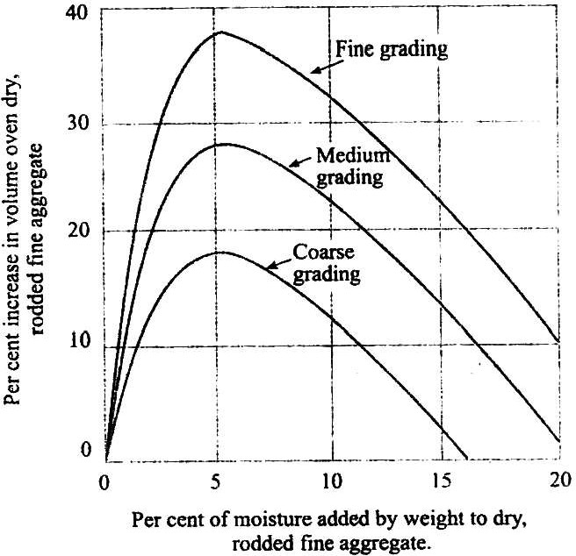

# Result:

Bulking of given Sand = % of water

# Viva Voce:

1. What is the significance of this test?

# References:

1. Neville A.M, properties of concrete, 3rdEdn. Pitman Publishing Company, 1981.
2. Gambhir .M.L, Concrete Manual, 4thEdn.,DhanpatRai Sons, Delhi

# EXPERIMENT NO: 10

# WORKABILITY TESTS ON FRESH CONCRETE

* 1. **SLUMP CONE TEST**

# Aim:

To assess the workability of given concrete mix by slump test.

# Reference Standards

IS : 1199-195~~9~~Methods of Sampling and Analysis of Concrete.

**Equipment & Apparatus**

Slum cone Graduated cylinder BalanceVibrator

Vee bee apparatus stop watch

**Procedure:**

Place the fresh concrete mix in the clean slump cone in four equal layers, tamping each layer 25 times with the tamping rod in a uniform manner the cross section. For the 2 nd and subsequent layers the rod should penetrate into

the under lying layers during such tamping. 3

Strike - off the top of concrete flush with the mould with a trowel so that it is exactly filled.

Remove the metallic cone by raising it slowly and carefully in a vertical direction.

As soon as the concrete settlement stop measure the subsidence of concrete in mm. This substance is slump.

TABLE 1

|  |  |  |  |  |
| --- | --- | --- | --- | --- |
| **Sl no** | **Degree of Workability** | **Slump (mm)** | **Compaction**  **Factor** | **Situation** |
| 1. | Very Low | 0-25 | 0.78 | Roads vibrated by power  operated machines. Concrete may be compacted with hand |
| 2. | Low | 25-50 | 0.85 | Road vibrated by hand operated machine  For more workability mix concrete may be |
|  |  |  |  | manually compacted in road using rounded  Or irregular shapes. Mass concrete  Foundations without vibration or lightly  Reinforced sections with vibrations. |
| 3. | Medium | 50-100 | 0.95 | manually Compacted flat slabs using  crushed  Aggregate. Normal reinforced concrete  Manually compacted and highly reinforced  Section with vibration. |
| 4. | High | 100-175 | 0.95 | For section with congested reinforcement.  Not normally suitable for vibration. |

**Safety & Precautions:**

Use hand gloves, safety shoes & apron at the time of After test switch off the machine.

Keep all the exposed metal parts greased.

Keep the guide rods firmly fixed to the base & top plate.

Equipment should be cleaned thoroughly before testing & after testing.

# 

# Result:

Slump = mm

**Viva Voce:**

1. What is the significance of this test?
2. What are the dimensions of slump cone?

# b. Compaction Factor test

**Aim**:

To assess the workability of given concrete mix by compaction factor test.

# Reference Standards

IS : 1199-195~~9~~Methods of Sampling and Analysis of Concrete.

**Equipment & Apparatus**

* Compaction factor apparatus
* Graduated cylinder
* Balance Vibrator Vee-Bee apparatus
* stop watch
* spatula
* Trowel
* Tamping rod

# Procedure:

Keep the compaction factor apparatus on a level ground and clean the inner surface of the hopper and cylinder. Fasten the hopper trap door.

Weigh the empty cylinder accurately (W1). Fix the cylinder on the ~~b~~ase with fly nut and bolt in such a way that central axes of the hoppers and cylinder lie in one verticalline.

Fill the freshly mixed concrete in the upper hopper gently and carefully with a hand scoop without any compacting effort. After 2 minutes release the trap door so that the concrete may fall in to the lower hopper bringing concrete to some degree of compaction. Immediately after the concrete has come to rest in this hopper open its trap door and allow the concrete to fall into the cylinder.

Remove the excess concrete above the top of the cylinder by a pair of trowels with blades kept horizontal. Clean the cylinder from all the sides properly and weigh it to find the weigh of this partially compacted concrete (W2).

Refill the cylinder with the same sample of concrete in approximately 5 cm thick lawyers using mechanical vibration so as to expel all the air in it order to obtain full compaction. Level up the top and weigh this cylinder to get the weight of fully compacted concrete (W3}.

# Observations and Calculations:

**Note**: The proportion of various in gradients in the concrete mix are, cement, sand, coarse aggregate, water and admixtures, if any.

W2 W1

Compaction factor (CF) = =

W3 W1

# Safety & Precautions:

Use hand gloves, safety shoes & apron at the time of test. After test switch off the machine.

Keep all the exposed metal parts greased.

Keep the guide rods firmly fixed to the base & top plate.

Equipment should be cleaned thoroughly before testing & after testing.

# Result:

Compaction factor of concrete=

# Viva Voce:

1. What is the significance of this test?
2. What are the dimensions of cylinder?

# EXPERIMENT NO: 11

**TEST FOR COMPRESSIVE STRENGTH OF CEMENT CONCRETE**

# Aim:

# The tests are required to determine the strength of concrete and therefore its suitability for the job.

# Reference Standards

IS : 516-195~~9~~ Methods of tests for strength of concrete.

# Equipment & Apparatus

Compression testing machine (2000 KN)Curing tank/Accelerated curing tank Balance (0-10 Kg)

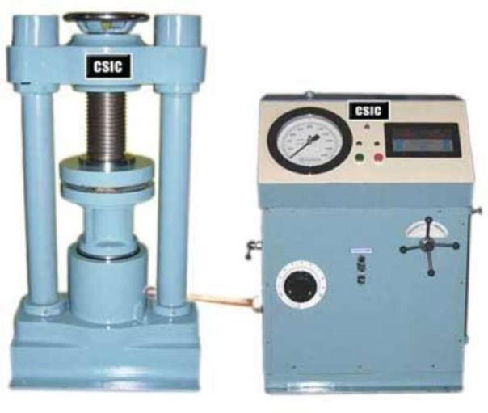

**Fig**: Compressive Strength Test on Concrete

# Procedure:

Representative samples of concrete shall be taken and used for casting cubes 15 cm x 15 cm x 15 cm or cylindrical specimens of 15 cm dia x 30 cm long.

The concrete shall be filled into the moulds in layers approximately 5 cm deep. It wouldbe distributed evenly and compacted either by vibration or by hand tamping. After the top layer has been compacted, the surface of concrete shall be finished level with the top ofthe mould using a trowel; and covered with a glass plate to prevent evaporation.

The specimen shall be stored at site for 24+ ½ h under damp matting or sack. After that, the samples shall be stored in clean water at 27+20C; until the time of test. The ends of all cylindrical specimens that are not plane within 0.05 mm shall be capped.

Just prior to testing, the cylindrical specimen shall be capped with sulphur mixture comprising 3 parts sulphur to 1 part of inert filler such as fire clay.

Specimen shall be tested immediately on removal from water and while they are still in wet condition.

The bearing surface of the testing specimen shall be wiped clean and any loose material removed from the surface. In the case of cubes, the specimen shall be placed in the machine in such a manner that the load cube as cast, that is, not to the top and bottom.

Align the axis of the specimen with the steel plates, do not use any packing. The load shall be applied slowly without shock and increased continuously at a rate of approximately 140 kg/sq.cm/min until the resistance of the specimen to the increased load breaks down and no greater load can be sustained. The maximum load applied to the specimen shall then be recorded and any unusual features noted at the time of failure brought out in the report.

# Calculation:

Compressive strength is calculate using the following formula

***Compressive strength (kg/cm2) = Wf / Ap***

Where

Wf = Maximum applied load just before load, (kg)Ap = Plan area of cube mould, (mm2)

# Safety & Precautions:

Use hand gloves, safety shoes & apron at the time of test. After test switch off the machine.

Keep all the exposed metal parts greased.

Keep the guide rods firmly fixed to the base & top plate.

Equipment should be cleaned thoroughly before testing & after testing.

# Result:

The Compressive strength of concrete = N/mm2.

# Viva Voce:

1. What is the significance of this test?
2. Define casting and curing.

**TECHNO INDIA NJR INSTITUTE OF TECHNOLOGY UDAIPUR**

**Civil Engineering**

**B. TECH II– YEAR (IV Sem) SUBJECT** CONCRETE LAB (4CE4-25)

**VIVA**

* 1. What is the significance of this test for compressive strength of cement concrete?
  2. Define casting and curing
  3. What is the significance of this Compaction Factor test?
  4. What are the dimensions of cylinder
  5. What are the dimensions of slump cone?
  6. What are the sieve sizes using to find out fineness modulus test?
  7. What is the specific limit of soundness test?
  8. What you understand by term ultimate strength of cement?
  9. What precautions do you take during determination of compressive strength
  10. What is Initial setting time of cement?
  11. What is Final setting time of cement?
  12. What is normal or standard consistency of a cement paste?
  13. What are the factors affecting the result of the NORMAL CONSISTENCY OF CEMENT?
  14. What do you understand by the term flash setting?
  15. What is size of the sieve that is used in fineness test?
  16. What is the necessity to do the fineness test?
  17. What is the specific limit of fineness test

**TECHNO INDIA NJR INSTITUTE OF TECHNOLOGY UDAIPUR**

**Civil Engineering**

**B. TECH II– YEAR (IV Sem)**

**SUBJECT** CONCRETE LAB (4CE4-25)

**Quiz**

1. What is Concrete Technology?
2. Concrete Technology deals with the study of bricks
3. Concrete Technology is the study of building materials
4. Concrete Technology deals with the study of properties of concrete
5. None of the mentioned

Answer: (c)

1. What is concrete?
2. A mixture of homogenous materials
3. A mixture of material and hydrogen
4. A mixture of cement and hydrogen sulphide
5. A mixture of cement, water, and aggregates

Answer: (d)

1. Why concrete technology is needed?
2. Concrete technology is needed to build a building
3. Concrete technology is needed to address properties of concrete
4. Concrete technology is needed to produce building materials
5. None of the mentioned

Answer: (b)

1. Concrete technology is useful for civil engineers because it allows them to
2. know how to appropriately stock the materials needed for concrete
3. conduct various concrete tests
4. familiarise them with the fundamental principles of concrete
5. all of the mentioned

Answer: (d)

1. Who is the father of concrete technology?
2. William Aspdin
3. Royston Saint John
4. Joseph Aspdin
5. None of the above

Answer: (a)

1. Which type of concrete is classified based on the design of concrete?
2. Plain
3. Reinforced
4. Prestressed
5. All of the above

Answer: (d)

1. How many basic types of concrete are there?
2. 20 types
3. 24 types
4. 22 types
5. 21 types

Answer: (b)

1. What is the full form of HRM in concrete technology?
2. Human Resource Management
3. Human Reserve Management
4. Humidity and Resource Management
5. None of the above

Answer: (a)

1. What are the ingredients of concrete?
2. Binding material
3. Fine aggregate
4. Admixtures
5. All of the above

Answer: (a)

1. What is the objective of concrete technology?
2. To find the material strength
3. Calculate the amount of cement required
4. To define and understand concepts related to Cement
5. To define and understand concepts related to Concrete technology

Answer: (d)

1. For a compressive strength of 3000 psi, the lightweight cement content is pounds per cubic yard.

a) 400-590

b) 440-560

c) 430-560

d) 730-750

Answer: (b)

1. What is the importance of the Standard Consistency Test?
2. It is used to determine the quality of water
3. It is used to determine the quality of aggregates
4. It is used to determine the quality of cement
5. None of the above

Answer: (a)

1. Hydration of cement is chemical reaction of cement with
2. base
3. acid
4. salt and acid
5. water

Answer: (d)

1. Which of the following cement is used in sewage and water treatment plants?
2. Sulphate Resisting Cement
3. Quick Setting Cement
4. Low Heat Cement
5. Rapid Hardening Cement

Answer: (a)

1. Which of the following cement is used for interior and exterior decorative works?
2. Low Heat Cement
3. High Alumina Cement
4. Rapid Hardening Cement
5. Colored Cement

Answer: (d)