**Course File**

***Subject Title/Subject Code : /OBJECT ORIENTED PROGRAMMING 3CS4-06***

Semester : III Year : II

|  |  |  |
| --- | --- | --- |
| Name of the Faculty: Ms.Deepti Gour |  | |
|  |  | |
| E-mail id: deepti.gour@technonjr.org |  |

**Class Schedule**

**Total Number of Lectures:** 40

i**)Course Objective**

Students will learn concepts of object-oriented programming to students with a background in the procedural paradigm. A brief review of control structures and data types with emphasis on structured data types and array processing. It then moves on to introduce the object-oriented programming paradigm, focusing on the definition and use of classes along with the fundamentals of object-oriented design including Constructor and Destructor, Inheritance, Polymorphism & Exceptional Handling.

**INDEX - COURSE FILE**

|  |  |  |  |
| --- | --- | --- | --- |
| **S. No.** | **CONTENT / ITEM NO.** | **PAGE NO.** |  |
| **Status** |
| 1 | Vision And Mission Of The Institute |  |  |
| 2 | Vision And Mission Of The Department |  |  |
| 3 | Program Educational Objective Of Department (PEO’s) |  |  |
| 4 | Program Outcomes Of Department (PO’s) |  |  |
| 5 | Course Outcome (COs) |  |  |
| 6 | COs mapping with Pos and PSOs |  |  |
| 7 | Academic Calendar |  |  |
| 8 | Evaluation Scheme |  |  |
| 9 | Course Syllabus |  |  |
| 10 | Prescribed Books |  |  |
| 11 | Copy Of Time Table |  |  |
| 12 | Course Schedule Plan |  |  |
| 13 | Assignment Sheet (Unit Wise) |  |  |
| 14 | Quiz Questions (One From Each Unit) |  |  |
| 15 | Question Papers Of Mid Term Exam-I |  |  |
| 16 | Marks and Gap Analysis in Mid Term I |  |  |
| 17 | Remedial Action Taken To Remove the Gaps after mid Term I |  |  |
| 18 | Question Papers Of Mid Term Exam-II |  |  |
| 19 | Gap Analysis in Mid Term II |  |  |
| 20 | Remedial Action Taken To Remove the Gaps after mid Term II |  |  |
| 21 | Model Question Paper With Key Solution |  |  |
| 22 | University Question Paper (Last one year) |  |  |
| 23 | Student Performance Report |  |  |
| 24 | Result Analysis |  |  |

**VISSION & MISSION OF INSTITUTE**

## Vision

Empowering student with recent and emerging technologies to create innovative technical leaders capable of contributing to industrial and societal needs for betterment of mankind across the globe.

## Mission

**M1**: To provide dynamic learning environment to students by providing constant exposure to latest technologies by linking closely with the industries.

**M2**: To establish effective interface with industry to obtain live problems to enhance critical thinking and problem solving skills among students and consultancy projects for faculty.

**M3**: To provide avenues and opportunities to faculty for domain specific trainings and qualification upgradation.

**M4**: To develop ethical leaders with strong communication skills.

**VISION & MISSION OF DEPARTMENT**

**Department Vision**

**To be among top five well known department of Computer Science and Engineering in the state of Rajasthan in placing the students at premier industry.**

**Department Mission**

**M1: To equip students with ability to be innovative and excellence to face the challenges in the digital world.**

**M2: To prepare students with high quality employability skills catering to current trends in industries, problem solving skills, innovative pursuits and ready to face challenges in the domain and allied disciplines.**

**M3: To provide ambience for entrepreneurship and start-ups through incubation center among students.**

**M4: To encourage continuous faculty training on industry-based Development, and Innovation.**

**PROGRAMME EDUCATIONAL OBJECTIVES (PEOs)**

**Technical Proficiency** Graduates will have a strong foundation in core concepts, tools, and technologies relevant to their discipline.

**Career Development** Graduate will be capable of pursuing diverse career paths in field of Computer Science & Engineering with proficiency in software development/ pursue higher education an or become entrepreneurs.

**Problem-Solving** Graduates will have a strong math foundation so that they will be proficient problem solvers, capable of identifying, analyzing , and solving complex technical problems using critical thinking and creative approaches.

**Professional Attitude** Graduates will be sensitive to societal and professional environment, possess strong communication skills and will be skilled in working collaboratively within diverse teams adhering to ethical standards and professional practices.

**Learning Environment** To create a learning environment that ensures graduates continue learning throughout their careers, effortlessly adopting new technologies to stay innovative in their chosen fields and remain effective contributors in their chosen field.

**PROGRAM SPECIFIC OUTCOMES (PSO's)**

**PSO1**: Students will be able to design, develop, test, debug, deploy, analyze, troubleshoot, maintain, manage, and ensure security during the complete product lifecycle.

**PSO2**: Student will be able to apply software engineering/ information system development skills to solve problems across diverse domains.

**PSO3**: Students will be well-prepared to initiate and oversee innovative startups within their respective sectors.

**PROGRAMME OUTCOMES (POs)**

**A student will develop:**

**PO01. ENGINEERING KNOWLEDGE**: Apply the knowledge of mathematics, science, engineering fundamentals, and an engineering specialization to the solution of complex engineering problems.

**PO02. PROBLEM ANALYSIS:** Identify, formulate, review research literature, and analyze complex engineering problems reaching substantiated conclusions using first principles of mathematics, natural sciences, and engineering sciences

**PO03. DESIGN/ DEVELOPMENT OF SOLUTION:** Design solutions for complex engineering problems and design system components or processes that meet the specified needs with appropriate consideration for the public health and safety, and the cultural, societal, and environmental considerations.

**PO04. CONDUCTION OF INVESTIGATION OF COMPLEX PROBLEMS:** Use research-based knowledge and research methods including design of experiments, analysis and interpretation of data, and synthesis of the information to provide valid conclusions.

**PO05. MODERN TOOL USAGE:** Create, select, and apply appropriate techniques, resources, and modern engineering and IT tools including prediction and modelling to complex engineering activities with and understanding of the limitations.

**PO06. THE ENGINEERING AND SOCIETY:** Apply reasoning informed by the contextual knowledge to assess societal, health, safety, legal and cultural issues and the consequent responsibilities relevant to the professional engineering practice.

**PO07. ENVIRONMENT & SUSTAINABILITY:** Understand the impact of the professional engineering solutions in societal and environmental contexts, and demonstrate the knowledge of, and need for sustainable development.

**PO08. ETHICS:** Apply ethical principles and commit to professional ethics and responsibilities and norms of the engineering practice.

**PO09. INDIVIDUAL AND TEAM WORK:** Function effectively as an individual, and as a member or leader in diverse teams, and in multi disciplinary settings.

**PO10. COMMUNICATION:** Communicate effectively on complex engineering activities with the engineering community and with society at large, such as, being able to comprehend and write effective reports and design documentation, make effective presentations, and give and receive clear instructions.

**PO11. PROJECT MANAGEMENT & FINANCE:** Demonstrate knowledge and understanding of the engineering and management principles and apply these to one’s own work, as a member and leader in a team, to manage projects and in multidisciplinary environments.

**PO12. LIFE-LONG LEARNING:** Recognize the need for, and have the preparation and ability to engage in independent and life-long learning in the broadest context of technological change.

**COURSE OUTCOMES (COs) OF THE SUBJECT**

|  |  |  |
| --- | --- | --- |
| CO No. | Mapping | Statement |
| CO23406.1 | Synthesis | Student should be able to write programs using different programming paradigm such as top down and bottom up. |
| CO23406.2 | Synthesis | Students should be able to write programs using OOPs concept, they should be able to create classes and to call the properties of classes using objects. They should be able to apply access specifiers on the members of the class. |
| CO23406.3 | Design | Students should be able to write C++ code to inherit properties of one class into another. They should be able to apply the concept of virtual functions with aspect to multiple inheritance. |
| CO23406.4 | Design | Students should be able to write the C++ code for the operator overloading function and can perform overriding of functions. |
| CO23406.5 | Design | Student should be able to create dynamic arrays using template programming. Also, he will be able to define generic functions who can perform operations on different datatypes. |

**COS MAPPING WITH POs AND PSOs**

|  |  |  |  |  |  |  |  |  |  |  |  |  |  |  |  |
| --- | --- | --- | --- | --- | --- | --- | --- | --- | --- | --- | --- | --- | --- | --- | --- |
| **Course Outcome** | **PO1** | **PO2** | **PO3** | **PO4** | **PO5** | **PO6** | **PO7** | **PO8** | **PO9** | **PO10** | **PO11** | **PO12** | **PSO1** | **PSO2** | **PSO3** |
| CO23CS406.1 | 3 | 3 | 0 | 0 | 0 | 0 | 0 | 0 | 0 | 0 | 0 | 0 | 3 | 3 | 3 |
| CO23CS406.2 | 3 | 2 | 2 | 0 | 0 | 0 | 0 | 0 | 0 | 0 | 0 | 0 | 3 | 3 | 3 |
| CO23CS406.3 | 3 | 0 | 2 | 2 | 1 | 0 | 0 | 0 | 0 | 0 | 0 | 0 | 2 | 2 | 0 |
| CO23CS406.4 | 3 | 2 | 2 | 0 | 1 | 0 | 0 | 0 | 0 | 0 | 0 | 0 | 3 | 3 | 3 |
| CO23CS406.5 | 1 | 3 | 1 | 0 | 0 | 0 | 0 | 0 | 0 | 0 | 0 | 0 | 3 | 3 | 1 |

**UNIVERSITY ACADEMIC CALENDAR**

Date: 1/08/2023

**Notice: Academic Calendar 2023-2024**

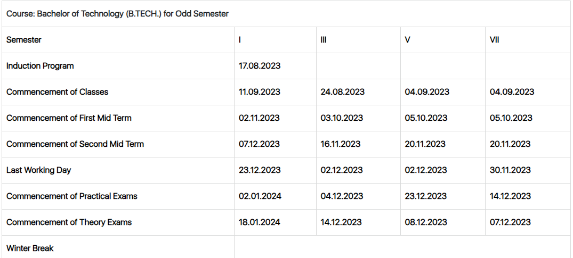

|  |  |  |  |  |
| --- | --- | --- | --- | --- |
| **Academic Calendar Odd Semester 2023-24** | | | | |
| **Particulars** | **B.Tech-I** | **B.Tech- III** | **B.Tech- V** | **B.Tech- VII** |
| Commencement of classes | 11-09-2023 | 24-08-2023 | 04-09-2023 | 04-09-2023 |
| Last Working Day | 23-12-2023 | 02-12-2023 | 02-12-2023 | 30-11-2023 |
| Course Progression Report-I | 25-10-2023 | 27-09-2023 | 27-09-2023 | 27-09-2023 |
| First Mid Term Exam | 02-11-2023 | 03-10-2023 | 05-10-2023 | 05-10-2023 |
| Remedial Class-I | 14-11-2024 | 16-10-2023 | 16-10-2023 | 16-10-2023 |
| Course Progression Report-II | 01-12-2023 | 10-11-2023 | 10-11-2023 | 10-11-2023 |
| Second Mid Term Exam | 07-12-2023 | 16-11-2023 | 20-11-2023 | 20-11-2023 |
| Remedial Class-II | 20-12-2023 | 29-11-2023 | 29-11-2023 | 29-11-2023 |
| Commencement of Theory Exam | 18-01-2023 | 14-12-2023 | 08-12-2023 | 07-12-2023 |
| Commencement of Practical Exam | 01-01-2024 | 04-12-2023 | 23-12-2023 | 14-12-2023 |

Academic Calendar for Odd Semester for Session

**Evaluation Scheme**

FACULTY DETAILS:

Name of the Faculty : Deepti Gour

Designation : Assistant Professor

Department : Computer Science Engineering

1. TARGET

a) Percentage Pass : 100%

b) Percentage I class: 60 %

2. METHOD OF EVALUATION

2.1. Continuous Assessment Examinations (Mid-Term 1, Mid-Term 2)

2.2. Assignments / Seminars

2.3. Mini Projects

2.4. Quiz

2.5. Semester Examination Others___________________________________________________

3. List out any new topic(s) or any innovation you would like to introduce in teaching the subject in this Semester.

1. Take the help of creative tools to stimulate creativity. Include slide presentations, demonstration or forms of visual exercises that will excite the young minds and capture their interest.

Signature of Faculty: **Signature of HOD**

**UNIVERSITY SYLLABUS**

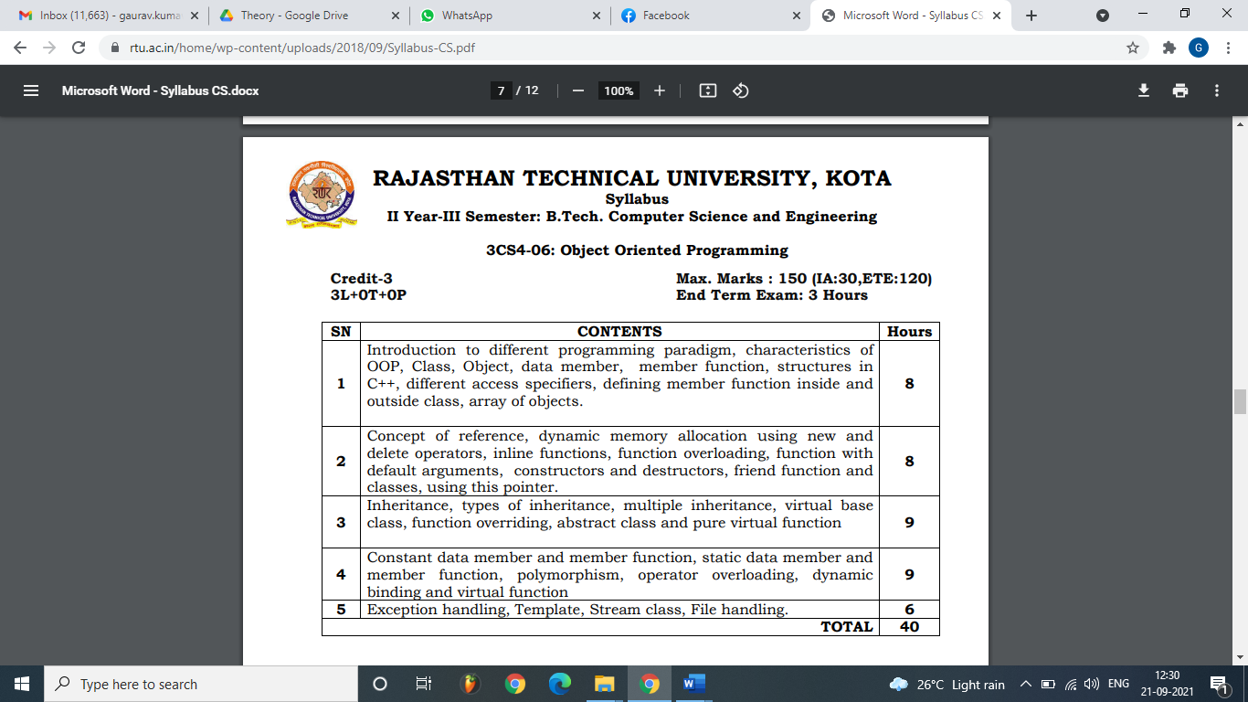

# Learning Resources

## Text Books/Reference Books

1. **Object Oriented Programming with C++, Balagurusamy**
2. C++ : The Complete Reference, Herbert Schildt
3. How to Program C++, Dietel, Pearson
4. Mastering C++ By K.R.Venugopal, TMH
5. Object Oriented Programming in C++ By Robert Lafore, Pearson
6. Object Oriented Design & Modelling, Rambaugh, Pearson

## Online References

**LinkedIn Learning (formerly Lynda.com)**

* + "C++ Essential Training" by Bill Weinman

## Teaching Resources

* Presentations, during classroom discussion, will be available on Google in PDF format
* Various online and offline resources will be shared during course compilation

# Assessment

## Internal

* Online Quiz during course compilation with tools like Kahoot, Google forms etc.
* Program list for respective topic wise.
* Assignment Submission through Google Classroom after every Unit of Syllabus.
* Case studies and Problem Scenario discussion after every topic
* Presentation and Report on Final Assignment

## External

* As per Rajasthan Technical University – Kota’s guidelines
* Previous Years Question Papers are available on [www.rtu.ac.in](http://www.rtu.ac.in)or Examination Cell of [www.technonjr.org](http://www.technonjr.org)

**WEEKLY TIMETABLE OF THE TEACHER**

First Time Table: with effect from (Date):

|  |  |  |  |  |  |  |
| --- | --- | --- | --- | --- | --- | --- |
| **III Semester (2nd Year)** | | | | | | |
| **Time-Table** | | | | | | |
| **(Section A - Branch CSE )** | | | | | | |
| **Room No:** | | |  |  | **w.e.f.: 25/09/2023** | |
| **Day/Time** | **9:00 – 10:00** | **10:00 – 11:00** | **11:00 – 12:00** | **12:00 – 1:00** | **1:00 – 2:00** | **2:00 – 4:00** |
| **Monday** |  |  | **OOPS** |  | **LUNCH** |  |
|  |  | **DG** |  |  |
| **Tuesday** |  |  |  | **OOPS** |  |
|  |  |  | **DG** |  |
| **Wednesday** |  |  | **OOPS** |  |  |
|  |  | **DG** |  |  |
| **Thursday** |  |  | **OOPS** |  |  |
|  |  | **DG** |  |  |
| **Friday** |  |  |  |  |  |
|  |  |  |  |  |
| **Saturday** |  |  |  |  |  |
|  |  |  |  |  |
|  |  |  |  |  |  |  |
| **(Section B - Branch CSE )** | | | | | | |
| **Room No:** | | |  |  | **w.e.f.: 25/09/2023** | |
| **Day/Time** | **9:00 – 10:00** | **10:00 – 11:00** | **11:00 – 12:00** | **12:00 – 1:00** | **1:00 – 2:00** | **2:00 – 4:00** |
| **Monday** |  |  |  | **OOPS** | **LUNCH** |  |
|  |  |  | **DG** |  |
| **Tuesday** |  |  |  |  |  |
|  |  |  |  |  |
| **Wednesday** |  |  |  | **OOPS** |  |
|  |  |  | **DG** |  |
| **Thursday** |  |  |  |  |  |
|  |  |  |  |  |
| **Friday** |  | **OOPS** | **OOPS** |  |  |
|  | **DG** | **DG** |  |  |
| **Saturday** |  |  |  |  |  |
|  |  |  |  |  |
|  |  |  |  |  |  |  |
| **(Section C - Branch CSE )** | | | | | | |
| **Room No:** | | |  |  | **w.e.f.: 25/09/2023** | |
| **Day/Time** | **9:00 – 10:00** | **10:00 – 11:00** | **11:00 – 12:00** | **12:00 – 1:00** | **1:00 – 2:00** | **2:00 – 4:00** |
| **Monday** |  | **OOPS** |  |  | **LUNCH** |  |
|  | **DG** |  |  |  |
| **Tuesday** |  | **OOPS** |  |  |  |
|  | **DG** |  |  |  |
| **Wednesday** |  |  |  |  |  |
|  |  |  |  |  |
| **Thursday** |  | **OOPS** |  |  |  |
|  | **DG** |  |  |  |
| **Friday** |  |  |  | **OOPS** |  |
|  |  |  | **DG** |  |
| **Saturday** |  |  |  |  |  |
|  |  |  |  |  |

**COURSE-PLAN**

|  |  |  |  |
| --- | --- | --- | --- |
| UNIT | Lect.  No. | TOPICS | **Teaching Methods/ Teaching Aids** |
| **1** | **1** | Introduction to different programming paradigm, | White Board, PPT, |
| 1 | 2 | characteristics of OOP | White Board, PPT, Demonstration |
| 1 | 3 | Class, Object | White Board |
| 1 | 4 | data member, member function | White Board |
| 1 | 5 | structures in C++, different access specifiers | White Board, PPT |
| 1 | 6 | defining member function inside and outside class, | White Board |
| 1 | 7 | array of objects. | White Board, PPT |
| 1 | 8 | Concept of reference, | White Board |
| 1 | 9 | dynamic memory allocation using | White Board, PPT, |
| 1 | 10 | new and delete operators | White Board, PPT, Demonstration |
| 2 | 11 | inline functions | White Board |
| 2 | 12 | function overloading | White Board |
| 2 | 13 | function with default arguments | White Board, PPT |
| 2 | 14 | constructors | White Board |
| 2 | 15 | Destructors | White Board, PPT |
| 3 | 16 | friend function | White Board |
| 3 | 17 | Friend and classes | White Board, PPT, |
| 3 | 18 | this pointer. | White Board, Demonstration |
| 3 | 19 | Inheritance | White Board |
| 3 | 20 | types of inheritance | White Board |
| 3 | 21 | multiple inheritance, | White Board, PPT |
| 3 | 22 | virtual base class | White Board |
| 4 | 23 | function overriding | White Board, PPT |
| 4 | 24 | abstract class | White Board |
| 4 | 25 | pure virtual function | White Board, PPT, |
| 4 | 26 | Constant data member and member function | White Board, PPT, Demonstration |
| 4 | 27 | static data member | White Board |
| 4 | 28 | static member function | White Board |
| 5 | 29 | polymorphism, | White Board, PPT |
| 5 | 30 | operator overloading | White Board |
| 5 | **31** | dynamic binding | White Board, PPT |
| 5 | 31 | virtual function | White Board |
| 5 | 33 | Exception handling | White Board, PPT, |
| 5 | 34 | Try throw catch statmenets | White Board, PPT, Demonstration |
| 5 | 35 | Template | White Board |
| 5 | 36 | Function and class templates | White Board |
| 5 | 37 | Stream class | White Board, PPT |
| 5 | 38 | File handling (File attributes and types) | White Board |
| Unit 1-5 | 39 | Programming exercise | Verbalization, White Board, PPT |
| Unit 1-5 | 40 | Online Quiz (from Unit 1 – Unit 5- 50 Q) | MCQ online quiz |

**Signature of Faculty: Signature of HOD**

**Assignment – 1 (OBJECT ORIENTED PROGRAMMING)**

|  |  |
| --- | --- |
| A. Write a C++ program to input 3 variables and find out the sum and average. | (CO1) |
| B. Write a C++ program to swap 2 no’s using function & pointer. |
| C. Write a program to find factorial of a number using recursion function. |
| D. Writer a program to implement struct book having book name, page no and price. Create an array of struct variable to accessing structure variables. |
| A. Write a Program to find Multiplication and Division using inline function. | (CO2) |
| B. Write a Program to find volume of Different Shapes (Cube, Cylinder, Rectangular box) using Function Overloading. |
| C. Write h program to implement class having get data() and put data() function. |
| A. Write a Program using class to process Shopping List for a Departmental Store. The list includes details such as the Code No and Price of each item and perform the operations like Adding, Deleting Items to the list and Printing the Total value of a Order. | (CO3) |
| B. Write a Program to find Maximum out of Two Numbers using friend function. |
| C. Write a Program to swap private data members of classes named as class_1, class_2 using friend function. |
| D. Write a Program to design a class complex to represent complex numbers. The complex class should use an external function (use it as a friend function) to add two complex no. the function should return an object of type complex representing the sum of two complex no. |
| A. Write a program to use Overloaded constructor. | (CO4) |
| B. Write a Program using copy constructor to copy data of an object to another object. |
| C. Write a Program to construct the object of a class and after that destroy all objects of that class. |
| D. Write a Program to overload the unary minus operator. |
| A. Write a program to implement Single and multiple Inheritances. | CCO5) |
| B. Write a Program to use of pointer to objects. |
| C. Write a Program to implement the bubble sort using template function. |
| D. Write a program to implement the exception handling with multiple catch statements. |

**Assessment Methodology:**

1. Practical exam in lab where they have to write code on C/C++ compiler for the given problem statement. (Once in a week)
2. Assignment 7-10 Programs from each unit.
3. Final paper at the end of the semester subjective.

**Teaching and Learning resources unit-wise:**

**Unit-1**

A. Introduction to POP/OOP

Video Tutorials: https://www.youtube.com/watch?v=wN0x9eZLix4

Theory concepts: https://www.geeksforgeeks.org/object-oriented-programming-in-cpp/

Sample Quiz: https://www.geeksforgeeks.org/c-programming-multiple-choice-questions/

B. Concept of Class and Objects

Video Tutorials: https://www.youtube.com/watch?v=wN0x9eZLix4

Theory concepts: https://www.geeksforgeeks.org/object-oriented-programming-in-cpp/

Sample Quiz: https://www.geeksforgeeks.org/c-plus-plus-gq/class-and-object-gq/

**Unit-2**

1. Concept of Friend Function

Video Tutorials: https://www.youtube.com/watch?v=FErlySnTBWc&ab_channel=LearningLad

Theory concepts: https://www.geeksforgeeks.org/functions-in-c/?ref=lbp

Sample Quiz: https://www.geeksforgeeks.org/c-plus-plus-gq/friend-function-and-class-gq/

1. Constructor/Destructor

Video Tutorials: https://www.youtube.com/watch?v=hAA8FBq2bA4&ab_channel=SimpleSnippets

Theory concepts: https://www.geeksforgeeks.org/constructors-c/?ref=lbp

Sample Quiz: https://www.geeksforgeeks.org/c-plus-plus-gq/constructors-gq/

**Unit-3**

1. Inheritance

Video Tutorials: https://www.youtube.com/watch?v=rr7HVs4d1Qo&ab_channel=SimpleSnippets

Theory concepts: https://www.geeksforgeeks.org/inheritance-in-c/

Sample Quiz: https://www.geeksforgeeks.org/c-plus-plus-gq/inheritance-gq/

B. Virtual Functions

Video Tutorials: https://www.youtube.com/watch?v=JU8DbwBvOWE&ab_channel=SimpleSnippets

Theory concepts: https://www.geeksforgeeks.org/virtual-function-cpp/

Sample Quiz: https://www.geeksforgeeks.org/c-plus-plus-gq/virtual-functions-gq/

**Unit-4**

1. Static Data Member/Member Function

Video Tutorials: https://www.youtube.com/watch?v=1QTZeeDL0bc&ab_channel=SimpleSnippets

Theory concepts: https://www.geeksforgeeks.org/static-data-members-c/

Sample Quiz: https://www.geeksforgeeks.org/c-plus-plus-gq/static-keyword-gq/

1. Polymorphism

Video Tutorials: https://www.youtube.com/watch?v=uc_Hr10cBBE&ab_channel=SimpleSnippets

Theory concepts: https://www.geeksforgeeks.org/polymorphism-in-c/

Sample Quiz: https://www.geeksforgeeks.org/c-plus-plus-gq/operator-overloading-gq/

**Unit-5**

1. Templates

Video Tutorials: <https://www.youtube.com/watch?v=CWj7lLY2GLA&ab_channel=SimpleSnippets>

Theory concepts: <https://www.geeksforgeeks.org/templates-cpp/>

Sample Quiz: <https://www.geeksforgeeks.org/c-plus-plus-gq/templates-gq/>

1. Exceptional Handling

Video Tutorials: https://www.youtube.com/watch?v=EyXXLpFriMc&ab_channel=SimpleSnippets

Theory concepts: https://www.geeksforgeeks.org/exception-handling-c/?ref=lbp

Sample Quiz: https://www.geeksforgeeks.org/c-plus-plus-gq/exception-handling-gq/

1. File Handling

Video Tutorials: https://www.youtube.com/watch?v=TF2-F2duY6c&ab_channel=SimpleSnippets

Theory concepts: https://www.geeksforgeeks.org/file-handling-c-classes/?ref=lbp

Sample Quiz: https://www.sanfoundry.com/cplusplus-programming-questions-answers-file-handling/

**SAMPLE QUIZ QUESTIONS**

|  |
| --- |
| **Q: What are the main differences between procedural programming and object-oriented programming?** |
| a) Procedural programming focuses on procedures or routines, while OOP focuses on objects. |
| b) Procedural programming uses objects, while OOP does not. |
| c) OOP cannot handle complex tasks, while procedural programming can. |
| d) Procedural programming allows for data encapsulation, while OOP does not. |
| **Q: Which of the following is NOT a characteristic of object-oriented programming?** |
| a) Encapsulation |
| b) Inheritance |
| c) Abstraction |
| d) Pre-processing |
| **Q: What is the relationship between a class and an object?** |
| a) A class is an instance of an object. |
| b) An object is a blueprint for a class. |
| c) A class is a blueprint for creating objects. |
| d) An object defines the structure of a class. |
| **Q: Which of the following defines a data member in a class?** |
| a) A variable that holds data within an object. |
| b) A function that operates on data within an object. |
| c) A class that holds data. |
| d) An object that contains functions. |
| **Q: Which access specifier allows members to be accessible from outside the class?** |
| a) Private |
| b) Protected |
| c) Public |
| d) Internal |
| **Q: How do you define a member function outside the class definition in C++?** |
| a) By using the function name directly. |
| b) By using the scope resolution operator (::). |
| c) By using the dot operator (.). |
| d) By using the arrow operator (->). |
| **Q: How do you declare an array of objects in C++?** |
| a) ClassName objectName[size]; |
| b) ClassName objectName; |
| c) ClassName objectName[]; |
| d) ClassName[] objectName; |
| **Q: What is a reference in C++?** |
| a) A variable that stores the address of another variable. |
| b) An alias for another variable. |
| c) A pointer to a function. |
| d) A constant variable. |
| **Q: How do you allocate memory dynamically for an integer in C++?** |
| a) int *p = new int; |
| b) int p = new int; |
| c) int p = allocate int; |
| d) int *p = allocate int; |
| **Q: How do you deallocate memory for an integer pointer p in C++?** |
| a) delete p; |
| b) free(p); |
| c) remove(p); |
| d) deallocate p; |
| **Q: What is the purpose of an inline function in C++?** |
| a) To improve performance by avoiding function call overhead. |
| b) To allow functions to be overloaded. |
| c) To enable dynamic binding. |
| d) To create virtual functions. |
| **Q: What is function overloading?** |
| a) Defining multiple functions with the same name but different parameters. |
| b) Defining multiple functions with the same name and same parameters. |
| c) Defining a function within another function. |
| d) Defining a function without any parameters. |
| **Q: How do you provide default arguments in a function in C++?** |
| a) void func(int x = 10); |
| b) void func(int x); |
| c) void func(default int x); |
| d) void func(int x) = default; |
| **Q: What is a constructor in C++?** |
| a) A special member function that initializes objects. |
| b) A special member function that destroys objects. |
| c) A function that can be called multiple times. |
| d) A function that returns a value. |
| **Q: What is the main purpose of a destructor in C++?** |
| a) To initialize objects. |
| b) To clean up resources when an object is no longer needed. |
| c) To create objects. |
| d) To overload functions. |
| **Q: What is a friend function in C++?** |
| a) A function that can access private and protected members of a class. |
| b) A function that is a member of a class. |
| c) A function that cannot access private members of a class. |
| d) A function that can only access public members of a class. |
| **Q: What is the this pointer in C++?** |
| a) A pointer that points to the current object. |
| b) A pointer that points to the base class. |
| c) A pointer that points to the derived class. |
| d) A pointer that points to a friend class. |
| **Q: What is inheritance in C++?** |
| a) The process by which one class acquires the properties and functionalities of another class. |
| b) The process of overloading a function. |
| c) The process of creating an inline function. |
| d) The process of destroying objects. |
| **Q: Which of the following is NOT a type of inheritance in C++?** |
| a) Single inheritance |
| b) Multiple inheritance |
| c) Multilevel inheritance |
| d) Parallel inheritance |
| **Q: What is multiple inheritance in C++?** |
| a) A class derived from more than one base class. |
| b) A class derived from a single base class. |
| c) A class that cannot be inherited. |
| d) A class with multiple constructors. |
| **Q: What is the purpose of a virtual base class in C++?** |
| a) To avoid multiple copies of base class members when using multiple inheritance. |
| b) To create an inline function. |
| c) To provide a default implementation. |
| d) To overload a function. |
| **Q: What is function overriding in C++?** |
| a) Redefining a base class function in a derived class. |
| b) Defining multiple functions with the same name but different parameters. |
| c) Creating an inline function. |
| d) Overloading a constructor. |
| **Q: What is an abstract class in C++?** |
| a) A class that cannot be instantiated and is meant to be inherited. |
| b) A class with no member functions. |
| c) A class with only private members. |
| d) A class with no constructors. |
| **Q: What is a pure virtual function in C++?** |
| a) A function declared with = 0 and meant to be overridden in derived classes. |
| b) A function that cannot be overridden. |
| c) A function that is defined in the base class. |
| d) A function that is declared as inline. |

**Mid Term Paper-I**

**TECHNO INDIA NJR INSTITUTE OF TECHNOLOGY, UDAIPUR**

**B. TECH 2nd – YEAR (III SEM.) – MT-I**

**Object Oriented Programming** (**3CS4-06**)

***Time: 2 Hr Max. Marks: 70***

**Note:**

1. The paper is divided into 2 parts: Part-A and, Part-B.
2. Part-A contains 10 questions and carries 2 mark each.
3. Part-B contains 5 questions. Each question is having two options and carries 10 marks each.

**Part- A (20 Marks)**

|  |  |
| --- | --- |
| 1. What is Dynamic Binding? How it is useful in C++. | CO1 |
| 1. Write Few Differences between POP & OOP. | CO1 |
| 1. Write a C++ program using function template to calculate area of circle and square. | CO1 |
| 1. What is Abstraction in C++? Give Suitable example. | CO1 |
| 1. Define This Pointer and write suitable example. | CO2 |
| 1. What are Run Time Error, Logical Error and Syntax Error in C++. | CO2 |
| 1. Define Access Specifiers in C++ classes. Give example for Public, Private and Protected specifiers. | CO2 |
| 1. Why use inline function in C++? Give suitable example. | CO2 |
| 1. What are the differences between class and structure? | CO3 |
| 1. Write few areas of application of OOP. | CO3 |

**Part- B (50 Marks)**

|  |  |
| --- | --- |
| 1. Define Scope resolution operator C++. Write syntax wand give suitable example. Write a program by using a function to use reference variables to swap the values of two integers. | CO1 |
| OR | |
| 1. Define a class to create, update and manage online product and order list of customer. Take your own assumptions for data and member functions. | CO1 |

|  |  |
| --- | --- |
| 1. Create a User info class that includes member values for Name, Age and Salary. Create member function Read_User (), that accept user information and Show_ User () , that display user information, add error checking to Show_User () to accept user age in between to 18-70 only, else give msg –“Invalid User Age”. | CO1 |
| OR | |
| 2. Define Class and Object? How can we define member function inside and outside the class in C++ ? Explain with suitable example. | CO1 |

|  |  |  |  |
| --- | --- | --- | --- |
| 1. What are the Features of OOP? Explain any 5 Features in detail. Write separate suitable syntax and code for all features. | | CO2 | |
| OR | | | |
| 3. What are Virtual Function and Pure Virtual Function? Write advantages of Virtual Function. Write a program to use virtual function in derived class. | | CO2 | |

|  |  |
| --- | --- |
| 1. What is Friend Function? Write advantages of friend function. Write a program to access Non Member Data of class by using friend function. | CO2 |
| OR | |
| 4. Write Short Notes on : (2 X 5= 10)  a) Write a code to explain concept of Copy Constructor b) Header Files in C++  c) Constructor & Destructor in OOP d) Abstract Class in C++  e) Polymorphism in OOP | CO2 |

|  |  |
| --- | --- |
| 1. What is Inheritance in OOP? Explain types of Inheritance and write a program to Addition and multiplication of three numbers using Multiple Inheritance in C++? | CO3 |
| OR | |
| 5. What is Function Overloading in C++? What’s the need of Function Overloading? Write a program to use display_result () for perform addition of two integers, two float and print two character or string by using function overloading. | CO3 |

**Marks and Gap Analysis of Mid-Term 1**

|  |  |  |  |  |
| --- | --- | --- | --- | --- |
| Sr. No | RTU Roll Number | Name of the Student | M-1 Marks (70) | Remark ( Remedial Class need or not – Y/N ) |
| 1 | 22ETCCS001 | AADARSH SONI | 65 | N |
| 2 | 22ETCCS002 | ABDUL ATTIF | 57 | N |
| 3 | 22ETCCS003 | ABHIJEET GARG | 65 | N |
| 4 | 22ETCCS004 | ADITYA CHHIPA | 65 | N |
| 5 | 22ETCCS005 | ADITYA GIRI GOSWAMI | 67 | N |
| 6 | 22ETCCS006 | ADITYA SHARMA | 67 | N |
| 7 | 22ETCCS007 | AJIT KUMAR | 57 | N |
| 8 | 22ETCCS008 | AKASH SONI | 70 | N |
| 9 | 22ETCCS009 | AKSHAT JANGID | 65 | N |
| 10 | 22ETCCS010 | AKSHAT KUMAR SAINI | 62 | N |
| 11 | 22ETCCS011 | AKSHI BARGURJAR | 66 | N |
| 12 | 22ETCCS012 | AKSHIT NALWAYA | 57 | N |
| 13 | 22ETCCS013 | AKSHITA KUMAWAT | 62 | N |
| 14 | 22ETCCS014 | AKSHITA PANCHAL | 62 | N |
| 15 | 22ETCCS015 | ALI ASGAR ORA WALA | 57 | N |
| 16 | 22ETCCS017 | ANGHA VARANGAONKAR | 62 | N |
| 17 | 22ETCCS018 | ANKIT DHANAWAT | 57 | N |
| 18 | 22ETCCS019 | ANSHIKA JAIN | 66 | N |
| 19 | 22ETCCS020 | ARCHIT JAIN | 57 | N |
| 20 | 22ETCCS021 | ARIN UPADHAYAY | 52 | N |
| 21 | 22ETCCS022 | ARUSH MENARIA | 67 | N |
| 22 | 22ETCCS023 | ARYAN TALWAR | 66 | N |
| 23 | 22ETCCS024 | AVIKA SURANA | 55 | N |
| 24 | 22ETCCS025 | BHAWANA KUMARI | 70 | N |
| 25 | 22ETCCS026 | BHUMI JAIN | 70 | N |
| 26 | 22ETCCS027 | BHUWAN SUTHAR | 55 | N |
| 27 | 22ETCCS028 | CHETAN NAGDA | 55 | N |
| 28 | 22ETCCS029 | CHIRAG SHARMA | 52 | N |
| 29 | 22ETCCS030 | MS. CIA SHARMMA | 67 | N |
| 30 | 22ETCCS031 | DAIVIK SHARMA | 57 | N |
| 31 | 22ETCCS032 | DAKSH JAIN | 62 | N |
| 32 | 22ETCCS033 | DAKSH MENARIA | 48 | N |
| 33 | 22ETCCS034 | DEV PARAKH | 70 | N |
| 34 | 22ETCCS035 | DHANESH JOSHI | 66 | N |
| 35 | 22ETCCS036 | DHEERAJ SINGH THAPA | 48 | N |
| 36 | 22ETCCS037 | DHWANI KHUSHLANI | 70 | N |
| 37 | 22ETCCS038 | DIKSHIT DARJI | 57 | N |
| 38 | 22ETCCS039 | MSDIKSHITA SHARMA | 67 | N |
| 39 | 22ETCCS040 | DIVYA BAGORA | 66 | N |
| 40 | 22ETCCS041 | DIVYANSHU SHARMA | 55 | N |
| 41 | 22ETCCS042 | DIVYASHAKTI PAL | 67 | N |
| 42 | 22ETCCS043 | DIYA JAIN | 57 | N |
| 43 | 22ETCCS044 | DIYA PALIWAL | 62 | N |
| 44 | 22ETCCS045 | FALGUN CHOUDHARY | 67 | N |
| 45 | 22ETCCS046 | GARGI SHARMA | 66 | N |
| 46 | 22ETCCS047 | GARV BAKLIWAL | 65 | N |
| 47 | 22ETCCS048 | GARVIT NANDAWAT | 48 | N |
| 48 | 22ETCCS049 | GAURAV JAIN | 67 | N |
| 49 | 22ETCCS050 | GAURAVI NEGI | 57 | N |
| 50 | 22ETCCS051 | GAURI SUTHAR | 70 | N |
| 51 | 22ETCCS053 | GOURAV POKHARNA | 65 | N |
| 52 | 22ETCCS054 | HARDIK BATWAL | 70 | N |
| 53 | 22ETCCS055 | HARSH DANGI | 67 | N |
| 54 | 22ETCCS056 | HARSH KAWADIA | 65 | N |
| 55 | 22ETCCS057 | HARSH TAMBOLI | 66 | N |
| 56 | 22ETCCS058 | HARSHAL JAIN | 67 | N |
| 57 | 22ETCCS059 | HARSHIT POKHARNA | 70 | N |
| 58 | 22ETCCS060 | HARSHVARDHAN SINGH CHAUHAN | 62 | N |
| 59 | 22ETCCS061 | HARSHVARDHAN SINGH KITAWAT | 57 | N |
| 60 | 22ETCCS062 | HEMANT AHUJA | 65 | N |
| 61 | 22ETCCS064 | HIMANK LOHAR | 57 | N |
| 62 | 22ETCCS065 | HIMANSHI PRAJAPAT | 67 | N |
| 63 | 22ETCCS066 | HIMANSHU KALAL | 57 | N |
| 64 | 22ETCCS067 | HONHAR RAWAL | 48 | N |
| 65 | 22ETCCS068 | HUSAIN BOHRA TIDIWALA | 57 | N |
| 66 | 22ETCCS069 | JAINISH JAIN | 48 | N |
| 67 | 22ETCCS070 | JAYESH JOSHI | 62 | N |
| 68 | 22ETCCS071 | JAYESH MANDAWAT | 57 | N |
| 69 | 22ETCCS072 | JINENDRA SINGH DODIYA | 48 | N |
| 70 | 22ETCCS073 | KANIKA GUPTA | 57 | N |
| 71 | 22ETCCS074 | KANISHK GUPTA | 66 | N |
| 72 | 22ETCCS075 | KAPIL KALAL | 48 | N |
| 73 | 22ETCCS076 | KARAN SWAMI | 62 | N |
| 74 | 22ETCCS077 | KARTIK JAIN | 70 | N |
| 75 | 22ETCCS078 | KARTIK KRISHNA KALE | 67 | N |
| 76 | 22ETCCS079 | KAVYA PALIWAL | 52 | N |
| 77 | 22ETCCS080 | KETAN OJHA | 57 | N |
| 78 | 22ETCCS081 | KHUSH JAIN | 70 | N |
| 79 | 22ETCCS082 | KHUSHI SHARMA | 66 | N |
| 80 | 22ETCCS083 | KIRTAN TAMBOLI | 67 | N |
| 81 | 22ETCCS085 | KONPAL SHARMA | 65 | N |
| 82 | 22ETCCS086 | KRITI PATWA | 70 | N |
| 83 | 22ETCCS087 | KUSH PARSAI | 66 | N |
| 84 | 22ETCCS088 | KUSHAL MEENA | 52 | N |
| 85 | 22ETCCS089 | LAKSHIT PALIWAL | 65 | N |
| 86 | 22ETCCS090 | LAKSHY JAIN | 55 | N |
| 87 | 22ETCCS091 | LAKSHYARAJ CHOUDHARY | 57 | N |
| 88 | 22ETCCS092 | LAL SINGH JHALA | 57 | N |
| 89 | 22ETCCS093 | LUCKY LOHAR | 57 | N |
| 90 | 22ETCCS094 | MAHATV BHATNAGAR | 55 | N |
| 91 | 22ETCCS095 | MAHENDRA SINGH SISODIYA | 62 | N |
| 92 | 22ETCCS096 | MSMAHIMA CHOUHAN | 67 | N |
| 93 | 22ETCCS097 | MAHIPAL SINGH JHALA | 66 | N |
| 94 | 22ETCCS098 | MAHIRAJ SINGH SANKHLA | 57 | N |
| 95 | 22ETCCS099 | MANAS PARWANI | 66 | N |
| 96 | 22ETCCS100 | MANASVI SHARMA | 66 | N |
| 97 | 22ETCCS101 | MANASWINI SHARMA | 57 | N |
| 98 | 22ETCCS102 | MANSI DUBE | 70 | N |
| 99 | 22ETCCS103 | MAYANK KASERA | 57 | N |
| 100 | 22ETCCS104 | MAYANK TRIVEDI | 52 | N |
| 101 | 22ETCCS105 | MEDHAVI KAUSHIK | 65 | N |
| 102 | 22ETCCS106 | MEETRAJ SINGH | 57 | N |
| 103 | 22ETCCS107 | MITALI PALIWAL | 62 | N |
| 104 | 22ETCCS108 | MITVESH AMETA | 48 | N |
| 105 | 22ETCCS109 | MOHAMMED YASAR | 48 | N |
| 106 | 22ETCCS110 | MOHIT KALAL | 52 | N |
| 107 | 22ETCCS111 | MOHIT KUMAWAT | 57 | N |
| 108 | 22ETCCS112 | MONIL SETH | 67 | N |
| 109 | 22ETCCS113 | NAKUL PANDYA | 55 | N |
| 110 | 22ETCCS114 | NEERAJ DANGI | 52 | N |
| 111 | 22ETCCS115 | NIKHIL RAJ MALI | 57 | N |
| 112 | 22ETCCS116 | NIMISHKA CHAUHAN | 57 | N |
| 113 | 22ETCCS117 | NISHANT MENARIA | 67 | N |
| 114 | 22ETCCS118 | MSPALAK KUMAWAT | 67 | N |
| 115 | 22ETCCS119 | PARSHVI HARKAWAT | 67 | N |
| 116 | 22ETCCS120 | PRAGYA BUJ | 62 | N |
| 117 | 22ETCCS121 | PRATIBHA SINGH | 70 | N |
| 118 | 22ETCCS122 | PRINCE DANGI | 52 | N |
| 119 | 22ETCCS123 | PRIYANSH JAIN | 66 | N |
| 120 | 22ETCCS124 | PURVAM CHATURVEDI | 52 | N |
| 121 | 22ETCCS125 | PUSHKAR GAMETI | 57 | N |
| 122 | 22ETCCS126 | PUSHPENDRA MENARIA | 70 | N |
| 123 | 22ETCCS127 | QAIDJOHAR JUKKER | 70 | N |
| 124 | 22ETCCS128 | RAGHAVENDRA BAHETI | 62 | N |
| 125 | 22ETCCS129 | RAJ LAXKAR | 57 | N |
| 126 | 22ETCCS130 | RAJ SHRIMALI | 62 | N |
| 127 | 22ETCCS131 | RAM MUNDRA | 55 | N |
| 128 | 22ETCCS132 | RAMMITH K R | 55 | N |
| 129 | 22ETCCS133 | RANITH BISWAS | 48 | N |
| 130 | 22ETCCS134 | RANJIT SINGH SHAKTAWAT | 67 | N |
| 131 | 22ETCCS135 | MSRAUNAK TAK | 70 | N |
| 132 | 22ETCCS136 | RAVI JOSHI | 52 | N |
| 133 | 22ETCCS137 | RAVI MENARIYA | 70 | N |
| 134 | 22ETCCS138 | RITIK SHARMA | 66 | N |
| 135 | 22ETCCS139 | RITISHA SEN | 62 | N |
| 136 | 22ETCCS140 | ROHIT AGARWAL | 67 | N |
| 137 | 22ETCCS141 | ROSHAN SHARMA | 70 | N |
| 138 | 22ETCCS142 | ROSHNI MENARIA | 55 | N |
| 139 | 22ETCCS143 | RUDRA PUROHIT | 52 | N |
| 140 | 22ETCCS144 | RUDRAVEER SINGH PANWAR | 66 | N |
| 141 | 22ETCCS145 | SHAAN SANADHYA | 57 | N |
| 142 | 22ETCCS146 | SHACHI JAIN | 57 | N |
| 143 | 22ETCCS147 | SHAURYA KUNDAR | 57 | N |
| 144 | 22ETCCS148 | SHOURYA BORDIA | 48 | N |
| 145 | 22ETCCS149 | SHUBHAM YADAV | 55 | N |
| 146 | 22ETCCS150 | SIDDHARTH KUMAR SINGH | 48 | N |
| 147 | 22ETCCS151 | SIDDHARTH MENARIA | 62 | N |
| 148 | 22ETCCS152 | SRAJAN MENARIA | 48 | N |
| 149 | 22ETCCS154 | SUMIT DANGI | 65 | N |
| 150 | 22ETCCS155 | SURBHI TAILOR | 57 | N |
| 151 | 22ETCCS156 | SURYANSH MADHUKAR | 57 | N |
| 152 | 22ETCCS157 | TALENT JAIN | 62 | N |
| 153 | 22ETCCS158 | TANISHK VYAS | 65 | N |
| 154 | 22ETCCS159 | TANVI SHARMA | 65 | N |
| 155 | 22ETCCS160 | TOHEED AKHTAR | 67 | N |
| 156 | 22ETCCS161 | TUSHAR PRAJAPAT | 57 | N |
| 157 | 22ETCCS162 | TUSHAR SINGH RAWAT | 52 | N |
| 158 | 22ETCCS163 | UJJWAL SINGH CHOUHAN | 62 | N |
| 159 | 22ETCCS164 | USHIT SHARMA | 57 | N |
| 160 | 22ETCCS165 | UTKARSH BAJPAI | 62 | N |
| 161 | 22ETCCS166 | VAIBHAV GOYAL | 67 | N |
| 162 | 22ETCCS167 | VANSH BHATNAGAR | 66 | N |
| 163 | 22ETCCS168 | VINAY VADERA | 55 | N |
| 164 | 22ETCCS169 | VINITA MENARIA | 67 | N |
| 165 | 22ETCCS170 | VISHAL MENARIYA | 67 | N |
| 166 | 22ETCCS171 | VISHAL SINGH RAO | 57 | N |
| 167 | 22ETCCS172 | VIVEK SHARMA | 70 | N |
| 168 | 22ETCCS173 | VIVEK SHRIMALI | 57 | N |
| 169 | 22ETCCS174 | YANA OZHA | 67 | N |
| 170 | 22ETCCS175 | YASH VAGHELA | 62 | N |
| 171 | 22ETCCS300 | KEVALI ASHOK KANAGALE | 70 | N |
| 172 | 22ETCCS301 | KARAN SUTHAR | 48 | N |
| 173 | 22ETCCS302 | VINEET SHARMA | 62 | N |
| 174 | 23ETCCS200 | GOPAL PALIWAL | 57 | N |
| 175 | 23ETCCS201 | MANISH VYAS | 48 | N |
| 176 | 23ETCCS202 | RAHUL RAJPUROHIT | 57 | N |
| 177 | 23ETCCS203 | VAISHALI H PUROHIT | 57 | N |
| 178 | 23ETCCS204 | YASH SINGHATWADIA | 52 | N |

**\***(Y, if obtained marks are <50%)

**Signature of Faculty: Signature of HOD**

**Remedial Action Taken to Remove the Gaps (After Mid- Term 1)**

|  |  |  |  |  |  |
| --- | --- | --- | --- | --- | --- |
| S.no. | University Roll no. | Name of Student | Topics to be discussed in Remedial Class | Schedule Date of Remedial Class | Outcome  Achieved |
|  |  |  | OOP & POP Concept  Basic OOP’s Concept  Inline Function |  | CO1 |
|  |  |  | CO2 |
|  |  |  | CO2 |
|  |  |  | CO3 |
|  |  |  |  |
|  |  |  |  |
|  |  |  |  |
|  |  |  |  |
|  |  |  |  |
|  |  |  |  |

**Signature of Faculty: Signature of HOD**

**Mid Term Exam – II**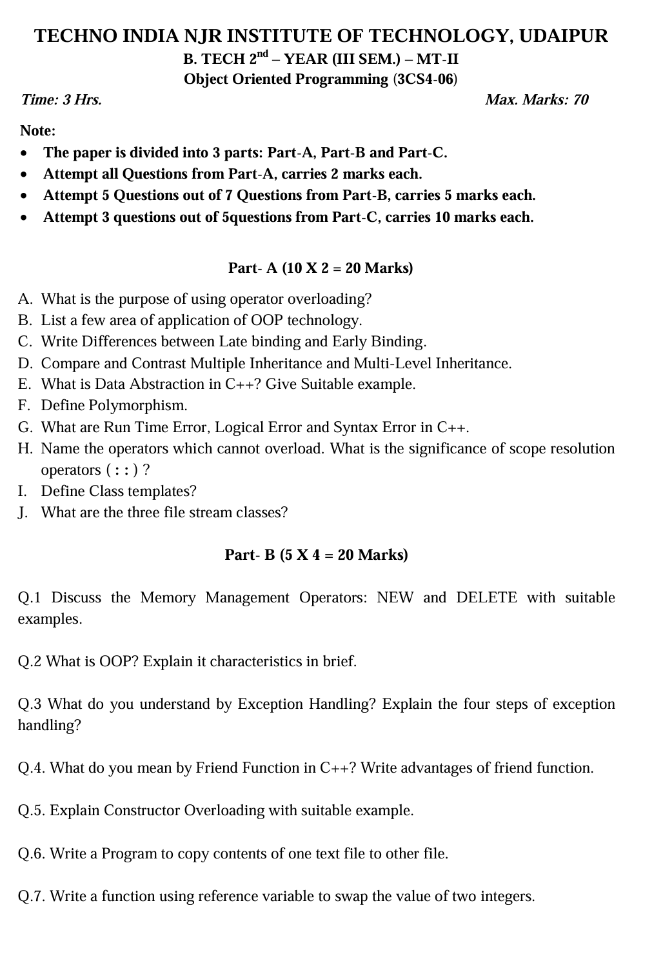

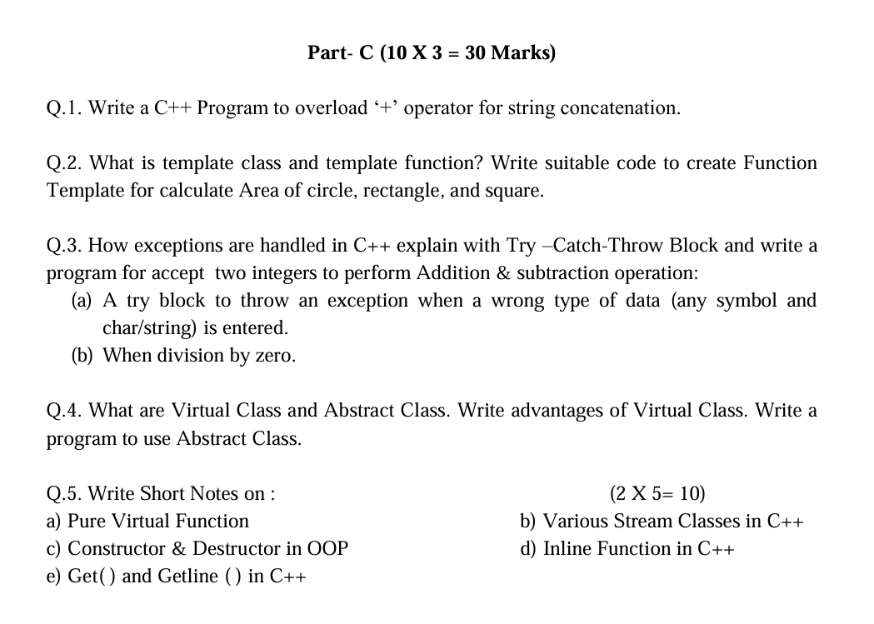

**Marks and Gap Analysis of Mid-Term II**

|  |  |  |  |  |
| --- | --- | --- | --- | --- |
| Sr. No | RTU Roll Number | Name of the Student | M-1 Marks (70) | Remark ( Remedial Class need or not – Y/N ) |
| 1 | 22ETCCS001 | AADARSH SONI | 61 | N |
| 2 | 22ETCCS002 | ABDUL ATTIF | 59 | N |
| 3 | 22ETCCS003 | ABHIJEET GARG | 61 | N |
| 4 | 22ETCCS004 | ADITYA CHHIPA | 61 | N |
| 5 | 22ETCCS005 | ADITYA GIRI GOSWAMI | 69 | N |
| 6 | 22ETCCS006 | ADITYA SHARMA | 69 | N |
| 7 | 22ETCCS007 | AJIT KUMAR | 59 | N |
| 8 | 22ETCCS008 | AKASH SONI | 70 | N |
| 9 | 22ETCCS009 | AKSHAT JANGID | 61 | N |
| 10 | 22ETCCS010 | AKSHAT KUMAR SAINI | 60 | N |
| 11 | 22ETCCS011 | AKSHI BARGURJAR | 64 | N |
| 12 | 22ETCCS012 | AKSHIT NALWAYA | 59 | N |
| 13 | 22ETCCS013 | AKSHITA KUMAWAT | 60 | N |
| 14 | 22ETCCS014 | AKSHITA PANCHAL | 60 | N |
| 15 | 22ETCCS015 | ALI ASGAR ORA WALA | 59 | N |
| 16 | 22ETCCS017 | ANGHA VARANGAONKAR | 60 | N |
| 17 | 22ETCCS018 | ANKIT DHANAWAT | 59 | N |
| 18 | 22ETCCS019 | ANSHIKA JAIN | 64 | N |
| 19 | 22ETCCS020 | ARCHIT JAIN | 59 | N |
| 20 | 22ETCCS021 | ARIN UPADHAYAY | 50 | N |
| 21 | 22ETCCS022 | ARUSH MENARIA | 69 | N |
| 22 | 22ETCCS023 | ARYAN TALWAR | 64 | N |
| 23 | 22ETCCS024 | AVIKA SURANA | 53 | N |
| 24 | 22ETCCS025 | BHAWANA KUMARI | 70 | N |
| 25 | 22ETCCS026 | BHUMI JAIN | 70 | N |
| 26 | 22ETCCS027 | BHUWAN SUTHAR | 53 | N |
| 27 | 22ETCCS028 | CHETAN NAGDA | 53 | N |
| 28 | 22ETCCS029 | CHIRAG SHARMA | 50 | N |
| 29 | 22ETCCS030 | MS. CIA SHARMMA | 69 | N |
| 30 | 22ETCCS031 | DAIVIK SHARMA | 59 | N |
| 31 | 22ETCCS032 | DAKSH JAIN | 60 | N |
| 32 | 22ETCCS033 | DAKSH MENARIA | 50 | N |
| 33 | 22ETCCS034 | DEV PARAKH | 70 | N |
| 34 | 22ETCCS035 | DHANESH JOSHI | 64 | N |
| 35 | 22ETCCS036 | DHEERAJ SINGH THAPA | 50 | N |
| 36 | 22ETCCS037 | DHWANI KHUSHLANI | 70 | N |
| 37 | 22ETCCS038 | DIKSHIT DARJI | 59 | N |
| 38 | 22ETCCS039 | MSDIKSHITA SHARMA | 69 | N |
| 39 | 22ETCCS040 | DIVYA BAGORA | 64 | N |
| 40 | 22ETCCS041 | DIVYANSHU SHARMA | 53 | N |
| 41 | 22ETCCS042 | DIVYASHAKTI PAL | 69 | N |
| 42 | 22ETCCS043 | DIYA JAIN | 59 | N |
| 43 | 22ETCCS044 | DIYA PALIWAL | 60 | N |
| 44 | 22ETCCS045 | FALGUN CHOUDHARY | 69 | N |
| 45 | 22ETCCS046 | GARGI SHARMA | 64 | N |
| 46 | 22ETCCS047 | GARV BAKLIWAL | 61 | N |
| 47 | 22ETCCS048 | GARVIT NANDAWAT | 50 | N |
| 48 | 22ETCCS049 | GAURAV JAIN | 69 | N |
| 49 | 22ETCCS050 | GAURAVI NEGI | 59 | N |
| 50 | 22ETCCS051 | GAURI SUTHAR | 70 | N |
| 51 | 22ETCCS053 | GOURAV POKHARNA | 61 | N |
| 52 | 22ETCCS054 | HARDIK BATWAL | 70 | N |
| 53 | 22ETCCS055 | HARSH DANGI | 69 | N |
| 54 | 22ETCCS056 | HARSH KAWADIA | 61 | N |
| 55 | 22ETCCS057 | HARSH TAMBOLI | 64 | N |
| 56 | 22ETCCS058 | HARSHAL JAIN | 69 | N |
| 57 | 22ETCCS059 | HARSHIT POKHARNA | 70 | N |
| 58 | 22ETCCS060 | HARSHVARDHAN SINGH CHAUHAN | 60 | N |
| 59 | 22ETCCS061 | HARSHVARDHAN SINGH KITAWAT | 59 | N |
| 60 | 22ETCCS062 | HEMANT AHUJA | 61 | N |
| 61 | 22ETCCS064 | HIMANK LOHAR | 59 | N |
| 62 | 22ETCCS065 | HIMANSHI PRAJAPAT | 69 | N |
| 63 | 22ETCCS066 | HIMANSHU KALAL | 59 | N |
| 64 | 22ETCCS067 | HONHAR RAWAL | 50 | N |
| 65 | 22ETCCS068 | HUSAIN BOHRA TIDIWALA | 59 | N |
| 66 | 22ETCCS069 | JAINISH JAIN | 50 | N |
| 67 | 22ETCCS070 | JAYESH JOSHI | 60 | N |
| 68 | 22ETCCS071 | JAYESH MANDAWAT | 59 | N |
| 69 | 22ETCCS072 | JINENDRA SINGH DODIYA | 50 | N |
| 70 | 22ETCCS073 | KANIKA GUPTA | 59 | N |
| 71 | 22ETCCS074 | KANISHK GUPTA | 64 | N |
| 72 | 22ETCCS075 | KAPIL KALAL | 50 | N |
| 73 | 22ETCCS076 | KARAN SWAMI | 60 | N |
| 74 | 22ETCCS077 | KARTIK JAIN | 70 | N |
| 75 | 22ETCCS078 | KARTIK KRISHNA KALE | 69 | N |
| 76 | 22ETCCS079 | KAVYA PALIWAL | 50 | N |
| 77 | 22ETCCS080 | KETAN OJHA | 59 | N |
| 78 | 22ETCCS081 | KHUSH JAIN | 70 | N |
| 79 | 22ETCCS082 | KHUSHI SHARMA | 64 | N |
| 80 | 22ETCCS083 | KIRTAN TAMBOLI | 69 | N |
| 81 | 22ETCCS085 | KONPAL SHARMA | 61 | N |
| 82 | 22ETCCS086 | KRITI PATWA | 70 | N |
| 83 | 22ETCCS087 | KUSH PARSAI | 64 | N |
| 84 | 22ETCCS088 | KUSHAL MEENA | 50 | N |
| 85 | 22ETCCS089 | LAKSHIT PALIWAL | 61 | N |
| 86 | 22ETCCS090 | LAKSHY JAIN | 70 | N |
| 87 | 22ETCCS091 | LAKSHYARAJ CHOUDHARY | 70 | N |
| 88 | 22ETCCS092 | LAL SINGH JHALA | 55 | N |
| 89 | 22ETCCS093 | LUCKY LOHAR | 55 | N |
| 90 | 22ETCCS094 | MAHATV BHATNAGAR | 53 | N |
| 91 | 22ETCCS095 | MAHENDRA SINGH SISODIYA | 60 | N |
| 92 | 22ETCCS096 | MSMAHIMA CHOUHAN | 69 | N |
| 93 | 22ETCCS097 | MAHIPAL SINGH JHALA | 64 | N |
| 94 | 22ETCCS098 | MAHIRAJ SINGH SANKHLA | 55 | N |
| 95 | 22ETCCS099 | MANAS PARWANI | 64 | N |
| 96 | 22ETCCS100 | MANASVI SHARMA | 64 | N |
| 97 | 22ETCCS101 | MANASWINI SHARMA | 58 | N |
| 98 | 22ETCCS102 | MANSI DUBE | 70 | N |
| 99 | 22ETCCS103 | MAYANK KASERA | 55 | N |
| 100 | 22ETCCS104 | MAYANK TRIVEDI | 50 | N |
| 101 | 22ETCCS105 | MEDHAVI KAUSHIK | 61 | N |
| 102 | 22ETCCS106 | MEETRAJ SINGH | 55 | N |
| 103 | 22ETCCS107 | MITALI PALIWAL | 60 | N |
| 104 | 22ETCCS108 | MITVESH AMETA | 50 | N |
| 105 | 22ETCCS109 | MOHAMMED YASAR | 50 | N |
| 106 | 22ETCCS110 | MOHIT KALAL | 50 | N |
| 107 | 22ETCCS111 | MOHIT KUMAWAT | 55 | N |
| 108 | 22ETCCS112 | MONIL SETH | 69 | N |
| 109 | 22ETCCS113 | NAKUL PANDYA | 53 | N |
| 110 | 22ETCCS114 | NEERAJ DANGI | 50 | N |
| 111 | 22ETCCS115 | NIKHIL RAJ MALI | 59 | N |
| 112 | 22ETCCS116 | NIMISHKA CHAUHAN | 55 | N |
| 113 | 22ETCCS117 | NISHANT MENARIA | 69 | N |
| 114 | 22ETCCS118 | MSPALAK KUMAWAT | 69 | N |
| 115 | 22ETCCS119 | PARSHVI HARKAWAT | 69 | N |
| 116 | 22ETCCS120 | PRAGYA BUJ | 60 | N |
| 117 | 22ETCCS121 | PRATIBHA SINGH | 70 | N |
| 118 | 22ETCCS122 | PRINCE DANGI | 50 | N |
| 119 | 22ETCCS123 | PRIYANSH JAIN | 64 | N |
| 120 | 22ETCCS124 | PURVAM CHATURVEDI | 50 | N |
| 121 | 22ETCCS125 | PUSHKAR GAMETI | 59 | N |
| 122 | 22ETCCS126 | PUSHPENDRA MENARIA | 70 | N |
| 123 | 22ETCCS127 | QAIDJOHAR JUKKER | 70 | N |
| 124 | 22ETCCS128 | RAGHAVENDRA BAHETI | 60 | N |
| 125 | 22ETCCS129 | RAJ LAXKAR | 59 | N |
| 126 | 22ETCCS130 | RAJ SHRIMALI | 60 | N |
| 127 | 22ETCCS131 | RAM MUNDRA | 53 | N |
| 128 | 22ETCCS132 | RAMMITH K R | 53 | N |
| 129 | 22ETCCS133 | RANITH BISWAS | 50 | N |
| 130 | 22ETCCS134 | RANJIT SINGH SHAKTAWAT | 69 | N |
| 131 | 22ETCCS135 | MSRAUNAK TAK | 70 | N |
| 132 | 22ETCCS136 | RAVI JOSHI | 50 | N |
| 133 | 22ETCCS137 | RAVI MENARIYA | 70 | N |
| 134 | 22ETCCS138 | RITIK SHARMA | 64 | N |
| 135 | 22ETCCS139 | RITISHA SEN | 60 | N |
| 136 | 22ETCCS140 | ROHIT AGARWAL | 69 | N |
| 137 | 22ETCCS141 | ROSHAN SHARMA | 70 | N |
| 138 | 22ETCCS142 | ROSHNI MENARIA | 53 | N |
| 139 | 22ETCCS143 | RUDRA PUROHIT | 50 | N |
| 140 | 22ETCCS144 | RUDRAVEER SINGH PANWAR | 64 | N |
| 141 | 22ETCCS145 | SHAAN SANADHYA | 55 | N |
| 142 | 22ETCCS146 | SHACHI JAIN | 59 | N |
| 143 | 22ETCCS147 | SHAURYA KUNDAR | 55 | N |
| 144 | 22ETCCS148 | SHOURYA BORDIA | 50 | N |
| 145 | 22ETCCS149 | SHUBHAM YADAV | 53 | N |
| 146 | 22ETCCS150 | SIDDHARTH KUMAR SINGH | 50 | N |
| 147 | 22ETCCS151 | SIDDHARTH MENARIA | 60 | N |
| 148 | 22ETCCS152 | SRAJAN MENARIA | 50 | N |
| 149 | 22ETCCS154 | SUMIT DANGI | 61 | N |
| 150 | 22ETCCS155 | SURBHI TAILOR | 55 | N |
| 151 | 22ETCCS156 | SURYANSH MADHUKAR | 59 | N |
| 152 | 22ETCCS157 | TALENT JAIN | 60 | N |
| 153 | 22ETCCS158 | TANISHK VYAS | 61 | N |
| 154 | 22ETCCS159 | TANVI SHARMA | 61 | N |
| 155 | 22ETCCS160 | TOHEED AKHTAR | 69 | N |
| 156 | 22ETCCS161 | TUSHAR PRAJAPAT | 59 | N |
| 157 | 22ETCCS162 | TUSHAR SINGH RAWAT | 50 | N |
| 158 | 22ETCCS163 | UJJWAL SINGH CHOUHAN | 60 | N |
| 159 | 22ETCCS164 | USHIT SHARMA | 55 | N |
| 160 | 22ETCCS165 | UTKARSH BAJPAI | 60 | N |
| 161 | 22ETCCS166 | VAIBHAV GOYAL | 69 | N |
| 162 | 22ETCCS167 | VANSH BHATNAGAR | 64 | N |
| 163 | 22ETCCS168 | VINAY VADERA | 53 | N |
| 164 | 22ETCCS169 | VINITA MENARIA | 69 | N |
| 165 | 22ETCCS170 | VISHAL MENARIYA | 69 | N |
| 166 | 22ETCCS171 | VISHAL SINGH RAO | 59 | N |
| 167 | 22ETCCS172 | VIVEK SHARMA | 70 | N |
| 168 | 22ETCCS173 | VIVEK SHRIMALI | 59 | N |
| 169 | 22ETCCS174 | YANA OZHA | 69 | N |
| 170 | 22ETCCS175 | YASH VAGHELA | 60 | N |
| 171 | 22ETCCS300 | KEVALI ASHOK KANAGALE | 70 | N |
| 172 | 22ETCCS301 | KARAN SUTHAR | 50 | N |
| 173 | 22ETCCS302 | VINEET SHARMA | 60 | N |
| 174 | 23ETCCS200 | GOPAL PALIWAL | 55 | N |
| 175 | 23ETCCS201 | MANISH VYAS | 50 | N |
| 176 | 23ETCCS202 | RAHUL RAJPUROHIT | 59 | N |
| 177 | 23ETCCS203 | VAISHALI H PUROHIT | 59 | N |
| 178 | 23ETCCS204 | YASH SINGHATWADIA | 50 | N |

**\***(Y, if obtained marks are <50%)

**Signature of Faculty: Signature of HOD**

**Remedial Action Taken to Remove the Gaps (After Mid- Term 2 )**

|  |  |  |  |  |  |
| --- | --- | --- | --- | --- | --- |
| Sr. No. | University Roll no. | Name of Student | Topics to be discussed in Remedial Class | Schedule Date of Remedial Class | Course Outcome |
| 1 |  |  | Inheritance & its Types |  | CO3 |
| 2 |  |  | Operator Overloading |  | CO4 |
| 3 |  |  | Exception Handling , Stram Classes, Templates & File Handling |  | CO5 |
| 4 |  |  |  |  |  |
| 5 |  |  |  |  |  |

**Signature of Faculty: Signature of HOD**

**Model Question Paper**

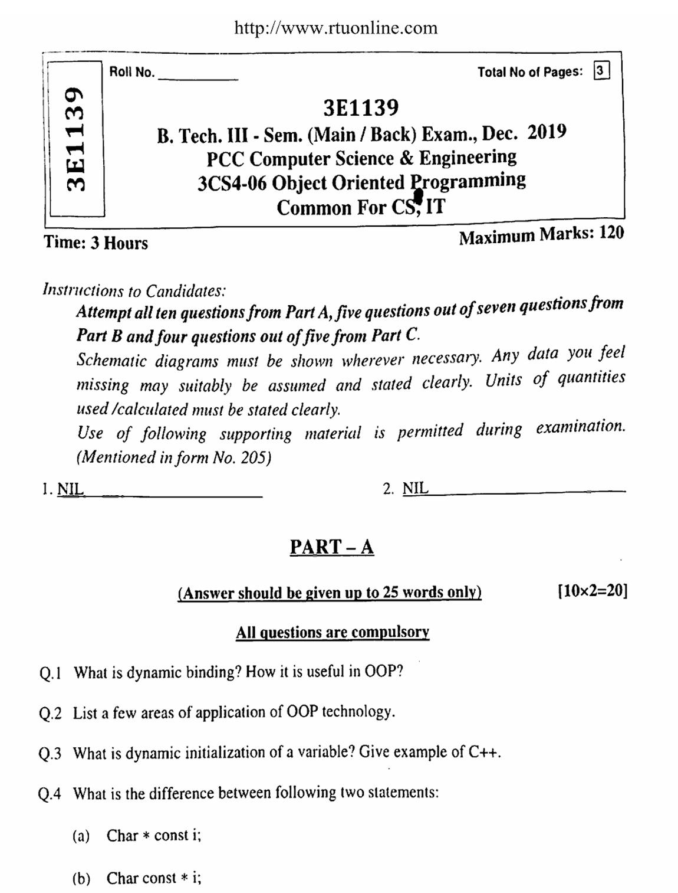

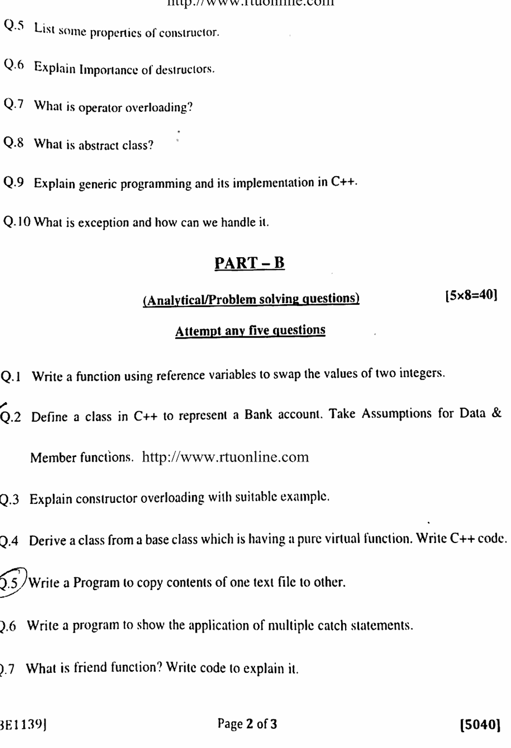

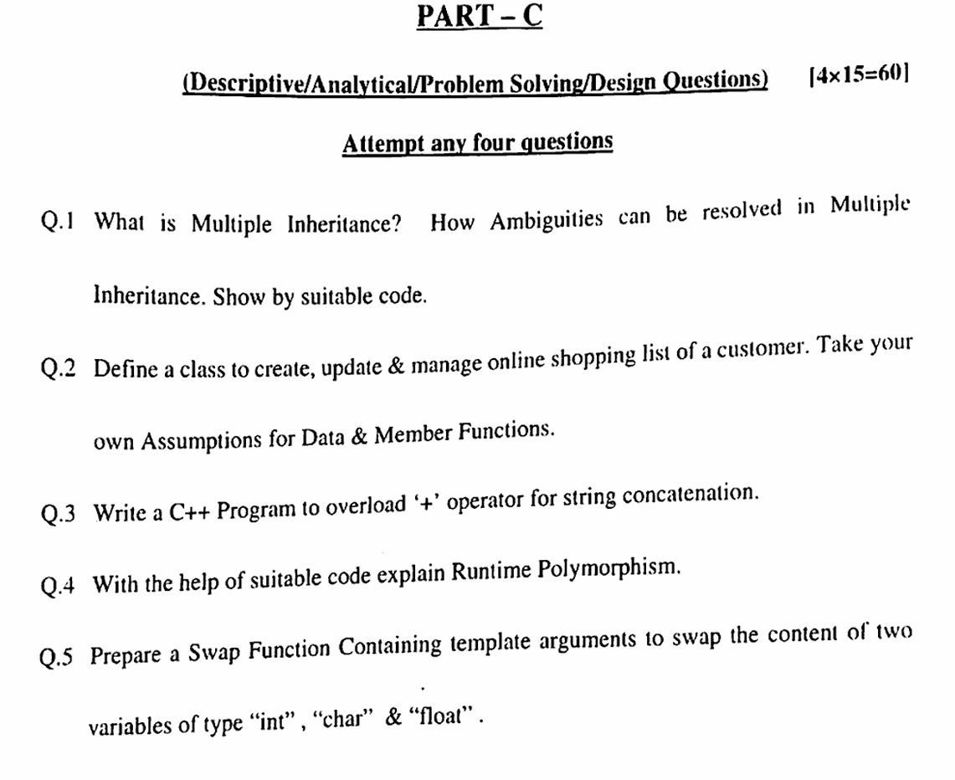

**RESULT ANALYSIS**

|  |  |  |  |  |  |
| --- | --- | --- | --- | --- | --- |
| **S.NO.** | **RTU ROLL NUMBER** | **NAME OF STUDENT** | **END TERM MARKS** | **SESSIONAL MARKS** | **TOTAL** |
| **MAX MARKS** | **70** | **30** | **100** |
| **Set Target Level** | | | **60%** | **75%** |  |
| 1 | 22ETCCS001 | AADARSH SONI | 38 | 27 | 65 |
| 2 | 22ETCCS002 | ABDUL ATTIF | 36 | 25 | 61 |
| 3 | 22ETCCS003 | ABHIJEET GARG | 45 | 27 | 72 |
| 4 | 22ETCCS004 | ADITYA CHHIPA | 38 | 27 | 65 |
| 5 | 22ETCCS005 | ADITYA GIRI GOSWAMI | 42 | 29 | 71 |
| 6 | 22ETCCS006 | ADITYA SHARMA | 39 | 29 | 68 |
| 7 | 22ETCCS007 | AJIT KUMAR | 45 | 24 | 69 |
| 8 | 22ETCCS008 | AKASH SONI | 43 | 30 | 73 |
| 9 | 22ETCCS009 | AKSHAT JANGID | 41 | 27 | 68 |
| 10 | 22ETCCS010 | AKSHAT KUMAR SAINI | 42 | 26 | 68 |
| 11 | 22ETCCS011 | AKSHI BARGURJAR | 37 | 28 | 65 |
| 12 | 22ETCCS012 | AKSHIT NALWAYA | 33 | 25 | 58 |
| 13 | 22ETCCS013 | AKSHITA KUMAWAT | 28 | 26 | 54 |
| 14 | 22ETCCS014 | AKSHITA PANCHAL | 26 | 26 | 52 |
| 15 | 22ETCCS015 | ALI ASGAR ORA WALA | 25 | 25 | 50 |
| 16 | 22ETCCS017 | ANGHA VARANGAONKAR | 38 | 26 | 64 |
| 17 | 22ETCCS018 | ANKIT DHANAWAT | 34 | 25 | 59 |
| 18 | 22ETCCS019 | ANSHIKA JAIN | 39 | 28 | 67 |
| 19 | 22ETCCS020 | ARCHIT JAIN | 18 | 25 | 43 |
| 20 | 22ETCCS021 | ARIN UPADHAYAY | 23 | 22 | 45 |
| 21 | 22ETCCS022 | ARUSH MENARIA | 52 | 29 | 81 |
| 22 | 22ETCCS023 | ARYAN TALWAR | 45 | 28 | 73 |
| 23 | 22ETCCS024 | AVIKA SURANA | 49 | 23 | 72 |
| 24 | 22ETCCS025 | BHAWANA KUMARI | 50 | 30 | 80 |
| 25 | 22ETCCS026 | BHUMI JAIN | 51 | 30 | 81 |
| 26 | 22ETCCS027 | BHUWAN SUTHAR | 40 | 23 | 63 |
| 27 | 22ETCCS028 | CHETAN NAGDA | 46 | 23 | 69 |
| 28 | 22ETCCS029 | CHIRAG SHARMA | 34 | 22 | 56 |
| 29 | 22ETCCS030 | MS. CIA SHARMMA | 42 | 29 | 71 |
| 30 | 22ETCCS031 | DAIVIK SHARMA | 29 | 24 | 53 |
| 31 | 22ETCCS032 | DAKSH JAIN | 36 | 26 | 62 |
| 32 | 22ETCCS033 | DAKSH MENARIA | 30 | 21 | 51 |
| 33 | 22ETCCS034 | DEV PARAKH | 36 | 30 | 66 |
| 34 | 22ETCCS035 | DHANESH JOSHI | 39 | 28 | 67 |
| 35 | 22ETCCS036 | DHEERAJ SINGH THAPA | 27 | 21 | 48 |
| 36 | 22ETCCS037 | DHWANI KHUSHLANI | 52 | 30 | 82 |
| 37 | 22ETCCS038 | DIKSHIT DARJI | 39 | 25 | 64 |
| 38 | 22ETCCS039 | MSDIKSHITA SHARMA | 32 | 29 | 61 |
| 39 | 22ETCCS040 | DIVYA BAGORA | 49 | 28 | 77 |
| 40 | 22ETCCS041 | DIVYANSHU SHARMA | 45 | 23 | 68 |
| 41 | 22ETCCS042 | DIVYASHAKTI PAL | 40 | 29 | 69 |
| 42 | 22ETCCS043 | DIYA JAIN | 39 | 25 | 64 |
| 43 | 22ETCCS044 | DIYA PALIWAL | 35 | 26 | 61 |
| 44 | 22ETCCS045 | FALGUN CHOUDHARY | 52 | 29 | 81 |
| 45 | 22ETCCS046 | GARGI SHARMA | 53 | 28 | 81 |
| 46 | 22ETCCS047 | GARV BAKLIWAL | 54 | 27 | 81 |
| 47 | 22ETCCS048 | GARVIT NANDAWAT | 48 | 21 | 69 |
| 48 | 22ETCCS049 | GAURAV JAIN | 42 | 29 | 71 |
| 49 | 22ETCCS050 | GAURAVI NEGI | 43 | 25 | 68 |
| 50 | 22ETCCS051 | GAURI SUTHAR | 52 | 30 | 82 |
| 51 | 22ETCCS053 | GOURAV POKHARNA | 54 | 27 | 81 |
| 52 | 22ETCCS054 | HARDIK BATWAL | 54 | 30 | 84 |
| 53 | 22ETCCS055 | HARSH DANGI | 35 | 29 | 64 |
| 54 | 22ETCCS056 | HARSH KAWADIA | 41 | 27 | 68 |
| 55 | 22ETCCS057 | HARSH TAMBOLI | 35 | 28 | 63 |
| 56 | 22ETCCS058 | HARSHAL JAIN | 48 | 29 | 77 |
| 57 | 22ETCCS059 | HARSHIT POKHARNA | 35 | 30 | 65 |
| 58 | 22ETCCS060 | HARSHVARDHAN SINGH CHAUHAN | 44 | 26 | 70 |
| 59 | 22ETCCS061 | HARSHVARDHAN SINGH KITAWAT | 41 | 25 | 66 |
| 60 | 22ETCCS062 | HEMANT AHUJA | 51 | 27 | 78 |
| 61 | 22ETCCS064 | HIMANK LOHAR | 47 | 25 | 72 |
| 62 | 22ETCCS065 | HIMANSHI PRAJAPAT | 50 | 29 | 79 |
| 63 | 22ETCCS066 | HIMANSHU KALAL | 35 | 24 | 59 |
| 64 | 22ETCCS067 | HONHAR RAWAL | 22 | 21 | 43 |
| 65 | 22ETCCS068 | HUSAIN BOHRA TIDIWALA | 39 | 24 | 63 |
| 66 | 22ETCCS069 | JAINISH JAIN | 14 | 21 | 35 |
| 67 | 22ETCCS070 | JAYESH JOSHI | 38 | 26 | 64 |
| 68 | 22ETCCS071 | JAYESH MANDAWAT | 35 | 25 | 60 |
| 69 | 22ETCCS072 | JINENDRA SINGH DODIYA | 12 | 21 | 33 |
| 70 | 22ETCCS073 | KANIKA GUPTA | 24 | 25 | 49 |
| 71 | 22ETCCS074 | KANISHK GUPTA | 30 | 28 | 58 |
| 72 | 22ETCCS075 | KAPIL KALAL | 23 | 21 | 44 |
| 73 | 22ETCCS076 | KARAN SWAMI | 37 | 26 | 63 |
| 74 | 22ETCCS077 | KARTIK JAIN | 48 | 30 | 78 |
| 75 | 22ETCCS078 | KARTIK KRISHNA KALE | 30 | 29 | 59 |
| 76 | 22ETCCS079 | KAVYA PALIWAL | 31 | 22 | 53 |
| 77 | 22ETCCS080 | KETAN OJHA | 35 | 24 | 59 |
| 78 | 22ETCCS081 | KHUSH JAIN | 44 | 30 | 74 |
| 79 | 22ETCCS082 | KHUSHI SHARMA | 40 | 28 | 68 |
| 80 | 22ETCCS083 | KIRTAN TAMBOLI | 37 | 29 | 66 |
| 81 | 22ETCCS085 | KONPAL SHARMA | 32 | 27 | 59 |
| 82 | 22ETCCS086 | KRITI PATWA | 41 | 30 | 71 |
| 83 | 22ETCCS087 | KUSH PARSAI | 30 | 28 | 58 |
| 84 | 22ETCCS088 | KUSHAL MEENA | 25 | 22 | 47 |
| 85 | 22ETCCS089 | LAKSHIT PALIWAL | 36 | 27 | 63 |
| 86 | 22ETCCS090 | LAKSHY JAIN | 30 | 23 | 53 |
| 87 | 22ETCCS091 | LAKSHYARAJ CHOUDHARY | 34 | 25 | 59 |
| 88 | 22ETCCS092 | LAL SINGH JHALA | 42 | 24 | 66 |
| 89 | 22ETCCS093 | LUCKY LOHAR | 29 | 24 | 53 |
| 90 | 22ETCCS094 | MAHATV BHATNAGAR | 36 | 23 | 59 |
| 91 | 22ETCCS095 | MAHENDRA SINGH SISODIYA | 34 | 26 | 60 |
| 92 | 22ETCCS096 | MSMAHIMA CHOUHAN | 37 | 29 | 66 |
| 93 | 22ETCCS097 | MAHIPAL SINGH JHALA | 35 | 28 | 63 |
| 94 | 22ETCCS098 | MAHIRAJ SINGH SANKHLA | 30 | 24 | 54 |
| 95 | 22ETCCS099 | MANAS PARWANI | 31 | 28 | 59 |
| 96 | 22ETCCS100 | MANASVI SHARMA | 35 | 28 | 63 |
| 97 | 22ETCCS101 | MANASWINI SHARMA | 41 | 25 | 66 |
| 98 | 22ETCCS102 | MANSI DUBE | 53 | 30 | 83 |
| 99 | 22ETCCS103 | MAYANK KASERA | 40 | 24 | 64 |
| 100 | 22ETCCS104 | MAYANK TRIVEDI | 31 | 22 | 53 |
| 101 | 22ETCCS105 | MEDHAVI KAUSHIK | 33 | 27 | 60 |
| 102 | 22ETCCS106 | MEETRAJ SINGH | 36 | 24 | 60 |
| 103 | 22ETCCS107 | MITALI PALIWAL | 39 | 26 | 65 |
| 104 | 22ETCCS108 | MITVESH AMETA | 35 | 21 | 56 |
| 105 | 22ETCCS109 | MOHAMMED YASAR | 15 | 21 | 36 |
| 106 | 22ETCCS110 | MOHIT KALAL | 17 | 22 | 39 |
| 107 | 22ETCCS111 | MOHIT KUMAWAT | 33 | 24 | 57 |
| 108 | 22ETCCS112 | MONIL SETH | 41 | 29 | 70 |
| 109 | 22ETCCS113 | NAKUL PANDYA | 32 | 23 | 55 |
| 110 | 22ETCCS114 | NEERAJ DANGI | 29 | 22 | 51 |
| 111 | 22ETCCS115 | NIKHIL RAJ MALI | 38 | 25 | 63 |
| 112 | 22ETCCS116 | NIMISHKA CHAUHAN | 18 | 24 | 42 |
| 113 | 22ETCCS117 | NISHANT MENARIA | 42 | 29 | 71 |
| 114 | 22ETCCS118 | MSPALAK KUMAWAT | 34 | 29 | 63 |
| 115 | 22ETCCS119 | PARSHVI HARKAWAT | 47 | 29 | 76 |
| 116 | 22ETCCS120 | PRAGYA BUJ | 36 | 26 | 62 |
| 117 | 22ETCCS121 | PRATIBHA SINGH | 37 | 30 | 67 |
| 118 | 22ETCCS122 | PRINCE DANGI | 28 | 22 | 50 |
| 119 | 22ETCCS123 | PRIYANSH JAIN | 42 | 28 | 70 |
| 120 | 22ETCCS124 | PURVAM CHATURVEDI | 25 | 22 | 47 |
| 121 | 22ETCCS125 | PUSHKAR GAMETI | 38 | 25 | 63 |
| 122 | 22ETCCS126 | PUSHPENDRA MENARIA | 39 | 30 | 69 |
| 123 | 22ETCCS127 | QAIDJOHAR JUKKER | 40 | 30 | 70 |
| 124 | 22ETCCS128 | RAGHAVENDRA BAHETI | 31 | 26 | 57 |
| 125 | 22ETCCS129 | RAJ LAXKAR | 35 | 25 | 60 |
| 126 | 22ETCCS130 | RAJ SHRIMALI | 21 | 26 | 47 |
| 127 | 22ETCCS131 | RAM MUNDRA | 24 | 23 | 47 |
| 128 | 22ETCCS132 | RAMMITH K R | 16 | 23 | 39 |
| 129 | 22ETCCS133 | RANITH BISWAS | 11 | 21 | 32 |
| 130 | 22ETCCS134 | RANJIT SINGH SHAKTAWAT | 24 | 29 | 53 |
| 131 | 22ETCCS135 | MSRAUNAK TAK | 58 | 30 | 88 |
| 132 | 22ETCCS136 | RAVI JOSHI | 41 | 22 | 63 |
| 133 | 22ETCCS137 | RAVI MENARIYA | 51 | 30 | 81 |
| 134 | 22ETCCS138 | RITIK SHARMA | 46 | 28 | 74 |
| 135 | 22ETCCS139 | RITISHA SEN | 50 | 26 | 76 |
| 136 | 22ETCCS140 | ROHIT AGARWAL | 25 | 29 | 54 |
| 137 | 22ETCCS141 | ROSHAN SHARMA | 25 | 30 | 55 |
| 138 | 22ETCCS142 | ROSHNI MENARIA | 15 | 23 | 38 |
| 139 | 22ETCCS143 | RUDRA PUROHIT | 23 | 22 | 45 |
| 140 | 22ETCCS144 | RUDRAVEER SINGH PANWAR | 30 | 28 | 58 |
| 141 | 22ETCCS145 | SHAAN SANADHYA | 35 | 24 | 59 |
| 142 | 22ETCCS146 | SHACHI JAIN | 42 | 25 | 67 |
| 143 | 22ETCCS147 | SHAURYA KUNDAR | 51 | 24 | 75 |
| 144 | 22ETCCS148 | SHOURYA BORDIA | 10 | 21 | 31 |
| 145 | 22ETCCS149 | SHUBHAM YADAV | 29 | 23 | 52 |
| 146 | 22ETCCS150 | SIDDHARTH KUMAR SINGH | 50 | 21 | 71 |
| 147 | 22ETCCS151 | SIDDHARTH MENARIA | 38 | 26 | 64 |
| 148 | 22ETCCS152 | SRAJAN MENARIA | 21 | 21 | 42 |
| 149 | 22ETCCS154 | SUMIT DANGI | 25 | 27 | 52 |
| 150 | 22ETCCS155 | SURBHI TAILOR | 23 | 24 | 47 |
| 151 | 22ETCCS156 | SURYANSH MADHUKAR | 19 | 25 | 44 |
| 152 | 22ETCCS157 | TALENT JAIN | 21 | 26 | 47 |
| 153 | 22ETCCS158 | TANISHK VYAS | 22 | 27 | 49 |
| 154 | 22ETCCS159 | TANVI SHARMA | 33 | 27 | 60 |
| 155 | 22ETCCS160 | TOHEED AKHTAR | 44 | 29 | 73 |
| 156 | 22ETCCS161 | TUSHAR PRAJAPAT | 14 | 25 | 39 |
| 157 | 22ETCCS162 | TUSHAR SINGH RAWAT | 38 | 22 | 60 |
| 158 | 22ETCCS163 | UJJWAL SINGH CHOUHAN | 33 | 26 | 59 |
| 159 | 22ETCCS164 | USHIT SHARMA | 35 | 24 | 59 |
| 160 | 22ETCCS165 | UTKARSH BAJPAI | 43 | 26 | 69 |
| 161 | 22ETCCS166 | VAIBHAV GOYAL | 55 | 29 | 84 |
| 162 | 22ETCCS167 | VANSH BHATNAGAR | 49 | 28 | 77 |
| 163 | 22ETCCS168 | VINAY VADERA | 38 | 23 | 61 |
| 164 | 22ETCCS169 | VINITA MENARIA | 44 | 29 | 73 |
| 165 | 22ETCCS170 | VISHAL MENARIYA | 42 | 29 | 71 |
| 166 | 22ETCCS171 | VISHAL SINGH RAO | 22 | 25 | 47 |
| 167 | 22ETCCS172 | VIVEK SHARMA | 58 | 30 | 88 |
| 168 | 22ETCCS173 | VIVEK SHRIMALI | 43 | 25 | 68 |
| 169 | 22ETCCS174 | YANA OZHA | 58 | 29 | 87 |
| 170 | 22ETCCS175 | YASH VAGHELA | 29 | 26 | 55 |
| 171 | 22ETCCS300 | KEVALI ASHOK KANAGALE | 54 | 30 | 84 |
| 172 | 22ETCCS301 | KARAN SUTHAR | 20 | 21 | 41 |
| 173 | 22ETCCS302 | VINEET SHARMA | 16 | 26 | 42 |
| 174 | 23ETCCS200 | GOPAL PALIWAL | 24 | 24 | 48 |
| 175 | 23ETCCS201 | MANISH VYAS | 20 | 21 | 41 |
| 176 | 23ETCCS202 | RAHUL RAJPUROHIT | 38 | 25 | 63 |
| 177 | 23ETCCS203 | VAISHALI H PUROHIT | 32 | 25 | 57 |
| 178 | 23ETCCS204 | YASH SINGHATWADIA | 29 | 22 | 51 |
|  |  |  | 178 | 178 |  |

|  |  |  |  |  |
| --- | --- | --- | --- | --- |
| TOTAL | PASS | FAIL | ABSENT | PASS % |
| 178 | 174 | 04 | Nil | 97.75 |

**Indirect Assessment:**

**Overall Teacher Self-Assessment (after course) in terms of course objective and outcomes**

**Course Objectives:**

* **To understand the Fundamental Object-Oriented Programming Concepts:**
* **To learn about** the core principles of OOP, including classes, objects, inheritance, polymorphism, encapsulation, and abstraction in OOP.
* **To implement Object-Oriented Programming Components (**Develop and utilize OOP components such as classes, methods, and objects. Employ OOP tools like Integrated Development Environments (IDEs) and version control systems).
* **To Apply Object-Oriented Programming Principles to Practical Projects: (** Apply OOP principles in real-world projects, demonstrating the ability to design, develop, and maintain object-oriented software systems.)

**Course Outcomes**:

* Students can explain the theory and principles of Object Oriented Programming.
* **Students can perform requirements analysis and system design for a given object-oriented program and small project.**
* **Students can implement basic object-oriented applications that follow industry standards.**
* **Students can apply their knowledge to complete a comprehensive object-oriented programming.**

**Methodology to identify bright student**

Considered a range of criteria, including academic performance, creativity, critical thinking, problem-solving skills, and enthusiasm for learning. Bright students often excel in multiple areas. Observed how students perform in the classroom. In terms of active participation, engagement in discussions, leadership, and the ability to grasp complex concepts.

**Efforts to keep students engaged**

* + - 1. **Incorporate Active Learning Strategies:**
* Implement group discussions, collaborative problem-solving activities, and hands-on OOP projects.
* Encourage students to actively participate in coding sessions, debugging exercises, and real-world OOP concepts and development tasks.
  + - 1. **Use Varied Teaching Methods:**
* Combine traditional lectures with group work, pair programming, and peer reviews focused on OOP.
* Include multimedia presentations demonstrating OOP concepts, different processes, tools, and methodologies.
  + - 1. **Technology Integration:**
* Utilize online platforms for code repositories, version control, and collaborative development (e.g., GitHub, GitLab) to support OOP projects.

**Methodology to identify weak student**

Consider a range of criteria to identify students who may need additional support in software engineering:

* **Classroom Observation**: Monitor student engagement and participation during lectures, labs, and group activities.
* **Formative Assessment**: Use quizzes, in-class exercises, and informal checks to gauge understanding of software engineering concepts.
* **Summative Assessment**: Evaluate performance on exams, major projects, and final presentations to identify areas of weakness.
* **Assignment Review**: Analyze the quality of submitted assignments and code to pinpoint specific learning gaps.

**Targeted inventions for weak student**

• **Additional Resources**:

* Provide supplementary learning materials, such as textbooks, online resources, or multimedia content, to offer alternative explanations and reinforce key concepts.

Examples:

* Coursera OOP course
* NSDC , Programming through Object Oriented Concept

• **Remedial Classes**:

* Establish a tutoring program where students can receive extra help from teachers or advanced peers.
* Conduct extra lab sessions focusing on hands-on coding practice, debugging, and understanding complex concepts.

• **Flipped Classroom**:

* Assign pre-class learning materials, often in the form of videos, readings, or online modules, to cover foundational concepts before coming to class.
* Use class time for interactive discussions, practical exercises, and addressing specific student questions.

S

**BOOKS for OOP:**

**"Object Oriented Programming with C++" by E. Balagurusamy**

* This book provides a comprehensive introduction to OOP using C++. It covers fundamental concepts such as classes, objects, inheritance, polymorphism, and templates, with numerous examples and exercises to reinforce learning.

**"Design Patterns: Elements of Reusable Object-Oriented Software" by Erich Gamma, Richard Helm, Ralph Johnson, and John Vlissides (Gang of Four)**

* This classic book provides a comprehensive introduction to design patterns in OOP and is essential for understanding how to create reusable and maintainable object-oriented software.

**Head First Design Patterns" by Eric Freeman, Bert Bates, Kathy Sierra, and Elisabeth Robson**

* Known for its engaging and accessible style, this book simplifies complex design patterns and is ideal for beginners and intermediate programmers who want a practical understanding of OOP concepts​ .