**Course File**

***Subject Title/Subject Code : Software Engineering/3CS4-07***

Semester : III Year : II (Batch 2023-24)

|  |  |  |
| --- | --- | --- |
| Name of the Faculty: Ms. Deepti Gour |  | |
|  |  | |
| E-mail id: deepti.gour@technonjr.org |  |

**Class Schedule**

**Total Number of Lectures:** 42

i**)Course Objective**

Typically aims to equip students with the knowledge, skills, and mindset necessary to effectively design, develop, and maintain high-quality software systems.

**INDEX - COURSE FILE**

|  |  |  |  |
| --- | --- | --- | --- |
| **S. No.** | **CONTENT / ITEM NO.** | **PAGE NO.** | **Status** |
| 1 | Vision And Mission Of The Institute |  |  |
| 2 | Vision And Mission Of The Department |  |  |
| 3 | Program Educational Objective Of Department (PEO’s) |  |  |
| 4 | Program Outcomes Of Department (PO’s) |  |  |
| 5 | Course Outcome (COs) |  |  |
| 6 | COs mapping with Pos and PSOs |  |  |
| 7 | Academic Calendar |  |  |
| 8 | Evaluation Scheme |  |  |
| 9 | Course Syllabus |  |  |
| 10 | Prescribed Books |  |  |
| 11 | Copy Of Time Table |  |  |
| 12 | Course Schedule Plan |  |  |
| 13 | Assignment Sheet (Unit Wise) |  |  |
| 14 | Quiz Questions (One From Each Unit) |  |  |
| 15 | Question Papers Of Mid Term Exam-I |  |  |
| 16 | Marks and Gap Analysis in Mid Term I |  |  |
| 17 | Remedial Action Taken To Remove the Gaps after mid Term I |  |  |
| 18 | Question Papers Of Mid Term Exam-II |  |  |
| 19 | Gap Analysis in Mid Term II |  |  |
| 20 | Remedial Action Taken To Remove the Gaps after mid Term II |  |  |
| 21 | Model Question Paper With Key Solution |  |  |
| 22 | University Question Paper (Last one year) |  |  |
| 23 | Student Performance Report |  |  |
| 24 | Result Analysis |  |  |

**VISSION & MISSION OF INSTITUTE**

## Vision

Empowering student with recent and emerging technologies to create innovative technical leaders capable of contributing to industrial and societal needs for betterment of mankind across the globe.

## Mission

**M1**: To provide dynamic learning environment to students by providing constant exposure to latest technologies by linking closely with the industries.

**M2**: To establish effective interface with industry to obtain live problems to enhance critical thinking and problem solving skills among students and consultancy projects for faculty.

**M3**: To provide avenues and opportunities to faculty for domain specific trainings and qualification upgradation.

**M4**: To develop ethical leaders with strong communication skills.

**VISION & MISSION OF DEPARTMENT**

**Department Vision**

**To be among top five well known department of Computer Science and Engineering in the state of Rajasthan in placing the students at premier industry.**

**Department Mission**

**M1: To equip students with ability to be innovative and excellence to face the challenges in the digital world.**

**M2: To prepare students with high quality employability skills catering to current trends in industries, problem solving skills, innovative pursuits and ready to face challenges in the domain and allied disciplines.**

**M3: To provide ambience for entrepreneurship and start-ups through incubation center among students.**

**M4: To encourage continuous faculty training on industry-based Development, and Innovation.**

**PROGRAMME EDUCATIONAL OBJECTIVES (PEOs)**

**Technical Proficiency** Graduates will have a strong foundation in core concepts, tools, and technologies relevant to their discipline.

**Career Development** Graduate will be capable of pursuing diverse career paths in field of Computer Science & Engineering with proficiency in software development/ pursue higher education an or become entrepreneurs.

**Problem-Solving** Graduates will have a strong math foundation so that they will be proficient problem solvers, capable of identifying, analyzing , and solving complex technical problems using critical thinking and creative approaches.

**Professional Attitude** Graduates will be sensitive to societal and professional environment, possess strong communication skills and will be skilled in working collaboratively within diverse teams adhering to ethical standards and professional practices.

**Learning Environment** To create a learning environment that ensures graduates continue learning throughout their careers, effortlessly adopting new technologies to stay innovative in their chosen fields and remain effective contributors in their chosen field.

**PROGRAM SPECIFIC OUTCOMES (PSO's)**

**PSO1**: Students will be able to design, develop, test, debug, deploy, analyze, troubleshoot, maintain, manage, and ensure security during the complete product lifecycle.

**PSO2**: Student will be able to apply software engineering/ information system development skills to solve problems across diverse domains.

**PSO3**: Students will be well-prepared to initiate and oversee innovative startups within their respective sectors.

**PROGRAMME OUTCOMES (POs)**

**A student will develop:**

**PO01. ENGINEERING KNOWLEDGE**: Apply the knowledge of mathematics, science, engineering fundamentals, and an engineering specialization to the solution of complex engineering problems.

**PO02. PROBLEM ANALYSIS:** Identify, formulate, review research literature, and analyze complex engineering problems reaching substantiated conclusions using first principles of mathematics, natural sciences, and engineering sciences

**PO03. DESIGN/ DEVELOPMENT OF SOLUTION:** Design solutions for complex engineering problems and design system components or processes that meet the specified needs with appropriate consideration for the public health and safety, and the cultural, societal, and environmental considerations.

**PO04. CONDUCTION OF INVESTIGATION OF COMPLEX PROBLEMS:** Use research-based knowledge and research methods including design of experiments, analysis and interpretation of data, and synthesis of the information to provide valid conclusions.

**PO05. MODERN TOOL USAGE:** Create, select, and apply appropriate techniques, resources, and modern engineering and IT tools including prediction and modelling to complex engineering activities with and understanding of the limitations.

**PO06. THE ENGINEERING AND SOCIETY:** Apply reasoning informed by the contextual knowledge to assess societal, health, safety, legal and cultural issues and the consequent responsibilities relevant to the professional engineering practice.

**PO07. ENVIRONMENT & SUSTAINABILITY:** Understand the impact of the professional engineering solutions in societal and environmental contexts, and demonstrate the knowledge of, and need for sustainable development.

**PO08. ETHICS:** Apply ethical principles and commit to professional ethics and responsibilities and norms of the engineering practice.

**PO09. INDIVIDUAL AND TEAM WORK:** Function effectively as an individual, and as a member or leader in diverse teams, and in multi disciplinary settings.

**PO10. COMMUNICATION:** Communicate effectively on complex engineering activities with the engineering community and with society at large, such as, being able to comprehend and write effective reports and design documentation, make effective presentations, and give and receive clear instructions.

**PO11. PROJECT MANAGEMENT & FINANCE:** Demonstrate knowledge and understanding of the engineering and management principles and apply these to one’s own work, as a member and leader in a team, to manage projects and in multidisciplinary environments.

**PO12. LIFE-LONG LEARNING:** Recognize the need for, and have the preparation and ability to engage in independent and life-long learning in the broadest context of technological change.

**COURSE OUTCOMES (COs) OF THE SUBJECT**

|  |  |  |
| --- | --- | --- |
| CO No. | Mapping | Statement |
| CO23407.1 | Analyzing | Student will be summarize fundamental concepts in software engineering, SDLC, software requirements specification, formal requirements specification and verification |
| CO23407.2 | Applying | Student will be able to evaluate cost based online of code using Software Project Management. |
| CO23407.3 | Applying | Student will be able to structure various documents such as requirement analysis (SRS) and Structured analysis. |
| CO23407.4 | Analyzing | Student will be able to compare various software models based on software design. |
| CO23407.5 | Analyzing | Student will be summarize fundamental concepts in software engineering, SDLC, software requirements specification, formal requirements specification and verification |

**COS MAPPING WITH POs AND PSOs**

|  |  |  |  |  |  |  |  |  |  |  |  |  |  |  |  |
| --- | --- | --- | --- | --- | --- | --- | --- | --- | --- | --- | --- | --- | --- | --- | --- |
| **Course Outcome** | **PO1** | **PO2** | **PO3** | **PO4** | **PO5** | **PO6** | **PO7** | **PO8** | **PO9** | **PO10** | **PO11** | **PO12** | **PSO1** | **PSO2** | **PSO3** |
| CO23CS407.1 | 2 | 2 | 0 | 2 | 0 | 0 | 0 | 0 | 0 | 0 | 0 | 1 | 3 | 3 | 3 |
| CO23CS407.2 | 2 | 2 | 1 | 2 | 0 | 0 | 0 | 0 | 0 | 0 | 0 | 1 | 3 | 3 | 3 |
| CO23CS407.3 | 2 | 2 | 1 | 2 | 0 | 0 | 0 | 0 | 0 | 0 | 0 | 1 | 2 | 2 | 0 |
| CO23CS407.4 | 2 | 2 | 1 | 2 | 0 | 1 | 0 | 0 | 0 | 0 | 0 | 1 | 3 | 3 | 3 |
| CO23CS407.5 | 2 | 2 | 1 | 2 | 2 | 1 | 0 | 0 | 0 | 0 | 0 | 1 | 3 | 3 | 1 |

**UNIVERSITY ACADEMIC CALENDAR**

Date: 1/08/2023

**Notice: Academic Calendar 2023-2024**

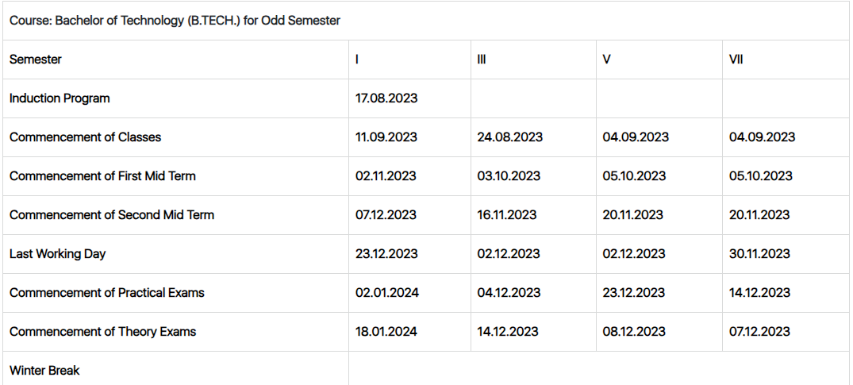

|  |  |  |  |  |
| --- | --- | --- | --- | --- |
| **Academic Calendar Odd Semester 2023-24** | | | | |
| **Particulars** | **B.Tech-I** | **B.Tech- III** | **B.Tech- V** | **B.Tech- VII** |
| Commencement of classes | 11-09-2023 | 24-08-2023 | 04-09-2023 | 04-09-2023 |
| Last Working Day | 23-12-2023 | 02-12-2023 | 02-12-2023 | 30-11-2023 |
| Course Progression Report-I | 25-10-2023 | 27-09-2023 | 27-09-2023 | 27-09-2023 |
| First Mid Term Exam | 02-11-2023 | 03-10-2023 | 05-10-2023 | 05-10-2023 |
| Remedial Class-I | 14-11-2024 | 16-10-2023 | 16-10-2023 | 16-10-2023 |
| Course Progression Report-II | 01-12-2023 | 10-11-2023 | 10-11-2023 | 10-11-2023 |
| Second Mid Term Exam | 07-12-2023 | 16-11-2023 | 20-11-2023 | 20-11-2023 |
| Remedial Class-II | 20-12-2023 | 29-11-2023 | 29-11-2023 | 29-11-2023 |
| Commencement of Theory Exam | 18-01-2023 | 14-12-2023 | 08-12-2023 | 07-12-2023 |
| Commencement of Practical Exam | 01-01-2024 | 04-12-2023 | 23-12-2023 | 14-12-2023 |

Academic Calendar for Odd Semester for Session

**Evaluation Scheme**

FACULTY DETAILS:

Name of the Faculty : Pushpendra Singh Chundawat

Designation : Assistant Professor

Department : Computer Science Engineering

1. TARGET

a) Percentage Pass : 100%

b) Percentage I class: 60 %

2. METHOD OF EVALUATION

2.1. Continuous Assessment Examinations (Mid-Term 1, Mid-Term 2)

2.2. Assignments / Seminars

2.3. Mini Projects

2.4. Quiz

2.5. Semester Examination Others___________________________________________________

3. List out any new topic(s) or any innovation you would like to introduce in teaching the subject in this Semester.

1. Take the help of creative tools to stimulate creativity. Include slide presentations, demonstration or forms of visual exercises that will excite the young minds and capture their interest.

Signature of Faculty: **Signature of HOD**

**UNIVERSITY SYLLABUS**

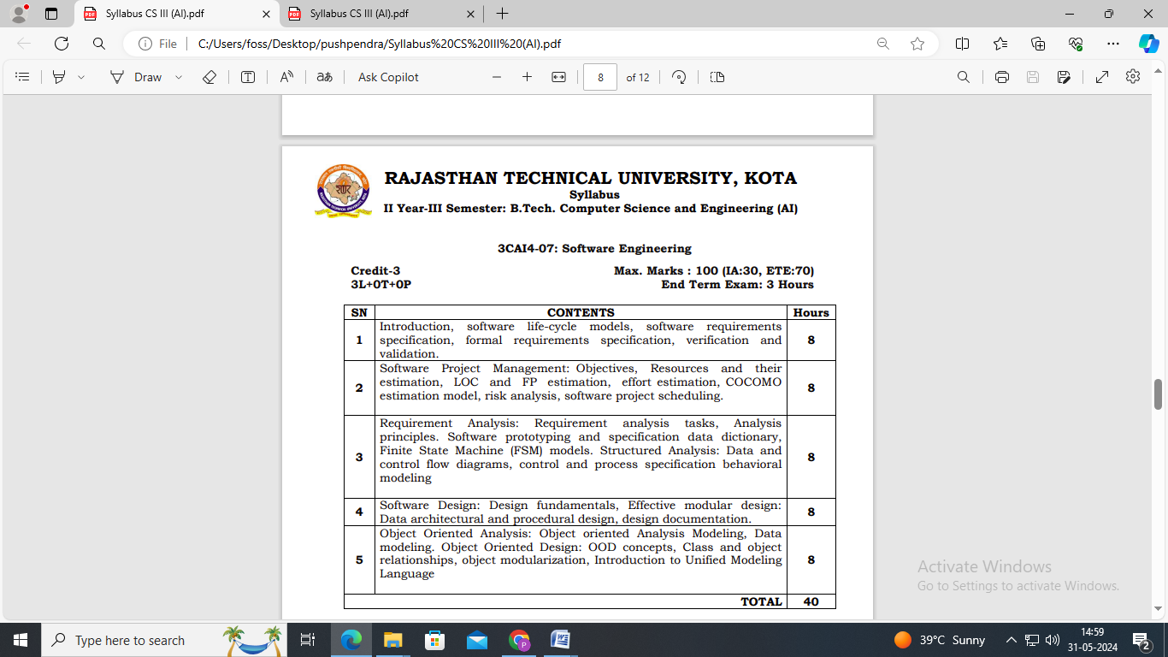

# Learning Resources

## Text Books/Reference Books

1. Software Engineering: A Practitioner's Approach by Roger S. Pressman, Tata McGraw Hills. ISBN: 9339212088
2. Software Engineering by Ian Summerville. ISBN: 9332582699
3. Software Engineering: A Precise Approach by PankajJalote. ISBN: 9788126523115
4. Software Engineering Fundamental By Ali Behforooz, Frederick J Hudson, Oxford University Press. ISBN: 0195681460
5. Software Engineering – 3rd SEM for CS/IT from Genius Publications in India.

## Online References

* ***Slides*** of **Ian Summerville**  
  <https://iansommerville.com/software-engineering-book/slides/>
* ***Notes*** by [www.geeksforgeeks.org](http://www.geeksforgeeks.org)  
  <https://www.geeksforgeeks.org/software-engineering/>
* NPTEL ***Videos***  
  <https://nptel.ac.in/courses/106/105/106105182/>

## Teaching Resources

* Presentations, during classroom discussion, will be available on Google in PDF format
* Various online and offline resources will be shared during course compilation

# Assessment

## Internal

* Online Quiz during course compilation with tools like Kahoot, Google forms etc.
* Assignment Submission through Google Classroom after every Unit of Syllabus.
* Case studies and Problem Scenario discussion after every topic
* Presentation and Report on Final Assignment

## External

* As per Rajasthan Technical University – Kota’s guidelines
* Previous Years Question Papers are available on [www.rtu.ac.in](http://www.rtu.ac.in)or Examination Cell of [www.technonjr.org](http://www.technonjr.org)

**WEEKLY TIME TABLE OF THE TEACHER**

|  |  |  |  |  |  |  |
| --- | --- | --- | --- | --- | --- | --- |
| **TECHNO INDIA NJR INSTITUTE OF TECHNOLOGY** | | | | | | |
| **III Semester (2nd Year)** | | | | | | |
| **Time-Table** | | | | | | |
| **(Section A - Branch CSE )** | | | | | | |
| **Room No:** | | |  |  | **w.e.f.: 25/09/2023** | |
| **Day/Time** | **9:00 – 10:00** | **10:00 – 11:00** | **11:00 – 12:00** | **12:00 – 1:00** | **1:00 – 2:00** | **2:00 – 4:00** |
| **Monday** |  |  |  |  | **LUNCH** |  |
|  |  |  |  |  |
| **Tuesday** |  |  |  |  |  |
|  |  |  |  |  |
| **Wednesday** |  |  |  | **SE** |  |
|  |  |  | **DG** |  |
| **Thursday** |  |  |  | **SE** |  |
|  |  |  | **DG** |  |
| **Friday** |  | **SE** |  |  |  |
|  | **DG** |  |  |  |
| **Saturday** |  | **SE** |  |  |  |
|  | **DG** |  |  |  |
|  |  |  |  |  |  |  |
| **(Section B - Branch CSE )** | | | | | | |
| **Room No:** | | |  |  | **w.e.f.: 25/09/2023** | |
| **Day/Time** | **9:00 – 10:00** | **10:00 – 11:00** | **11:00 – 12:00** | **12:00 – 1:00** | **1:00 – 2:00** | **2:00 – 4:00** |
| **Monday** |  |  | **SE** |  | **LUNCH** |  |
|  |  | **DG** |  |  |
| **Tuesday** |  | **SE** |  |  |  |
|  | **DG** |  |  |  |
| **Wednesday** |  | **SE** |  |  |  |
|  | **DG** |  |  |  |
| **Thursday** | **SE** |  |  |  |  |
| **DG** |  |  |  |  |
| **Friday** |  |  |  |  |  |
|  |  |  |  |  |
| **Saturday** |  |  |  |  |  |
|  |  |  |  |  |
|  |  |  |  |  |  |  |
| **(Section C - Branch CSE )** | | | | | | |
| **Room No:** | | |  |  | **w.e.f.: 25/09/2023** | |
| **Day/Time** | **9:00 – 10:00** | **10:00 – 11:00** | **11:00 – 12:00** | **12:00 – 1:00** | **1:00 – 2:00** | **2:00 – 4:00** |
| **Monday** |  |  |  | **SE** | **LUNCH** |  |
|  |  |  | **DG** |  |
| **Tuesday** |  |  | **SE** |  |  |
|  |  | **DG** |  |  |
| **Wednesday** | **SE** |  |  |  |  |
| **DG** |  |  |  |  |
| **Thursday** |  |  |  |  |  |
|  |  |  |  |  |
| **Friday** |  |  |  |  |  |
|  |  |  |  |  |
| **Saturday** |  |  | **SE** |  |  |
|  |  | **DG** |  |  |

**COURSE-PLAN**

|  |  |  |  |
| --- | --- | --- | --- |
| UNIT | Lect.  No. | TOPICS | **Teaching Methods/ Teaching Aids** |
| **1** | **1** | Introduction of software engineering | White Board, PPT, |
| 1 | 2 | Fundamental of Software life-cycle models, Problems and Solution – Case Analogy | White Board, PPT, Demonstration |
| 1 | 3 | Software life-cycle different models | White Board, PPT , Video |
| 1 | 4 | Software requirements specification | White Board |
| 1 | 5 | Formal requirements specification | White Board, PPT |
| 1 | 6 | Software validation | White Board, Docx Sample |
| 1 | 7 | Software verification | White Board, PPT, Sample Docx |
| 2 | 8 | Software project management objectives | White Board |
| 2 | 9 | Software project management resources and estimation | White Board, PPT, |
| 2 | 10 | LOC and FP estimation | White Board, PPT, Demonstration |
| 2 | 11 | LOC Types – Numerical Problems | White Board |
| 2 | 12 | Effort Estimation – Methods | White Board |
| 2 | 13 | COCOMO estimation model | White Board, PPT |
| 2 | 14 | COCOMO estimation model types – Numerical for each | White Board |
| 2 | 15 | PERT method and Numerical problem | White Board, PPT |
| 3 | 16 | Risk Analysis Model | White Board |
| 3 | 17 | Software project Scheduling | White Board, PPT, |
| 3 | 18 | Software project Scheduling - Patterns | White Board, Demonstration |
| 3 | 19 | Requirement Analysis Tasks | White Board |
| 3 | 20 | Analysis principles & Design Pattern | White Board |
| 3 | 21 | Software prototyping and specification data dictionary | White Board, PPT |
| 3 | 22 | FSM models | White Board |
| 4 | 23 | Data Flow Diagram and Control Flow diagrams | White Board, PPT |
| 4 | 24 | Control specification behavioral modeling | White Board |
| 4 | 25 | Structural Process behavioral modeling | White Board, PPT, |
| 4 | 26 | Software design fundamentals | White Board, PPT, Demonstration |
| 4 | 27 | Effective Modular design | White Board |
| 4 | 28 | Design Modelling and Its types - Data architecture | White Board |
| 5 | 29 | Data architecture and procedural design pattern | White Board, PPT |
| 5 | 30 | Design Documentation | White Board |
| 5 | **31** | Design Documentation Types – 5 types | White Board, PPT |
| 5 | 31 | Object Oriented Analysis Modeling | White Board |
| 5 | 33 | Data Modeling | White Board, PPT, |
| 5 | 34 | OOD Concepts – Class , Object , Function | White Board, PPT, Demonstration |
| 5 | 35 | Class and Object Relationships – ER , Class & Object | White Board |
| 5 | 36 | Object Modularization | White Board |
| 5 | 37 | Introduction of Unified Modeling Language | White Board, PPT |
| 5 | 38 | Unified Modeling Language | White Board |
| Unit 1-3 | 39 | Revision - Case Studies 1: for SDLC -Design Documentation | White Board, PPT |
| Unit 4-5 | 40 | Revision – Case Studies 2: UML Diagram | White Board |
| Complete Course | 41 | Revision of Important topics | Verbalization with LMS & PPT |
| Unit 1-5 | 42 | Problem solving – Q_A Session | Verbalization with LMS & PPT |

**Signature of Faculty: Signature of HOD**

**Assignment – 1 (Software Engineering)**

1. Write an Functional and Non-Functional Requirements for Accounting Software. (CO1)

2. Elaborate on Software requirements specification and Formal requirements specification for Accounting Software and Library Management System. (CO2)

3. Draw ER Diagram , Data Flow Diagram and Context Diagram for Accounting System. (CO3)

4. Explain Object Oriented data model in detail with Class , Object and State Diagram. (CO4)

5. Explain Use Case Diagram and Behavioral Diagram in details. (CO5)

**Assignment – 2 ( Software Engineering)**

1. Mention the Advantages and disadvantages of the incremental process and prototype model. (CO1) 2. What are the different phases of SDLC? (CO2)

3. Explain Object Oriented Modelling concepts in detail. (CO3)

4. Define Structured analysis, Decision Tree and Decision Table and also write their suitable examples. (CO4)

5. Explain the difference between structural and OO analysis with a suitable example. (CO5)

**SAMPLE QUIZ QUESTIONS**

|  |  |
| --- | --- |
| 1. | What are some disadvantages of the classic life cycle model, also known as the Waterfall model? |
| 2. | Differentiate between alpha and beta testing? |
| 3. | Mention the different types of software maintenance. |
| 4. | Differentiate between computer software and a computer program? |
| 5. | What is the full meaning of SDLC? |
| 6. | What is debugging? |
| 7. | What is the Waterfall method? |
| 8. | What is software engineering? |
| 9. | What are the targeted accomplishments of a software engineering model? |
| 10. | What are internal milestones in software engineering? |
| 11. | What are some evolutionary process models? |
| 12. | What is cohesion? |
| 13. | What are the different types of cohesion in software engineering? |
| 14. | What is a COCOMO model? |
| 15. | What is software architecture? |

**Mid Term Paper-I**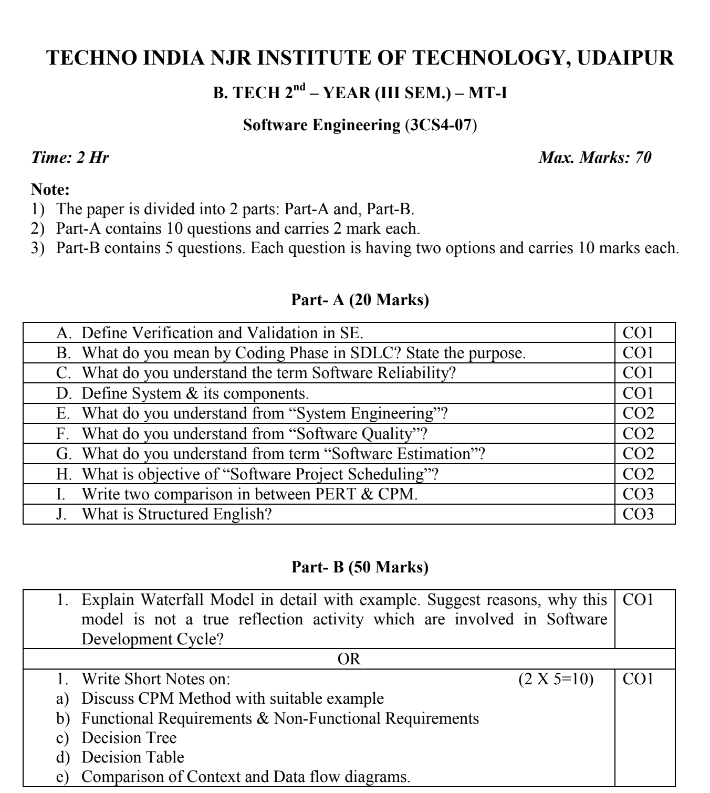

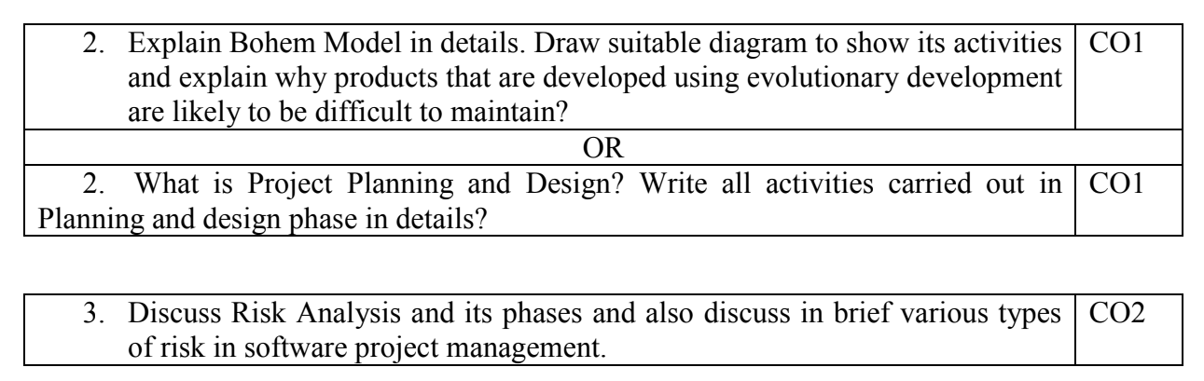

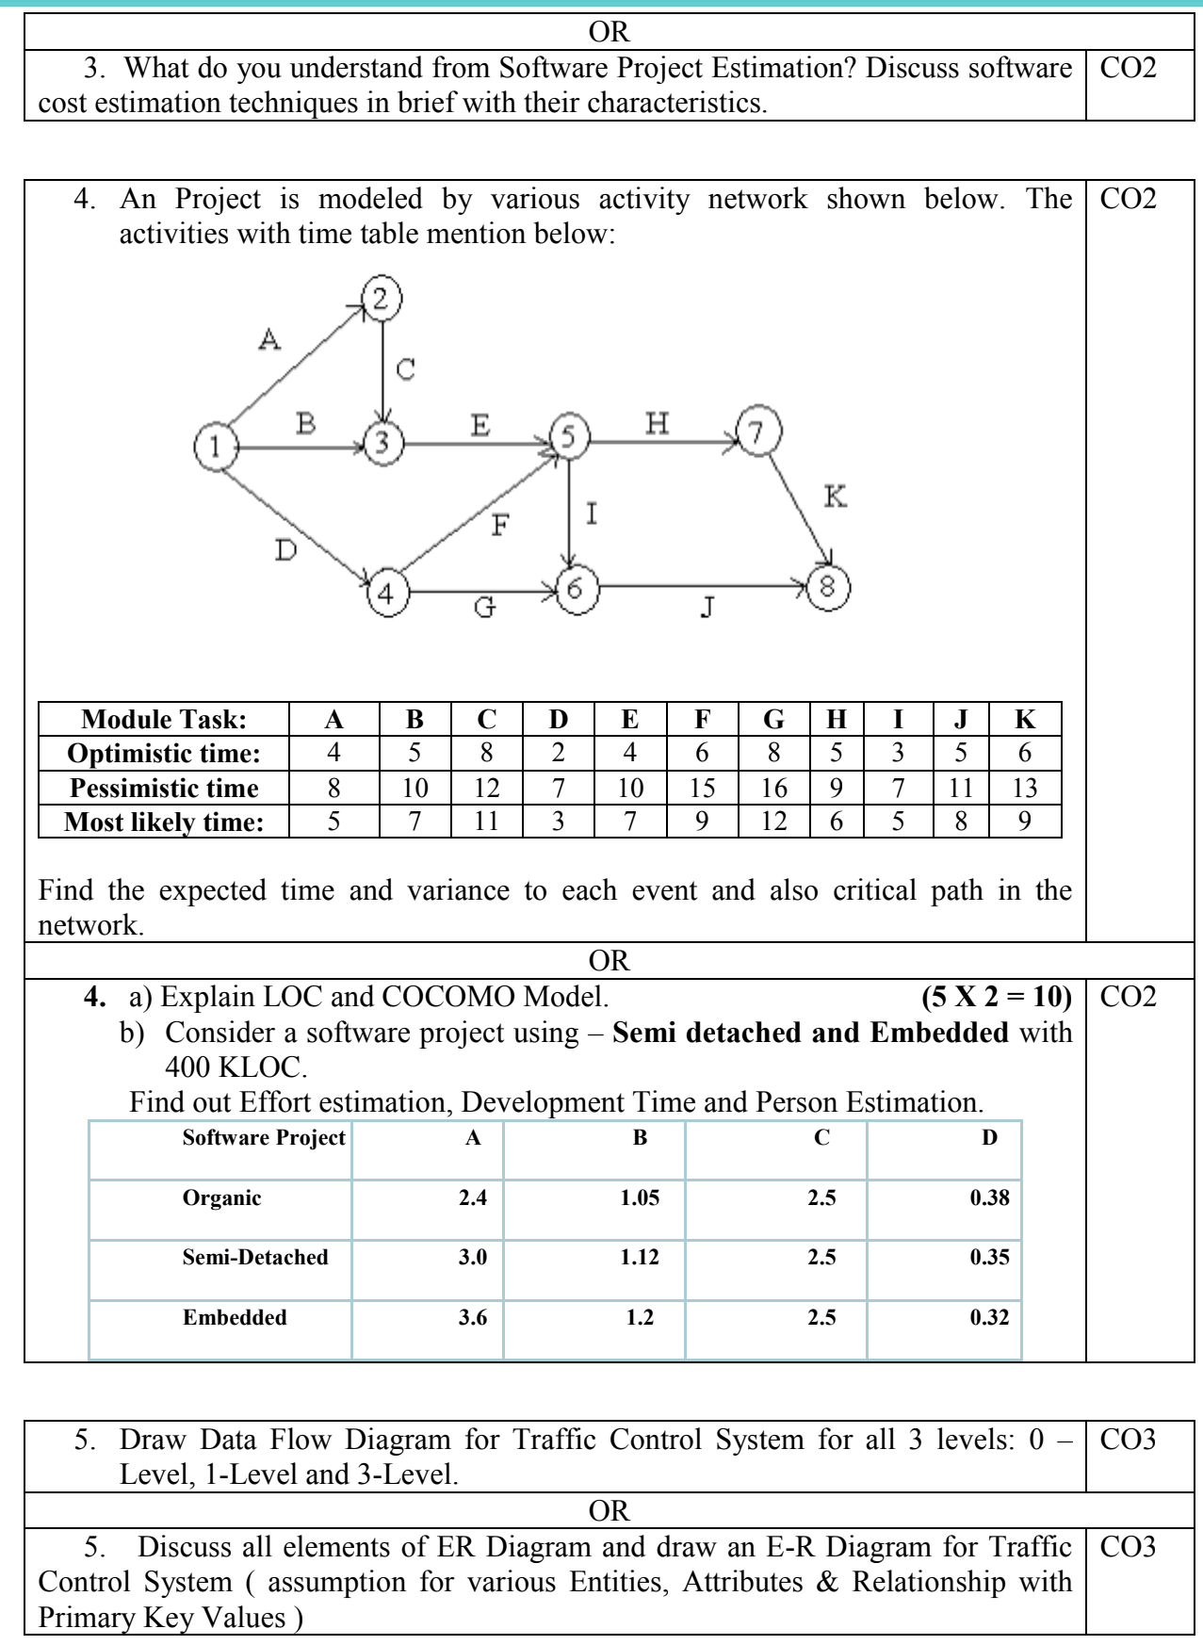

|  |  |  |  |  |
| --- | --- | --- | --- | --- |
| **Marks and Gap Analysis of Mid-Term 1** | | | | |
| Sr. No | RTU Roll Number | Name of the Student | M-1 Marks (70) | Remark ( Remedial Class need or not – Y/N ) |
| 1 | 22ETCCS001 | AADARSH SONI | 65 | N |
| 2 | 22ETCCS002 | ABDUL ATTIF | 67 | N |
| 3 | 22ETCCS003 | ABHIJEET GARG | 67 | N |
| 4 | 22ETCCS004 | ADITYA CHHIPA | 67 | N |
| 5 | 22ETCCS005 | ADITYA GIRI GOSWAMI | 67 | N |
| 6 | 22ETCCS006 | ADITYA SHARMA | 69 | N |
| 7 | 22ETCCS007 | AJIT KUMAR | 59 | N |
| 8 | 22ETCCS008 | AKASH SONI | 67 | N |
| 9 | 22ETCCS009 | AKSHAT JANGID | 69 | N |
| 10 | 22ETCCS010 | AKSHAT KUMAR SAINI | 69 | N |
| 11 | 22ETCCS011 | AKSHI BARGURJAR | 67 | N |
| 12 | 22ETCCS012 | AKSHIT NALWAYA | 58 | N |
| 13 | 22ETCCS013 | AKSHITA KUMAWAT | 59 | N |
| 14 | 22ETCCS014 | AKSHITA PANCHAL | 69 | N |
| 15 | 22ETCCS015 | ALI ASGAR ORA WALA | 49 | N |
| 16 | 22ETCCS017 | ANGHA VARANGAONKAR | 70 | N |
| 17 | 22ETCCS018 | ANKIT DHANAWAT | 60 | N |
| 18 | 22ETCCS019 | ANSHIKA JAIN | 70 | N |
| 19 | 22ETCCS020 | ARCHIT JAIN | 58 | N |
| 20 | 22ETCCS021 | ARIN UPADHAYAY | 58 | N |
| 21 | 22ETCCS022 | ARUSH MENARIA | 70 | N |
| 22 | 22ETCCS023 | ARYAN TALWAR | 65 | N |
| 23 | 22ETCCS024 | AVIKA SURANA | 58 | N |
| 24 | 22ETCCS025 | BHAWANA KUMARI | 69 | N |
| 25 | 22ETCCS026 | BHUMI JAIN | 70 | N |
| 26 | 22ETCCS027 | BHUWAN SUTHAR | 58 | N |
| 27 | 22ETCCS028 | CHETAN NAGDA | 49 | N |
| 28 | 22ETCCS029 | CHIRAG SHARMA | 49 | N |
| 29 | 22ETCCS030 | MS. CIA SHARMMA | 69 | N |
| 30 | 22ETCCS031 | DAIVIK SHARMA | 65 | N |
| 31 | 22ETCCS032 | DAKSH JAIN | 65 | N |
| 32 | 22ETCCS033 | DAKSH MENARIA | 48 | N |
| 33 | 22ETCCS034 | DEV PARAKH | 67 | N |
| 34 | 22ETCCS035 | DHANESH JOSHI | 69 | N |
| 35 | 22ETCCS036 | DHEERAJ SINGH THAPA | 48 | N |
| 36 | 22ETCCS037 | DHWANI KHUSHLANI | 70 | N |
| 37 | 22ETCCS038 | DIKSHIT DARJI | 60 | N |
| 38 | 22ETCCS039 | MSDIKSHITA SHARMA | 59 | N |
| 39 | 22ETCCS040 | DIVYA BAGORA | 67 | N |
| 40 | 22ETCCS041 | DIVYANSHU SHARMA | 58 | N |
| 41 | 22ETCCS042 | DIVYASHAKTI PAL | 67 | N |
| 42 | 22ETCCS043 | DIYA JAIN | 59 | N |
| 43 | 22ETCCS044 | DIYA PALIWAL | 65 | N |
| 44 | 22ETCCS045 | FALGUN CHOUDHARY | 69 | N |
| 45 | 22ETCCS046 | GARGI SHARMA | 67 | N |
| 46 | 22ETCCS047 | GARV BAKLIWAL | 49 | N |
| 47 | 22ETCCS048 | GARVIT NANDAWAT | 48 | N |
| 48 | 22ETCCS049 | GAURAV JAIN | 65 | N |
| 49 | 22ETCCS050 | GAURAVI NEGI | 59 | N |
| 50 | 22ETCCS051 | GAURI SUTHAR | 69 | N |
| 51 | 22ETCCS053 | GOURAV POKHARNA | 49 | N |
| 52 | 22ETCCS054 | HARDIK BATWAL | 70 | N |
| 53 | 22ETCCS055 | HARSH DANGI | 67 | N |
| 54 | 22ETCCS056 | HARSH KAWADIA | 65 | N |
| 55 | 22ETCCS057 | HARSH TAMBOLI | 59 | N |
| 56 | 22ETCCS058 | HARSHAL JAIN | 65 | N |
| 57 | 22ETCCS059 | HARSHIT POKHARNA | 67 | N |
| 58 | 22ETCCS060 | HARSHVARDHAN SINGH CHAUHAN | 49 | N |
| 59 | 22ETCCS061 | HARSHVARDHAN SINGH KITAWAT | 59 | N |
| 60 | 22ETCCS062 | HEMANT AHUJA | 69 | N |
| 61 | 22ETCCS064 | HIMANK LOHAR | 58 | N |
| 62 | 22ETCCS065 | HIMANSHI PRAJAPAT | 70 | N |
| 63 | 22ETCCS066 | HIMANSHU KALAL | 65 | N |
| 64 | 22ETCCS067 | HONHAR RAWAL | 48 | N |
| 65 | 22ETCCS068 | HUSAIN BOHRA TIDIWALA | 59 | N |
| 66 | 22ETCCS069 | JAINISH JAIN | 48 | N |
| 67 | 22ETCCS070 | JAYESH JOSHI | 65 | N |
| 68 | 22ETCCS071 | JAYESH MANDAWAT | 58 | N |
| 69 | 22ETCCS072 | JINENDRA SINGH DODIYA | 60 | N |
| 70 | 22ETCCS073 | KANIKA GUPTA | 59 | N |
| 71 | 22ETCCS074 | KANISHK GUPTA | 65 | N |
| 72 | 22ETCCS075 | KAPIL KALAL | 48 | N |
| 73 | 22ETCCS076 | KARAN SWAMI | 60 | N |
| 74 | 22ETCCS077 | KARTIK JAIN | 69 | N |
| 75 | 22ETCCS078 | KARTIK KRISHNA KALE | 65 | N |
| 76 | 22ETCCS079 | KAVYA PALIWAL | 48 | N |
| 77 | 22ETCCS080 | KETAN OJHA | 67 | N |
| 78 | 22ETCCS081 | KHUSH JAIN | 70 | N |
| 79 | 22ETCCS082 | KHUSHI SHARMA | 69 | N |
| 80 | 22ETCCS083 | KIRTAN TAMBOLI | 67 | N |
| 81 | 22ETCCS085 | KONPAL SHARMA | 67 | N |
| 82 | 22ETCCS086 | KRITI PATWA | 70 | N |
| 83 | 22ETCCS087 | KUSH PARSAI | 59 | N |
| 84 | 22ETCCS088 | KUSHAL MEENA | 49 | N |
| 85 | 22ETCCS089 | LAKSHIT PALIWAL | 67 | N |
| 86 | 22ETCCS090 | LAKSHY JAIN | 48 | N |
| 87 | 22ETCCS091 | LAKSHYARAJ CHOUDHARY | 60 | N |
| 88 | 22ETCCS092 | LAL SINGH JHALA | 53 | N |
| 89 | 22ETCCS093 | LUCKY LOHAR | 60 | N |
| 90 | 22ETCCS094 | MAHATV BHATNAGAR | 65 | N |
| 91 | 22ETCCS095 | MAHENDRA SINGH SISODIYA | 67 | N |
| 92 | 22ETCCS096 | MSMAHIMA CHOUHAN | 70 | N |
| 93 | 22ETCCS097 | MAHIPAL SINGH JHALA | 59 | N |
| 94 | 22ETCCS098 | MAHIRAJ SINGH SANKHLA | 49 | N |
| 95 | 22ETCCS099 | MANAS PARWANI | 60 | N |
| 96 | 22ETCCS100 | MANASVI SHARMA | 65 | N |
| 97 | 22ETCCS101 | MANASWINI SHARMA | 69 | N |
| 98 | 22ETCCS102 | MANSI DUBE | 70 | N |
| 99 | 22ETCCS103 | MAYANK KASERA | 58 | N |
| 100 | 22ETCCS104 | MAYANK TRIVEDI | 49 | N |
| 101 | 22ETCCS105 | MEDHAVI KAUSHIK | 69 | N |
| 102 | 22ETCCS106 | MEETRAJ SINGH | 59 | N |
| 103 | 22ETCCS107 | MITALI PALIWAL | 58 | N |
| 104 | 22ETCCS108 | MITVESH AMETA | 48 | N |
| 105 | 22ETCCS109 | MOHAMMED YASAR | 60 | N |
| 106 | 22ETCCS110 | MOHIT KALAL | 58 | N |
| 107 | 22ETCCS111 | MOHIT KUMAWAT | 58 | N |
| 108 | 22ETCCS112 | MONIL SETH | 70 | N |
| 109 | 22ETCCS113 | NAKUL PANDYA | 60 | N |
| 110 | 22ETCCS114 | NEERAJ DANGI | 58 | N |
| 111 | 22ETCCS115 | NIKHIL RAJ MALI | 48 | N |
| 112 | 22ETCCS116 | NIMISHKA CHAUHAN | 60 | N |
| 113 | 22ETCCS117 | NISHANT MENARIA | 59 | N |
| 114 | 22ETCCS118 | MSPALAK KUMAWAT | 69 | N |
| 115 | 22ETCCS119 | PARSHVI HARKAWAT | 69 | N |
| 116 | 22ETCCS120 | PRAGYA BUJ | 65 | N |
| 117 | 22ETCCS121 | PRATIBHA SINGH | 70 | N |
| 118 | 22ETCCS122 | PRINCE DANGI | 58 | N |
| 119 | 22ETCCS123 | PRIYANSH JAIN | 70 | N |
| 120 | 22ETCCS124 | PURVAM CHATURVEDI | 53 | N |
| 121 | 22ETCCS125 | PUSHKAR GAMETI | 60 | N |
| 122 | 22ETCCS126 | PUSHPENDRA MENARIA | 70 | N |
| 123 | 22ETCCS127 | QAIDJOHAR JUKKER | 65 | N |
| 124 | 22ETCCS128 | RAGHAVENDRA BAHETI | 60 | N |
| 125 | 22ETCCS129 | RAJ LAXKAR | 48 | N |
| 126 | 22ETCCS130 | RAJ SHRIMALI | 53 | N |
| 127 | 22ETCCS131 | RAM MUNDRA | 53 | N |
| 128 | 22ETCCS132 | RAMMITH K R | 59 | N |
| 129 | 22ETCCS133 | RANITH BISWAS | 48 | N |
| 130 | 22ETCCS134 | RANJIT SINGH SHAKTAWAT | 69 | N |
| 131 | 22ETCCS135 | MSRAUNAK TAK | 69 | N |
| 132 | 22ETCCS136 | RAVI JOSHI | 58 | N |
| 133 | 22ETCCS137 | RAVI MENARIYA | 69 | N |
| 134 | 22ETCCS138 | RITIK SHARMA | 65 | N |
| 135 | 22ETCCS139 | RITISHA SEN | 69 | N |
| 136 | 22ETCCS140 | ROHIT AGARWAL | 67 | N |
| 137 | 22ETCCS141 | ROSHAN SHARMA | 58 | N |
| 138 | 22ETCCS142 | ROSHNI MENARIA | 58 | N |
| 139 | 22ETCCS143 | RUDRA PUROHIT | 53 | N |
| 140 | 22ETCCS144 | RUDRAVEER SINGH PANWAR | 67 | N |
| 141 | 22ETCCS145 | SHAAN SANADHYA | 67 | N |
| 142 | 22ETCCS146 | SHACHI JAIN | 58 | N |
| 143 | 22ETCCS147 | SHAURYA KUNDAR | 59 | N |
| 144 | 22ETCCS148 | SHOURYA BORDIA | 60 | N |
| 145 | 22ETCCS149 | SHUBHAM YADAV | 58 | N |
| 146 | 22ETCCS150 | SIDDHARTH KUMAR SINGH | 49 | N |
| 147 | 22ETCCS151 | SIDDHARTH MENARIA | 53 | N |
| 148 | 22ETCCS152 | SRAJAN MENARIA | 58 | N |
| 149 | 22ETCCS154 | SUMIT DANGI | 58 | N |
| 150 | 22ETCCS155 | SURBHI TAILOR | 48 | N |
| 151 | 22ETCCS156 | SURYANSH MADHUKAR | 60 | N |
| 152 | 22ETCCS157 | TALENT JAIN | 48 | N |
| 153 | 22ETCCS158 | TANISHK VYAS | 59 | N |
| 154 | 22ETCCS159 | TANVI SHARMA | 58 | N |
| 155 | 22ETCCS160 | TOHEED AKHTAR | 60 | N |
| 156 | 22ETCCS161 | TUSHAR PRAJAPAT | 53 | N |
| 157 | 22ETCCS162 | TUSHAR SINGH RAWAT | 53 | N |
| 158 | 22ETCCS163 | UJJWAL SINGH CHOUHAN | 53 | N |
| 159 | 22ETCCS164 | USHIT SHARMA | 58 | N |
| 160 | 22ETCCS165 | UTKARSH BAJPAI | 49 | N |
| 161 | 22ETCCS166 | VAIBHAV GOYAL | 69 | N |
| 162 | 22ETCCS167 | VANSH BHATNAGAR | 65 | N |
| 163 | 22ETCCS168 | VINAY VADERA | 58 | N |
| 164 | 22ETCCS169 | VINITA MENARIA | 67 | N |
| 165 | 22ETCCS170 | VISHAL MENARIYA | 70 | N |
| 166 | 22ETCCS171 | VISHAL SINGH RAO | 59 | N |
| 167 | 22ETCCS172 | VIVEK SHARMA | 67 | N |
| 168 | 22ETCCS173 | VIVEK SHRIMALI | 59 | N |
| 169 | 22ETCCS174 | YANA OZHA | 69 | N |
| 170 | 22ETCCS175 | YASH VAGHELA | 58 | N |
| 171 | 22ETCCS300 | KEVALI ASHOK KANAGALE | 70 | N |
| 172 | 22ETCCS301 | KARAN SUTHAR | 48 | N |
| 173 | 22ETCCS302 | VINEET SHARMA | 59 | N |
| 174 | 23ETCCS200 | GOPAL PALIWAL | 60 | N |
| 175 | 23ETCCS201 | MANISH VYAS | 49 | N |
| 176 | 23ETCCS202 | RAHUL RAJPUROHIT | 59 | N |
| 177 | 23ETCCS203 | VAISHALI H PUROHIT | 65 | N |
| 178 | 23ETCCS204 | YASH SINGHATWADIA | 53 | N |

**\***(Y, if obtained marks are <50%)

**Signature of Faculty: Signature of HOD**

**Remedial Action Taken to Remove the Gaps (After Mid- Term 1)**

|  |  |  |  |  |  |
| --- | --- | --- | --- | --- | --- |
| S.no. | University Roll no. | Name of Student | Topics to be discussed in Remedial Class | Schedule Date of Remedial Class | Outcome  Achieved |
|  |  | NIL | SDLC Models  Structured Analysis  Finite State Machine |  | CO1 |
|  |  |  | CO2 |
|  |  |  | CO2 |
|  |  |  | CO3 |
|  |  |  |  |
|  |  |  |  |
|  |  |  |  |
|  |  |  |  |
|  |  |  |  |
|  |  |  |  |

**Signature of Faculty: Signature of HOD**

**Mid Term Exam – II**

|  |  |  |  |  |
| --- | --- | --- | --- | --- |
| Sr. No | RTU Roll Number | Name of the Student | M-1 Marks (70) | Remark ( Remedial Class need or not – Y/N ) |
| 1 | 22ETCCS001 | AADARSH SONI | 61 | N |
| 2 | 22ETCCS002 | ABDUL ATTIF | 63 | N |
| 3 | 22ETCCS003 | ABHIJEET GARG | 63 | N |
| 4 | 22ETCCS004 | ADITYA CHHIPA | 63 | N |
| 5 | 22ETCCS005 | ADITYA GIRI GOSWAMI | 63 | N |
| 6 | 22ETCCS006 | ADITYA SHARMA | 67 | N |
| 7 | 22ETCCS007 | AJIT KUMAR | 63 | N |
| 8 | 22ETCCS008 | AKASH SONI | 63 | N |
| 9 | 22ETCCS009 | AKSHAT JANGID | 67 | N |
| 10 | 22ETCCS010 | AKSHAT KUMAR SAINI | 67 | N |
| 11 | 22ETCCS011 | AKSHI BARGURJAR | 63 | N |
| 12 | 22ETCCS012 | AKSHIT NALWAYA | 54 | N |
| 13 | 22ETCCS013 | AKSHITA KUMAWAT | 63 | N |
| 14 | 22ETCCS014 | AKSHITA PANCHAL | 67 | N |
| 15 | 22ETCCS015 | ALI ASGAR ORA WALA | 53 | N |
| 16 | 22ETCCS017 | ANGHA VARANGAONKAR | 70 | N |
| 17 | 22ETCCS018 | ANKIT DHANAWAT | 56 | N |
| 18 | 22ETCCS019 | ANSHIKA JAIN | 70 | N |
| 19 | 22ETCCS020 | ARCHIT JAIN | 54 | N |
| 20 | 22ETCCS021 | ARIN UPADHAYAY | 54 | N |
| 21 | 22ETCCS022 | ARUSH MENARIA | 70 | N |
| 22 | 22ETCCS023 | ARYAN TALWAR | 61 | N |
| 23 | 22ETCCS024 | AVIKA SURANA | 54 | N |
| 24 | 22ETCCS025 | BHAWANA KUMARI | 67 | N |
| 25 | 22ETCCS026 | BHUMI JAIN | 70 | N |
| 26 | 22ETCCS027 | BHUWAN SUTHAR | 54 | N |
| 27 | 22ETCCS028 | CHETAN NAGDA | 53 | N |
| 28 | 22ETCCS029 | CHIRAG SHARMA | 53 | N |
| 29 | 22ETCCS030 | MS. CIA SHARMMA | 67 | N |
| 30 | 22ETCCS031 | DAIVIK SHARMA | 61 | N |
| 31 | 22ETCCS032 | DAKSH JAIN | 61 | N |
| 32 | 22ETCCS033 | DAKSH MENARIA | 50 | N |
| 33 | 22ETCCS034 | DEV PARAKH | 63 | N |
| 34 | 22ETCCS035 | DHANESH JOSHI | 67 | N |
| 35 | 22ETCCS036 | DHEERAJ SINGH THAPA | 50 | N |
| 36 | 22ETCCS037 | DHWANI KHUSHLANI | 70 | N |
| 37 | 22ETCCS038 | DIKSHIT DARJI | 56 | N |
| 38 | 22ETCCS039 | MSDIKSHITA SHARMA | 63 | N |
| 39 | 22ETCCS040 | DIVYA BAGORA | 63 | N |
| 40 | 22ETCCS041 | DIVYANSHU SHARMA | 54 | N |
| 41 | 22ETCCS042 | DIVYASHAKTI PAL | 63 | N |
| 42 | 22ETCCS043 | DIYA JAIN | 63 | N |
| 43 | 22ETCCS044 | DIYA PALIWAL | 61 | N |
| 44 | 22ETCCS045 | FALGUN CHOUDHARY | 67 | N |
| 45 | 22ETCCS046 | GARGI SHARMA | 63 | N |
| 46 | 22ETCCS047 | GARV BAKLIWAL | 53 | N |
| 47 | 22ETCCS048 | GARVIT NANDAWAT | 50 | N |
| 48 | 22ETCCS049 | GAURAV JAIN | 61 | N |
| 49 | 22ETCCS050 | GAURAVI NEGI | 63 | N |
| 50 | 22ETCCS051 | GAURI SUTHAR | 67 | N |
| 51 | 22ETCCS053 | GOURAV POKHARNA | 53 | N |
| 52 | 22ETCCS054 | HARDIK BATWAL | 70 | N |
| 53 | 22ETCCS055 | HARSH DANGI | 63 | N |
| 54 | 22ETCCS056 | HARSH KAWADIA | 61 | N |
| 55 | 22ETCCS057 | HARSH TAMBOLI | 63 | N |
| 56 | 22ETCCS058 | HARSHAL JAIN | 61 | N |
| 57 | 22ETCCS059 | HARSHIT POKHARNA | 63 | N |
| 58 | 22ETCCS060 | HARSHVARDHAN SINGH CHAUHAN | 53 | N |
| 59 | 22ETCCS061 | HARSHVARDHAN SINGH KITAWAT | 63 | N |
| 60 | 22ETCCS062 | HEMANT AHUJA | 67 | N |
| 61 | 22ETCCS064 | HIMANK LOHAR | 54 | N |
| 62 | 22ETCCS065 | HIMANSHI PRAJAPAT | 70 | N |
| 63 | 22ETCCS066 | HIMANSHU KALAL | 61 | N |
| 64 | 22ETCCS067 | HONHAR RAWAL | 50 | N |
| 65 | 22ETCCS068 | HUSAIN BOHRA TIDIWALA | 63 | N |
| 66 | 22ETCCS069 | JAINISH JAIN | 50 | N |
| 67 | 22ETCCS070 | JAYESH JOSHI | 61 | N |
| 68 | 22ETCCS071 | JAYESH MANDAWAT | 54 | N |
| 69 | 22ETCCS072 | JINENDRA SINGH DODIYA | 56 | N |
| 70 | 22ETCCS073 | KANIKA GUPTA | 63 | N |
| 71 | 22ETCCS074 | KANISHK GUPTA | 61 | N |
| 72 | 22ETCCS075 | KAPIL KALAL | 50 | N |
| 73 | 22ETCCS076 | KARAN SWAMI | 56 | N |
| 74 | 22ETCCS077 | KARTIK JAIN | 67 | N |
| 75 | 22ETCCS078 | KARTIK KRISHNA KALE | 61 | N |
| 76 | 22ETCCS079 | KAVYA PALIWAL | 50 | N |
| 77 | 22ETCCS080 | KETAN OJHA | 63 | N |
| 78 | 22ETCCS081 | KHUSH JAIN | 70 | N |
| 79 | 22ETCCS082 | KHUSHI SHARMA | 67 | N |
| 80 | 22ETCCS083 | KIRTAN TAMBOLI | 63 | N |
| 81 | 22ETCCS085 | KONPAL SHARMA | 63 | N |
| 82 | 22ETCCS086 | KRITI PATWA | 70 | N |
| 83 | 22ETCCS087 | KUSH PARSAI | 63 | N |
| 84 | 22ETCCS088 | KUSHAL MEENA | 53 | N |
| 85 | 22ETCCS089 | LAKSHIT PALIWAL | 63 | N |
| 86 | 22ETCCS090 | LAKSHY JAIN | 70 | N |
| 87 | 22ETCCS091 | LAKSHYARAJ CHOUDHARY | 70 | N |
| 88 | 22ETCCS092 | LAL SINGH JHALA | 55 | N |
| 89 | 22ETCCS093 | LUCKY LOHAR | 56 | N |
| 90 | 22ETCCS094 | MAHATV BHATNAGAR | 61 | N |
| 91 | 22ETCCS095 | MAHENDRA SINGH SISODIYA | 63 | N |
| 92 | 22ETCCS096 | MSMAHIMA CHOUHAN | 70 | N |
| 93 | 22ETCCS097 | MAHIPAL SINGH JHALA | 63 | N |
| 94 | 22ETCCS098 | MAHIRAJ SINGH SANKHLA | 53 | N |
| 95 | 22ETCCS099 | MANAS PARWANI | 56 | N |
| 96 | 22ETCCS100 | MANASVI SHARMA | 61 | N |
| 97 | 22ETCCS101 | MANASWINI SHARMA | 67 | N |
| 98 | 22ETCCS102 | MANSI DUBE | 70 | N |
| 99 | 22ETCCS103 | MAYANK KASERA | 54 | N |
| 100 | 22ETCCS104 | MAYANK TRIVEDI | 53 | N |
| 101 | 22ETCCS105 | MEDHAVI KAUSHIK | 67 | N |
| 102 | 22ETCCS106 | MEETRAJ SINGH | 63 | N |
| 103 | 22ETCCS107 | MITALI PALIWAL | 54 | N |
| 104 | 22ETCCS108 | MITVESH AMETA | 50 | N |
| 105 | 22ETCCS109 | MOHAMMED YASAR | 56 | N |
| 106 | 22ETCCS110 | MOHIT KALAL | 54 | N |
| 107 | 22ETCCS111 | MOHIT KUMAWAT | 54 | N |
| 108 | 22ETCCS112 | MONIL SETH | 70 | N |
| 109 | 22ETCCS113 | NAKUL PANDYA | 56 | N |
| 110 | 22ETCCS114 | NEERAJ DANGI | 54 | N |
| 111 | 22ETCCS115 | NIKHIL RAJ MALI | 50 | N |
| 112 | 22ETCCS116 | NIMISHKA CHAUHAN | 56 | N |
| 113 | 22ETCCS117 | NISHANT MENARIA | 63 | N |
| 114 | 22ETCCS118 | MSPALAK KUMAWAT | 67 | N |
| 115 | 22ETCCS119 | PARSHVI HARKAWAT | 67 | N |
| 116 | 22ETCCS120 | PRAGYA BUJ | 61 | N |
| 117 | 22ETCCS121 | PRATIBHA SINGH | 70 | N |
| 118 | 22ETCCS122 | PRINCE DANGI | 54 | N |
| 119 | 22ETCCS123 | PRIYANSH JAIN | 70 | N |
| 120 | 22ETCCS124 | PURVAM CHATURVEDI | 55 | N |
| 121 | 22ETCCS125 | PUSHKAR GAMETI | 56 | N |
| 122 | 22ETCCS126 | PUSHPENDRA MENARIA | 70 | N |
| 123 | 22ETCCS127 | QAIDJOHAR JUKKER | 61 | N |
| 124 | 22ETCCS128 | RAGHAVENDRA BAHETI | 56 | N |
| 125 | 22ETCCS129 | RAJ LAXKAR | 50 | N |
| 126 | 22ETCCS130 | RAJ SHRIMALI | 55 | N |
| 127 | 22ETCCS131 | RAM MUNDRA | 55 | N |
| 128 | 22ETCCS132 | RAMMITH K R | 63 | N |
| 129 | 22ETCCS133 | RANITH BISWAS | 50 | N |
| 130 | 22ETCCS134 | RANJIT SINGH SHAKTAWAT | 67 | N |
| 131 | 22ETCCS135 | MSRAUNAK TAK | 67 | N |
| 132 | 22ETCCS136 | RAVI JOSHI | 54 | N |
| 133 | 22ETCCS137 | RAVI MENARIYA | 67 | N |
| 134 | 22ETCCS138 | RITIK SHARMA | 61 | N |
| 135 | 22ETCCS139 | RITISHA SEN | 67 | N |
| 136 | 22ETCCS140 | ROHIT AGARWAL | 63 | N |
| 137 | 22ETCCS141 | ROSHAN SHARMA | 54 | N |
| 138 | 22ETCCS142 | ROSHNI MENARIA | 54 | N |
| 139 | 22ETCCS143 | RUDRA PUROHIT | 55 | N |
| 140 | 22ETCCS144 | RUDRAVEER SINGH PANWAR | 63 | N |
| 141 | 22ETCCS145 | SHAAN SANADHYA | 63 | N |
| 142 | 22ETCCS146 | SHACHI JAIN | 54 | N |
| 143 | 22ETCCS147 | SHAURYA KUNDAR | 63 | N |
| 144 | 22ETCCS148 | SHOURYA BORDIA | 56 | N |
| 145 | 22ETCCS149 | SHUBHAM YADAV | 54 | N |
| 146 | 22ETCCS150 | SIDDHARTH KUMAR SINGH | 53 | N |
| 147 | 22ETCCS151 | SIDDHARTH MENARIA | 55 | N |
| 148 | 22ETCCS152 | SRAJAN MENARIA | 54 | N |
| 149 | 22ETCCS154 | SUMIT DANGI | 54 | N |
| 150 | 22ETCCS155 | SURBHI TAILOR | 50 | N |
| 151 | 22ETCCS156 | SURYANSH MADHUKAR | 56 | N |
| 152 | 22ETCCS157 | TALENT JAIN | 50 | N |
| 153 | 22ETCCS158 | TANISHK VYAS | 63 | N |
| 154 | 22ETCCS159 | TANVI SHARMA | 54 | N |
| 155 | 22ETCCS160 | TOHEED AKHTAR | 56 | N |
| 156 | 22ETCCS161 | TUSHAR PRAJAPAT | 55 | N |
| 157 | 22ETCCS162 | TUSHAR SINGH RAWAT | 55 | N |
| 158 | 22ETCCS163 | UJJWAL SINGH CHOUHAN | 55 | N |
| 159 | 22ETCCS164 | USHIT SHARMA | 54 | N |
| 160 | 22ETCCS165 | UTKARSH BAJPAI | 53 | N |
| 161 | 22ETCCS166 | VAIBHAV GOYAL | 67 | N |
| 162 | 22ETCCS167 | VANSH BHATNAGAR | 61 | N |
| 163 | 22ETCCS168 | VINAY VADERA | 54 | N |
| 164 | 22ETCCS169 | VINITA MENARIA | 63 | N |
| 165 | 22ETCCS170 | VISHAL MENARIYA | 70 | N |
| 166 | 22ETCCS171 | VISHAL SINGH RAO | 63 | N |
| 167 | 22ETCCS172 | VIVEK SHARMA | 63 | N |
| 168 | 22ETCCS173 | VIVEK SHRIMALI | 63 | N |
| 169 | 22ETCCS174 | YANA OZHA | 67 | N |
| 170 | 22ETCCS175 | YASH VAGHELA | 54 | N |
| 171 | 22ETCCS300 | KEVALI ASHOK KANAGALE | 70 | N |
| 172 | 22ETCCS301 | KARAN SUTHAR | 50 | N |
| 173 | 22ETCCS302 | VINEET SHARMA | 63 | N |
| 174 | 23ETCCS200 | GOPAL PALIWAL | 56 | N |
| 175 | 23ETCCS201 | MANISH VYAS | 53 | N |
| 176 | 23ETCCS202 | RAHUL RAJPUROHIT | 63 | N |
| 177 | 23ETCCS203 | VAISHALI H PUROHIT | 61 | N |
| 178 | 23ETCCS204 | YASH SINGHATWADIA | 55 | N |

**\***(Y, if obtained marks are <50%)

**Signature of Faculty: Signature of HOD**

**Remedial Action Taken to Remove the Gaps (After Mid- Term 2 )**

|  |  |  |  |  |  |
| --- | --- | --- | --- | --- | --- |
| Sr. No. | University Roll no. | Name of Student | Topics to be discussed in Remedial Class | Schedule Date of Remedial Class | Course Outcome |
| 1 |  | NIL | Finite State Machine |  | CO3 |
| 2 |  |  | Software Modularity, Cohesion & Coupling, & Architectural Diagram |  | CO4 |
| 3 |  |  | UML -Its Diagram Types |  | CO5 |
| 4 |  |  |  |  |  |
| 5 |  |  |  |  |  |

**Signature of Faculty: Signature of HOD**

**Model Question Paper**

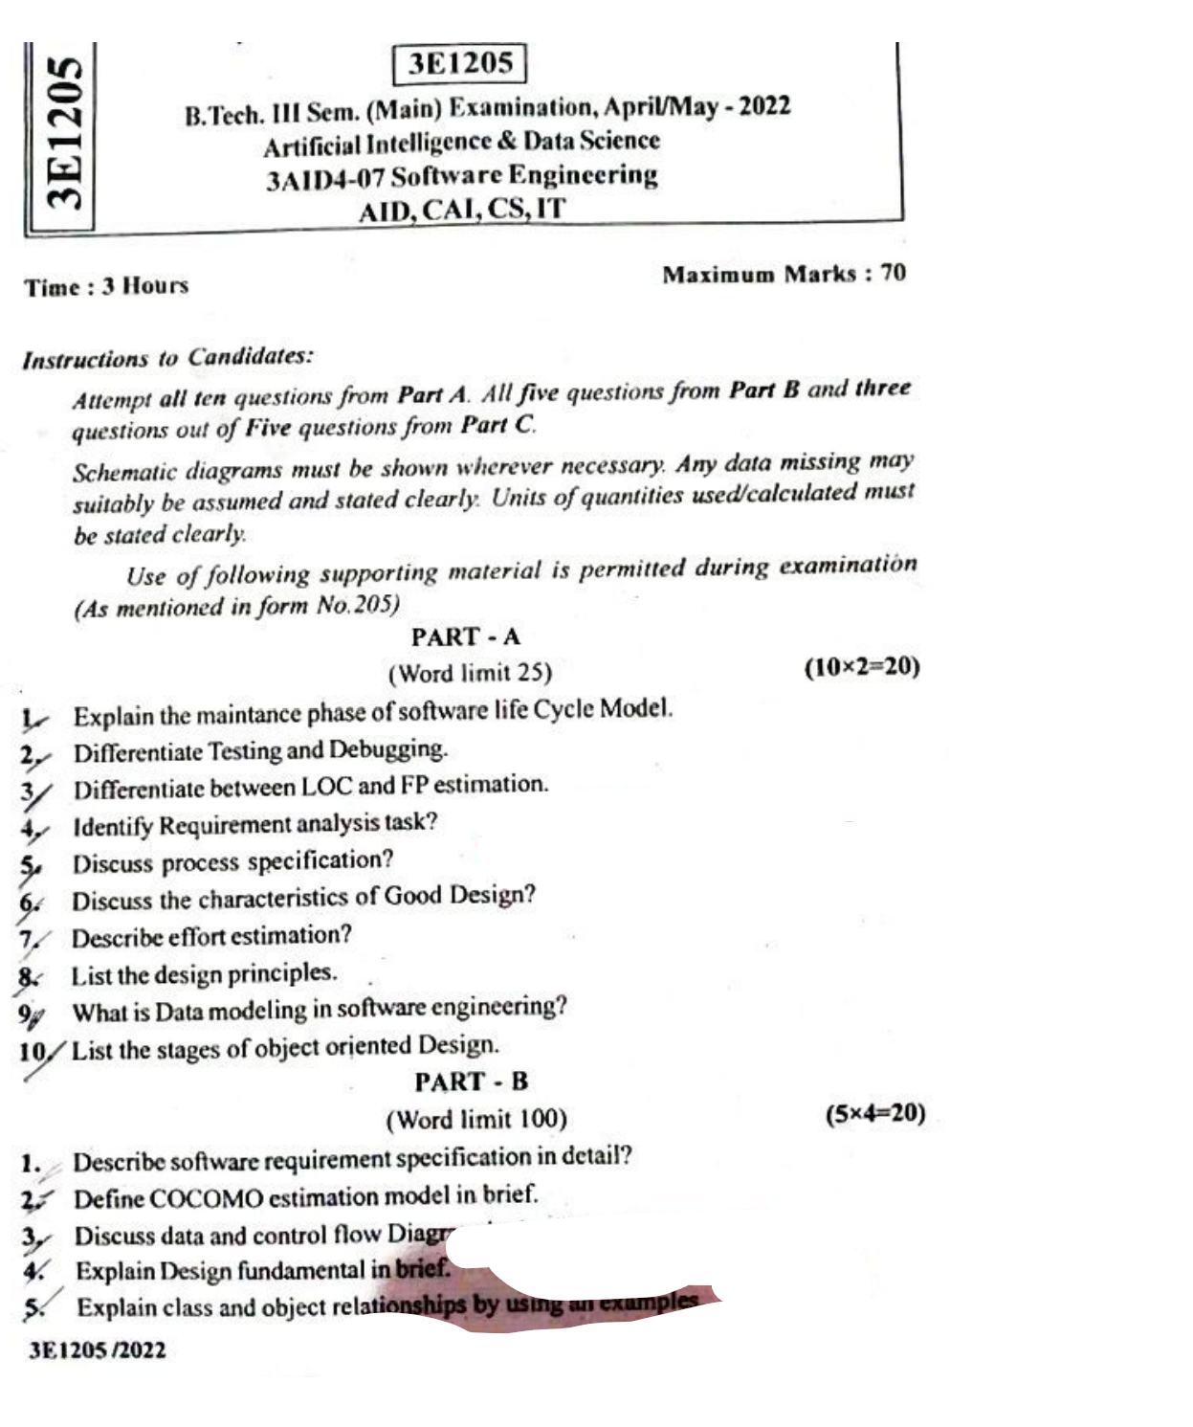

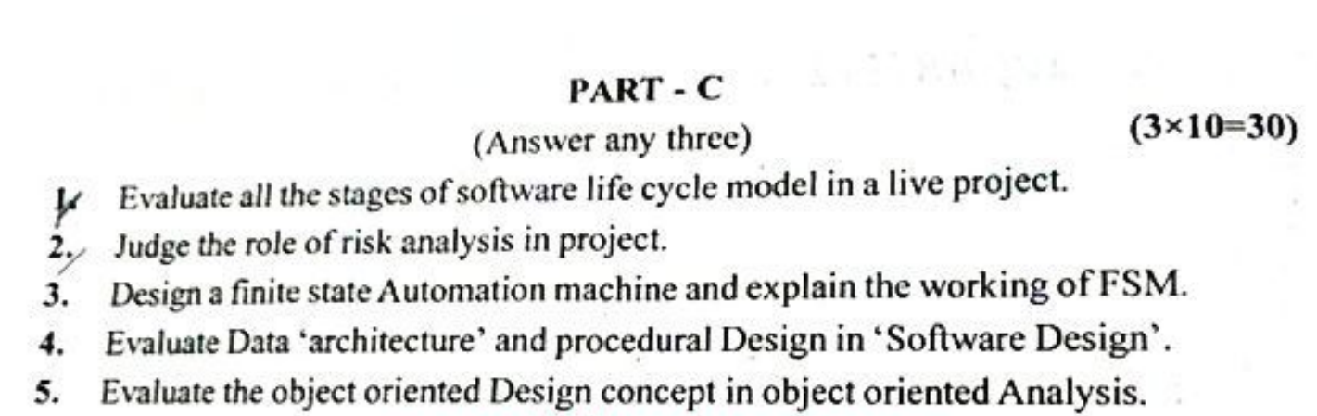

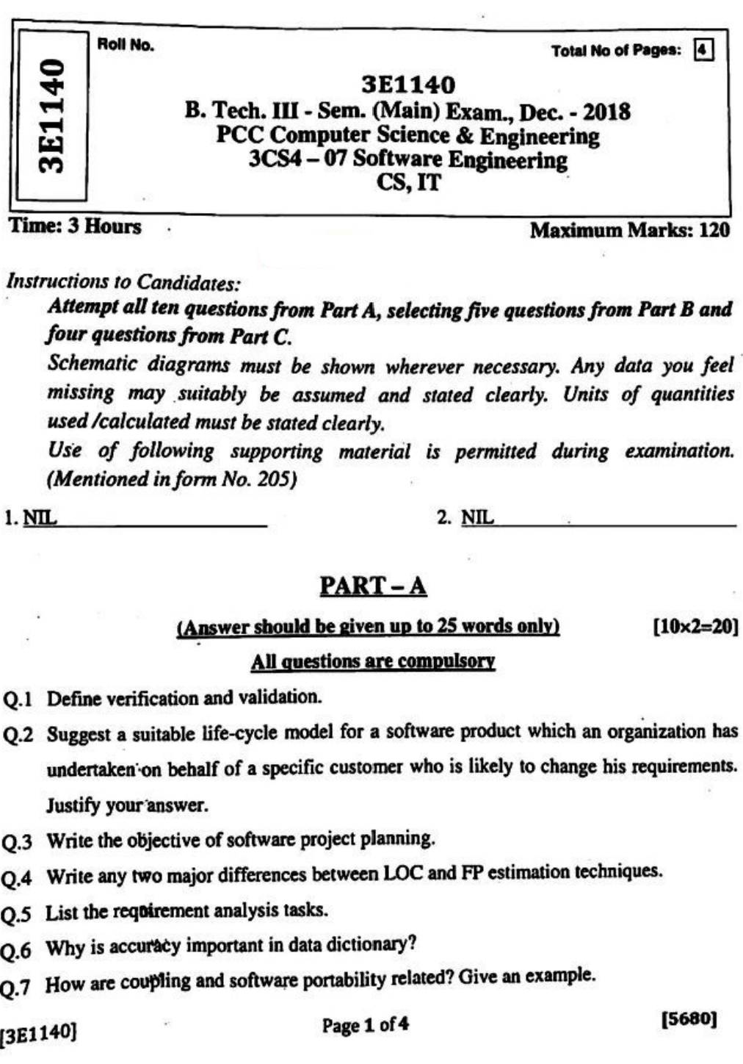

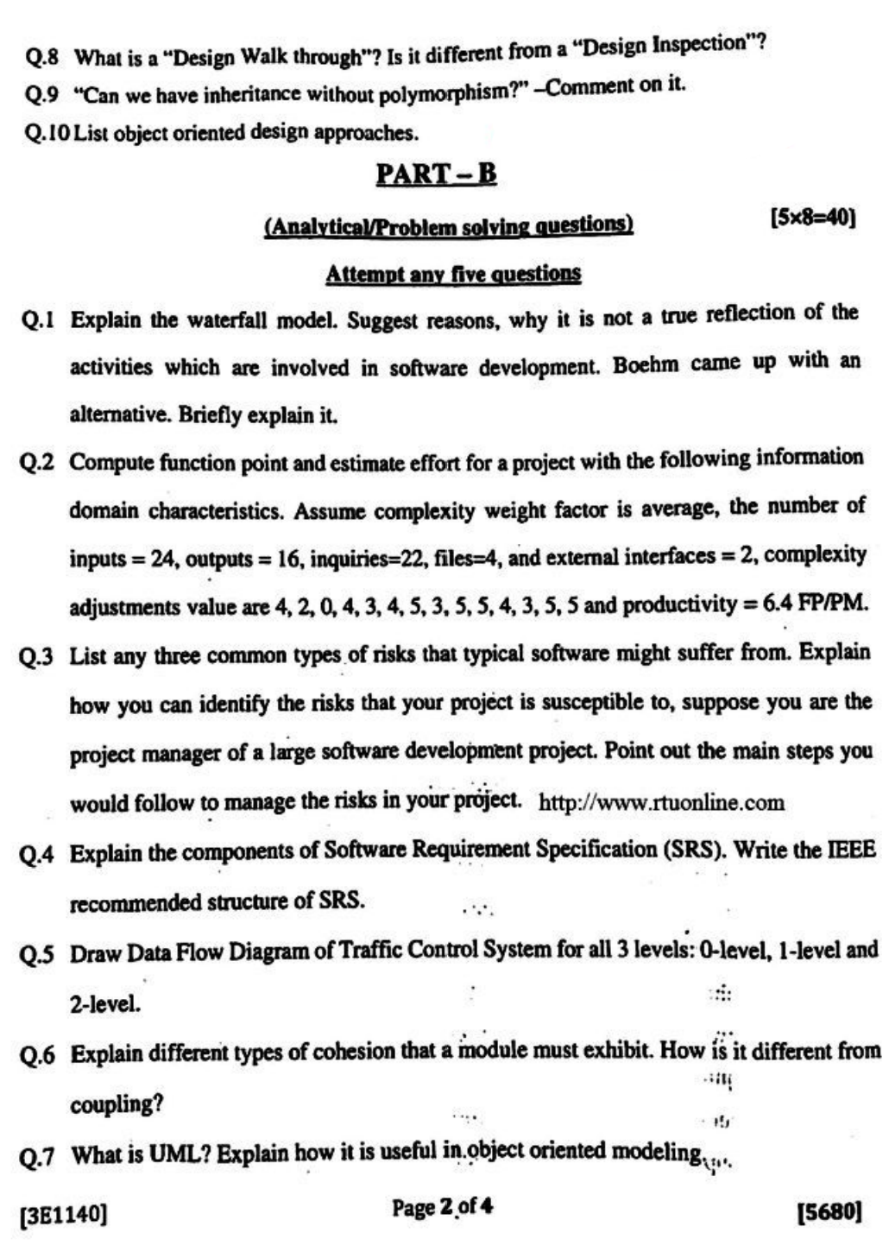

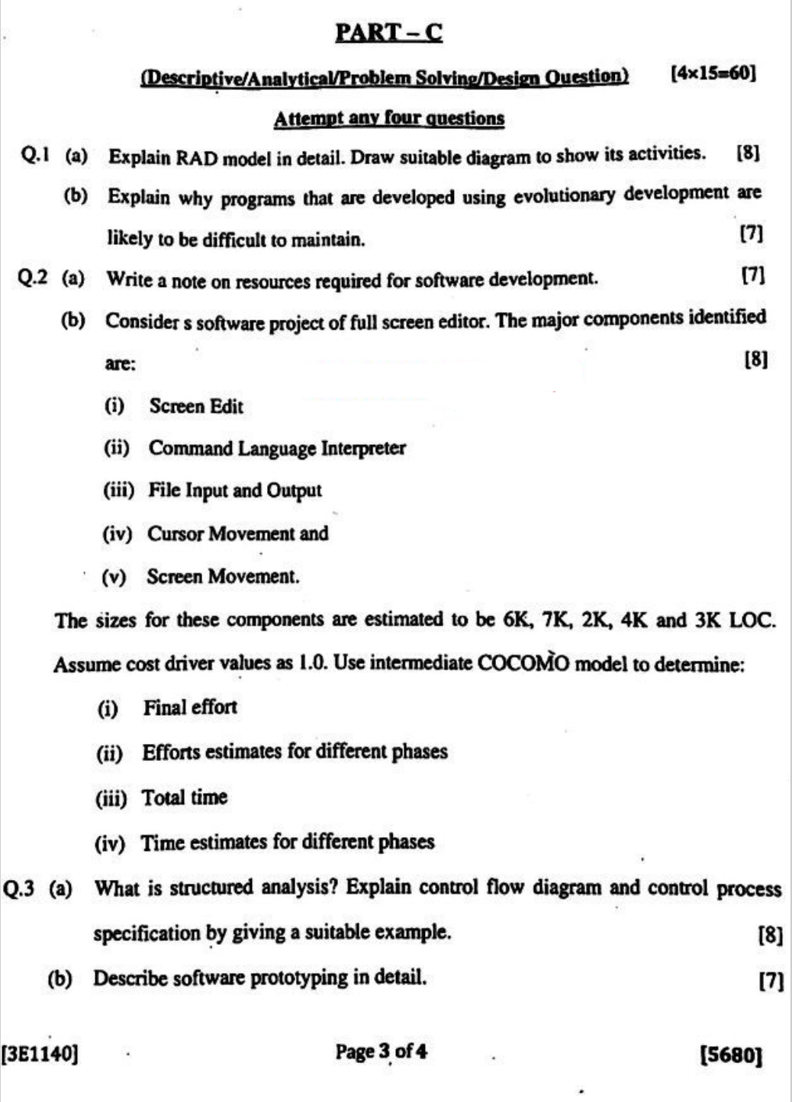

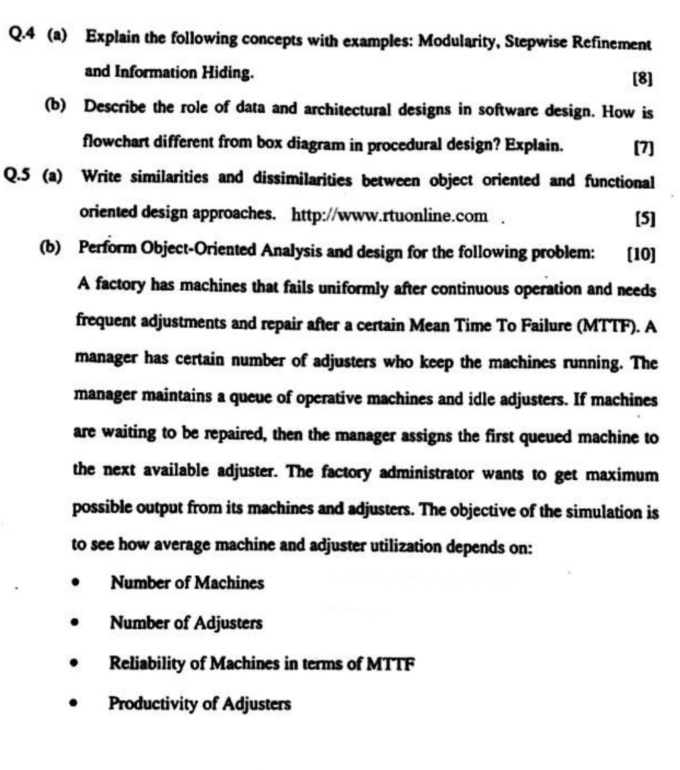

**RESULT ANALYSIS**

|  |  |  |  |  |  |
| --- | --- | --- | --- | --- | --- |
| **S.NO.** | **RTU ROLL NUMBER** | **NAME OF STUDENT** | **END TERM MARKS** | **SESSIONAL MARKS** | **TOTAL** |
| **MAX MARKS** | **70** | **30** | **100** |
| **Set Target Level** | | | **60%** | **75%** |  |
| 1 | 22ETCCS001 | AADARSH SONI | 32 | 27 | 59 |
| 2 | 22ETCCS002 | ABDUL ATTIF | 42 | 28 | 70 |
| 3 | 22ETCCS003 | ABHIJEET GARG | 49 | 28 | 77 |
| 4 | 22ETCCS004 | ADITYA CHHIPA | 46 | 28 | 74 |
| 5 | 22ETCCS005 | ADITYA GIRI GOSWAMI | 44 | 28 | 72 |
| 6 | 22ETCCS006 | ADITYA SHARMA | 57 | 29 | 86 |
| 7 | 22ETCCS007 | AJIT KUMAR | 50 | 26 | 76 |
| 8 | 22ETCCS008 | AKASH SONI | 46 | 28 | 74 |
| 9 | 22ETCCS009 | AKSHAT JANGID | 64 | 29 | 93 |
| 10 | 22ETCCS010 | AKSHAT KUMAR SAINI | 50 | 29 | 79 |
| 11 | 22ETCCS011 | AKSHI BARGURJAR | 50 | 28 | 78 |
| 12 | 22ETCCS012 | AKSHIT NALWAYA | 40 | 24 | 64 |
| 13 | 22ETCCS013 | AKSHITA KUMAWAT | 33 | 26 | 59 |
| 14 | 22ETCCS014 | AKSHITA PANCHAL | 51 | 29 | 80 |
| 15 | 22ETCCS015 | ALI ASGAR ORA WALA | 36 | 22 | 58 |
| 16 | 22ETCCS017 | ANGHA VARANGAONKAR | 49 | 30 | 79 |
| 17 | 22ETCCS018 | ANKIT DHANAWAT | 34 | 25 | 59 |
| 18 | 22ETCCS019 | ANSHIKA JAIN | 50 | 30 | 80 |
| 19 | 22ETCCS020 | ARCHIT JAIN | 39 | 24 | 63 |
| 20 | 22ETCCS021 | ARIN UPADHAYAY | 35 | 24 | 59 |
| 21 | 22ETCCS022 | ARUSH MENARIA | 58 | 30 | 88 |
| 22 | 22ETCCS023 | ARYAN TALWAR | 54 | 27 | 81 |
| 23 | 22ETCCS024 | AVIKA SURANA | 56 | 24 | 80 |
| 24 | 22ETCCS025 | BHAWANA KUMARI | 52 | 29 | 81 |
| 25 | 22ETCCS026 | BHUMI JAIN | 62 | 30 | 92 |
| 26 | 22ETCCS027 | BHUWAN SUTHAR | 52 | 24 | 76 |
| 27 | 22ETCCS028 | CHETAN NAGDA | 39 | 22 | 61 |
| 28 | 22ETCCS029 | CHIRAG SHARMA | 46 | 22 | 68 |
| 29 | 22ETCCS030 | MS. CIA SHARMMA | 52 | 29 | 81 |
| 30 | 22ETCCS031 | DAIVIK SHARMA | 42 | 27 | 69 |
| 31 | 22ETCCS032 | DAKSH JAIN | 41 | 27 | 68 |
| 32 | 22ETCCS033 | DAKSH MENARIA | 39 | 21 | 60 |
| 33 | 22ETCCS034 | DEV PARAKH | 43 | 28 | 71 |
| 34 | 22ETCCS035 | DHANESH JOSHI | 49 | 29 | 78 |
| 35 | 22ETCCS036 | DHEERAJ SINGH THAPA | 32 | 21 | 53 |
| 36 | 22ETCCS037 | DHWANI KHUSHLANI | 59 | 30 | 89 |
| 37 | 22ETCCS038 | DIKSHIT DARJI | 43 | 25 | 68 |
| 38 | 22ETCCS039 | MSDIKSHITA SHARMA | 41 | 26 | 67 |
| 39 | 22ETCCS040 | DIVYA BAGORA | 53 | 28 | 81 |
| 40 | 22ETCCS041 | DIVYANSHU SHARMA | 49 | 24 | 73 |
| 41 | 22ETCCS042 | DIVYASHAKTI PAL | 37 | 28 | 65 |
| 42 | 22ETCCS043 | DIYA JAIN | 50 | 26 | 76 |
| 43 | 22ETCCS044 | DIYA PALIWAL | 54 | 27 | 81 |
| 44 | 22ETCCS045 | FALGUN CHOUDHARY | 53 | 29 | 82 |
| 45 | 22ETCCS046 | GARGI SHARMA | 49 | 28 | 77 |
| 46 | 22ETCCS047 | GARV BAKLIWAL | 50 | 22 | 72 |
| 47 | 22ETCCS048 | GARVIT NANDAWAT | 33 | 21 | 54 |
| 48 | 22ETCCS049 | GAURAV JAIN | 44 | 27 | 71 |
| 49 | 22ETCCS050 | GAURAVI NEGI | 35 | 26 | 61 |
| 50 | 22ETCCS051 | GAURI SUTHAR | 57 | 29 | 86 |
| 51 | 22ETCCS053 | GOURAV POKHARNA | 47 | 22 | 69 |
| 52 | 22ETCCS054 | HARDIK BATWAL | 49 | 30 | 79 |
| 53 | 22ETCCS055 | HARSH DANGI | 49 | 28 | 77 |
| 54 | 22ETCCS056 | HARSH KAWADIA | 51 | 27 | 78 |
| 55 | 22ETCCS057 | HARSH TAMBOLI | 43 | 26 | 69 |
| 56 | 22ETCCS058 | HARSHAL JAIN | 53 | 27 | 80 |
| 57 | 22ETCCS059 | HARSHIT POKHARNA | 48 | 28 | 76 |
| 58 | 22ETCCS060 | HARSHVARDHAN SINGH CHAUHAN | 52 | 22 | 74 |
| 59 | 22ETCCS061 | HARSHVARDHAN SINGH KITAWAT | 40 | 26 | 66 |
| 60 | 22ETCCS062 | HEMANT AHUJA | 51 | 29 | 80 |
| 61 | 22ETCCS064 | HIMANK LOHAR | 51 | 24 | 75 |
| 62 | 22ETCCS065 | HIMANSHI PRAJAPAT | 53 | 30 | 83 |
| 63 | 22ETCCS066 | HIMANSHU KALAL | 46 | 27 | 73 |
| 64 | 22ETCCS067 | HONHAR RAWAL | 21 | 21 | 42 |
| 65 | 22ETCCS068 | HUSAIN BOHRA TIDIWALA | 43 | 26 | 69 |
| 66 | 22ETCCS069 | JAINISH JAIN | 19 | 21 | 40 |
| 67 | 22ETCCS070 | JAYESH JOSHI | 46 | 27 | 73 |
| 68 | 22ETCCS071 | JAYESH MANDAWAT | 37 | 24 | 61 |
| 69 | 22ETCCS072 | JINENDRA SINGH DODIYA | 31 | 25 | 56 |
| 70 | 22ETCCS073 | KANIKA GUPTA | 34 | 26 | 60 |
| 71 | 22ETCCS074 | KANISHK GUPTA | 30 | 27 | 57 |
| 72 | 22ETCCS075 | KAPIL KALAL | 47 | 21 | 68 |
| 73 | 22ETCCS076 | KARAN SWAMI | 57 | 25 | 82 |
| 74 | 22ETCCS077 | KARTIK JAIN | 51 | 29 | 80 |
| 75 | 22ETCCS078 | KARTIK KRISHNA KALE | 45 | 27 | 72 |
| 76 | 22ETCCS079 | KAVYA PALIWAL | 36 | 21 | 57 |
| 77 | 22ETCCS080 | KETAN OJHA | 49 | 28 | 77 |
| 78 | 22ETCCS081 | KHUSH JAIN | 56 | 30 | 86 |
| 79 | 22ETCCS082 | KHUSHI SHARMA | 45 | 29 | 74 |
| 80 | 22ETCCS083 | KIRTAN TAMBOLI | 47 | 28 | 75 |
| 81 | 22ETCCS085 | KONPAL SHARMA | 49 | 28 | 77 |
| 82 | 22ETCCS086 | KRITI PATWA | 46 | 30 | 76 |
| 83 | 22ETCCS087 | KUSH PARSAI | 42 | 26 | 68 |
| 84 | 22ETCCS088 | KUSHAL MEENA | 34 | 22 | 56 |
| 85 | 22ETCCS089 | LAKSHIT PALIWAL | 40 | 28 | 68 |
| 86 | 22ETCCS090 | LAKSHY JAIN | 31 | 21 | 52 |
| 87 | 22ETCCS091 | LAKSHYARAJ CHOUDHARY | 38 | 25 | 63 |
| 88 | 22ETCCS092 | LAL SINGH JHALA | 45 | 23 | 68 |
| 89 | 22ETCCS093 | LUCKY LOHAR | 32 | 25 | 57 |
| 90 | 22ETCCS094 | MAHATV BHATNAGAR | 45 | 27 | 72 |
| 91 | 22ETCCS095 | MAHENDRA SINGH SISODIYA | 44 | 28 | 72 |
| 92 | 22ETCCS096 | MSMAHIMA CHOUHAN | 52 | 30 | 82 |
| 93 | 22ETCCS097 | MAHIPAL SINGH JHALA | 38 | 26 | 64 |
| 94 | 22ETCCS098 | MAHIRAJ SINGH SANKHLA | 25 | 22 | 47 |
| 95 | 22ETCCS099 | MANAS PARWANI | 36 | 25 | 61 |
| 96 | 22ETCCS100 | MANASVI SHARMA | 45 | 27 | 72 |
| 97 | 22ETCCS101 | MANASWINI SHARMA | 52 | 29 | 81 |
| 98 | 22ETCCS102 | MANSI DUBE | 56 | 30 | 86 |
| 99 | 22ETCCS103 | MAYANK KASERA | 36 | 24 | 60 |
| 100 | 22ETCCS104 | MAYANK TRIVEDI | 28 | 22 | 50 |
| 101 | 22ETCCS105 | MEDHAVI KAUSHIK | 45 | 29 | 74 |
| 102 | 22ETCCS106 | MEETRAJ SINGH | 43 | 26 | 69 |
| 103 | 22ETCCS107 | MITALI PALIWAL | 47 | 24 | 71 |
| 104 | 22ETCCS108 | MITVESH AMETA | 33 | 21 | 54 |
| 105 | 22ETCCS109 | MOHAMMED YASAR | 28 | 25 | 53 |
| 106 | 22ETCCS110 | MOHIT KALAL | 38 | 24 | 62 |
| 107 | 22ETCCS111 | MOHIT KUMAWAT | 31 | 24 | 55 |
| 108 | 22ETCCS112 | MONIL SETH | 53 | 30 | 83 |
| 109 | 22ETCCS113 | NAKUL PANDYA | 42 | 25 | 67 |
| 110 | 22ETCCS114 | NEERAJ DANGI | 36 | 24 | 60 |
| 111 | 22ETCCS115 | NIKHIL RAJ MALI | 47 | 21 | 68 |
| 112 | 22ETCCS116 | NIMISHKA CHAUHAN | 42 | 25 | 67 |
| 113 | 22ETCCS117 | NISHANT MENARIA | 48 | 26 | 74 |
| 114 | 22ETCCS118 | MSPALAK KUMAWAT | 46 | 29 | 75 |
| 115 | 22ETCCS119 | PARSHVI HARKAWAT | 57 | 29 | 86 |
| 116 | 22ETCCS120 | PRAGYA BUJ | 46 | 27 | 73 |
| 117 | 22ETCCS121 | PRATIBHA SINGH | 45 | 30 | 75 |
| 118 | 22ETCCS122 | PRINCE DANGI | 32 | 24 | 56 |
| 119 | 22ETCCS123 | PRIYANSH JAIN | 54 | 30 | 84 |
| 120 | 22ETCCS124 | PURVAM CHATURVEDI | 36 | 23 | 59 |
| 121 | 22ETCCS125 | PUSHKAR GAMETI | 35 | 25 | 60 |
| 122 | 22ETCCS126 | PUSHPENDRA MENARIA | 52 | 30 | 82 |
| 123 | 22ETCCS127 | QAIDJOHAR JUKKER | 41 | 27 | 68 |
| 124 | 22ETCCS128 | RAGHAVENDRA BAHETI | 41 | 25 | 66 |
| 125 | 22ETCCS129 | RAJ LAXKAR | 35 | 21 | 56 |
| 126 | 22ETCCS130 | RAJ SHRIMALI | 45 | 23 | 68 |
| 127 | 22ETCCS131 | RAM MUNDRA | 42 | 23 | 65 |
| 128 | 22ETCCS132 | RAMMITH K R | 39 | 26 | 65 |
| 129 | 22ETCCS133 | RANITH BISWAS | 22 | 21 | 43 |
| 130 | 22ETCCS134 | RANJIT SINGH SHAKTAWAT | 44 | 29 | 73 |
| 131 | 22ETCCS135 | MSRAUNAK TAK | 50 | 29 | 79 |
| 132 | 22ETCCS136 | RAVI JOSHI | 39 | 24 | 63 |
| 133 | 22ETCCS137 | RAVI MENARIYA | 44 | 29 | 73 |
| 134 | 22ETCCS138 | RITIK SHARMA | 44 | 27 | 71 |
| 135 | 22ETCCS139 | RITISHA SEN | 49 | 29 | 78 |
| 136 | 22ETCCS140 | ROHIT AGARWAL | 47 | 28 | 75 |
| 137 | 22ETCCS141 | ROSHAN SHARMA | 29 | 24 | 53 |
| 138 | 22ETCCS142 | ROSHNI MENARIA | 35 | 24 | 59 |
| 139 | 22ETCCS143 | RUDRA PUROHIT | 41 | 23 | 64 |
| 140 | 22ETCCS144 | RUDRAVEER SINGH PANWAR | 40 | 28 | 68 |
| 141 | 22ETCCS145 | SHAAN SANADHYA | 36 | 28 | 64 |
| 142 | 22ETCCS146 | SHACHI JAIN | 42 | 24 | 66 |
| 143 | 22ETCCS147 | SHAURYA KUNDAR | 39 | 26 | 65 |
| 144 | 22ETCCS148 | SHOURYA BORDIA | 35 | 25 | 60 |
| 145 | 22ETCCS149 | SHUBHAM YADAV | 39 | 24 | 63 |
| 146 | 22ETCCS150 | SIDDHARTH KUMAR SINGH | 33 | 22 | 55 |
| 147 | 22ETCCS151 | SIDDHARTH MENARIA | 41 | 23 | 64 |
| 148 | 22ETCCS152 | SRAJAN MENARIA | 36 | 24 | 60 |
| 149 | 22ETCCS154 | SUMIT DANGI | 39 | 24 | 63 |
| 150 | 22ETCCS155 | SURBHI TAILOR | 38 | 21 | 59 |
| 151 | 22ETCCS156 | SURYANSH MADHUKAR | 39 | 25 | 64 |
| 152 | 22ETCCS157 | TALENT JAIN | 30 | 21 | 51 |
| 153 | 22ETCCS158 | TANISHK VYAS | 40 | 26 | 66 |
| 154 | 22ETCCS159 | TANVI SHARMA | 45 | 24 | 69 |
| 155 | 22ETCCS160 | TOHEED AKHTAR | 45 | 25 | 70 |
| 156 | 22ETCCS161 | TUSHAR PRAJAPAT | 29 | 23 | 52 |
| 157 | 22ETCCS162 | TUSHAR SINGH RAWAT | 31 | 23 | 54 |
| 158 | 22ETCCS163 | UJJWAL SINGH CHOUHAN | 36 | 23 | 59 |
| 159 | 22ETCCS164 | USHIT SHARMA | 29 | 24 | 53 |
| 160 | 22ETCCS165 | UTKARSH BAJPAI | 33 | 22 | 55 |
| 161 | 22ETCCS166 | VAIBHAV GOYAL | 60 | 29 | 89 |
| 162 | 22ETCCS167 | VANSH BHATNAGAR | 41 | 27 | 68 |
| 163 | 22ETCCS168 | VINAY VADERA | 24 | 24 | 48 |
| 164 | 22ETCCS169 | VINITA MENARIA | 49 | 28 | 77 |
| 165 | 22ETCCS170 | VISHAL MENARIYA | 52 | 30 | 82 |
| 166 | 22ETCCS171 | VISHAL SINGH RAO | 49 | 26 | 75 |
| 167 | 22ETCCS172 | VIVEK SHARMA | 52 | 28 | 80 |
| 168 | 22ETCCS173 | VIVEK SHRIMALI | 40 | 26 | 66 |
| 169 | 22ETCCS174 | YANA OZHA | 49 | 29 | 78 |
| 170 | 22ETCCS175 | YASH VAGHELA | 40 | 24 | 64 |
| 171 | 22ETCCS300 | KEVALI ASHOK KANAGALE | 43 | 30 | 73 |
| 172 | 22ETCCS301 | KARAN SUTHAR | 33 | 21 | 54 |
| 173 | 22ETCCS302 | VINEET SHARMA | 31 | 26 | 57 |
| 174 | 23ETCCS200 | GOPAL PALIWAL | 39 | 25 | 64 |
| 175 | 23ETCCS201 | MANISH VYAS | 30 | 22 | 52 |
| 176 | 23ETCCS202 | RAHUL RAJPUROHIT | 44 | 26 | 70 |
| 177 | 23ETCCS203 | VAISHALI H PUROHIT | 47 | 27 | 74 |
| 178 | 23ETCCS204 | YASH SINGHATWADIA | 32 | 23 | 55 |

|  |  |  |  |  |
| --- | --- | --- | --- | --- |
| TOTAL | PASS | FAIL | ABSENT | PASS % |
| 178 | 178 | Nil | Nil | 100% |

**Indirect Assessment:**

**Overall Teacher Self Assessment (after course) in terms of course objective and outcomes**

**Course Objectives:**

* To understand the Fundamental Software Engineering Concepts:
* To learn about Requirements Analysis, System Design, and Testing:
* To implement Software Engineering Components and Tools:
* To Apply Software Engineering Principles to Practical Projects:

**Course Outcomes**:

* Students can explain the theory and principles of software engineering.
* Students can perform requirements analysis and system design for a given software project.
* Students can implement a basic software applications that follow industry standards.
* Students can apply their knowledge to complete a comprehensive software engineering project.

**Methodology to identify bright student**

Considered a range of criteria, including academic performance, creativity, critical thinking, problem-solving skills, and enthusiasm for learning. Bright students often excel in multiple areas. Observed how students perform in the classroom. In terms of active participation, engagement in discussions, leadership, and the ability to grasp complex concepts.

**Efforts to keep students engaged**

1. **Incorporate active learning strategies**:
   * Implement group discussions, collaborative problem-solving activities, and hands-on projects.
   * Encourage students to actively participate in coding sessions, debugging exercises, and real-world software development tasks.

### Use a Varied Teaching Methods:

### Combine traditional lectures with group work, pair programming, and peer reviews.

* + Include multimedia presentations to demonstrate software development processes, tools, and methodologies.

### Technology Integration:

* + Utilize online platforms for code repositories, version control, and collaborative development (e.g., GitHub, GitLab).

**Methodology to identify weak student**

Consider a range of criteria to identify students who may need additional support in software engineering:

* **Classroom Observation**: Monitor student engagement and participation during lectures, labs, and group activities.
* **Formative Assessment**: Use quizzes, in-class exercises, and informal checks to gauge understanding of software engineering concepts.
* **Summative Assessment**: Evaluate performance on exams, major projects, and final presentations to identify areas of weakness.
* **Assignment Review**: Analyze the quality of submitted assignments and code to pinpoint specific learning gaps.

**Targeted inventions for weak student**

• **Additional Resources**:

* Provide supplementary learning materials, such as textbooks, online resources, or multimedia content, to offer alternative explanations and reinforce key concepts.
* Examples:
  + NPTEL Software engineering course
  + NSDC , Agile Methodology and PMP video

• **Remedial Classes**:

* Establish a tutoring program where students can receive extra help from teachers or advanced peers.
* Conduct extra lab sessions focusing on hands-on coding practice, debugging, and understanding complex concepts.

• **Flipped Classroom**:

* Assign pre-class learning materials, often in the form of videos, readings, or online modules, to cover foundational concepts before coming to class.
* Use class time for interactive discussions, practical exercises, and addressing specific student questions.

highly recommended books for software engineering that cater to different aspects of the field:

1. **"Software Engineering: A Practitioner's Approach" by Roger S. Pressman and Bruce R. Maxim**:
2. **"Clean Code: A Handbook of Agile Software Craftsmanship" by Robert C. Martin**:
3. **"Design Patterns: Elements of Reusable Object-Oriented Software" by Erich Gamma, Richard Helm, Ralph Johnson, and John Vlissides**:
4. **“Software Engineering" by Ian Sommerville**:
5. **"Code Complete: A Practical Handbook of Software Construction" by Steve McConnell**:
6. **"Domain-Driven Design: Tackling Complexity in the Heart of Software" by Eric Evans**: