**Techno India NJR Institute of Technology**



**Course File**

**Session 2023-24**

**Microprocessor and Interfaces (4CS3-04)**

Yogendra Singh Solanki

(Assistant Professor)

**Department of ECE**

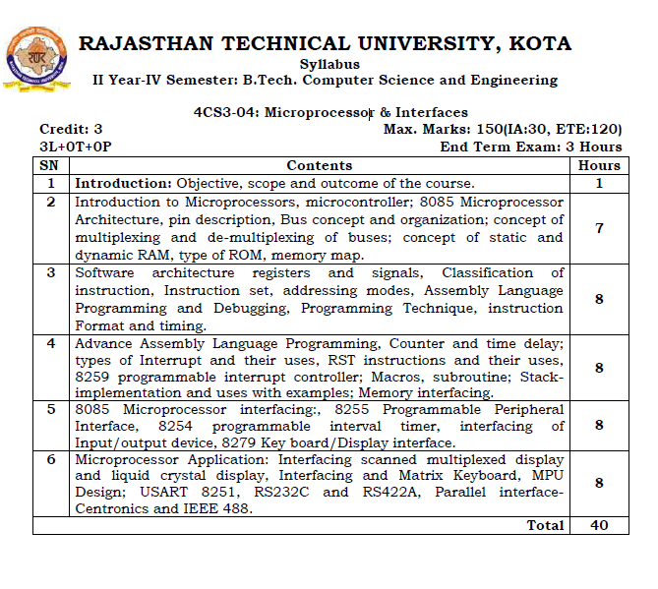

**Course Overview:**

Microprocessors and Interfacing course is intended to introduce the architecture, programming of microprocessors and interfacing various hardware circuits to microprocessors. The topics covered are architecture, addressing modes, instruction set of 8085, 8086, minimum and maximum mode operation of 8086, 8086 INSTRUCTION SET, Assembly language programming fundamentals, interfacing of static Ram, EPROM, 8255 PPI,DMA Controller 8257, keyboard, display, 8279, stepper motor, A/D and D/A converter, 8259 interrupt controller, data transmission,8251 USART, 8253 architecture, modes of timer operation, RS 232C Serial interface

**Course Outcomes:**

|  |  |  |
| --- | --- | --- |
| **CO.NO.** | **Cognitive Level** | **Course Outcome** |
| 1 | Synthesis | Student will be able to draw and explain the 8085 microprocessor’s architecture, pin description and its functionality in depth. Student will be able to explain about microprocessor-based system by designing logical circuitry in order to interface processor with memory and I/O devices. |
| 2 | Synthesis | Students will learn instructions of 8085 microprocessor, their classification and different programming techniques. Student will be able to identify the addressing modes and length in bytes of instructions. |
| 3 | Synthesis | Students will learn additional 16-bit instructions and arithmetic operations. Student will be able to design, write, and analyze assembly language programs of 8085 microprocessor. Student will be able to explain about various interrupts available in 8085 microprocessor. Interrupt structure, interrupt vector table and interrupt service routines etc. as well as how serial communication takes place. |
| 4 | Synthesis | Students are able to design and develop the circuit for memory and I/O interfacing with 8085 microprocessor. |
| 5 | Synthesis | To design and develop I2C module for data transmission between processor and LCD module. |

**Prerequisites:**

1. Fundamentals of semiconductor devices.
2. Must have completed the course on Digital Electronics.

**Course Outcome Mapping with Program Outcome:**

|  |  |  |  |  |  |  |  |  |  |  |  |  |
| --- | --- | --- | --- | --- | --- | --- | --- | --- | --- | --- | --- | --- |
| **Course Outcome** | **Program Outcomes (PO’s)** | | | | | | | | | | | |
| **CO. NO.** | **Domain Specific** | | | | | **Domain Independent** | | | | | | |
|  | **PO1** | **PO2** | **PO3** | **PO4** | **PO5** | **PO6** | **PO7** | **PO8** | **PO9** | **PO10** | **PO11** | **PO12** |
| CO1 | 2 | 2 | 2 | 1 | 1 | 0 | 0 | 0 | 1 | 0 | 0 | 1 |
| CO2 | 2 | 2 | 2 | 1 | 1 | 0 | 0 | 0 | 1 | 0 | 0 | 1 |
| CO3 | 2 | 2 | 2 | 2 | 1 | 0 | 0 | 0 | 1 | 0 | 0 | 1 |
| CO4 | 1 | 1 | 1 | 0 | 0 | 0 | 0 | 0 | 0 | 0 | 0 | 1 |
| CO5 | 2 | 2 | 2 | 2 | 1 | 0 | 0 | 0 | 1 | 0 | 0 | 2 |
| 1: Slight (Low) , 2: Moderate (Medium), 3: Substantial (High) | | | | | | | | | | | | |

**Course Coverage Module Wise:**

|  |  |  |
| --- | --- | --- |
| **Lecture No.** | **Unit** | **Topic** |
|  | **1** | **Introduction:** Objective, scope and outcome of the course |
|  | **2** | **Introduction to Microprocessors, microcontroller**. |
|  | 2 | 8085 Microprocessor Architecture |
|  | 2 | 8085 Microprocessor Architecture |
|  | 2 | pin description |
|  | 2 | Bus concept and organization; |
|  | 2 | Concept of multiplexing and de-multiplexing of buses |
|  | 2 | Concept of static and dynamic RAM, type of ROM, memory map. |
|  | **3** | **Software architecture registers and signals** |
|  | 3 | Classification of instruction |
|  | 3 | Instruction set |
|  | 3 | Instruction set |
|  | 3 | Instruction set |
|  | 3 | addressing modes |
|  | 3 | Assembly Language Programming and Debugging, Programming Technique |
|  | 3 | Instruction Format and timing. |
|  | 3 | Instruction Format and timing. |
|  | **4** | **Advance Assembly Language Programming** |
|  | 4 | Counter and time delay |
|  | 4 | types of Interrupt and their uses, |
|  | 4 | RST instructions and their uses |
|  | 4 | 8259 programmable interrupt controller |
|  | 4 | 8259 programmable interrupt controller |
|  | 4 | Macros, subroutine; Stack implementation and uses with examples |
|  | 4 | Memory interfacing |
|  | **5** | **8085 Microprocessor interfacing** |
|  | 5 | 8255 Programmable Peripheral Interface |
|  | 5 | 8255 Programmable Peripheral Interface |
|  | 5 | 8254 programmable interval timer |
|  | 5 | 8254 programmable interval timer |
|  | 5 | 8254 programmable interval timer |
|  | 5 | Interfacing of Input/output device |
|  | 5 | 8279 Key board/Display interface |
|  | 5 | 8279 Key board/Display interface |
|  | **6** | **Microprocessor Application** |
|  | 6 | Interfacing scanned multiplexed display |
|  | 6 | Interfacing liquid crystal display |
|  | 6 | Interfacing and Matrix Keyboard, |
|  | 6 | USART 8251 |
|  | 6 | RS232C and RS422A, Parallel interface Centronics and IEEE 488. |

**TEXT/REFERENCE BOOKS**

1. Microprocessor Architecture, Programming & Applications, R. Gaonkar, Wiely Eastern Ltd.
2. Microprocessor & Interfacing, D. V. Hall, McGraw Hill.
3. Introduction to Microprocessors, P. Mathur, McGraw Hill Education.

**Teaching and Learning resources:**

* **MOOC (NPTEL):** - https://nptel.ac.in/courses/108/107/108107029/

**Assessment Methodology:**

1. Practical exam & Viva based onhardware kits of 8085 Microprocessor.
2. Two Midterm exams where student have to showcase subjective learning.
3. Final Exam (subjective paper) at the end of the semester.

