**Course File**

***Subject Title/Subject Code : Operating System/5CS4-03***

Semester : V Year : III

|  |  |  |
| --- | --- | --- |
| Name of the Faculty: Pooja Dave |  | |
|  |  | |
| E-mail id: pooja.dave@technonjr.org |  |

**Class Schedule**

**Total Number of Lectures:** 42

i**)Course Objective**

The objectives of a course in Operating Systems typically revolve around providing students with a comprehensive understanding of the fundamental concepts, principles, and functionalities of operating systems. Some common objectives of an Operating Systems

**INDEX - COURSE FILE**

|  |  |  |
| --- | --- | --- |
| **S. No.** | **CONTENT / ITEM NO.** | **PAGE NO.** |
| **Status** |
| 1 | Vision And Mission Of The Institute |  |  |
| 2 | Vision And Mission Of The Department |  |  |
| 3 | Program Educational Objective Of Department (PEO’s) |  |  |
| 4 | Program Outcomes Of Department (PO’s) |  |  |
| 5 | Course Outcome (COs) |  |  |
| 6 | COs mapping with Pos and PSOs |  |  |
| 7 | Academic Calendar |  |  |
| 8 | Evaluation Scheme |  |  |
| 9 | Course Syllabus |  |  |
| 10 | Prescribed Books |  |  |
| 11 | Copy Of Time Table |  |  |
| 12 | Course Schedule Plan |  |  |
| 13 | Assignment Sheet (Unit Wise) |  |  |
| 14 | Quiz Questions (One From Each Unit) |  |  |
| 15 | Question Papers Of Mid Term Exam-I |  |  |
| 16 | Marks and Gap Analysis in Mid Term I |  |  |
| 17 | Remedial Action Taken To Remove the Gaps after mid Term I |  |  |
| 18 | Question Papers Of Mid Term Exam-II |  |  |
| 19 | Gap Analysis in Mid Term II |  |  |
| 20 | Remedial Action Taken To Remove the Gaps after mid Term II |  |  |
| 21 | Model Question Paper With Key Solution |  |  |
| 22 | University Question Paper (Last one year) |  |  |
| 23 | Student Performance Report |  |  |
| 24 | Result Analysis |  |  |

**VISSION & MISSION OF INSTITUTE**

## Vision

Empowering student with recent and emerging technologies to create innovative technical leaders capable of contributing to industrial and societal needs for betterment of mankind across the globe.

## Mission

**M1**: To provide dynamic learning environment to students by providing constant exposure to latest technologies by linking closely with the industries.

**M2**: To establish effective interface with industry to obtain live problems to enhance critical thinking and problem solving skills among students and consultancy projects for faculty.

**M3**: To provide avenues and opportunities to faculty for domain specific trainings and qualification upgradation.

**M4**: To develop ethical leaders with strong communication skills.

**VISION & MISSION OF DEPARTMENT**

**Department Vision**

**To be among top five well known department of Computer Science and Engineering in the state of Rajasthan in placing the students at premier industry.**

**Department Mission**

**M1: To equip students with ability to be innovative and excellence to face the challenges in the digital world.**

**M2: To prepare students with high quality employability skills catering to current trends in industries, problem solving skills, innovative pursuits and ready to face challenges in the domain and allied disciplines.**

**M3: To provide ambience for entrepreneurship and start-ups through incubation center among students.**

**M4: To encourage continuous faculty training on industry-based Development, and Innovation.**

**PROGRAMME EDUCATIONAL OBJECTIVES (PEOs)**

**Technical Proficiency** Graduates will have a strong foundation in core concepts, tools, and technologies relevant to their discipline.

**Career Development** Graduate will be capable of pursuing diverse career paths in field of Computer Science & Engineering with proficiency in software development/ pursue higher education an or become entrepreneurs.

**Problem-Solving** Graduates will have a strong math foundation so that they will be proficient problem solvers, capable of identifying, analyzing , and solving complex technical problems using critical thinking and creative approaches.

**Professional Attitude** Graduates will be sensitive to societal and professional environment, possess strong communication skills and will be skilled in working collaboratively within diverse teams adhering to ethical standards and professional practices.

**Learning Environment** To create a learning environment that ensures graduates continue learning throughout their careers, effortlessly adopting new technologies to stay innovative in their chosen fields and remain effective contributors in their chosen field.

**PROGRAM SPECIFIC OUTCOMES (PSO's)**

**PSO1**: Students will be able to design, develop, test, debug, deploy, analyze , troubleshoot, maintain, manage, and ensure security during the complete product lifecycle.

**PSO2**: Student will be able to apply software engineering/ information system development skills to solve problems across diverse domains.

**PSO3**: Students will be well-prepared to initiate and oversee innovative startups within their respective sectors.

**PROGRAMME OUTCOMES (POs)**

**A student will develop:**

**PO 01. ENGINEERING KNOWLEDGE:** Apply the knowledge of mathematics, science, engineering fundamentals, and an engineering specialization to the solution of complex engineering problems.

**PO02. PROBLEM ANALYSIS**: Identify, formulate, review research literature, and analyze complex engineering problems reaching substantiated conclusions using first principles of mathematics, natural sciences, and engineering sciences

**PO03. DESIGN/ DEVELOPMENT OF SOLUTION:** Design solutions for complex engineering problems and design system components or processes that meet the specified needs with appropriate consideration for the public health and safety, and the cultural, societal, and environmental considerations.

**PO04. CONDUCTION OF INVESTIGATION OF COMPLEX PROBLEMS:** Use research-based knowledge and research methods including design of experiments, analysis and interpretation of data, and synthesis of the information to provide valid conclusions.

**PO05. MODERN TOOL USAGE:** Create, select, and apply appropriate techniques, resources, and modern engineering and IT tools including prediction and modelling to complex engineering activities with and understanding of the limitations.

**PO06. THE ENGINEERING AND SOCIETY:** Apply reasoning informed by the contextual knowledge to assess societal, health, safety, legal and cultural issues and the consequent responsibilities relevant to the professional engineering practice.

**PO07. ENVIRONMENT & SUSTAINABILITY:** Understand the impact of the professional engineering solutions in societal and environmental contexts, and demonstrate the knowledge of, and need for sustainable development.

**PO08. ETHICS:** Apply ethical principles and commit to professional ethics and responsibilities and norms of the engineering practice.

**PO09. INDIVIDUAL AND TEAM WORK**: Function effectively as an individual, and as a member or leader in diverse teams, and in multi disciplinary settings.

**PO10. COMMUNICATION**: Communicate effectively on complex engineering activities with the engineering community and with society at large, such as, being able to comprehend and write effective reports and design documentation, make effective presentations, and give and receive clear instructions.

**PO11. PROJECT MANAGEMENT & FINANCE**: Demonstrate knowledge and understanding of the engineering and management principles and apply these to one’s own work, as a member and leader in a team, to manage projects and in multidisciplinary environments.

**PO12. LIFE-LONG LEARNING:** Recognize the need for, and have the preparation and ability to engage in independent and life-long learning in the broadest context of technological change.

**COURSE OUTCOMES (COs) OF THE SUBJECT**

|  |  |  |
| --- | --- | --- |
| CO No. | Mapping | Statement |
| CO35402.1 | Analyzing | Students will be able to summarize principles of operating systems, design, and implementations, Understand the various components and functions of an operating system. |
| CO35402.2 | Applying | Students will be able to analyze and apply suitable Process Scheduling Algorithm and Memory Partition Techniques, apply appropriate techniques to avoid control problems such as mutual exclusion and deadlocks |
| CO35402.3 | Applying | Students will be able to memorize deadlock, Methods for handling deadlocks and memory management strategies |
| CO35402.4 | Analyzing | Students will be able to compare various memory management algorithm and CPU scheduling techniques. Implement and evaluate operating system components in Windows and Unix environments |
| CO35402.5 | Analyzing | Students will be able to measure and memorize various file and disk management strategies. |

**COS MAPPING WITH POs AND PSOs**

|  |  |  |  |  |  |  |  |  |  |  |  |  |  |  |  |
| --- | --- | --- | --- | --- | --- | --- | --- | --- | --- | --- | --- | --- | --- | --- | --- |
| **Course Outcome** | **PO1** | **PO2** | **PO3** | **PO4** | **PO5** | **PO6** | **PO7** | **PO8** | **PO9** | **PO10** | **PO11** | **PO12** | **PSO1** | **PSO2** | **PSO3** |
| **CO1** | 3 | 2 | 2 | 1 | - | 1 | 1 | - | - | - | - | 3 | 1 | - | - |
| **CO2** | 3 | 2 | 1 | 3 | 2 | 1 | 1 | - | - | - | - | 2 | 2 | 1 | - |
| **CO3** | 3 | 2 | 1 | 2 | 1 | 1 | 1 | - | 1 | - | - | 2 | 2 | 1 | - |
| **CO4** | 3 | 2 | 1 | 2 | 1 | 1 | 1 | - | - | - | - | 2 | 2 | 1 | - |
| **CO5** | 3 | 2 | 1 | 3 | 2 | 1 | 1 | - | - | - | - | 3 | 2 | - | - |

**UNIVERSITY ACADEMIC CALENDAR**

Academic Calendar for Even Semester for Session

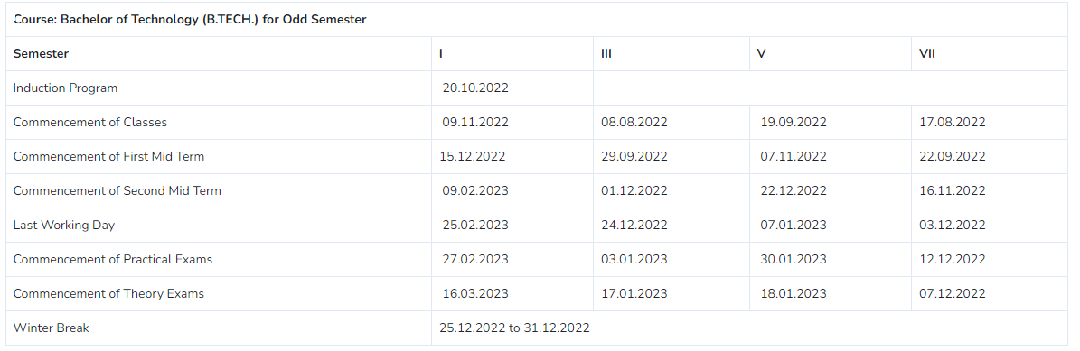

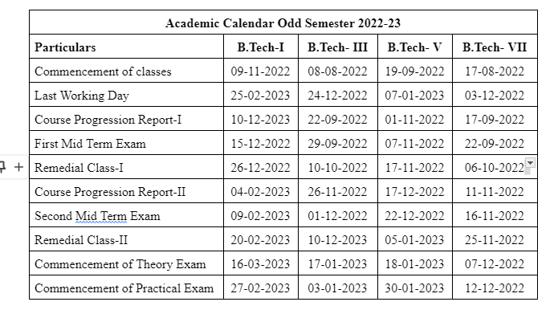

**Evaluation Scheme**

FACULTY DETAILS:

Name of the Faculty : Pooja Dave

Designation : Assistant Professor

Department : Computer Science Engineering

1. TARGET

a) Percentage Pass : 100%

b) Percentage I class: 60 %

2. METHOD OF EVALUATION

2.1. Continuous Assessment Examinations (Mid-Term 1, Mid-Term 2)

2.2. Assignments / Seminars

2.3. Mini Projects

2.4. Quiz

2.5. Semester Examination Others___________________________________________________

3. List out any new topic(s) or any innovation you would like to introduce in teaching the subject in this Semester.

1. Take the help of creative tools to stimulate creativity. Include slide presentations, demonstration or forms of visual exercises that will excite the young minds and capture their interest.

Signature of Faculty: **Signature of HOD**

**UNIVERSITY SYLLABUS**

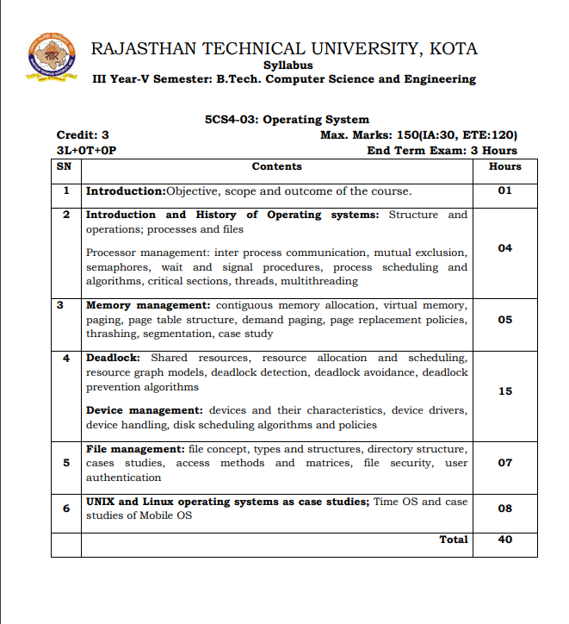

**PRESCRIBED BOOKS**

1. Operating System Concepts" by Abraham Silberschatz, Peter Baer Galvin, Greg Gagne.

2. Operating Systems: Internals and Design Principles" by William Stallings.

3. Operating Systems: Three Easy Pieces" by Remzi H. Arpaci-Dusseau and Andrea C. Arpaci-Dusseau.

**TECHNO INDIA NJR INSTITUTE OF TECHNOLOGY**

**Department of Computer Science & Engineering**

**V Semester (3rd Year)**

**Timetable**

First Time Table: with effect from (Date):

|  |  |  |  |  |  |  |  |
| --- | --- | --- | --- | --- | --- | --- | --- |
| **Day** | **9:00-10:00** | **10:00-11:00** | **11:00-12:00** | **12:00-1:00** | **1:00-2:00** | **2:00-3:00** | **3:00-4:00** |
| Monday |  | OS(B) |  |  | LUNCH |  |  |
| Tuesday | OS(B) |  |  |  |  |  |
| Wednesday | OS(A) |  | OS(B) |  |  |  |
| Thursday |  |  | OS(A) |  |  |  |
| Friday |  |  |  | OS(A) |  |  |
| Saturday | OS(A) |  |  | OS(B) |  |  |

**COURSE-PLAN**

|  |  |  |  |
| --- | --- | --- | --- |
| UNIT | Lect.  No. | TOPICS | **Teaching Methods/ Teaching Aids** |
| **1** | **1** | Introduction of Operating System and also Discuss about the environment of operating system. | White Board, PPT, |
| 1 | 2 | Discuss about the History of Operating System. | White Board, PPT, Demonstration |
| 1 | 3 | What are Using different types of operating hierarchical structure and operation. | White Board |
| 1 | 4 | Define different types of files and processing systems. | White Board |
| 1 | 5 | What do you mean by Inter Process Communication (IPC). | White Board, PPT |
| 1 | 6 | Define the terms mutual exclusion | White Board |
| 1 | 7 | Semaphore | White Board |
| 1 | 8 | Wait and Signal procedures | White Board, PPT |
| 1 | 9 | What are the different types of Process Scheduling and its algorithm with numeric examples. | White Board, PPT |
| 1 | 10 | Discuss about the Critical Section of Process Management in context of Operating System. | White Board |
| 1 | 11 | What do you mean by Treads and also explain Multithreading system in Operating System. | White Board, PPT, |
| 2 | 12 | What do you mean by Memory Management. | White Board, PPT, Demonstration |
| 2 | 13 | Describe Contiguous Memory Allocation. | White Board |
| 2 | 14 | What is Virtual Memory concept and explain the working of Virtual Memory. | White Board |
| 2 | 15 | Describe what is Page in context of Operating System. | White Board, PPT |
| 2 | 16 | Explain the concept of Page Table. | White Board, PPT |
| 2 | 17 | What do you mean by Demand Paging. | White Board |
| 2 | 18 | Explain the concept of Page Replacement Policies. | White Board, PPT |
| 2 | 19 | What do you mean by Thrashing in context of Operating System. | White Board |
| 2 | 20 | Describe Segmentation. | White Board, PPT, |
| 3 | 21 | Introduction about Deadlock | White Board, Demonstration |
| 3 | 22 | Necessary conditions of Deadlock | White Board, PPT |
| 3 | 23 | Shared resources in Deadlock | White Board |
| 3 | 24 | Resource allocation and scheduling. | White Board |
| 3 | 25 | Resource graph model in Deadlock | White Board, PPT |
| 3 | 26 | How to detect Deadlock in Operating System | White Board |
| 3 | 27 | Deadlock Avoidance | White Board, PPT |
| 3 | 28 | Deadlock Prevention Algorithms | White Board |
| 3 | 29 | Device Management: Device and their Characteristics. | White Board, PPT, |
| 3 | 30 | Device drivers, device Handling, disk scheduling algorithms and policies. | White Board, PPT, Demonstration |
| 4 | **31** | Introduction about File Management: File Concept | White Board |
| 4 | 32 | Types and structure of Files | White Board |
| 4 | 33 | Directory Structures, in concept of file management. | White Board, PPT |
| 4 | 34 | Describe File Security | White Board |
| 4 | 35 | User authentication in File Management. | White Board |
| 5 | 36 | Introduction Unix and Linux Operating System. | White Board, PPT |
| 5 | 37 | Unix: Features Of Unix Operating Systems | White Board |
| 5 | 38 | What is Time Operating System. | White Board, PPT, |
| 5 | 39 | Case studies on Mobile Operating System | White Board, PPT, Demonstration |
| 5 | 40 | Revision of Important topics | White Board |
| 5 | 41 | Problem solving | White Board, PPT |
| 5 | 42 | Problem solving | White Board |

**Signature of Faculty: Signature of HOD**

**Assignment – 1 ()**

1**.** What is an operating System and Explain the Types of Operating System**. (CO1)**

2**.** What is kernel. **(CO1)**

3. Explain Threading. In Operating System.(**CO2)**

4. What is Multiuser Operating System**(CO2)**

5. Difference Between Process and Thread . **(CO2)**

**Assignment – 2 ()**

1. Differentiate between Windows and Linux based operating system. **(CO3)**

2. What are the necessary conditions for deadlock? Explain resource graph model and safe- unsafe states with a suitable example **(CO4)**

3. What is deadlock? What are the necessary conditions for a deadlock to occur? Explain each condition briefly? **(CO4)**

4. What do you mean by demand paging? Explain virtual memory and page fault concept in detail. **(CO5)**

5. Consider the following page reference string 1, 2, 3, 4, 1, 2, 5, 1, 2, 3, 4, 5 Compare the number of page faults with frame size 3, 4 with FIFO & LRU page replacement algorithm. **(CO5)**

**SAMPLE QUIZ QUESTIONS**

|  |  |
| --- | --- |
| 1. | What is an operating system? |
| 2. | What is the main function of the command interpreter? |
| 3. | To access the services of the operating system, the interface is provided by the ___________ |
| 4. | CPU scheduling is the basis of ___________ |
| 5. | Where is the operating system placed in the memory? |
| 6. | In operating system, each process has its own __________ |
| 7. | What is the Full Form Of FCFS And SJF? |
| 8. | For an effective operating system, when to check for deadlock? |
| 9. | A deadlock avoidance algorithm dynamically examines the __________ to ensure that a circular wait condition can never exist. |
| 10. | The operating system is responsible for? |
| 11. | Swapping _______ be done when a process has pending I/O, or has to execute I/O operations only into operating system buffers. |
| 12. | What is virtual machine? |
| 13. | What is Deadlock? |
| 14. | What is memory Management? |
| 15. | In Unix, which system call creates the new process? |

**Mid Term Paper-I**

**TECHNO INDIA NJR INSTITUTE OF TECHNOLOGY, UDAIPUR**

B. TECH 3rd – YEAR (V SEM.) – MT-I

Operating System (**5CS4-03**)

Time: 2 Hr Max. Marks: 70

**Note:**

1. The paper is divided into 2 parts: Part-A and, Part-B
2. Part-A contains 10 questions and carries 2 mark each.
3. Part-B contains 5 questions. Each question is having two options and carries 10 marks each.

Part- A (20 Marks)

|  |  |
| --- | --- |
| 1. What do you mean by operating system? | CO1 |
| 1. Explain the purpose of an operating system? | CO1 |
| 1. Explain Kernel of Operating System? | CO1 |
| D. What do you mean by critical section? | CO2 |
| E. Define page in memory management? | CO2 |
| F. Describe memory management in Operating system. | CO2 |
| G. Difference Between Process and Thread? | CO2 |
| H. What do you mean by Preemption and Non-Preemption. | CO2 |
| I. What are the features of Linux Operating System. | CO3 |
| J. Describe the importance of Mobile Operating system. | CO3 |

*CO1- 8, CO2-8,CO3-4*

Part- B (50 Marks)

|  |  |
| --- | --- |
| 1. What are the different types of Scheduling Algorithm and Explain the Criteria or Parameters of Scheduling algorithm | CO1 |
| OR | |
| 1. Explain the types of Operating System and what are the difference between multitasking and multiprogramming system. | CO1 |

|  |  |
| --- | --- |
| 2. Write the Difference Between Multiprogramming and Multiprocessor systems. | CO1 |
| OR | |
| 2. Define the Priority Scheduling in Operating System. Find the Priority Scheduling and Calculate Average Turn Around Time, Average Waiting Time as well as Average Response Time.   |  |  |  | | --- | --- | --- | | PROCESS | ARRIVAL TIME | BURST TIME | | P1 | 0 | 2 | | P2 | 1 | 3 | | P3 | 2 | 4 | | P4 | 3 | 5 | | P5 | 4 | 6 | | CO1 |

|  |  |
| --- | --- |
| 3. Explain Demand Paging and Page Fault. When Page fault occurs and how it can be recovered by operating system. | CO2 |
| OR | |
| 3. How does Virtual Memory work. Explain Swap-in, Swap-out in Virtual Memory. | CO2 |

|  |  |
| --- | --- |
| 4**.** What is Paging in the context of operating System. Explain Page table in Paging. | CO2 |
| OR | |
| 4. How does Virtual Memory work. Explain Swap-in, Swap-out in Virtual Memory. | CO2 |

|  |  |
| --- | --- |
| 5. Explain directory structure with the help of diagram. | CO3 |
| OR | |
| 5. What is BIOS & BOOT Strap Loader? | CO3 |

CO1-40 CO2-40 CO3-20

**Marks and Gap Analysis of Mid-Term 1**

|  |  |  |  |  |
| --- | --- | --- | --- | --- |
| S.No. | University Roll No. | Name of Student | Mid-Term 1  MM-32 | Remark  ( Remedial Class need or not – Y/N ) |
|  | 21ETCCS001 | AARSH BHARTI | 55 | N |
|  | 21ETCCS002 | MS AASTHA DAKHERA | 70 | N |
|  | 21ETCCS003 | ABHISHEK PRAJAPAT | 56 | N |
|  | 21ETCCS005 | AKSHANSH SONI | 70 | N |
|  | 21ETCCS006 | AKSHAT SINGH CHOUHAN | 44 | N |
|  | 21ETCCS007 | ANIRUDH SINGH RAJPUROHIT | 56 | N |
|  | 21ETCCS008 | ANISH SINGHAL | 60 | N |
|  | 21ETCCS009 | ANJALI SONI | 57 | N |
|  | 21ETCCS010 | ANURAG MENARIA | 57 | N |
|  | 21ETCCS011 | ANUSHKA VIJAY | 61 | N |
|  | 21ETCCS012 | APURVA LODHA | 70 | N |
|  | 21ETCCS013 | ARUN LOHAR | 70 | N |
|  | 21ETCCS014 | ARVIND SINGH | 56 | N |
|  | 21ETCCS015 | ARVIND SUTHAR | 50 | N |
|  | 21ETCCS016 | AVANI JOSHI | 57 | N |
|  | 21ETCCS017 | AYAN KHAN | 61 | N |
|  | 21ETCCS018 | AYUSH JHOTA | 58 | N |
|  | 21ETCCS019 | AYUSH TALESARA | 51 | N |
|  | 21ETCCS020 | BHAVYA MEHTA | 58 | N |
|  | 21ETCCS021 | BHERU SINGH PANWAR | 70 | N |
|  | 21ETCCS022 | MS BHUMIKA VARDAR | 59 | N |
|  | 21ETCCS025 | CHINMAY MENARIA | 59 | N |
|  | 21ETCCS026 | DAKSH VYAS | 60 | N |
|  | 21ETCCS027 | DEEPAK DHAKAR | 57 | N |
|  | 21ETCCS029 | DHIREN SUHALKA | 52 | N |
|  | 21ETCCS030 | DHRUV BAGORA | 60 | N |
|  | 21ETCCS031 | DIKSHA AGARWAL | 61 | N |
|  | 21ETCCS032 | DINESH AUDICHYA | 60 | N |
|  | 21ETCCS034 | DIVYANSHU MENARIA | 54 | N |
|  | 21ETCCS035 | DIVYANSHU SAHU | 70 | N |
|  | 21ETCCS036 | DURGA SANKAR DANGI | 70 | N |
|  | 21ETCCS037 | GAGAN MANGAL | 62 | N |
|  | 21ETCCS038 | GARVITA BAYA | 70 | N |
|  | 21ETCCS039 | GARVITA JAIN | 70 | N |
|  | 21ETCCS040 | GAZI AMAN KHAN | 35 | N |
|  | 21ETCCS041 | HARSH | 54 | N |
|  | 21ETCCS042 | HARSH SONI | 70 | N |
|  | 21ETCCS043 | HARSHAL PALIWAL | 59 | N |
|  | 21ETCCS044 | HARSHIT PUROHIT | 70 | N |
|  | 21ETCCS045 | HARSHIT SHARMA | 62 | N |
|  | 21ETCCS046 | HARSHITA RATHORE | 55 | N |
|  | 21ETCCS047 | HEET DOSI | 55 | N |
|  | 21ETCCS048 | MS HETAL SHARMA | 62 | N |
|  | 21ETCCS049 | JAHNAVI JOSHI | 70 | N |
|  | 21ETCCS050 | JAINIL JAIN | 62 | N |
|  | 21ETCCS051 | JASWANT SINGH RAO | 62 | N |
|  | 21ETCCS052 | JATIN VASHISHTHA | 66 | N |
|  | 21ETCCS053 | JAY JOSHI | 70 | N |
|  | 21ETCCS054 | JAYDEEP DANGI | 70 | N |
|  | 21ETCCS055 | JIGYASA CHATURVEDI | 66 | N |
|  | 21ETCCS056 | KAILASH JOSHI | 63 | N |
|  | 21ETCCS057 | KAMLESH KUMAR GHANCHI | 70 | N |
|  | 21ETCCS058 | KANISHKA PARMAR | 70 | N |
|  | 21ETCCS059 | KASHVI PANDEY | 70 | N |
|  | 21ETCCS060 | KHUSHAL PALIWAL | 66 | N |
|  | 21ETCCS061 | KHUSHI GAHLOT | 70 | N |
|  | 21ETCCS062 | KHUSHI VANAWAT | 66 | N |
|  | 21ETCCS064 | KUNAL CHOUBISA | 59 | N |
|  | 21ETCCS065 | KUNAL MENARIA | 61 | N |
|  | 21ETCCS066 | KUNAL PALIWAL | 62 | N |
|  | 21ETCCS067 | KUNAL SHARMA | 67 | N |
|  | 21ETCCS068 | KUNIKA KADECHA(RL) | 59 | N |
|  | 21ETCCS069 | LALITA DANGI | 70 | N |
|  | 21ETCCS070 | LAVISHA JAIN | 70 | N |
|  | 21ETCCS071 | LOKANTIK JAIN | 70 | N |
|  | 21ETCCS073 | MAHAK BANSAL | 59 | N |
|  | 21ETCCS074 | MANSI GEHLOT | 70 | N |
|  | 21ETCCS075 | MAYANK KANERIYA | 70 | N |
|  | 21ETCCS076 | MAYANK MALIWAL | 66 | N |
|  | 21ETCCS078 | MITANSH JAIN | 62 | N |
|  | 21ETCCS079 | MOHAMMED OWAIS KHAN | 63 | N |
|  | 21ETCCS081 | NAVNEET ANAND | 67 | N |
|  | 21ETCCS082 | NEHAL DHING | 70 | N |
|  | 21ETCCS084 | NIPUN MALI | 63 | N |
|  | 21ETCCS085 | NISHA LOHAR | 70 | N |
|  | 21ETCCS086 | PRADHUMAN SINGH CHAUDHARY | 70 | N |
|  | 21ETCCS087 | PRANJAL SINGHVI | 68 | N |
|  | 21ETCCS088 | RAJAT PATIDAR | 65 | N |
|  | 21ETCCS089 | RIYA JAIN | 70 | N |
|  | 21ETCCS090 | ROHIN GANG | 50 | N |
|  | 21ETCCS091 | RUPAL SONI | 70 | N |
|  | 21ETCCS092 | SAHIL SOLANKI | 67 | N |
|  | 21ETCCS093 | SARGAM JAIN | 70 | N |
|  | 21ETCCS094 | SATYEN KHARADI | 67 | N |
|  | 21ETCCS095 | SHASHANK MENARIA | 63 | N |
|  | 21ETCCS096 | SHUBHAM DAS | 68 | N |
|  | 21ETCCS097 | SUDEEP ROY | 51 | N |
|  | 21ETCCS098 | SUMIT VASITA | 45 | N |
|  | 21ETCCS099 | SUYASH SONI | 68 | N |
|  | 21ETCCS100 | MS TANISHA KUMAWAT | 70 | N |
|  | 21ETCCS101 | TUSHAR YADAV | 46 | N |
|  | 21ETCCS102 | VAIBHAV GARG | 70 | N |
|  | 21ETCCS103 | VAIBHAV SONI | 70 | N |
|  | 21ETCCS104 | VARUN SHARMA | 63 | N |
|  | 21ETCCS105 | VEDANSHI PAREEK | 70 | N |
|  | 21ETCCS106 | VEDAS DIXIT | 68 | N |
|  | 21ETCCS107 | VIKRAM SINGH SISODIYA | 70 | N |
|  | 21ETCCS108 | VIMANYU P SHARMA | 69 | N |
|  | 21ETCCS109 | VISHAL KUMAWAT | 64 | N |
|  | 21ETCCS110 | VISHAL PUSHKARNA | 69 | N |
|  | 21ETCCS111 | VYOM BHATT | 70 | N |
|  | 21ETCCS112 | YASH JAIN | 64 | N |
|  | 21ETCCS113 | YASH JOSHI | 69 | N |
|  | 21ETCCS114 | YASH PURI GOSWAMI | 60 | N |
|  | 21ETCCS115 | YOGESH JAIPAL | 65 | N |
|  | 21ETCCS116 | MS YUVIKA CHOUDHARY | 65 | N |
|  | 21ETCCS117 | YUVRAJ SINGH KANAWAT | 52 | N |
|  | 21ETCCS300 | NEELAM KATARIYA | 69 | N |
|  | 21ETCCS400 | Shabbir Husain | 36 | N |
|  | 21ETCCS401 | Ali Hussain | 38 | N |
|  | 22ETCCS200 | Saurabh Soni | 70 | N |

**\***(Y, if obtained marks are <50%)

**Signature of Faculty: Signature of HOD**

**Mid Term Exam – II**

**Marks and Gap Analysis of Mid-Term II**

|  |  |  |  |  |
| --- | --- | --- | --- | --- |
| Sr. No. | University Roll No. | Name of Student | Mid-Term 2  MM-32 | Remark  ( Remedial Class need or not – Y/N ) |
|  | 21ETCCS001 | AARSH BHARTI | 67 | N |
|  | 21ETCCS002 | MS AASTHA DAKHERA | 70 | N |
|  | 21ETCCS003 | ABHISHEK PRAJAPAT | 66 | N |
|  | 21ETCCS005 | AKSHANSH SONI | 70 | N |
|  | 21ETCCS006 | AKSHAT SINGH CHOUHAN | 68 | N |
|  | 21ETCCS007 | ANIRUDH SINGH RAJPUROHIT | 66 | N |
|  | 21ETCCS008 | ANISH SINGHAL | 70 | N |
|  | 21ETCCS009 | ANJALI SONI | 69 | N |
|  | 21ETCCS010 | ANURAG MENARIA | 69 | N |
|  | 21ETCCS011 | ANUSHKA VIJAY | 69 | N |
|  | 21ETCCS012 | APURVA LODHA | 70 | N |
|  | 21ETCCS013 | ARUN LOHAR | 70 | N |
|  | 21ETCCS014 | ARVIND SINGH | 66 | N |
|  | 21ETCCS015 | ARVIND SUTHAR | 66 | N |
|  | 21ETCCS016 | AVANI JOSHI | 65 | N |
|  | 21ETCCS017 | AYAN KHAN | 69 | N |
|  | 21ETCCS018 | AYUSH JHOTA | 68 | N |
|  | 21ETCCS019 | AYUSH TALESARA | 65 | N |
|  | 21ETCCS020 | BHAVYA MEHTA | 68 | N |
|  | 21ETCCS021 | BHERU SINGH PANWAR | 70 | N |
|  | 21ETCCS022 | MS BHUMIKA VARDAR | 67 | N |
|  | 21ETCCS025 | CHINMAY MENARIA | 67 | N |
|  | 21ETCCS026 | DAKSH VYAS | 66 | N |
|  | 21ETCCS027 | DEEPAK DHAKAR | 65 | N |
|  | 21ETCCS029 | DHIREN SUHALKA | 64 | N |
|  | 21ETCCS030 | DHRUV BAGORA | 66 | N |
|  | 21ETCCS031 | DIKSHA AGARWAL | 69 | N |
|  | 21ETCCS032 | DINESH AUDICHYA | 66 | N |
|  | 21ETCCS034 | DIVYANSHU MENARIA | 62 | N |
|  | 21ETCCS035 | DIVYANSHU SAHU | 70 | N |
|  | 21ETCCS036 | DURGA SANKAR DANGI | 70 | N |
|  | 21ETCCS037 | GAGAN MANGAL | 68 | N |
|  | 21ETCCS038 | GARVITA BAYA | 70 | N |
|  | 21ETCCS039 | GARVITA JAIN | 70 | N |
|  | 21ETCCS040 | GAZI AMAN KHAN | 67 | N |
|  | 21ETCCS041 | HARSH | 62 | N |
|  | 21ETCCS042 | HARSH SONI | 70 | N |
|  | 21ETCCS043 | HARSHAL PALIWAL | 63 | N |
|  | 21ETCCS044 | HARSHIT PUROHIT | 70 | N |
|  | 21ETCCS045 | HARSHIT SHARMA | 68 | N |
|  | 21ETCCS046 | HARSHITA RATHORE | 61 | N |
|  | 21ETCCS047 | HEET DOSI | 61 | N |
|  | 21ETCCS048 | MS HETAL SHARMA | 64 | N |
|  | 21ETCCS049 | JAHNAVI JOSHI | 70 | N |
|  | 21ETCCS050 | JAINIL JAIN | 68 | N |
|  | 21ETCCS051 | JASWANT SINGH RAO | 64 | N |
|  | 21ETCCS052 | JATIN VASHISHTHA | 60 | N |
|  | 21ETCCS053 | JAY JOSHI | 70 | N |
|  | 21ETCCS054 | JAYDEEP DANGI | 70 | N |
|  | 21ETCCS055 | JIGYASA CHATURVEDI | 60 | N |
|  | 21ETCCS056 | KAILASH JOSHI | 67 | N |
|  | 21ETCCS057 | KAMLESH KUMAR GHANCHI | 70 | N |
|  | 21ETCCS058 | KANISHKA PARMAR | 70 | N |
|  | 21ETCCS059 | KASHVI PANDEY | 70 | N |
|  | 21ETCCS060 | KHUSHAL PALIWAL | 60 | N |
|  | 21ETCCS061 | KHUSHI GAHLOT | 70 | N |
|  | 21ETCCS062 | KHUSHI VANAWAT | 60 | N |
|  | 21ETCCS064 | KUNAL CHOUBISA | 57 | N |
|  | 21ETCCS065 | KUNAL MENARIA | 55 | N |
|  | 21ETCCS066 | KUNAL PALIWAL | 54 | N |
|  | 21ETCCS067 | KUNAL SHARMA | 59 | N |
|  | 21ETCCS068 | KUNIKA KADECHA(RL) | 63 | N |
|  | 21ETCCS069 | LALITA DANGI | 70 | N |
|  | 21ETCCS070 | LAVISHA JAIN | 70 | N |
|  | 21ETCCS071 | LOKANTIK JAIN | 70 | N |
|  | 21ETCCS073 | MAHAK BANSAL | 63 | N |
|  | 21ETCCS074 | MANSI GEHLOT | 70 | N |
|  | 21ETCCS075 | MAYANK KANERIYA | 70 | N |
|  | 21ETCCS076 | MAYANK MALIWAL | 64 | N |
|  | 21ETCCS078 | MITANSH JAIN | 54 | N |
|  | 21ETCCS079 | MOHAMMED OWAIS KHAN | 53 | N |
|  | 21ETCCS081 | NAVNEET ANAND | 63 | N |
|  | 21ETCCS082 | NEHAL DHING | 70 | N |
|  | 21ETCCS084 | NIPUN MALI | 59 | N |
|  | 21ETCCS085 | NISHA LOHAR | 70 | N |
|  | 21ETCCS086 | PRADHUMAN SINGH CHAUDHARY | 70 | N |
|  | 21ETCCS087 | PRANJAL SINGHVI | 58 | N |
|  | 21ETCCS088 | RAJAT PATIDAR | 51 | N |
|  | 21ETCCS089 | RIYA JAIN | 70 | N |
|  | 21ETCCS090 | ROHIN GANG | 66 | N |
|  | 21ETCCS091 | RUPAL SONI | 70 | N |
|  | 21ETCCS092 | SAHIL SOLANKI | 63 | N |
|  | 21ETCCS093 | SARGAM JAIN | 70 | N |
|  | 21ETCCS094 | SATYEN KHARADI | 63 | N |
|  | 21ETCCS095 | SHASHANK MENARIA | 59 | N |
|  | 21ETCCS096 | SHUBHAM DAS | 62 | N |
|  | 21ETCCS097 | SUDEEP ROY | 65 | N |
|  | 21ETCCS098 | SUMIT VASITA | 67 | N |
|  | 21ETCCS099 | SUYASH SONI | 58 | N |
|  | 21ETCCS100 | MS TANISHA KUMAWAT | 70 | N |
|  | 21ETCCS101 | TUSHAR YADAV | 66 | N |
|  | 21ETCCS102 | VAIBHAV GARG | 70 | N |
|  | 21ETCCS103 | VAIBHAV SONI | 70 | N |
|  | 21ETCCS104 | VARUN SHARMA | 59 | N |
|  | 21ETCCS105 | VEDANSHI PAREEK | 70 | N |
|  | 21ETCCS106 | VEDAS DIXIT | 58 | N |
|  | 21ETCCS107 | VIKRAM SINGH SISODIYA | 70 | N |
|  | 21ETCCS108 | VIMANYU P SHARMA | 61 | N |
|  | 21ETCCS109 | VISHAL KUMAWAT | 58 | N |
|  | 21ETCCS110 | VISHAL PUSHKARNA | 61 | N |
|  | 21ETCCS111 | VYOM BHATT | 60 | N |
|  | 21ETCCS112 | YASH JAIN | 58 | N |
|  | 21ETCCS113 | YASH JOSHI | 57 | N |
|  | 21ETCCS114 | YASH PURI GOSWAMI | 70 | N |
|  | 21ETCCS115 | YOGESH JAIPAL | 57 | N |
|  | 21ETCCS116 | MS YUVIKA CHOUDHARY | 57 | N |
|  | 21ETCCS117 | YUVRAJ SINGH KANAWAT | 64 | N |
|  | 21ETCCS300 | NEELAM KATARIYA | 57 | N |
|  | 21ETCCS400 | Shabbir Husain | 66 | N |
|  | 21ETCCS401 | Ali Hussain | 64 | N |
|  | 22ETCCS200 | Saurabh Soni | 70 | N |

**\***(Y, if obtained marks are <50%)

**Signature of Faculty: Signature of HOD**

**Model Question Paper**

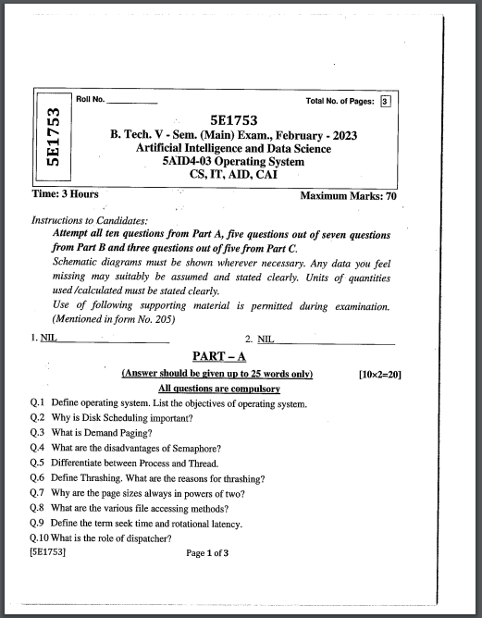

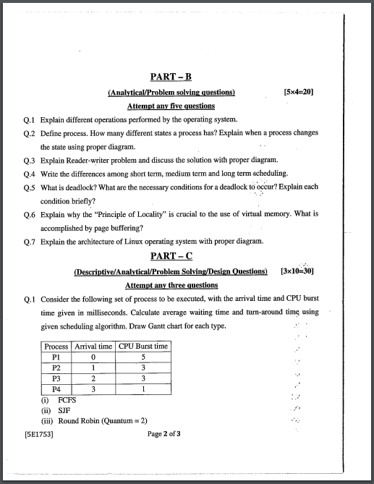

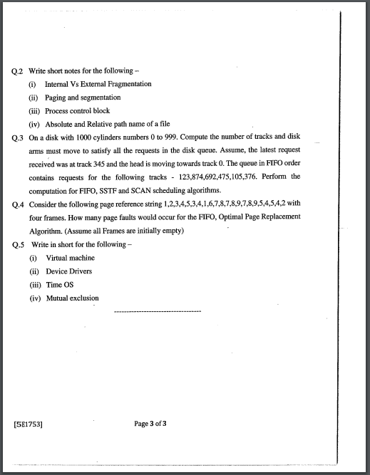

**STUDENT PERFORMANCE REPORT**

|  |  |  |  |
| --- | --- | --- | --- |
| **ROLL NO.** | **NAME** | **ASSIGNMENT-2** | **ASSIGNMENT-2** |
| 21ETCCS001 | AARSH BHARTI | A++ | A++ |
| 21ETCCS002 | MS AASTHA DAKHERA | A+ | A+ |
| 21ETCCS003 | ABHISHEK PRAJAPAT | A++ | A |
| 21ETCCS005 | AKSHANSH SONI | A+ | B+ |
| 21ETCCS006 | AKSHAT SINGH CHOUHAN | A++ | A+ |
| 21ETCCS007 | ANIRUDH SINGH RAJPUROHIT | B+ | B+ |
| 21ETCCS008 | ANISH SINGHAL | A+ | A++ |
| 21ETCCS009 | ANJALI SONI | A+ | A+ |
| 21ETCCS010 | ANURAG MENARIA | A++ | A++ |
| 21ETCCS011 | ANUSHKA VIJAY | A++ | A++ |
| 21ETCCS012 | APURVA LODHA | A | A |
| 21ETCCS013 | ARUN LOHAR | A+ | B+ |
| 21ETCCS014 | ARVIND SINGH | A++ | A++ |
| 21ETCCS015 | ARVIND SUTHAR | A+ | A |
| 21ETCCS016 | AVANI JOSHI | A++ | A++ |
| 21ETCCS017 | AYAN KHAN | A++ | A++ |
| 21ETCCS018 | AYUSH JHOTA | A+ | A+ |
| 21ETCCS019 | AYUSH TALESARA | B+ | A |
| 21ETCCS020 | BHAVYA MEHTA | A+ | A |
| 21ETCCS021 | BHERU SINGH PANWAR | A++ | A++ |
| 21ETCCS022 | MS BHUMIKA VARDAR | A+ | A |
| 21ETCCS025 | CHINMAY MENARIA | A+ | A+ |
| 21ETCCS026 | DAKSH VYAS | A++ | A++ |
| 21ETCCS027 | DEEPAK DHAKAR | A++ | A++ |
| 21ETCCS029 | DHIREN SUHALKA | A+ | A+ |
| 21ETCCS030 | DHRUV BAGORA | A++ | A++ |
| 21ETCCS031 | DIKSHA AGARWAL | A+ | A+ |
| 21ETCCS032 | DINESH AUDICHYA | A+ | A+ |
| 21ETCCS034 | DIVYANSHU MENARIA | A+ | A |
| 21ETCCS035 | DIVYANSHU SAHU | B | B |
| 21ETCCS036 | DURGA SANKAR DANGI | A++ | A++ |
| 21ETCCS037 | GAGAN MANGAL | B+ | A+ |
| 21ETCCS038 | GARVITA BAYA | A++ | A+ |
| 21ETCCS039 | GARVITA JAIN | A+ | A+ |
| 21ETCCS040 | GAZI AMAN KHAN | A++ | A++ |
| 21ETCCS041 | HARSH | B | B |
| 21ETCCS042 | HARSH SONI | A+ | B |
| 21ETCCS043 | HARSHAL PALIWAL | B+ | B |
| 21ETCCS044 | HARSHIT PUROHIT | A+ | A+ |
| 21ETCCS045 | HARSHIT SHARMA | A++ | A++ |
| 21ETCCS046 | HARSHITA RATHORE | A+ | A+ |
| 21ETCCS047 | HEET DOSI | A++ | A++ |
| 21ETCCS048 | MS HETAL SHARMA | A+ | A |
| 21ETCCS049 | JAHNAVI JOSHI | B+ | B |
| 21ETCCS050 | JAINIL JAIN | A+ | A |
| 21ETCCS051 | JASWANT SINGH RAO | B | B |
| 21ETCCS052 | JATIN VASHISHTHA | A++ | A |
| 21ETCCS053 | JAY JOSHI | B+ | B |
| 21ETCCS054 | JAYDEEP DANGI | B+ | B |
| 21ETCCS055 | JIGYASA CHATURVEDI | A++ | A++ |
| 21ETCCS056 | KAILASH JOSHI | A+ | A+ |
| 21ETCCS057 | KAMLESH KUMAR GHANCHI | A++ | A++ |
| 21ETCCS058 | KANISHKA PARMAR | B+ | B |
| 21ETCCS059 | KASHVI PANDEY | B+ | B |
| 21ETCCS060 | KHUSHAL PALIWAL | A++ | A++ |
| 21ETCCS061 | KHUSHI GAHLOT | B+ | B |
| 21ETCCS062 | KHUSHI VANAWAT | A++ | A++ |
| 21ETCCS064 | KUNAL CHOUBISA | A++ | A |
| 21ETCCS065 | KUNAL MENARIA | A+ | A |
| 21ETCCS066 | KUNAL PALIWAL | A++ | A++ |
| 21ETCCS067 | KUNAL SHARMA | A++ | A++ |
| 21ETCCS068 | KUNIKA KADECHA(RL) | A++ | A++ |
| 21ETCCS069 | LALITA DANGI | B+ | A |
| 21ETCCS070 | LAVISHA JAIN | A++ | B |
| 21ETCCS071 | LOKANTIK JAIN | B+ | A++ |
| 21ETCCS073 | MAHAK BANSAL | A++ | A+ |
| 21ETCCS074 | MANSI GEHLOT | A+ | A+ |
| 21ETCCS075 | MAYANK KANERIYA | A+ | A+ |
| 21ETCCS076 | MAYANK MALIWAL | A++ | A++ |
| 21ETCCS078 | MITANSH JAIN | B+ | B |
| 21ETCCS079 | MOHAMMED OWAIS KHAN | A++ | B |
| 21ETCCS081 | NAVNEET ANAND | A++ | B |
| 21ETCCS082 | NEHAL DHING | B+ | B |
| 21ETCCS084 | NIPUN MALI | A++ | A++ |
| 21ETCCS085 | NISHA LOHAR | A++ | A++ |
| 21ETCCS086 | PRADHUMAN SINGH CHAUDHARY | B+ | B |
| 21ETCCS087 | PRANJAL SINGHVI | A++ | A++ |
| 21ETCCS088 | RAJAT PATIDAR | B+ | B |
| 21ETCCS089 | RIYA JAIN | A+ | A+ |
| 21ETCCS090 | ROHIN GANG | A++ | A |
| 21ETCCS091 | RUPAL SONI | A++ | A++ |
| 21ETCCS092 | SAHIL SOLANKI | B+ | B |
| 21ETCCS093 | SARGAM JAIN | A+ | A |
| 21ETCCS094 | SATYEN KHARADI | A+ | B |
| 21ETCCS095 | SHASHANK MENARIA | A++ | A++ |
| 21ETCCS096 | SHUBHAM DAS | B+ | B |
| 21ETCCS097 | SUDEEP ROY | A++ | A++ |
| 21ETCCS098 | SUMIT VASITA | B+ | A |
| 21ETCCS099 | SUYASH SONI | A++ | A++ |
| 21ETCCS100 | MS TANISHA KUMAWAT | A+ | A |
| 21ETCCS101 | TUSHAR YADAV | A+ | A+ |
| 21ETCCS102 | VAIBHAV GARG | A++ | A+ |
| 21ETCCS103 | VAIBHAV SONI | A+ | A+ |
| 21ETCCS104 | VARUN SHARMA | A++ | A++ |
| 21ETCCS105 | VEDANSHI PAREEK | A++ | A++ |
| 21ETCCS106 | VEDAS DIXIT | A++ | A+ |
| 21ETCCS107 | VIKRAM SINGH SISODIYA | A++ | A++ |
| 21ETCCS108 | VIMANYU P SHARMA | A++ | A++ |
| 21ETCCS109 | VISHAL KUMAWAT | A+ | A+ |
| 21ETCCS110 | VISHAL PUSHKARNA | B+ | A |
| 21ETCCS111 | VYOM BHATT | A++ | A++ |
| 21ETCCS112 | YASH JAIN | A++ | A++ |
| 21ETCCS113 | YASH JOSHI | A++ | A++ |
| 21ETCCS114 | YASH PURI GOSWAMI | A+ | A++ |
| 21ETCCS115 | YOGESH JAIPAL | A++ | A |
| 21ETCCS116 | MS YUVIKA CHOUDHARY | A+ | A |
| 21ETCCS117 | YUVRAJ SINGH KANAWAT | A++ | A+ |
| 21ETCCS300 | NEELAM KATARIYA | A+ | A++ |
| 21ETCCS400 | Shabbir Husain | A++ | B |
| 21ETCCS401 | Ali Hussain | A++ | B |
| 22ETCCS200 | Saurabh Soni | A++ | A+ |

|  |
| --- |
|  |
|  |

**Signature of Faculty: Signature of HOD**

**RESULT ANALYSIS**

|  |  |  |  |  |  |
| --- | --- | --- | --- | --- | --- |
| **S.NO.** | **RTU ROLL NUMBER** | **NAME OF STUDENT** | **END TERM MARKS** | **SESSIONAL MARKS** | **TOTAL** |
| **MAX MARKS** | **70** | **30** | **100** |
| **Set Target Level** | | | **60%** | **70%** |  |
|  | 21ETCCS001 | AARSH BHARTI | 43 | 26 | 69 |
|  | 21ETCCS002 | MS AASTHA DAKHERA | 55 | 30 | 85 |
|  | 21ETCCS003 | ABHISHEK PRAJAPAT | 40 | 26 | 66 |
|  | 21ETCCS005 | AKSHANSH SONI | 52 | 30 | 82 |
|  | 21ETCCS006 | AKSHAT SINGH CHOUHAN | 42 | 24 | 66 |
|  | 21ETCCS007 | ANIRUDH SINGH RAJPUROHIT | 42 | 26 | 68 |
|  | 21ETCCS008 | ANISH SINGHAL | 41 | 28 | 69 |
|  | 21ETCCS009 | ANJALI SONI | 60 | 27 | 87 |
|  | 21ETCCS010 | ANURAG MENARIA | 46 | 27 | 73 |
|  | 21ETCCS011 | ANUSHKA VIJAY | 34 | 28 | 62 |
|  | 21ETCCS012 | APURVA LODHA | 46 | 30 | 76 |
|  | 21ETCCS013 | ARUN LOHAR | 47 | 30 | 77 |
|  | 21ETCCS014 | ARVIND SINGH | 41 | 26 | 67 |
|  | 21ETCCS015 | ARVIND SUTHAR | 44 | 25 | 69 |
|  | 21ETCCS016 | AVANI JOSHI | 39 | 26 | 65 |
|  | 21ETCCS017 | AYAN KHAN | 45 | 28 | 73 |
|  | 21ETCCS018 | AYUSH JHOTA | 45 | 27 | 72 |
|  | 21ETCCS019 | AYUSH TALESARA | 42 | 25 | 67 |
|  | 21ETCCS020 | BHAVYA MEHTA | 40 | 27 | 67 |
|  | 21ETCCS021 | BHERU SINGH PANWAR | 41 | 30 | 71 |
|  | 21ETCCS022 | MS BHUMIKA VARDAR | 45 | 27 | 72 |
|  | 21ETCCS025 | CHINMAY MENARIA | 40 | 27 | 67 |
|  | 21ETCCS026 | DAKSH VYAS | 51 | 27 | 78 |
|  | 21ETCCS027 | DEEPAK DHAKAR | 38 | 26 | 64 |
|  | 21ETCCS029 | DHIREN SUHALKA | 32 | 25 | 57 |
|  | 21ETCCS030 | DHRUV BAGORA | 55 | 27 | 82 |
|  | 21ETCCS031 | DIKSHA AGARWAL | 57 | 28 | 85 |
|  | 21ETCCS032 | DINESH AUDICHYA | 42 | 27 | 69 |
|  | 21ETCCS034 | DIVYANSHU MENARIA | 43 | 25 | 68 |
|  | 21ETCCS035 | DIVYANSHU SAHU | 30 | 30 | 60 |
|  | 21ETCCS036 | DURGA SANKAR DANGI | 35 | 30 | 65 |
|  | 21ETCCS037 | GAGAN MANGAL | 50 | 28 | 78 |
|  | 21ETCCS038 | GARVITA BAYA | 39 | 30 | 69 |
|  | 21ETCCS039 | GARVITA JAIN | 64 | 30 | 94 |
|  | 21ETCCS040 | GAZI AMAN KHAN | 25 | 22 | 47 |
|  | 21ETCCS041 | HARSH | 26 | 25 | 51 |
|  | 21ETCCS042 | HARSH SONI | 40 | 30 | 70 |
|  | 21ETCCS043 | HARSHAL PALIWAL | 28 | 26 | 54 |
|  | 21ETCCS044 | HARSHIT PUROHIT | 52 | 30 | 82 |
|  | 21ETCCS045 | HARSHIT SHARMA | 50 | 28 | 78 |
|  | 21ETCCS046 | HARSHITA RATHORE | 46 | 25 | 71 |
|  | 21ETCCS047 | HEET DOSI | 29 | 25 | 54 |
|  | 21ETCCS048 | MS HETAL SHARMA | 38 | 27 | 65 |
|  | 21ETCCS049 | JAHNAVI JOSHI | 51 | 30 | 81 |
|  | 21ETCCS050 | JAINIL JAIN | 42 | 28 | 70 |
|  | 21ETCCS051 | JASWANT SINGH RAO | 50 | 27 | 77 |
|  | 21ETCCS052 | JATIN VASHISHTHA | 51 | 27 | 78 |
|  | 21ETCCS053 | JAY JOSHI | 66 | 30 | 96 |
|  | 21ETCCS054 | JAYDEEP DANGI | 56 | 30 | 86 |
|  | 21ETCCS055 | JIGYASA CHATURVEDI | 30 | 27 | 57 |
|  | 21ETCCS056 | KAILASH JOSHI | 40 | 28 | 68 |
|  | 21ETCCS057 | KAMLESH KUMAR GHANCHI | 35 | 30 | 65 |
|  | 21ETCCS058 | KANISHKA PARMAR | 67 | 30 | 97 |
|  | 21ETCCS059 | KASHVI PANDEY | 53 | 30 | 83 |
|  | 21ETCCS060 | KHUSHAL PALIWAL | 36 | 27 | 63 |
|  | 21ETCCS061 | KHUSHI GAHLOT | 48 | 30 | 78 |
|  | 21ETCCS062 | KHUSHI VANAWAT | 40 | 27 | 67 |
|  | 21ETCCS064 | KUNAL CHOUBISA | 20 | 25 | 45 |
|  | 21ETCCS065 | KUNAL MENARIA | 25 | 25 | 50 |
|  | 21ETCCS066 | KUNAL PALIWAL | 18 | 25 | 43 |
|  | 21ETCCS067 | KUNAL SHARMA | 28 | 27 | 55 |
|  | 21ETCCS068 | KUNIKA KADECHA(RL) | 46 | 26 | 72 |
|  | 21ETCCS069 | LALITA DANGI | 38 | 30 | 68 |
|  | 21ETCCS070 | LAVISHA JAIN | 49 | 30 | 79 |
|  | 21ETCCS071 | LOKANTIK JAIN | 33 | 30 | 63 |
|  | 21ETCCS073 | MAHAK BANSAL | 43 | 26 | 69 |
|  | 21ETCCS074 | MANSI GEHLOT | 60 | 30 | 90 |
|  | 21ETCCS075 | MAYANK KANERIYA | 57 | 30 | 87 |
|  | 21ETCCS076 | MAYANK MALIWAL | 46 | 28 | 74 |
|  | 21ETCCS078 | MITANSH JAIN | 32 | 25 | 57 |
|  | 21ETCCS079 | MOHAMMED OWAIS KHAN | 42 | 25 | 67 |
|  | 21ETCCS081 | NAVNEET ANAND | 43 | 28 | 71 |
|  | 21ETCCS082 | NEHAL DHING | 31 | 30 | 61 |
|  | 21ETCCS084 | NIPUN MALI | 40 | 26 | 66 |
|  | 21ETCCS085 | NISHA LOHAR | 46 | 30 | 76 |
|  | 21ETCCS086 | PRADHUMAN SINGH CHAUDHARY | 40 | 30 | 70 |
|  | 21ETCCS087 | PRANJAL SINGHVI | 48 | 27 | 75 |
|  | 21ETCCS088 | RAJAT PATIDAR | 37 | 25 | 62 |
|  | 21ETCCS089 | RIYA JAIN | 56 | 30 | 86 |
|  | 21ETCCS090 | ROHIN GANG | 43 | 25 | 68 |
|  | 21ETCCS091 | RUPAL SONI | 40 | 30 | 70 |
|  | 21ETCCS092 | SAHIL SOLANKI | 51 | 28 | 79 |
|  | 21ETCCS093 | SARGAM JAIN | 51 | 30 | 81 |
|  | 21ETCCS094 | SATYEN KHARADI | 58 | 28 | 86 |
|  | 21ETCCS095 | SHASHANK MENARIA | 28 | 26 | 54 |
|  | 21ETCCS096 | SHUBHAM DAS | 37 | 28 | 65 |
|  | 21ETCCS097 | SUDEEP ROY | 27 | 25 | 52 |
|  | 21ETCCS098 | SUMIT VASITA | 19 | 24 | 43 |
|  | 21ETCCS099 | SUYASH SONI | 49 | 27 | 76 |
|  | 21ETCCS100 | MS TANISHA KUMAWAT | 45 | 30 | 75 |
|  | 21ETCCS101 | TUSHAR YADAV | 28 | 24 | 52 |
|  | 21ETCCS102 | VAIBHAV GARG | 35 | 30 | 65 |
|  | 21ETCCS103 | VAIBHAV SONI | 58 | 30 | 88 |
|  | 21ETCCS104 | VARUN SHARMA | 37 | 26 | 63 |
|  | 21ETCCS105 | VEDANSHI PAREEK | 52 | 30 | 82 |
|  | 21ETCCS106 | VEDAS DIXIT | 52 | 27 | 79 |
|  | 21ETCCS107 | VIKRAM SINGH SISODIYA | 57 | 30 | 87 |
|  | 21ETCCS108 | VIMANYU P SHARMA | 42 | 28 | 70 |
|  | 21ETCCS109 | VISHAL KUMAWAT | 43 | 26 | 69 |
|  | 21ETCCS110 | VISHAL PUSHKARNA | 47 | 28 | 75 |
|  | 21ETCCS111 | VYOM BHATT | 45 | 28 | 73 |
|  | 21ETCCS112 | YASH JAIN | 46 | 26 | 72 |
|  | 21ETCCS113 | YASH JOSHI | 28 | 27 | 55 |
|  | 21ETCCS114 | YASH PURI GOSWAMI | 40 | 28 | 68 |
|  | 21ETCCS115 | YOGESH JAIPAL | 29 | 26 | 55 |
|  | 21ETCCS116 | MS YUVIKA CHOUDHARY | 39 | 26 | 65 |
|  | 21ETCCS117 | YUVRAJ SINGH KANAWAT | 33 | 25 | 58 |
|  | 21ETCCS300 | NEELAM KATARIYA | 37 | 27 | 64 |
|  | 21ETCCS400 | Shabbir Husain | 32 | 22 | 54 |
|  | 21ETCCS401 | Ali Hussain | 43 | 22 | 65 |
|  | 22ETCCS200 | Saurabh Soni | 37 | 30 | 67 |

|  |  |  |  |  |
| --- | --- | --- | --- | --- |
| TOTAL | PASS | FAIL | ABSENT | PASS % |
| 111 | 111 | 0 | 0 | 100 |

**Indirect Assessment:**

**Overall Teacher Self Assessment (at the completion of course) in terms of course objective and outcomes**

**Course Objectives:**

* Explore different OS architectures, such as monolithic, microkernel, and hybrid structures.
* Learn the concepts of processes and threads, process scheduling, and synchronization to manage concurrent execution efficiently.
* Understand memory hierarchy, virtual memory, and memory allocation techniques to optimize resource usage.
* Examine security measures and access control mechanisms implemented by operating systems to ensure data integrity and protect against unauthorized access.

**Course Outcomes**:

* Students will be able to summarize principles of operating systems, design, and implementations, Understand the various components and functions of an operating system.
* Students will be able to analyze and apply suitable Process Scheduling Algorithm and Memory Partition Techniques, apply appropriate techniques to avoid control problems such as mutual exclusion and deadlocks
* Students will be able to memorize deadlock, Methods for handling deadlocks and memory management strategies
* Students will be able to compare various memory management algorithm and CPU scheduling techniques. Implement and evaluate operating system components in Windows and Unix environments
* Students will be able to measure and memorize various file and disk management strategies.

**Methodology to identify bright student**

Considered a range of criteria, including academic performance, creativity, critical thinking, problem-solving skills, and enthusiasm for learning. Bright students often excel in multiple areas. Observed how students perform in the classroom. In terms of active participation, engagement in discussions, leadership, and the ability to grasp complex concepts.

**Efforts to keep students engaged**

1. Active Learning:
   * Incorporate active learning strategies, such as group discussions, problem-solving activities, and hands-on projects. Active participation keeps students engaged and encourages critical thinking.
2. Varied Teaching Methods:
   * Use a variety of teaching methods, including lectures, group work, multimedia presentations, and interactive activities to cater to different learning preferences.
3. Technology Integration:
   * Leverage technology, such as online platforms, educational apps, and interactive software, to make lessons more engaging and interactive.

Some extra learning for bright students

1. <https://www.geeksforgeeks.org/operating-systems/>

2. <https://www.javatpoint.com/os-fcfs-with-overhead>

3. <https://www.javatpoint.com/os-sjf-scheduling>

**Methodology to identify weak student**

Considered a range of criteria, including classroom observation, formative assessment, summative assessment, assignment review e.t.c. Weak students are struggling students with sensitivity and a desire to support their learning. Some measures, such as additional tutoring, personalized assignments, or alternative assessment methods, to help students succeed.

**Targeted inventions for weak student**

**1. Additional Resources**

Offer supplementary learning materials, such as textbooks, online resources, or multimedia content, to provide alternative explanations and reinforce key concepts.

**2. Remedial classes**

Establish a tutoring program where students can receive extra help from teachers.

**3. Flipped classroom**

Students are assigned pre-class learning materials, often in the form of videos, readings, or online modules, to cover the foundational concepts before coming to class.

Some additional resources or links for student to improve their understanding for topic

1. <https://archive.nptel.ac.in/courses/106/105/106105214/>

2. Operating System by Gates Smashers

3. Operating system by Neso academy.

4. **Operating System Concepts" by Abraham Silberschatz, Peter B. Galvin, and Greg Gagne**

This book is widely used in undergraduate operating systems courses. It covers fundamental concepts such as processes, memory management, file systems, and more.