Z

**Course File**

***Subject Title/Subject Cod : Analysis of Algorithms/5CS4-05***

Semester : V Year : III

| Name of the Faculty: Kirti Dashora |  | |
| --- | --- | --- |
|  |  | |
| E-mail id: kirti.dashora@technonjr.org |  |

**Class Schedule**

**Total Number of Lectures:** 42

i**)Course Objective**

**To develop efficient solutions to a wide range of computational problems and make informed decisions when selecting algorithms for specific applications**

**INDEX - COURSE FILE**

| **S. No.** | **CONTENT / ITEM NO.** | **PAGE NO.** |
| --- | --- | --- |
| **Status** |
| 1 | Vision And Mission Of The Institute |  |  |
| 2 | Vision And Mission Of The Department |  |  |
| 3 | Program Educational Objective Of Department (PEO’s) |  |  |
| 4 | Program Outcomes Of Department (PO’s) |  |  |
| 5 | Course Outcome (COs) |  |  |
| 6 | COs mapping with Pos and PSOs |  |  |
| 7 | Academic Calendar |  |  |
| 8 | Evaluation Scheme |  |  |
| 9 | Course Syllabus |  |  |
| 10 | Prescribed Books |  |  |
| 11 | Copy Of Time Table |  |  |
| 12 | Course Schedule Plan |  |  |
| 13 | Assignment Sheet (Unit Wise) |  |  |
| 14 | Quiz Questions (One From Each Unit) |  |  |
| 15 | Question Papers Of Mid Term Exam-I |  |  |
| 16 | Marks and Gap Analysis in Mid Term I |  |  |
| 17 | Remedial Action Taken To Remove the Gaps after mid Term I |  |  |
| 18 | Question Papers Of Mid Term Exam-II |  |  |
| 19 | Gap Analysis in Mid Term II |  |  |
| 20 | Remedial Action Taken To Remove the Gaps after mid Term II |  |  |
| 21 | Model Question Paper With Key Solution |  |  |
| 22 | University Question Paper (Last one year) |  |  |
| 23 | Student Performance Report |  |  |
| 24 | Result Analysis |  |  |

**VISSION & MISSION OF INSTITUTE**

## Vision

Empowering student with recent and emerging technologies to create innovative technical leaders capable of contributing to industrial and societal needs for betterment of mankind across the globe.

## Mission

**M1**: To provide dynamic learning environment to students by providing constant exposure to latest technologies by linking closely with the industries.

**M2**: To establish effective interface with industry to obtain live problems to enhance critical thinking and problem solving skills among students and consultancy projects for faculty.

**M3**: To provide avenues and opportunities to faculty for domain specific trainings and qualification upgradation.

**M4**: To develop ethical leaders with strong communication skills.

**VISION & MISSION OF DEPARTMENT**

**Department Vision**

**To be among top five well known department of Computer Science and Engineering in the state of Rajasthan in placing the students at premier industry.**

**Department Mission**

**M1: To equip students with ability to be innovative and excellence to face the challenges in the digital world.**

**M2: To prepare students with high quality employability skills catering to current trends in industries, problem solving skills, innovative pursuits and ready to face challenges in the domain and allied disciplines.**

**M3: To provide ambience for entrepreneurship and start-ups through incubation center among students.**

**M4: To encourage continuous faculty training on industry-based Development, and Innovation.**

**PROGRAMME EDUCATIONAL OBJECTIVES (PEOs)**

**Technical Proficiency** Graduates will have a strong foundation in core concepts, tools, and technologies relevant to their discipline.

**Career Development** Graduate will be capable of pursuing diverse career paths in field of Computer Science & Engineering with proficiency in software development/ pursue higher education an or become entrepreneurs.

**Problem-Solving** Graduates will have a strong math foundation so that they will be proficient problem solvers, capable of identifying, analyzing , and solving complex technical problems using critical thinking and creative approaches.

**Professional Attitude** Graduates will be sensitive to societal and professional environment, possess strong communication skills and will be skilled in working collaboratively within diverse teams adhering to ethical standards and professional practices.

**Learning Environment** To create a learning environment that ensures graduates continue learning throughout their careers, effortlessly adopting new technologies to stay innovative in their chosen fields and remain effective contributors in their chosen field.

**PROGRAM SPECIFIC OUTCOMES (PSO's)**

**PSO1**: Students will be able to design, develop, test, debug, deploy, analyze , troubleshoot, maintain, manage, and ensure security during the complete product lifecycle.

**PSO2**: Student will be able to apply software engineering/ information system development skills to solve problems across diverse domains.

**PSO3**: Students will be well-prepared to initiate and oversee innovative startups within their respective sectors.

**PROGRAMME OUTCOMES (POs)**

**A student will develop:**

**PO01. ENGINEERING KNOWLEDGE:** An ability to apply knowledge of Mathematics, Science and Engineering Fundamentals in Electronics and Communication Engineering.

**PO02. PROBLEM ANALYSIS:** ability to analyze and interpret data by designing and conducting experiments. Develop the knowledge of developing algorithms, designing, implementation and testing applications in electronics and communication related areas.

**PO03. DESIGN/ DEVELOPMENT OF SOLUTION:** An ability to Design a system Component or process to meet desired needs within realistic constraints such as economic, environmental, social, political, ethical, health and safety, manufacturability, and sustainability.

**PO04. CONDUCTION OF INVESTIGATION OF COMPLEX PROBLEMS:** Ability to Identify, formulate and solve engineering problems.

**PO05. MODERN TOOL USAGE:** An ability to use the techniques, skills and modern engineering tools necessary for engineering practice.

**PO06. THE ENGINEERING AND SOCIETY:** Broad education necessary to understand the impact of engineering solutions in a global, economic, environmental and societal context.

**PO07. ENVIRONMENT & SUSTAINABILITY:** Understand the impact of professional engineering solution in societal and environmental contexts, and demonstrate the knowledge of, and need of sustainable development.

**PO08. ETHICS:** An ability to understand the professional, social and ethical responsibility.

**PO09. INDIVIDUAL AND TEAM WORK:** Function effectively as an individual, and as a member or leader in diverse teams, and in multidisciplinary settings.

**PO10. COMMUNICATION:** An ability to Communicate effectively in order to succeed in their profession such as, being able to write effective reports and design documentation, make effective presentations.

**PO11. PROJECT MANAGEMENT & FINANCE:** Demonstrate knowledge and understanding of the engineering and management principles and apply these to one’s own work, as a member and leader in team, to manage projects and in multidisciplinary environment.

**PO12. LIFE-LONG LEARNING:** Recognize the need and an ability to engage in life-long learning.

**COURSE OUTCOMES (COs) OF THE SUBJECT**

| CO No. | Mapping | Statement |
| --- | --- | --- |
| CO35402.1 | Analyzing | Student will be able to design algorithms and to analyze the performance of algorithms by identify different aspects of time and space complexity of recursive and non recursive codes |
| CO35402.2 | Applying | Students will able to apply various algorithms for different computing problems using dynamic programming and branch and bound techniques and try to solve different more real time complex problems |
| CO35402.3 | Evaluating | Students will be able to design and evaluate algorithms using various algorithm design techniques for pattern matching algorithms formulate assignment problems |
| CO35402.4 | Analyzing | Students will be able to analyze randomized algorithms, Recite algorithms that employ randomization. |
| CO35402.5 | Understanding | Relate the concepts of NP Completeness for analyze and solving the complexity of real life problems. |

**COS MAPPING WITH POs AND PSOs**

| **Course Outcome** | **Program Outcomes (PO’s)** | | | | | | | | | | | |
| --- | --- | --- | --- | --- | --- | --- | --- | --- | --- | --- | --- | --- |
| **CO. NO.** | **Domain Specific (PSO)** | | | | | **Domain Independent (PO)** | | | | | | |
|  | **PO1** | **PO2** | **PO3** | **PO4** | **PO5** | **PO6** | **PO7** | **PO8** | **PO9** | **PO10** | **PO11** | **PO12** |
| CO1 | 2 | 2 | 3 | 2 | 1 | 0 | 0 | 1 | 1 | 0 | 0 | 1 |
| CO2 | 2 | 2 | 3 | 3 | 1 | 0 | 0 | 0 | 0 | 0 | 0 | 1 |
| CO3 | 2 | 3 | 3 | 1 | 1 | 0 | 0 | 1 | 0 | 0 | 0 | 1 |
| CO4 | 1 | 2 | 3 | 2 | 1 | 0 | 0 | 1 | 0 | 0 | 0 | 1 |
| CO5 | 3 | 2 | 3 | 2 | 0 | 0 | 0 | 0 | 1 | 0 | 0 | 1 |
| 1: Slight (Low) , 2: Moderate (Medium), 3: Substantial (High) | | | | | | | | | | | | |

**UNIVERSITY ACADEMIC CALENDAR**

Academic Calendar for Even Semester for Session

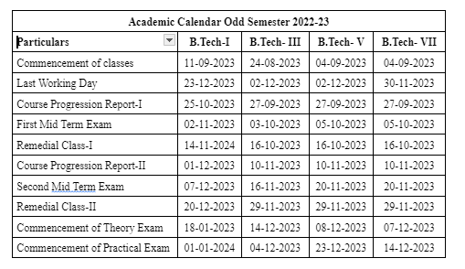

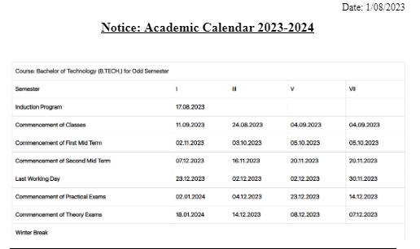

**Evaluation Scheme**

FACULTY DETAILS:

Name of the Faculty : Kirti Dashora

Designation : Assistant Professor

Department : Computer Science Engineering

1. TARGET

a) Percentage Pass : 100%

b) Percentage I class: 60 %

2. METHOD OF EVALUATION

2.1. Continuous Assessment Examinations (Mid-Term 1, Mid-Term 2)

2.2. Assignments / Seminars 

2.3. Mini Projects 

2.4. Quiz 

2.5. Semester Examination Others___________________________________________________

3. List out any new topic(s) or any innovation you would like to introduce in teaching the subject in this Semester.

1. Take the help of creative tools to stimulate creativity. Include slide presentations, demonstration or forms of visual exercises that will excite the young minds and capture their interest.

Signature of Faculty: **Signature of HOD**

**UNIVERSITY SYLLABUS**

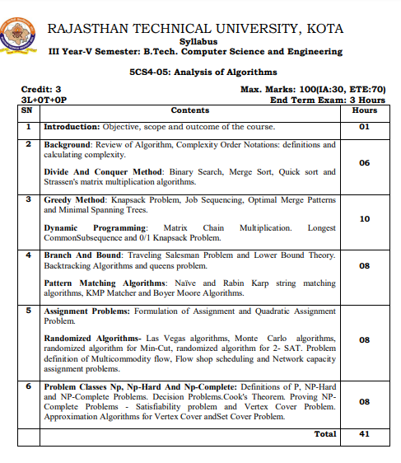

**PRESCRIBED BOOKS**

1. Cormen, Leiserson, Rivest: Introduction to Algorithms, Prentice Hall of India.

2. Horowitz and Sahani: Fundamental of Computer algorithms.

3. Aho A.V , J.D Ulman: Design and analysis of Algorithms, Addison Wesley

**WEEKLY TIME TABLE OF THE TEACHER**

First Time Table: with effect from (Date):

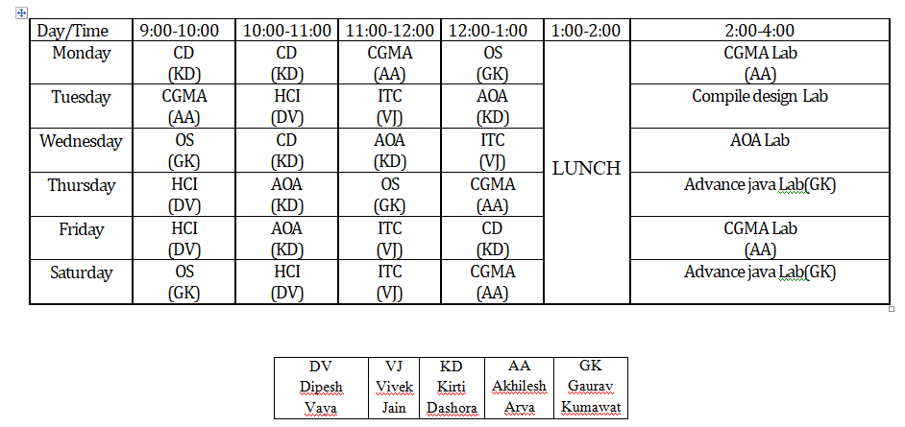

**COURSE-PLAN**

| UNIT | Lect.  No. | TOPICS | **Teaching Methods/ Teaching Aids** |
| --- | --- | --- | --- |
| **1** | **1** | **Introduction:** Objective, scope and outcome of the course | White Board, PPT, |
| 1 | 2 | **Background**: Review of Algorithm | White Board, PPT, Demonstration |
| 1 | 3 | Complexity Order Notations: definitions and calculating complexity | White Board |
| 1 | 4 | **Divide And Conquer Method** | White Board |
| 1 | 5 | Binary Search, Merge Sort | White Board, PPT |
| 1 | 6 | Quick sort | White Board |
| 1 | 7 | Strassen's matrix multiplication algorithms | White Board, PPT |
| 2 | 8 | **Greedy Method**: | White Board |
| 2 | 9 | Knapsack Problem | White Board, PPT, |
| 2 | 10 | Job Sequencing | White Board, PPT, Demonstration |
| 2 | 11 | Optimal Merge Patterns | White Board |
| 2 | 12 | Minimal Spanning Trees | White Board |
| 2 | 13 | **Dynamic Programming** | White Board, PPT |
| 2 | 14 | Matrix Chain Multiplication | White Board |
| 2 | 15 | Matrix Chain Multiplication | White Board, PPT |
| 2 | 16 | Longest Common Subsequence | White Board |
| 2 | 17 | 0/1 Knapsack Problem. | White Board, PPT, |
| 2 | 18 | **Branch And Bound** | White Board, Demonstration |
| 3 | 19 | Traveling Salesman Problem | White Board |
| 3 | 20 | Lower Bound Theory | White Board |
| 3 | 21 | Backtracking Algorithms and queens problem | White Board, PPT |
| 3 | 22 | **Pattern Matching Algorithms**Naïve | White Board |
| 3 | 23 | Rabin Karp string matching algorithms | White Board, PPT |
| 3 | 24 | KMP Matcher | White Board |
| 3 | 25 | Boyer Moore Algorithms | White Board, PPT, |
| 4 | 26 | **Assignment Problems** | White Board, PPT, Demonstration |
| 4 | 27 | Formulation of Assignment | White Board |
| 4 | 28 | Quadratic Assignment Problem. | White Board |
| 4 | 29 | **Randomized Algorithms** | White Board, PPT |
| 4 | 30 | Las Vegas algorithms, Monte Carlo algorithms | White Board |
| 5 | **31** | Randomized algorithm for Min-Cut, randomized algorithm for 2- SAT | White Board, PPT |
| 5 | 31 | Problem definition of Multicommodity flow | White Board |
| 5 | 33 | Flow shop scheduling | White Board, PPT, |
| 5 | 34 | Network capacity assignment problems | White Board, PPT, Demonstration |
| 5 | 35 | **Problem Classes Np, Np-Hard And Np-Complete** | White Board |
| 5 | 36 | Definitions of P, NP-Hard and NP-Complete Problems | White Board |
| 5 | 37 | Decision Problems. Cook's Theorem | White Board, PPT |
| 5 | 38 | Proving NP Complete Problems | White Board |
| 5 | 39 | Satisfiability problem | White Board, PPT |
| 5 | 40 | Vertex Cover Problem | White Board |

**Signature of Faculty: Signature of HOD**

**Assignment – 1 ()**

**Assignment – 1 ()**

1. Perform best , average and worst case run time analysis of insertion sort algorithm? [CO-1]

2. Explain O,Ω,ᶿ, notations for a given function f(n)=5n2+3n-7 [CO-1]

3. Write an algorithm for merge sort and sort given list using merge sort method

20,35,18,8,14,41,3,33 [CO-2]

4. Differentiate between Greedy algorithm and Dynamic programming [CO-2]

5. Write a program for 0/1 knapsack problem using backtracking strategy.[CO-2]

ependency graph III) Syntax tree. **(CO3)**

**Assignment – 2 ()**

1. List the various string matching algorithms along with worst case complexity.[CO-3]

2. Explain Quadratic and Biquadratic assignment Problem. [CO-3]

3. Explain flow shop scheduling problem with the help of example. [CO-4]

4. What is difference between Quick sort and randomized Quick sort? [CO-4]

5. State and prove Cook’s theorem. [CO-5]

**SAMPLE QUIZ QUESTIONS**

| 1. | **Which of the following algorithms are used to find the shortest path from a source node to all other nodes in a weighted graph?** |
| --- | --- |
| 2. | **What is the maximum number of swaps that can be performed in the Selection Sort algorithm?** |
| 3. | **What is the technique called in which it does not require extra memory for carrying out the sorting procedure?** |
| 4. | **What is the time complexity in decreasing the node value in a binomial heap?** |
| 5. | **What is the time complexity of the binary search algorithm?** |
| 6. | **What is the time complexity of the following code snippet in C++?** |
| 7. | **What is the time complexity of the Sieve of Eratosthenes to check if a number is prime?** |
| 8. | **What is the time complexity to insert an element to the front of a LinkedList(head pointer given)?** |
| 9. | **What should be considered when designing an algorithm?** |
| 10. | **What will be the best sorting algorithm, given that the array elements are small (<= 1e6)?** |
| 11. | **When a pop() operation is called on an empty queue, what is the condition called?** |
| 12. | **Which of the following algorithms are used for string and pattern matching problems??** |
| 13. | **What is the best time complexity we can achieve to precompute all-pairs shortest paths in a weighted graph?** |
| 14. | **Which of the following are applications of Topological Sort of a graph?** |
| 15. | **Which of the following data structure is used to perform recursion?** |

**Mid Term Paper-I**

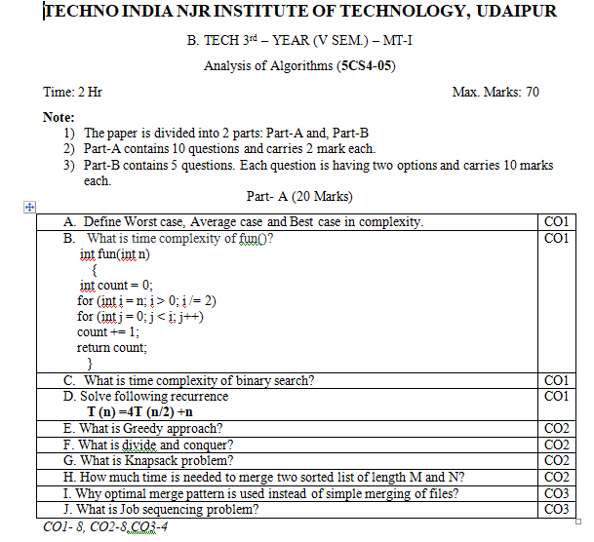

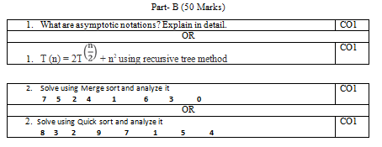

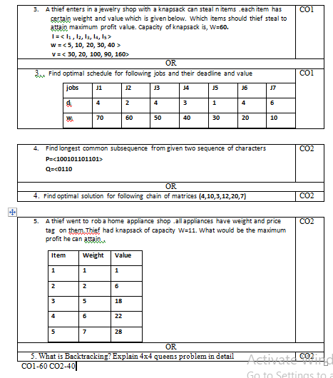

**Marks and Gap Analysis of Mid-Term 1**

| S.No. | University Roll No. | Name of Student | Mid-Term 1  MM-32 | Remark  ( Remedial Class need or not – Y/N ) |
| --- | --- | --- | --- | --- |
| 1 | 21ETCCS001 | AARSH BHARTI | 60 | N |
| 2 | 21ETCCS002 | MS AASTHA DAKHERA | 70 | N |
| 3 | 21ETCCS003 | ABHISHEK PRAJAPAT | 50 | N |
| 4 | 21ETCCS005 | AKSHANSH SONI | 57 | N |
| 5 | 21ETCCS006 | AKSHAT SINGH CHOUHAN | 51 | N |
| 6 | 21ETCCS007 | ANIRUDH SINGH RAJPUROHIT | 55 | N |
| 7 | 21ETCCS008 | ANISH SINGHAL | 61 | N |
| 8 | 21ETCCS009 | ANJALI SONI | 52 | N |
| 9 | 21ETCCS010 | ANURAG MENARIA | 54 | N |
| 10 | 21ETCCS011 | ANUSHKA VIJAY | 57 | N |
| 11 | 21ETCCS012 | APURVA LODHA | 70 | N |
| 12 | 21ETCCS013 | ARUN LOHAR | 58 | N |
| 13 | 21ETCCS014 | ARVIND SINGH | 54 | N |
| 14 | 21ETCCS015 | ARVIND SUTHAR | 58 | N |
| 15 | 21ETCCS016 | AVANI JOSHI | 55 | N |
| 16 | 21ETCCS017 | AYAN KHAN | 61 | N |
| 17 | 21ETCCS018 | AYUSH JHOTA | 70 | N |
| 18 | 21ETCCS019 | AYUSH TALESARA | 59 | N |
| 19 | 21ETCCS020 | BHAVYA MEHTA | 55 | N |
| 20 | 21ETCCS021 | BHERU SINGH PANWAR | 61 | N |
| 21 | 21ETCCS022 | MS BHUMIKA VARDAR | 70 | N |
| 22 | 21ETCCS025 | CHINMAY MENARIA | 70 | N |
| 23 | 21ETCCS026 | DAKSH VYAS | 62 | N |
| 24 | 21ETCCS027 | DEEPAK DHAKAR | 59 | N |
| 25 | 21ETCCS029 | DHIREN SUHALKA | 44 | N |
| 26 | 21ETCCS030 | DHRUV BAGORA | 45 | N |
| 27 | 21ETCCS031 | DIKSHA AGARWAL | 70 | N |
| 28 | 21ETCCS032 | DINESH AUDICHYA | 56 | N |
| 29 | 21ETCCS034 | DIVYANSHU MENARIA | 60 | N |
| 30 | 21ETCCS035 | DIVYANSHU SAHU | 70 | N |
| 31 | 21ETCCS036 | DURGA SANKAR DANGI | 62 | N |
| 32 | 21ETCCS037 | GAGAN MANGAL | 70 | N |
| 33 | 21ETCCS038 | GARVITA BAYA | 70 | N |
| 34 | 21ETCCS039 | GARVITA JAIN | 62 | N |
| 35 | 21ETCCS040 | GAZI AMAN KHAN | 59 | N |
| 36 | 21ETCCS041 | HARSH | 43 | N |
| 37 | 21ETCCS042 | HARSH SONI | 70 | N |
| 38 | 21ETCCS043 | HARSHAL PALIWAL | 63 | N |
| 39 | 21ETCCS044 | HARSHIT PUROHIT | 70 | N |
| 40 | 21ETCCS045 | HARSHIT SHARMA | 70 | N |
| 41 | 21ETCCS046 | HARSHITA RATHORE | 60 | N |
| 42 | 21ETCCS047 | HEET DOSI | 46 | N |
| 43 | 21ETCCS048 | MS HETAL SHARMA | 60 | N |
| 44 | 21ETCCS049 | JAHNAVI JOSHI | 70 | N |
| 45 | 21ETCCS050 | JAINIL JAIN | 66 | N |
| 46 | 21ETCCS051 | JASWANT SINGH RAO | 62 | N |
| 47 | 21ETCCS052 | JATIN VASHISHTHA | 62 | N |
| 48 | 21ETCCS053 | JAY JOSHI | 70 | N |
| 49 | 21ETCCS054 | JAYDEEP DANGI | 67 | N |
| 50 | 21ETCCS055 | JIGYASA CHATURVEDI | 67 | N |
| 51 | 21ETCCS056 | KAILASH JOSHI | 70 | N |
| 52 | 21ETCCS057 | KAMLESH KUMAR GHANCHI | 67 | N |
| 53 | 21ETCCS058 | KANISHKA PARMAR | 70 | N |
| 54 | 21ETCCS059 | KASHVI PANDEY | 61 | N |
| 55 | 21ETCCS060 | KHUSHAL PALIWAL | 66 | N |
| 56 | 21ETCCS061 | KHUSHI GAHLOT | 70 | N |
| 57 | 21ETCCS062 | KHUSHI VANAWAT | 68 | N |
| 58 | 21ETCCS064 | KUNAL CHOUBISA | 47 | N |
| 59 | 21ETCCS065 | KUNAL MENARIA | 56 | N |
| 60 | 21ETCCS066 | KUNAL PALIWAL | 66 | N |
| 61 | 21ETCCS067 | KUNAL SHARMA | 62 | N |
| 62 | 21ETCCS068 | KUNIKA KADECHA(RL) | 66 | N |
| 63 | 21ETCCS069 | LALITA DANGI | 69 | N |
| 64 | 21ETCCS070 | LAVISHA JAIN | 69 | N |
| 65 | 21ETCCS071 | LOKANTIK JAIN | 66 | N |
| 66 | 21ETCCS073 | MAHAK BANSAL | 70 | N |
| 67 | 21ETCCS074 | MANSI GEHLOT | 70 | N |
| 68 | 21ETCCS075 | MAYANK KANERIYA | 56 | N |
| 69 | 21ETCCS076 | MAYANK MALIWAL | 62 | N |
| 70 | 21ETCCS078 | MITANSH JAIN | 63 | N |
| 71 | 21ETCCS079 | MOHAMMED OWAIS KHAN | 50 | N |
| 72 | 21ETCCS081 | NAVNEET ANAND | 60 | N |
| 73 | 21ETCCS082 | NEHAL DHING | 70 | N |
| 74 | 21ETCCS084 | NIPUN MALI | 57 | N |
| 75 | 21ETCCS085 | NISHA LOHAR | 70 | N |
| 76 | 21ETCCS086 | PRADHUMAN SINGH CHAUDHARY | 70 | N |
| 77 | 21ETCCS087 | PRANJAL SINGHVI | 61 | N |
| 78 | 21ETCCS088 | RAJAT PATIDAR | 65 | N |
| 79 | 21ETCCS089 | RIYA JAIN | 70 | N |
| 80 | 21ETCCS090 | ROHIN GANG | 51 | N |
| 81 | 21ETCCS091 | RUPAL SONI | 70 | N |
| 82 | 21ETCCS092 | SAHIL SOLANKI | 67 | N |
| 83 | 21ETCCS093 | SARGAM JAIN | 70 | N |
| 84 | 21ETCCS094 | SATYEN KHARADI | 57 | N |
| 85 | 21ETCCS095 | SHASHANK MENARIA | 59 | N |
| 86 | 21ETCCS096 | SHUBHAM DAS | 68 | N |
| 87 | 21ETCCS097 | SUDEEP ROY | 50 | N |
| 88 | 21ETCCS098 | SUMIT VASITA | 44 | N |
| 89 | 21ETCCS099 | SUYASH SONI | 70 | N |
| 90 | 21ETCCS100 | MS TANISHA KUMAWAT | 70 | N |
| 91 | 21ETCCS101 | TUSHAR YADAV | 51 | N |
| 92 | 21ETCCS102 | VAIBHAV GARG | 61 | N |
| 93 | 21ETCCS103 | VAIBHAV SONI | 70 | N |
| 94 | 21ETCCS104 | VARUN SHARMA | 59 | N |
| 95 | 21ETCCS105 | VEDANSHI PAREEK | 61 | N |
| 96 | 21ETCCS106 | VEDAS DIXIT | 59 | N |
| 97 | 21ETCCS107 | VIKRAM SINGH SISODIYA | 70 | N |
| 98 | 21ETCCS108 | VIMANYU P SHARMA | 52 | N |
| 99 | 21ETCCS109 | VISHAL KUMAWAT | 68 | N |
| 100 | 21ETCCS110 | VISHAL PUSHKARNA | 54 | N |
| 101 | 21ETCCS111 | VYOM BHATT | 68 | N |
| 102 | 21ETCCS112 | YASH JAIN | 69 | N |
| 103 | 21ETCCS113 | YASH JOSHI | 69 | N |
| 104 | 21ETCCS114 | YASH PURI GOSWAMI | 69 | N |
| 105 | 21ETCCS115 | YOGESH JAIPAL | 54 | N |
| 106 | 21ETCCS116 | MS YUVIKA CHOUDHARY | 63 | N |
| 107 | 21ETCCS117 | YUVRAJ SINGH KANAWAT | 55 | N |
| 108 | 21ETCCS300 | NEELAM KATARIYA | 63 | N |
| 109 | 21ETCCS400 | Shabbir Husain | 54 | N |
| 110 | 21ETCCS401 | Ali Hussain | 55 | N |
| 111 | 22ETCCS200 | Saurabh Soni | 59 | N |

**\***(Y, if obtained marks are <50%)

**Signature of Faculty: Signature of HOD**

**Mid Term Exam – II**

**Marks and Gap Analysis of Mid-Term II**

| Sr. No. | University Roll No. | Name of Student | Mid-Term 2  MM-32 | Remark  ( Remedial Class need or not – Y/N ) |
| --- | --- | --- | --- | --- |
| 1 | 21ETCCS001 | AARSH BHARTI | 70 | N |
| 2 | 21ETCCS002 | MS AASTHA DAKHERA | 70 | N |
| 3 | 21ETCCS003 | ABHISHEK PRAJAPAT | 66 | N |
| 4 | 21ETCCS005 | AKSHANSH SONI | 69 | N |
| 5 | 21ETCCS006 | AKSHAT SINGH CHOUHAN | 65 | N |
| 6 | 21ETCCS007 | ANIRUDH SINGH RAJPUROHIT | 67 | N |
| 7 | 21ETCCS008 | ANISH SINGHAL | 69 | N |
| 8 | 21ETCCS009 | ANJALI SONI | 64 | N |
| 9 | 21ETCCS010 | ANURAG MENARIA | 62 | N |
| 10 | 21ETCCS011 | ANUSHKA VIJAY | 69 | N |
| 11 | 21ETCCS012 | APURVA LODHA | 70 | N |
| 12 | 21ETCCS013 | ARUN LOHAR | 68 | N |
| 13 | 21ETCCS014 | ARVIND SINGH | 62 | N |
| 14 | 21ETCCS015 | ARVIND SUTHAR | 68 | N |
| 15 | 21ETCCS016 | AVANI JOSHI | 61 | N |
| 16 | 21ETCCS017 | AYAN KHAN | 69 | N |
| 17 | 21ETCCS018 | AYUSH JHOTA | 70 | N |
| 18 | 21ETCCS019 | AYUSH TALESARA | 67 | N |
| 19 | 21ETCCS020 | BHAVYA MEHTA | 61 | N |
| 20 | 21ETCCS021 | BHERU SINGH PANWAR | 69 | N |
| 21 | 21ETCCS022 | MS BHUMIKA VARDAR | 70 | N |
| 22 | 21ETCCS025 | CHINMAY MENARIA | 70 | N |
| 23 | 21ETCCS026 | DAKSH VYAS | 68 | N |
| 24 | 21ETCCS027 | DEEPAK DHAKAR | 67 | N |
| 25 | 21ETCCS029 | DHIREN SUHALKA | 68 | N |
| 26 | 21ETCCS030 | DHRUV BAGORA | 67 | N |
| 27 | 21ETCCS031 | DIKSHA AGARWAL | 70 | N |
| 28 | 21ETCCS032 | DINESH AUDICHYA | 66 | N |
| 29 | 21ETCCS034 | DIVYANSHU MENARIA | 66 | N |
| 30 | 21ETCCS035 | DIVYANSHU SAHU | 70 | N |
| 31 | 21ETCCS036 | DURGA SANKAR DANGI | 68 | N |
| 32 | 21ETCCS037 | GAGAN MANGAL | 70 | N |
| 33 | 21ETCCS038 | GARVITA BAYA | 70 | N |
| 34 | 21ETCCS039 | GARVITA JAIN | 68 | N |
| 35 | 21ETCCS040 | GAZI AMAN KHAN | 57 | N |
| 36 | 21ETCCS041 | HARSH | 59 | N |
| 37 | 21ETCCS042 | HARSH SONI | 70 | N |
| 38 | 21ETCCS043 | HARSHAL PALIWAL | 67 | N |
| 39 | 21ETCCS044 | HARSHIT PUROHIT | 70 | N |
| 40 | 21ETCCS045 | HARSHIT SHARMA | 70 | N |
| 41 | 21ETCCS046 | HARSHITA RATHORE | 66 | N |
| 42 | 21ETCCS047 | HEET DOSI | 66 | N |
| 43 | 21ETCCS048 | MS HETAL SHARMA | 66 | N |
| 44 | 21ETCCS049 | JAHNAVI JOSHI | 70 | N |
| 45 | 21ETCCS050 | JAINIL JAIN | 64 | N |
| 46 | 21ETCCS051 | JASWANT SINGH RAO | 64 | N |
| 47 | 21ETCCS052 | JATIN VASHISHTHA | 64 | N |
| 48 | 21ETCCS053 | JAY JOSHI | 70 | N |
| 49 | 21ETCCS054 | JAYDEEP DANGI | 63 | N |
| 50 | 21ETCCS055 | JIGYASA CHATURVEDI | 63 | N |
| 51 | 21ETCCS056 | KAILASH JOSHI | 70 | N |
| 52 | 21ETCCS057 | KAMLESH KUMAR GHANCHI | 63 | N |
| 53 | 21ETCCS058 | KANISHKA PARMAR | 70 | N |
| 54 | 21ETCCS059 | KASHVI PANDEY | 55 | N |
| 55 | 21ETCCS060 | KHUSHAL PALIWAL | 60 | N |
| 56 | 21ETCCS061 | KHUSHI GAHLOT | 70 | N |
| 57 | 21ETCCS062 | KHUSHI VANAWAT | 62 | N |
| 58 | 21ETCCS064 | KUNAL CHOUBISA | 65 | N |
| 59 | 21ETCCS065 | KUNAL MENARIA | 66 | N |
| 60 | 21ETCCS066 | KUNAL PALIWAL | 60 | N |
| 61 | 21ETCCS067 | KUNAL SHARMA | 54 | N |
| 62 | 21ETCCS068 | KUNIKA KADECHA(RL) | 60 | N |
| 63 | 21ETCCS069 | LALITA DANGI | 61 | N |
| 64 | 21ETCCS070 | LAVISHA JAIN | 61 | N |
| 65 | 21ETCCS071 | LOKANTIK JAIN | 60 | N |
| 66 | 21ETCCS073 | MAHAK BANSAL | 60 | N |
| 67 | 21ETCCS074 | MANSI GEHLOT | 70 | N |
| 68 | 21ETCCS075 | MAYANK KANERIYA | 66 | N |
| 69 | 21ETCCS076 | MAYANK MALIWAL | 54 | N |
| 70 | 21ETCCS078 | MITANSH JAIN | 53 | N |
| 71 | 21ETCCS079 | MOHAMMED OWAIS KHAN | 62 | N |
| 72 | 21ETCCS081 | NAVNEET ANAND | 70 | N |
| 73 | 21ETCCS082 | NEHAL DHING | 70 | N |
| 74 | 21ETCCS084 | NIPUN MALI | 65 | N |
| 75 | 21ETCCS085 | NISHA LOHAR | 70 | N |
| 76 | 21ETCCS086 | PRADHUMAN SINGH CHAUDHARY | 70 | N |
| 77 | 21ETCCS087 | PRANJAL SINGHVI | 69 | N |
| 78 | 21ETCCS088 | RAJAT PATIDAR | 51 | N |
| 79 | 21ETCCS089 | RIYA JAIN | 70 | N |
| 80 | 21ETCCS090 | ROHIN GANG | 61 | N |
| 81 | 21ETCCS091 | RUPAL SONI | 70 | N |
| 82 | 21ETCCS092 | SAHIL SOLANKI | 59 | N |
| 83 | 21ETCCS093 | SARGAM JAIN | 70 | N |
| 84 | 21ETCCS094 | SATYEN KHARADI | 65 | N |
| 85 | 21ETCCS095 | SHASHANK MENARIA | 63 | N |
| 86 | 21ETCCS096 | SHUBHAM DAS | 58 | N |
| 87 | 21ETCCS097 | SUDEEP ROY | 66 | N |
| 88 | 21ETCCS098 | SUMIT VASITA | 58 | N |
| 89 | 21ETCCS099 | SUYASH SONI | 70 | N |
| 90 | 21ETCCS100 | MS TANISHA KUMAWAT | 70 | N |
| 91 | 21ETCCS101 | TUSHAR YADAV | 65 | N |
| 92 | 21ETCCS102 | VAIBHAV GARG | 69 | N |
| 93 | 21ETCCS103 | VAIBHAV SONI | 70 | N |
| 94 | 21ETCCS104 | VARUN SHARMA | 63 | N |
| 95 | 21ETCCS105 | VEDANSHI PAREEK | 69 | N |
| 96 | 21ETCCS106 | VEDAS DIXIT | 63 | N |
| 97 | 21ETCCS107 | VIKRAM SINGH SISODIYA | 70 | N |
| 98 | 21ETCCS108 | VIMANYU P SHARMA | 64 | N |
| 99 | 21ETCCS109 | VISHAL KUMAWAT | 58 | N |
| 100 | 21ETCCS110 | VISHAL PUSHKARNA | 62 | N |
| 101 | 21ETCCS111 | VYOM BHATT | 58 | N |
| 102 | 21ETCCS112 | YASH JAIN | 57 | N |
| 103 | 21ETCCS113 | YASH JOSHI | 57 | N |
| 104 | 21ETCCS114 | YASH PURI GOSWAMI | 57 | N |
| 105 | 21ETCCS115 | YOGESH JAIPAL | 62 | N |
| 106 | 21ETCCS116 | MS YUVIKA CHOUDHARY | 59 | N |
| 107 | 21ETCCS117 | YUVRAJ SINGH KANAWAT | 61 | N |
| 108 | 21ETCCS300 | NEELAM KATARIYA | 59 | N |
| 109 | 21ETCCS400 | Shabbir Husain | 58 | N |
| 110 | 21ETCCS401 | Ali Hussain | 61 | N |
| 111 | 22ETCCS200 | Saurabh Soni | 57 | N |

**\***(Y, if obtained marks are <50%)

**Signature of Faculty: Signature of HOD**

**Model Question Paper**

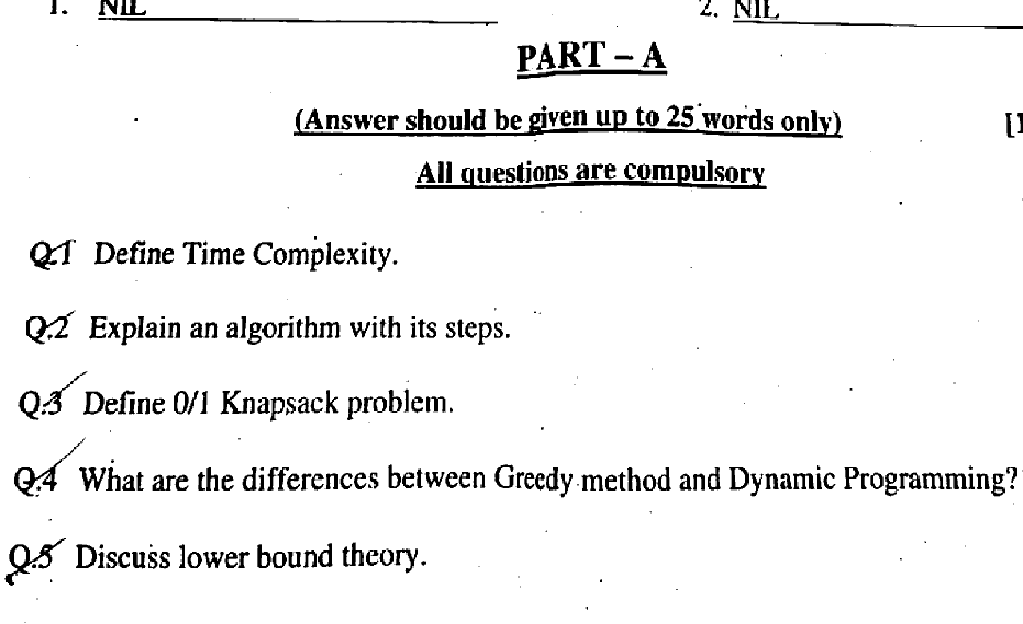

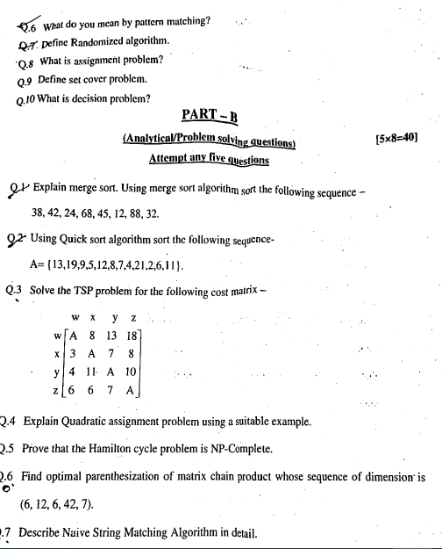

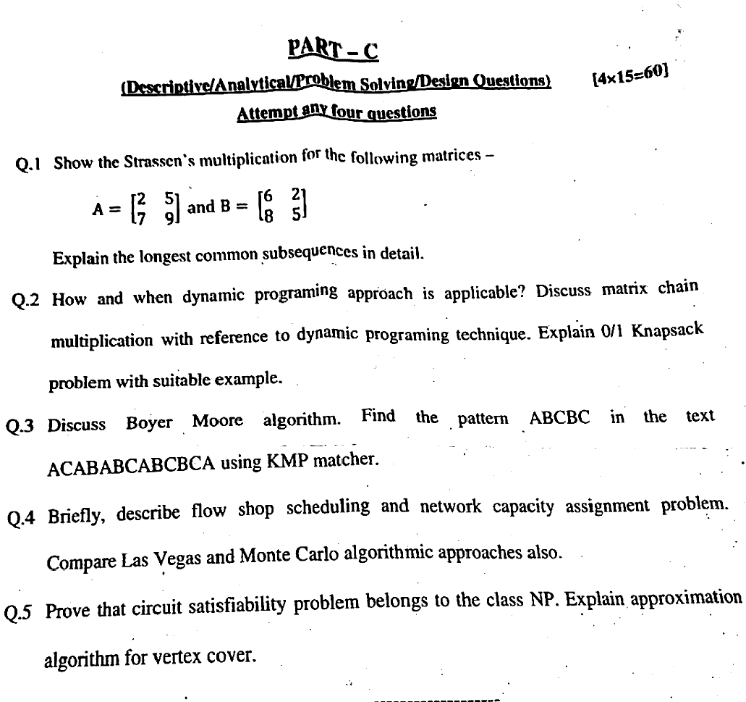

**STUDENT PERFORMANCE REPORT**

| **S.no** | **ROLL NO.** | **NAME** | **Assignmen-1** | **Assignment-2** | |
| --- | --- | --- | --- | --- | --- |
| 1. 1 | 21ETCCS001 | AARSH BHARTI | B+ | B++ |
|  | 21ETCCS002 | MS AASTHA DAKHERA | A++ | A++ |
|  | 21ETCCS003 | ABHISHEK PRAJAPAT | B+ | B+ |
|  | 21ETCCS005 | AKSHANSH SONI | B+ | B+ |
|  | 21ETCCS006 | AKSHAT SINGH CHOUHAN | B | B |
|  | 21ETCCS007 | ANIRUDH SINGH RAJPUROHIT | A+ | A+ |
|  | 21ETCCS008 | ANISH SINGHAL | A++ | A++ |
|  | 21ETCCS009 | ANJALI SONI | A++ | A+ |
|  | 21ETCCS010 | ANURAG MENARIA | B+ | B++ |
|  | 21ETCCS011 | ANUSHKA VIJAY | A++ | A++ |
|  | 21ETCCS012 | APURVA LODHA | B+ | B+ |
|  | 21ETCCS013 | ARUN LOHAR | B+ | B+ |
|  | 21ETCCS014 | ARVIND SINGH | B | B |
|  | 21ETCCS015 | ARVIND SUTHAR | A+ | A+ |
|  | 21ETCCS016 | AVANI JOSHI | A++ | A++ |
|  | 21ETCCS017 | AYAN KHAN | A++ | A+ |
|  | 21ETCCS018 | AYUSH JHOTA | B+ | B++ |
|  | 21ETCCS019 | AYUSH TALESARA | A++ | A++ |
|  | 21ETCCS020 | BHAVYA MEHTA | B+ | B+ |
|  | 21ETCCS021 | BHERU SINGH PANWAR | B+ | B+ |
|  | 21ETCCS022 | MS BHUMIKA VARDAR | B | B |
|  | 21ETCCS025 | CHINMAY MENARIA | A+ | A+ |
|  | 21ETCCS026 | DAKSH VYAS | A++ | A++ |
|  | 21ETCCS027 | DEEPAK DHAKAR | A++ | A+ |
|  | 21ETCCS029 | DHIREN SUHALKA | B+ | B++ |
|  | 21ETCCS030 | DHRUV BAGORA | A++ | A++ |
|  | 21ETCCS031 | DIKSHA AGARWAL | B+ | B+ |
|  | 21ETCCS032 | DINESH AUDICHYA | B+ | B+ |
|  | 21ETCCS034 | DIVYANSHU MENARIA | B | B |
|  | 21ETCCS035 | DIVYANSHU SAHU | A+ | A+ |
|  | 21ETCCS036 | DURGA SANKAR DANGI | A++ | A++ |
|  | 21ETCCS037 | GAGAN MANGAL | A++ | A+ |
|  | 21ETCCS038 | GARVITA BAYA | B+ | B++ |
|  | 21ETCCS039 | GARVITA JAIN | A++ | A++ |
|  | 21ETCCS040 | GAZI AMAN KHAN | B+ | B+ |
|  | 21ETCCS041 | HARSH | B+ | B+ |
|  | 21ETCCS042 | HARSH SONI | B | B |
|  | 21ETCCS043 | HARSHAL PALIWAL | A+ | A+ |
|  | 21ETCCS044 | HARSHIT PUROHIT | A++ | A++ |
|  | 21ETCCS045 | HARSHIT SHARMA | A++ | A+ |
|  | 21ETCCS046 | HARSHITA RATHORE | B+ | B++ |
|  | 21ETCCS047 | HEET DOSI | A++ | A++ |
|  | 21ETCCS048 | MS HETAL SHARMA | B+ | B+ |
|  | 21ETCCS049 | JAHNAVI JOSHI | B+ | B+ |
|  | 21ETCCS050 | JAINIL JAIN | B | B |
|  | 21ETCCS051 | JASWANT SINGH RAO | A+ | A+ |
|  | 21ETCCS052 | JATIN VASHISHTHA | A++ | A++ |
|  | 21ETCCS053 | JAY JOSHI | A++ | A+ |
|  | 21ETCCS054 | JAYDEEP DANGI | B+ | B++ |
|  | 21ETCCS055 | JIGYASA CHATURVEDI | A++ | A++ |
|  | 21ETCCS056 | KAILASH JOSHI | B+ | B+ |
|  | 21ETCCS057 | KAMLESH KUMAR GHANCHI | B+ | B+ |
|  | 21ETCCS058 | KANISHKA PARMAR | B | B |
|  | 21ETCCS059 | KASHVI PANDEY | A+ | A+ |
|  | 21ETCCS060 | KHUSHAL PALIWAL | A++ | A++ |
|  | 21ETCCS061 | KHUSHI GAHLOT | A++ | A+ |
|  | 21ETCCS062 | KHUSHI VANAWAT | B+ | B++ |
|  | 21ETCCS064 | KUNAL CHOUBISA | A++ | A++ |
|  | 21ETCCS065 | KUNAL MENARIA | B+ | B+ |
|  | 21ETCCS066 | KUNAL PALIWAL | B+ | B+ |
|  | 21ETCCS067 | KUNAL SHARMA | B | B |
|  | 21ETCCS068 | KUNIKA KADECHA(RL) | A+ | A+ |
|  | 21ETCCS069 | LALITA DANGI | A++ | A++ |
|  | 21ETCCS070 | LAVISHA JAIN | A++ | A+ |
|  | 21ETCCS071 | LOKANTIK JAIN | B+ | B++ |
|  | 21ETCCS073 | MAHAK BANSAL | A++ | A++ |
|  | 21ETCCS074 | MANSI GEHLOT | B+ | B+ |
|  | 21ETCCS075 | MAYANK KANERIYA | B+ | B+ |
|  | 21ETCCS076 | MAYANK MALIWAL | B | B |
|  | 21ETCCS078 | MITANSH JAIN | A+ | A+ |
|  | 21ETCCS079 | MOHAMMED OWAIS KHAN | A++ | A++ |
|  | 21ETCCS081 | NAVNEET ANAND | A++ | A+ |
|  | 21ETCCS082 | NEHAL DHING | B+ | B++ |
|  | 21ETCCS084 | NIPUN MALI | A++ | A++ |
|  | 21ETCCS085 | NISHA LOHAR | B+ | B+ |
|  | 21ETCCS086 | PRADHUMAN SINGH CHAUDHARY | B+ | B+ |
|  | 21ETCCS087 | PRANJAL SINGHVI | B | B |
|  | 21ETCCS088 | RAJAT PATIDAR | A+ | A+ |
|  | 21ETCCS089 | RIYA JAIN | A++ | A++ |
|  | 21ETCCS090 | ROHIN GANG | A++ | A+ |
|  | 21ETCCS091 | RUPAL SONI | B+ | B++ |
|  | 21ETCCS092 | SAHIL SOLANKI | A++ | A++ |
|  | 21ETCCS093 | SARGAM JAIN | B+ | B+ |
|  | 21ETCCS094 | SATYEN KHARADI | B+ | B+ |
|  | 21ETCCS095 | SHASHANK MENARIA | B | B |
|  | 21ETCCS096 | SHUBHAM DAS | A+ | A+ |
|  | 21ETCCS097 | SUDEEP ROY | A++ | A++ |
|  | 21ETCCS098 | SUMIT VASITA | A++ | A+ |
|  | 21ETCCS099 | SUYASH SONI | B+ | B++ |
|  | 21ETCCS100 | MS TANISHA KUMAWAT | A++ | A++ |
|  | 21ETCCS101 | TUSHAR YADAV | B+ | B+ |
|  | 21ETCCS102 | VAIBHAV GARG | B+ | B+ |
|  | 21ETCCS103 | VAIBHAV SONI | B | B |
|  | 21ETCCS104 | VARUN SHARMA | A+ | A+ |
|  | 21ETCCS105 | VEDANSHI PAREEK | A++ | A++ |
|  | 21ETCCS106 | VEDAS DIXIT | A++ | A+ |
|  | 21ETCCS107 | VIKRAM SINGH SISODIYA | B+ | B++ |
|  | 21ETCCS108 | VIMANYU P SHARMA | A++ | A++ |
|  | 21ETCCS109 | VISHAL KUMAWAT | B+ | B+ |
|  | 21ETCCS110 | VISHAL PUSHKARNA | B+ | B+ |
|  | 21ETCCS111 | VYOM BHATT | B | B |
|  | 21ETCCS112 | YASH JAIN | A+ | A+ |
|  | 21ETCCS113 | YASH JOSHI | A++ | A++ |
|  | 21ETCCS114 | YASH PURI GOSWAMI | A++ | A+ |
|  | 21ETCCS115 | YOGESH JAIPAL | B+ | B++ |
|  | 21ETCCS116 | MS YUVIKA CHOUDHARY | A++ | A++ |
|  | 21ETCCS117 | YUVRAJ SINGH KANAWAT | B+ | B+ |
|  | 21ETCCS300 | NEELAM KATARIYA | B+ | B+ |
|  | 21ETCCS400 | SHABBIR HUSSAIN | B | B |
|  | 21ETCCS401 | ALI HUSSAIN | A+ | A+ |
|  | 22ETCCS200 | SAURABH SONI | A++ | A++ |

|  |
| --- |
|  |

**Signature of Faculty: Signature of HOD**

**RESULT ANALYSIS**

| **S.NO.** | **RTU ROLL NUMBER** | **NAME OF STUDENT** | **END TERM MARKS** | **SESSIONAL MARKS** | **TOTAL** |
| --- | --- | --- | --- | --- | --- |
| **MAX MARKS** | **70** | **30** | **100** |
| **Set Target Level** | | | **60%** | **75%** |  |
| 1 | 21ETCCS001 | AARSH BHARTI | 53 | 22 | 75 |
| 2 | 21ETCCS002 | MS AASTHA DAKHERA | 64 | 30 | 94 |
| 3 | 21ETCCS003 | ABHISHEK PRAJAPAT | 42 | 23 | 65 |
| 4 | 21ETCCS005 | AKSHANSH SONI | 48 | 22 | 70 |
| 5 | 21ETCCS006 | AKSHAT SINGH CHOUHAN | 51 | 20 | 71 |
| 6 | 21ETCCS007 | ANIRUDH SINGH RAJPUROHIT | 28 | 27 | 55 |
| 7 | 21ETCCS008 | ANISH SINGHAL | 42 | 30 | 72 |
| 8 | 21ETCCS009 | ANJALI SONI | 52 | 28 | 80 |
| 9 | 21ETCCS010 | ANURAG MENARIA | 45 | 30 | 75 |
| 10 | 21ETCCS011 | ANUSHKA VIJAY | 37 | 20 | 57 |
| 11 | 21ETCCS012 | APURVA LODHA | 58 | 22 | 80 |
| 12 | 21ETCCS013 | ARUN LOHAR | 57 | 20 | 77 |
| 13 | 21ETCCS014 | ARVIND SINGH | 38 | 29 | 67 |
| 14 | 21ETCCS015 | ARVIND SUTHAR | 45 | 30 | 75 |
| 15 | 21ETCCS016 | AVANI JOSHI | 56 | 20 | 76 |
| 16 | 21ETCCS017 | AYAN KHAN | 48 | 27 | 75 |
| 17 | 21ETCCS018 | AYUSH JHOTA | 56 | 20 | 76 |
| 18 | 21ETCCS019 | AYUSH TALESARA | 34 | 20 | 54 |
| 19 | 21ETCCS020 | BHAVYA MEHTA | 56 | 30 | 86 |
| 20 | 21ETCCS021 | BHERU SINGH PANWAR | 57 | 27 | 84 |
| 21 | 21ETCCS022 | MS BHUMIKA VARDAR | 41 | 29 | 70 |
| 22 | 21ETCCS025 | CHINMAY MENARIA | 34 | 29 | 63 |
| 23 | 21ETCCS026 | DAKSH VYAS | 23 | 22 | 45 |
| 24 | 21ETCCS027 | DEEPAK DHAKAR | 29 | 22 | 51 |
| 25 | 21ETCCS029 | DHIREN SUHALKA | 23 | 25 | 48 |
| 26 | 21ETCCS030 | DHRUV BAGORA | 48 | 24 | 72 |
| 27 | 21ETCCS031 | DIKSHA AGARWAL | 53 | 27 | 80 |
| 28 | 21ETCCS032 | DINESH AUDICHYA | 31 | 27 | 58 |
| 29 | 21ETCCS034 | DIVYANSHU MENARIA | 41 | 27 | 68 |
| 30 | 21ETCCS035 | DIVYANSHU SAHU | 41 | 24 | 65 |
| 31 | 21ETCCS036 | DURGA SANKAR DANGI | 58 | 22 | 80 |
| 32 | 21ETCCS037 | GAGAN MANGAL | 44 | 30 | 74 |
| 33 | 21ETCCS038 | GARVITA BAYA | 52 | 30 | 82 |
| 34 | 21ETCCS039 | GARVITA JAIN | 56 | 30 | 86 |
| 35 | 21ETCCS040 | GAZI AMAN KHAN | 32 | 20 | 52 |
| 36 | 21ETCCS041 | HARSH | 30 | 20 | 50 |
| 37 | 21ETCCS042 | HARSH SONI | 46 | 22 | 68 |
| 38 | 21ETCCS043 | HARSHAL PALIWAL | 50 | 29 | 79 |
| 39 | 21ETCCS044 | HARSHIT PUROHIT | 61 | 30 | 91 |
| 40 | 21ETCCS045 | HARSHIT SHARMA | 35 | 20 | 55 |
| 41 | 21ETCCS046 | HARSHITA RATHORE | 54 | 20 | 74 |
| 42 | 21ETCCS047 | HEET DOSI | 33 | 22 | 55 |
| 43 | 21ETCCS048 | MS HETAL SHARMA | 37 | 20 | 57 |
| 44 | 21ETCCS049 | JAHNAVI JOSHI | 56 | 30 | 86 |
| 45 | 21ETCCS050 | JAINIL JAIN | 37 | 20 | 57 |
| 46 | 21ETCCS051 | JASWANT SINGH RAO | 47 | 30 | 77 |
| 47 | 21ETCCS052 | JATIN VASHISHTHA | 41 | 29 | 70 |
| 48 | 21ETCCS053 | JAY JOSHI | 47 | 24 | 71 |
| 49 | 21ETCCS054 | JAYDEEP DANGI | 55 | 29 | 84 |
| 50 | 21ETCCS055 | JIGYASA CHATURVEDI | 60 | 30 | 90 |
| 51 | 21ETCCS056 | KAILASH JOSHI | 46 | 22 | 68 |
| 52 | 21ETCCS057 | KAMLESH KUMAR GHANCHI | 54 | 27 | 81 |
| 53 | 21ETCCS058 | KANISHKA PARMAR | 62 | 30 | 92 |
| 54 | 21ETCCS059 | KASHVI PANDEY | 47 | 25 | 72 |
| 55 | 21ETCCS060 | KHUSHAL PALIWAL | 36 | 29 | 65 |
| 56 | 21ETCCS061 | KHUSHI GAHLOT | 53 | 27 | 80 |
| 57 | 21ETCCS062 | KHUSHI VANAWAT | 54 | 22 | 76 |
| 58 | 21ETCCS064 | KUNAL CHOUBISA | 21 | 22 | 43 |
| 59 | 21ETCCS065 | KUNAL MENARIA | 22 | 28 | 50 |
| 60 | 21ETCCS066 | KUNAL PALIWAL | 41 | 22 | 63 |
| 61 | 21ETCCS067 | KUNAL SHARMA | 47 | 23 | 70 |
| 62 | 21ETCCS068 | KUNIKA KADECHA(RL) | 62 | 29 | 91 |
| 63 | 21ETCCS069 | LALITA DANGI | 40 | 20 | 60 |
| 64 | 21ETCCS070 | LAVISHA JAIN | 52 | 27 | 79 |
| 65 | 21ETCCS071 | LOKANTIK JAIN | 35 | 22 | 57 |
| 66 | 21ETCCS073 | MAHAK BANSAL | 34 | 20 | 54 |
| 67 | 21ETCCS074 | MANSI GEHLOT | 61 | 30 | 91 |
| 68 | 21ETCCS075 | MAYANK KANERIYA | 58 | 20 | 78 |
| 69 | 21ETCCS076 | MAYANK MALIWAL | 50 | 20 | 70 |
| 70 | 21ETCCS078 | MITANSH JAIN | 40 | 30 | 70 |
| 71 | 21ETCCS079 | MOHAMMED OWAIS KHAN | 28 | 23 | 51 |
| 72 | 21ETCCS081 | NAVNEET ANAND | 38 | 29 | 67 |
| 73 | 21ETCCS082 | NEHAL DHING | 49 | 29 | 78 |
| 74 | 21ETCCS084 | NIPUN MALI | 34 | 29 | 63 |
| 75 | 21ETCCS085 | NISHA LOHAR | 55 | 23 | 78 |
| 76 | 21ETCCS086 | PRADHUMAN SINGH CHAUDHARY | 45 | 30 | 75 |
| 77 | 21ETCCS087 | PRANJAL SINGHVI | 33 | 20 | 53 |
| 78 | 21ETCCS088 | RAJAT PATIDAR | 22 | 20 | 42 |
| 79 | 21ETCCS089 | RIYA JAIN | 57 | 20 | 77 |
| 80 | 21ETCCS090 | ROHIN GANG | 44 | 22 | 66 |
| 81 | 21ETCCS091 | RUPAL SONI | 64 | 22 | 86 |
| 82 | 21ETCCS092 | SAHIL SOLANKI | 50 | 22 | 72 |
| 83 | 21ETCCS093 | SARGAM JAIN | 61 | 22 | 83 |
| 84 | 21ETCCS094 | SATYEN KHARADI | 32 | 22 | 54 |
| 85 | 21ETCCS095 | SHASHANK MENARIA | 44 | 30 | 74 |
| 86 | 21ETCCS096 | SHUBHAM DAS | 45 | 24 | 69 |
| 87 | 21ETCCS097 | SUDEEP ROY | 30 | 30 | 60 |
| 88 | 21ETCCS098 | SUMIT VASITA | 16 | 29 | 45 |
| 89 | 21ETCCS099 | SUYASH SONI | 39 | 20 | 59 |
| 90 | 21ETCCS100 | MS TANISHA KUMAWAT | 47 | 24 | 71 |
| 91 | 21ETCCS101 | TUSHAR YADAV | 14 | 29 | 43 |
| 92 | 21ETCCS102 | VAIBHAV GARG | 46 | 20 | 66 |
| 93 | 21ETCCS103 | VAIBHAV SONI | 47 | 22 | 69 |
| 94 | 21ETCCS104 | VARUN SHARMA | 29 | 22 | 51 |
| 95 | 21ETCCS105 | VEDANSHI PAREEK | 53 | 25 | 78 |
| 96 | 21ETCCS106 | VEDAS DIXIT | 45 | 30 | 75 |
| 97 | 21ETCCS107 | VIKRAM SINGH SISODIYA | 37 | 22 | 59 |
| 98 | 21ETCCS108 | VIMANYU P SHARMA | 34 | 30 | 64 |
| 99 | 21ETCCS109 | VISHAL KUMAWAT | 31 | 24 | 55 |
| 100 | 21ETCCS110 | VISHAL PUSHKARNA | 49 | 22 | 71 |
| 101 | 21ETCCS111 | VYOM BHATT | 51 | 30 | 81 |
| 102 | 21ETCCS112 | YASH JAIN | 44 | 28 | 72 |
| 103 | 21ETCCS113 | YASH JOSHI | 39 | 20 | 59 |
| 104 | 21ETCCS114 | YASH PURI GOSWAMI | 55 | 28 | 83 |
| 105 | 21ETCCS115 | YOGESH JAIPAL | 36 | 30 | 66 |
| 106 | 21ETCCS116 | MS YUVIKA CHOUDHARY | 44 | 28 | 72 |
| 107 | 21ETCCS117 | YUVRAJ SINGH KANAWAT | 41 | 20 | 61 |
| 108 | 21ETCCS300 | NEELAM KATARIYA | 44 | 20 | 64 |
| 109 | 21ETCCS400 | SHABBIR HUSSAIN | 39 | 22 | 61 |
| 110 | 21ETCCS401 | ALI HUSSAIN | 43 | 30 | 73 |
| 111 | 22ETCCS200 | SAURABH SONI | 41 | 30 | 71 |

| TOTAL | PASS | FAIL | ABSENT | PASS % |
| --- | --- | --- | --- | --- |
| 111 | 111 | 0 | 0 | 100 |

**Indirect Assessment:**

**Overall Teacher Self Assessment (at the completion of course) in terms of course objective and outcomes**

**Course Objectives:**

To understand the fundamental concepts of algorithms.

Learn to evaluate efficiency and complexity of algorithms.

To design various algorithms for various problems.

To develop problem solving skills and critical thinking

**Course Outcomes**:

Student will be able to design and analyze algorithms

Students will able to apply various algorithms for different computing problems.

Students will be able to analyze randomized algorithms

Students can solve the complexity of real life problems.

**Methodology to identify bright student**

Considered a range of criteria, including academic performance, creativity, critical thinking, problem-solving skills, and enthusiasm for learning. Bright students often excel in multiple areas. Observed how students perform in the classroom. In terms of active participation, engagement in discussions, leadership, and the ability to grasp complex concepts.

**Efforts to keep students engaged**

1. Active Learning:
   * Incorporate active learning strategies, such as group discussions, problem-solving activities, and hands-on projects. Active participation keeps students engaged and encourages critical thinking.
2. Varied Teaching Methods:
   * Use a variety of teaching methods, including lectures, group work, multimedia presentations, and interactive activities to cater to different learning preferences.
3. Technology Integration:
   * Leverage technology, such as online platforms, educational apps, and interactive software, to make lessons more engaging and interactive.

Some extra learning for bright students

1. <https://www.geeksforgeeks.org/introduction-to-amortized-analysis/>

2. <https://www.geeksforgeeks.org/painters-partition-problem/>

3. <https://www.geeksforgeeks.org/wildcard-pattern-matching/>

**Methodology to identify weak student**

Considered a range of criteria, including classroom observation, formative assessment, summative assessment, assignment review e.t.c. Weak students are struggling students with sensitivity and a desire to support their learning. Some measures, such as additional tutoring, personalized assignments, or alternative assessment methods, to help students succeed.

**Targeted inventions for weak student**

**1. Additional Resources**

Offer supplementary learning materials, such as textbooks, online resources, or multimedia content, to provide alternative explanations and reinforce key concepts.

**2. Remedial classes**

Establish a tutoring program where students can receive extra help from teachers.

**3. Flipped classroom**

Students are assigned pre-class learning materials, often in the form of videos, readings, or online modules, to cover the foundational concepts before coming to class.

Some additional resources or links for student to improve their understanding for topic

1. <https://www.javatpoint.com/daa-tutorial>

2. Design and analysis of algorithm by **neso academy**

3. “Fundamentals of Computer Algorithms” by Sahni Horowitz