**Course File**

***Subject Title/Subject Code : Human Computer Interaction/5CS5-12***

Semester : V Year : III

| Name of the Faculty: Payal Patel |  | |
| --- | --- | --- |
|  |  | |
| E-mail id: payal.patel@technonjr.org |  |

**Class Schedule**

**Total Number of Lectures:** 42

i**)Course Objective**

A fundamental principle of Human-Computer Interaction (HCI) is the concept of **"User-Centered Design" (UCD).** User-Centered Design places the user and their needs at the forefront of the design and development process for interactive systems. This principle emphasizes designing products, systems, or interfaces with a deep understanding of the users' characteristics, tasks, and goals.

**INDEX - COURSE FILE**

| **S. No.** | **CONTENT / ITEM NO.** | **PAGE NO.** |
| --- | --- | --- |
| **Status** |
| 1 | Vision And Mission Of The Institute |  |  |
| 2 | Vision And Mission Of The Department |  |  |
| 3 | Program Educational Objective Of Department (PEO’s) |  |  |
| 4 | Program Outcomes Of Department (PO’s) |  |  |
| 5 | Course Outcome (COs) |  |  |
| 6 | COs mapping with Pos and PSOs |  |  |
| 7 | Academic Calendar |  |  |
| 8 | Evaluation Scheme |  |  |
| 9 | Course Syllabus |  |  |
| 10 | Prescribed Books |  |  |
| 11 | Copy Of Time Table |  |  |
| 12 | Course Schedule Plan |  |  |
| 13 | Assignment Sheet (Unit Wise) |  |  |
| 14 | Quiz Questions (One From Each Unit) |  |  |
| 15 | Question Papers Of Mid Term Exam-I |  |  |
| 16 | Marks and Gap Analysis in Mid Term I |  |  |
| 17 | Remedial Action Taken To Remove the Gaps after mid Term I |  |  |
| 18 | Question Papers Of Mid Term Exam-II |  |  |
| 19 | Gap Analysis in Mid Term II |  |  |
| 20 | Remedial Action Taken To Remove the Gaps after mid Term II |  |  |
| 21 | Model Question Paper With Key Solution |  |  |
| 22 | University Question Paper (Last one year) |  |  |
| 23 | Student Performance Report |  |  |
| 24 | Result Analysis |  |  |

**VISSION & MISSION OF INSTITUTE**

## Vision

Empowering student with recent and emerging technologies to create innovative technical leaders capable of contributing to industrial and societal needs for betterment of mankind across the globe.

## Mission

**M1**: To provide dynamic learning environment to students by providing constant exposure to latest technologies by linking closely with the industries.

**M2**: To establish effective interface with industry to obtain live problems to enhance critical thinking and problem solving skills among students and consultancy projects for faculty.

**M3**: To provide avenues and opportunities to faculty for domain specific trainings and qualification upgradation.

**M4**: To develop ethical leaders with strong communication skills.

**VISION & MISSION OF DEPARTMENT**

**Department Vision**

**To be among top five well known department of Computer Science and Engineering in the state of Rajasthan in placing the students at premier industry.**

**Department Mission**

**M1: To equip students with ability to be innovative and excellence to face the challenges in the digital world.**

**M2: To prepare students with high quality employability skills catering to current trends in industries, problem solving skills, innovative pursuits and ready to face challenges in the domain and allied disciplines.**

**M3: To provide ambience for entrepreneurship and start-ups through incubation center among students.**

**M4: To encourage continuous faculty training on industry-based Development, and Innovation.**

**PROGRAMME EDUCATIONAL OBJECTIVES (PEOs)**

**Technical Proficiency** Graduates will have a strong foundation in core concepts, tools, and technologies relevant to their discipline.

**Career Development** Graduate will be capable of pursuing diverse career paths in field of Computer Science & Engineering with proficiency in software development/ pursue higher education an or become entrepreneurs.

**Problem-Solving** Graduates will have a strong math foundation so that they will be proficient problem solvers, capable of identifying, analyzing , and solving complex technical problems using critical thinking and creative approaches.

**Professional Attitude** Graduates will be sensitive to societal and professional environment, possess strong communication skills and will be skilled in working collaboratively within diverse teams adhering to ethical standards and professional practices.

**Learning Environment** To create a learning environment that ensures graduates continue learning throughout their careers, effortlessly adopting new technologies to stay innovative in their chosen fields and remain effective contributors in their chosen field.

**PROGRAM SPECIFIC OUTCOMES (PSO's)**

**PSO1**: Students will be able to design, develop, test, debug, deploy, analyze , troubleshoot, maintain, manage, and ensure security during the complete product lifecycle.

**PSO2**: Student will be able to apply software engineering/ information system development skills to solve problems across diverse domains.

**PSO3**: Students will be well-prepared to initiate and oversee innovative startups within their respective sectors.

**PROGRAMME OUTCOMES (POs)**

**A student will develop:**

**PO 01. ENGINEERING KNOWLEDGE**: Apply the knowledge of mathematics, science, engineering fundamentals, and an engineering specialization to the solution of complex engineering problems.

**PO02. PROBLEM ANALYSIS**: Identify, formulate, review research literature, and analyze complex engineering problems reaching substantiated conclusions using first principles of mathematics, natural sciences, and engineering sciences

**PO03. DESIGN/ DEVELOPMENT OF SOLUTION**: Design solutions for complex engineering problems and design system components or processes that meet the specified needs with appropriate consideration for the public health and safety, and the cultural, societal, and environmental considerations.

**PO04. CONDUCTION OF INVESTIGATION OF COMPLEX PROBLEMS:** Use research-based knowledge and research methods including design of experiments, analysis and interpretation of data, and synthesis of the information to provide valid conclusions.

**PO05. MODERN TOOL USAGE:** Create, select, and apply appropriate techniques, resources, and modern engineering and IT tools including prediction and modelling to complex engineering activities with and understanding of the limitations.

**PO06. THE ENGINEERING AND SOCIETY:** Apply reasoning informed by the contextual knowledge to assess societal, health, safety, legal and cultural issues and the consequent responsibilities relevant to the professional engineering practice.

**PO07. ENVIRONMENT & SUSTAINABILITY**: Understand the impact of the professional engineering solutions in societal and environmental contexts, and demonstrate the knowledge of, and need for sustainable development.

**PO08. ETHICS**: Apply ethical principles and commit to professional ethics and responsibilities and norms of the engineering practice.

**PO09. INDIVIDUAL AND TEAM WORK**: Function effectively as an individual, and as a member or leader in diverse teams, and in multi disciplinary settings.

**PO10. COMMUNICATION**: Communicate effectively on complex engineering activities with the engineering community and with society at large, such as, being able to comprehend and write effective reports and design documentation, make effective presentations, and give and receive clear instructions.

**PO11. PROJECT MANAGEMENT & FINANCE:** Demonstrate knowledge and understanding of the engineering and management principles and apply these to one’s own work, as a member and leader in a team, to manage projects and in multidisciplinary environments.

**PO12. LIFE-LONG LEARNING**: Recognize the need for, and have the preparation and ability to engage in independent and life-long learning in the broadest context of technological change.

**COURSE OUTCOMES (COs) OF THE SUBJECT**

| CO No. | Mapping | Statement |
| --- | --- | --- |
| CO35402.1 | Analyzing | Student will be able to list the capabilities of both humans and computers from the viewpoint of human information processing. |
| CO35402.2 | Applying | Student will be able to describe typical human–computer interaction (HCI) models and styles, as well as various historic HCI paradigms. |
| CO35402.3 | Applying | Students will be able to apply an interactive design process and universal design principles to designing HCI systems. |
| CO35402.4 | Analyzing | Students will analyze and identify user models& support, socio-organizational issues, and stakeholder requirements of HCIs. |
| CO35402.5 | Applying | Students will be able to discuss tasks and dialogs of relevant HCI systems based on task analysis and dialog design. |

**COS MAPPING WITH POs AND PSOs**

| **Course Outcome** | **PO1** | **PO2** | **PO3** | **PO4** | **PO5** | **PO6** | **PO7** | **PO8** | **PO9** | **PO10** | **PO11** | **PO12** | **PSO1** | **PSO2** | **PSO3** |
| --- | --- | --- | --- | --- | --- | --- | --- | --- | --- | --- | --- | --- | --- | --- | --- |
| **CO1** | 3 | 1 | - | 1 | - | - | - | - | - | - | - | 1 | 2 | 1 | 1 |
| **CO2** | 2 | 2 | - | 1 | - | - | - | - | - | - | - | 1 | 2 | 1 | 1 |
| **CO3** | 3 | 2 | 3 | 1 | - | - | - | 1 | 1 | - | 1 | 1 | 2 | 1 | 1 |
| **CO4** | 2 | 2 | 1 | 3 | 1 | - | - | - | 1 | 2 | 2 | 1 | 2 | 1 | 1 |
| **CO5** | 1 | 3 | 3 | 2 | 1 | - | - | - | - | - | 2 | 1 | 2 | 1 | 1 |

**UNIVERSITY ACADEMIC CALENDAR**

Academic Calendar for Even Semester for Session

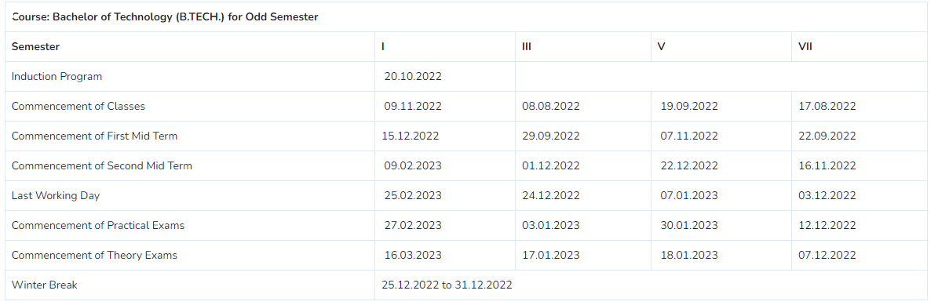

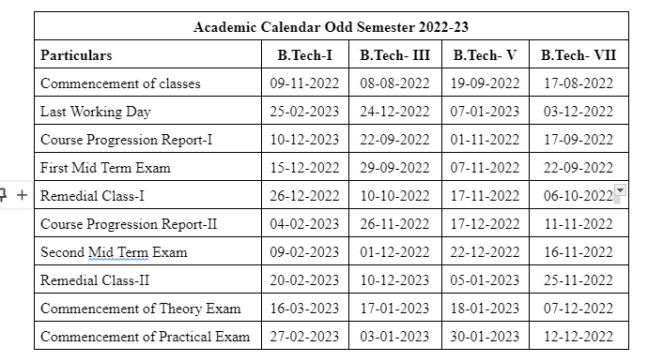

**Evaluation Scheme**

FACULTY DETAILS:

Name of the Faculty : Payal Patel

Designation :

Department : Computer Science Engineering

1. TARGET

a) Percentage Pass : 100%

b) Percentage I class: 60%

2. METHOD OF EVALUATION

2.1. Continuous Assessment Examinations (Mid-Term 1, Mid-Term 2)

2.2. Assignments / Seminars 

2.3. Mini Projects 

2.4. Quiz 

2.5. Semester Examination Others___________________________________________________

3. List out any new topic(s) or any innovation you would like to introduce in teaching the subject in this Semester.

1. Take the help of creative tools to stimulate creativity. Include slide presentations, demonstration or forms of visual exercises that will excite the young minds and capture their interest.

Signature of Faculty: **Signature of HOD**

**UNIVERSITY SYLLABUS**

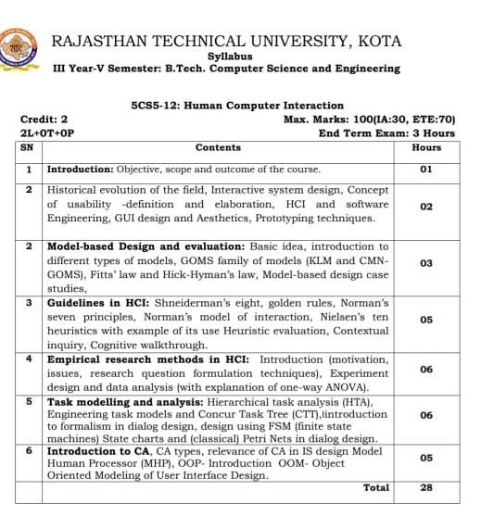

**PRESCRIBED BOOKS**

* human Computer Interaction/ Alan Dix Janet Finlay/ Pearson
* Human Computer Interaction /Andrew Sears/ CRC Press

**WEEKLY TIME TABLE OF THE TEACHER**

First Time Table: with effect from (Date):

| **Day** | **1** | **2** | **3** | **4** | **5** | **6** | **7** |
| --- | --- | --- | --- | --- | --- | --- | --- |
| Monday | HCI(B) |  |  | HCI(A) |  |  |  |
| Tuesday |  |  |  |  |  |  |  |
| Wednesday |  |  | HCI(A) |  |  |  |  |
| Thursday |  | HCI(B) |  |  |  |  |  |
| Friday | HCI(A) |  | HCI(B) |  |  |  |  |
| Saturday |  | HCI(A) | HCI(B) |  |  |  |  |

**COURSE-PLAN**

| UNIT | Lect.  No. | TOPICS | **Teaching Methods/ Teaching Aids** |
| --- | --- | --- | --- |
| **1** | **1** | Introduction: Objective, scope and outcome of the course | White Board, demonstration |
| 2 | 2 | Introduction of historical evolution in computer field and how to interact user with computer | White Board, PPT, Demonstration |
| 2 | 3 | Concept of human computer and usability or definition | White Board |
| 2 | 4 | Difference between HCI and software engineering | White Board |
| 2 | 5 | Basic interaction with user on the graphical user interface design and Aesthetics | White Board |
| 2 | 6 | Introduction of prototyping technique and resource | White Board |
| 3 | 7 | Introduction and evolution of model based design and different types of models | White Board, PPT |
| 3 | 8 | What are working of GOMS family model (KLM , CMN -GOMS) and uses of GOMS rule | White Board |
| 3 | 9 | Difference between Fitt’s law and hick-hymans law and what is a design case and study Model based design. | White Board, PPT, |
| 4 | 10 | Introduction and evolution of HCI guidelines | White Board, PPT, Demonstration |
| 4 | 11 | What are the performing of Shneiderman’s eight golden rules | White Board |
| 4 | 12 | What are the principal and study of Normans seven rules | White Board, PPT |
| 4 | 13 | How to interact and design Normans model of interaction | White Board, |
| 4 | 14 | Introduction and evolution Nielsen’s ten heuristic with example | White Board |
| 4 | 15 | What is a uses of contextual inquiry and interaction between graphical user interface | White Board, |
| 4 | 16 | What is uses of cognitive walkthrough and features | White Board Demonstration |
| 5 | 17 | Introduction and principal of Empirical research method in HCI and motivation issue in HCI | White Board, |
| 5 | 18 | What is a formulation technique and experiment of data analytics with explanation of one way ANOVA | White Board, |
| 6 | 19 | What are the working and analysis of task modeling and also discuss about the hierarchical task analysis | White Board |
| 6 | 20 | What are difference between engineering task models and concur task Tree (CTT) | White Board |
| 6 | 21 | Introduction to formalism in dialog design and finite state machine(FSM) and define and discuss state chart and Petri Nets in dialog design | White Board, PPT |
| 7 | 22 | Introduction and evolution CA and their types and also discuss about relevance of CA | White Board |
| 7 | 23 | What is analysis and design in CA in IS design model | White Board |
| 7 | 24 | Explain and define detail of model human processor (MHP) | White Board, Demonstration |
| 7 | 25 | What is object oriented programming | White Board |
| 7 | 26 | Introduction about user interface design | White Board |
| 7 | 27 | Introduction about user interface design | White Board |
| 7 | 28 | discuss object oriented modeling | White Board |

**Signature of Faculty: Signature of HOD**

**Assignment – 1 ()**

Q1. Write Short note on:-

* OOP-OOM
* Contextual inquiry

Q2. What is HCI in software engineering also define waterfall model and prototyping technique?

Q3. Describe GOM’S Model, Nielsen’s ten heuristics with example of its use heuristics evaluation?

Q4. What is mean by Human computer interaction?

**Assignment – 2 ()**

1. Justify Shneiderman’s eight golden rules through example.

2. Give explanation of one-way ANOVA.

3. What techniques a researcher should keep in mind while research question formulation?

4. Write a short note on Hierarchical Task Analysis.

5. Explain about elements and their roles used to make petri net.

**SAMPLE QUIZ QUESTIONS**

| 1. | What does HCI stand for? |  |
| --- | --- | --- |
| 2. | Which of the following are important in the design focus of HCI? |  |
| 3. | Which one of these is a good reason for taking care to design a good computer-human interface? |  |
| 4. | HCI is based on psychological factors of humans? |  |
| 5. | Which one of these is a good reason to include sounds in an HCI? |  |
| 6. | Which of these films uses futuristic HCI? |  |
| 7. | The term human-computer interaction has only been in widespread use since the early |  |
| 8. | What does ASCII stand for? |  |
| 9. | Which of these are the goals of a good design? |  |
| 10. | Which one of these is not an interface style? |  |
| 11. | What is usability? |  |
| 12. | What is HCI? |  |
| 13. | Goals of HCI? |  |
| 14. | Which one of the following is the most likely interface metaphor used by a smartphone? |  |
| 15. | HCI draws which of the fields together? |  |

**TECHNO INDIA NJR INSTITUTE OF TECHNOLOGY, UDAIPUR**

**B. TECH 3rd – YEAR (III SEM.) – MT-I**

**HUMAN COMPUTER INTERACTION**(**5CS5-12**)

**Time:** 2 Hr **Max. Marks:** 70

**Note:**

1. The paper is divided into 2 parts: Part-A and, Part-B.
2. Part-A contains 10 questions and carries 2 mark each.
3. Part-B contains 5 questions. Each question is having two options and carries 10 marks each.

Part- A (20 Marks)

| 1. What is meant by Human-Computer Interaction? | CO1 |
| --- | --- |
| 1. Describe the goals of HCI? | CO1 |
| 1. What is scope in HCI? | CO1 |
| 1. What is Fitts law? Describe in brief | CO1 |
| 1. What is meant by GOMS and Full form of GOMS? | CO2 |
| 1. Explain Norman’s seven principal (Only Point)? | CO2 |
| 1. What are the fields of interdisciplinary in HCI? | CO2 |
| 1. Compare human brain model with machine? | CO2 |
| 1. What is empirical method? | CO3 |
| 1. What is Anova? | CO3 |

Part- B (50 Marks)

| 1. What is usability engineering? Discuss the problems with usability engineering? | CO1 |
| --- | --- |
| OR | |
| 1. Describe GUI Aesthetics and prototyping techniques | CO1 |

| 1. Explain KLM-GOMS model and its advantages | CO1 |
| --- | --- |
| OR | |
| 2. What is Hick’s Law and its use? | CO1 |

| 1. Describe Shneiderman’s eight golden rules of interface design? | CO2 |
| --- | --- |
| OR | |
| 3. Describe Nielsen’s 10 heuristics for UI Design | CO2 |
| 4. What are four questions of Cognitive Walkthrough? Discuss along with example. | CO2 |
| OR | |
| 1. Short note on:   Contextual inquiry | CO2 |

| 5.What is ANOVA? Describe steps of ANOVA | CO3 |
| --- | --- |
| OR | |
| 5. What is Research question formulation techniques in HCI ? | CO3 |

**Marks and Gap Analysis of Mid-Term 1**

| S.No. | University Roll No. | Name of Student | Mid-Term 1  MM-32 | Remark  ( Remedial Class need or not – Y/N ) |
| --- | --- | --- | --- | --- |
|  | 21ETCCS001 | AARSH BHARTI | 50 | N |
|  | 21ETCCS002 | MS AASTHA DAKHERA | 70 | N |
|  | 21ETCCS003 | ABHISHEK PRAJAPAT | 57 | N |
|  | 21ETCCS005 | AKSHANSH SONI | 57 | N |
|  | 21ETCCS006 | AKSHAT SINGH CHOUHAN | 44 | N |
|  | 21ETCCS007 | ANIRUDH SINGH RAJPUROHIT | 45 | N |
|  | 21ETCCS008 | ANISH SINGHAL | 70 | N |
|  | 21ETCCS009 | ANJALI SONI | 70 | N |
|  | 21ETCCS010 | ANURAG MENARIA | 58 | N |
|  | 21ETCCS011 | ANUSHKA VIJAY | 58 | N |
|  | 21ETCCS012 | APURVA LODHA | 70 | N |
|  | 21ETCCS013 | ARUN LOHAR | 60 | N |
|  | 21ETCCS014 | ARVIND SINGH | 51 | N |
|  | 21ETCCS015 | ARVIND SUTHAR | 52 | N |
|  | 21ETCCS016 | AVANI JOSHI | 59 | N |
|  | 21ETCCS017 | AYAN KHAN | 61 | N |
|  | 21ETCCS018 | AYUSH JHOTA | 61 | N |
|  | 21ETCCS019 | AYUSH TALESARA | 55 | N |
|  | 21ETCCS020 | BHAVYA MEHTA | 70 | N |
|  | 21ETCCS021 | BHERU SINGH PANWAR | 61 | N |
|  | 21ETCCS022 | MS BHUMIKA VARDAR | 59 | N |
|  | 21ETCCS025 | CHINMAY MENARIA | 62 | N |
|  | 21ETCCS026 | DAKSH VYAS | 62 | N |
|  | 21ETCCS027 | DEEPAK DHAKAR | 60 | N |
|  | 21ETCCS029 | DHIREN SUHALKA | 46 | N |
|  | 21ETCCS030 | DHRUV BAGORA | 70 | N |
|  | 21ETCCS031 | DIKSHA AGARWAL | 70 | N |
|  | 21ETCCS032 | DINESH AUDICHYA | 70 | N |
|  | 21ETCCS034 | DIVYANSHU MENARIA | 54 | N |
|  | 21ETCCS035 | DIVYANSHU SAHU | 60 | N |
|  | 21ETCCS036 | DURGA SANKAR DANGI | 70 | N |
|  | 21ETCCS037 | GAGAN MANGAL | 60 | N |
|  | 21ETCCS038 | GARVITA BAYA | 70 | N |
|  | 21ETCCS039 | GARVITA JAIN | 62 | N |
|  | 21ETCCS040 | GAZI AMAN KHAN | 47 | N |
|  | 21ETCCS041 | HARSH | 62 | N |
|  | 21ETCCS042 | HARSH SONI | 62 | N |
|  | 21ETCCS043 | HARSHAL PALIWAL | 66 | N |
|  | 21ETCCS044 | HARSHIT PUROHIT | 70 | N |
|  | 21ETCCS045 | HARSHIT SHARMA | 70 | N |
|  | 21ETCCS046 | HARSHITA RATHORE | 56 | N |
|  | 21ETCCS047 | HEET DOSI | 54 | N |
|  | 21ETCCS048 | MS HETAL SHARMA | 63 | N |
|  | 21ETCCS049 | JAHNAVI JOSHI | 70 | N |
|  | 21ETCCS050 | JAINIL JAIN | 56 | N |
|  | 21ETCCS051 | JASWANT SINGH RAO | 66 | N |
|  | 21ETCCS052 | JATIN VASHISHTHA | 66 | N |
|  | 21ETCCS053 | JAY JOSHI | 70 | N |
|  | 21ETCCS054 | JAYDEEP DANGI | 70 | N |
|  | 21ETCCS055 | JIGYASA CHATURVEDI | 70 | N |
|  | 21ETCCS056 | KAILASH JOSHI | 66 | N |
|  | 21ETCCS057 | KAMLESH KUMAR GHANCHI | 67 | N |
|  | 21ETCCS058 | KANISHKA PARMAR | 70 | N |
|  | 21ETCCS059 | KASHVI PANDEY | 67 | N |
|  | 21ETCCS060 | KHUSHAL PALIWAL | 55 | N |
|  | 21ETCCS061 | KHUSHI GAHLOT | 56 | N |
|  | 21ETCCS062 | KHUSHI VANAWAT | 67 | N |
|  | 21ETCCS064 | KUNAL CHOUBISA | 50 | N |
|  | 21ETCCS065 | KUNAL MENARIA | 55 | N |
|  | 21ETCCS066 | KUNAL PALIWAL | 57 | N |
|  | 21ETCCS067 | KUNAL SHARMA | 59 | N |
|  | 21ETCCS068 | KUNIKA KADECHA(RL) | 57 | N |
|  | 21ETCCS069 | LALITA DANGI | 70 | N |
|  | 21ETCCS070 | LAVISHA JAIN | 70 | N |
|  | 21ETCCS071 | LOKANTIK JAIN | 66 | N |
|  | 21ETCCS073 | MAHAK BANSAL | 67 | N |
|  | 21ETCCS074 | MANSI GEHLOT | 70 | N |
|  | 21ETCCS075 | MAYANK KANERIYA | 70 | N |
|  | 21ETCCS076 | MAYANK MALIWAL | 68 | N |
|  | 21ETCCS078 | MITANSH JAIN | 59 | N |
|  | 21ETCCS079 | MOHAMMED OWAIS KHAN | 59 | N |
|  | 21ETCCS081 | NAVNEET ANAND | 70 | N |
|  | 21ETCCS082 | NEHAL DHING | 70 | N |
|  | 21ETCCS084 | NIPUN MALI | 59 | N |
|  | 21ETCCS085 | NISHA LOHAR | 70 | N |
|  | 21ETCCS086 | PRADHUMAN SINGH CHAUDHARY | 68 | N |
|  | 21ETCCS087 | PRANJAL SINGHVI | 63 | N |
|  | 21ETCCS088 | RAJAT PATIDAR | 61 | N |
|  | 21ETCCS089 | RIYA JAIN | 70 | N |
|  | 21ETCCS090 | ROHIN GANG | 62 | N |
|  | 21ETCCS091 | RUPAL SONI | 70 | N |
|  | 21ETCCS092 | SAHIL SOLANKI | 68 | N |
|  | 21ETCCS093 | SARGAM JAIN | 70 | N |
|  | 21ETCCS094 | SATYEN KHARADI | 69 | N |
|  | 21ETCCS095 | SHASHANK MENARIA | 63 | N |
|  | 21ETCCS096 | SHUBHAM DAS | 69 | N |
|  | 21ETCCS097 | SUDEEP ROY | 51 | N |
|  | 21ETCCS098 | SUMIT VASITA | 54 | N |
|  | 21ETCCS099 | SUYASH SONI | 68 | N |
|  | 21ETCCS100 | MS TANISHA KUMAWAT | 69 | N |
|  | 21ETCCS101 | TUSHAR YADAV | 35 | N |
|  | 21ETCCS102 | VAIBHAV GARG | 70 | N |
|  | 21ETCCS103 | VAIBHAV SONI | 70 | N |
|  | 21ETCCS104 | VARUN SHARMA | 63 | N |
|  | 21ETCCS105 | VEDANSHI PAREEK | 60 | N |
|  | 21ETCCS106 | VEDAS DIXIT | 61 | N |
|  | 21ETCCS107 | VIKRAM SINGH SISODIYA | 69 | N |
|  | 21ETCCS108 | VIMANYU P SHARMA | 64 | N |
|  | 21ETCCS109 | VISHAL KUMAWAT | 69 | N |
|  | 21ETCCS110 | VISHAL PUSHKARNA | 64 | N |
|  | 21ETCCS111 | VYOM BHATT | 57 | N |
|  | 21ETCCS112 | YASH JAIN | 57 | N |
|  | 21ETCCS113 | YASH JOSHI | 58 | N |
|  | 21ETCCS114 | YASH PURI GOSWAMI | 62 | N |
|  | 21ETCCS115 | YOGESH JAIPAL | 63 | N |
|  | 21ETCCS116 | MS YUVIKA CHOUDHARY | 58 | N |
|  | 21ETCCS117 | YUVRAJ SINGH KANAWAT | 65 | N |
|  | 21ETCCS300 | NEELAM KATARIYA | 59 | N |
|  | 21ETCCS400 | Shabbir Husain | 55 | N |
|  | 21ETCCS401 | Ali Hussain | 36 | N |
|  | 22ETCCS200 | Saurabh Soni | 59 | N |

**\***(Y, if obtained marks are <50%)

**Signature of Faculty: Signature of HOD**

**TECHNO INDIA NJR INSTITUTE OF TECHNOLOGY, UDAIPUR**

**B. TECH 3rd – YEAR (III SEM.) – MT-II**

**HUMAN COMPUTER INTERACTION**(**5CS5-12**)

**Time:** 2 Hr **Max. Marks:** 70

**Note:**

1. The paper is divided into 2 parts: Part-A and, Part-B.
2. Part-A contains 10 questions and carries 2 mark each.
3. Part-B contains 5 questions. Each question is having two options and carries 10 marks each.

Part- A (20 Marks)

| 1. What is ANOVA ? | CO3 |
| --- | --- |
| 1. Explain steps of solve to ANOVA? | CO3 |
| 1. What is design? | CO4 |
| 1. What is evaluation? | CO4 |
| 1. What do you mean by task analysis? | CO4 |
| 1. What do you mean by HTA? | CO4 |
| 1. What are the fields of interdisciplinary in HCI? | CO5 |
| 1. Compare human brain model with machine? | CO5 |
| 1. Explain input output devices in computer? | CO5 |
| 1. What do you mean by CA? | CO5 |

Part- B (50 Marks)

| 1. The following table gives the average monthly sale of 4 salesmen in three different types of territories:  | Territory | A | B | C | D | TOTAL | | --- | --- | --- | --- | --- | --- | | X | 5 | 4 | 4 | 7 | 20 | | Y | 7 | 8 | 5 | 4 | 24 | | Z | 9 | 6 | 6 | 7 | 28 | | total | 21 | 18 | 15 | 18 | 72 |   Carry out a two way analysis of variance table from the above facts and interpret the result.  The 5% value of F for (3,6) and (2,6) degree of freedom are 4.76 and 5.14 respectively? | CO3 |
| --- | --- | --- | --- | --- | --- | --- | --- | --- | --- | --- | --- | --- | --- | --- | --- | --- | --- | --- | --- | --- | --- | --- | --- | --- | --- | --- | --- | --- | --- | --- | --- |
| OR | |
| 1. The following table gives the average monthly sale of 4 salesmen in three different types of territories:  | Territory | A | B | C | D | TOTAL | | --- | --- | --- | --- | --- | --- | |  | 5 | 4 | 4 | 7 | 20 | |  | 7 | 8 | 5 | 4 | 24 | |  | 9 | 6 | 6 | 7 | 28 | | total | 21 | 18 | 15 | 18 | 72 |   Carry out a ONE way analysis of variance table from the above facts and interpret the result. | CO3 |

| 1. Short note on: 2. Hierarchical Task Analysis(HTA) 3. Concur Task Tree(CTT) | CO4 |
| --- | --- |
| OR | |
| 2. Explain Three – State Model in physical and device Models with example? | CO4 |

| 1. Explain introduction to formalism in dialog design ? | CO4 |
| --- | --- |
| OR | |
| 3. Explain about elements and their roles used to make petri net. | CO4 |
|  | |
| 4.given details of working of Joystick and touch Screen, CRT and LCD? | CO5 |
| OR |  |
| 4.What do you mean by CA and Explain CA type? |  |

| 5.Short note on:  OOP  OOM | CO5 |
| --- | --- |
| OR | |
| 5. Explain various input output channels in model human processor? | CO5 |

**Mid Term Exam – II**

**Marks and Gap Analysis of Mid-Term II**

| S.No. | University Roll No. | Name of Student | Mid-Term II  MM-32 | Remark  ( Remedial Class need or not – Y/N ) |
| --- | --- | --- | --- | --- |
|  | 21ETCCS001 | AARSH BHARTI | 66 | N |
|  | 21ETCCS002 | MS AASTHA DAKHERA | 70 | N |
|  | 21ETCCS003 | ABHISHEK PRAJAPAT | 69 | N |
|  | 21ETCCS005 | AKSHANSH SONI | 69 | N |
|  | 21ETCCS006 | AKSHAT SINGH CHOUHAN | 68 | N |
|  | 21ETCCS007 | ANIRUDH SINGH RAJPUROHIT | 67 | N |
|  | 21ETCCS008 | ANISH SINGHAL | 70 | N |
|  | 21ETCCS009 | ANJALI SONI | 70 | N |
|  | 21ETCCS010 | ANURAG MENARIA | 68 | N |
|  | 21ETCCS011 | ANUSHKA VIJAY | 68 | N |
|  | 21ETCCS012 | APURVA LODHA | 70 | N |
|  | 21ETCCS013 | ARUN LOHAR | 70 | N |
|  | 21ETCCS014 | ARVIND SINGH | 65 | N |
|  | 21ETCCS015 | ARVIND SUTHAR | 64 | N |
|  | 21ETCCS016 | AVANI JOSHI | 67 | N |
|  | 21ETCCS017 | AYAN KHAN | 69 | N |
|  | 21ETCCS018 | AYUSH JHOTA | 69 | N |
|  | 21ETCCS019 | AYUSH TALESARA | 67 | N |
|  | 21ETCCS020 | BHAVYA MEHTA | 70 | N |
|  | 21ETCCS021 | BHERU SINGH PANWAR | 69 | N |
|  | 21ETCCS022 | MS BHUMIKA VARDAR | 67 | N |
|  | 21ETCCS025 | CHINMAY MENARIA | 68 | N |
|  | 21ETCCS026 | DAKSH VYAS | 68 | N |
|  | 21ETCCS027 | DEEPAK DHAKAR | 66 | N |
|  | 21ETCCS029 | DHIREN SUHALKA | 66 | N |
|  | 21ETCCS030 | DHRUV BAGORA | 70 | N |
|  | 21ETCCS031 | DIKSHA AGARWAL | 70 | N |
|  | 21ETCCS032 | DINESH AUDICHYA | 70 | N |
|  | 21ETCCS034 | DIVYANSHU MENARIA | 62 | N |
|  | 21ETCCS035 | DIVYANSHU SAHU | 66 | N |
|  | 21ETCCS036 | DURGA SANKAR DANGI | 70 | N |
|  | 21ETCCS037 | GAGAN MANGAL | 66 | N |
|  | 21ETCCS038 | GARVITA BAYA | 70 | N |
|  | 21ETCCS039 | GARVITA JAIN | 68 | N |
|  | 21ETCCS040 | GAZI AMAN KHAN | 65 | N |
|  | 21ETCCS041 | HARSH | 64 | N |
|  | 21ETCCS042 | HARSH SONI | 64 | N |
|  | 21ETCCS043 | HARSHAL PALIWAL | 60 | N |
|  | 21ETCCS044 | HARSHIT PUROHIT | 70 | N |
|  | 21ETCCS045 | HARSHIT SHARMA | 70 | N |
|  | 21ETCCS046 | HARSHITA RATHORE | 66 | N |
|  | 21ETCCS047 | HEET DOSI | 62 | N |
|  | 21ETCCS048 | MS HETAL SHARMA | 67 | N |
|  | 21ETCCS049 | JAHNAVI JOSHI | 70 | N |
|  | 21ETCCS050 | JAINIL JAIN | 66 | N |
|  | 21ETCCS051 | JASWANT SINGH RAO | 60 | N |
|  | 21ETCCS052 | JATIN VASHISHTHA | 60 | N |
|  | 21ETCCS053 | JAY JOSHI | 70 | N |
|  | 21ETCCS054 | JAYDEEP DANGI | 70 | N |
|  | 21ETCCS055 | JIGYASA CHATURVEDI | 70 | N |
|  | 21ETCCS056 | KAILASH JOSHI | 64 | N |
|  | 21ETCCS057 | KAMLESH KUMAR GHANCHI | 63 | N |
|  | 21ETCCS058 | KANISHKA PARMAR | 70 | N |
|  | 21ETCCS059 | KASHVI PANDEY | 63 | N |
|  | 21ETCCS060 | KHUSHAL PALIWAL | 61 | N |
|  | 21ETCCS061 | KHUSHI GAHLOT | 66 | N |
|  | 21ETCCS062 | KHUSHI VANAWAT | 63 | N |
|  | 21ETCCS064 | KUNAL CHOUBISA | 62 | N |
|  | 21ETCCS065 | KUNAL MENARIA | 61 | N |
|  | 21ETCCS066 | KUNAL PALIWAL | 65 | N |
|  | 21ETCCS067 | KUNAL SHARMA | 57 | N |
|  | 21ETCCS068 | KUNIKA KADECHA(RL) | 65 | N |
|  | 21ETCCS069 | LALITA DANGI | 70 | N |
|  | 21ETCCS070 | LAVISHA JAIN | 70 | N |
|  | 21ETCCS071 | LOKANTIK JAIN | 60 | N |
|  | 21ETCCS073 | MAHAK BANSAL | 59 | N |
|  | 21ETCCS074 | MANSI GEHLOT | 70 | N |
|  | 21ETCCS075 | MAYANK KANERIYA | 70 | N |
|  | 21ETCCS076 | MAYANK MALIWAL | 58 | N |
|  | 21ETCCS078 | MITANSH JAIN | 63 | N |
|  | 21ETCCS079 | MOHAMMED OWAIS KHAN | 63 | N |
|  | 21ETCCS081 | NAVNEET ANAND | 70 | N |
|  | 21ETCCS082 | NEHAL DHING | 70 | N |
|  | 21ETCCS084 | NIPUN MALI | 63 | N |
|  | 21ETCCS085 | NISHA LOHAR | 70 | N |
|  | 21ETCCS086 | PRADHUMAN SINGH CHAUDHARY | 62 | N |
|  | 21ETCCS087 | PRANJAL SINGHVI | 59 | N |
|  | 21ETCCS088 | RAJAT PATIDAR | 55 | N |
|  | 21ETCCS089 | RIYA JAIN | 70 | N |
|  | 21ETCCS090 | ROHIN GANG | 54 | N |
|  | 21ETCCS091 | RUPAL SONI | 70 | N |
|  | 21ETCCS092 | SAHIL SOLANKI | 58 | N |
|  | 21ETCCS093 | SARGAM JAIN | 70 | N |
|  | 21ETCCS094 | SATYEN KHARADI | 61 | N |
|  | 21ETCCS095 | SHASHANK MENARIA | 59 | N |
|  | 21ETCCS096 | SHUBHAM DAS | 61 | N |
|  | 21ETCCS097 | SUDEEP ROY | 61 | N |
|  | 21ETCCS098 | SUMIT VASITA | 58 | N |
|  | 21ETCCS099 | SUYASH SONI | 58 | N |
|  | 21ETCCS100 | MS TANISHA KUMAWAT | 57 | N |
|  | 21ETCCS101 | TUSHAR YADAV | 67 | N |
|  | 21ETCCS102 | VAIBHAV GARG | 60 | N |
|  | 21ETCCS103 | VAIBHAV SONI | 70 | N |
|  | 21ETCCS104 | VARUN SHARMA | 59 | N |
|  | 21ETCCS105 | VEDANSHI PAREEK | 70 | N |
|  | 21ETCCS106 | VEDAS DIXIT | 69 | N |
|  | 21ETCCS107 | VIKRAM SINGH SISODIYA | 57 | N |
|  | 21ETCCS108 | VIMANYU P SHARMA | 58 | N |
|  | 21ETCCS109 | VISHAL KUMAWAT | 57 | N |
|  | 21ETCCS110 | VISHAL PUSHKARNA | 58 | N |
|  | 21ETCCS111 | VYOM BHATT | 69 | N |
|  | 21ETCCS112 | YASH JAIN | 69 | N |
|  | 21ETCCS113 | YASH JOSHI | 68 | N |
|  | 21ETCCS114 | YASH PURI GOSWAMI | 54 | N |
|  | 21ETCCS115 | YOGESH JAIPAL | 53 | N |
|  | 21ETCCS116 | MS YUVIKA CHOUDHARY | 68 | N |
|  | 21ETCCS117 | YUVRAJ SINGH KANAWAT | 51 | N |
|  | 21ETCCS300 | NEELAM KATARIYA | 67 | N |
|  | 21ETCCS400 | Shabbir Husain | 57 | N |
|  | 21ETCCS401 | Ali Hussain | 66 | N |
|  | 22ETCCS200 | Saurabh Soni | 67 | N |

**\***(Y, if obtained marks are <50%)

**Signature of Faculty: Signature of HOD**

**Model Question Paper**

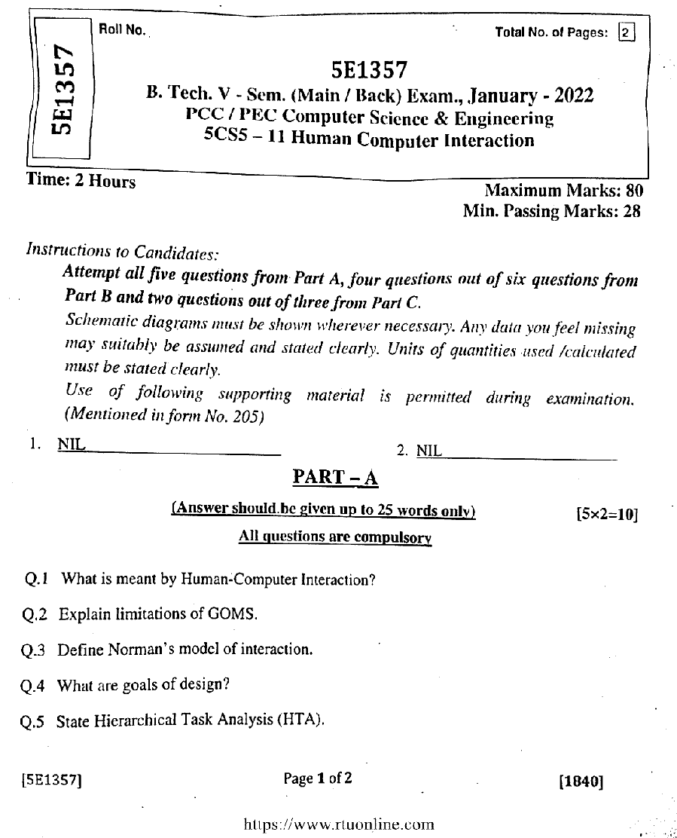

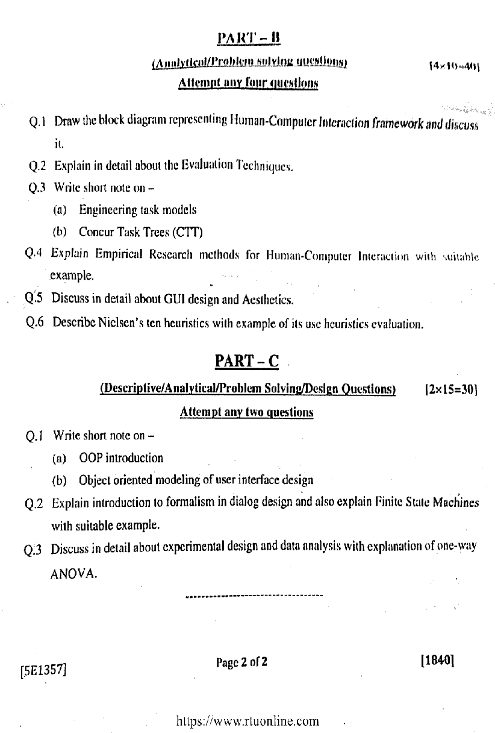

**STUDENT PERFORMANCE REPORT**

| **ROLL NO.** | **NAME** | **MIT-1** | **MIT-2** | **ASSIGNMENT1** |
| --- | --- | --- | --- | --- |
| 21ETCCS001 | AARSH BHARTI | 50 | 66 | AB |
| 21ETCCS002 | MS AASTHA DAKHERA | 70 | 70 | A++ |
| 21ETCCS003 | ABHISHEK PRAJAPAT | 57 | 69 | A |
| 21ETCCS005 | AKSHANSH SONI | 57 | 69 | A |
| 21ETCCS006 | AKSHAT SINGH CHOUHAN | 44 | 68 | A++ |
| 21ETCCS007 | ANIRUDH SINGH RAJPUROHIT | 45 | 67 | A++ |
| 21ETCCS008 | ANISH SINGHAL | 70 | 70 | A++ |
| 21ETCCS009 | ANJALI SONI | 70 | 70 | A++ |
| 21ETCCS010 | ANURAG MENARIA | 58 | 68 | AB |
| 21ETCCS011 | ANUSHKA VIJAY | 58 | 68 | A++ |
| 21ETCCS012 | APURVA LODHA | 70 | 70 | A++ |
| 21ETCCS013 | ARUN LOHAR | 60 | 70 | A++ |
| 21ETCCS014 | ARVIND SINGH | 51 | 65 | A++ |
| 21ETCCS015 | ARVIND SUTHAR | 52 | 64 | A++ |
| 21ETCCS016 | AVANI JOSHI | 59 | 67 | A++ |
| 21ETCCS017 | AYAN KHAN | 61 | 69 | A |
| 21ETCCS018 | AYUSH JHOTA | 61 | 69 | A++ |
| 21ETCCS019 | AYUSH TALESARA | 55 | 67 | A++ |
| 21ETCCS020 | BHAVYA MEHTA | 70 | 70 | A++ |
| 21ETCCS021 | BHERU SINGH PANWAR | 61 | 69 | A++ |
| 21ETCCS022 | MS BHUMIKA VARDAR | 59 | 67 | A++ |
| 21ETCCS025 | CHINMAY MENARIA | 62 | 68 | A |
| 21ETCCS026 | DAKSH VYAS | 62 | 68 | A++ |
| 21ETCCS027 | DEEPAK DHAKAR | 60 | 66 | A |
| 21ETCCS029 | DHIREN SUHALKA | 46 | 66 | A++ |
| 21ETCCS030 | DHRUV BAGORA | 70 | 70 | A++ |
| 21ETCCS031 | DIKSHA AGARWAL | 70 | 70 | A++ |
| 21ETCCS032 | DINESH AUDICHYA | 70 | 70 | A++ |
| 21ETCCS034 | DIVYANSHU MENARIA | 54 | 62 | A++ |
| 21ETCCS035 | DIVYANSHU SAHU | 60 | 66 | A++ |
| 21ETCCS036 | DURGA SANKAR DANGI | 70 | 70 | A++ |
| 21ETCCS037 | GAGAN MANGAL | 60 | 66 | AB |
| 21ETCCS038 | GARVITA BAYA | 70 | 70 | A++ |
| 21ETCCS039 | GARVITA JAIN | 62 | 68 | A++ |
| 21ETCCS040 | GAZI AMAN KHAN | 47 | 65 | AB |
| 21ETCCS041 | HARSH | 62 | 64 | A++ |
| 21ETCCS042 | HARSH SONI | 62 | 64 | A++ |
| 21ETCCS043 | HARSHAL PALIWAL | 66 | 60 | A++ |
| 21ETCCS044 | HARSHIT PUROHIT | 70 | 70 | A++ |
| 21ETCCS045 | HARSHIT SHARMA | 70 | 70 | A++ |
| 21ETCCS046 | HARSHITA RATHORE | 56 | 66 | A++ |
| 21ETCCS047 | HEET DOSI | 54 | 62 | B |
| 21ETCCS048 | MS HETAL SHARMA | 63 | 67 | A++ |
| 21ETCCS049 | JAHNAVI JOSHI | 70 | 70 | A++ |
| 21ETCCS050 | JAINIL JAIN | 56 | 66 | A++ |
| 21ETCCS051 | JASWANT SINGH RAO | 66 | 60 | A++ |
| 21ETCCS052 | JATIN VASHISHTHA | 66 | 60 | A++ |
| 21ETCCS053 | JAY JOSHI | 70 | 70 | A++ |
| 21ETCCS054 | JAYDEEP DANGI | 70 | 70 | A++ |
| 21ETCCS055 | JIGYASA CHATURVEDI | 70 | 70 | A++ |
| 21ETCCS056 | KAILASH JOSHI | 66 | 64 | A++ |
| 21ETCCS057 | KAMLESH KUMAR GHANCHI | 67 | 63 | A++ |
| 21ETCCS058 | KANISHKA PARMAR | 70 | 70 | A++ |
| 21ETCCS059 | KASHVI PANDEY | 67 | 63 | A++ |
| 21ETCCS060 | KHUSHAL PALIWAL | 55 | 61 | A++ |
| 21ETCCS061 | KHUSHI GAHLOT | 56 | 66 | A++ |
| 21ETCCS062 | KHUSHI VANAWAT | 67 | 63 | A++ |
| 21ETCCS064 | KUNAL CHOUBISA | 50 | 62 | A++ |
| 21ETCCS065 | KUNAL MENARIA | 55 | 61 | A++ |
| 21ETCCS066 | KUNAL PALIWAL | 57 | 65 | A++ |
| 21ETCCS067 | KUNAL SHARMA | 59 | 57 | A++ |
| 21ETCCS068 | KUNIKA KADECHA(RL) | 57 | 65 | A++ |
| 21ETCCS069 | LALITA DANGI | 70 | 70 | A++ |
| 21ETCCS070 | LAVISHA JAIN | 70 | 70 | A++ |
| 21ETCCS071 | LOKANTIK JAIN | 66 | 60 | A++ |
| 21ETCCS073 | MAHAK BANSAL | 67 | 59 | A++ |
| 21ETCCS074 | MANSI GEHLOT | 70 | 70 | A++ |
| 21ETCCS075 | MAYANK KANERIYA | 70 | 70 | A++ |
| 21ETCCS076 | MAYANK MALIWAL | 68 | 58 | A++ |
| 21ETCCS078 | MITANSH JAIN | 59 | 63 | A |
| 21ETCCS079 | MOHAMMED OWAIS KHAN | 59 | 63 | A |
| 21ETCCS081 | NAVNEET ANAND | 70 | 70 | A |
| 21ETCCS082 | NEHAL DHING | 70 | 70 | A++ |
| 21ETCCS084 | NIPUN MALI | 59 | 63 | A++ |
| 21ETCCS085 | NISHA LOHAR | 70 | 70 | A++ |
| 21ETCCS086 | PRADHUMAN SINGH CHAUDHARY | 68 | 62 | A++ |
| 21ETCCS087 | PRANJAL SINGHVI | 63 | 59 | A++ |
| 21ETCCS088 | RAJAT PATIDAR | 61 | 55 | AB |
| 21ETCCS089 | RIYA JAIN | 70 | 70 | A++ |
| 21ETCCS090 | ROHIN GANG | 62 | 54 | B |
| 21ETCCS091 | RUPAL SONI | 70 | 70 | A++ |
| 21ETCCS092 | SAHIL SOLANKI | 68 | 58 | A++ |
| 21ETCCS093 | SARGAM JAIN | 70 | 70 | A++ |
| 21ETCCS094 | SATYEN KHARADI | 69 | 61 | A++ |
| 21ETCCS095 | SHASHANK MENARIA | 63 | 59 | A++ |
| 21ETCCS096 | SHUBHAM DAS | 69 | 61 | A++ |
| 21ETCCS097 | SUDEEP ROY | 51 | 61 | A |
| 21ETCCS098 | SUMIT VASITA | 54 | 58 | A |
| 21ETCCS099 | SUYASH SONI | 68 | 58 | A++ |
| 21ETCCS100 | MS TANISHA KUMAWAT | 69 | 57 | A++ |
| 21ETCCS101 | TUSHAR YADAV | 35 | 67 | A++ |
| 21ETCCS102 | VAIBHAV GARG | 70 | 60 | A++ |
| 21ETCCS103 | VAIBHAV SONI | 70 | 70 | A++ |
| 21ETCCS104 | VARUN SHARMA | 63 | 59 | A++ |
| 21ETCCS105 | VEDANSHI PAREEK | 60 | 70 | A++ |
| 21ETCCS106 | VEDAS DIXIT | 61 | 69 | A++ |
| 21ETCCS107 | VIKRAM SINGH SISODIYA | 69 | 57 | A++ |
| 21ETCCS108 | VIMANYU P SHARMA | 64 | 58 | A |
| 21ETCCS109 | VISHAL KUMAWAT | 69 | 57 | A |
| 21ETCCS110 | VISHAL PUSHKARNA | 64 | 58 | A++ |
| 21ETCCS111 | VYOM BHATT | 57 | 69 | A++ |
| 21ETCCS112 | YASH JAIN | 57 | 69 | A++ |
| 21ETCCS113 | YASH JOSHI | 58 | 68 | A++ |
| 21ETCCS114 | YASH PURI GOSWAMI | 62 | 54 | A++ |
| 21ETCCS115 | YOGESH JAIPAL | 63 | 53 | A++ |
| 21ETCCS116 | MS YUVIKA CHOUDHARY | 58 | 68 | A++ |
| 21ETCCS117 | YUVRAJ SINGH KANAWAT | 65 | 51 | A+ |
| 21ETCCS300 | NEELAM KATARIYA | 59 | 67 | A++ |
| 21ETCCS400 | Shabbir Husain | 55 | 57 | B |
| 21ETCCS401 | Ali Hussain | 36 | 66 | AB |
| 22ETCCS200 | Saurabh Soni | 59 | 67 | A++ |

**Signature of Faculty: Signature of HOD**

**RESULT ANALYSIS**

| **S.NO.** | **RTU ROLL NUMBER** | **NAME OF STUDENT** | **END TERM MARKS** | **SESSIONAL MARKS** | **TOTAL** |
| --- | --- | --- | --- | --- | --- |
| **MAX MARKS** | **70** | **30** | **100** |
| **Set Target Level** | | | **60%** | **75%** |  |
|  | 21ETCCS001 | AARSH BHARTI | 56 | 25 | 81 |
|  | 21ETCCS002 | MS AASTHA DAKHERA | 56 | 30 | 86 |
|  | 21ETCCS003 | ABHISHEK PRAJAPAT | 38 | 27 | 65 |
|  | 21ETCCS005 | AKSHANSH SONI | 45 | 27 | 72 |
|  | 21ETCCS006 | AKSHAT SINGH CHOUHAN | 34 | 24 | 58 |
|  | 21ETCCS007 | ANIRUDH SINGH RAJPUROHIT | 43 | 24 | 67 |
|  | 21ETCCS008 | ANISH SINGHAL | 44 | 30 | 74 |
|  | 21ETCCS009 | ANJALI SONI | 54 | 30 | 84 |
|  | 21ETCCS010 | ANURAG MENARIA | 40 | 27 | 67 |
|  | 21ETCCS011 | ANUSHKA VIJAY | 31 | 27 | 58 |
|  | 21ETCCS012 | APURVA LODHA | 54 | 30 | 84 |
|  | 21ETCCS013 | ARUN LOHAR | 37 | 28 | 65 |
|  | 21ETCCS014 | ARVIND SINGH | 28 | 25 | 53 |
|  | 21ETCCS015 | ARVIND SUTHAR | 23 | 25 | 48 |
|  | 21ETCCS016 | AVANI JOSHI | 40 | 27 | 67 |
|  | 21ETCCS017 | AYAN KHAN | 38 | 28 | 66 |
|  | 21ETCCS018 | AYUSH JHOTA | 41 | 28 | 69 |
|  | 21ETCCS019 | AYUSH TALESARA | 30 | 26 | 56 |
|  | 21ETCCS020 | BHAVYA MEHTA | 48 | 30 | 78 |
|  | 21ETCCS021 | BHERU SINGH PANWAR | 49 | 28 | 77 |
|  | 21ETCCS022 | MS BHUMIKA VARDAR | 43 | 27 | 70 |
|  | 21ETCCS025 | CHINMAY MENARIA | 35 | 28 | 63 |
|  | 21ETCCS026 | DAKSH VYAS | 34 | 28 | 62 |
|  | 21ETCCS027 | DEEPAK DHAKAR | 29 | 27 | 56 |
|  | 21ETCCS029 | DHIREN SUHALKA | 30 | 24 | 54 |
|  | 21ETCCS030 | DHRUV BAGORA | 56 | 30 | 86 |
|  | 21ETCCS031 | DIKSHA AGARWAL | 57 | 30 | 87 |
|  | 21ETCCS032 | DINESH AUDICHYA | 38 | 30 | 68 |
|  | 21ETCCS034 | DIVYANSHU MENARIA | 17 | 25 | 42 |
|  | 21ETCCS035 | DIVYANSHU SAHU | 33 | 27 | 60 |
|  | 21ETCCS036 | DURGA SANKAR DANGI | 50 | 30 | 80 |
|  | 21ETCCS037 | GAGAN MANGAL | 28 | 27 | 55 |
|  | 21ETCCS038 | GARVITA BAYA | 58 | 30 | 88 |
|  | 21ETCCS039 | GARVITA JAIN | 59 | 28 | 87 |
|  | 21ETCCS040 | GAZI AMAN KHAN | 27 | 24 | 51 |
|  | 21ETCCS041 | HARSH | 19 | 27 | 46 |
|  | 21ETCCS042 | HARSH SONI | 41 | 27 | 68 |
|  | 21ETCCS043 | HARSHAL PALIWAL | 49 | 27 | 76 |
|  | 21ETCCS044 | HARSHIT PUROHIT | 54 | 30 | 84 |
|  | 21ETCCS045 | HARSHIT SHARMA | 43 | 30 | 73 |
|  | 21ETCCS046 | HARSHITA RATHORE | 51 | 26 | 77 |
|  | 21ETCCS047 | HEET DOSI | 35 | 25 | 60 |
|  | 21ETCCS048 | MS HETAL SHARMA | 53 | 28 | 81 |
|  | 21ETCCS049 | JAHNAVI JOSHI | 62 | 30 | 92 |
|  | 21ETCCS050 | JAINIL JAIN | 37 | 26 | 63 |
|  | 21ETCCS051 | JASWANT SINGH RAO | 36 | 27 | 63 |
|  | 21ETCCS052 | JATIN VASHISHTHA | 33 | 27 | 60 |
|  | 21ETCCS053 | JAY JOSHI | 57 | 30 | 87 |
|  | 21ETCCS054 | JAYDEEP DANGI | 58 | 30 | 88 |
|  | 21ETCCS055 | JIGYASA CHATURVEDI | 56 | 30 | 86 |
|  | 21ETCCS056 | KAILASH JOSHI | 37 | 28 | 65 |
|  | 21ETCCS057 | KAMLESH KUMAR GHANCHI | 45 | 28 | 73 |
|  | 21ETCCS058 | KANISHKA PARMAR | 55 | 30 | 85 |
|  | 21ETCCS059 | KASHVI PANDEY | 37 | 28 | 65 |
|  | 21ETCCS060 | KHUSHAL PALIWAL | 38 | 25 | 63 |
|  | 21ETCCS061 | KHUSHI GAHLOT | 52 | 26 | 78 |
|  | 21ETCCS062 | KHUSHI VANAWAT | 56 | 28 | 84 |
|  | 21ETCCS064 | KUNAL CHOUBISA | 22 | 24 | 46 |
|  | 21ETCCS065 | KUNAL MENARIA | 31 | 25 | 56 |
|  | 21ETCCS066 | KUNAL PALIWAL | 34 | 26 | 60 |
|  | 21ETCCS067 | KUNAL SHARMA | 28 | 25 | 53 |
|  | 21ETCCS068 | KUNIKA KADECHA(RL) | 52 | 26 | 78 |
|  | 21ETCCS069 | LALITA DANGI | 49 | 30 | 79 |
|  | 21ETCCS070 | LAVISHA JAIN | 50 | 30 | 80 |
|  | 21ETCCS071 | LOKANTIK JAIN | 39 | 27 | 66 |
|  | 21ETCCS073 | MAHAK BANSAL | 42 | 27 | 69 |
|  | 21ETCCS074 | MANSI GEHLOT | 56 | 30 | 86 |
|  | 21ETCCS075 | MAYANK KANERIYA | 47 | 30 | 77 |
|  | 21ETCCS076 | MAYANK MALIWAL | 49 | 27 | 76 |
|  | 21ETCCS078 | MITANSH JAIN | 32 | 26 | 58 |
|  | 21ETCCS079 | MOHAMMED OWAIS KHAN | 32 | 26 | 58 |
|  | 21ETCCS081 | NAVNEET ANAND | 38 | 30 | 68 |
|  | 21ETCCS082 | NEHAL DHING | 52 | 30 | 82 |
|  | 21ETCCS084 | NIPUN MALI | 24 | 26 | 50 |
|  | 21ETCCS085 | NISHA LOHAR | 55 | 30 | 85 |
|  | 21ETCCS086 | PRADHUMAN SINGH CHAUDHARY | 49 | 28 | 77 |
|  | 21ETCCS087 | PRANJAL SINGHVI | 36 | 26 | 62 |
|  | 21ETCCS088 | RAJAT PATIDAR | 41 | 25 | 66 |
|  | 21ETCCS089 | RIYA JAIN | 57 | 30 | 87 |
|  | 21ETCCS090 | ROHIN GANG | 47 | 25 | 72 |
|  | 21ETCCS091 | RUPAL SONI | 53 | 30 | 83 |
|  | 21ETCCS092 | SAHIL SOLANKI | 44 | 27 | 71 |
|  | 21ETCCS093 | SARGAM JAIN | 47 | 30 | 77 |
|  | 21ETCCS094 | SATYEN KHARADI | 39 | 28 | 67 |
|  | 21ETCCS095 | SHASHANK MENARIA | 31 | 26 | 57 |
|  | 21ETCCS096 | SHUBHAM DAS | 36 | 28 | 64 |
|  | 21ETCCS097 | SUDEEP ROY | 32 | 24 | 56 |
|  | 21ETCCS098 | SUMIT VASITA | 13 | 24 | 37 |
|  | 21ETCCS099 | SUYASH SONI | 38 | 27 | 65 |
|  | 21ETCCS100 | MS TANISHA KUMAWAT | 48 | 27 | 75 |
|  | 21ETCCS101 | TUSHAR YADAV | 30 | 22 | 52 |
|  | 21ETCCS102 | VAIBHAV GARG | 47 | 28 | 75 |
|  | 21ETCCS103 | VAIBHAV SONI | 54 | 30 | 84 |
|  | 21ETCCS104 | VARUN SHARMA | 22 | 26 | 48 |
|  | 21ETCCS105 | VEDANSHI PAREEK | 50 | 28 | 78 |
|  | 21ETCCS106 | VEDAS DIXIT | 48 | 28 | 76 |
|  | 21ETCCS107 | VIKRAM SINGH SISODIYA | 42 | 27 | 69 |
|  | 21ETCCS108 | VIMANYU P SHARMA | 34 | 26 | 60 |
|  | 21ETCCS109 | VISHAL KUMAWAT | 39 | 27 | 66 |
|  | 21ETCCS110 | VISHAL PUSHKARNA | 44 | 26 | 70 |
|  | 21ETCCS111 | VYOM BHATT | 57 | 27 | 84 |
|  | 21ETCCS112 | YASH JAIN | 34 | 27 | 61 |
|  | 21ETCCS113 | YASH JOSHI | 38 | 27 | 65 |
|  | 21ETCCS114 | YASH PURI GOSWAMI | 41 | 25 | 66 |
|  | 21ETCCS115 | YOGESH JAIPAL | 29 | 25 | 54 |
|  | 21ETCCS116 | MS YUVIKA CHOUDHARY | 50 | 27 | 77 |
|  | 21ETCCS117 | YUVRAJ SINGH KANAWAT | 35 | 25 | 60 |
|  | 21ETCCS300 | NEELAM KATARIYA | 46 | 27 | 73 |
|  | 21ETCCS400 | Shabbir Husain | 33 | 24 | 57 |
|  | 21ETCCS401 | Ali Hussain | 29 | 22 | 51 |
|  | 22ETCCS200 | Saurabh Soni | 39 | 27 | 66 |

| TOTAL | PASS | FAIL | ABSENT | PASS % |
| --- | --- | --- | --- | --- |
| 111 | 111 | 0 | 0 | 100 |

**Indirect Assessment:**

**Overall Teacher Self Assessment (at the completion of course) in terms of course objective and outcomes**

**Course Objectives:**

The course introduces students to analysis, design, and evaluation of the interaction between people and information and communication technologies

**Course Outcomes**:

Students will be able to introduce and prototype the design of HCI.

Students will be able to apply model based design and computation.

Students will get to know guidelines and empirical research in HCI.

Students can do task modelling and analysis in HCI.

**Methodology to identify bright student**

Considered a range of criteria, including academic performance, creativity, critical thinking, problem-solving skills, and enthusiasm for learning. Bright students often excel in multiple areas. Observed how students perform in the classroom. In terms of active participation, engagement in discussions, leadership, and the ability to grasp complex concepts.

**Efforts to keep students engaged**

1. Active Learning:
   * Incorporate active learning strategies, such as group discussions, problem-solving activities, and hands-on projects. Active participation keeps students engaged and encourages critical thinking.
2. Varied Teaching Methods:
   * Use a variety of teaching methods, including lectures, group work, multimedia presentations, and interactive activities to cater to different learning preferences.
3. Technology Integration:
   * Leverage technology, such as online platforms, educational apps, and interactive software, to make lessons more engaging and interactive.

Some extra learning for bright students

1. <https://www.youtube.com/watch?v=Tpg4TBAm6vw&t=132s>

2. <https://www.youtube.com/watch?v=5EsSXcHaKhE>

3. <https://www.youtube.com/watch?v=Rlg5tQWVrbc&t=679s>

**Methodology to identify weak student**

Considered a range of criteria, including classroom observation, formative assessment, summative assessment, assignment review e.t.c. Weak students are struggling students with sensitivity and a desire to support their learning. Some measures, such as additional tutoring, personalized assignments, or alternative assessment methods, to help students succeed.

**Targeted inventions for weak student**

**1. Additional Resources**

Offer supplementary learning materials, such as textbooks, online resources, or multimedia content, to provide alternative explanations and reinforce key concepts.

**2. Remedial classes**

Establish a tutoring program where students can receive extra help from teachers.

**3. Flipped classroom**

Students are assigned pre-class learning materials, often in the form of videos, readings, or online modules, to cover the foundational concepts before coming to class.

Some additional resources or links for student to improve their understanding for topic

1. <https://www.youtube.com/watch?v=Rlg5tQWVrbc&t=1047s>

2. <https://www.youtube.com/watch?v=_75orcropXE&t=11s>

3. Human Computer Interface by Nishtha Keswani.