Techno India NJR Institute of Technology



Course File
Microcontroller (4EC4-05)
Session (2022-23)

Dr. Vivek Jain
(Associate Professor)
Department of ECE

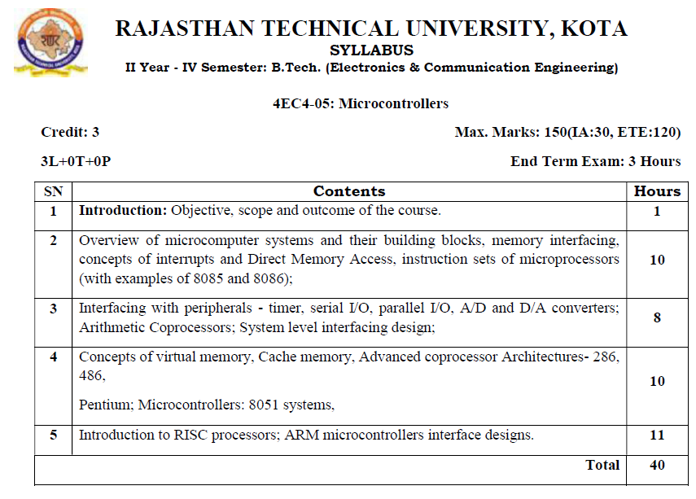
Course Overview:

The objective of this course is to enable the students to understand embedded-system programming and apply that knowledge to design and develop embedded solutions. Interaction with peripheral devices. Identify hardware and software components to build an embedded system.

Course Outcomes:
CO.NO. | Cognitive Level | Course Outcome
1 | Comprehension | Basic knowledge of assembly language and C language.
2 | Application | Use interfacing circuit for peripherals like, I/O, A/D, D/A, timer etc
3 | Analysis | Categorize different types of microcontrollers on the basis of speed, power consumption and response time.
4 | Synthesis | Design and develop interfacing circuit for memory organization.
5 | Evaluate | Compare RSIC architecture with CICS architecture based systems.

Prerequisites:
- Fundamentals knowledge of binary number system.
- Fundamentals knowledge of digital electronics.
- Fundamentals knowledge of sequential and combinational circuit.

Course Outcome Mapping with Program Outcome:
Course Outcome | Program Outcomes (PO’s)
CO. NO. | Domain Specific |  |  |  |  | Domain Independent
 | PO1 | PO2 | PO3 | PO4 | PO5 | PO6 | PO7 | PO8 | PO9 | PO10 | PO11 | PO12
CO1 | 0 | 0 | 2 | 1 | 0 | 1 | 0 | 0 | 0 | 0 | 0 | 0
CO2 | 0 | 0 | 2 | 0 | 1 | 1 | 0 | 0 | 0 | 0 | 0 | 0
CO3 | 1 | 2 | 2 | 0 | 0 | 0 | 0 | 0 | 1 | 0 | 0 | 1
CO4 | 2 | 2 | 1 | 0 | 0 | 0 | 1 | 0 | 1 | 0 | 0 | 1
CO5 | 0 | 0 | 2 | 2 | 1 | 0 | 1 | 0 | 0 | 0 | 0 | 0
1: Slight (Low) , 2: Moderate (Medium), 3: Substantial (High)
Course Coverage Module Wise:
Lecture No. | Unit | Topic
1 | 1 | ZERO LECTURE
2 | 2 | OVERVIEW OF MICROCOMPUTER SYSTEMS AND THEIR BUILDING BLOCKS
3 | 2 | Overview of microcomputer systems and their building blocks
4 | 2 | Memory interfacing
5 | 2 | Memory interfacing
6 | 2 | Concepts of interrupts
7 | 2 | Direct Memory Access
8 | 2 | Direct Memory Access
9 | 2 | Instruction sets of microprocessors (with examples of 8085 and 8086)
10 | 2 | Instruction sets of microprocessors (with examples of 8085 and 8086)
11 | 2 | Instruction sets of microprocessors (with examples of 8085 and 8086)
12 | 3 | INSTRUCTION SETS OF MICROPROCESSORS (WITH EXAMPLES OF 8085 AND 8086)
13 | 3 | Interfacing with peripherals
14 | 3 | Timer
15 | 3 | Serial I/O
16 | 3 | Parallel I/O
17 | 3 | A /D and D/A converters
18 | 3 | A /D and D/A converters
19 | 3 | Arithmetic Coprocessors
20 | 4 | SYSTEM LEVEL INTERFACING DESIGN
21 | 4 | Concepts of virtual memory, Cache memory
22 | 4 | Concepts of virtual memory, Cache memory
23 | 4 | Advanced coprocessor Architectures- 286, 486, Pentium
24 | 4 | Advanced coprocessor Architectures- 286, 486, Pentium
25 | 4 | Advanced coprocessor Architectures- 286, 486, Pentium
26 | 4 | Microcontrollers: 8051 systems
27 | 4 | Microcontrollers: 8051 systems
28 | 4 | Microcontrollers: 8051 systems
29 | 4 | Microcontrollers: 8051 systems
30 | 5 | MICROCONTROLLERS: 8051 SYSTEMS
31 | 5 | Introduction to RISC processors
32 | 5 | Introduction to RISC processors
33 | 5 | Introduction to RISC processors
34 | 5 | ARM microcontrollers interface designs
35 | 5 | ARM microcontrollers interface designs
36 | 5 | ARM microcontrollers interface designs
37 | 5 | ARM microcontrollers interface designs
38 | 5 | ARM microcontrollers interface designs
39 | 5 | Spill Over Classes
40 | 5 | Spill Over Classes

TEXT and Reference Book
- Microprocessor Architecture: Programming and Applications ith the 8085/8080A, R. S. Gaonkar ,Penram International Publishing, 1996
- Computer Organization and Design The hardware and software interface D A Patterson and J H Hennessy ,Morgan Kaufman Publishers.
- Microprocessors Interfacing, Douglas Hall, Tata McGraw Hill, 1991.
- The 8051 Microcontroller, Kenneth J. Ayala, Penram International Publishing, 1996.

QUIZ Link
https://www.sanfoundry.com/microcontroller-mcqs-introduction/
https://www.indiabix.com/digital-electronics/the-8051-microcontroller/

NPTEL COURSES LINK
https://archive.nptel.ac.in/courses/108/105/108105102/

Faculty Notes Link
https://drive.google.com/drive/folders/1L6NtNyjJPFW-pA0ewsewVbkr0a_p0XEV?usp=drive_link

Assessment Methodology:
- Practical exam using Keil Compiler.
- Two Midterm exams where student have to showcase subjective learning.
- Final Exam (subjective paper) at the end of the semester.

