Techno India NJR Institute of Technology
Department of Electronics and Communication Engineering

B.Tech. IV Semester

Lab: Analog and Digital Communication Lab (4EC4-21)
Session 2022-23

Hitesh Sen
(Associate Professor)
Department of ECE

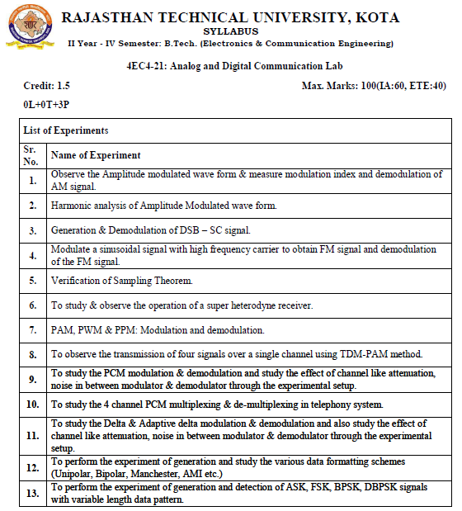

Course Outcomes:
CO.NO. | Cognitive Level | Course Outcome
1 | Comprehension | Understand different analog modulation schemes and evaluate modulation index
2 | Application | Able to understand the principle of superhetrodyne receiver
3 | Analysis | Develop time division multiplexing concepts in real time applications
4 | Synthesis | Develop and able to comprehend different data formatting schemes
5 | Evaluation | Comprehend and analyze the concepts of different digital modulation techniques in communication.

Course Outcome Mapping with Program Outcomes:
Course Outcome | PO1 | PO2 | PO3 | PO4 | PO5 | PO6 | PO7 | PO8 | PO9 | PO10 | PO11 | PO12
CO1 | 3 | 2 |  | 1
CO2 | 3 | 2 | 1 | 0
CO3 | 3 | 3 | 2 | 2 | 1
CO4 | 3 | 3 | 2 | 2 | 1
CO5 | 3 | 3 | 2 | 2 | 1
C36402 (AVG) | 2.25 | 1.75 | 2.25 | 1.00 | 2.00 | 0.00 | 0.00 | 0.00 | 0.00 | 0.00 | 0.00 | 0.00

Experiment List
S.N. | List of the Experiment
1 | To study SCILAB and communication tool box.
2 | To generate AM wave using Matlab Software
3 | To generate AM wave and plot it’s frequency spectrum using Matlab Software.
4 | Generation of the AM wave for different value of modulation index (m<1, m = 1 and  m>1) using Matlab Software.
5 | To generate FM wave and plot it’s frequency spectrum using Matlab Software.
6 | To generate PM wave and plot it’s frequency spectrum using Matlab Software.
7 | To generate Amplitude Modulation (AM) wave and determine Modulation Index  ‘ma’ and demodulate amplitude modulated wave using kit.
8 | Study of Super heterodyne AM receiver.
9 | To generate PAM, PWM and PPM wave and its plot using Matlab Software.
10 | To generate AM Wave using EMONA kit.

Sample Programs:
Exp.1- Matlab Code to generate AM Wave
clc;
clear all;
t=[0:0.01:10];
fm = 0.25;// Modulating signal frequency
fc = 10;// Carrier signal frequency
ma=1.0 // Modulation index
// Message or modulating signal 14
mt = sin(2*%pi*fm*t);
subplot (3,1,1);
plot(t,mt)
title('Message signal: m(t) = Am*sin(2*pi*fm*t)');
xlabel('Time (t in sec --->');
ylabel('Amplitude (A in Volts)');
xgrid;
// Sinusoidal Carrier Signal
ct = sin(2*%pi*fc*t);
subplot(3,1,2);
plot(t,ct)
title('Carrier signal: c(t) = Ac*sin(2*pi*fc*t)');
xlabel('Time (t in sec --->');
ylabel('Amplitude (A in Volts)');
xgrid;
// AM-DSB/SC Modulated signal
yt = mt.*ct; //(array operator)
subplot(3,1,3)
plot(t,yt, t,mt,'r',t,-mt,'r')
title('AM-DSB/SC Modulated signal: y(t) = m(t).*c(t)');
xlabel('Time (t in sec --->');
ylabel('Amplitude (in Volts)');
xgrid;
// AM-DSB/FC Modulated signal
//plot2d(x,y,5): positive intezer gives the colour &
//negative intezer gives the marker
figure(2);
subplot (3,1,1);
plot(t,mt)
title('Message signal: m(t) = Am*sin(2*pi*fm*t)');
xlabel('Time (t in sec --->');
ylabel('Amplitude (A in Volts)');
xgrid;
subplot(3,1,2);
plot(t,ct)
title('Carrier signal: c(t) = Ac*sin(2*pi*fc*t)');
xlabel('Time (t in sec --->');
ylabel('Amplitude (A in Volts)');
xgrid;
st=ct.*(1+ma*mt);
subplot(3,1,3); 15
plot(t,st, t,(1+ma*mt),'r',t,-(1+ma*mt),'r');
title('AM-DSB/FC Modulated signal: s(t) = (1+ma*m(t)).*c(t)');
xlabel('Time (t in sec --->');
ylabel('Amplitude (A in Volts)');
xgrid;
Result or Output:

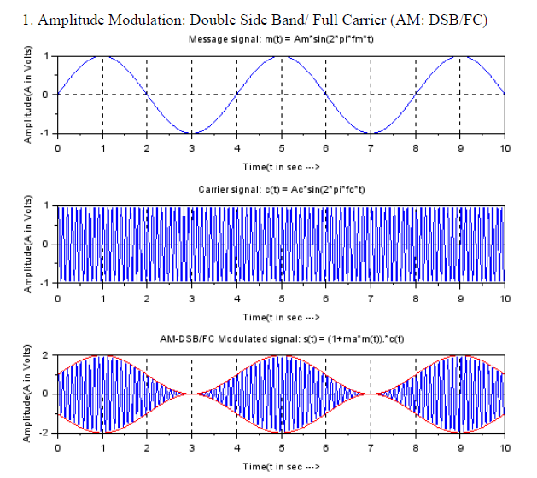

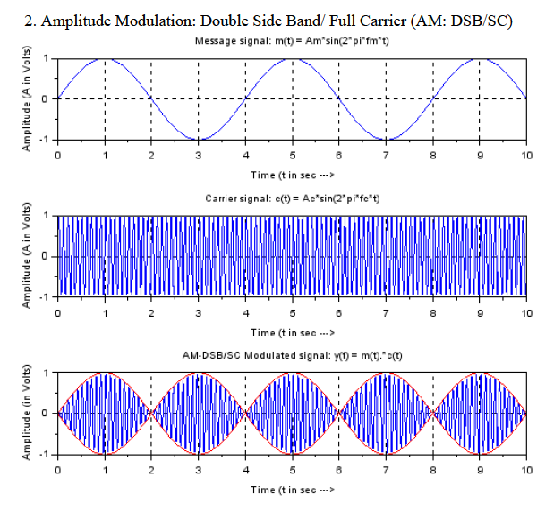

Exp.2- Matlab Code to generate AM Wave and its frequency spectrum
clc;
clear all;
close ;
t=[0:0.01:10];
fm = 0.25;// Modulating signal frequency
fc = 10;// Carrier signal frequency
ma=1.0 // Modulation index
mt = sin(2*%pi*fm*t); // Message or modulating signal
ct = sin(2*%pi*fc*t); // Sinusoidal Carrier Signal
st=ct.*(1+ma*mt);
subplot(3,1,1); plot(t,mt)
title('Message signal: m(t) = Am*sin(2*pi*fm*t)');
xlabel('Time (t in sec) --->'); ylabel('Amplitude (A in Volts)'); xgrid;
subplot(3,1,2); plot(t,ct)
title('Carrier signal: c(t) = Ac*sin(2*pi*fc*t)');
xlabel('Time (t in sec) --->'); ylabel('Amplitude (A in Volts)'); xgrid;
subplot(3,1,3); plot(t,st, t,(1+ma*mt),'r',t,-(1+ma*mt),'r');
title('AM-DSB/FC Modulated signal: s(t) = (1+ma*m(t)).*c(t)');
xlabel('Time (t in sec) --->'); ylabel('Amplitude (A in Volts)'); xgrid;
MF=fft(mt);
CF=fft(ct);
SF=fft(st);
N=size(t,'*');
F=1/0.01*(0:(N/2))/N;
n=size(F,'*');
figure
subplot(2,1,1); plot(t,mt)
title('Message signal: m(t) = Am*sin(2*pi*fm*t)');
xlabel('Time (t in sec) --->'); ylabel('Amplitude (A in Volts)'); xgrid;
subplot(2,1,2); plot(F,abs(MF(1:n)));
title('Spectrum of Modulating Signal');
xlabel('Frequency(f in Hz) --->'); ylabel('Absolute Magnitude'); xgrid
figure
subplot(2,1,1); plot(t,ct)
title('Carrier signal: c(t) = Ac*sin(2*pi*fc*t)');
xlabel('Time (t in sec) --->'); ylabel('Amplitude (A in Volts)'); xgrid;
subplot(2,1,2); plot(F,abs(CF(1:n)));
title('Spectrum of Carrier Signal');
xlabel('Frequency(f in Hz) --->'); ylabel('Absolute Magnitude'); xgrid
figure
subplot(2,1,1); plot(t,st, t,(1+ma*mt),'r',t,-(1+ma*mt),'r');
title('AM-DSB/FC Modulated signal: s(t) = (1+ma*m(t)).*c(t)');
xlabel('Time (t in sec) --->'); ylabel('Amplitude (A in Volts)'); xgrid;
subplot(2,1,2); plot(F,abs(SF(1:n)));
title('Spectrum of Modulated Signal');
xlabel('Frequency(f in Hz) --->'); ylabel('Absolute Magnitude'); xgrid

Result or Output:

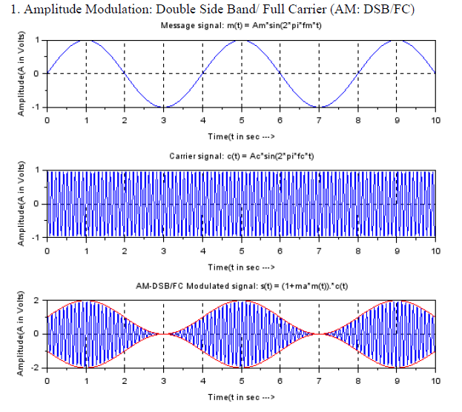

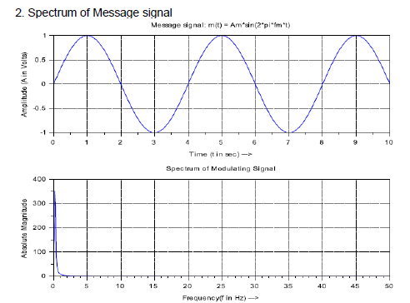

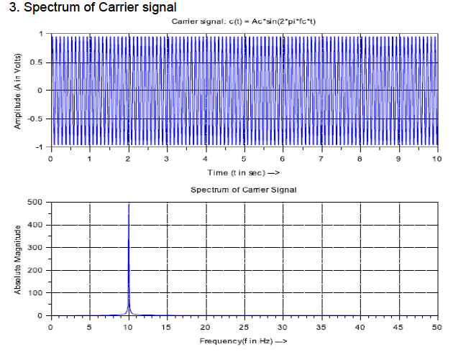
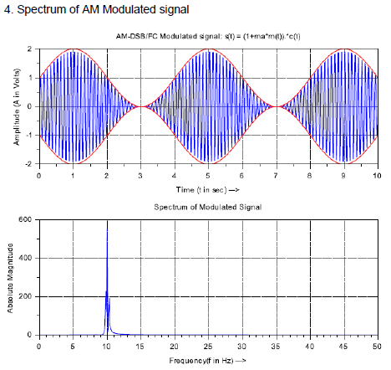

Exp.3- Matlab Code to generation AM wave for different value of modulation index (m<1, m = 1 and m>1)
//Amplitude modulation ----with different Modulation Index
Ac=1;//Carrier Amplitude
Fc=0.4;//Carrier frequency
Fm=0.02;//%baseband frequency
Fs=10;//sampling
// Under different modulation Index
m1=0.25; m2=0.75; m3=1.0; m4=1.25; m5=0.25;
t=0:1/Fs:200;
mt=cos(2*%pi*Fm*t);
mt1=cos(2*%pi*Fm*t);
vc=Ac.*cos(2*%pi*Fc*t);
st1=vc.*(1+m1*mt);
st2=vc.*(1+m2*mt);
st3=vc.*(1+m3*mt);
st4=vc.*(1+m4*mt);
figure(1);
subplot(3,1,1);
plot(t,mt1);
title('\ Modulating Signal');
xlabel('time (s)');
ylabel('amplitude');
xgrid
subplot(3,1,2);
plot(t,vc);
title('\ Carrier Signal');
xlabel('time (s)');
ylabel('amplitude');
xgrid
subplot(3,1,3);
plot(t,st3);
title('\ 100% AM Modulated Signal');
xlabel('time (s)');
ylabel('amplitude');
xgrid
figure(2);
// Under Modulation (m = 0.25)
subplot(2,2,1);
plot(t,st1,t,Ac*(m1*mt+ones(1,length(mt))),'r', t,-Ac*(m1*mt+ones(1,length(mt))),'r');
title('m =0.25 Under Modulation: s(t) = vc(t)*(1+ m1*m(t)');
xlabel('time (s)');
ylabel('amplitude');
xgrid
// Under Modulation (m = 0.75)
subplot(2,2,2);
plot(t,st2,t,Ac*(m2*mt+ones(1,length(mt))),'r', t,-Ac*(m2*mt+ones(1,length(mt))),'r');
title('m =0.75 Under Modulation: s(t) = vc(t)*(1+ m1*m(t)');
xlabel('time (s)');
ylabel('amplitude');
xgrid
// Critical (or 100% or m =1.0) Modulation
subplot(2,2,3);
plot(t,st3,t,Ac*(m3*mt+ones(1,length(mt))),'r', t,-Ac*(m3*mt+ones(1,length(mt))),'r');
title('m =1.0 Critical Modulation: s(t) = vc(t)*(1+ m1*m(t)');
xlabel('time (s)');
ylabel('amplitude');
xgrid
// Over Modulation (m = 1.25)
subplot(2,2,4);
plot(t,st4,t,Ac*(m4*mt+ones(1,length(mt))),'r', t,-Ac*(m4*mt+ones(1,length(mt))),'r');
title('\m =1.25 Over Modulation: s(t) = vc(t)*(1+ m1*m(t)');
xlabel('time (s)');
ylabel('amplitude');
xgrid

Result or Output:
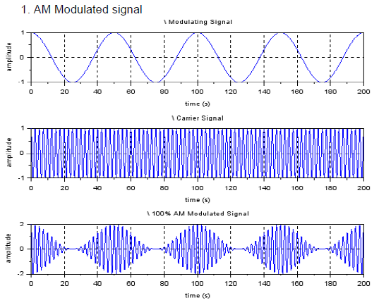
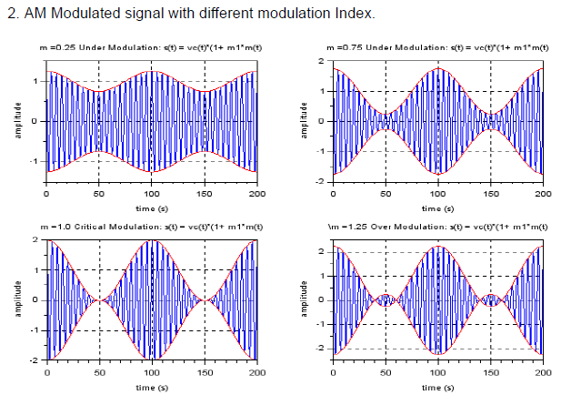
Exp.4- Matlab Code to generate FM Wave and its frequency spectrum
//The frequency modulated waveform in time domain.
clc
clear all
close
// setting
vc=1;// Amplitude of carrier
vm=1;// Amplitude of modulating signal
fm=25;// Modulating signal frequency
fc=500;// Carrier signal frequency
mf=10;mp=10;// modulation indices of FM and PM
// x-axis:Time(second)
t=0:0.00001:0.09999;//Declare time interval
f=0:10:99990;//Declare frequency interval
N=size(t,'*');
F=1/0.00001*(0:(N/2))/N;
n=size(F,'*');
n_s=(n-1)/50;
// y-axis:Voltage(volt)
wc=2*%pi*fc;
wm=2*%pi*fm;
ct = vc*cos(wc*t);//carrier signal
mt = vm*cos(wm*t);//modulating signal
FM = vc*cos((wc*t)+10*sin(wm*t));//Frequency modulated signal
PM = vc*cos((wc*t)+10*cos(wm*t));//phase modulated signal
CF=fft(ct);
MF=fft(mt);
FMF=fft(FM);
PMF=fft(PM);
//Plot modulating signal carrier signal and its spectrum
figure(1);
subplot(221);
plot(t,mt);
title('Modulating Signal');
xlabel('Time(second)');
ylabel('Amplitude');
xgrid;
subplot(222);
plot(t,ct);
title('Carrier Signal');
xlabel('Time(second)');
ylabel('Amplitude');
xgrid;
subplot(223);
plot(F(1:n_s),abs(MF(1:n_s)));
title('Msg Signal Spectrum');
xlabel('Freq(Hz)');
ylabel('Magnitude');
xgrid;
subplot(224);
plot(F(1:n_s),abs(CF(1:n_s)));
title('Carrier Signal Spectrum'); xlabel('Freq(Hz)'),ylabel('Magnitude'); xgrid;
figure(2);
subplot(211); plot(t,mt);
title('Modulating Signal');
xlabel('Time(second)');
ylabel('Amplitude');
xgrid;
subplot(212);
plot(t,FM);
plot(t,mt,'r');
xlabel ('Time(second)'),
ylabe l('Amplitude');
title('FM time-domain');
xgrid;
//Plot figure in time - frequency domain
figure(3);
subplot(211);
plot(t,FM);
plot(t,mt,'r');
xlabel('Time(second)');
ylabel('Amplitude');
xgrid;
title('FM time-domain');
xgrid;
subplot(212);
plot(F(1:n_s),abs(FMF(1:n_s)));
title('FM Freq-domain');
xlabel('Freq(Hz)');
ylabel('Magnitude');
xgrid;

Result or Output:
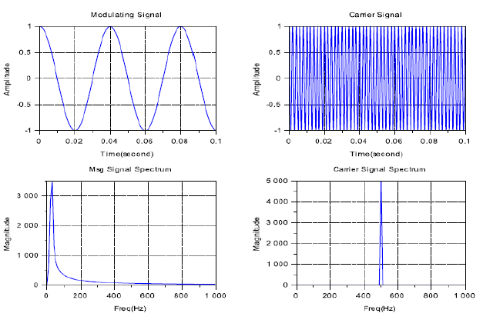
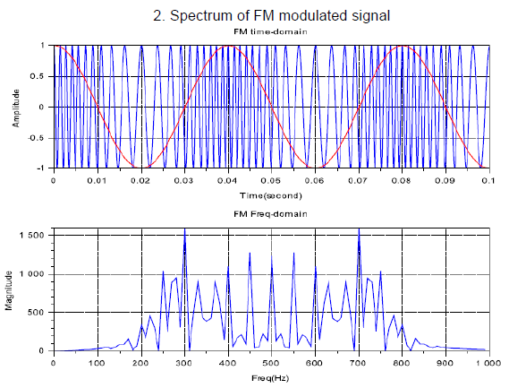

Exp.4- Matlab Code to generate PM Wave and its frequency spectrum
//The Phase modulated waveform in time domain and frequency domain.
clc
clear all
close
// setting
vc=1;// Amplitude of carrier
vm=1;// Amplitude of modulating signal
fm=25;// Modulating signal frequency
fc=500;// Carrier signal frequency
mf=10;mp=10;// modulation indices of FM and PM
// x-axis:Time(second)
t=0:0.00001:0.09999;//Declare time interval
N=size(t,'*');
F=1/0.00001*(0:(N/2))/N;//Declare frequency interval
n=size(F,'*');
n_s=(n-1)/50;
// y-axis:Voltage(volt)
wc=2*%pi*fc;
wm=2*%pi*fm;
ct = vc*cos(wc*t);//carrier signal
CF=fft(ct); //carrier signal spectrum
mt = vm*cos(wm*t);//modulating signal
MF=fft(mt); //modulating signal spectrum
FM = vc*cos((wc*t)+10*sin(wm*t));//Frequency modulated signal
FMF=fft(FM); //Spectrum of Frequency modulated signal
PM = vc*cos((wc*t)+10*cos(wm*t));//phase modulated signal
PMF=fft(PM); //Spectrum of phase modulated signal
//Plot modulating signal carrier signal and its spectrum
figure(1);
subplot(211);
plot(t,mt);
title('Modulating Signal');
xlabel('Time(second)');
ylabel('Amplitude');
xgrid;
subplot(212);
plot(t,PM);
plot(t,mt,'r');
xlabel('Time(second)');
ylabel('Amplitude');
title('FM time-domain');
xgrid;
//Plot figure in time - frequency domain
figure(2);
subplot(211);
plot(t,PM);
plot(t,mt,'r');
xlabel('Time(second)');
ylabel('Amplitude');
xgrid;
title('PM time-domain');
xgrid;
subplot(212);
plot(F(1:n_s),abs(PMF(1:n_s)));
title('PM Freq-domain');
xlabel('Freq(Hz)');
ylabel('Magnitude');
xgrid;

Result or Output:

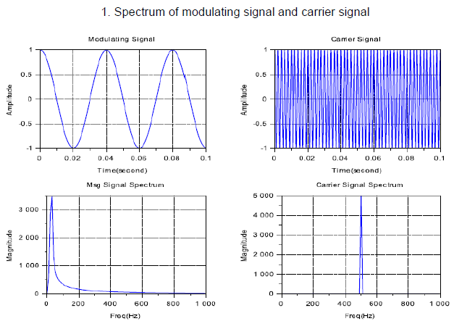

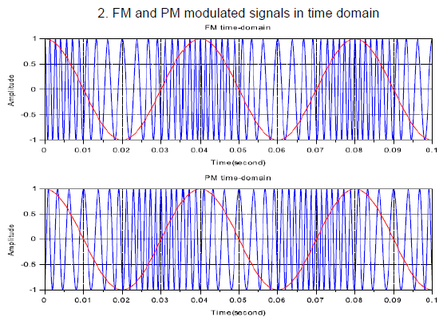

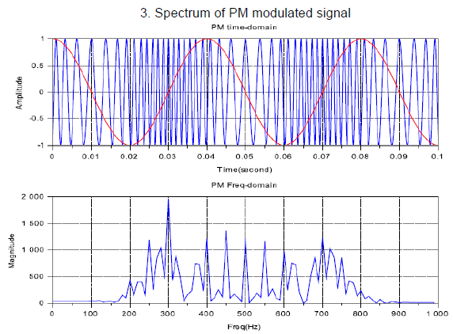

VIVA

Q.1 What is Amplitude Modulation?
Q.2 What is sampling? What is sampling theorem?
Q.3 What are the disadvantages of analog communication?
Q.4 What happens in over modulation?
Q.5 What are different types of analog modulation?
Q.6 What is need for modulation?
Q.7 What are the advantages of PAM and PWM?
Q.8 What is frequency modulation?
Q.9 What are the advantages of digital communication?
Q.10 What are the different types of digital communications?
Q.11 How to convert an analog signal into digital signal?
Q.12 Define pulse amplitude modulation?
Q.13 What is amplitude shift keying?
Q.14 What is phase shift keying?
Q.15 What is frequency shift keying?
Q.16 Why ASK is also called On-Off keying?
Q.17 What is the bandwidth of BPSK signal?
Q.18 Compare ASK, PSK and FSK?
Q.19 What is Nyquist Rate?
Q.20 Draw block diagram of analog communication system.
Q.21 With the help of a block diagram, explain the process of converting analog signal to digital signal?
Q.22 Discuss the functions of a sampler and quantizer?
Q.23 Which types of Coding techniques are familiar to you?
Q.24 Discuss in detail about the aliasing effect and explain how it is rectified?
Q.25 Illustrate about Phase Shift keying (PSK) technique?
Q.26 Give the differences between Bit Rate and Baud Rate?
Q.27 List down the advantages and disadvantages of digital communication techniques?
Q.28 Write down any 6 different digital modulation techniques you know?
Q.29 What is aliasing?
Q.30 How can aliasing be avoided?
Q.31 What do you mean by FM and classify FM?
Q.32 What is synchronization in communication?
Q.34 What is the function of band pass filter in communication?
Q.34 What are the advantages of SSB over DSB-SC?
Q.34 Wha do you mean by inter symbol interference?
Q.35 Why we use MSK?
Q.36 Why we use ADM (Adaptive Delta Modulation)?
Q.37 What is the drawback of delta modulation?

