
Techno India NJR Institute of Technology

ARTIFICIAL INTELLIGENCE AND EXPERT SYSTEMS (8EC5-11)

Kirti Dashora
(CSE Deptt.)

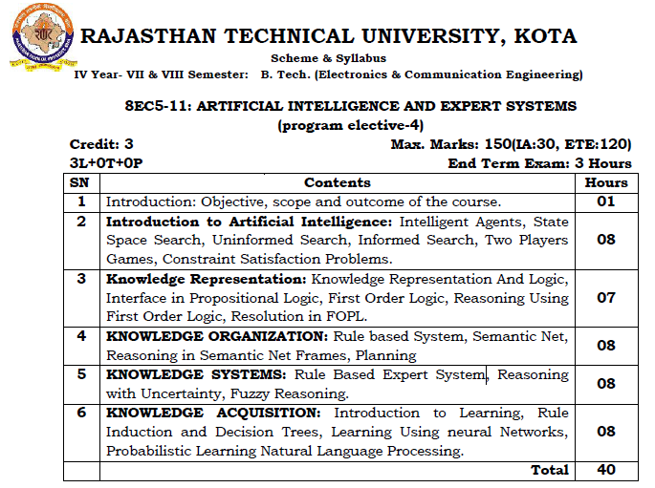

Course Overview:
This course teaches what every student should know about Artificial Intelligence. AI is a fast-moving technology with impacts and implications for both our individual lives and society as a whole. In this course, students will get a basic introduction to the building blocks and components of artificial intelligence, learning about concepts like algorithms, machine learning, and neural networks. Students will also explore how AI is already being used, and evaluate problem areas of AI, such as bias. The course also contains a balanced look at AI’s impact on existing jobs, as well as its potential to create new and exciting career fields in the future. Students will leave the course with a solid understanding of what AI is, how it works, areas of caution, and what they can do with the technology.

Course outcome:
CO. NO. | Cognitive Level | Course Outcome
1 | Knowledge | Define the fundamentals of artificial intelligence , Intelligent Agents, State Space and Uninformed Search, Informed Search and constraint satisfaction
2 | Comprehension | Student able to Describe predicate logic, reasoning using first order logic and Resolution in FOPL
3 | Application | Student able to Use basics of Rule based System, Semantic Net, Reasoning in Semantic Net Frames
4 | Analysis | Student able to Examine of rule based expert systems, reasoning with uncertainty and fuzzy logic based reasoning
5 | Synthesis | Explain and Synthesis of various machine learning algorithms like Decision Tree, Artificial Neural Networks, Probabilistic Learning. Knowledge of basic concepts and challenges in Natural  Language Processing

Prerequisites:
- Strong knowledge of Mathematics
- Good command over programming languages
- Good Analytical Skills
- Ability to understand complex algorithms
- Basic knowledge of Statistics and modeling

Course Outcome Mapping with Program Outcome:
Course Outcome | Program Outcomes (PO’s)
CO. NO. | Domain Specific (PSO) |  |  |  |  | Domain Independent (PO)
 | PO1 | PO2 | PO3 | PO4 | PO5 | PO6 | PO7 | PO8 | PO9 | PO10 | PO11 | PO12
CO1 | 2 | 2 | 2 | 2 | 0 | 2 | 0 | 0 | 0 | 0 | 0 | 2
CO2 | 1 | 2 | 1 | 1 | 0 | 2 | 0 | 0 | 0 | 2 | 1 | 1
CO3 | 2 | 2 | 1 | 1 | 1 | 2 | 1 | 0 | 0 | 1 | 0 | 2
CO4 | 1 | 1 | 2 | 1 | 1 | 2 | 0 | 0 | 1 | 0 | 0 | 2
CO5 | 2 | 2 | 2 | 2 | 2 | 2 | 0 | 1 | 1 | 0 | 2 | 2
1: Slight (Low) , 2: Moderate (Medium), 3: Substantial (High)

Course Coverage Module Wise:
Course Coverage Module Wise:
Lecture No. | Unit | Topic
 | 1 | Introduction: Objective, scope and outcome of the course.
 | 2 | Introduction to Artificial Intelligence
 | 2 | Explain Intelligent Agents
 | 2 | State Space Search
 | 2 | Uninformed Search
 | 2 | Informed Search
 | 2 | Two Players Games
 | 2 | Constraint Satisfaction Problems
 | 2 | Conclusion
 | 3 | Knowledge Representation
 | 3 | Describe Knowledge Representation And Logic
 | 3 | Define Representation And Logic
 | 3 | Interface in Propositional Logic
 | 3 | First Order Logic
 | 3 | Reasoning Using First Order Logic
 | 3 | Resolution in FOPL
 | 4 | KNOWLEDGE ORGANIZATION
 | 4 | Describe Rule based System
 | 4 | Implementation and Application of Rule based System
 | 4 | Describe Semantic Net
 | 4 | Implementation and Application of Semantic Net
 | 4 | Describe Reasoning in Semantic Net Frames
 | 4 | Implementation and Application of Reasoning in Semantic Net Frames
 | 4 | Planning
 | 5 | KNOWLEDGE SYSTEMS
 | 5 | Introduction of Rule Based Expert System
 | 5 | Need of Rule Based Expert System
 | 5 | Introduction of Reasoning with Uncertainty
 | 5 | Need of Reasoning with Uncertainty
 | 5 | Introduction of Fuzzy Reasoning
 | 5 | Implementation of Fuzzy Reasoning
 | 5 | Application of Fuzzy Reasoning

Tex t Books & References:
1. Artificial Intelligence: Elaine Rich, Kevin Knight, Mc-Graw Hill.
2. Introduction to AI & Expert System: Dan W. Patterson, PHI.
3. Artificial Intelligence by Luger (Pearson Education)
4. Russel & Norvig, Artificial Intelligence: A Modern Approach, Prentice-Hall.
Course Level Problems (Test Items):
S.No | List of Practicals
1 | Study of Prolog
2 | Write simple fact for the statements using PROLOG
3 | Write predicates One converts centigrade temperatures to Fahrenheit, the other checks if a temperature is below freezing.
4 | Write a program to solve the Monkey Banana problem
5 | WAP in turbo prolog for medical diagnosis and show the advantage and disadvantage of green and red cuts.
6 | WAP to implement factorial, fibonacci of a given number
7 | Write a program to solve 4-Queen problem.
8 | Write a program to solve traveling salesman problem.
9 | Write a program to solve water jug problem using LISP

Assessment Methodology:
- MCQ after every module completion.
- Practical exam in lab where they have to write code on C compiler for the given problem statement. (Once in a week)
- Assignments one from each unit.
- Midterm subjective paper where they have to write algorithms to perform different operations on different data structures as mentioned in the modules. (Twice during the semester)
- Final paper at the end of the semester subjective.

Online /NPTEL Certifications
- Fundamentals Of Artificial Intelligence by NPTEL.
- AI for everyone offered by DeepLearning.AI.
- Master The fundamentals of AI and Machine Learning(LinkedIn learning –Lynda).
- Learn with Google AI by Microsoft
- Artificial Intelligence Nanodegree program(Udacity)

UNIT 1
Introduction: Objective, scope and outcome of the course.
Objective:- Compare AI with human intelligence and traditional information processing and discuss its strengths and limitations as well as its application to complex and human-centred problems.

Artificial Intelligence is composed of two words Artificial and Intelligence, where Artificial defines "man-made," and intelligence defines "thinking power", hence AI means "a man-made thinking power."
So, we can define AI as:
"It is a branch of computer science by which we can create intelligent machines which can behave like a human, think like humans, and able to make decisions."
Artificial Intelligence exists when a machine can have human based skills such as learning, reasoning, and solving problems
With Artificial Intelligence you do not need to preprogram a machine to do some work, despite that you can create a machine with programmed algorithms which can work with own intelligence, and that is the awesomeness of AI.
It is believed that AI is not a new technology, and some people says that as per Greek myth, there were Mechanical men in early days which can work and behave like humans.

Why Artificial Intelligence?
Before Learning about Artificial Intelligence, we should know that what is the importance of AI and why should we learn it. Following are some main reasons to learn about AI:
- With the help of AI, you can create such software or devices which can solve real-world problems very easily and with accuracy such as health issues, marketing, traffic issues, etc.
- With the help of AI, you can create your personal virtual Assistant, such as Cortana, Google Assistant, Siri, etc.
- With the help of AI, you can build such Robots which can work in an environment where survival of humans can be at risk.
- AI opens a path for other new technologies, new devices, and new Opportunities.

Goals of Artificial Intelligence
Following are the main goals of Artificial Intelligence:
- Replicate human intelligence
- Solve Knowledge-intensive tasks
- An intelligent connection of perception and action
- Building a machine which can perform tasks that requires human intelligence such as:
  - Proving a theorem
  - Playing chess
  - Plan some surgical operation
  - Driving a car in traffic
- Creating some system which can exhibit intelligent behavior, learn new things by itself, demonstrate, explain, and can advise to its user.

What Comprises to Artificial Intelligence?
Artificial Intelligence is not just a part of computer science even it's so vast and requires lots of other factors which can contribute to it. To create the AI first we should know that how intelligence is composed, so the Intelligence is an intangible part of our brain which is a combination of Reasoning, learning, problem-solving perception, language understanding, etc.
To achieve the above factors for a machine or software Artificial Intelligence requires the following discipline:
- Mathematics
- Biology
- Psychology
- Sociology
- Computer Science
- Neurons Study
- Statistics
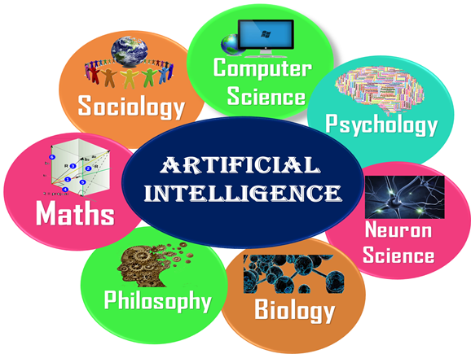

Advantages of Artificial Intelligence
Following are some main advantages of Artificial Intelligence:
- High Accuracy with less errors: AI machines or systems are prone to less errors and high accuracy as it takes decisions as per pre-experience or information.
- High-Speed: AI systems can be of very high-speed and fast-decision making, because of that AI systems can beat a chess champion in the Chess game.
- High reliability: AI machines are highly reliable and can perform the same action multiple times with high accuracy.
- Useful for risky areas: AI machines can be helpful in situations such as defusing a bomb, exploring the ocean floor, where to employ a human can be risky.
- Digital Assistant: AI can be very useful to provide digital assistant to the users such as AI technology is currently used by various E-commerce websites to show the products as per customer requirement.
- Useful as a public utility: AI can be very useful for public utilities such as a self-driving car which can make our journey safer and hassle-free, facial recognition for security purpose, Natural language processing to communicate with the human in human-language, etc.

Disadvantages of Artificial Intelligence
Every technology has some disadvantages, and thesame goes for Artificial intelligence. Being so advantageous technology still, it has some disadvantages which we need to keep in our mind while creating an AI system. Following are the disadvantages of AI:
- High Cost: The hardware and software requirement of AI is very costly as it requires lots of maintenance to meet current world requirements.
- Can't think out of the box: Even we are making smarter machines with AI, but still they cannot work out of the box, as the robot will only do that work for which they are trained, or programmed.
- No feelings and emotions: AI machines can be an outstanding performer, but still it does not have the feeling so it cannot make any kind of emotional attachment with human, and may sometime be harmful for users if the proper care is not taken.
- Increase dependency on machines: With the increment of technology, people are getting more dependent on devices and hence they are losing their mental capabilities.
- No Original Creativity: As humans are so creative and can imagine some new ideas but still AI machines cannot beat this power of human intelligence and cannot be creative and imaginative.

Application of AI
Artificial Intelligence has various applications in today's society. It is becoming essential for today's time because it can solve complex problems with an efficient way in multiple industries, such as Healthcare, entertainment, finance, education, etc. AI is making our daily life more comfortable and fast.
Following are some sectors which have the application of Artificial Intelligence:
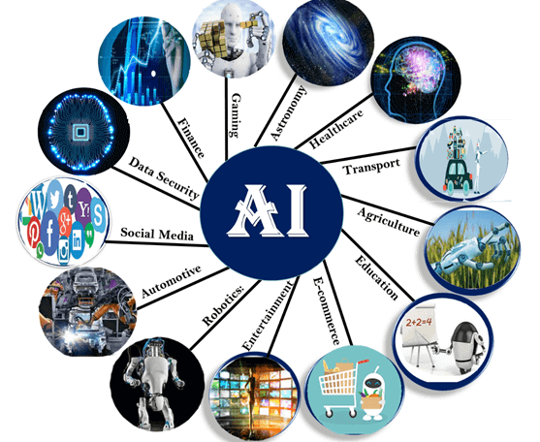

1. AI in Astronomy
- Artificial Intelligence can be very useful to solve complex universe problems. AI technology can be helpful for understanding the universe such as how it works, origin, etc.

2. AI in Healthcare
- In the last, five to ten years, AI becoming more advantageous for the healthcare industry and going to have a significant impact on this industry.
- Healthcare Industries are applying AI to make a better and faster diagnosis than humans. AI can help doctors with diagnoses and can inform when patients are worsening so that medical help can reach to the patient before hospitalization.

3. AI in Gaming
- AI can be used for gaming purpose. The AI machines can play strategic games like chess, where the machine needs to think of a large number of possible places.

4. AI in Finance
- AI and finance industries are the best matches for each other. The finance industry is implementing automation, chatbot, adaptive intelligence, algorithm trading, and machine learning into financial processes.

5. AI in Data Security
- The security of data is crucial for every company and cyber-attacks are growing very rapidly in the digital world. AI can be used to make your data more safe and secure. Some examples such as AEG bot, AI2 Platform,are used to determine software bug and cyber-attacks in a better way.

6. AI in Social Media
- Social Media sites such as Facebook, Twitter, and Snapchat contain billions of user profiles, which need to be stored and managed in a very efficient way. AI can organize and manage massive amounts of data. AI can analyze lots of data to identify the latest trends, hashtag, and requirement of different users.

7. AI in Travel & Transport
- AI is becoming highly demanding for travel industries. AI is capable of doing various travel related works such as from making travel arrangement to suggesting the hotels, flights, and best routes to the customers. Travel industries are using AI-powered chatbots which can make human-like interaction with customers for better and fast response.

8. AI in Automotive Industry
- Some Automotive industries are using AI to provide virtual assistant to their user for better performance. Such as Tesla has introduced TeslaBot, an intelligent virtual assistant.
- Various Industries are currently working for developing self-driven cars which can make your journey more safe and secure.

9. AI in Robotics:
- Artificial Intelligence has a remarkable role in Robotics. Usually, general robots are programmed such that they can perform some repetitive task, but with the help of AI, we can create intelligent robots which can perform tasks with their own experiences without pre-programmed.
- Humanoid Robots are best examples for AI in robotics, recently the intelligent Humanoid robot named as Erica and Sophia has been developed which can talk and behave like humans.

10. AI in Entertainment
- We are currently using some AI based applications in our daily life with some entertainment services such as Netflix or Amazon. With the help of ML/AI algorithms, these services show the recommendations for programs or shows.

11. AI in Agriculture
- Agriculture is an area which requires various resources, labor, money, and time for best result. Now a day's agriculture is becoming digital, and AI is emerging in this field. Agriculture is applying AI as agriculture robotics, solid and crop monitoring, predictive analysis. AI in agriculture can be very helpful for farmers.

12. AI in E-commerce
- AI is providing a competitive edge to the e-commerce industry, and it is becoming more demanding in the e-commerce business. AI is helping shoppers to discover associated products with recommended size, color, or even brand.

13. AI in education:
- AI can automate grading so that the tutor can have more time to teach. AI chatbot can communicate with students as a teaching assistant.
- AI in the future can be work as a personal virtual tutor for students, which will be accessible easily at any time and any place.

Types of Artificial Intelligence:
Artificial Intelligence can be divided in various types, there are mainly two types of main categorization which are based on capabilities and based on functionally of AI. Following is flow diagram which explain the types of AI.
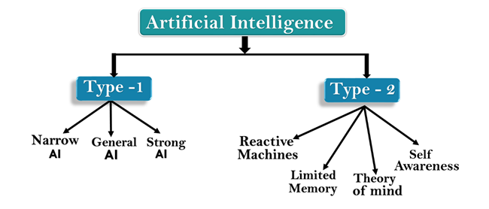

AI type-1: Based on Capabilities

1. Weak AI or Narrow AI:
- Narrow AI is a type of AI which is able to perform a dedicated task with intelligence.The most common and currently available AI is Narrow AI in the world of Artificial Intelligence.
- Narrow AI cannot perform beyond its field or limitations, as it is only trained for one specific task. Hence it is also termed as weak AI. Narrow AI can fail in unpredictable ways if it goes beyond its limits.
- Apple Siriis a good example of Narrow AI, but it operates with a limited pre-defined range of functions.
- IBM's Watson supercomputer also comes under Narrow AI, as it uses an Expert system approach combined with Machine learning and natural language processing.
- Some Examples of Narrow AI are playing chess, purchasing suggestions on e-commerce site, self-driving cars, speech recognition, and image recognition.

2. General AI:
- General AI is a type of intelligence which could perform any intellectual task with efficiency like a human.
- The idea behind the general AI to make such a system which could be smarter and think like a human by its own.
- Currently, there is no such system exist which could come under general AI and can perform any task as perfect as a human.
- The worldwide researchers are now focused on developing machines with General AI.
- As systems with general AI are still under research, and it will take lots of efforts and time to develop such systems.

3. Super AI:
- Super AI is a level of Intelligence of Systems at which machines could surpass human intelligence, and can perform any task better than human with cognitive properties. It is an outcome of general AI.
- Some key characteristics of strong AI include capability include the ability to think, to reason,solve the puzzle, make judgments, plan, learn, and communicate by its own.
- Super AI is still a hypothetical concept of Artificial Intelligence. Development of such systems in real is still world changing task.
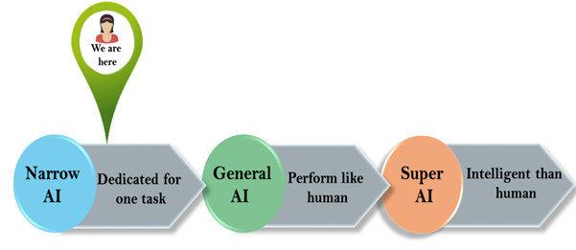

Artificial Intelligence type-2: Based on functionality

1. Reactive Machines
- Purely reactive machines are the most basic types of Artificial Intelligence.
- Such AI systems do not store memories or past experiences for future actions.
- These machines only focus on current scenarios and react on it as per possible best action.
- IBM's Deep Blue system is an example of reactive machines.
- Google's AlphaGo is also an example of reactive machines.

2. Limited Memory
- Limited memory machines can store past experiences or some data for a short period of time.
- These machines can use stored data for a limited time period only.
- Self-driving cars are one of the best examples of Limited Memory systems. These cars can store recent speed of nearby cars, the distance of other cars, speed limit, and other information to navigate the road.

3. Theory of Mind
- Theory of Mind AI should understand the human emotions, people, beliefs, and be able to interact socially like humans.
- This type of AI machines are still not developed, but researchers are making lots of efforts and improvement for developing such AI machines.

4. Self-Awareness
- Self-awareness AI is the future of Artificial Intelligence. These machines will be super intelligent, and will have their own consciousness, sentiments, and self-awareness.
- These machines will be smarter than human mind.
- Self-Awareness AI does not exist in reality still and it is a hypothetical concept.

Questions:

What do you understand by Artificial Intelligence?

Why do we need Artificial Intelligence?

Give some real-world applications of AI.

How Artificial intelligence, Machine Learning, and Deep Learning differ from each other?

What are the types of AI?

UNIT 2
Introduction to AI and Intelligent agent
Objective: Analyze the structures and algorithms of a selection of techniques related to searching, reasoning, machine learning, and language processing.

Types of AI Agents
Agents can be grouped into five classes based on their degree of perceived intelligence and capability. All these agents can improve their performance and generate better action over the time. These are given below:
- Simple Reflex Agent
- Model-based reflex agent
- Goal-based agents
- Utility-based agent
- Learning agent

1. Simple Reflex agent:
- The Simple reflex agents are the simplest agents. These agents take decisions on the basis of the current percepts and ignore the rest of the percept history.
- These agents only succeed in the fully observable environment.
- The Simple reflex agent does not consider any part of percepts history during their decision and action process.
- The Simple reflex agent works on Condition-action rule, which means it maps the current state to action. Such as a Room Cleaner agent, it works only if there is dirt in the room.
- Problems for the simple reflex agent design approach:
  - They have very limited intelligence
  - They do not have knowledge of non-perceptual parts of the current state
  - Mostly too big to generate and to store.
  - Not adaptive to changes in the environment.
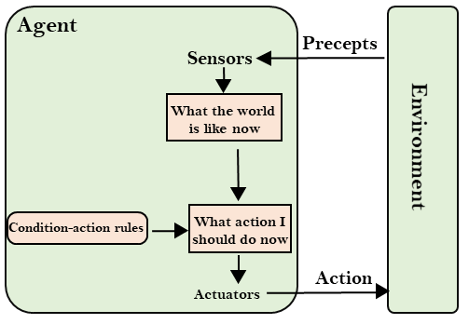

2. Model-based reflex agent
- The Model-based agent can work in a partially observable environment, and track the situation.
- A model-based agent has two important factors:
  - Model: It is knowledge about "how things happen in the world," so it is called a Model-based agent.
  - Internal State: It is a representation of the current state based on percept history.
- These agents have the model, "which is knowledge of the world" and based on the model they perform actions.
- Updating the agent state requires information about:
  - How the world evolves
  - How the agent's action affects the world.
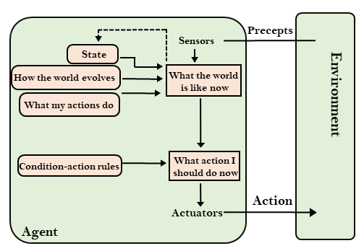

3. Goal-based agents
- The knowledge of the current state environment is not always sufficient to decide for an agent to what to do.
- The agent needs to know its goal which describes desirable situations.
- Goal-based agents expand the capabilities of the model-based agent by having the "goal" information.
- They choose an action, so that they can achieve the goal.
- These agents may have to consider a long sequence of possible actions before deciding whether the goal is achieved or not. Such considerations of different scenario are called searching and planning, which makes an agent proactive.
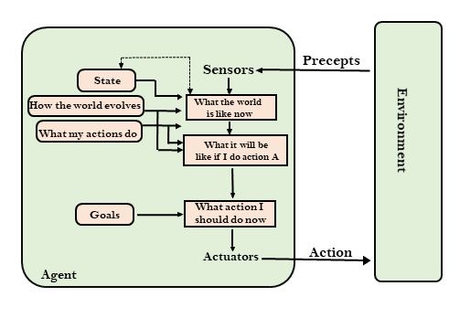

4. Utility-based agents
- These agents are similar to the goal-based agent but provide an extra component of utility measurement which makes them different by providing a measure of success at a given state.
- Utility-based agent act based not only goals but also the best way to achieve the goal.
- The Utility-based agent is useful when there are multiple possible alternatives, and an agent has to choose in order to perform the best action.
- The utility function maps each state to a real number to check how efficiently each action achieves the goals.
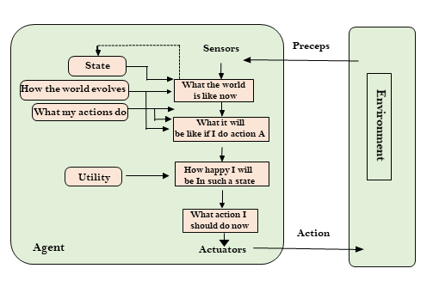

5. Learning Agents
- A learning agent in AI is the type of agent which can learn from its past experiences, or it has learning capabilities.
- It starts to act with basic knowledge and then able to act and adapt automatically through learning.
- A learning agent has mainly four conceptual components, which are:
  - Learning element: It is responsible for making improvements by learning from environment
  - Critic: Learning element takes feedback from critic which describes that how well the agent is doing with respect to a fixed performance standard.
  - Performance element: It is responsible for selecting external action
  - Problem generator: This component is responsible for suggesting actions that will lead to new and informative experiences.
- Hence, learning agents are able to learn, analyze performance, and look for new ways to improve the performance.
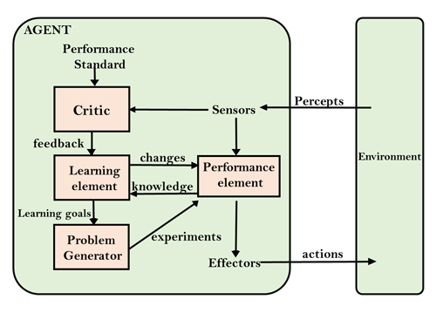

Agents in Artificial Intelligence
An AI system can be defined as the study of the rational agent and its environment. The agents sense the environment through sensors and act on their environment through actuators. An AI agent can have mental properties such as knowledge, belief, intention, etc.

What is an Agent?
An agent can be anything that perceiveits environment through sensors and act upon that environment through actuators. An Agent runs in the cycle of perceiving, thinking, and acting. An agent can be:
- Human-Agent: A human agent has eyes, ears, and other organs which work for sensors and hand, legs, vocal tract work for actuators.
- Robotic Agent: A robotic agent can have cameras, infrared range finder, NLP for sensors and various motors for actuators.
- Software Agent: Software agent can have keystrokes, file contents as sensory input and act on those inputs and display output on the screen.
Hence the world around us is full of agents such as thermostat, cellphone, camera, and even we are also agents.
Before moving forward, we should first know about sensors, effectors, and actuators.
Sensor: Sensor is a device which detects the change in the environment and sends the information to other electronic devices. An agent observes its environment through sensors.
Actuators: Actuators are the component of machines that converts energy into motion. The actuators are only responsible for moving and controlling a system. An actuator can be an electric motor, gears, rails, etc.
Effectors: Effectors are the devices which affect the environment. Effectors can be legs, wheels, arms, fingers, wings, fins, and display screen.
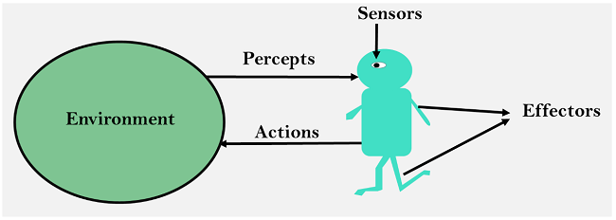

Intelligent Agents:
An intelligent agent is an autonomous entity which act upon an environment using sensors and actuators for achieving goals. An intelligent agent may learn from the environment to achieve their goals. A thermostat is an example of an intelligent agent.
Following are the main four rules for an AI agent:
- Rule 1: An AI agent must have the ability to perceive the environment.
- Rule 2: The observation must be used to make decisions.
- Rule 3: Decision should result in an action.
- Rule 4: The action taken by an AI agent must be a rational action.

Rational Agent:
A rational agent is an agent which has clear preference, models uncertainty, and acts in a way to maximize its performance measure with all possible actions.
A rational agent is said to perform the right things. AI is about creating rational agents to use for game theory and decision theory for various real-world scenarios.
For an AI agent, the rational action is most important because in AI reinforcement learning algorithm, for each best possible action, agent gets the positive reward and for each wrong action, an agent gets a negative reward.

Note: Rational agents in AI are very similar to intelligent agents.

Rationality:
The rationality of an agent is measured by its performance measure. Rationality can be judged on the basis of following points:
- Performance measure which defines the success criterion.
- Agent prior knowledge of its environment.
- Best possible actions that an agent can perform.
- The sequence of percepts.

Note: Rationality differs from Omniscience because an Omniscient agent knows the actual outcome of its action and act accordingly, which is not possible in reality.

Structure of an AI Agent
The task of AI is to design an agent program which implements the agent function. The structure of an intelligent agent is a combination of architecture and agent program. It can be viewed as:
- Agent = Architecture + Agent program
Following are the main three terms involved in the structure of an AI agent:
Architecture: Architecture is machinery that an AI agent executes on.
Agent Function: Agent function is used to map a percept to an action.
- f:P* → A
Agent program: Agent program is an implementation of agent function. An agent program executes on the physical architecture to produce function f.

PEAS Representation
PEAS is a type of model on which an AI agent works upon. When we define an AI agent or rational agent, then we can group its properties under PEAS representation model. It is made up of four words:
- P: Performance measure
- E: Environment
- A: Actuators
- S: Sensors
Here performance measure is the objective for the success of an agent's behavior.

PEAS for self-driving cars:
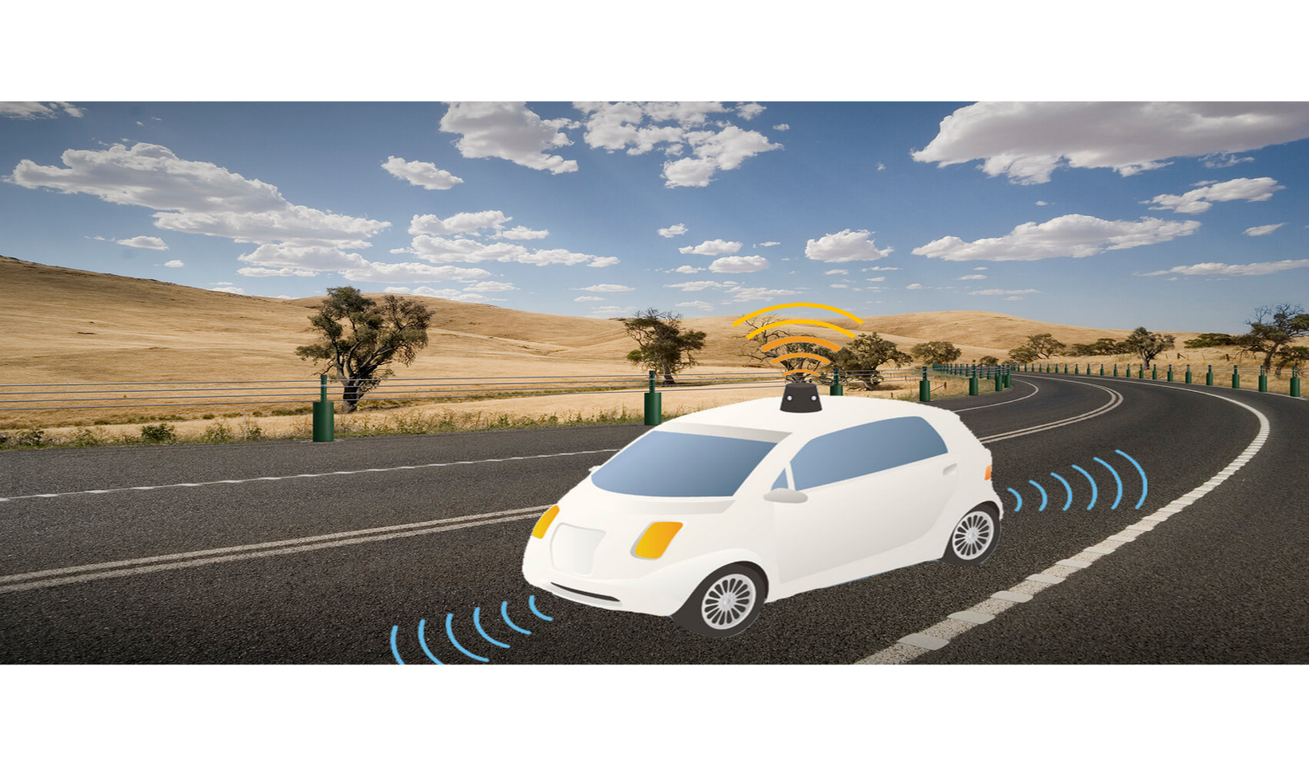
Let's suppose a self-driving car then PEAS representation will be:
Performance: Safety, time, legal drive, comfort
Environment: Roads, other vehicles, road signs, pedestrian
Actuators: Steering, accelerator, brake, signal, horn
Sensors: Camera, GPS, speedometer, odometer, accelerometer, sonar.

Example of Agents with their PEAS representation
Agent | Performance measure | Environment | Actuators | Sensors
1. Medical Diagnose | - Healthy patient  - Minimized cost | - Patient  - Hospital  - Staff | - Tests  - Treatments | Keyboard  (Entry of symptoms)
2. Vacuum Cleaner | - Cleanness  - Efficiency  - Battery life  - Security | - Room  - Table  - Wood floor  - Carpet  - Various obstacles | - Wheels  - Brushes  - Vacuum Extractor | - Camera  - Dirt detection sensor  - Cliff sensor  - Bump Sensor  - Infrared Wall Sensor
3. Part -picking Robot | - Percentage of parts in correct bins. | - Conveyor belt with parts,  - Bins | - Jointed Arms  - Hand | - Camera  - Joint angle sensors.

Agent Environment in AI
An environment is everything in the world which surrounds the agent, but it is not a part of an agent itself. An environment can be described as a situation in which an agent is present.
The environment is where agent lives, operate and provide the agent with something to sense and act upon it. An environment is mostly said to be non-feministic.

Features of Environment
As per Russell and Norvig, an environment can have various features from the point of view of an agent:
- Fully observable vs Partially Observable
- Static vs Dynamic
- Discrete vs Continuous
- Deterministic vs Stochastic
- Single-agent vs Multi-agent
- Episodic vs sequential
- Known vs Unknown
- Accessible vs Inaccessible

1. Fully observable vs Partially Observable:
- If an agent sensor can sense or access the complete state of an environment at each point of time then it is a fully observable environment, else it is partially observable.
- A fully observable environment is easy as there is no need to maintain the internal state to keep track history of the world.
- An agent with no sensors in all environments then such an environment is called as unobservable.

2. Deterministic vs Stochastic:
- If an agent's current state and selected action can completely determine the next state of the environment, then such environment is called a deterministic environment.
- A stochastic environment is random in nature and cannot be determined completely by an agent.
- In a deterministic, fully observable environment, agent does not need to worry about uncertainty.

3. Episodic vs Sequential:
- In an episodic environment, there is a series of one-shot actions, and only the current percept is required for the action.
- However, in Sequential environment, an agent requires memory of past actions to determine the next best actions.

4. Single-agent vs Multi-agent
- If only one agent is involved in an environment, and operating by itself then such an environment is called single agent environment.
- However, if multiple agents are operating in an environment, then such an environment is called a multi-agent environment.
- The agent design problems in the multi-agent environment are different from single agent environment.

5. Static vs Dynamic:
- If the environment can change itself while an agent is deliberating then such environment is called a dynamic environment else it is called a static environment.
- Static environments are easy to deal because an agent does not need to continue looking at the world while deciding for an action.
- However for dynamic environment, agents need to keep looking at the world at each action.
- Taxi driving is an example of a dynamic environment whereas Crossword puzzles are an example of a static environment.

6. Discrete vs Continuous:
- If in an environment there are a finite number of percepts and actions that can be performed within it, then such an environment is called a discrete environment else it is called continuous environment.
- A chess gamecomes under discrete environment as there is a finite number of moves that can be performed.
- A self-driving car is an example of a continuous environment.

7. Known vs Unknown
- Known and unknown are not actually a feature of an environment, but it is an agent's state of knowledge to perform an action.
- In a known environment, the results for all actions are known to the agent. While in unknown environment, agent needs to learn how it works in order to perform an action.
- It is quite possible that a known environment to be partially observable and an Unknown environment to be fully observable.

8. Accessible vs Inaccessible
- If an agent can obtain complete and accurate information about the state's environment, then such an environment is called an Accessible environment else it is called inaccessible.
- An empty room whose state can be defined by its temperature is an example of an accessible environment.
- Information about an event on earth is an example of Inaccessible environment.

Search Algorithms in Artificial Intelligence
Search algorithms are one of the most important areas of Artificial Intelligence. This topic will explain all about the search algorithms in AI.

Problem-solving agents:
In Artificial Intelligence, Search techniques are universal problem-solving methods. Rational agents or Problem-solving agents in AI mostly used these search strategies or algorithms to solve a specific problem and provide the best result. Problem-solving agents are the goal-based agents and use atomic representation. In this topic, we will learn various problem-solving search algorithms.

Search Algorithm Terminologies:
- Search: Searchingis a step by step procedure to solve a search-problem in a given search space. A search problem can have three main factors:
  - Search Space: Search space represents a set of possible solutions, which a system may have.
  - Start State: It is a state from where agent begins the search.
  - Goal test: It is a function which observe the current state and returns whether the goal state is achieved or not.
- Search tree: A tree representation of search problem is called Search tree. The root of the search tree is the root node which is corresponding to the initial state.
- Actions: It gives the description of all the available actions to the agent.
- Transition model: A description of what each action do, can be represented as a transition model.
- Path Cost: It is a function which assigns a numeric cost to each path.
- Solution: It is an action sequence which leads from the start node to the goal node.
- Optimal Solution: If a solution has the lowest cost among all solutions.

Properties of Search Algorithms:
Following are the four essential properties of search algorithms to compare the efficiency of these algorithms:
Completeness: A search algorithm is said to be complete if it guarantees to return a solution if at least any solution exists for any random input.
Optimality: If a solution found for an algorithm is guaranteed to be the best solution (lowest path cost) among all other solutions, then such a solution for is said to be an optimal solution.
Time Complexity: Time complexity is a measure of time for an algorithm to complete its task.
Exception Handling in Java - Javatpoint
Space Complexity: It is the maximum storage space required at any point during the search, as the complexity of the problem.

Types of search algorithms
Based on the search problems we can classify the search algorithms into uninformed (Blind search) search and informed search (Heuristic search) algorithms.
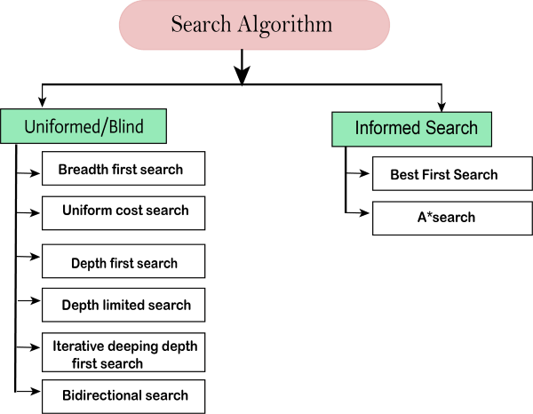

Uninformed/Blind Search:
The uninformed search does not contain any domain knowledge such as closeness, the location of the goal. It operates in a brute-force way as it only includes information about how to traverse the tree and how to identify leaf and goal nodes. Uninformed search applies a way in which search tree is searched without any information about the search space like initial state operators and test for the goal, so it is also called blind search.It examines each node of the tree until it achieves the goal node.
It can be divided into five main types:
- Breadth-first search
- Uniform cost search
- Depth-first search
- Iterative deepening depth-first search
- Bidirectional Search

Informed Search
Informed search algorithms use domain knowledge. In an informed search, problem information is available which can guide the search. Informed search strategies can find a solution more efficiently than an uninformed search strategy. Informed search is also called a Heuristic search.
A heuristic is a way which might not always be guaranteed for best solutions but guaranteed to find a good solution in reasonable time.
Informed search can solve much complex problem which could not be solved in another way.
An example of informed search algorithms is a traveling salesman problem.
- Greedy Search
- A* Search

Uninformed Search Algorithms
Uninformed search is a class of general-purpose search algorithms which operates in brute force-way. Uninformed search algorithms do not have additional information about state or search space other than how to traverse the tree, so it is also called blind search.
Following are the various types of uninformed search algorithms:
- Breadth-first Search
- Depth-first Search
- Depth-limited Search
- Iterative deepening depth-first search
- Uniform cost search
- Bidirectional Search

1. Breadth-first Search:
- Breadth-first search is the most common search strategy for traversing a tree or graph. This algorithm searches breadthwise in a tree or graph, so it is called breadth-first search.
- BFS algorithm starts searching from the root node of the tree and expands all successor node at the current level before moving to nodes of next level.
- The breadth-first search algorithm is an example of a general-graph search algorithm.
- Breadth-first search implemented using FIFO queue data structure.
Advantages:
- BFS will provide a solution if any solution exists.
- If there are more than one solutions for a given problem, then BFS will provide the minimal solution which requires the least number of steps.
Disadvantages:
- It requires lots of memory since each level of the tree must be saved into memory to expand the next level.
- BFS needs lots of time if the solution is far away from the root node.

Example:
In the below tree structure, we have shown the traversing of the tree using BFS algorithm from the root node S to goal node K. BFS search algorithm traverse in layers, so it will follow the path which is shown by the dotted arrow, and the traversed path will be:
- S---> A--->B---->C--->D---->G--->H--->E---->F---->I---->K
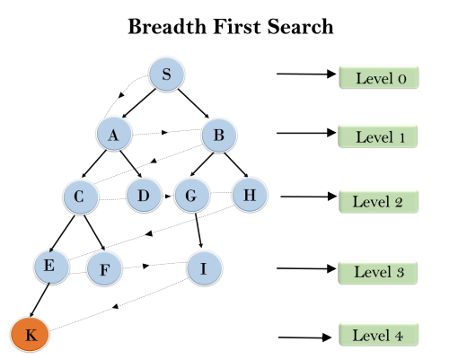
Time Complexity: Time Complexity of BFS algorithm can be obtained by the number of nodes traversed in BFS until the shallowest Node. Where the d= depth of shallowest solution and b is a node at every state.
How to find Nth Highest Salary in SQL
T (b) = 1+b²+b³+.......+ b^{d}= O (b^{d})
Space Complexity: Space complexity of BFS algorithm is given by the Memory size of frontier which is O(b^{d}).
Completeness: BFS is complete, which means if the shallowest goal node is at some finite depth, then BFS will find a solution.
Optimality: BFS is optimal if path cost is a non-decreasing function of the depth of the node.

2. Depth-first Search
- Depth-first search isa recursive algorithm for traversing a tree or graph data structure.
- It is called the depth-first search because it starts from the root node and follows each path to its greatest depth node before moving to the next path.
- DFS uses a stack data structure for its implementation.
- The process of the DFS algorithm is similar to the BFS algorithm.

Note: Backtracking is an algorithm technique for finding all possible solutions using recursion.
Advantage:
- DFS requires very less memory as it only needs to store a stack of the nodes on the path from root node to the current node.
- It takes less time to reach to the goal node than BFS algorithm (if it traverses in the right path).
Disadvantage:
- There is the possibility that many states keep re-occurring, and there is no guarantee of finding the solution.
- DFS algorithm goes for deep down searching and sometime it may go to the infinite loop.

Example:
In the below search tree, we have shown the flow of depth-first search, and it will follow the order as:
Root node--->Left node ----> right node.
It will start searching from root node S, and traverse A, then B, then D and E, after traversing E, it will backtrack the tree as E has no other successor and still goal node is not found. After backtracking it will traverse node C and then G, and here it will terminate as it found goal node.
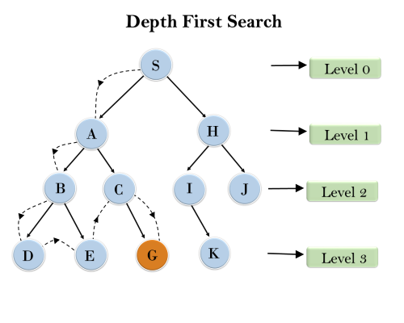
Completeness: DFS search algorithm is complete within finite state space as it will expand every node within a limited search tree.
Time Complexity: Time complexity of DFS will be equivalent to the node traversed by the algorithm. It is given by:
T(n)= 1+ n²+ n³ +.........+ n^{m}=O(n^{m})
Where, m= maximum depth of any node and this can be much larger than d (Shallowest solution depth)
Space Complexity: DFS algorithm needs to store only single path from the root node, hence space complexity of DFS is equivalent to the size of the fringe set, which is O(bm).
Optimal: DFS search algorithm is non-optimal, as it may generate a large number of steps or high cost to reach to the goal node.

3. Depth-Limited Search Algorithm:
A depth-limited search algorithm is similar to depth-first search with a predetermined limit. Depth-limited search can solve the drawback of the infinite path in the Depth-first search. In this algorithm, the node at the depth limit will treat as it has no successor nodes further.
Depth-limited search can be terminated with two Conditions of failure:
- Standard failure value: It indicates that problem does not have any solution.
- Cutoff failure value: It defines no solution for the problem within a given depth limit.
Advantages:
Depth-limited search is Memory efficient.
Disadvantages:
- Depth-limited search also has a disadvantage of incompleteness.
- It may not be optimal if the problem has more than one solution.

Example:
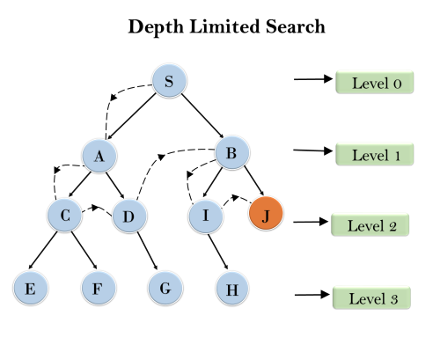
Completeness: DLS search algorithm is complete if the solution is above the depth-limit.
Time Complexity: Time complexity of DLS algorithm is O(b^{ℓ}).
Space Complexity: Space complexity of DLS algorithm is O(b×ℓ).
Optimal: Depth-limited search can be viewed as a special case of DFS, and it is also not optimal even if ℓ>d.

4. Uniform-cost Search Algorithm:
Uniform-cost search is a searching algorithm used for traversing a weighted tree or graph. This algorithm comes into play when a different cost is available for each edge. The primary goal of the uniform-cost search is to find a path to the goal node which has the lowest cumulative cost. Uniform-cost search expands nodes according to their path costs form the root node. It can be used to solve any graph/tree where the optimal cost is in demand. A uniform-cost search algorithm is implemented by the priority queue. It gives maximum priority to the lowest cumulative cost. Uniform cost search is equivalent to BFS algorithm if the path cost of all edges is the same.
Advantages:
- Uniform cost search is optimal because at every state the path with the least cost is chosen.
Disadvantages:
- It does not care about the number of steps involve in searching and only concerned about path cost. Due to which this algorithm may be stuck in an infinite loop.

Example:
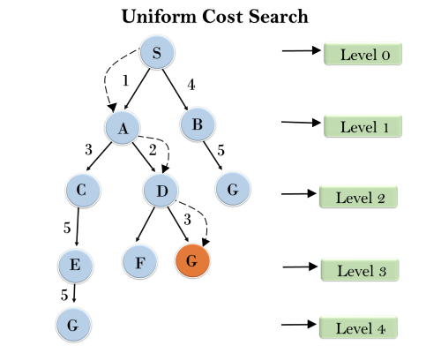
Completeness:
Uniform-cost search is complete, such as if there is a solution, UCS will find it.
Time Complexity:
Let C* is Cost of the optimal solution, and ε is each step to get closer to the goal node. Then the number of steps is = C*/ε+1. Here we have taken +1, as we start from state 0 and end to C*/ε.
Hence, the worst-case time complexity of Uniform-cost search isO(b^{1 + [C*/ε]})/.
Space Complexity:
The same logic is for space complexity so, the worst-case space complexity of Uniform-cost search is O(b^{1 + [C*/ε]}).
Optimal:
Uniform-cost search is always optimal as it only selects a path with the lowest path cost.

5. Iterative deepeningdepth-first Search:
The iterative deepening algorithm is a combination of DFS and BFS algorithms. This search algorithm finds out the best depth limit and does it by gradually increasing the limit until a goal is found.
This algorithm performs depth-first search up to a certain "depth limit", and it keeps increasing the depth limit after each iteration until the goal node is found.
This Search algorithm combines the benefits of Breadth-first search's fast search and depth-first search's memory efficiency.
The iterative search algorithm is useful uninformed search when search space is large, and depth of goal node is unknown.
Advantages:
- Itcombines the benefits of BFS and DFS search algorithm in terms of fast search and memory efficiency.
Disadvantages:
- The main drawback of IDDFS is that it repeats all the work of the previous phase.

Example:
Following tree structure is showing the iterative deepening depth-first search. IDDFS algorithm performs various iterations until it does not find the goal node. The iteration performed by the algorithm is given as:
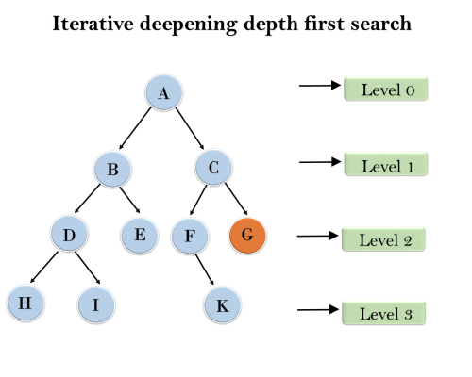
1'st Iteration-----> A
2'nd Iteration----> A, B, C
3'rd Iteration------>A, B, D, E, C, F, G
4'th Iteration------>A, B, D, H, I, E, C, F, K, G
In the fourth iteration, the algorithm will find the goal node.
Completeness:
This algorithm is complete is ifthe branching factor is finite.
Time Complexity:
Let's suppose b is the branching factor and depth is d then the worst-case time complexity is O(b^{d}).
Space Complexity:
The space complexity of IDDFS will be O(bd).
Optimal:
IDDFS algorithm is optimal if path cost is a non- decreasing function of the depth of the node.

6. Bidirectional Search Algorithm:
Bidirectional search algorithm runs two simultaneous searches, one form initial state called as forward-search and other from goal node called as backward-search, to find the goal node. Bidirectional search replaces one single search graph with two small subgraphs in which one starts the search from an initial vertex and other starts from goal vertex. The search stops when these two graphs intersect each other.
Bidirectional search can use search techniques such as BFS, DFS, DLS, etc.
Advantages:
- Bidirectional search is fast.
- Bidirectional search requires less memory
Disadvantages:
- Implementation of the bidirectional search tree is difficult.
- In bidirectional search, one should know the goal state in advance.

Example:
In the below search tree, bidirectional search algorithm is applied. This algorithm divides one graph/tree into two sub-graphs. It starts traversing from node 1 in the forward direction and starts from goal node 16 in the backward direction.
The algorithm terminates at node 9 where two searches meet.
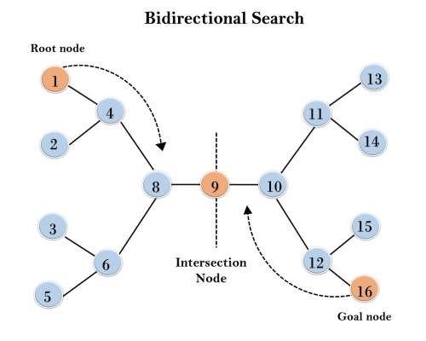
Completeness: Bidirectional Search is complete if we use BFS in both searches.
Time Complexity: Time complexity of bidirectional search using BFS is O(b^{d}).
Space Complexity: Space complexity of bidirectional search is O(b^{d}).
Optimal: Bidirectional search is Optimal.

Informed Search Algorithms
So far we have talked about the uninformed search algorithms which looked through search space for all possible solutions of the problem without having any additional knowledge about search space. But informed search algorithm contains an array of knowledge such as how far we are from the goal, path cost, how to reach to goal node, etc. This knowledge help agents to explore less to the search space and find more efficiently the goal node.
The informed search algorithm is more useful for large search space. Informed search algorithm uses the idea of heuristic, so it is also called Heuristic search.
Heuristics function: Heuristic is a function which is used in Informed Search, and it finds the most promising path. It takes the current state of the agent as its input and produces the estimation of how close agent is from the goal. The heuristic method, however, might not always give the best solution, but it guaranteed to find a good solution in reasonable time. Heuristic function estimates how close a state is to the goal. It is represented by h(n), and it calculates the cost of an optimal path between the pair of states. The value of the heuristic function is always positive.
Admissibility of the heuristic function is given as:
- h(n) <= h*(n)
Here h(n) is heuristic cost, and h*(n) is the estimated cost. Hence heuristic cost should be less than or equal to the estimated cost.

Pure Heuristic Search:
Pure heuristic search is the simplest form of heuristic search algorithms. It expands nodes based on their heuristic value h(n). It maintains two lists, OPEN and CLOSED list. In the CLOSED list, it places those nodes which have already expanded and in the OPEN list, it places nodes which have yet not been expanded.
Exception Handling in Java - Javatpoint
On each iteration, each node n with the lowest heuristic value is expanded and generates all its successors and n is placed to the closed list. The algorithm continues unit a goal state is found.
In the informed search we will discuss two main algorithms which are given below:
- Best First Search Algorithm(Greedy search)
- A* Search Algorithm

1.) Best-first Search Algorithm (Greedy Search):
Greedy best-first search algorithm always selects the path which appears best at that moment. It is the combination of depth-first search and breadth-first search algorithms. It uses the heuristic function and search. Best-first search allows us to take the advantages of both algorithms. With the help of best-first search, at each step, we can choose the most promising node. In the best first search algorithm, we expand the node which is closest to the goal node and the closest cost is estimated by heuristic function, i.e.
- f(n)= g(n).
Were, h(n)= estimated cost from node n to the goal.
The greedy best first algorithm is implemented by the priority queue.

Best first search algorithm:
- Step 1: Place the starting node into the OPEN list.
- Step 2: If the OPEN list is empty, Stop and return failure.
- Step 3: Remove the node n, from the OPEN list which has the lowest value of h(n), and places it in the CLOSED list.
- Step 4: Expand the node n, and generate the successors of node n.
- Step 5: Check each successor of node n, and find whether any node is a goal node or not. If any successor node is goal node, then return success and terminate the search, else proceed to Step 6.
- Step 6: For each successor node, algorithm checks for evaluation function f(n), and then check if the node has been in either OPEN or CLOSED list. If the node has not been in both list, then add it to the OPEN list.
- Step 7: Return to Step 2.

Advantages:
- Best first search can switch between BFS and DFS by gaining the advantages of both the algorithms.
- This algorithm is more efficient than BFS and DFS algorithms.

Disadvantages:
- It can behave as an unguided depth-first search in the worst case scenario.
- It can get stuck in a loop as DFS.
- This algorithm is not optimal.

Example:
Consider the below search problem, and we will traverse it using greedy best-first search. At each iteration, each node is expanded using evaluation function f(n)=h(n) , which is given in the below table.
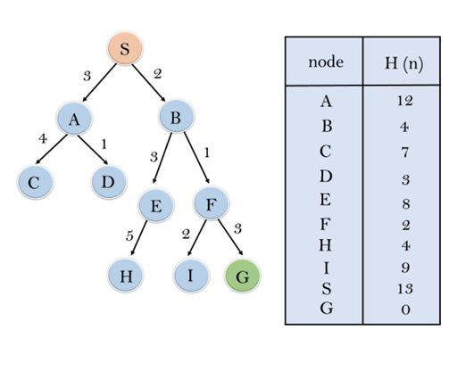
In this search example, we are using two lists which are OPEN and CLOSED Lists. Following are the iteration for traversing the above example.
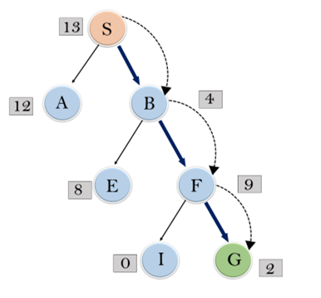
Expand the nodes of S and put in the CLOSED list
Initialization: Open [A, B], Closed [S]
Iteration 1: Open [A], Closed [S, B]
Iteration 2: Open [E, F, A], Closed [S, B]
: Open [E, A], Closed [S, B, F]
Iteration 3: Open [I, G, E, A], Closed [S, B, F]
: Open [I, E, A], Closed [S, B, F, G]
Hence the final solution path will be: S----> B----->F----> G
Time Complexity: The worst case time complexity of Greedy best first search is O(b^{m}).
Space Complexity: The worst case space complexity of Greedy best first search is O(b^{m}). Where, m is the maximum depth of the search space.
Complete: Greedy best-first search is also incomplete, even if the given state space is finite.
Optimal: Greedy best first search algorithm is not optimal.

2.) A* Search Algorithm:
A* search is the most commonly known form of best-first search. It uses heuristic function h(n), and cost to reach the node n from the start state g(n). It has combined features of UCS and greedy best-first search, by which it solve the problem efficiently. A* search algorithm finds the shortest path through the search space using the heuristic function. This search algorithm expands less search tree and provides optimal result faster. A* algorithm is similar to UCS except that it uses g(n)+h(n) instead of g(n).
In A* search algorithm, we use search heuristic as well as the cost to reach the node. Hence we can combine both costs as following, and this sum is called as a fitness number.
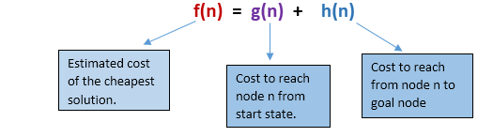
At each point in the search space, only those node is expanded which have the lowest value of f(n), and the algorithm terminates when the goal node is found.

Algorithm of A* search:
Step1: Place the starting node in the OPEN list.
Step 2: Check if the OPEN list is empty or not, if the list is empty then return failure and stops.
Step 3: Select the node from the OPEN list which has the smallest value of evaluation function (g+h), if node n is goal node then return success and stop, otherwise
Step 4: Expand node n and generate all of its successors, and put n into the closed list. For each successor n', check whether n' is already in the OPEN or CLOSED list, if not then compute evaluation function for n' and place into Open list.
Step 5: Else if node n' is already in OPEN and CLOSED, then it should be attached to the back pointer which reflects the lowest g(n') value.
Step 6: Return to Step 2.

Advantages:
- A* search algorithm is the best algorithm than other search algorithms.
- A* search algorithm is optimal and complete.
- This algorithm can solve very complex problems.

Disadvantages:
- It does not always produce the shortest path as it mostly based on heuristics and approximation.
- A* search algorithm has some complexity issues.
- The main drawback of A* is memory requirement as it keeps all generated nodes in the memory, so it is not practical for various large-scale problems.

Example:
In this example, we will traverse the given graph using the A* algorithm. The heuristic value of all states is given in the below table so we will calculate the f(n) of each state using the formula f(n)= g(n) + h(n), where g(n) is the cost to reach any node from start state.
Here we will use OPEN and CLOSED list.
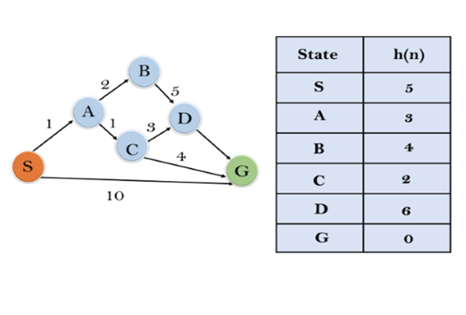
Solution:
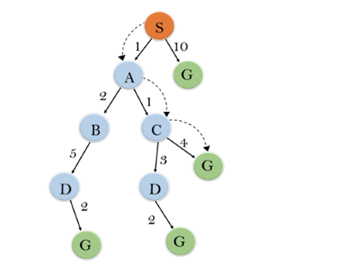
Initialization: {(S, 5)}
Iteration1: {(S--> A, 4), (S-->G, 10)}
Iteration2: {(S--> A-->C, 4), (S--> A-->B, 7), (S-->G, 10)}
Iteration3: {(S--> A-->C--->G, 6), (S--> A-->C--->D, 11), (S--> A-->B, 7), (S-->G, 10)}
Iteration 4 will give the final result, as S--->A--->C--->G it provides the optimal path with cost 6.
Points to remember:
- A* algorithm returns the path which occurred first, and it does not search for all remaining paths.
- The efficiency of A* algorithm depends on the quality of heuristic.
- A* algorithm expands all nodes which satisfy the condition f(n)<="" li="">
Complete: A* algorithm is complete as long as:
- Branching factor is finite.
- Cost at every action is fixed.
Optimal: A* search algorithm is optimal if it follows below two conditions:
- Admissible: the first condition requires for optimality is that h(n) should be an admissible heuristic for A* tree search. An admissible heuristic is optimistic in nature.
- Consistency: Second required condition is consistency for only A* graph-search.
If the heuristic function is admissible, then A* tree search will always find the least cost path.
Time Complexity: The time complexity of A* search algorithm depends on heuristic function, and the number of nodes expanded is exponential to the depth of solution d. So the time complexity is O(b^d), where b is the branching factor.
Space Complexity: The space complexity of A* search algorithm is O(b^d)
Questions:
1. What is the intelligent agent in AI, and where are they used?
2. Explain the minimax algorithm along with the different terms.
3.Give the steps for A* algorithm?
4.What is a heuristic function, and where is it used?
5.Mention the difference between breadth first search and best first search in artificial intelligence

UNIT 3
Game Playing
Objective: Design AI functions and components involved in intelligent systems such as computer games, expert systems.

Adversarial Search
Adversarial search is a search, where we examine the problem which arises when we try to plan ahead of the world and other agents are planning against us.
- In previous topics, we have studied the search strategies which are only associated with a single agent that aims to find the solution which often expressed in the form of a sequence of actions.
- But, there might be some situations where more than one agent is searching for the solution in the same search space, and this situation usually occurs in game playing.
- The environment with more than one agent is termed as multi-agent environment, in which each agent is an opponent of other agent and playing against each other. Each agent needs to consider the action of other agent and effect of that action on their performance.
- So, Searches in which two or more players with conflicting goals are trying to explore the same search space for the solution, are called adversarial searches, often known as Games.
- Games are modeled as a Search problem and heuristic evaluation function, and these are the two main factors which help to model and solve games in AI.

Types of Games in AI:
 | Deterministic | Chance Moves
Perfect information | Chess, Checkers, go, Othello | Backgammon, monopoly
Imperfect information | Battleships, blind, tic-tac-toe | Bridge, poker, scrabble, nuclear war
- Perfect information: A game with the perfect information is that in which agents can look into the complete board. Agents have all the information about the game, and they can see each other moves also. Examples are Chess, Checkers, Go, etc.
- Imperfect information: If in a game agents do not have all information about the game and not aware with what's going on, such type of games are called the game with imperfect information, such as tic-tac-toe, Battleship, blind, Bridge, etc.
- Deterministic games: Deterministic games are those games which follow a strict pattern and set of rules for the games, and there is no randomness associated with them. Examples are chess, Checkers, Go, tic-tac-toe, etc.
- Non-deterministic games: Non-deterministic are those games which have various unpredictable events and has a factor of chance or luck. This factor of chance or luck is introduced by either dice or cards. These are random, and each action response is not fixed. Such games are also called as stochastic games.
Example: Backgammon, Monopoly, Poker, etc.

Note: In this topic, we will discuss deterministic games, fully observable environment, zero-sum, and where each agent acts alternatively.

Zero-Sum Game
- Zero-sum games are adversarial search which involves pure competition.
- In Zero-sum game each agent's gain or loss of utility is exactly balanced by the losses or gains of utility of another agent.
- One player of the game try to maximize one single value, while other player tries to minimize it.
- Each move by one player in the game is called as ply.
- Chess and tic-tac-toe are examples of a Zero-sum game.

Zero-sum game: Embedded thinking
The Zero-sum game involved embedded thinking in which one agent or player is trying to figure out:
- What to do.
- How to decide the move
- Needs to think about his opponent as well
- The opponent also thinks what to do
Each of the players is trying to find out the response of his opponent to their actions. This requires embedded thinking or backward reasoning to solve the game problems in AI.

Formalization of the problem:
A game can be defined as a type of search in AI which can be formalized of the following elements:
- Initial state: It specifies how the game is set up at the start.
- Player(s): It specifies which player has moved in the state space.
- Action(s): It returns the set of legal moves in state space.
- Result(s, a): It is the transition model, which specifies the result of moves in the state space.
- Terminal-Test(s): Terminal test is true if the game is over, else it is false at any case. The state where the game ends is called terminal states.
- Utility(s, p): A utility function gives the final numeric value for a game that ends in terminal states s for player p. It is also called payoff function. For Chess, the outcomes are a win, loss, or draw and its payoff values are +1, 0, ½. And for tic-tac-toe, utility values are +1, -1, and 0.

Game tree:
A game tree is a tree where nodes of the tree are the game states and Edges of the tree are the moves by players. Game tree involves initial state, actions function, and result Function.
Example: Tic-Tac-Toe game tree:
C++ vs Java
The following figure is showing part of the game-tree for tic-tac-toe game. Following are some key points of the game:
- There are two players MAX and MIN.
- Players have an alternate turn and start with MAX.
- MAX maximizes the result of the game tree
- MIN minimizes the result.
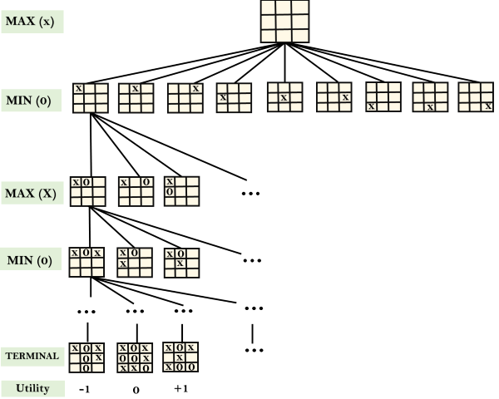
Example Explanation:
- From the initial state, MAX has 9 possible moves as he starts first. MAX place x and MIN place o, and both player plays alternatively until we reach a leaf node where one player has three in a row or all squares are filled.
- Both players will compute each node, minimax, the minimax value which is the best achievable utility against an optimal adversary.
- Suppose both the players are well aware of the tic-tac-toe and playing the best play. Each player is doing his best to prevent another one from winning. MIN is acting against Max in the game.
- So in the game tree, we have a layer of Max, a layer of MIN, and each layer is called as Ply. Max place x, then MIN puts o to prevent Max from winning, and this game continues until the terminal node.
- In this either MIN wins, MAX wins, or it's a draw. This game-tree is the whole search space of possibilities that MIN and MAX are playing tic-tac-toe and taking turns alternately.
Hence adversarial Search for the minimax procedure works as follows:
- It aims to find the optimal strategy for MAX to win the game.
- It follows the approach of Depth-first search.
- In the game tree, optimal leaf node could appear at any depth of the tree.
- Propagate the minimax values up to the tree until the terminal node discovered.
In a given game tree, the optimal strategy can be determined from the minimax value of each node, which can be written as MINIMAX(n). MAX prefer to move to a state of maximum value and MIN prefer to move to a state of minimum value then:
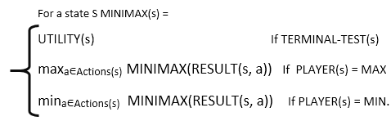

Mini-Max Algorithm in Artificial Intelligence
- Mini-max algorithm is a recursive or backtracking algorithm which is used in decision-making and game theory. It provides an optimal move for the player assuming that opponent is also playing optimally.
- Mini-Max algorithm uses recursion to search through the game-tree.
- Min-Max algorithm is mostly used for game playing in AI. Such as Chess, Checkers, tic-tac-toe, go, and various tow-players game. This Algorithm computes the minimax decision for the current state.
- In this algorithm two players play the game, one is called MAX and other is called MIN.
- Both the players fight it as the opponent player gets the minimum benefit while they get the maximum benefit.
- Both Players of the game are opponent of each other, where MAX will select the maximized value and MIN will select the minimized value.
- The minimax algorithm performs a depth-first search algorithm for the exploration of the complete game tree.
- The minimax algorithm proceeds all the way down to the terminal node of the tree, then backtrack the tree as the recursion.

Pseudo-code for MinMax Algorithm:
- function minimax(node, depth, maximizingPlayer) is
- if depth ==0 or node is a terminal node then
- return static evaluation of node

- if MaximizingPlayer then // for Maximizer Player
- maxEva= -infinity
- for each child of node do
- eva= minimax(child, depth-1, false)
- maxEva= max(maxEva,eva) //gives Maximum of the values
- return maxEva

- else // for Minimizer player
- minEva= +infinity
- for each child of node do
- eva= minimax(child, depth-1, true)
- minEva= min(minEva, eva) //gives minimum of the values
- return minEva
Initial call:
Minimax(node, 3, true)

Working of Min-Max Algorithm:
- The working of the minimax algorithm can be easily described using an example. Below we have taken an example of game-tree which is representing the two-player game.
- In this example, there are two players one is called Maximizer and other is called Minimizer.
- Maximizer will try to get the Maximum possible score, and Minimizer will try to get the minimum possible score.
- This algorithm applies DFS, so in this game-tree, we have to go all the way through the leaves to reach the terminal nodes.
- At the terminal node, the terminal values are given so we will compare those value and backtrack the tree until the initial state occurs. Following are the main steps involved in solving the two-player game tree:
Step-1: In the first step, the algorithm generates the entire game-tree and apply the utility function to get the utility values for the terminal states. In the below tree diagram, let's take A is the initial state of the tree. Suppose maximizer takes first turn which has worst-case initial value =- infinity, and minimizer will take next turn which has worst-case initial value = +infinity.
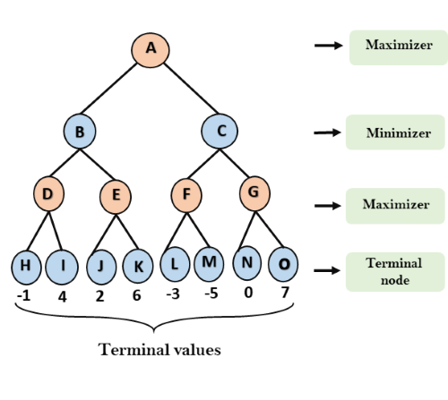
Step 2: Now, first we find the utilities value for the Maximizer, its initial value is -∞, so we will compare each value in terminal state with initial value of Maximizer and determines the higher nodes values. It will find the maximum among the all.
- For node D max(-1,- -∞) => max(-1,4)= 4
- For Node E max(2, -∞) => max(2, 6)= 6
- For Node F max(-3, -∞) => max(-3,-5) = -3
- For node G max(0, -∞) = max(0, 7) = 7
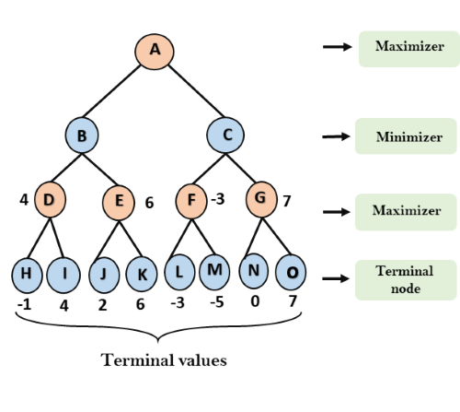
Step 3: In the next step, it's a turn for minimizer, so it will compare all nodes value with +∞, and will find the 3rd layer node values.
- For node B= min(4,6) = 4
- For node C= min (-3, 7) = -3
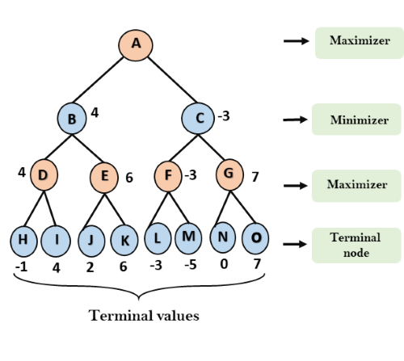
Step 3: Now it's a turn for Maximizer, and it will again choose the maximum of all nodes value and find the maximum value for the root node. In this game tree, there are only 4 layers, hence we reach immediately to the root node, but in real games, there will be more than 4 layers.
Features of Java - Javatpoint
- For node A max(4, -3)= 4
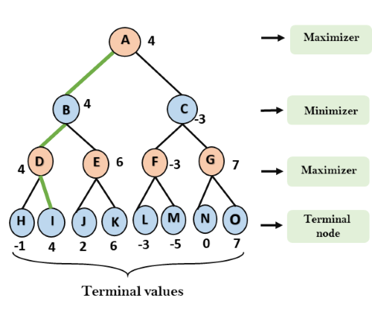
That was the complete workflow of the minimax two player game.

Properties of Mini-Max algorithm:
- Complete- Min-Max algorithm is Complete. It will definitely find a solution (if exist), in the finite search tree.
- Optimal- Min-Max algorithm is optimal if both opponents are playing optimally.
- Time complexity- As it performs DFS for the game-tree, so the time complexity of Min-Max algorithm is O(b^{m}), where b is branching factor of the game-tree, and m is the maximum depth of the tree.
- Space Complexity- Space complexity of Mini-max algorithm is also similar to DFS which is O(bm).

Limitation of the minimax Algorithm:
The main drawback of the minimax algorithm is that it gets really slow for complex games such as Chess, go, etc. This type of games has a huge branching factor, and the player has lots of choices to decide. This limitation of the minimax algorithm can be improved from alpha-beta pruning which we have discussed in the next topic.

Alpha-Beta Pruning
- Alpha-beta pruning is a modified version of the minimax algorithm. It is an optimization technique for the minimax algorithm.
- As we have seen in the minimax search algorithm that the number of game states it has to examine are exponential in depth of the tree. Since we cannot eliminate the exponent, but we can cut it to half. Hence there is a technique by which without checking each node of the game tree we can compute the correct minimax decision, and this technique is called pruning. This involves two threshold parameter Alpha and beta for future expansion, so it is called alpha-beta pruning. It is also called as Alpha-Beta Algorithm.
- Alpha-beta pruning can be applied at any depth of a tree, and sometimes it not only prune the tree leaves but also entire sub-tree.
- The two-parameter can be defined as:
  - Alpha: The best (highest-value) choice we have found so far at any point along the path of Maximizer. The initial value of alpha is -∞.
  - Beta: The best (lowest-value) choice we have found so far at any point along the path of Minimizer. The initial value of beta is +∞.
- The Alpha-beta pruning to a standard minimax algorithm returns the same move as the standard algorithm does, but it removes all the nodes which are not really affecting the final decision but making algorithm slow. Hence by pruning these nodes, it makes the algorithm fast.

Note: To better understand this topic, kindly study the minimax algorithm.

Condition for Alpha-beta pruning:
The main condition which required for alpha-beta pruning is:
- α>=β

Key points about alpha-beta pruning:
- The Max player will only update the value of alpha.
- The Min player will only update the value of beta.
- While backtracking the tree, the node values will be passed to upper nodes instead of values of alpha and beta.
- We will only pass the alpha, beta values to the child nodes.

Pseudo-code for Alpha-beta Pruning:
- function minimax(node, depth, alpha, beta, maximizingPlayer) is
- if depth ==0 or node is a terminal node then
- return static evaluation of node

- if MaximizingPlayer then // for Maximizer Player
- maxEva= -infinity
- for each child of node do
- eva= minimax(child, depth-1, alpha, beta, False)
- maxEva= max(maxEva, eva)
- alpha= max(alpha, maxEva)
- if beta<=alpha
- break
- return maxEva

- else // for Minimizer player
- minEva= +infinity
- for each child of node do
- eva= minimax(child, depth-1, alpha, beta, true)
- minEva= min(minEva, eva)
- beta= min(beta, eva)
- if beta<=alpha
- break
- return minEva

Working of Alpha-Beta Pruning:
Let's take an example of two-player search tree to understand the working of Alpha-beta pruning
Step 1: At the first step the, Max player will start first move from node A where α= -∞ and β= +∞, these value of alpha and beta passed down to node B where again α= -∞ and β= +∞, and Node B passes the same value to its child D.
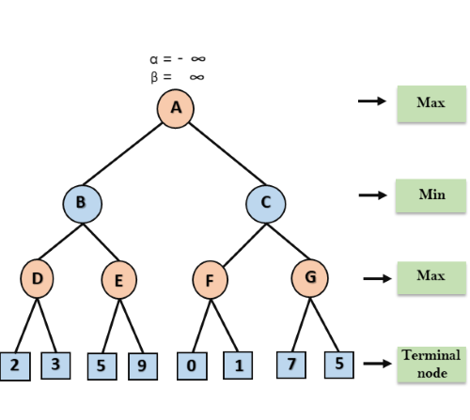
Step 2: At Node D, the value of α will be calculated as its turn for Max. The value of α is compared with firstly 2 and then 3, and the max (2, 3) = 3 will be the value of α at node D and node value will also 3.
Step 3: Now algorithm backtrack to node B, where the value of β will change as this is a turn of Min, Now β= +∞, will compare with the available subsequent nodes value, i.e. min (∞, 3) = 3, hence at node B now α= -∞, and β= 3.
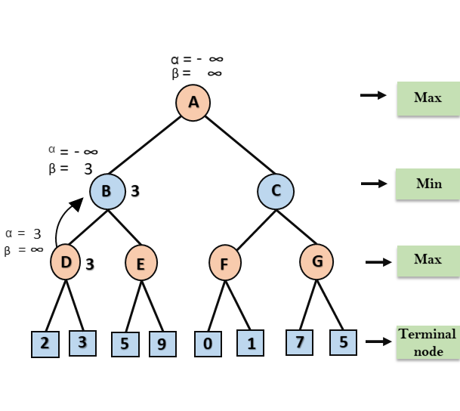
In the next step, algorithm traverse the next successor of Node B which is node E, and the values of α= -∞, and β= 3 will also be passed.
Features of Java - Javatpoint
Step 4: At node E, Max will take its turn, and the value of alpha will change. The current value of alpha will be compared with 5, so max (-∞, 5) = 5, hence at node E α= 5 and β= 3, where α>=β, so the right successor of E will be pruned, and algorithm will not traverse it, and the value at node E will be 5.
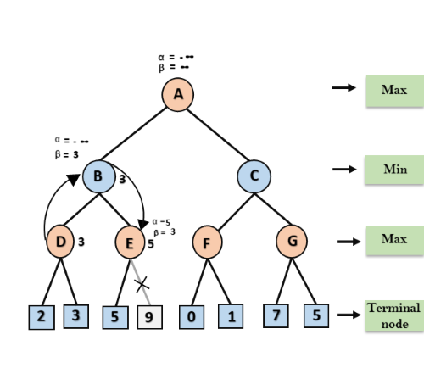
Step 5: At next step, algorithm again backtrack the tree, from node B to node A. At node A, the value of alpha will be changed the maximum available value is 3 as max (-∞, 3)= 3, and β= +∞, these two values now passes to right successor of A which is Node C.
At node C, α=3 and β= +∞, and the same values will be passed on to node F.
Step 6: At node F, again the value of α will be compared with left child which is 0, and max(3,0)= 3, and then compared with right child which is 1, and max(3,1)= 3 still α remains 3, but the node value of F will become 1.
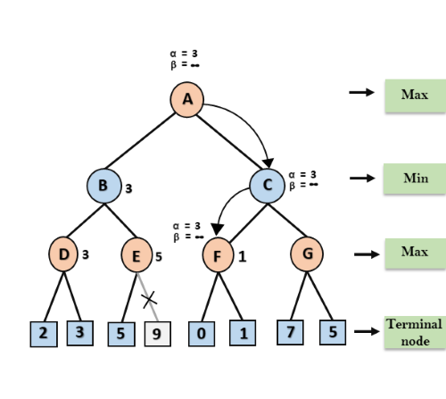
Step 7: Node F returns the node value 1 to node C, at C α= 3 and β= +∞, here the value of beta will be changed, it will compare with 1 so min (∞, 1) = 1. Now at C, α=3 and β= 1, and again it satisfies the condition α>=β, so the next child of C which is G will be pruned, and the algorithm will not compute the entire sub-tree G.
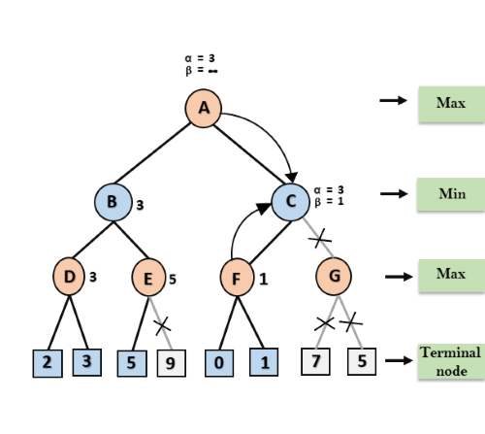
Step 8: C now returns the value of 1 to A here the best value for A is max (3, 1) = 3. Following is the final game tree which is the showing the nodes which are computed and nodes which has never computed. Hence the optimal value for the maximizer is 3 for this example.
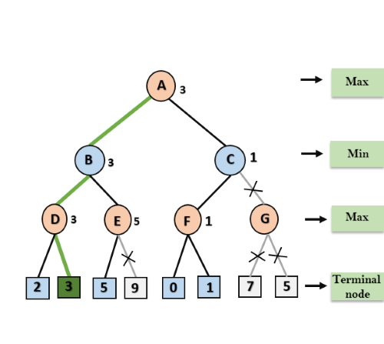

Move Ordering in Alpha-Beta pruning:
The effectiveness of alpha-beta pruning is highly dependent on the order in which each node is examined. Move order is an important aspect of alpha-beta pruning.
It can be of two types:
- Worst ordering: In some cases, alpha-beta pruning algorithm does not prune any of the leaves of the tree, and works exactly as minimax algorithm. In this case, it also consumes more time because of alpha-beta factors, such a move of pruning is called worst ordering. In this case, the best move occurs on the right side of the tree. The time complexity for such an order is O(b^{m}).
- Ideal ordering: The ideal ordering for alpha-beta pruning occurs when lots of pruning happens in the tree, and best moves occur at the left side of the tree. We apply DFS hence it first search left of the tree and go deep twice as minimax algorithm in the same amount of time. Complexity in ideal ordering is O(b^{m/2}).

Rules to find good ordering:
Following are some rules to find good ordering in alpha-beta pruning:
- Occur the best move from the shallowest node.
- Order the nodes in the tree such that the best nodes are checked first.
- Use domain knowledge while finding the best move. Ex: for Chess, try order: captures first, then threats, then forward moves, backward moves.
- We can bookkeep the states, as there is a possibility that states may repeat.
WATER JUG PROBLEM
Problem: There are two jugs of volume A litre and B litre. Neither has any measuring mark on it.There is a pump that can be used to fill the jugs with water.How can you get exactly x litre of water into the A litre jug.Assuming that we have unlimited supply of water.
Note:Let's assume we have A=4 litre and B= 3 litre jugs. And we want exactly 2 Litre water into jug A (i.e 4 litre jug) how we will do this.
Solution:
The state space for this problem can be described as the set of ordered pairs of integers (x,y)
Where,
x represents the quantity of water in the 4-gallon jug x= 0,1,2,3,4
y represents the quantity of water in 3-gallon jug y=0,1,2,3
Start State: (0,0)
Goal State: (2,0)
Generate production rules for the water jug problem
We basically perform three operations to achieve the goal.
- Fill water jug.
- Empty water jug
- and Transfer water jug
Rule | State | Process
1 | (X,Y | X<4) | (4,Y)  {Fill 4-gallon jug}
2 | (X,Y |Y<3) | (X,3)  {Fill 3-gallon jug}
3 | (X,Y |X>0) | (0,Y)  {Empty 4-gallon jug}
4 | (X,Y | Y>0) | (X,0)  {Empty 3-gallon jug}
5 | (X,Y | X+Y>=4 ^ Y>0) | (4,Y-(4-X))  {Pour water from 3-gallon jug into 4-gallon jug until 4-gallon jug is full}
6 | (X,Y | X+Y>=3 ^X>0) | (X-(3-Y),3)  {Pour water from 4-gallon jug into 3-gallon jug until 3-gallon jug is full}
7 | (X,Y | X+Y<=4 ^Y>0) | (X+Y,0)  {Pour all water from 3-gallon jug into 4-gallon jug}
8 | (X,Y | X+Y <=3^ X>0) | (0,X+Y)  {Pour all water from 4-gallon jug into 3-gallon jug}
9 | (0,2) | (2,0)  {Pour 2 gallon water from 3 gallon jug into 4 gallon jug}
Initialization:
Start State: (0,0)
Apply Rule 2:
Fill 3-gallon jug
Now the state is (x,3)
Iteration 1:
Current State: (x,3)
Apply Rule 7:
Pour all water from 3-gallon jug into 4-gallon jug
Now the state is (3,0)
Iteration 2:
Current State : (3,0)
Apply Rule 2:
Fill 3-gallon jug
Now the state is (3,3)
Iteration 3:
Current State:(3,3)
Apply Rule 5:
Pour water from 3-gallon jug into 4-gallon jug until 4-gallon jug is full
Now the state is (4,2)
Iteration 4:
Current State : (4,2)
Apply Rule 3:
Empty 4-gallon jug
Now state is (0,2)
Iteration 5:
Current State : (0,2)
Apply Rule 9:
Pour 2 gallon water from 3 gallon jug into 4 gallon jug
Now the state is (2,0)-- Goal Achieved.

Questions:

1. What is game theory? How is it important in AI?

2. Explain the minimax algorithm along with the different terms.

3. Which algorithm is used by Facebook for face recognition? Explain its working.

4. How can AI be used in fraud detection?
5. Explain WaterJug problem in detail.

Unit-4
Knowledge and Reasoning
Objective: Design AI functions and components involved in semantic web, information retrieval, machine translation, mobile robots, decision support systems based on knowledge and reasoning.

Knowledge representation
Humans are best at understanding, reasoning, and interpreting knowledge. Human knows things, which is knowledge and as per their knowledge they perform various actions in the real world. But how machines do all these things comes under knowledge representation and reasoning. Hence we can describe Knowledge representation as following:
- Knowledge representation and reasoning (KR, KRR) is the part of Artificial intelligence which concerned with AI agents thinking and how thinking contributes to intelligent behavior of agents.
- It is responsible for representing information about the real world so that a computer can understand and can utilize this knowledge to solve the complex real world problems such as diagnosis a medical condition or communicating with humans in natural language.
- It is also a way which describes how we can represent knowledge in artificial intelligence. Knowledge representation is not just storing data into some database, but it also enables an intelligent machine to learn from that knowledge and experiences so that it can behave intelligently like a human.

What to Represent:
Following are the kind of knowledge which needs to be represented in AI systems:
- Object: All the facts about objects in our world domain. E.g., Guitars contains strings, trumpets are brass instruments.
- Events: Events are the actions which occur in our world.
- Performance: It describe behavior which involves knowledge about how to do things.
- Meta-knowledge: It is knowledge about what we know.
- Facts: Facts are the truths about the real world and what we represent.
- Knowledge-Base: The central component of the knowledge-based agents is the knowledge base. It is represented as KB. The Knowledgebase is a group of the Sentences (Here, sentences are used as a technical term and not identical with the English language).
Knowledge: Knowledge is awareness or familiarity gained by experiences of facts, data, and situations. Following are the types of knowledge in artificial intelligence:

Types of knowledge
Following are the various types of knowledge:
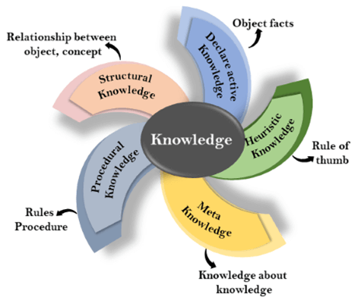

1. Declarative Knowledge:
- Declarative knowledge is to know about something.
- It includes concepts, facts, and objects.
- It is also called descriptive knowledge and expressed in declarativesentences.
- It is simpler than procedural language.
2. Procedural Knowledge
- It is also known as imperative knowledge.
- Procedural knowledge is a type of knowledge which is responsible for knowing how to do something.
- It can be directly applied to any task.
- It includes rules, strategies, procedures, agendas, etc.
- Procedural knowledge depends on the task on which it can be applied.
3. Meta-knowledge:
- Knowledge about the other types of knowledge is called Meta-knowledge.
4. Heuristic knowledge:
- Heuristic knowledge is representing knowledge of some experts in a field or subject.
- Heuristic knowledge is rules of thumb based on previous experiences, awareness of approaches, and which are good to work but not guaranteed.
5. Structural knowledge:
- Structural knowledge is basic knowledge to problem-solving.
- It describes relationships between various concepts such as kind of, part of, and grouping of something.
- It describes the relationship that exists between concepts or objects.

The relation between knowledge and intelligence:
Knowledge of real-worlds plays a vital role in intelligence and same for creating artificial intelligence. Knowledge plays an important role in demonstrating intelligent behavior in AI agents. An agent is only able to accurately act on some input when he has some knowledge or experience about that input.
Let's suppose if you met some person who is speaking in a language which you don't know, then how you will able to act on that. The same thing applies to the intelligent behavior of the agents.
As we can see in below diagram, there is one decision maker which act by sensing the environment and using knowledge. But if the knowledge part will not present then, it cannot display intelligent behavior.

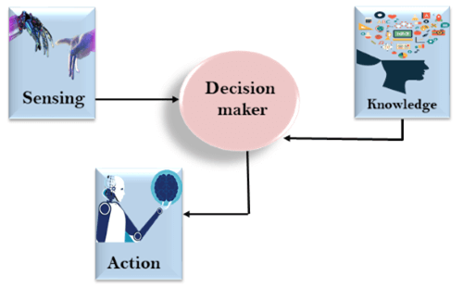

AI knowledge cycle:
An Artificial intelligence system has the following components for displaying intelligent behavior:
- Perception
- Learning
- Knowledge Representation and Reasoning
- Planning
- Execution
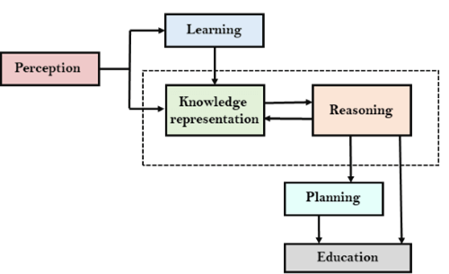
The above diagram is showing how an AI system can interact with the real world and what components help it to show intelligence. AI system has Perception component by which it retrieves information from its environment. It can be visual, audio or another form of sensory input. The learning component is responsible for learning from data captured by Perception comportment. In the complete cycle, the main components are knowledge representation and Reasoning. These two components are involved in showing the intelligence in machine-like humans. These two components are independent with each other but also coupled together. The planning and execution depend on analysis of Knowledge representation and reasoning.

Approaches to knowledge representation:
There are mainly four approaches to knowledge representation, which are givenbelow:

1. Simple relational knowledge:
- It is the simplest way of storing facts which uses the relational method, and each fact about a set of the object is set out systematically in columns.
- This approach of knowledge representation is famous in database systems where the relationship between different entities is represented.
- This approach has little opportunity for inference.
Example: The following is the simple relational knowledge representation.
Player | Weight | Age
Player1 | 65 | 23
Player2 | 58 | 18
Player3 | 75 | 24

2. Inheritable knowledge:
- In the inheritable knowledge approach, all data must be stored into a hierarchy of classes.
- All classes should be arranged in a generalized form or a hierarchal manner.
- In this approach, we apply inheritance property.
- Elements inherit values from other members of a class.
- This approach contains inheritable knowledge which shows a relation between instance and class, and it is called instance relation.
- Every individual frame can represent the collection of attributes and its value.
- In this approach, objects and values are represented in Boxed nodes.
- We use Arrows which point from objects to their values.
- Example:
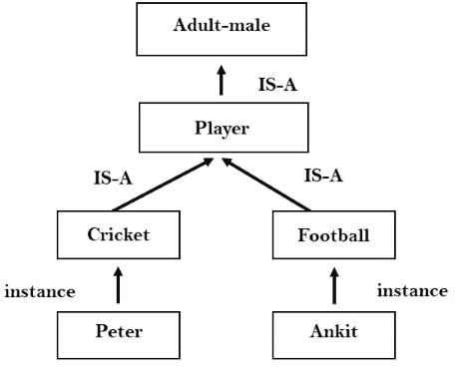

3. Inferential knowledge:
- Inferential knowledge approach represents knowledge in the form of formal logics.
- This approach can be used to derive more facts.
- It guaranteed correctness.
- Example: Let's suppose there are two statements:
  - Marcus is a man
  - All men are mortal
Then it can represent as;
man(Marcus)
∀x = man (x) ----------> mortal (x)s

4. Procedural knowledge:
- Procedural knowledge approach uses small programs and codes which describes how to do specific things, and how to proceed.
- In this approach, one important rule is used which is If-Then rule.
- In this knowledge, we can use various coding languages such as LISP language and Prolog language.
- We can easily represent heuristic or domain-specific knowledge using this approach.
- But it is not necessary that we can represent all cases in this approach.

Requirements for knowledge Representation system:
A good knowledge representation system must possess the following properties.
- 1. Representational Accuracy:
KR system should have the ability to represent all kind of required knowledge.
- 2. Inferential Adequacy:
KR system should have ability to manipulate the representational structures to produce new knowledge corresponding to existing structure.
- 3. Inferential Efficiency:
The ability to direct the inferential knowledge mechanism into the most productive directions by storing appropriate guides.
- 4. Acquisitional efficiency- The ability to acquire the new knowledge easily using automatic methods.

Techniques of knowledge representation
There are mainly four ways of knowledge representation which are given as follows:
- Logical Representation
- Semantic Network Representation
- Frame Representation
- Production Rules

1. Logical Representation
Logical representation is a language with some concrete rules which deals with propositions and has no ambiguity in representation. Logical representation means drawing a conclusion based on various conditions. This representation lays down some important communication rules. It consists of precisely defined syntax and semantics which supports the sound inference. Each sentence can be translated into logics using syntax and semantics.

Syntax:
- Syntaxes are the rules which decide how we can construct legal sentences in the logic.
- It determines which symbol we can use in knowledge representation.
- How to write those symbols.

Semantics:
- Semantics are the rules by which we can interpret the sentence in the logic.
- Semantic also involves assigning a meaning to each sentence.
Logical representation can be categorised into mainly two logics:
- Propositional Logics
- Predicate logics

Advantages of logical representation:
- Logical representation enables us to do logical reasoning.
- Logical representation is the basis for the programming languages.

Disadvantages of logical Representation:
- Logical representations have some restrictions and are challenging to work with.
- Logical representation technique may not be very natural, and inference may not be so efficient.

2. Semantic Network Representation
Semantic networks are alternative of predicate logic for knowledge representation. In Semantic networks, we can represent our knowledge in the form of graphical networks. This network consists of nodes representing objects and arcs which describe the relationship between those objects. Semantic networks can categorize the object in different forms and can also link those objects. Semantic networks are easy to understand and can be easily extended.
This representation consist of mainly two types of relations:
- IS-A relation (Inheritance)
- Kind-of-relation
Example: Following are some statements which we need to represent in the form of nodes and arcs.

Statements:
- Jerry is a cat.
- Jerry is a mammal
- Jerry is owned by Priya.
- Jerry is brown colored.
- All Mammals are animal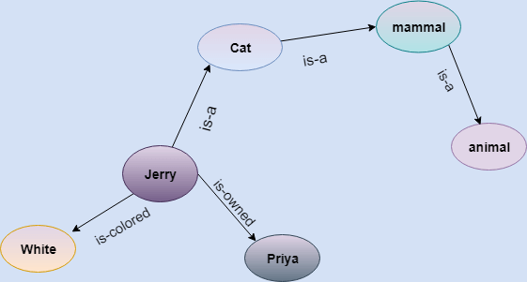
In the above diagram, we have represented the different type of knowledge in the form of nodes and arcs. Each object is connected with another object by some relation.

Drawbacks in Semantic representation:
- Semantic networks take more computational time at runtime as we need to traverse the complete network tree to answer some questions. It might be possible in the worst case scenario that after traversing the entire tree, we find that the solution does not exist in this network.
- Semantic networks try to model human-like memory (Which has 1015 neurons and links) to store the information, but in practice, it is not possible to build such a vast semantic network.
- These types of representations are inadequate as they do not have any equivalent quantifier, e.g., for all, for some, none, etc.
- Semantic networks do not have any standard definition for the link names.
- These networks are not intelligent and depend on the creator of the system.

Advantages of Semantic network:
- Semantic networks are a natural representation of knowledge.
- Semantic networks convey meaning in a transparent manner.
- These networks are simple and easily understandable.

3. Frame Representation
A frame is a record like structure which consists of a collection of attributes and its values to describe an entity in the world. Frames are the AI data structure which divides knowledge into substructures by representing stereotypes situations. It consists of a collection of slots and slot values. These slots may be of any type and sizes. Slots have names and values which are called facets.
Facets: The various aspects of a slot is known as Facets. Facets are features of frames which enable us to put constraints on the frames. Example: IF-NEEDED facts are called when data of any particular slot is needed. A frame may consist of any number of slots, and a slot may include any number of facets and facets may have any number of values. A frame is also known as slot-filter knowledge representation in artificial intelligence.
Frames are derived from semantic networks and later evolved into our modern-day classes and objects. A single frame is not much useful. Frames system consist of a collection of frames which are connected. In the frame, knowledge about an object or event can be stored together in the knowledge base. The frame is a type of technology which is widely used in various applications including Natural language processing and machine visions.

Example: 1
Let's take an example of a frame for a book
Slots | Filters
Title | Artificial Intelligence
Genre | Computer Science
Author | Peter Norvig
Edition | Third Edition
Year | 1996
Page | 1152

Example 2:
Let's suppose we are taking an entity, Peter. Peter is an engineer as a profession, and his age is 25, he lives in city London, and the country is England. So following is the frame representation for this:
Slots | Filter
Name | Peter
Profession | Doctor
Age | 25
Marital status | Single
Weight | 78

Advantages of frame representation:
- The frame knowledge representation makes the programming easier by grouping the related data.
- The frame representation is comparably flexible and used by many applications in AI.
- It is very easy to add slots for new attribute and relations.
- It is easy to include default data and to search for missing values.
- Frame representation is easy to understand and visualize.

Disadvantages of frame representation:
- In frame system inference mechanism is not be easily processed.
- Inference mechanism cannot be smoothly proceeded by frame representation.
- Frame representation has a much generalized approach.

4. Production Rules
Production rules system consist of (condition, action) pairs which mean, "If condition then action". It has mainly three parts:
- The set of production rules
- Working Memory
- The recognize-act-cycle
In production rules agent checks for the condition and if the condition exists then production rule fires and corresponding action is carried out. The condition part of the rule determines which rule may be applied to a problem. And the action part carries out the associated problem-solving steps. This complete process is called a recognize-act cycle.
The working memory contains the description of the current state of problems-solving and rule can write knowledge to the working memory. This knowledge match and may fire other rules.
If there is a new situation (state) generates, then multiple production rules will be fired together, this is called conflict set. In this situation, the agent needs to select a rule from these sets, and it is called a conflict resolution.

Example:
- IF (at bus stop AND bus arrives) THEN action (get into the bus)
- IF (on the bus AND paid AND empty seat) THEN action (sit down).
- IF (on bus AND unpaid) THEN action (pay charges).
- IF (bus arrives at destination) THEN action (get down from the bus).

Advantages of Production rule:
- The production rules are expressed in natural language.
- The production rules are highly modular, so we can easily remove, add or modify an individual rule.

Disadvantages of Production rule:
- Production rule system does not exhibit any learning capabilities, as it does not store the result of the problem for the future uses.
- During the execution of the program, many rules may be active hence rule-based production systems are inefficient.

Propositional logic in Artificial intelligence
Propositional logic (PL) is the simplest form of logic where all the statements are made by propositions. A proposition is a declarative statement which is either true or false. It is a technique of knowledge representation in logical and mathematical form.

Example:
- a) It is Sunday.
- b) The Sun rises from West (False proposition)
- c) 3+3= 7(False proposition)
- d) 5 is a prime number.
Following are some basic facts about propositional logic:
- Propositional logic is also called Boolean logic as it works on 0 and 1.
- In propositional logic, we use symbolic variables to represent the logic, and we can use any symbol for a representing a proposition, such A, B, C, P, Q, R, etc.
- Propositions can be either true or false, but it cannot be both.
- Propositional logic consists of an object, relations or function, and logical connectives.
- These connectives are also called logical operators.
- The propositions and connectives are the basic elements of the propositional logic.
- Connectives can be said as a logical operator which connects two sentences.
- A proposition formula which is always true is called tautology, and it is also called a valid sentence.
- A proposition formula which is always false is called Contradiction.
- A proposition formula which has both true and false values is called
- Statements which are questions, commands, or opinions are not propositions such as "Where is Rohini", "How are you", "What is your name", are not propositions.

Syntax of propositional logic:
The syntax of propositional logic defines the allowable sentences for the knowledge representation. There are two types of Propositions:
- Atomic Propositions
- Compound propositions
- Atomic Proposition: Atomic propositions are the simple propositions. It consists of a single proposition symbol. These are the sentences which must be either true or false.
Example:
- a) 2+2 is 4, it is an atomic proposition as it is a true fact.
- b) "The Sun is cold" is also a proposition as it is a false fact.
- Compound proposition: Compound propositions are constructed by combining simpler or atomic propositions, using parenthesis and logical connectives.
Example:
- a) "It is raining today, and street is wet."
- b) "Ankit is a doctor, and his clinic is in Mumbai."

Logical Connectives:
Logical connectives are used to connect two simpler propositions or representing a sentence logically. We can create compound propositions with the help of logical connectives. There are mainly five connectives, which are given as follows:
- Negation: A sentence such as ¬ P is called negation of P. A literal can be either Positive literal or negative literal.
- Conjunction: A sentence which has ∧ connective such as, P ∧ Q is called a conjunction.
Example: Rohan is intelligent and hardworking. It can be written as,
P= Rohan is intelligent,
Q= Rohan is hardworking. → P∧ Q.
- Disjunction: A sentence which has ∨ connective, such as P ∨ Q. is called disjunction, where P and Q are the propositions.
Example: "Ritika is a doctor or Engineer",
Here P= Ritika is Doctor. Q= Ritika is Doctor, so we can write it as P ∨ Q.
- Implication: A sentence such as P → Q, is called an implication. Implications are also known as if-then rules. It can be represented as
If it is raining, then the street is wet.
Let P= It is raining, and Q= Street is wet, so it is represented as P → Q
- Biconditional: A sentence such as P⇔ Q is a Biconditional sentence, example If I am breathing, then I am alive
P= I am breathing, Q= I am alive, it can be represented as P ⇔ Q.

Following is the summarized table for Propositional Logic Connectives:

Truth Table:
In propositional logic, we need to know the truth values of propositions in all possible scenarios. We can combine all the possible combination with logical connectives, and the representation of these combinations in a tabular format is called Truth table. Following are the truth table for all logical connectives:

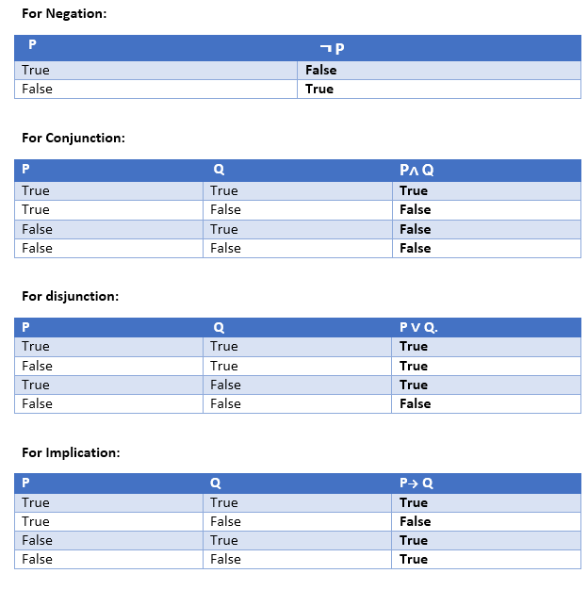

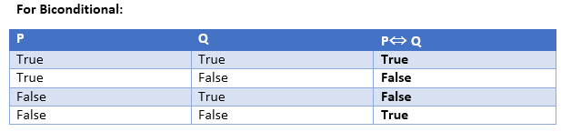

Truth table with three propositions:
We can build a proposition composing three propositions P, Q, and R. This truth table is made-up of 8n Tuples as we have taken three proposition symbols.
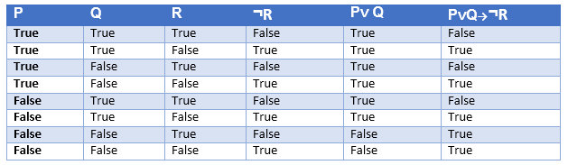

Precedence of connectives:
Just like arithmetic operators, there is a precedence order for propositional connectors or logical operators. This order should be followed while evaluating a propositional problem. Following is the list of the precedence order for operators:
Precedence | Operators
First Precedence | Parenthesis
Second Precedence | Negation
Third Precedence | Conjunction(AND)
Fourth Precedence | Disjunction(OR)
Fifth Precedence | Implication
Six Precedence | Biconditional

Logical equivalence:
Logical equivalence is one of the features of propositional logic. Two propositions are said to be logically equivalent if and only if the columns in the truth table are identical to each other.
Let's take two propositions A and B, so for logical equivalence, we can write it as A⇔B. In below truth table we can see that column for ¬A∨ B and A→B, are identical hence A is Equivalent to B
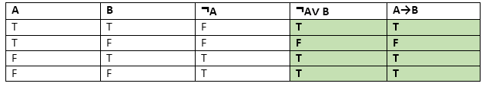

Properties of Operators:
- Commutativity:
  - P∧ Q= Q ∧ P, or
  - P ∨ Q = Q ∨ P.
- Associativity:
  - (P ∧ Q) ∧ R= P ∧ (Q ∧ R),
  - (P ∨ Q) ∨ R= P ∨ (Q ∨ R)
- Identity element:
  - P ∧ True = P,
  - P ∨ True= True.
- Distributive:
  - P∧ (Q ∨ R) = (P ∧ Q) ∨ (P ∧ R).
  - P ∨ (Q ∧ R) = (P ∨ Q) ∧ (P ∨ R).
- DE Morgan's Law:
  - ¬ (P ∧ Q) = (¬P) ∨ (¬Q)
  - ¬ (P ∨ Q) = (¬ P) ∧ (¬Q).
- Double-negation elimination:
  - ¬ (¬P) = P.
Limitations of Propositional logic:
- We cannot represent relations like ALL, some, or none with propositional logic. Example:
  - All the girls are intelligent.
  - Some apples are sweet.
- Propositional logic has limited expressive power.
- In propositional logic, we cannot describe statements in terms of their properties or logical relationships.

Rules of Inference in Artificial intelligence

Inference:
In artificial intelligence, we need intelligent computers which can create new logic from old logic or by evidence, so generating the conclusions from evidence and facts is termed as Inference.

Inference rules:
Inference rules are the templates for generating valid arguments. Inference rules are applied to derive proofs in artificial intelligence, and the proof is a sequence of the conclusion that leads to the desired goal.
In inference rules, the implication among all the connectives plays an important role. Following are some terminologies related to inference rules:
- Implication: It is one of the logical connectives which can be represented as P → Q. It is a Boolean expression.
- Converse: The converse of implication, which means the right-hand side proposition goes to the left-hand side and vice-versa. It can be written as Q → P.
- Contrapositive: The negation of converse is termed as contrapositive, and it can be represented as ¬ Q → ¬ P.
- Inverse: The negation of implication is called inverse. It can be represented as ¬ P → ¬ Q.
From the above term some of the compound statements are equivalent to each other, which we can prove using truth table:

Types of Inference rules:

1. Modus Ponens:
The Modus Ponens rule is one of the most important rules of inference, and it states that if P and P → Q is true, then we can infer that Q will be true. It can be represented as:
Example:
Statement-1: "If I am sleepy then I go to bed" ==> P→ Q
Statement-2: "I am sleepy" ==> P
Conclusion: "I go to bed." ==> Q.
Hence, we can say that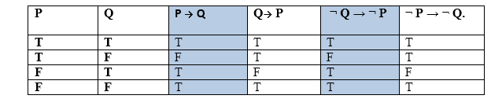, if P→ Q is true and P is true then Q will be true.
Proof by Truth table:

2. Modus Tollens:
The Modus Tollens rule state that if P→ Q is true and ¬ Q is true, then ¬ P will also true. It can be represented as:
Statement-1: "If I am sleepy then I go to bed" ==> P→ Q
Statement-2: "I do not go to the bed."==> ~Q
Statement-3: Which infers that "I am not sleepy" => ~P

Proof by Truth table:
s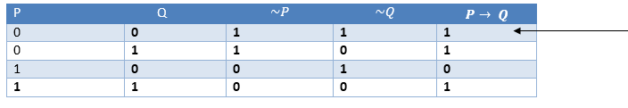

3. Hypothetical Syllogism:
The Hypothetical Syllogism rule state that if P→R is true whenever P→Q is true, and Q→R is true. It can be represented as the following notation:
Example:
Statement-1: If you have my home key then you can unlock my home. P→Q
Statement-2: If you can unlock my home then you can take my money. Q→R
Conclusion: If you have my home key then you can take my money. P→R
Proof by truth table:
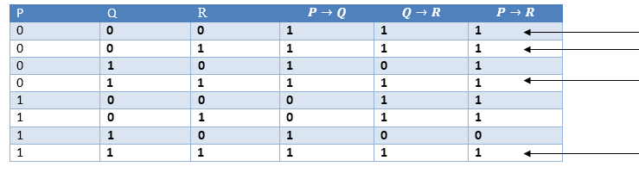

4. Disjunctive Syllogism:
The Disjunctive syllogism rule state that if P∨Q is true, and ¬P is true, then Q will be true. It can be represented as:
Example:
Statement-1: Today is Sunday or Monday. ==>P∨Q
Statement-2: Today is not Sunday. ==> ¬P
Conclusion: Today is Monday. ==> Q
Proof by truth-table:
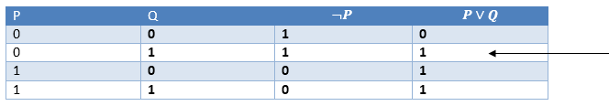

5. Addition:
The Addition rule is one the common inference rule, and it states that If P is true, then P∨Q will be true.
Example:
Statement: I have a vanilla ice-cream. ==> P
Statement-2: I have Chocolate ice-cream.
Conclusion: I have vanilla or chocolate ice-cream. ==> (P∨Q)
Proof by Truth-Table:
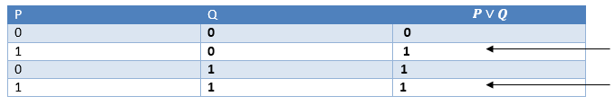

6. Simplification:
The simplification rule state that if P∧ Q is true, then Q or P will also be true. It can be represented as:
Proof by Truth-Table:
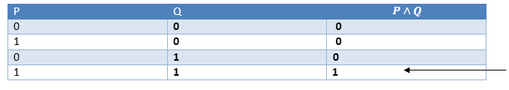

7. Resolution:
The Resolution rule state that if P∨Q and ¬ P∧R is true, then Q∨R will also be true. It can be represented as
Proof by Truth-Table:
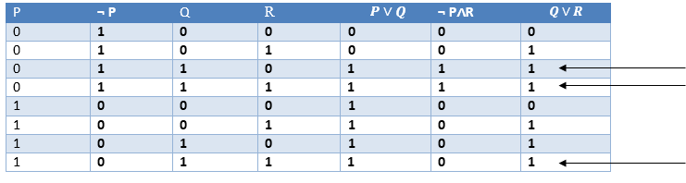
Example. Show that is a tautology.
I construct the truth table for and show that the formula is always true.
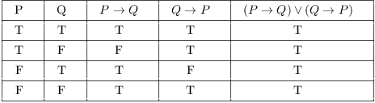
The last column contains only T's. Therefore, the formula is a tautology.

Example. Construct a truth table for .
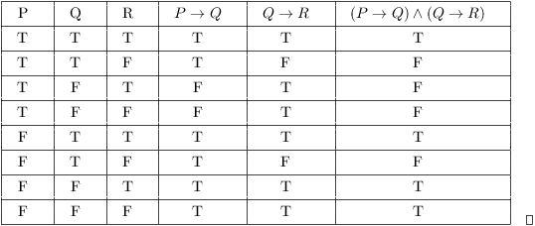

You can see that constructing truth tables for statements with lots of connectives or lots of simple statements is pretty tedious and error-prone. While there might be some applications of this (e.g. to digital circuits), at some point the best thing would be to write a program to construct truth tables (and this has surely been done).
The point here is to understand how the truth value of a complex statement depends on the truth values of its simple statements and its logical connectives. In most work, mathematicians don't normally use statements which are very complicated from a logical point of view.
Example. Show that and are logically equivalent.
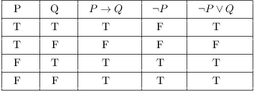
Since the columns for and are identical, the two statements are logically equivalent. This tautology is called Conditional Disjunction. You can use this equivalence to replace a conditional by a disjunction.

Knowledge-Based Agent in Artificial intelligence
- An intelligent agent needs knowledge about the real world for taking decisions and reasoning to act efficiently.
- Knowledge-based agents are those agents who have the capability of maintaining an internal state of knowledge, reason over that knowledge, update their knowledge after observations and take actions. These agents can represent the world with some formal representation and act intelligently.
- Knowledge-based agents are composed of two main parts:
  - Knowledge-base and
  - Inference system.
A knowledge-based agent must able to do the following:
- An agent should be able to represent states, actions, etc.
- An agent Should be able to incorporate new percepts
- An agent can update the internal representation of the world
- An agent can deduce the internal representation of the world
- An agent can deduce appropriate actions.

The architecture of knowledge-based agent:
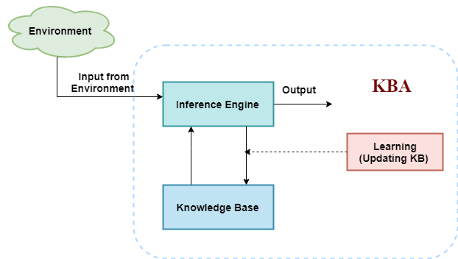
The knowledge-based agent (KBA) take input from the environment by perceiving the environment. The input is taken by the inference engine of the agent and which also communicate with KB to decide as per the knowledge store in KB. The learning element of KBA regularly updates the KB by learning new knowledge.
Knowledge base: Knowledge-base is a central component of a knowledge-based agent, it is also known as KB. It is a collection of sentences (here 'sentence' is a technical term and it is not identical to sentence in English). These sentences are expressed in a language which is called a knowledge representation language. The Knowledge-base of KBA stores fact about the world.

Why use a knowledge base?
Knowledge-base is required for updating knowledge for an agent to learn with experiences and take action as per the knowledge.

Inference system
Inference means deriving new sentences from old. Inference system allows us to add a new sentence to the knowledge base. A sentence is a proposition about the world. Inference system applies logical rules to the KB to deduce new information.
Inference system generates new facts so that an agent can update the KB. An inference system works mainly in two rules which are given as:
- Forward chaining
- Backward chaining

Operations Performed by KBA
Following are three operations which are performed by KBA in order to show the intelligent behavior:
- TELL: This operation tells the knowledge base what it perceives from the environment.
- ASK: This operation asks the knowledge base what action it should perform.
- Perform: It performs the selected action.

A generic knowledge-based agent:
Following is the structure outline of a generic knowledge-based agents program:
- function KB-AGENT(percept):
- persistent: KB, a knowledge base
- t, a counter, initially 0, indicating time
- TELL(KB, MAKE-PERCEPT-SENTENCE(percept, t))
- Action = ASK(KB, MAKE-ACTION-QUERY(t))
- TELL(KB, MAKE-ACTION-SENTENCE(action, t))
- t = t + 1
- return action
The knowledge-based agent takes percept as input and returns an action as output. The agent maintains the knowledge base, KB, and it initially has some background knowledge of the real world. It also has a counter to indicate the time for the whole process, and this counter is initialized with zero.
Each time when the function is called, it performs its three operations:
- Firstly it TELLs the KB what it perceives.
- Secondly, it asks KB what action it should take
- Third agent program TELLS the KB that which action was chosen.
The MAKE-PERCEPT-SENTENCE generates a sentence as setting that the agent perceived the given percept at the given time.
The MAKE-ACTION-QUERY generates a sentence to ask which action should be done at the current time.
MAKE-ACTION-SENTENCE generates a sentence which asserts that the chosen action was executed.

Various levels of knowledge-based agent:
A knowledge-based agent can be viewed at different levels which are given below:

1. Knowledge level
Knowledge level is the first level of knowledge-based agent, and in this level, we need to specify what the agent knows, and what the agent goals are. With these specifications, we can fix its behavior. For example, suppose an automated taxi agent needs to go from a station A to station B, and he knows the way from A to B, so this comes at the knowledge level.

2. Logical level:
At this level, we understand that how the knowledge representation of knowledge is stored. At this level, sentences are encoded into different logics. At the logical level, an encoding of knowledge into logical sentences occurs. At the logical level we can expect to the automated taxi agent to reach to the destination B.

3. Implementation level:
This is the physical representation of logic and knowledge. At the implementation level agent perform actions as per logical and knowledge level. At this level, an automated taxi agent actually implement his knowledge and logic so that he can reach to the destination.

Approaches to designing a knowledge-based agent:
There are mainly two approaches to build a knowledge-based agent:
- 1. Declarative approach: We can create a knowledge-based agent by initializing with an empty knowledge base and telling the agent all the sentences with which we want to start with. This approach is called Declarative approach.
- 2. Procedural approach: In the procedural approach, we directly encode desired behavior as a program code. Which means we just need to write a program that already encodes the desired behavior or agent.
However, in the real world, a successful agent can be built by combining both declarative and procedural approaches, and declarative knowledge can often be compiled into more efficient procedural code.

Forward Chaining and backward chaining in AI
In artificial intelligence, forward and backward chaining is one of the important topics, but before understanding forward and backward chaining lets first understand that from where these two terms came.

Inference engine:
The inference engine is the component of the intelligent system in artificial intelligence, which applies logical rules to the knowledge base to infer new information from known facts. The first inference engine was part of the expert system. Inference engine commonly proceeds in two modes, which are:
- Forward chaining
- Backward chaining
Horn Clause and Definite clause:
Horn clause and definite clause are the forms of sentences, which enables knowledge base to use a more restricted and efficient inference algorithm. Logical inference algorithms use forward and backward chaining approaches, which require KB in the form of the first-order definite clause.
Definite clause: A clause which is a disjunction of literals with exactly one positive literal is known as a definite clause or strict horn clause.
Horn clause: A clause which is a disjunction of literals with at most one positive literal is known as horn clause. Hence all the definite clauses are horn clauses.
Example: (¬ p V ¬ q V k). It has only one positive literal k.
It is equivalent to p ∧ q → k.

Forward Chaining
Forward chaining is also known as a forward deduction or forward reasoning method when using an inference engine. Forward chaining is a form of reasoning which start with atomic sentences in the knowledge base and applies inference rules (Modus Ponens) in the forward direction to extract more data until a goal is reached.
The Forward-chaining algorithm starts from known facts, triggers all rules whose premises are satisfied, and add their conclusion to the known facts. This process repeats until the problem is solved.
Properties of Forward-Chaining:
- It is a down-up approach, as it moves from bottom to top.
- It is a process of making a conclusion based on known facts or data, by starting from the initial state and reaches the goal state.
- Forward-chaining approach is also called as data-driven as we reach to the goal using available data.
- Forward -chaining approach is commonly used in the expert system, such as CLIPS, business, and production rule systems.
Consider the following famous example which we will use in both approaches:

Example:
"As per the law, it is a crime for an American to sell weapons to hostile nations. Country A, an enemy of America, has some missiles, and all the missiles were sold to it by Robert, who is an American citizen."
Prove that "Robert is criminal."
To solve the above problem, first, we will convert all the above facts into first-order definite clauses, and then we will use a forward-chaining algorithm to reach the goal.

Facts Conversion into FOL:
- It is a crime for an American to sell weapons to hostile nations. (Let's say p, q, and r are variables)
American (p) ∧ weapon(q) ∧ sells (p, q, r) ∧ hostile(r) → Criminal(p) ...(1)
- Country A has some missiles. ?p Owns(A, p) ∧ Missile(p). It can be written in two definite clauses by using Existential Instantiation, introducing new Constant T1.
Owns(A, T1) ......(2)
Missile(T1) .......(3)
- All of the missiles were sold to country A by Robert.
?p Missiles(p) ∧ Owns (A, p) → Sells (Robert, p, A) ......(4)
- Missiles are weapons.
Missile(p) → Weapons (p) .......(5)
- Enemy of America is known as hostile.
Enemy(p, America) →Hostile(p) ........(6)
- Country A is an enemy of America.
Enemy (A, America) .........(7)
- Robert is American
American(Robert). ..........(8)

Forward chaining proof:
Step-1:
In the first step we will start with the known facts and will choose the sentences which do not have implications, such as: American(Robert), Enemy(A, America), Owns(A, T1), and Missile(T1). All these facts will be represented as below.
Step-2:
At the second step, we will see those facts which infer from available facts and with satisfied premises.
Rule-(1) does not satisfy premises, so it will not be added in the first iteration.
Rule-(2) and (3) are already added.
Rule-(4) satisfy with the substitution {p/T1}, so Sells (Robert, T1, A) is added, which infers from the conjunction of Rule (2) and (3).
Rule-(6) is satisfied with the substitution(p/A), so Hostile(A) is added and which infers from Rule-(7).
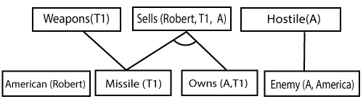
Step-3:
At step-3, as we can check Rule-(1) is satisfied with the substitution {p/Robert, q/T1, r/A}, so we can add Criminal(Robert) which infers all the available facts. And hence we reached our goal statement.
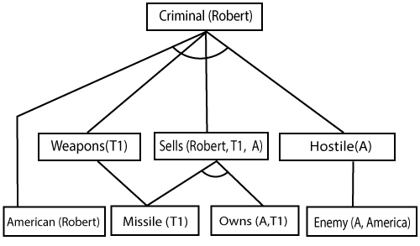

Hence it is proved that Robert is Criminal using forward chaining approach.

B. Backward Chaining:
Backward-chaining is also known as a backward deduction or backward reasoning method when using an inference engine. A backward chaining algorithm is a form of reasoning, which starts with the goal and works backward, chaining through rules to find known facts that support the goal.
Properties of backward chaining:
- It is known as a top-down approach.
- Backward-chaining is based on modus ponens inference rule.
- In backward chaining, the goal is broken into sub-goal or sub-goals to prove the facts true.
- It is called a goal-driven approach, as a list of goals decides which rules are selected and used.
- Backward -chaining algorithm is used in game theory, automated theorem proving tools, inference engines, proof assistants, and various AI applications.
- The backward-chaining method mostly used a depth-first search strategy for proof.

Example:
In backward-chaining, we will use the same above example, and will rewrite all the rules.
- American (p) ∧ weapon(q) ∧ sells (p, q, r) ∧ hostile(r) → Criminal(p) ...(1)
Owns(A, T1) ........(2)
- Missile(T1)
- ?p Missiles(p) ∧ Owns (A, p) → Sells (Robert, p, A) ......(4)
- Missile(p) → Weapons (p) .......(5)
- Enemy(p, America) →Hostile(p) ........(6)
- Enemy (A, America) .........(7)
- American(Robert). ..........(8)

Backward-Chaining proof:
In Backward chaining, we will start with our goal predicate, which is Criminal(Robert), and then infer further rules.
Step-1:
At the first step, we will take the goal fact. And from the goal fact, we will infer other facts, and at last, we will prove those facts true. So our goal fact is "Robert is Criminal," so following is the predicate of it.
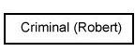
Step-2:
At the second step, we will infer other facts form goal fact which satisfies the rules. So as we can see in Rule-1, the goal predicate Criminal (Robert) is present with substitution {Robert/P}. So we will add all the conjunctive facts below the first level and will replace p with Robert.
Here we can see American (Robert) is a fact, so it is proved here.
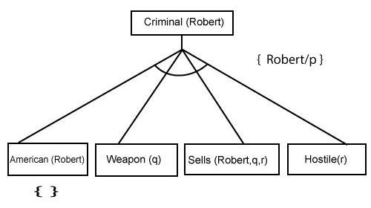

Step-3:t At step-3, we will extract further fact Missile(q) which infer from Weapon(q), as it satisfies Rule-(5). Weapon (q) is also true with the substitution of a constant T1 at q.
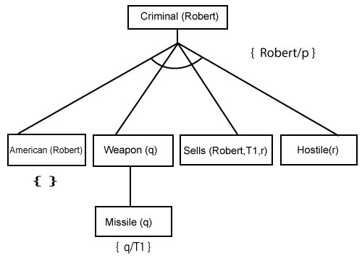

Step-4:
At step-4, we can infer facts Missile(T1) and Owns(A, T1) form Sells(Robert, T1, r) which satisfies the Rule- 4, with the substitution of A in place of r. So these two statements are proved here.
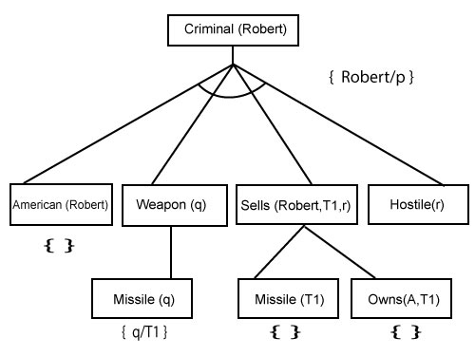
Step-5:
At step-5, we can infer the fact Enemy(A, America) from Hostile(A) which satisfies Rule- 6. And hence all the statements are proved true using backward chaining.

First-Order Logic in Artificial intelligence
In the topic of Propositional logic, we have seen that how to represent statements using propositional logic. But unfortunately, in propositional logic, we can only represent the facts, which are either true or false. PL is not sufficient to represent the complex sentences or natural language statements. The propositional logic has very limited expressive power. Consider the following sentence, which we cannot represent using PL logic.
- "Some humans are intelligent", or
- "Sachin likes cricket."
To represent the above statements, PL logic is not sufficient, so we required some more powerful logic, such as first-order logic.

First-Order logic:
- First-order logic is another way of knowledge representation in artificial intelligence. It is an extension to propositional logic.
- FOL is sufficiently expressive to represent the natural language statements in a concise way.
- First-order logic is also known as Predicate logic or First-order predicate logic. First-order logic is a powerful language that develops information about the objects in a more easy way and can also express the relationship between those objects.
- First-order logic (like natural language) does not only assume that the world contains facts like propositional logic but also assumes the following things in the world:
  - Objects: A, B, people, numbers, colors, wars, theories, squares, pits, wumpus, ......
  - Relations: It can be unary relation such as: red, round, is adjacent, or n-any relation such as: the sister of, brother of, has color, comes between
  - Function: Father of, best friend, third inning of, end of, ......
- As a natural language, first-order logic also has two main parts:
  - Syntax
  - Semantics

Syntax of First-Order logic:
The syntax of FOL determines which collection of symbols is a logical expression in first-order logic. The basic syntactic elements of first-order logic are symbols. We write statements in short-hand notation in FOL.

Basic Elements of First-order logic:
Following are the basic elements of FOL syntax:
Following are the basic elements of FOL syntax:
Constant | 1, 2, A, John, Mumbai, cat,....
Variables | x, y, z, a, b,....
Predicates | Brother, Father, >,....
Function | sqrt, LeftLegOf, ....
Connectives | ∧, ∨, ¬, ⇒, ⇔
Equality | ==
Quantifier | ∀, ∃

Atomic sentences:
- Atomic sentences are the most basic sentences of first-order logic. These sentences are formed from a predicate symbol followed by a parenthesis with a sequence of terms.
- We can represent atomic sentences as Predicate (term1, term2, ......, term n).
Example: Ravi and Ajay are brothers: => Brothers(Ravi, Ajay).
Chinky is a cat: => cat (Chinky).

Complex Sentences:
- Complex sentences are made by combining atomic sentences using connectives.
First-order logic statements can be divided into two parts:
- Subject: Subject is the main part of the statement.
- Predicate: A predicate can be defined as a relation, which binds two atoms together in a statement.
Consider the statement: "x is an integer.", it consists of two parts, the first part x is the subject of the statement and second part "is an integer," is known as a predicate.
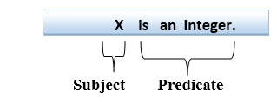

Quantifiers in First-order logic:
- A quantifier is a language element which generates quantification, and quantification specifies the quantity of specimen in the universe of discourse.
- These are the symbols that permit to determine or identify the range and scope of the variable in the logical expression. There are two types of quantifier:
  - Universal Quantifier, (for all, everyone, everything)
  - Existential quantifier, (for some, at least one).

Universal Quantifier:
Universal quantifier is a symbol of logical representation, which specifies that the statement within its range is true for everything or every instance of a particular thing.
The Universal quantifier is represented by a symbol ∀, which resembles an inverted A.

Note: In universal quantifier we use implication "→".
If x is a variable, then ∀x is read as:
- For all x
- For each x
- For every x.

Example:
All man drink coffee.
Let a variable x which refers to a cat so all x can be represented in UOD as below:
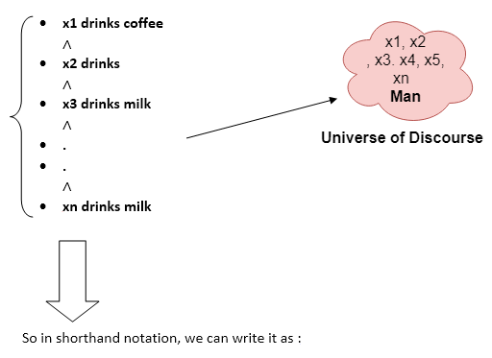
∀x man(x) → drink (x, coffee).
It will be read as: There are all x where x is a man who drink coffee.

Existential Quantifier:
Existential quantifiers are the type of quantifiers, which express that the statement within its scope is true for at least one instance of something.
It is denoted by the logical operator ∃, which resembles as inverted E. When it is used with a predicate variable then it is called as an existential quantifier.

Note: In Existential quantifier we always use AND or Conjunction symbol (∧).
If x is a variable, then existential quantifier will be ∃x or ∃(x). And it will be read as:
- There exists a 'x.'
- For some 'x.'
- For at least one 'x.'

Example:
Some boys are intelligent.
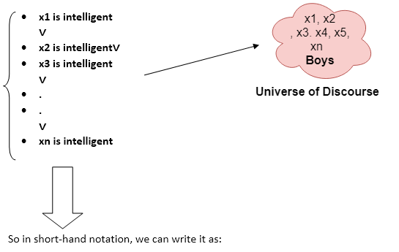

∃x: boys(x) ∧ intelligent(x)
It will be read as: There are some x where x is a boy who is intelligent.

Points to remember:
- The main connective for universal quantifier ∀ is implication →.
- The main connective for existential quantifier ∃ is and ∧.

Properties of Quantifiers:
- In universal quantifier, ∀x∀y is similar to ∀y∀x.
- In Existential quantifier, ∃x∃y is similar to ∃y∃x.
- ∃x∀y is not similar to ∀y∃x.
Some Examples of FOL using quantifier:
1. All birds fly.
In this question the predicate is "fly(bird)."
And since there are all birds who fly so it will be represented as follows.
∀x bird(x) →fly(x).
2. Every man respects his parent.
In this question, the predicate is "respect(x, y)," where x=man, and y= parent.
Since there is every man so will use ∀, and it will be represented as follows:
∀x man(x) → respects (x, parent).
3. Some boys play cricket.
In this question, the predicate is "play(x, y)," where x= boys, and y= game. Since there are some boys so we will use ∃, and it will be represented as:
∃x boys(x) → play(x, cricket).
4. Not all students like both Mathematics and Science.
In this question, the predicate is "like(x, y)," where x= student, and y= subject.
Since there are not all students, so we will use ∀ with negation, so following representation for this:
¬∀ (x) [ student(x) → like(x, Mathematics) ∧ like(x, Science)].
5. Only one student failed in Mathematics.
In this question, the predicate is "failed(x, y)," where x= student, and y= subject.
Since there is only one student who failed in Mathematics, so we will use following representation for this:
∃(x) [ student(x) → failed (x, Mathematics) ∧∀ (y) [¬(x==y) ∧ student(y) → ¬failed (x, Mathematics)].

Free and Bound Variables:
The quantifiers interact with variables which appear in a suitable way. There are two types of variables in First-order logic which are given below:
Free Variable: A variable is said to be a free variable in a formula if it occurs outside the scope of the quantifier.
Example: ∀x ∃(y)[P (x, y, z)], where z is a free variable.
Bound Variable: A variable is said to be a bound variable in a formula if it occurs within the scope of the quantifier.
Example: ∀x [A (x) B( y)], here x and y are the bound variables.

Inference in First-Order Logic
Inference in First-Order Logic is used to deduce new facts or sentences from existing sentences. Before understanding the FOL inference rule, let's understand some basic terminologies used in FOL.
Substitution:
Substitution is a fundamental operation performed on terms and formulas. It occurs in all inference systems in first-order logic. The substitution is complex in the presence of quantifiers in FOL. If we write F[a/x], so it refers to substitute a constant "a" in place of variable "x".
Equality:
First-Order logic does not only use predicate and terms for making atomic sentences but also uses another way, which is equality in FOL. For this, we can use equality symbols which specify that the two terms refer to the same object.
Example: Brother (John) = Smith.
As in the above example, the object referred by the Brother (John) is similar to the object referred by Smith. The equality symbol can also be used with negation to represent that two terms are not the same objects.
Example: ￢(x=y) which is equivalent to x ≠y.

FOL inference rules for quantifier:
As propositional logic we also have inference rules in first-order logic, so following are some basic inference rules in FOL:
- Universal Generalization
- Universal Instantiation
- Existential Instantiation
- Existential introduction
1. Universal Generalization:
- Universal generalization is a valid inference rule which states that if premise P(c) is true for any arbitrary element c in the universe of discourse, then we can have a conclusion as ∀ x P(x).
- It can be represented as: 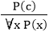.
- This rule can be used if we want to show that every element has a similar property.
- In this rule, x must not appear as a free variable.
Example: Let's represent, P(c): "A byte contains 8 bits", so for ∀ x P(x) "All bytes contain 8 bits.", it will also be true.
2. Universal Instantiation:
- Universal instantiation is also called as universal elimination or UI is a valid inference rule. It can be applied multiple times to add new sentences.
- The new KB is logically equivalent to the previous KB.
- As per UI, we can infer any sentence obtained by substituting a ground term for the variable.
- The UI rule state that we can infer any sentence P(c) by substituting a ground term c (a constant within domain x) from ∀ x P(x) for any object in the universe of discourse.
- It can be represented as: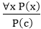.
Example:1.
IF "Every person like ice-cream"=> ∀x P(x) so we can infer that
"John likes ice-cream" => P(c)
Example: 2.
Let's take a famous example,
"All kings who are greedy are Evil." So let our knowledge base contains this detail as in the form of FOL:
∀x king(x) ∧ greedy (x) → Evil (x),
So from this information, we can infer any of the following statements using Universal Instantiation:
- King(John) ∧ Greedy (John) → Evil (John),
- King(Richard) ∧ Greedy (Richard) → Evil (Richard),
- King(Father(John)) ∧ Greedy (Father(John)) → Evil (Father(John)),
3. Existential Instantiation:
- Existential instantiation is also called as Existential Elimination, which is a valid inference rule in first-order logic.
- It can be applied only once to replace the existential sentence.
- The new KB is not logically equivalent to old KB, but it will be satisfiable if old KB was satisfiable.
- This rule states that one can infer P(c) from the formula given in the form of ∃x P(x) for a new constant symbol c.
- The restriction with this rule is that c used in the rule must be a new term for which P(c ) is true.
- It can be represented as: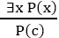
Example:
From the given sentence: ∃x Crown(x) ∧ OnHead(x, John),
So we can infer: Crown(K) ∧ OnHead( K, John), as long as K does not appear in the knowledge base.
- The above used K is a constant symbol, which is called Skolem constant.
- The Existential instantiation is a special case of Skolemization process.
4. Existential introduction
- An existential introduction is also known as an existential generalization, which is a valid inference rule in first-order logic.
- This rule states that if there is some element c in the universe of discourse which has a property P, then we can infer that there exists something in the universe which has the property P.
- It can be represented as: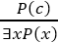
- Example: Let's say that,
"Priyanka got good marks in English."
"Therefore, someone got good marks in English."

Generalized Modus Ponens Rule:
For the inference process in FOL, we have a single inference rule which is called Generalized Modus Ponens. It is lifted version of Modus ponens.
Generalized Modus Ponens can be summarized as, " P implies Q and P is asserted to be true, therefore Q must be True."
According to Modus Ponens, for atomic sentences pi, pi', q. Where there is a substitution θ such that SUBST (θ, pi',) = SUBST(θ, pi), it can be represented as:
Example:
We will use this rule for Kings are evil, so we will find some x such that x is king, and x is greedy so we can infer that x is evil.
- Here let say, p1' is king(John) p1 is king(x)
- p2' is Greedy(y) p2 is Greedy(x)
- θ is {x/John, y/John} q is evil(x)
SUBST(θ,q).

Reasoning:
The reasoning is the mental process of deriving logical conclusion and making predictions from available knowledge, facts, and beliefs. Or we can say, "Reasoning is a way to infer facts from existing data." It is a general process of thinking rationally, to find valid conclusions.
In artificial intelligence, the reasoning is essential so that the machine can also think rationally as a human brain, and can perform like a human.

Types of Reasoning
In artificial intelligence, reasoning can be divided into the following categories:
- Deductive reasoning
- Inductive reasoning
- Abductive reasoning
- Common Sense Reasoning
- Monotonic Reasoning
- Non-monotonic Reasoning

1. Deductive reasoning:
Deductive reasoning is deducing new information from logically related known information. It is the form of valid reasoning, which means the argument's conclusion must be true when the premises are true.
Deductive reasoning is a type of propositional logic in AI, and it requires various rules and facts. It is sometimes referred to as top-down reasoning, and contradictory to inductive reasoning.
In deductive reasoning, the truth of the premises guarantees the truth of the conclusion.
Deductive reasoning mostly starts from the general premises to the specific conclusion, which can be explained as below example.
Example:
Premise-1: All the human eats veggies
Premise-2: Suresh is human.
Conclusion: Suresh eats veggies.
The general process of deductive reasoning is given below:
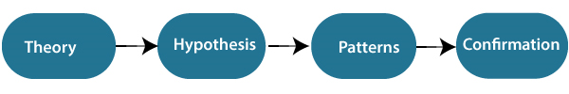

2. Inductive Reasoning:
Inductive reasoning is a form of reasoning to arrive at a conclusion using limited sets of facts by the process of generalization. It starts with the series of specific facts or data and reaches to a general statement or conclusion.
Inductive reasoning is a type of propositional logic, which is also known as cause-effect reasoning or bottom-up reasoning.
In inductive reasoning, we use historical data or various premises to generate a generic rule, for which premises support the conclusion.
In inductive reasoning, premises provide probable supports to the conclusion, so the truth of premises does not guarantee the truth of the conclusion.
Example:
Premise: All of the pigeons we have seen in the zoo are white.
Conclusion: Therefore, we can expect all the pigeons to be white.
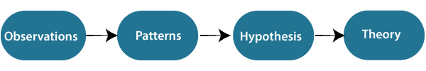

3. Abductive reasoning:
Abductive reasoning is a form of logical reasoning which starts with single or multiple observations then seeks to find the most likely explanation or conclusion for the observation.
Abductive reasoning is an extension of deductive reasoning, but in abductive reasoning, the premises do not guarantee the conclusion.
Example:
Implication: Cricket ground is wet if it is raining
Axiom: Cricket ground is wet.
Conclusion It is raining.

4. Common Sense Reasoning
Common sense reasoning is an informal form of reasoning, which can be gained through experiences.
Common Sense reasoning simulates the human ability to make presumptions about events which occurs on every day.
It relies on good judgment rather than exact logic and operates on heuristic knowledge and heuristic rules.
Example:
- One person can be at one place at a time.
- If I put my hand in a fire, then it will burn.
The above two statements are the examples of common sense reasoning which a human mind can easily understand and assume.

5. Monotonic Reasoning:
In monotonic reasoning, once the conclusion is taken, then it will remain the same even if we add some other information to existing information in our knowledge base. In monotonic reasoning, adding knowledge does not decrease the set of prepositions that can be derived.
To solve monotonic problems, we can derive the valid conclusion from the available facts only, and it will not be affected by new facts.
Monotonic reasoning is not useful for the real-time systems, as in real time, facts get changed, so we cannot use monotonic reasoning.
Monotonic reasoning is used in conventional reasoning systems, and a logic-based system is monotonic.
Any theorem proving is an example of monotonic reasoning.
Example:
- Earth revolves around the Sun.
It is a true fact, and it cannot be changed even if we add another sentence in knowledge base like, "The moon revolves around the earth" Or "Earth is not round," etc.

Advantages of Monotonic Reasoning:
- In monotonic reasoning, each old proof will always remain valid.
- If we deduce some facts from available facts, then it will remain valid for always.

Disadvantages of Monotonic Reasoning:
- We cannot represent the real world scenarios using Monotonic reasoning.
- Hypothesis knowledge cannot be expressed with monotonic reasoning, which means facts should be true.
- Since we can only derive conclusions from the old proofs, so new knowledge from the real world cannot be added.

6. Non-monotonic Reasoning
In Non-monotonic reasoning, some conclusions may be invalidated if we add some more information to our knowledge base.
Logic will be said as non-monotonic if some conclusions can be invalidated by adding more knowledge into our knowledge base.
Non-monotonic reasoning deals with incomplete and uncertain models.
"Human perceptions for various things in daily life, "is a general example of non-monotonic reasoning.
Example: Let suppose the knowledge base contains the following knowledge:
- Birds can fly
- Penguins cannot fly
- Pitty is a bird
So from the above sentences, we can conclude that Pitty can fly.
However, if we add one another sentence into knowledge base "Pitty is a penguin", which concludes "Pitty cannot fly", so it invalidates the above conclusion.

Advantages of Non-monotonic reasoning:
- For real-world systems such as Robot navigation, we can use non-monotonic reasoning.
- In Non-monotonic reasoning, we can choose probabilistic facts or can make assumptions.

Disadvantages of Non-monotonic Reasoning:
- In non-monotonic reasoning, the old facts may be invalidated by adding new sentences.
- It cannot be used for theorem proving.

Probabilistic reasoning in Artificial intelligence

Uncertainty:
Till now, we have learned knowledge representation using first-order logic and propositional logic with certainty, which means we were sure about the predicates. With this knowledge representation, we might write A→B, which means if A is true then B is true, but consider a
situation where we are not sure about whether A is true or not then we cannot express this statement, this situation is called uncertainty.
So to represent uncertain knowledge, where we are not sure about the predicates, we need uncertain reasoning or probabilistic reasoning.

Causes of uncertainty:
Following are some leading causes of uncertainty to occur in the real world.
- Information occurred from unreliable sources.
- Experimental Errors
- Equipment fault
- Temperature variation
- Climate change.

Probabilistic reasoning:
Probabilistic reasoning is a way of knowledge representation where we apply the concept of probability to indicate the uncertainty in knowledge. In probabilistic reasoning, we combine probability theory with logic to handle the uncertainty.
We use probability in probabilistic reasoning because it provides a way to handle the uncertainty that is the result of someone's laziness and ignorance.
In the real world, there are lots of scenarios, where the certainty of something is not confirmed, such as "It will rain today," "behavior of someone for some situations," "A match between two teams or two players." These are probable sentences for which we can assume that it will happen but not sure about it, so here we use probabilistic reasoning.
Need of probabilistic reasoning in AI:
- When there are unpredictable outcomes.
- When specifications or possibilities of predicates becomes too large to handle.
- When an unknown error occurs during an experiment.
In probabilistic reasoning, there are two ways to solve problems with uncertain knowledge:
- Bayes' rule
- Bayesian Statistics
As probabilistic reasoning uses probability and related terms, so before understanding probabilistic reasoning, let's understand some common terms:
Probability: Probability can be defined as a chance that an uncertain event will occur. It is the numerical measure of the likelihood that an event will occur. The value of probability always remains between 0 and 1 that represent ideal uncertainties.
- 0 ≤ P(A) ≤ 1, where P(A) is the probability of an event A.
- P(A) = 0, indicates total uncertainty in an event A.
- P(A) =1, indicates total certainty in an event A.
We can find the probability of an uncertain event by using the below formula.
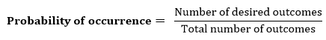

- P(¬A) = probability of a not happening event.
- P(¬A) + P(A) = 1.
Event: Each possible outcome of a variable is called an event.
Sample space: The collection of all possible events is called sample space.
Random variables: Random variables are used to represent the events and objects in the real world.
Prior probability: The prior probability of an event is probability computed before observing new information.
Posterior Probability: The probability that is calculated after all evidence or information has taken into account. It is a combination of prior probability and new information.

Conditional probability:
Conditional probability is a probability of occurring an event when another event has already happened.
Let's suppose, we want to calculate the event A when event B has already occurred, "the probability of A under the conditions of B", it can be written as:
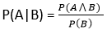
Where P(A⋀B)= Joint probability of a and B
P(B)= Marginal probability of B.
If the probability of A is given and we need to find the probability of B, then it will be given as:
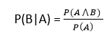
It can be explained by using the below Venn diagram, where B is occurred event, so sample space will be reduced to set B, and now we can only calculate event A when event B is already occurred by dividing the probability of P(A⋀B) by P( B ).
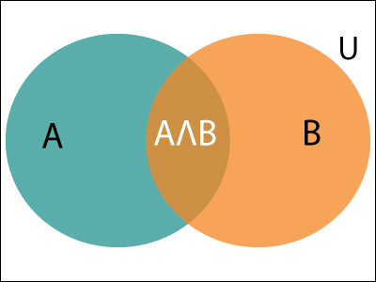

Example:
In a class, there are 70% of the students who like English and 40% of the students who likes English and mathematics, and then what is the percent of students those who like English also like mathematics?
Solution:
Let, A is an event that a student likes Mathematics
B is an event that a student likes English.
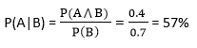

Resolution in FOL

Resolution
Resolution is a theorem proving technique that proceeds by building refutation proofs, i.e., proofs by contradictions. It was invented by a Mathematician John Alan Robinson in the year 1965.
Resolution is used, if there are various statements are given, and we need to prove a conclusion of those statements. Unification is a key concept in proofs by resolutions. Resolution is a single inference rule which can efficiently operate on the conjunctive normal form or clausal form.
Clause: Disjunction of literals (an atomic sentence) is called a clause. It is also known as a unit clause.
Conjunctive Normal Form: A sentence represented as a conjunction of clauses is said to be conjunctive normal form or CNF.

The resolution inference rule:
The resolution rule for first-order logic is simply a lifted version of the propositional rule. Resolution can resolve two clauses if they contain complementary literals, which are assumed to be standardized apart so that they share no variables.

Where l_{i} and m_{j} are complementary literals.
This rule is also called the binary resolution rule because it only resolves exactly two literals.

Example:
We can resolve two clauses which are given below:
[Animal (g(x) V Loves (f(x), x)] and [￢ Loves(a, b) V ￢Kills(a, b)]
Where two complimentary literals are: Loves (f(x), x) and ￢ Loves (a, b)
These literals can be unified with unifier θ= [a/f(x), and b/x] , and it will generate a resolvent clause:
[Animal (g(x) V ￢ Kills(f(x), x)].

Steps for Resolution:
- Conversion of facts into first-order logic.
- Convert FOL statements into CNF
- Negate the statement which needs to prove (proof by contradiction)
- Draw resolution graph (unification).
To better understand all the above steps, we will take an example in which we will apply resolution.

Example:
- John likes all kind of food.
- Apple and vegetable are food
- Anything anyone eats and not killed is food.
- Anil eats peanuts and still alive
- Harry eats everything that Anil eats.
Prove by resolution that:
- John likes peanuts.
Step-1: Conversion of Facts into FOL
In the first step we will convert all the given statements into its first order logic.
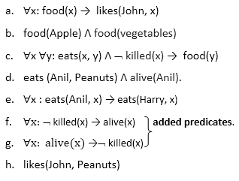
Step-2: Conversion of FOL into CNF
In First order logic resolution, it is required to convert the FOL into CNF as CNF form makes easier for resolution proofs.
- Eliminate all implication (→) and rewrite
  - ∀x ¬ food(x) V likes(John, x)
  - food(Apple) Λ food(vegetables)
  - ∀x ∀y ¬ [eats(x, y) Λ ¬ killed(x)] V food(y)
  - eats (Anil, Peanuts) Λ alive(Anil)
  - ∀x ¬ eats(Anil, x) V eats(Harry, x)
  - ∀x¬ [¬ killed(x) ] V alive(x)
  - ∀x ¬ alive(x) V ¬ killed(x)
  - likes(John, Peanuts).
- Move negation (¬)inwards and rewrite
  - ∀x ¬ food(x) V likes(John, x)
  - food(Apple) Λ food(vegetables)
  - ∀x ∀y ¬ eats(x, y) V killed(x) V food(y)
  - eats (Anil, Peanuts) Λ alive(Anil)
  - ∀x ¬ eats(Anil, x) V eats(Harry, x)
  - ∀x ¬killed(x) ] V alive(x)
  - ∀x ¬ alive(x) V ¬ killed(x)
  - likes(John, Peanuts).
- Rename variables or standardize variables
  - ∀x ¬ food(x) V likes(John, x)
  - food(Apple) Λ food(vegetables)
  - ∀y ¬ eats(y, f(y)) V killed(y) V food(F(y))
  - eats (Anil, Peanuts) Λ alive(Anil)
  - ∀w¬ eats(Anil, w) V eats(Harry, w)
  - ∀g ¬killed(g) ] V alive(g)
  - ∀k ¬ alive(k) V ¬ killed(k)
  - likes(John, Peanuts).
- Eliminate existential instantiation quantifier by elimination.
In this step, we will eliminate existential quantifier ∃, and this process is known as Skolemization. But in this example problem since there is no existential quantifier so all the statements will remain same in this step.
- Drop Universal quantifiers.
In this step we will drop all universal quantifier since all the statements are not implicitly quantified so we don't need it.
  - ¬ food(x) V likes(John, x)
  - food(Apple)
  - food(vegetables)
  - ¬ eats(y, z) V killed(y) V food(z)
  - eats (Anil, Peanuts)
  - alive(Anil)
  - ¬ eats(Anil, w) V eats(Harry, w)
  - killed(g) V alive(g)
  - ¬ alive(k) V ¬ killed(k)
  - likes(John, Peanuts).

Note: Statements "food(Apple) Λ food(vegetables)" and "eats (Anil, Peanuts) Λ alive(Anil)" can be written in two separate statements.
- Distribute conjunction ∧ over disjunction ¬.
This step will not make any change in this problem.
Step-3: Negate the statement to be proved
In this statement, we will apply negation to the conclusion statements, which will be written as ¬likes(John, Peanuts)
Step-4: Draw Resolution graph:
Now in this step, we will solve the problem by resolution tree using substitution. For the above problem, it will be given as follows:
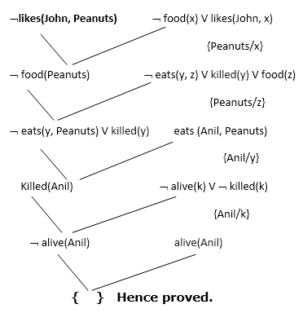

Hence the negation of the conclusion has been proved as a complete contradiction with the given set of statements.

Explanation of Resolution graph:
- In the first step of resolution graph, ¬likes(John, Peanuts) , and likes(John, x) get resolved(canceled) by substitution of {Peanuts/x}, and we are left with ¬ food(Peanuts)
- In the second step of the resolution graph, ¬ food(Peanuts) , and food(z) get resolved (canceled) by substitution of { Peanuts/z}, and we are left with ¬ eats(y, Peanuts) V killed(y) .
- In the third step of the resolution graph, ¬ eats(y, Peanuts) and eats (Anil, Peanuts) get resolved by substitution {Anil/y}, and we are left with Killed(Anil) .
- In the fourth step of the resolution graph, Killed(Anil) and ¬ killed(k) get resolve by substitution {Anil/k}, and we are left with ¬ alive(Anil) .
- In the last step of the resolution graph ¬ alive(Anil) and alive(Anil) get resolved.

What is Unification?
- Unification is a process of making two different logical atomic expressions identical by finding a substitution. Unification depends on the substitution process.
- It takes two literals as input and makes them identical using substitution.
- Let Ψ₁ and Ψ₂ be two atomic sentences and 𝜎 be a unifier such that, Ψ₁𝜎 = Ψ₂𝜎, then it can be expressed as UNIFY(Ψ₁, Ψ₂).
- Example: Find the MGU for Unify{King(x), King(John)}
Let Ψ₁ = King(x), Ψ₂ = King(John),
Substitution θ = {John/x} is a unifier for these atoms and applying this substitution, and both expressions will be identical.
- The UNIFY algorithm is used for unification, which takes two atomic sentences and returns a unifier for those sentences (If any exist).
- Unification is a key component of all first-order inference algorithms.
- It returns fail if the expressions do not match with each other.
- The substitution variables are called Most General Unifier or MGU.
E.g. Let's say there are two different expressions, P(x, y), and P(a, f(z)).
In this example, we need to make both above statements identical to each other. For this, we will perform the substitution.
P(x, y)......... (i)
P(a, f(z))......... (ii)
- Substitute x with a, and y with f(z) in the first expression, and it will be represented as a/x and f(z)/y.
- With both the substitutions, the first expression will be identical to the second expression and the substitution set will be: [a/x, f(z)/y].

Conditions for Unification:
Following are some basic conditions for unification:
- Predicate symbol must be same, atoms or expression with different predicate symbol can never be unified.
- Number of Arguments in both expressions must be identical.
- Unification will fail if there are two similar variables present in the same expression.

Unification Algorithm:
Algorithm: Unify(Ψ₁, Ψ₂)
Step. 1: If Ψ₁ or Ψ₂ is a variable or constant, then:
a) If Ψ₁ or Ψ₂ are identical, then return NIL.
b) Else if Ψ₁is a variable,
a. then if Ψ₁ occurs in Ψ₂, then return FAILURE
b. Else return { (Ψ₂/ Ψ₁)}.
c) Else if Ψ₂ is a variable,
a. If Ψ₂ occurs in Ψ₁ then return FAILURE,
b. Else return {( Ψ₁/ Ψ₂)}.
d) Else return FAILURE.
Step.2: If the initial Predicate symbol in Ψ₁ and Ψ₂ are not same, then return FAILURE.
Step. 3: IF Ψ₁ and Ψ₂ have a different number of arguments, then return FAILURE.
Step. 4: Set Substitution set(SUBST) to NIL.
Step. 5: For i=1 to the number of elements in Ψ₁.
a) Call Unify function with the ith element of Ψ₁ and ith element of Ψ₂, and put the result into S.
b) If S = failure then returns Failure
c) If S ≠ NIL then do,
a. Apply S to the remainder of both L1 and L2.
b. SUBST= APPEND(S, SUBST).
Step.6: Return SUBST.

Implementation of the Algorithm
Step.1: Initialize the substitution set to be empty.
Step.2: Recursively unify atomic sentences:
- Check for Identical expression match.
- If one expression is a variable v_{i}, and the other is a term t_{i} which does not contain variable v_{i}, then:
  - Substitute t_{i} / v_{i} in the existing substitutions
  - Add t_{i} /v_{i} to the substitution setlist.
  - If both the expressions are functions, then function name must be similar, and the number of arguments must be the same in both the expression.
For each pair of the following atomic sentences find the most general unifier (If exist).
1. Find the MGU of {p(f(a), g(Y)) and p(X, X)}
Sol: S₀ => Here, Ψ₁ = p(f(a), g(Y)), and Ψ₂ = p(X, X)
SUBST θ= {f(a) / X}
S1 => Ψ₁ = p(f(a), g(Y)), and Ψ₂ = p(f(a), f(a))
SUBST θ= {f(a) / g(y)}, Unification failed.
Unification is not possible for these expressions.
2. Find the MGU of {p(b, X, f(g(Z))) and p(Z, f(Y), f(Y))}
Here, Ψ₁ = p(b, X, f(g(Z))) , and Ψ₂ = p(Z, f(Y), f(Y))
S₀ => { p(b, X, f(g(Z))); p(Z, f(Y), f(Y))}
SUBST θ={b/Z}
S₁ => { p(b, X, f(g(b))); p(b, f(Y), f(Y))}
SUBST θ={f(Y) /X}
S₂ => { p(b, f(Y), f(g(b))); p(b, f(Y), f(Y))}
SUBST θ= {g(b) /Y}
S₂ => { p(b, f(g(b)), f(g(b)); p(b, f(g(b)), f(g(b))} Unified Successfully.
And Unifier = { b/Z, f(Y) /X , g(b) /Y}.
3. Find the MGU of {p (X, X), and p (Z, f(Z))}
Here, Ψ₁ = {p (X, X), and Ψ₂ = p (Z, f(Z))
S₀ => {p (X, X), p (Z, f(Z))}
SUBST θ= {X/Z}
S1 => {p (Z, Z), p (Z, f(Z))}
SUBST θ= {f(Z) / Z}, Unification Failed.
Hence, unification is not possible for these expressions.
4. Find the MGU of UNIFY(prime (11), prime(y))
Here, Ψ₁ = {prime(11) , and Ψ₂ = prime(y)}
S₀ => {prime(11) , prime(y)}
SUBST θ= {11/y}
S₁ => {prime(11) , prime(11)} , Successfully unified.
Unifier: {11/y}.
5. Find the MGU of Q(a, g(x, a), f(y)), Q(a, g(f(b), a), x)}
Here, Ψ₁ = Q(a, g(x, a), f(y)), and Ψ₂ = Q(a, g(f(b), a), x)
S₀ => {Q(a, g(x, a), f(y)); Q(a, g(f(b), a), x)}
SUBST θ= {f(b)/x}
S₁ => {Q(a, g(f(b), a), f(y)); Q(a, g(f(b), a), f(b))}
SUBST θ= {b/y}
S₁ => {Q(a, g(f(b), a), f(b)); Q(a, g(f(b), a), f(b))}, Successfully Unified.
Unifier: [a/a, f(b)/x, b/y].
6. UNIFY(knows(Richard, x), knows(Richard, John))
Here, Ψ₁ = knows(Richard, x), and Ψ₂ = knows(Richard, John)
S₀ => { knows(Richard, x); knows(Richard, John)}
SUBST θ= {John/x}
S₁ => { knows(Richard, John); knows(Richard, John)}, Successfully Unified.
Unifier: {John/x}.

Bayes' theorem:
Bayes' theorem is also known as Bayes' rule, Bayes' law, or Bayesian reasoning, which determines the probability of an event with uncertain knowledge.
In probability theory, it relates the conditional probability and marginal probabilities of two random events.
Bayes' theorem was named after the British mathematician Thomas Bayes. The Bayesian inference is an application of Bayes' theorem, which is fundamental to Bayesian statistics.
It is a way to calculate the value of P(B|A) with the knowledge of P(A|B).
Bayes' theorem allows updating the probability prediction of an event by observing new information of the real world.
Example: If cancer corresponds to one's age then by using Bayes' theorem, we can determine the probability of cancer more accurately with the help of age.
Bayes' theorem can be derived using product rule and conditional probability of event A with known event B:
As from product rule we can write:
- P(A ⋀ B)= P(A|B) P(B) or
Similarly, the probability of event B with known event A:
- P(A ⋀ B)= P(B|A) P(A)
Equating right hand side of both the equations, we will get:
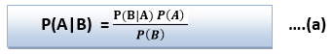
The above equation (a) is called as Bayes' rule or Bayes' theorem. This equation is basic of most modern AI systems for probabilistic inference.
It shows the simple relationship between joint and conditional probabilities. Here,
P(A|B) is known as posterior, which we need to calculate, and it will be read as Probability of hypothesis A when we have occurred an evidence B.
P(B|A) is called the likelihood, in which we consider that hypothesis is true, then we calculate the probability of evidence.
P(A) is called the prior probability, probability of hypothesis before considering the evidence
P(B) is called marginal probability, pure probability of an evidence.
In the equation (a), in general, we can write P (B) = P(A)*P(B|Ai), hence the Bayes' rule can be written as:
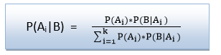
Where A₁, A₂, A₃,........, A_{n} is a set of mutually exclusive and exhaustive events.

Applying Bayes' rule:
Bayes' rule allows us to compute the single term P(B|A) in terms of P(A|B), P(B), and P(A). This is very useful in cases where we have a good probability of these three terms and want to determine the fourth one. Suppose we want to perceive the effect of some unknown cause, and want to compute that cause, then the Bayes' rule becomes:

Example-1:
Question: what is the probability that a patient has diseases meningitis with a stiff neck?
Given Data:
A doctor is aware that disease meningitis causes a patient to have a stiff neck, and it occurs 80% of the time. He is also aware of some more facts, which are given as follows:
- The Known probability that a patient has meningitis disease is 1/30,000.
- The Known probability that a patient has a stiff neck is 2%.
Let a be the proposition that patient has stiff neck and b be the proposition that patient has meningitis. , so we can calculate the following as:
P(a|b) = 0.8
P(b) = 1/30000
P(a)= .02
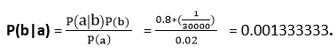
Hence, we can assume that 1 patient out of 750 patients has meningitis disease with a stiff neck.
Example-2:
Question: From a standard deck of playing cards, a single card is drawn. The probability that the card is king is 4/52, then calculate posterior probability P(King|Face), which means the drawn face card is a king card.
Solution:
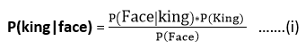
P(king): probability that the card is King= 4/52= 1/13
P(face): probability that a card is a face card= 3/13
P(Face|King): probability of face card when we assume it is a king = 1
Putting all values in equation (i) we will get:
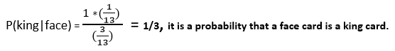

Application of Bayes' theorem in Artificial intelligence:
Following are some applications of Bayes' theorem:
- It is used to calculate the next step of the robot when the already executed step is given.
- Bayes' theorem is helpful in weather forecasting.
- It can solve the Monty Hall problem.

Bayesian Belief Network in artificial intelligence
Bayesian belief network is key computer technology for dealing with probabilistic events and to solve a problem which has uncertainty. We can define a Bayesian network as:
"A Bayesian network is a probabilistic graphical model which represents a set of variables and their conditional dependencies using a directed acyclic graph."
It is also called a Bayes network, belief network, decision network, or Bayesian model.
Bayesian networks are probabilistic, because these networks are built from a probability distribution, and also use probability theory for prediction and anomaly detection.
Real world applications are probabilistic in nature, and to represent the relationship between multiple events, we need a Bayesian network. It can also be used in various tasks including prediction, anomaly detection, diagnostics, automated insight, reasoning, time series prediction, and decision making under uncertainty.
Bayesian Network can be used for building models from data and experts opinions, and it consists of two parts:
- Directed Acyclic Graph
- Table of conditional probabilities.
The generalized form of Bayesian network that represents and solve decision problems under uncertain knowledge is known as an Influence diagram.
A Bayesian network graph is made up of nodes and Arcs (directed links), where:
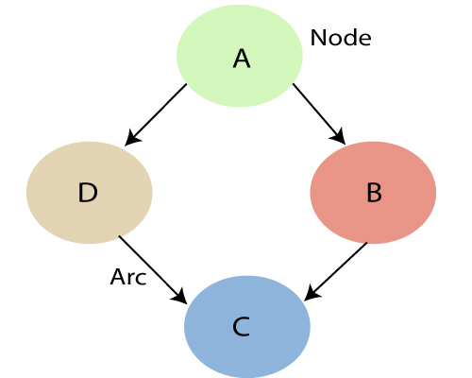
- Each node corresponds to the random variables, and a variable can be continuous or discrete.
- Arc or directed arrows represent the causal relationship or conditional probabilities between random variables. These directed links or arrows connect the pair of nodes in the graph.
These links represent that one node directly influence the other node, and if there is no directed link that means that nodes are independent with each other
  - In the above diagram, A, B, C, and D are random variables represented by the nodes of the network graph.
  - If we are considering node B, which is connected with node A by a directed arrow, then node A is called the parent of Node B.
  - Node C is independent of node A.
The Bayesian network has mainly two components:
- Causal Component
- Actual numbers
Each node in the Bayesian network has condition probability distribution P(X_{i} |Parent(X_{i}) ), which determines the effect of the parent on that node.
Bayesian network is based on Joint probability distribution and conditional probability. So let's first understand the joint probability distribution:

Joint probability distribution:
If we have variables x1, x2, x3,....., xn, then the probabilities of a different combination of x1, x2, x3.. xn, are known as Joint probability distribution.
P[x₁, x₂, x₃,....., x_{n}], it can be written as the following way in terms of the joint probability distribution.
= P[x₁| x₂, x₃,....., x_{n}]P[x₂, x₃,....., x_{n}]
= P[x₁| x₂, x₃,....., x_{n}]P[x₂|x₃,....., x_{n}]....P[x_{n-1}|x_{n}]P[x_{n}].
In general for each variable Xi, we can write the equation as:
P(X_{i}|X_{i-1},........., X₁) = P(X_{i} |Parents(X_{i} ))

Explanation of Bayesian network:
Let's understand the Bayesian network through an example by creating a directed acyclic graph:
Example: Harry installed a new burglar alarm at his home to detect burglary. The alarm reliably responds at detecting a burglary but also responds for minor earthquakes. Harry has two neighbors David and Sophia, who have taken a responsibility to inform Harry at work when they hear the alarm. David always calls Harry when he hears the alarm, but sometimes he got confused with the phone ringing and calls at that time too. On the other hand, Sophia likes to listen to high music, so sometimes she misses to hear the alarm. Here we would like to compute the probability of Burglary Alarm.
Problem:
Calculate the probability that alarm has sounded, but there is neither a burglary, nor an earthquake occurred, and David and Sophia both called the Harry.
Solution:
- The Bayesian network for the above problem is given below. The network structure is showing that burglary and earthquake is the parent node of the alarm and directly affecting the probability of alarm's going off, but David and Sophia's calls depend on alarm probability.
- The network is representing that our assumptions do not directly perceive the burglary and also do not notice the minor earthquake, and they also not confer before calling.
- The conditional distributions for each node are given as conditional probabilities table or CPT.
- Each row in the CPT must be sum to 1 because all the entries in the table represent an exhaustive set of cases for the variable.
- In CPT, a boolean variable with k boolean parents contains 2^{K} probabilities. Hence, if there are two parents, then CPT will contain 4 probability values

List of all events occurring in this network:
- Burglary (B)
- Earthquake(E)
- Alarm(A)
- David Calls(D)
- Sophia calls(S)
We can write the events of problem statement in the form of probability: P[D, S, A, B, E], can rewrite the above probability statement using joint probability distribution:
P[D, S, A, B, E]= P[D | S, A, B, E]. P[S, A, B, E]
=P[D | S, A, B, E]. P[S | A, B, E]. P[A, B, E]
= P [D| A]. P [ S| A, B, E]. P[ A, B, E]
= P[D | A]. P[ S | A]. P[A| B, E]. P[B, E]
= P[D | A ]. P[S | A]. P[A| B, E]. P[B |E]. P[E]
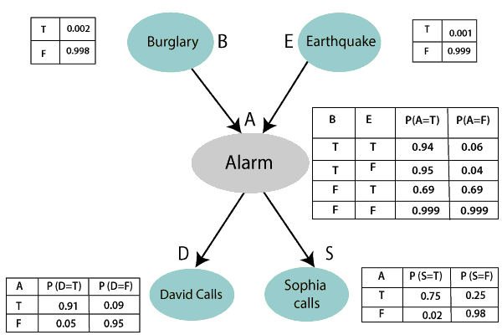
Let's take the observed probability for the Burglary and earthquake component:
P(B= True) = 0.002, which is the probability of burglary.
P(B= False)= 0.998, which is the probability of no burglary.
P(E= True)= 0.001, which is the probability of a minor earthquake
P(E= False)= 0.999, Which is the probability that an earthquake not occurred.
We can provide the conditional probabilities as per the below tables:
Conditional probability table for Alarm A:
The Conditional probability of Alarm A depends on Burglar and earthquake:
B | E | P(A= True) | P(A= False)
True | True | 0.94 | 0.06
True | False | 0.95 | 0.04
False | True | 0.31 | 0.69
False | False | 0.001 | 0.999
Conditional probability table for David Calls:
The Conditional probability of David that he will call depends on the probability of Alarm.
A | P(D= True) | P(D= False)
True | 0.91 | 0.09
False | 0.05 | 0.95
Conditional probability table for Sophia Calls:
The Conditional probability of Sophia that she calls is depending on its Parent Node "Alarm."
A | P(S= True) | P(S= False)
True | 0.75 | 0.25
False | 0.02 | 0.98
From the formula of joint distribution, we can write the problem statement in the form of probability distribution:
P(S, D, A, ¬B, ¬E) = P (S|A) *P (D|A)*P (A|¬B ^ ¬E) *P (¬B) *P (¬E).
= 0.75* 0.91* 0.001* 0.998*0.999
= 0.00068045.
Hence, a Bayesian network can answer any query about the domain by using Joint distribution.
The semantics of Bayesian Network:
There are two ways to understand the semantics of the Bayesian network, which is given below:
1. To understand the network as the representation of the Joint probability distribution.
It is helpful to understand how to construct the network.
2. To understand the network as an encoding of a collection of conditional independence statements.
It is helpful in designing inference procedure.

Questions
  - What are Bayesian Networks?
  - What is knowledge representation in AI?
  - What are the various techniques of knowledge representation in AI?
  - What is the inference engine, and why it is used in AI?
  - What do you understand by the fuzzy logic?

Unit-5
Learning
Objective: Students will be able to learn different forms of learning.
What is learning?
- According to Herbert Simon, learning denotes changes in a system that enable a system to do the same task more efficiently the next time.
- Arthur Samuel stated that, "Machine learning is the subfield of computer science, that gives computers the ability to learn without being explicitly programmed ".
- In 1997, Mitchell proposed that, " A computer program is said to learn from experience 'E' with respect to some class of tasks 'T' and performance measure 'P', if its performance at tasks in 'T', as measured by 'P', improves with experience E ".
- The main purpose of machine learning is to study and design the algorithms that can be used to produce the predicates from the given dataset.
- Besides these, the machine learning includes the agents percepts for acting as well as to improve their future performance.
The following tasks must be learned by an agent.
- To predict or decide the result state for an action.
- To know the values for each state(understand which state has high or low vale).
- To keep record of relevant percepts.
Why do we require machine learning?
- Machine learning plays an important role in improving and understanding the efficiency of human learning.
- Machine learning is used to discover a new things not known to many human beings.
Various forms of learnings are explained below:
1. Rote learning
- Rote learning is possible on the basis of memorization.
- This technique mainly focuses on memorization by avoiding the inner complexities. So, it becomes possible for the learner to recall the stored knowledge.
For example: When a learner learns a poem or song by reciting or repeating it, without knowing the actual meaning of the poem or song.
2. Induction learning (Learning by example).
- Induction learning is carried out on the basis of supervised learning.
- In this learning process, a general rule is induced by the system from a set of observed instance.
- However, class definitions can be constructed with the help of a classification method.
For Example:
Consider that 'ƒ' is the target function and example is a pair (x ƒ(x)), where 'x' is input and ƒ(x) is the output function applied to 'x'.
Given problem: Find hypothesis h such as h ≈ ƒ

- So, in the following fig-a, points (x,y) are given in plane so that y = ƒ(x), and the task is to find a function h(x) that fits the point well.
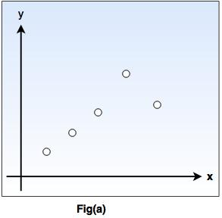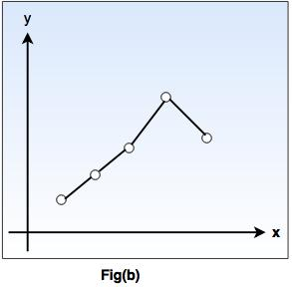
- In fig-b, a piecewise-linear 'h' function is given, while the fig-c shows more complicated 'h' function.
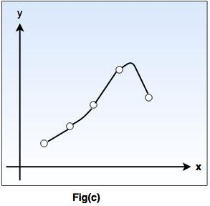
- Both the functions agree with the example points, but differ with the values of 'y' assigned to other x inputs.
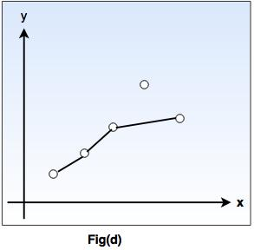
- As shown in fig.(d), we have a function that apparently ignores one of the example points, but fits others with a simple function. The true/ is unknown, so there are many choices for h, but without further knowledge, we have no way to prefer (b), (c), or (d).
3. Learning by taking advice
- This type is the easiest and simple way of learning.
- In this type of learning, a programmer writes a program to give some instructions to perform a task to the computer. Once it is learned (i.e. programmed), the system will be able to do new things.
- Also, there can be several sources for taking advice such as humans(experts), internet etc.
- However, this type of learning has a more necessity of inference than rote learning.
- As the stored knowledge in knowledge base gets transformed into an operational form, the reliability of the knowledge source is always taken into consideration.

Supervised Machine Learning
Supervised learning is the types of machine learning in which machines are trained using well "labelled" training data, and on basis of that data, machines predict the output. The labelled data means some input data is already tagged with the correct output.
In supervised learning, the training data provided to the machines work as the supervisor that teaches the machines to predict the output correctly. It applies the same concept as a student learns in the supervision of the teacher.
Supervised learning is a process of providing input data as well as correct output data to the machine learning model. The aim of a supervised learning algorithm is to find a mapping function to map the input variable(x) with the output variable(y).
In the real-world, supervised learning can be used for Risk Assessment, Image classification, Fraud Detection, spam filtering, etc.
Features of Java - Javatpoint

How Supervised Learning Works?
In supervised learning, models are trained using labelled dataset, where the model learns about each type of data. Once the training process is completed, the model is tested on the basis of test data (a subset of the training set), and then it predicts the output.
The working of Supervised learning can be easily understood by the below example and diagram:
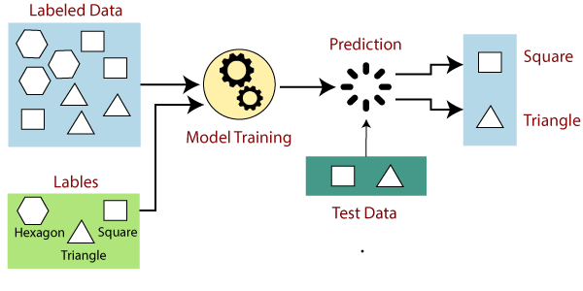
Suppose we have a dataset of different types of shapes which includes square, rectangle, triangle, and Polygon. Now the first step is that we need to train the model for each shape.
- If the given shape has four sides, and all the sides are equal, then it will be labelled as a Square.
- If the given shape has three sides, then it will be labelled as a triangle.
- If the given shape has six equal sides then it will be labelled as hexagon.
Now, after training, we test our model using the test set, and the task of the model is to identify the shape.
The machine is already trained on all types of shapes, and when it finds a new shape, it classifies the shape on the bases of a number of sides, and predicts the output.

Steps Involved in Supervised Learning:
- First Determine the type of training dataset
- Collect/Gather the labelled training data.
- Split the training dataset into training dataset, test dataset, and validation dataset.
- Determine the input features of the training dataset, which should have enough knowledge so that the model can accurately predict the output.
- Determine the suitable algorithm for the model, such as support vector machine, decision tree, etc.
- Execute the algorithm on the training dataset. Sometimes we need validation sets as the control parameters, which are the subset of training datasets.
- Evaluate the accuracy of the model by providing the test set. If the model predicts the correct output, which means our model is accurate.

Types of supervised Machine learning Algorithms:
Supervised learning can be further divided into two types of problems:
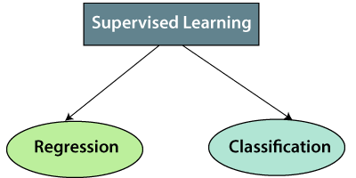
1. Regression
Regression algorithms are used if there is a relationship between the input variable and the output variable. It is used for the prediction of continuous variables, such as Weather forecasting, Market Trends, etc. Below are some popular Regression algorithms which come under supervised learning:
- Linear Regression
- Regression Trees
- Non-Linear Regression
- Bayesian Linear Regression
- Polynomial Regression
2. Classification
Classification algorithms are used when the output variable is categorical, which means there are two classes such as Yes-No, Male-Female, True-false, etc.
Spam Filtering,
- Random Forest
- Decision Trees
- Logistic Regression
- Support vector Machines

Note: We will discuss these algorithms in detail in later chapters.

Advantages of Supervised learning:
- With the help of supervised learning, the model can predict the output on the basis of prior experiences.
- In supervised learning, we can have an exact idea about the classes of objects.
- Supervised learning model helps us to solve various real-world problems such as fraud detection, spam filtering, etc.

Disadvantages of supervised learning:
- Supervised learning models are not suitable for handling the complex tasks.
- Supervised learning cannot predict the correct output if the test data is different from the training dataset.
- Training required lots of computation times.
- In supervised learning, we need enough knowledge about the classes of object.

Decision Tree Classification Algorithm
- Decision Tree is a Supervised learning technique that can be used for both classification and Regression problems, but mostly it is preferred for solving Classification problems. It is a tree-structured classifier, where internal nodes represent the features of a dataset, branches represent the decision rules and each leaf node represents the outcome.
- In a Decision tree, there are two nodes, which are the Decision Node and Leaf Node. Decision nodes are used to make any decision and have multiple branches, whereas Leaf nodes are the output of those decisions and do not contain any further branches.
- The decisions or the test are performed on the basis of features of the given dataset.
- It is a graphical representation for getting all the possible solutions to a problem/decision based on given conditions.
- It is called a decision tree because, similar to a tree, it starts with the root node, which expands on further branches and constructs a tree-like structure.
- In order to build a tree, we use the CART algorithm, which stands for Classification and Regression Tree algorithm.
- A decision tree simply asks a question, and based on the answer (Yes/No), it further split the tree into subtrees.
- Below diagram explains the general structure of a decision tree:

Note: A decision tree can contain categorical data (YES/NO) as well as numeric data.
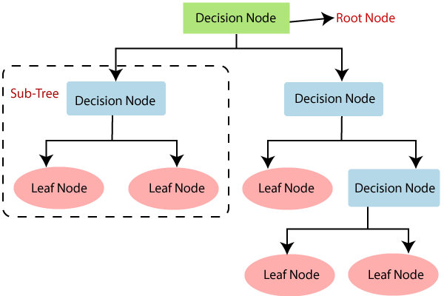

Why use Decision Trees?
There are various algorithms in Machine learning, so choosing the best algorithm for the given dataset and problem is the main point to remember while creating a machine learning model. Below are the two reasons for using the Decision tree:
- Decision Trees usually mimic human thinking ability while making a decision, so it is easy to understand.
- The logic behind the decision tree can be easily understood because it shows a tree-like structure.

Decision Tree Terminologies
• Root Node: Root node is from where the decision tree starts. It represents the entire dataset, which further gets divided into two or more homogeneous sets.
• Leaf Node: Leaf nodes are the final output node, and the tree cannot be segregated further after getting a leaf node.
• Splitting: Splitting is the process of dividing the decision node/root node into sub-nodes according to the given conditions.
• Branch/Sub Tree: A tree formed by splitting the tree.
• Pruning: Pruning is the process of removing the unwanted branches from the tree.
• Parent/Child node: The root node of the tree is called the parent node, and other nodes are called the child nodes.
How does the Decision Tree algorithm Work?
In a decision tree, for predicting the class of the given dataset, the algorithm starts from the root node of the tree. This algorithm compares the values of root attribute with the record (real dataset) attribute and, based on the comparison, follows the branch and jumps to the next node.
For the next node, the algorithm again compares the attribute value with the other sub-nodes and move further. It continues the process until it reaches the leaf node of the tree. The complete process can be better understood using the below algorithm:
4
- Step-1: Begin the tree with the root node, says S, which contains the complete dataset.
- Step-2: Find the best attribute in the dataset using Attribute Selection Measure (ASM).
- Step-3: Divide the S into subsets that contains possible values for the best attributes.
- Step-4: Generate the decision tree node, which contains the best attribute.
- Step-5: Recursively make new decision trees using the subsets of the dataset created in step -3. Continue this process until a stage is reached where you cannot further classify the nodes and called the final node as a leaf node.
Example: Suppose there is a candidate who has a job offer and wants to decide whether he should accept the offer or Not. So, to solve this problem, the decision tree starts with the root node (Salary attribute by ASM). The root node splits further into the next decision node (distance from the office) and one leaf node based on the corresponding labels. The next decision node further gets split into one decision node (Cab facility) and one leaf node. Finally, the decision node splits into two leaf nodes (Accepted offers and Declined offer). Consider the below diagram:
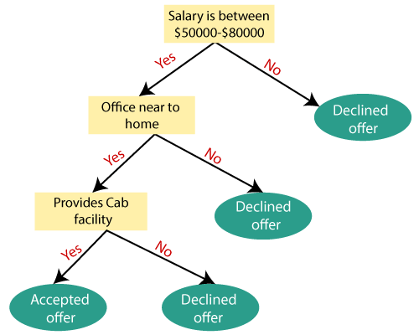

Attribute Selection Measures
While implementing a Decision tree, the main issue arises that how to select the best attribute for the root node and for sub-nodes. So, to solve such problems there is a technique which is called as Attribute selection measure or ASM. By this measurement, we can easily select the best attribute for the nodes of the tree. There are two popular techniques for ASM, which are:
- Information Gain
- Gini Index

1. Information Gain:
- Information gain is the measurement of changes in entropy after the segmentation of a dataset based on an attribute.
- It calculates how much information a feature provides us about a class.
- According to the value of information gain, we split the node and build the decision tree.
- A decision tree algorithm always tries to maximize the value of information gain, and a node/attribute having the highest information gain is split first. It can be calculated using the below formula:
- Information Gain= Entropy(S)- [(Weighted Avg) *Entropy(each feature)
Entropy: Entropy is a metric to measure the impurity in a given attribute. It specifies randomness in data. Entropy can be calculated as:
Entropy(s)= -P(yes)log2 P(yes)- P(no) log2 P(no)
Where,
- S= Total number of samples
- P(yes)= probability of yes
- P(no)= probability of no

2. Gini Index:
- Gini index is a measure of impurity or purity used while creating a decision tree in the CART(Classification and Regression Tree) algorithm.
- An attribute with the low Gini index should be preferred as compared to the high Gini index.
- It only creates binary splits, and the CART algorithm uses the Gini index to create binary splits.
- Gini index can be calculated using the below formula:
Gini Index= 1- ∑_{j}P_{j}²

Pruning: Getting an Optimal Decision tree
Pruning is a process of deleting the unnecessary nodes from a tree in order to get the optimal decision tree.
A too-large tree increases the risk of overfitting, and a small tree may not capture all the important features of the dataset. Therefore, a technique that decreases the size of the learning tree without reducing accuracy is known as Pruning. There are mainly two types of tree pruning technology used:
- Cost Complexity Pruning
- Reduced Error Pruning.

Advantages of the Decision Tree
- It is simple to understand as it follows the same process which a human follow while making any decision in real-life.
- It can be very useful for solving decision-related problems.
- It helps to think about all the possible outcomes for a problem.
- There is less requirement of data cleaning compared to other algorithms.

Disadvantages of the Decision Tree
- The decision tree contains lots of layers, which makes it complex.
- It may have an overfitting issue, which can be resolved using the Random Forest algorithm.
- For more class labels, the computational complexity of the decision tree may increase.

Support Vector Machine Algorithm
Support Vector Machine or SVM is one of the most popular Supervised Learning algorithms, which is used for Classification as well as Regression problems. However, primarily, it is used for Classification problems in Machine Learning.
The goal of the SVM algorithm is to create the best line or decision boundary that can segregate n-dimensional space into classes so that we can easily put the new data point in the correct category in the future. This best decision boundary is called a hyperplane.
SVM chooses the extreme points/vectors that help in creating the hyperplane. These extreme cases are called as support vectors, and hence algorithm is termed as Support Vector Machine. Consider the below diagram in which there are two different categories that are classified using a decision boundary or hyperplane:
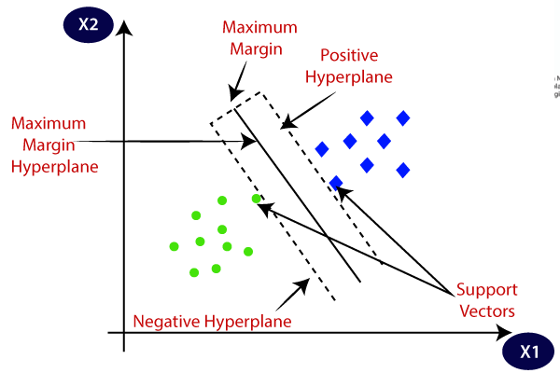
Example: SVM can be understood with the example that we have used in the KNN classifier. Suppose we see a strange cat that also has some features of dogs, so if we want a model that can accurately identify whether it is a cat or dog, so such a model can be created by using the SVM algorithm. We will first train our model with lots of images of cats and dogs so that it can learn about different features of cats and dogs, and then we test it with this strange creature. So as support vector creates a decision boundary between these two data (cat and dog) and choose extreme cases (support vectors), it will see the extreme case of cat and dog. On the basis of the support vectors, it will classify it as a cat. Consider the below diagram:
3
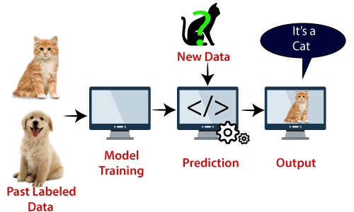
SVM algorithm can be used for Face detection, image classification, text categorization, etc.

Types of SVM
SVM can be of two types:
- Linear SVM: Linear SVM is used for linearly separable data, which means if a dataset can be classified into two classes by using a single straight line, then such data is termed as linearly separable data, and classifier is used called as Linear SVM classifier.
- Non-linear SVM: Non-Linear SVM is used for non-linearly separated data, which means if a dataset cannot be classified by using a straight line, then such data is termed as non-linear data and classifier used is called as Non-linear SVM classifier.

Hyperplane and Support Vectors in the SVM algorithm:
Hyperplane: There can be multiple lines/decision boundaries to segregate the classes in n-dimensional space, but we need to find out the best decision boundary that helps to classify the data points. This best boundary is known as the hyperplane of SVM.
The dimensions of the hyperplane depend on the features present in the dataset, which means if there are 2 features (as shown in image), then hyperplane will be a straight line. And if there are 3 features, then hyperplane will be a 2-dimension plane.
We always create a hyperplane that has a maximum margin, which means the maximum distance between the data points.
Support Vectors:
The data points or vectors that are the closest to the hyperplane and which affect the position of the hyperplane are termed as Support Vector. Since these vectors support the hyperplane, hence called a Support vector.

How does SVM works?
Linear SVM:
The working of the SVM algorithm can be understood by using an example. Suppose we have a dataset that has two tags (green and blue), and the dataset has two features x1 and x2. We want a classifier that can classify the pair(x1, x2) of coordinates in either green or blue. Consider the below image:
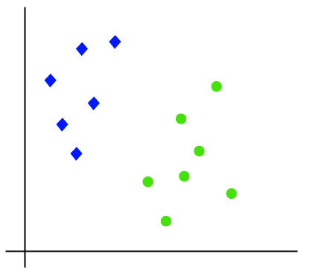
So as it is 2-d space so by just using a straight line, we can easily separate these two classes. But there can be multiple lines that can separate these classes. Consider the below image:
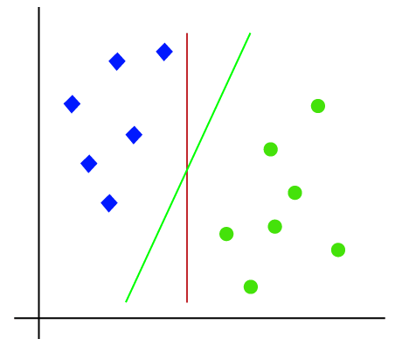
Hence, the SVM algorithm helps to find the best line or decision boundary; this best boundary or region is called as a hyperplane. SVM algorithm finds the closest point of the lines from both the classes. These points are called support vectors. The distance between the vectors and the hyperplane is called as margin. And the goal of SVM is to maximize this margin. The hyperplane with maximum margin is called the optimal hyperplane.
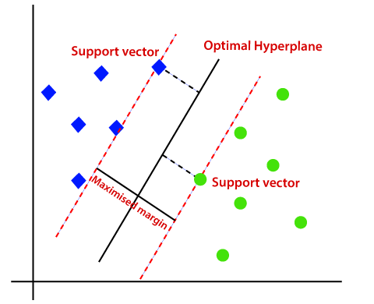
Non-Linear SVM:
If data is linearly arranged, then we can separate it by using a straight line, but for non-linear data, we cannot draw a single straight line. Consider the below image:
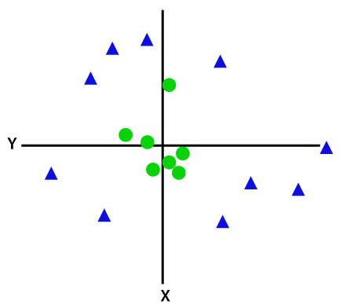
So to separate these data points, we need to add one more dimension. For linear data, we have used two dimensions x and y, so for non-linear data, we will add a third dimension z. It can be calculated as:
z=x² +y²
By adding the third dimension, the sample space will become as below image:
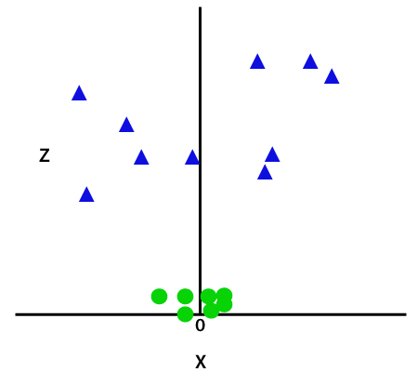
So now, SVM will divide the datasets into classes in the following way. Consider the below image:
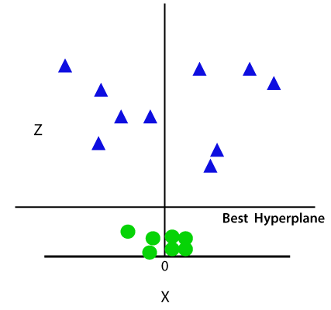
Since we are in 3-d Space, hence it is looking like a plane parallel to the x-axis. If we convert it in 2d space with z=1, then it will become as:
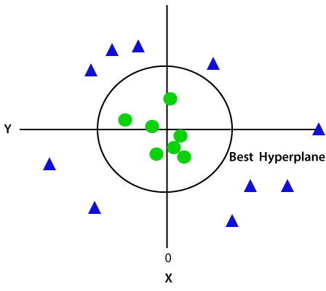
Hence we get a circumference of radius 1 in case of non-linear data.

Unsupervised Machine Learning
In the previous topic, we learned supervised machine learning in which models are trained using labeled data under the supervision of training data. But there may be many cases in which we do not have labeled data and need to find the hidden patterns from the given dataset. So, to solve such types of cases in machine learning, we need unsupervised learning techniques.

What is Unsupervised Learning?
As the name suggests, unsupervised learning is a machine learning technique in which models are not supervised using training dataset. Instead, models itself find the hidden patterns and insights from the given data. It can be compared to learning which takes place in the human brain while learning new things. It can be defined as:
Unsupervised learning is a type of machine learning in which models are trained using unlabeled dataset and are allowed to act on that data without any supervision.
Unsupervised learning cannot be directly applied to a regression or classification problem because unlike supervised learning, we have the input data but no corresponding output data. The goal of unsupervised learning is to find the underlying structure of dataset, group that data according to similarities, and represent that dataset in a compressed format.
Example: Suppose the unsupervised learning algorithm is given an input dataset containing images of different types of cats and dogs. The algorithm is never trained upon the given dataset, which means it does not have any idea about the features of the dataset. The task of the unsupervised learning algorithm is to identify the image features on their own. Unsupervised learning algorithm will perform this task by clustering the image dataset into the groups according to similarities between images.
C++ vs Java
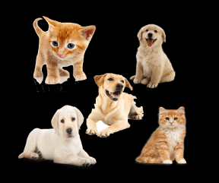

Why use Unsupervised Learning?
Below are some main reasons which describe the importance of Unsupervised Learning:
- Unsupervised learning is helpful for finding useful insights from the data.
- Unsupervised learning is much similar as a human learns to think by their own experiences, which makes it closer to the real AI.
- Unsupervised learning works on unlabeled and uncategorized data which make unsupervised learning more important.
- In real-world, we do not always have input data with the corresponding output so to solve such cases, we need unsupervised learning.

Working of Unsupervised Learning
Working of unsupervised learning can be understood by the below diagram:
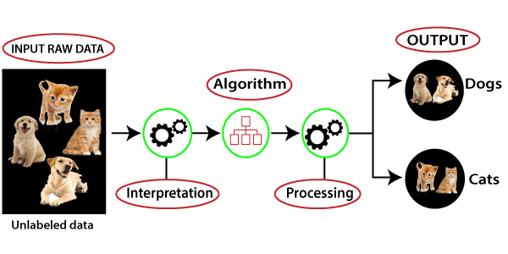
Here, we have taken an unlabeled input data, which means it is not categorized and corresponding outputs are also not given. Now, this unlabeled input data is fed to the machine learning model in order to train it. Firstly, it will interpret the raw data to find the hidden patterns from the data and then will apply suitable algorithms such as k-means clustering, Decision tree, etc.
Once it applies the suitable algorithm, the algorithm divides the data objects into groups according to the similarities and difference between the objects.

Types of Unsupervised Learning Algorithm:
The unsupervised learning algorithm can be further categorized into two types of problems:
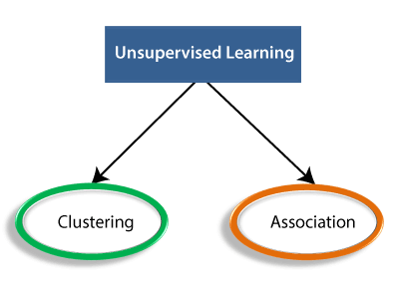
- Clustering: Clustering is a method of grouping the objects into clusters such that objects with most similarities remains into a group and has less or no similarities with the objects of another group. Cluster analysis finds the commonalities between the data objects and categorizes them as per the presence and absence of those commonalities.
- Association: An association rule is an unsupervised learning method which is used for finding the relationships between variables in the large database. It determines the set of items that occurs together in the dataset. Association rule makes marketing strategy more effective. Such as people who buy X item (suppose a bread) are also tend to purchase Y (Butter/Jam) item. A typical example of Association rule is Market Basket Analysis.

Note: We will learn these algorithms in later chapters.

Unsupervised Learning algorithms:
Below is the list of some popular unsupervised learning algorithms:
- K-means clustering
- KNN (k-nearest neighbors)
- Hierarchal clustering
- Anomaly detection
- Neural Networks
- Principle Component Analysis
- Independent Component Analysis
- Apriori algorithm
- Singular value decomposition

Advantages of Unsupervised Learning
- Unsupervised learning is used for more complex tasks as compared to supervised learning because, in unsupervised learning, we don't have labeled input data.
- Unsupervised learning is preferable as it is easy to get unlabeled data in comparison to labeled data.

Disadvantages of Unsupervised Learning
- Unsupervised learning is intrinsically more difficult than supervised learning as it does not have corresponding output.
- The result of the unsupervised learning algorithm might be less accurate as input data is not labeled, and algorithms do not know the exact output in advance.
Market Basket analysis
Market basket analysis a machine learning approach that attempts to find relationships among a group of items in a data set.
Association Rules
The heart of market basket analysis are association rules. Association rules explain patterns of relationship among items. Below is an example
{rice, seaweed} -> {soy sauce}
Everything in curly braces { } is an itemset, which is some form of data that occurs often in the dataset based on criteria. Rice and seaweed are our itemset on the left and soy sauce is our itemset on the right. The arrow -> indicates what comes first as we read from left to right. If we put this association rule in simple English it would say “if someone buys rice and seaweed then they will buy soy sauce”.
The practical application of this rule is to place rice, seaweed and soy sauce near each other in order to reinforce this rule when people come to shop.
The Algorithm
Market basket analysis uses an apriori algorithm. This algorithm is useful for unsupervised learning that does not require any training and thus no predictions. The Apriori algorithm is especially useful with large datasets but it employs simple procedures to find useful relationships among the items.
The shortcut that this algorithm uses is the “apriori property” which states that all suggsets of a frequent itemset must also be frequent. What this means in simple English is that the items in an itemset need to be common in the overall dataset. This simple rule saves a tremendous amount of computational time.
Support and Confidence
Two key pieces of information that can further refine the work of the Apriori algorithm is support and confidence. Support is a measure of the frequency of an itemset ranging from 0 (no support) to 1 (highest support). High support indicates the importance of the itemset in the data and contributes to the itemset being used to generate association rule(s).
Returning to our rice, seaweed, and soy sauce example. We can say that the support for soy sauce is 0.4. This means that soy sauce appears in 40% of the purchases in the dataset which is pretty high.
Confidence is a measure of the accuracy of an association rule which is measured from 0 to 1. The higher the confidence the more accurate the association rule. If we say that our rice, seaweed, and soy sauce rule has a confidence of 0.8 we are saying that when rice and seaweed are purchased together, 80% of the time soy sauce is purchased as well.
Support and confidence can be used to influence the apriori algorithm by setting cutoff values to be searched for. For example, if we set a minimum support of 0.5 and a confidence of 0.65 we are telling the computer to only report to us association rules that are above these cutoff points. This helps to remove useless rules that are obvious or useles
Market basket analysis is a useful tool for mining information from large datasets. The rules are easy to understanding. In addition, market basket analysis can be used in many fields beyond shopping and can include relationships within DNA, and other forms of human behavior. As such, care must be made so that unsound conclusions are not drawn from random patterns in the data

What are Artificial Neural Networks (ANNs)?
The inventor of the first neurocomputer, Dr. Robert Hecht-Nielsen, defines a neural network as −
"...a computing system made up of a number of simple, highly interconnected processing elements, which process information by their dynamic state response to external inputs.”

Basic Structure of ANNs
The idea of ANNs is based on the belief that working of human brain by making the right connections, can be imitated using silicon and wires as living neurons and dendrites.
The human brain is composed of 86 billion nerve cells called neurons. They are connected to other thousand cells by Axons. Stimuli from external environment or inputs from sensory organs are accepted by dendrites. These inputs create electric impulses, which quickly travel through the neural network. A neuron can then send the message to other neuron to handle the issue or does not send it forward.
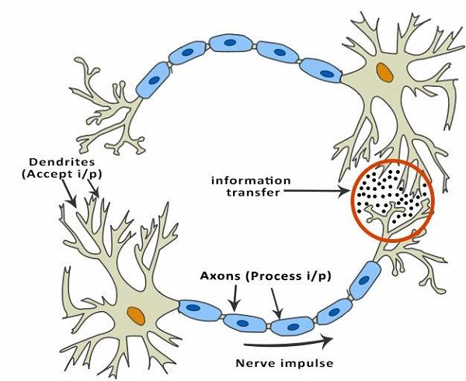
ANNs are composed of multiple nodes, which imitate biological neurons of human brain. The neurons are connected by links and they interact with each other. The nodes can take input data and perform simple operations on the data. The result of these operations is passed to other neurons. The output at each node is called its activation or node value.
Each link is associated with weight. ANNs are capable of learning, which takes place by altering weight values. The following illustration shows a simple ANN −
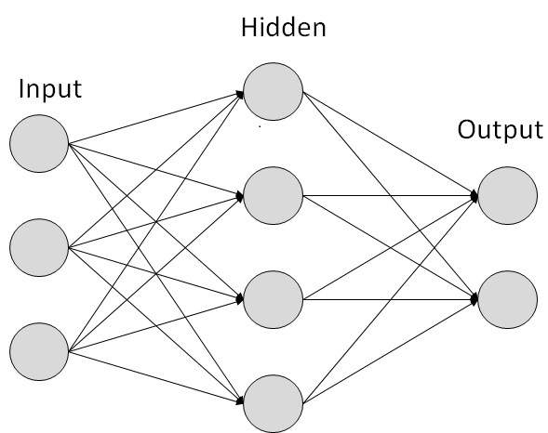

Types of Artificial Neural Networks
There are two Artificial Neural Network topologies − FeedForward and Feedback.

FeedForward ANN
In this ANN, the information flow is unidirectional. A unit sends information to other unit from which it does not receive any information. There are no feedback loops. They are used in pattern generation/recognition/classification. They have fixed inputs and outputs.
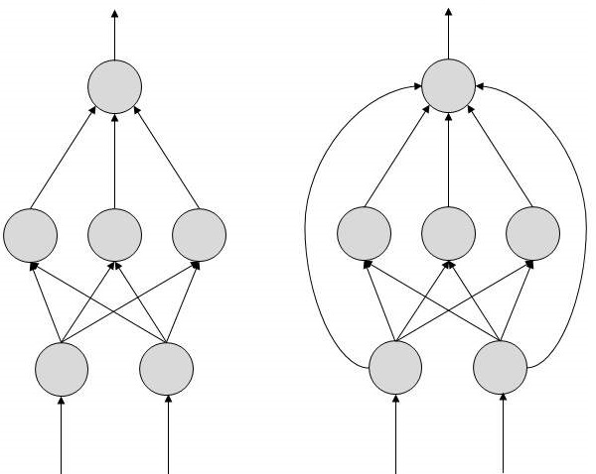

FeedBack ANN
Here, feedback loops are allowed. They are used in content addressable memories.
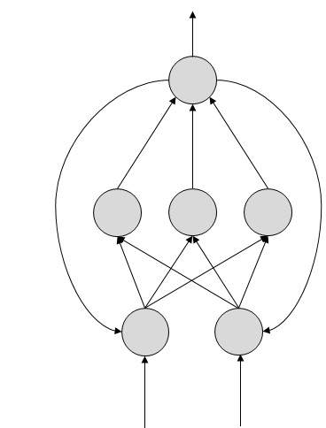

Working of ANNs
In the topology diagrams shown, each arrow represents a connection between two neurons and indicates the pathway for the flow of information. Each connection has a weight, an integer number that controls the signal between the two neurons.
If the network generates a “good or desired” output, there is no need to adjust the weights. However, if the network generates a “poor or undesired” output or an error, then the system alters the weights in order to improve subsequent results.

Machine Learning in ANNs
ANNs are capable of learning and they need to be trained. There are several learning strategies −
- Supervised Learning − It involves a teacher that is scholar than the ANN itself. For example, the teacher feeds some example data about which the teacher already knows the answers.
For example, pattern recognizing. The ANN comes up with guesses while recognizing. Then the teacher provides the ANN with the answers. The network then compares it guesses with the teacher’s “correct” answers and makes adjustments according to errors.
- Unsupervised Learning − It is required when there is no example data set with known answers. For example, searching for a hidden pattern. In this case, clustering i.e. dividing a set of elements into groups according to some unknown pattern is carried out based on the existing data sets present.
- Reinforcement Learning − This strategy built on observation. The ANN makes a decision by observing its environment. If the observation is negative, the network adjusts its weights to be able to make a different required decision the next time.

Questions
- Explain the term Q-learning.
- How is machine learning related to AI
- What is Markov's Decision process?
- What is an Artificial neural network? Name some commonly used Artificial Neural networks.
- What is reinforcement learning

Unit-6
Introduction to Natural Language Processing

What is NLP?
NLP stands for Natural Language Processing, which is a part of Computer Science, Human language, and Artificial Intelligence.
It is the technology that is used by machines to understand, analyse, manipulate, and interpret human's languages.
It helps developers to organize knowledge for performing tasks such as translation, automatic summarization, Named Entity Recognition (NER), speech recognition, relationship extraction, and topic segmentation.

Components of NLP
There are the following two components of NLP -
1. Natural Language Understanding (NLU)
Natural Language Understanding (NLU) helps the machine to understand and analyse human language by extracting the metadata from content such as concepts, entities, keywords, emotion, relations, and semantic roles.
NLU mainly used in Business applications to understand the customer's problem in both spoken and written language.
NLU involves the following tasks -
- It is used to map the given input into useful representation.
- It is used to analyze different aspects of the language.
2. Natural Language Generation (NLG)
- Natural Language Generation (NLG) acts as a translator that converts the computerized data into natural language representation. It mainly involves Text planning, Sentence planning, and Text Realization.

Applications of NLP
There are the following applications of NLP -
1. Question Answering
Question Answering focuses on building systems that automatically answer the questions asked by humans in a natural language.
Eg ALEXA

2. Spam Detection
Spam detection is used to detect unwanted e-mails getting to a user's inbox.
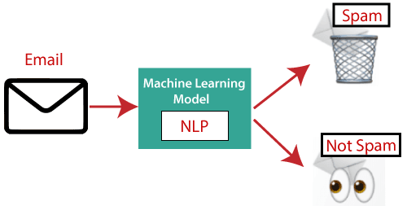
3. Sentiment Analysis
Sentiment Analysis is also known as opinion mining. It is used on the web to analyse the attitude, behaviour, and emotional state of the sender. This application is implemented through a combination of NLP (Natural Language Processing) and statistics by assigning the values to the text (positive, negative, or natural), identify the mood of the context (happy, sad, angry, etc.)
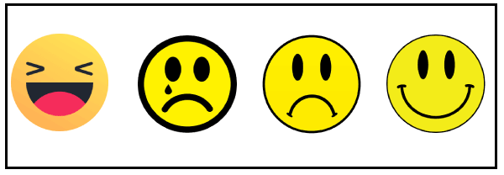
4. Machine Translation
Machine translation is used to translate text or speech from one natural language to another natural language.
Example: Google Translator
5. Spelling correction
Microsoft Corporation provides word processor software like MS-word, PowerPoint for the spelling correction.
6. Speech Recognition
Speech recognition is used for converting spoken words into text. It is used in applications, such as mobile, home automation, video recovery, dictating to Microsoft Word, voice biometrics, voice user interface, and so on.
7. Chatbot
Implementing the Chatbot is one of the important applications of NLP. It is used by many companies to provide the customer's chat services.
8. Information extraction
Information extraction is one of the most important applications of NLP. It is used for extracting structured information from unstructured or semi-structured machine-readable documents.
9. Natural Language Understanding (NLU)
It converts a large set of text into more formal representations such as first-order logic structures that are easier for the computer programs to manipulate notations of the natural language processing.

How to build an NLP pipeline
There are the following steps to build an NLP pipeline -
Step1: Sentence Segmentation
Sentence Segment is the first step for building the NLP pipeline. It breaks the paragraph into separate sentences.
Example: Consider the following paragraph -
Independence Day is one of the important festivals for every Indian citizen. It is celebrated on the 15th of August each year ever since India got independence from the British rule. The day celebrates independence in the true sense.
Sentence Segment produces the following result:
- "Independence Day is one of the important festivals for every Indian citizen."
- "It is celebrated on the 15th of August each year ever since India got independence from the British rule."
- "This day celebrates independence in the true sense."
Step2: Word Tokenization
Word Tokenizer is used to break the sentence into separate words or tokens.
Example:
Indiabix offers Corporate Training, Summer Training, Online Training, and Winter Training.
Word Tokenizer generates the following result:
"indiabix", "offers", "Corporate", "Training", "Summer", "Training", "Online", "Training", "and", "Winter", "Training", "."
Step3: Stemming
Stemming is used to normalize words into its base form or root form. For example, celebrates, celebrated and celebrating, all these words are originated with a single root word "celebrate." The big problem with stemming is that sometimes it produces the root word which may not have any meaning.
For Example, intelligence, intelligent, and intelligently, all these words are originated with a single root word "intelligen." In English, the word "intelligen" do not have any meaning.
Step 4: Lemmatization
Lemmatization is quite similar to the Stemming. It is used to group different inflected forms of the word, called Lemma. The main difference between Stemming and lemmatization is that it produces the root word, which has a meaning.
For example: In lemmatization, the words intelligence, intelligent, and intelligently has a root word intelligent, which has a meaning.
Step 5: Identifying Stop Words
In English, there are a lot of words that appear very frequently like "is", "and", "the", and "a". NLP pipelines will flag these words as stop words. Stop words might be filtered out before doing any statistical analysis.
Example: He is a good boy.

Note: When you are building a rock band search engine, then you do not ignore the word "The."
Step 6: Dependency Parsing
Dependency Parsing is used to find that how all the words in the sentence are related to each other.
Step 7: POS tags
POS stands for parts of speech, which includes Noun, verb, adverb, and Adjective. It indicates that how a word functions with its meaning as well as grammatically within the sentences. A word has one or more parts of speech based on the context in which it is used.
Example: "Google" something on the Internet.
In the above example, Google is used as a verb, although it is a proper noun.
Step 8: Named Entity Recognition (NER)
Named Entity Recognition (NER) is the process of detecting the named entity such as person name, movie name, organization name, or location.
Example: Steve Jobs introduced iPhone at the Macworld Conference in San Francisco, California.
Step 9: Chunking
Chunking is used to collect the individual piece of information and grouping them into bigger pieces of sentences.

What is an Expert System?
An expert system is a computer program that is designed to solve complex problems and to provide decision-making ability like a human expert. It performs this by extracting knowledge from its knowledge base using the reasoning and inference rules according to the user queries.
The expert system is a part of AI, and the first ES was developed in the year 1970, which was the first successful approach of artificial intelligence. It solves the most complex issue as an expert by extracting the knowledge stored in its knowledge base. The system helps in decision making for compsex problems using both facts and heuristics like a human expert. It is called so because it contains the expert knowledge of a specific domain and can solve any complex problem of that particular domain. These systems are designed for a specific domain, such as medicine, science, etc.
The performance of an expert system is based on the expert's knowledge stored in its knowledge base. The more knowledge stored in the KB, the more that system improves its performance. One of the common examples of an ES is a suggestion of spelling errors while typing in the Google search box.
The expert systems are the computer applications developed to solve complex problems in a particular domain, at the level of extra-ordinary human intelligence and expertise.

Characteristics of Expert Systems
- High performance
- Understandable
- Reliable
- Highly responsive

Capabilities of Expert Systems
The expert systems are capable of −
- Advising
- Instructing and assisting human in decision making
- Demonstrating
- Deriving a solution
- Diagnosing
- Explaining
- Interpreting input
- Predicting results
- Justifying the conclusion
- Suggesting alternative options to a problem
They are incapable of −
- Substituting human decision makers
- Possessing human capabilities
- Producing accurate output for inadequate knowledge base
- Refining their own knowledge
Below are some popular examples of the Expert System:
- DENDRAL: It was an artificial intelligence project that was made as a chemical analysis expert system. It was used in organic chemistry to detect unknown organic molecules with the help of their mass spectra and knowledge base of chemistry.
- MYCIN: It was one of the earliest backward chaining expert systems that was designed to find the bacteria causing infections like bacteraemia and meningitis. It was also used for the recommendation of antibiotics and the diagnosis of blood clotting diseases.
- PXDES: It is an expert system that is used to determine the type and level of lung cancer. To determine the disease, it takes a picture from the upper body, which looks like the shadow. This shadow identifies the type and degree of harm.
- CaDeT: The CaDet expert system is a diagnostic support system that can detect cancer at early stages.
Characteristics of Expert System
- High Performance: The expert system provides high performance for solving any type of complex problem of a specific domain with high efficiency and accuracy.
- Understandable: It responds in a way that can be easily understandable by the user. It can take input in human language and provides the output in the same way.
- Reliable: It is much reliable for generating an efficient and accurate output.
- Highly responsive: ES provides the result for any complex query within a very short period of time.
To recommend a solution, the Inference Engine uses the following strategies −
- Forward Chaining
- Backward Chaining
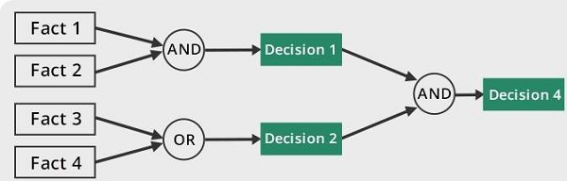

Forward Chaining
It is a strategy of an expert system to answer the question, “What can happen next?”
Here, the Inference Engine follows the chain of conditions and derivations and finally deduces the outcome. It considers all the facts and rules, and sorts them before concluding to a solution.
This strategy is followed for working on conclusion, result, or effect. For example, prediction of share market status as an effect of changes in interest rates.

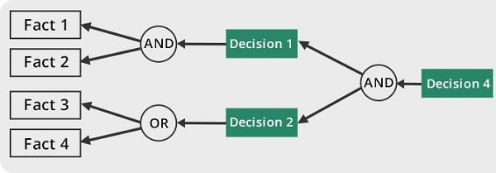

Backward Chaining
With this strategy, an expert system finds out the answer to the question, “Why this happened?”
On the basis of what has already happened, the Inference Engine tries to find out which conditions could have happened in the past for this result. This strategy is followed for finding out cause or reason. For example, diagnosis of blood cancer in humans.

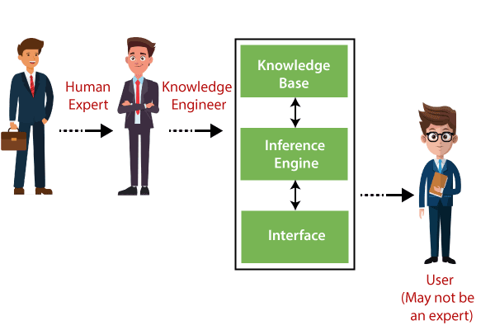

User Interface
User interface provides interaction between user of the ES and the ES itself. It is generally Natural Language Processing so as to be used by the user who is well-versed in the task domain. The user of the ES need not be necessarily an expert in Artificial Intelligence.
It explains how the ES has arrived at a particular recommendation. The explanation may appear in the following forms −
- Natural language displayed on screen.
- Verbal narrations in natural language.
- Listing of rule numbers displayed on the screen.
The user interface makes it easy to trace the credibility of the deductions.

Requirements of Efficient ES User Interface
- It should help users to accomplish their goals in shortest possible way.
- It should be designed to work for user’s existing or desired work practices.
- Its technology should be adaptable to user’s requirements; not the other way round.
- It should make efficient use of user input.

2. Inference Engine(Rules of Engine)
- The inference engine is known as the brain of the expert system as it is the main processing unit of the system. It applies inference rules to the knowledge base to derive a conclusion or deduce new information. It helps in deriving an error-free solution of queries asked by the user.
- With the help of an inference engine, the system extracts the knowledge from the knowledge base.
- There are two types of inference engine:
- Deterministic Inference engine: The conclusions drawn from this type of inference engine are assumed to be true. It is based on facts and rules.
- Probabilistic Inference engine: This type of inference engine contains uncertainty in conclusions, and based on the probability.
Inference engine uses the below modes to derive the solutions:
- Forward Chaining: It starts from the known facts and rules, and applies the inference rules to add their conclusion to the known facts.
- Backward Chaining: It is a backward reasoning method that starts from the goal and works backward to prove the known facts.

Expert Systems Limitations
No technology can offer easy and complete solution. Large systems are costly, require significant development time, and computer resources. ESs have their limitations which include −
- Limitations of the technology
- Difficult knowledge acquisition
- ES are difficult to maintain
- High development costs

Applications of Expert System
The following table shows where ES can be applied.
Application | Description
Design Domain | Camera lens design, automobile design.
Medical Domain | Diagnosis Systems to deduce cause of disease from observed data, conduction medical operations on humans.
Monitoring Systems | Comparing data continuously with observed system or with prescribed behavior such as leakage monitoring in long petroleum pipeline.
Process Control Systems | Controlling a physical process based on monitoring.
Knowledge Domain | Finding out faults in vehicles, computers.
Finance/Commerce | Detection of possible fraud, suspicious transactions, stock market trading, Airline scheduling, cargo scheduling.

Expert System Technology
There are several levels of ES technologies available. Expert systems technologies include −
- Expert System Development Environment − The ES development environment includes hardware and tools. They are −
  - Workstations, minicomputers, mainframes.
  - High level Symbolic Programming Languages such as LISt Programming (LISP) and PROgrammation en LOGique (PROLOG).
  - Large databases.
- Tools − They reduce the effort and cost involved in developing an expert system to large extent.
  - Powerful editors and debugging tools with multi-windows.
  - They provide rapid prototyping
  - Have Inbuilt definitions of model, knowledge representation, and inference design.
- Shells − A shell is nothing but an expert system without knowledge base. A shell provides the developers with knowledge acquisition, inference engine, user interface, and explanation facility. For example, few shells are given below −
  - Java Expert System Shell (JESS) that provides fully developed Java API for creating an expert system.
  - Vidwan, a shell developed at the National Centre for Software Technology, Mumbai in 1993. It enables knowledge encoding in the form of IF-THEN rules.

Development of Expert Systems: General Steps
The process of ES development is iterative. Steps in developing the ES include −

Identify Problem Domain
- The problem must be suitable for an expert system to solve it.
- Find the experts in task domain for the ES project.
- Establish cost-effectiveness of the system.

Design the System
- Identify the ES Technology
- Know and establish the degree of integration with the other systems and databases.
- Realize how the concepts can represent the domain knowledge best.

Develop the Prototype
From Knowledge Base: The knowledge engineer works to −
- Acquire domain knowledge from the expert.
- Represent it in the form of If-THEN-ELSE rules.

Test and Refine the Prototype
- The knowledge engineer uses sample cases to test the prototype for any deficiencies in performance.
- End users test the prototypes of the ES.

Develop and Complete the ES
- Test and ensure the interaction of the ES with all elements of its environment, including end users, databases, and other information systems.
- Document the ES project well.
- Train the user to use ES.

Maintain the System
- Keep the knowledge base up-to-date by regular review and update.
- Cater for new interfaces with other information systems, as those systems evolve.

Benefits of Expert Systems
- Availability − They are easily available due to mass production of software.
- Less Production Cost − Production cost is reasonable. This makes them affordable.
- Speed − They offer great speed. They reduce the amount of work an individual puts in.
- Less Error Rate − Error rate is low as compared to human errors.
- Reducing Risk − They can work in the environment dangerous to humans.
- Steady response − They work steadily without getting motional, tensed or fatigued.

1. User Interface
With the help of a user interface, the expert system interacts with the user, takes queries as an input in a readable format, and passes it to the inference engine. After getting the response from the inference engine, it displays the output to the user. In other words, it is an interface that helps a non-expert user to communicate with the expert system to find a solution.

2. Inference Engine(Rules of Engine)
- The inference engine is known as the brain of the expert system as it is the main processing unit of the system. It applies inference rules to the knowledge base to derive a conclusion or deduce new information. It helps in deriving an error-free solution of queries asked by the user.
- With the help of an inference engine, the system extracts the knowledge from the knowledge base.
- There are two types of inference engine:
- Deterministic Inference engine: The conclusions drawn from this type of inference engine are assumed to be true. It is based on facts and rules.
- Probabilistic Inference engine: This type of inference engine contains uncertainty in conclusions, and based on the probability.
Inference engine uses the below modes to derive the solutions:
- Forward Chaining: It starts from the known facts and rules, and applies the inference rules to add their conclusion to the known facts.
- Backward Chaining: It is a backward reasoning method that starts from the goal and works backward to prove the known facts.

3. Knowledge Base
- The knowledgebase is a type of storage that stores knowledge acquired from the different experts of the particular domain. It is considered as big storage of knowledge. The more the knowledge base, the more precise will be the Expert System.
- It is similar to a database that contains information and rules of a particular domain or subject.
- One can also view the knowledge base as collections of objects and their attributes. Such as a Lion is an object and its attributes are it is a mammal, it is not a domestic animal, etc.
Components of Knowledge Base
- Factual Knowledge: The knowledge which is based on facts and accepted by knowledge engineers comes under factual knowledge.
- Heuristic Knowledge: This knowledge is based on practice, the ability to guess, evaluation, and experiences.
Knowledge Representation: It is used to formalize the knowledge stored in the knowledge base using the If-else rules.
Knowledge Acquisitions: It is the process of extracting, organizing, and structuring the domain knowledge, specifying the rules to acquire the knowledge from various experts, and store that knowledge into the knowledge base.

Development of Expert System
Here, we will explain the working of an expert system by taking an example of MYCIN ES. Below are some steps to build an MYCIN:
- Firstly, ES should be fed with expert knowledge. In the case of MYCIN, human experts specialized in the medical field of bacterial infection, provide information about the causes, symptoms, and other knowledge in that domain.
- The KB of the MYCIN is updated successfully. In order to test it, the doctor provides a new problem to it. The problem is to identify the presence of the bacteria by inputting the details of a patient, including the symptoms, current condition, and medical history.
- The ES will need a questionnaire to be filled by the patient to know the general information about the patient, such as gender, age, etc.
- Now the system has collected all the information, so it will find the solution for the problem by applying if-then rules using the inference engine and using the facts stored within the KB.
- In the end, it will provide a response to the patient by using the user interface.
Participants in the development of Expert System
There are three primary participants in the building of Expert System:
- Expert: The success of an ES much depends on the knowledge provided by human experts. These experts are those persons who are specialized in that specific domain.
- Knowledge Engineer: Knowledge engineer is the person who gathers the knowledge from the domain experts and then codifies that knowledge to the system according to the formalism.
- End-User: This is a particular person or a group of people who may not be experts, and working on the expert system needs the solution or advice for his queries, which are complex.

Why Expert System?
Before using any technology, we must have an idea about why to use that technology and hence the same for the ES. Although we have human experts in every field, then what is the need to develop a computer-based system. So below are the points that are describing the need of the ES:
- No memory Limitations: It can store as much data as required and can memorize it at the time of its application. But for human experts, there are some limitations to memorize all things at every time.
- High Efficiency: If the knowledge base is updated with the correct knowledge, then it provides a highly efficient output, which may not be possible for a human.
- Expertise in a domain: There are lots of human experts in each domain, and they all have different skills, different experiences, and different skills, so it is not easy to get a final output for the query. But if we put the knowledge gained from human experts into the expert system, then it provides an efficient output by mixing all the facts and knowledge
- Not affected by emotions: These systems are not affected by human emotions such as fatigue, anger, depression, anxiety, etc.. Hence the performance remains constant.
- High security: These systems provide high security to resolve any query.
- Considers all the facts: To respond to any query, it checks and considers all the available facts and provides the result accordingly. But it is possible that a human expert may not consider some facts due to any reason.
- Regular updates improve the performance: If there is an issue in the result provided by the expert systems, we can improve the performance of the system by updating the knowledge base.

Capabilities of the Expert System
Below are some capabilities of an Expert System:
- Advising: It is capable of advising the human being for the query of any domain from the particular ES.
- Provide decision-making capabilities: It provides the capability of decision making in any domain, such as for making any financial decision, decisions in medical science, etc.
- Demonstrate a device: It is capable of demonstrating any new products such as its features, specifications, how to use that product, etc.
- Problem-solving: It has problem-solving capabilities.
- Explaining a problem: It is also capable of providing a detailed description of an input problem.
- Interpreting the input: It is capable of interpreting the input given by the user.
- Predicting results: It can be used for the prediction of a result.
- Diagnosis: An ES designed for the medical field is capable of diagnosing a disease without using multiple components as it already contains various inbuilt medical tools.

Advantages of Expert System
- These systems are highly reproducible.
- They can be used for risky places where the human presence is not safe.
- Error possibilities are less if the KB contains correct knowledge.
- The performance of these systems remains steady as it is not affected by emotions, tension, or fatigue.
- They provide a very high speed to respond to a particular query.

Limitations of Expert System
- The response of the expert system may get wrong if the knowledge base contains the wrong information.
- Like a human being, it cannot produce a creative output for different scenarios.
- Its maintenance and development costs are very high.
- Knowledge acquisition for designing is much difficult.
- For each domain, we require a specific ES, which is one of the big limitations.
- It cannot learn from itself and hence requires manual updates.

Applications of Expert System
- In designing and manufacturing domain
It can be broadly used for designing and manufacturing physical devices such as camera lenses and automobiles.
- In the knowledge domain
These systems are primarily used for publishing the relevant knowledge to the users. The two popular ES used for this domain is an advisor and a tax advisor.
- In the finance domain
In the finance industries, it is used to detect any type of possible fraud, suspicious activity, and advise bankers that if they should provide loans for business or not.
- In the diagnosis and troubleshooting of devices
In medical diagnosis, the ES system is used, and it was the first area where these systems were used.
- Planning and Scheduling
The expert systems can also be used for planning and scheduling some particular tasks for achieving the goal of that task.

Questions:

What are the different components of the Expert System?

What is NLP? What are the various components of NLP?

What is a Chatbot?

