**Techno India NJR Institute of Technology**

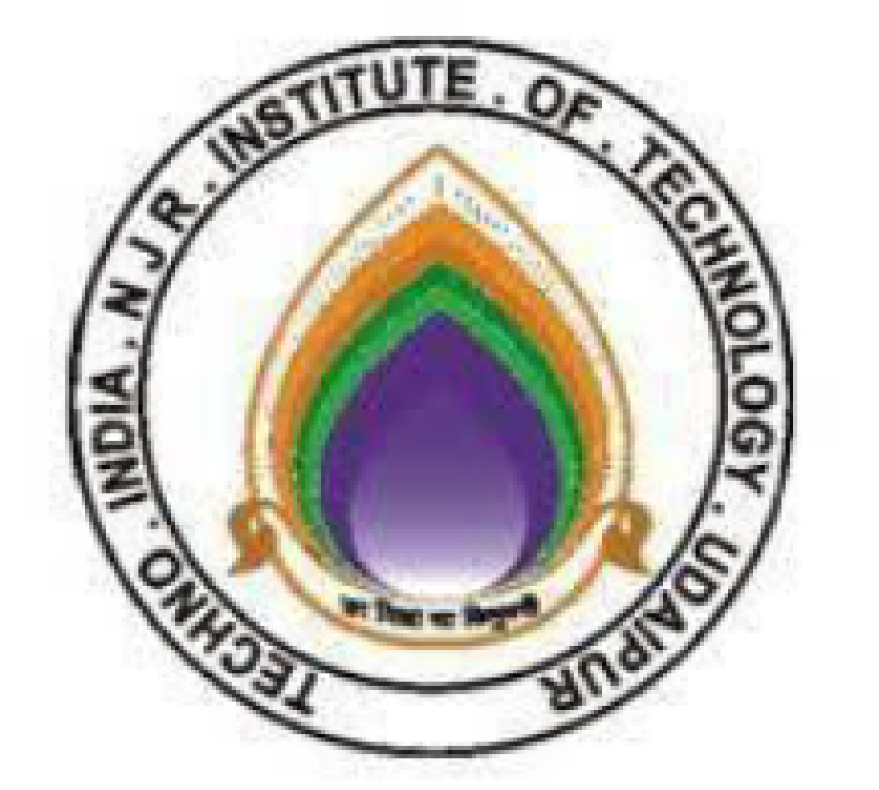

**Course File**

**Digital Signal Processing (5EC4-04)**

**Session 2023-24**

Dr. Vivek Jain

(Associate Professor)

**Department of ECE**

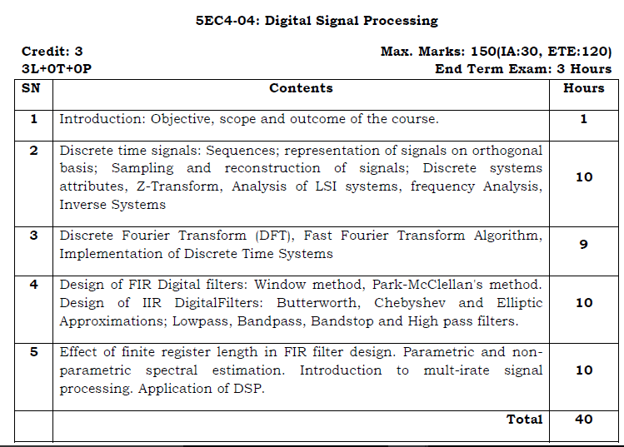

**Course Overview:**

The course covers theory and methods for digital signal processing including basic principles governing the analysis and design of discrete-time systems as signal processing devices. Review of discrete-time linear, time-invariant systems, Fourier transforms and z-transforms. Topics include sampling, impulse response, frequency response, finite and infinite impulse response systems, linear phase systems, digital filter design and implementation, discrete-time Fourier transforms, discrete Fourier transform, and the fast Fourier transform algorithms.

**Course Outcomes:**

| **CO.NO.** | **Cognitive Level** | **Course Outcome** |
| --- | --- | --- |
| 1 | **Comprehension** | Classify different types of signals and system properties. |
| 2 | **Application** | Demonstrate continuous and discrete systems in time and frequency domain using different transforms. |
| 3 | **Analysis** | Analyze the output of IIR and FIR system . |
| 4 | **Synthesis** | Design and Develop Sampling and reconstruction circuit . |
| 5 | **Evaluation** | Evaluate the outputof the MIMO systems. |

**Prerequisites:**

1. Fundamentals knowledge of differentiation and integration.
2. Fundamentals knowledge of partial fraction.
3. Fundamentals knowledge of Z transform and Basic signals.

**Course Outcome Mapping with Program Outcome:**

| **Course Outcome** | **Program Outcomes (PO’s)** | | | | | | | | | | | |
| --- | --- | --- | --- | --- | --- | --- | --- | --- | --- | --- | --- | --- |
| **CO. NO.** | **Domain Specific** | | | | | **Domain Independent** | | | | | | |
|  | **PO1** | **PO2** | **PO3** | **PO4** | **PO5** | **PO6** | **PO7** | **PO8** | **PO9** | **PO10** | **PO11** | **PO12** |
| CO1 | 2 | 2 | 2 | 1 | 2 | 0 | 0 | 0 | 0 | 0 | 0 | 0 |
| CO2 | 2 | 2 | 2 | 2 | 2 | 0 | 0 | 0 | 0 | 0 | 0 | 0 |
| CO3 | 1 | 2 | 2 | 2 | 2 | 0 | 0 | 0 | 0 | 0 | 0 | 0 |
| CO4 | 2 | 2 | 2 | 2 | 1 | 0 | 0 | 0 | 0 | 0 | 0 | 0 |
| CO5 | 2 | 2 | 2 | 2 | 1 | 0 | 0 | 2 | 0 | 0 | 0 | 1 |
| 1: Slight (Low) , 2: Moderate (Medium), 3: Substantial (High) | | | | | | | | | | | | |

**Course Coverage Module Wise:**

| **Lecture No.** | **Unit** | **Topic** |
| --- | --- | --- |
| 1 | **1** | **INTRODUCTION:** Objective, scope and outcome of the course. |
| 2 | **2** | **DISCRETE TIME SIGNALS**: Sequences |
| 3 | 2 | representation of signals on orthogonal basis |
| 4 | 2 | Sampling and reconstruction of signals |
| 5 | 2 | Sampling and reconstruction of signals |
| 6 | 2 | Discrete systems attributes |
| 7 | 2 | Discrete systems attributes |
| 8 | 2 | Z-Transform, Analysis of LSI systems |
| 9 | 2 | frequency Analysis of LTI systems |
| 10 | 2 | frequency Analysis of LTI systems |
| 11 | 2 | Inverse Systems |
| 12 | **3** | **DISCRETE FOURIER TRANSFORM (DFT)** |
| 13 | 3 | Discrete Fourier Transform (DFT) |
| 14 | 3 | Discrete Fourier Transform (DFT) |
| 15 | 3 | Fast Fourier Transform Algorithm |
| 16 | 3 | Fast Fourier Transform Algorithm |
| 17 | 3 | Fast Fourier Transform Algorithm |
| 18 | 3 | Fast Fourier Transform Algorithm |
| 19 | 3 | Implementation of Discrete Time Systems |
| 20 | 3 | Implementation of Discrete Time Systems |
| 21 | **4** | **DESIGN OF FIR DIGITAL FILTERS** |
| 22 | 4 | Window method |
| 23 | 4 | Park-McClellan's method |
| 24 | 4 | Design of IIR Digital Filters |
| 25 | 4 | Butterworth Approximation |
| 26 | 4 | Butterworth Approximation |
| 27 | 4 | Chebyshev and Elliptic Approximations |
| 28 | 4 | Chebyshev and Elliptic Approximations |
| 29 | 4 | Lowpass, Bandpass filter design |
| 30 | 4 | Band-Stop and High pass filters design |
| 31 | **5** | **EFFECT OF FINITE REGISTER LENGTH IN FIR FILTER DESIGN** |
| 32 | 5 | Effect of finite register length in FIR filter design |
| 33 | 5 | Parametric spectral estimation |
| 34 | 5 | Parametric spectral estimation |
| 35 | 5 | Nonparametric spectral estimation |
| 36 | 5 | Nonparametric spectral estimation |
| 37 | 5 | Introduction to mult-irate signal |
| 38 | 5 | Introduction to mult-irate signal |
| 39 | 5 | Application of DSP |
| 40 | 5 | Application of DSP |

| **TEXT/REFERENCE BOOKS**   1. Digital Signal Processing: Principals, Algorithms And Applications”, Proakis, Manolakis,4th ed., Pearson Education. 2. Discrete Time Signal Processing, Oppenheim, Schafer, 3rd ed. , PHI (2010). 3. Digital Signal Processing, Sanjit K Mitra, 4th ed., TMH. 4. Digital Signal Processing:A Modern Introduction,Ambardar, Cengage learning. |
| --- |

| **NPTEL COUSES LINK**   1. https://nptel.ac.in/courses/117/102/117102060/ |
| --- |

| **QUIZ Link**   1. <https://www.javatpoint.com/digital-signal-processing-mcq> 2. ions-anhttps://www.sanfoundry.com/1000-digital-signal-processing-questswers/ |
| --- |

| 1. https://drive.google.com/drive/folders/1tz45RE6Fci2XRBp02k1rv8_2y9gp7vxj?usp=sharing |
| --- |

**Assessment Methodology:**

1. Practical exam using MATALB software.
2. Two Midterm exams where student have to showcase subjective learning.
3. Final Exam (subjective paper) at the end of the semester.

