**Techno India NJR Institute of Technology**



**Course File**

**Embedded System (5EC5-12)**

**Session 203-24**

Hitesh Sen

(Associate Professor)

**Department of ECE**

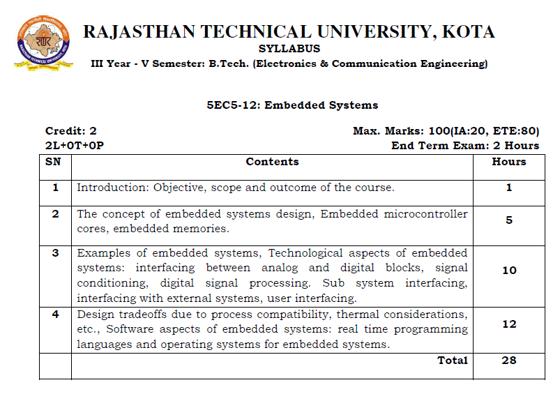

**Course Overview:**

Course Objectives: On completion of this course, successful participants will be able to: Perform effectively as entry level Embedded Systems professionals. Develop and maintain applications written using Embedded C. Independently design and develop a hardware platform encompassing a microcontroller and peripherals.

**Course Outcomes:**

|  |  |  |
| --- | --- | --- |
| **CO.NO.** | **Cognitive Level** | **Course Outcome** |
| 1 | **Comprehension** | Discuss the evolution of MP technology |
| 2 | **Application** | Learn the depth knowledge of applying the concepts of real time applications. Demand of energy in India in various sectors. |
| 3 | **Analysis** | Identify, formulate, and solve engineering problems in MP based and to analyze their outcomes. |
| 4 | **Synthesis** | Design and Develop Embedded system and Programmed, debug and test it. |
| 5 | **Evaluation** | Evaluate the responsetimeof the embedded systems. |

**Prerequisites:**

1. Fundamentals knowledge of binary number system.
2. Fundamentals knowledge of digital electronics.

**Course Outcome Mapping with Program Outcome:**

|  |  |  |  |  |  |  |  |  |  |  |  |  |
| --- | --- | --- | --- | --- | --- | --- | --- | --- | --- | --- | --- | --- |
| **Course Outcome** | **Program Outcomes (PO’s)** | | | | | | | | | | | |
| **CO. NO.** | **Domain Specific** | | | | | **Domain Independent** | | | | | | |
|  | **PO1** | **PO2** | **PO3** | **PO4** | **PO5** | **PO6** | **PO7** | **PO8** | **PO9** | **PO10** | **PO11** | **PO12** |
| CO1 | 2 | 1 | 1 | 1 | 2 | 2 | 2 | 1 | 0 | 0 | 1 | 1 |
| CO2 | 0 | 0 | 2 | 0 | 0 | 0 | 0 | 0 | 0 | 0 | 0 | 0 |
| CO3 | 1 | 2 | 2 | 1 | 1 | 1 | 0 | 0 | 0 | 0 | 0 | 0 |
| CO4 | 0 | 2 | 0 | 0 | 0 | 0 | 1 | 0 | 0 | 0 | 0 | 0 |
| CO5 | 0 | 0 | 0 | 2 | 2 | 0 | 0 | 0 | 0 | 0 | 0 | 0 |
| 1: Slight (Low) , 2: Moderate (Medium), 3: Substantial (High) | | | | | | | | | | | | |

**Course Coverage Module Wise:**

|  |  |  |
| --- | --- | --- |
| **Lecture No.** | **Unit** | **Topic** |
| 1 | **1** | **ZERO LECTURE.** |
| 2 | **2** | **THE CONCEPT OF EMBEDDED SYSTEMS DESIGN** |
| 3 | 2 | Embedded microcontroller cores |
| 4 | 2 | Embedded microcontroller cores |
| 5 | 2 | Embedded memories |
| 6 | 2 | Embedded memories |
| 7 | **3** | **EXAMPLES OF EMBEDDED SYSTEMS** |
| 8 | 3 | Examples of embedded systems |
| 9 | 3 | Technological aspects of embeddedsystems |
| 10 | 3 | Technological aspects of embeddedsystems |
| 11 | 3 | Interfacing between analog and digital blocks |
| 12 | 3 | Signal conditioning |
| 13 | 3 | Digital signal processing |
| 14 | 3 | Sub system interfacing |
| 15 | 3 | Interfacing with external systems |
| 16 | 3 | User interfacing |
| 17 | **4** | **DESIGN TRADEOFFS DUE TO PROCESS COMPATIBILITY** |
| 18 | 4 | Design tradeoffs due to process compatibility |
| 19 | 4 | Thermal considerations |
| 20 | 4 | Thermal considerations |
| 21 | 4 | Software aspects of embedded systems |
| 22 | 4 | Software aspects of embedded systems |
| 23 | 4 | Real time programming languages |
| 24 | 4 | Real time programming languages |
| 25 | 4 | Real time programming languages |
| 26 | 4 | Operating systems for embedded systems |
| 27 | 4 | Operating systems for embedded systems |
| 28 | 4 | Operating systems for embedded systems |

|  |
| --- |
| **TEXT/REFERENCE BOOKS**   1. Microprocessor Architecture: Programming and Applications with the 8085/8080A, R. S. Gaonkar, Penram International Publishing, 1996. 2. Embedded System Design, A Unified Hardware/Software Introduction, Frank Vahid/Tony Givaris, Jhon, Wiely Student Edition,2006. 3. The 8051 Microcontroller & Embedded System , Muhammad Ali Mazidi,Pearsons. 4. The 8051 Microcontroller, Kenneth J. Ayala, Penram International Publishing, 1996. |

|  |
| --- |
| **NPTEL COUSES LINK**   1. https://nptel.ac.in/courses/106/103/106103182/ |

|  |
| --- |
| **QUIZ Link**   1. <https://www.javatpoint.com/embedded-systems-mcq> 2. <https://www.sanfoundry.com/embedded-systems-questions-answers-mcqs/> 3. https://www.eguardian.co.in/embedded-systems-multiple-choice-questions-with-answers/ |

|  |
| --- |
| **Faculty Notes Link**   1. https://drive.google.com/drive/folders/10TWNEoIxLBCZE9KEGEMLhYPSD9dBHrCX?usp=sharing |

**Assessment Methodology:**

1. Practical exam using Keil Compiler.
2. Two Midterm exams where student have to showcase subjective learning.
3. Final Exam (subjective paper) at the end of the semester.

