**Techno India NJR Institute of Technology**

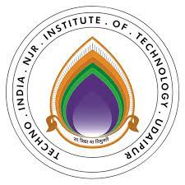

**Course File**

**Power Electronics (6EC3-01)**

**Mr. Rajkumar Soni**

(Assistant Professor)

Department of Electrical Engineering

# Syllabus:

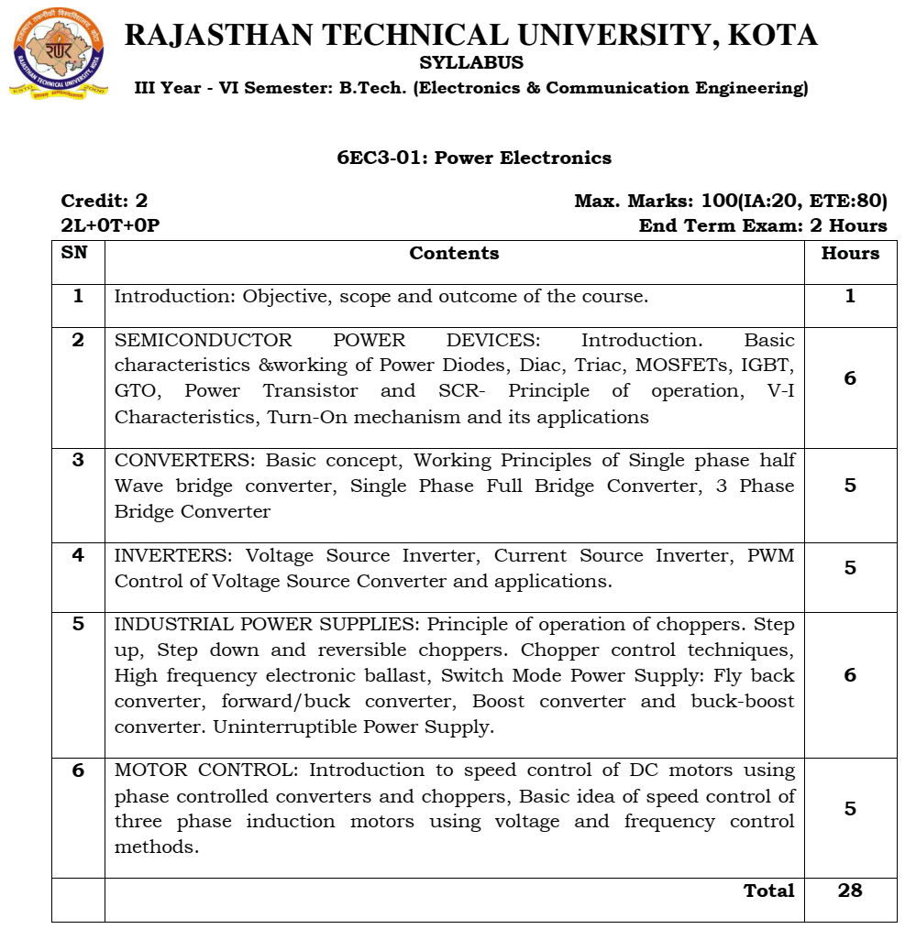

# Course Overview:

The course discusses power processing electronic circuits like rectifiers, AC voltage controllers, Frequency converters, DC-DC converters and inverters apart from introducing the basics of power semiconductor devices like SCRs, power BJTs, IGBTs and MOSFETs in this 40-hours course. The analysis of these power circuits are presented in detail along with the waveforms and control techniques. Finally, applications of power electronic technology in generation sector, transmission sector and also in day-to-day applications like battery charger, motor drives, power supplies are described.

This course will make the student ready to solve the power and energy sector problems. Also, brigs opportunities from renewable energy sector. Students will be able to solve for the steady-state voltages and currents of step-down, step-up, inverting, and other power converters and knows how to derive an averaged equivalent circuit model and solve for the converter efficiency

# Course Outcome:

|  |  |  |
| --- | --- | --- |
| **CO. NO.** | **Cognitive Level** | **Course Outcome** |
| 1 | Synthesis | Student will be able to explain switching characteristics of various Power Semiconductor devices and able to design and simulate their base/gate drive circuits. |
| 2 | Synthesis | Student will be able to summarize and synthesize the different controlled rectifier circuits and computing their performances. |
| 3 | Analysis | Students will be able to analyze different dc-dc converter circuits (isolated and non-isolated type) and computing their performances |
| 4 | Application | Students will be able to apply knowledge of single phase and three phase Voltage Source Inverter circuit topology with Sin PWM control, Space Vector PWM control and computing their performances. |
| 5 | Evaluation | Students will be able interpret and predict correct speed motors. |

# Prerequisites:

1. Basic Electrical Engineering, Circuit theory, signals and systems
2. Fundamentals of basic circuit elements and their properties.
3. Students should be efficient in applying basic laws of circuit analysis.
4. Students should be proficient in solving algebraic equations.
5. Students should be proficient in drawing waveforms.

# 

# Course Outcome Mapping with Program Outcome:

|  |  |  |  |  |  |  |  |  |  |  |  |  |
| --- | --- | --- | --- | --- | --- | --- | --- | --- | --- | --- | --- | --- |
| **Course Outcome** | **Program Outcomes (PO’s)** | | | | | | | | | | | |
|
| **CO. NO.** | **Domain Specific (PSO)** | | | | | **Domain Independent (PO)** | | | | | |  |
|  | **PO1** | **PO2** | **PO3** | **PO4** | **PO5** | **PO6** | **PO7** | **PO8** | **PO9** | **PO10** | **PO11** | **PO12** |
| CO1 | 2 | 1 | 0 | 1 | 1 | 0 | 0 | 0 | 0 | 0 | 0 | 0 |
| CO2 | 2 | 2 | 2 | 2 | 1 | 2 | 1 | 0 | 1 | 0 | 0 | 0 |
| CO3 | 2 | 2 | 2 | 2 | 1 | 2 | 1 | 0 | 1 | 0 | 0 | 0 |
| CO4 | 2 | 2 | 2 | 2 | 1 | 2 | 1 | 0 | 1 | 0 | 0 | 0 |
| CO5 | 1 | 2 | 1 | 2 | 1 | 1 | 1 | 0 | 0 | 0 | 0 | 0 |
| 1: Slight (Low), 2: Moderate (Medium), 3: Substantial (High) | | | | | | | | | | | |  |

# Course Coverage Module Wise:

|  |  |  |
| --- | --- | --- |
| **Lect. No.** | **Unit** | **Topic** |
| 1 | **1** | **INTRODUCTION: Objective, scope and outcome of the course** |
| 2 | **2** | **SEMICONDUCTOR DEVICES:**Introduction |
| 3 | 2 | Construction, Characteristics and working of Power Diode |
| 4 | 2 | Construction, Characteristics and working of DIAC, TRIAC |
| 5 | 2 | Construction, Characteristics and working of MOSFET |
| 6 | 2 | Construction, Characteristics and working of IGBT, GTO |
| 7 | 2 | Construction, Characteristics and working of Power Transistor |
| 8 | 2 | Construction and working of SCR |
| 9 | 2 | I-V Characteristics of SCR |
| 10 | 2 | SCR Turn-On mechanism and its applications |
| 11 | **3** | **CONVERTERS:**Basic Concepts and Categorization |
| 12 | 3 | Construction and working principle of Single-phasehalf bridge converter |
| 13 | 3 | Construction and working principle of Single-phase full bridge converter (R Load) |
| 14 | 3 | Working principle of Single-phase full bridge converter (RL Load) |
| 15 | 3 | Construction and working principle of Three-phase full bridge converter (R Load) |
| 16 | 3 | Construction and working principle of Three-phase full bridge converter (RL Load) |
| 17 | **4** | **INVERTERS:** Basic Concepts and Categorization |
| 18 | 4 | Single-phase Voltage Source Inverter |
| 19 | 4 | Three-phase Voltage Source Inverter (180 Degree mode) |
| 20 | 4 | Three-phase Voltage Source Inverter (120 Degree mode) |
| 21 | 4 | Current Source Inverter |
| 22 | 4 | PWM Control of Voltage Source Converter and applications |
| 23 | **5** | **INDUSTRIAL POWER SUPPLIES:** Principle of operation of choppers, Step-up chopper |
| 24 | 5 | Step-down chopper, reversible choppers |
| 25 | 5 | Chopper control techniques |
| 26 | 5 | High frequency electronic ballast, Switch Mode Power Supply Introduction |
| 27 | 5 | Fly back converter |
| 28 | 5 | forward/buck converter |
| 29 | 5 | Boost converter |
| 30 | 5 | Buck-boost converter |
| 31 | 5 | Uninterruptible Power Supply |
| 32 | **6** | **MOTOR CONTROL:** Introduction |
| 33 | 6 | Speed control of DC motors using phase-controlled converters |
| 34 | 6 | Speed control of DC motors using choppers |
| 35 | 6 | Basic idea of speed control of three-phase induction motors |
| 36 | 6 | Voltage Control method of three-phase induction motors |
| 37 | 6 | Frequency Control method of three-phase induction motors |
| 38 |  | Revision to course work.   * It should clearly mention the type of rectifiers to be covered like semi-converter and types of loads operations * Inverter working mode should be mention like 180 Degree 120 Degree   Industrial supply unit should be like Classes of chopper, Buck, Boost, Buck-boost converter, Flyback converter, Forward converter, UPS |

# Text/Reference Books:

# M. H. Rashid,” Power electronics: circuits, devices, and applications”, Pearson Education India, 2009.

# N. Mohan and T. M. Undeland,” Power Electronics: Converters, Applications and Design”, John Wiley & Sons, 2007.

# R. W. Erickson and D. Maksimovic,” Fundamentals of Power Electronics”, Springer Science & Business Media, 2007.

# L. Umanand,” Power Electronics: Essentials and Applications”, Wiley India, 2009

# Teaching and Learning resources:

|  |  |
| --- | --- |
| NPTEL Course Link | <https://nptel.ac.in/courses/108/102/108102145/> |
| Quiz | <https://quizizz.com/admin/quiz/5c9480fa0d3459001a4e41c7/power-electronics> |
| **Notes** | <http://www.svecw.edu.in/Docs%5CEEEPELNotes2013.pdf>  <https://sites.google.com/site/eeenotes2u/courses/power-electronics> |

# Assessment Methodology:

1. Assignments one from each unit.
2. Midterm subjective paper where they have to solve the given problem. (Twice during the semester)
3. Final paper at the end of the semester subjective

# Previous Year Question Paper:

