**Techno India NJR Institute of Technology**



**Course File**

**Session 2021-22**

**Introduction to MEMS (6EC5-11)**

Mr. Hitesh Sen

(Assistant Professor)

**Department of ECE**

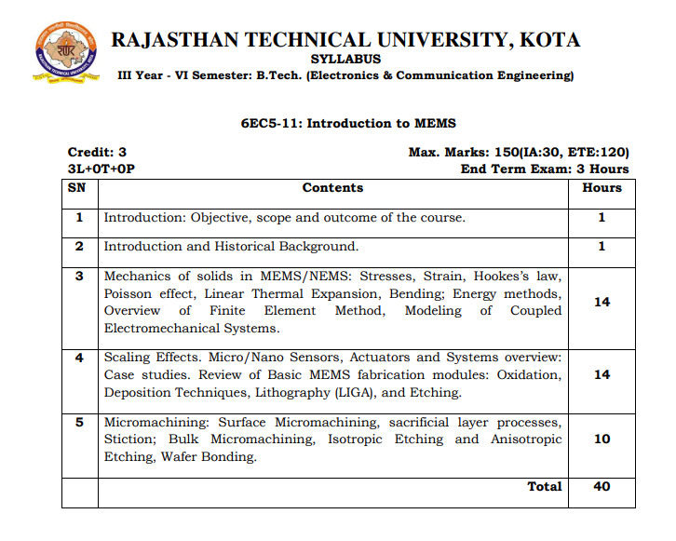

**Course Overview:**

This course is to inspire the students to expect to the trends in development and synthesizing of nano systems and measuring systems to nano scale. To expose the students to the evolution of Nano systems, to the various fabrication techniques. Also, to impart knowledge to the students about nano materials and various nano measurements techniques.

**Course Outcomes:**

|  |  |  |
| --- | --- | --- |
| **CO.NO.** | **Cognitive Level** | **Course Outcome** |
| 1 | Knowledge | Understand the characteristic techniques of micro system fabrication process |
| 2 | Comprehension | Describe the methods for processing MEMS and nano scale materials |
| 3 | Knowledge | Describe the evolution of Nano technology and its applications |
| 4 | Analysis | Analyze the various nano materials and measurements techniques and nano scale manufacturing |
| 5 | Analysis | Analyse & compare the various micromachining methods |

**Prerequisites:**

1. Fundamentals of electronics and electricals.
2. Knowledge of semiconductor Physics
3. Basic knowledge of kinematics of materials.

**Course Outcome Mapping with Program Outcome:**

|  |  |  |  |  |  |  |  |  |  |  |  |  |
| --- | --- | --- | --- | --- | --- | --- | --- | --- | --- | --- | --- | --- |
| **Course Outcome** | **Program Outcomes (PO’s)** | | | | | | | | | | | |
| **CO. NO.** | **Domain Specific** | | | | | **Domain Independent** | | | | | | |
|  | **PO1** | **PO2** | **PO3** | **PO4** | **PO5** | **PO6** | **PO7** | **PO8** | **PO9** | **PO10** | **PO11** | **PO12** |
| CO1 | 2 | 1 | 0 | 1 | 0 | 0 | 0 | 0 | 0 | 0 | 0 | 0 |
| CO2 | 2 | 2 | 0 | 0 | 0 | 0 | 0 | 0 | 0 | 0 | 0 | 0 |
| CO3 | 2 | 1 | 0 | 1 | 0 | 0 | 0 | 0 | 0 | 0 | 0 | 0 |
| CO4 | 2 | 2 | 1 | 1 | 0 | 0 | 0 | 0 | 0 | 0 | 0 | 0 |
| CO5 | 2 | 2 | 1 | 1 | 0 | 0 | 0 | 0 | 0 | 0 | 0 | 0 |
| 1: Slight (Low) , 2: Moderate (Medium), 3: Substantial (High) | | | | | | | | | | | | |

**Course Coverage Module Wise:**

|  |  |  |
| --- | --- | --- |
| **Lecture No.** | **Unit** | **Topic** |
| 1 | **1** | **INTRODUCTION: Objective, scope and outcome of the course** |
| 2 | **2** | **INTRODUCTION AND HISTORICAL BACKGROUND.** |
| 3 | **3** | **MECHANICS OF SOLIDS IN MEMS/NEMS** |
| 4 | 3 | Different types of stresses |
| 5 | 3 | Different types of strain |
| 6 | 3 | Hookes’s law |
| 7 | 3 | Poisson effect |
| 8 | 3 | Stress-strain curve |
| 9 | 3 | Linear Thermal Expansion |
| 10 | 3 | Bending |
| 11 | 3 | Static bending of thin plate |
| 12 | 3 | Bending of rectangular plate |
| 13 | 3 | Bending of circular plate |
| 14 | 3 | Energy methods |
| 15 | 3 | Overview of Finite Element Method |
| 16 | 3 | Modeling of Coupled Electromechanical Systems |
| 17 | **4** | **SCALING EFFECTS** |
| 18 | 4 | Scaling Effects |
| 19 | 4 | Different types of Micro/Nano Sensors |
| 20 | 4 | Different types of Micro/Nano Sensors |
| 21 | 4 | Different types of Micro/Nano Actuators |
| 22 | 4 | Different types of Micro/Nano Actuators |
| 23 | 4 | Different types of actuations |
| 24 | 4 | Review of Basic MEMS fabrication modules |
| 25 | 4 | Oxidation |
| 26 | 4 | Deposition Techniques: CVD |
| 27 | 4 | Deposition Techniques: PVD |
| 28 | 4 | Epitaxy |
| 29 | 4 | Lithography (LIGA) |
| 30 | 4 | Etching |
| 31 | **5** | **MICROMACHINING** |
| 32 | 5 | Introduction to Bulk Micromachining |
| 33 | 5 | Different steps used in bulk micromachining |
| 34 | 5 | Isotropic Etching |
| 35 | 5 | Anisotropic Etching |
| 36 | 5 | Introduction to surface Micromachining |
| 37 | 5 | Different steps used in surface micromachining |
| 38 | 5 | Sacrificial layer processes |
| 39 | 5 | Comparison in different micromachining methods |
| 40 | 5 | Wafer Bonding |

**TEXT/REFERENCE BOOKS**

1. Introduction to Nanotechnology, Risal Singh, Shipra Mital Gupta, Oxford University press.
2. Nano Essentials, T Pradeep, Mc Graw Hill, (2008).
3. Nanotechnology-Enabled Sensors, Kourosh Kalantar-zadehand Benjamin Fry, Springer, (2007).
4. Fundamental of Nanoelectronics, George W. Hanson, Pearson 2009
5. Principal of Nanotechnology, G. A. Mansoori, Wiley 2005
6. MEMS & Microsystems, Design and Manufacture, Tai-Ran HSU, TMH 2013

**Teaching and Learning resources:**

**MOOC (NPTEL): -** https://nptel.ac.in/courses/112/108/112108092/

**Assessment Methodology:**

1. Two Midterm exams where student have to showcase subjective learning.
2. Final Exam (subjective paper) at the end of the semester.

