**Course File**

***Subject Title/Subject Cod : 7AG6-60.2-Environmental Engineering & Disaster Management***

Semester : VII Year : IV

|  |  |  |
| --- | --- | --- |
| Name of the Faculty: Nishit Jain |  | |
|  |  | |
| E-mail id: nishit.jain@technonjr.org |  |

**Class Schedule**

**Total Number of Lectures:** 42

i**)Course Objective**

**Students will gain knowledge and comprehension of water supply systems, drinking water quality, wastewater, solid waste disposal, and disaster management, applying analytical and synthetic skills for practical solutions.**

**INDEX - COURSE FILE**

|  |  |  |
| --- | --- | --- |
| **S. No.** | **CONTENT / ITEM NO.** | **PAGE NO.** |
| **Status** |
| 1 | Vision And Mission Of The Institute |  |  |
| 2 | Vision And Mission Of The Department |  |  |
| 3 | Program Educational Objective Of Department (PEO’s) |  |  |
| 4 | Program Outcomes Of Department (PO’s) |  |  |
| 5 | Course Outcome (COs) |  |  |
| 6 | COs mapping with Pos and PSOs |  |  |
| 7 | Academic Calendar |  |  |
| 8 | Evaluation Scheme |  |  |
| 9 | Course Syllabus |  |  |
| 10 | Prescribed Books |  |  |
| 11 | Copy Of Time Table |  |  |
| 12 | Course Schedule Plan |  |  |
| 13 | Assignment Sheet (Unit Wise) |  |  |
| 14 | Quiz Questions (One From Each Unit) |  |  |
| 15 | Question Papers Of Mid Term Exam-I |  |  |
| 16 | Marks and Gap Analysis in Mid Term I |  |  |
| 17 | Remedial Action Taken To Remove the Gaps after mid Term I |  |  |
| 18 | Question Papers Of Mid Term Exam-II |  |  |
| 19 | Gap Analysis in Mid Term II |  |  |
| 20 | Remedial Action Taken To Remove the Gaps after mid Term II |  |  |
| 21 | Model Question Paper With Key Solution |  |  |
| 22 | University Question Paper (Last one year) |  |  |
| 23 | Student Performance Report |  |  |
| 24 | Result Analysis |  |  |

**VISSION & MISSION OF INSTITUTE**

## Vision

Empowering student with recent and emerging technologies to create innovative technical leaders capable of contributing to industrial and societal needs for betterment of mankind across the globe.

## Mission

**M1**: To provide dynamic learning environment to students by providing constant exposure to latest technologies by linking closely with the industries.

**M2**: To establish effective interface with industry to obtain live problems to enhance critical thinking and problem solving skills among students and consultancy projects for faculty.

**M3**: To provide avenues and opportunities to faculty for domain specific trainings and qualification upgradation.

**M4**: To develop ethical leaders with strong communication skills.

**VISION & MISSION OF DEPARTMENT**

**Department Vision**

**To be among top five well known department of Computer Science and Engineering in the state of Rajasthan in placing the students at premier industry.**

**Department Mission**

**M1: To equip students with ability to be innovative and excellence to face the challenges in the digital world.**

**M2: To prepare students with high quality employability skills catering to current trends in industries, problem solving skills, innovative pursuits and ready to face challenges in the domain and allied disciplines.**

**M3: To provide ambience for entrepreneurship and start-ups through incubation center among students.**

**M4: To encourage continuous faculty training on industry-based Development, and Innovation.**

**PROGRAMME EDUCATIONAL OBJECTIVES (PEOs)**

**Technical Proficiency** Graduates will have a strong foundation in core concepts, tools, and technologies relevant to their discipline.

**Career Development** Graduate will be capable of pursuing diverse career paths in field of Computer Science & Engineering with proficiency in software development/ pursue higher education an or become entrepreneurs.

**Problem-Solving** Graduates will have a strong math foundation so that they will be proficient problem solvers, capable of identifying, analyzing , and solving complex technical problems using critical thinking and creative approaches.

**Professional Attitude** Graduates will be sensitive to societal and professional environment, possess strong communication skills and will be skilled in working collaboratively within diverse teams adhering to ethical standards and professional practices.

**Learning Environment** To create a learning environment that ensures graduates continue learning throughout their careers, effortlessly adopting new technologies to stay innovative in their chosen fields and remain effective contributors in their chosen field.

**PROGRAM SPECIFIC OUTCOMES (PSO's)**

**PSO1**: Students will be able to design, develop, test, debug, deploy, analyze , troubleshoot, maintain, manage, and ensure security during the complete product lifecycle.

**PSO2**: Student will be able to apply software engineering/ information system development skills to solve problems across diverse domains.

**PSO3**: Students will be well-prepared to initiate and oversee innovative startups within their respective sectors.

**PROGRAMME OUTCOMES (POs)**

**A student will develop:**

**PO01. ENGINEERING KNOWLEDGE:** An ability to apply knowledge of Mathematics, Science and Engineering Fundamentals in Electronics and Communication Engineering.

**PO02. PROBLEM ANALYSIS:** ability to analyze and interpret data by designing and conducting experiments. Develop the knowledge of developing algorithms, designing, implementation and testing applications in electronics and communication related areas.

**PO03. DESIGN/ DEVELOPMENT OF SOLUTION:** An ability to Design a system Component or process to meet desired needs within realistic constraints such as economic, environmental, social, political, ethical, health and safety, manufacturability, and sustainability.

**PO04. CONDUCTION OF INVESTIGATION OF COMPLEX PROBLEMS:** Ability to Identify, formulate and solve engineering problems.

**PO05. MODERN TOOL USAGE:** An ability to use the techniques, skills and modern engineering tools necessary for engineering practice.

**PO06. THE ENGINEERING AND SOCIETY:** Broad education necessary to understand the impact of engineering solutions in a global, economic, environmental and societal context.

**PO07. ENVIRONMENT & SUSTAINABILITY:** Understand the impact of professional engineering solution in societal and environmental contexts, and demonstrate the knowledge of, and need of sustainable development.

**PO08. ETHICS:** An ability to understand the professional, social and ethical responsibility.

**PO09. INDIVIDUAL AND TEAM WORK:** Function effectively as an individual, and as a member or leader in diverse teams, and in multidisciplinary settings.

**PO10. COMMUNICATION:** An ability to Communicate effectively in order to succeed in their profession such as, being able to write effective reports and design documentation, make effective presentations.

**PO11. PROJECT MANAGEMENT & FINANCE:** Demonstrate knowledge and understanding of the engineering and management principles and apply these to one’s own work, as a member and leader in team, to manage projects and in multidisciplinary environment.

**PO12. LIFE-LONG LEARNING:** Recognize the need and an ability to engage in life-long learning.

**COURSE OUTCOMES (COs) OF THE SUBJECT**

|  |  |  |
| --- | --- | --- |
| CO No. | Mapping | Statement |
| CO476602.1 | Applying | To identify the significance of a secure water supply system, describe the needs for domestic water in urban and rural locations, and depict various water supply sources, including intakes and delivery systems. |
| CO476602.2 | Understanding | To review drinking water quality, familiarise themselves with Indian Standards for drinking water, and comprehend the significance of water treatment for ensuring safe drinking water. Also recognise the importance of sanitation in maintaining public health. |
| CO476602.3 | Analyzing | To examine the quantity, characteristics, and appropriate disposal methods of domestic wastewater in both urban and rural areas. To understand different sewer types, design discharge, and hydraulic design considerations for effective wastewater management. |
| CO476602.4 | Understanding | To identify the quantity, characteristics, and suitable disposal methods for solid waste in urban and rural areas. Discuss the concept of air pollution, the different types of pollutants, their properties, and their effects on living beings. |
| CO476602.5 | Understanding | To review various types of disasters and recognise the importance of disaster management. Illustrate the role of disaster management in mitigating the impact of disasters on communities and environments. |

**COS MAPPING WITH POs AND PSOs**

|  |  |  |  |  |  |  |  |  |  |  |  |  |  |  |  |
| --- | --- | --- | --- | --- | --- | --- | --- | --- | --- | --- | --- | --- | --- | --- | --- |
| **Course Outcome** | **PO1** | **PO2** | **PO3** | **PO4** | **PO5** | **PO6** | **PO7** | **PO8** | **PO9** | **PO10** | **PO11** | **PO12** | **PSO1** | **PSO2** | **PSO3** |
| **CO1** |  | 2 | 2 | 2 |  |  |  | 1 |  | 2 |  |  |  |  |  |
| **CO2** |  | 1 | 2 | 3 |  |  | 1 | 2 |  | 2 |  |  |  |  |  |
| **CO3** |  | 3 | 2 | 1 |  |  |  | 1 |  | 3 |  |  |  |  |  |
| **CO4** |  | 2 | 1 | 2 |  |  | 1 | 1 |  | 3 |  |  |  |  |  |
| **CO5** |  | 1 | 0 | 2 |  |  | 2 | 0 |  | 2 |  |  |  |  |  |

**Evaluation Scheme**

FACULTY DETAILS:

Name of the Faculty : Nishit Jain

Designation : Assistant Professor

Department : Civil Engineering

1. TARGET

a) Percentage Pass : 100%

b) Percentage I class: 60 %

2. METHOD OF EVALUATION

2.1. Continuous Assessment Examinations (Mid-Term 1, Mid-Term 2)

2.2. Assignments / Seminars

2.3. Mini Projects

2.4. Quiz

2.5. Semester Examination Others___________________________________________________

3. List out any new topic(s) or any innovation you would like to introduce in teaching the subject in this Semester.

1. Take the help of creative tools to stimulate creativity. Include slide presentations, demonstration or forms of visual exercises that will excite the young minds and capture their interest.

Signature of Faculty: **Signature of HOD**

**UNIVERSITY SYLLABUS**

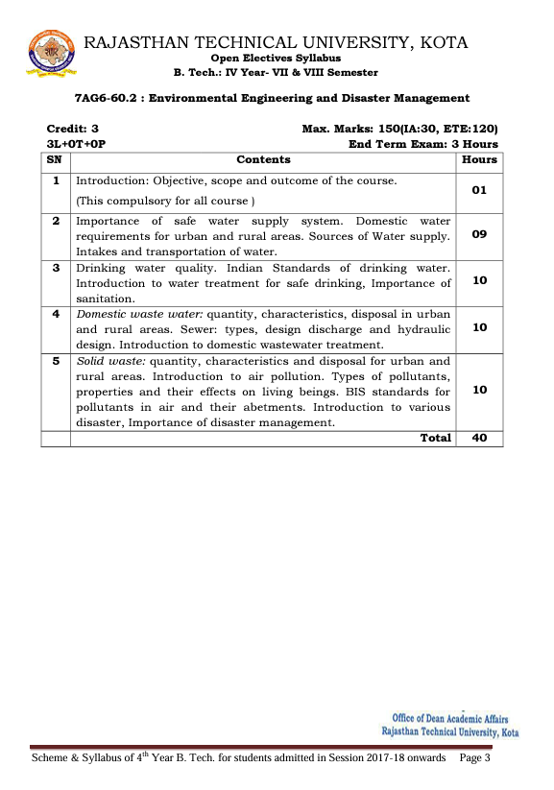

**PRESCRIBED BOOKS**

1. Water Supply Engineering - by Santosh Kumar Garg
2. Environmental Engineering - by N N Basak
3. Text Book on Waste Water Engineering - Environmental Engineering II - by Dr. Jai M Pau
4. Disaster Management - by R. Subramanian

**WEEKLY TIME TABLE OF THE TEACHER**

First Time Table: with effect from (Date):

|  |  |  |  |  |  |  |  |
| --- | --- | --- | --- | --- | --- | --- | --- |
| **Day** | **1** | **2** | **3** | **4** | **5** | **6** | **7** |
| Monday |  |  | EEDM | EG |  | CAMD LAB B1 |  |
| Tuesday | ANPC | EM | EEDM |  |  | CAMD LAB B2 |  |
| Wednesday |  | ANPC | EEDM | EM |  | CAMD LAB A1 |  |
| Thursday |  | EM | EEDM | EG |  | CAMD LAB A2 |  |
| Friday |  | EM | EG |  |  | CAMD LAB C2 |  |
| Saturday | ANPC |  | CAMD LAB C1 |  |  |  | ANPC |

Revision: 1 with effect from (Date):

|  |  |  |  |  |  |  |  |
| --- | --- | --- | --- | --- | --- | --- | --- |
| **Day** | **1** | **2** | **3** | **4** | **5** | **6** | **7** |
| Monday |  |  |  |  |  |  |  |
| Tuesday |  |  |  |  |  |  |  |
| Wednesday |  |  |  |  |  |  |  |
| Thursday |  |  |  |  |  |  |  |
| Friday |  |  |  |  |  |  |  |
| Saturday |  |  |  |  |  |  |  |

**COURSE-PLAN**

|  |  |  |  |
| --- | --- | --- | --- |
| UNIT | Lect.  No. | TOPICS | **Teaching Methods/ Teaching Aids** |
| 1 | **1** | Introduction: Objective, scope and outcomes of course. | PPT |
| 2 | 2 | Safe water supply:  Introduction of safe water. | PPT |
| 2 | 3 | Importance of safe water system. | PPT |
| 2 | 4 | Domestic water requirements for urban. | PPT |
| 2 | 5 | Domestic water requirements for Rural. | PPT |
| 2 | 6 | Important water sources. | PPT |
| 2 | 7 | Intake of water sources. | PPT |
| 2 | 8 | transportation and supply of water | PPT |
| 2 | 9 | Revision of the chapter | PPT |
| 2 | 10 | Class test of the chapter. | PPT |
| 3 | 11 | Drinking water quality: Introduction of pure water. | PPT |
| 3 | 12 | Quality of drinking water. | PPT |
| 3 | 13 | Indian standard quality of drinking water. | PPT |
| 3 | 14 | Introduction of water treatment plant. | PPT |
| 3 | 15 | Types of water treatment methods. | PPT |
| 3 | 16 | Characteristics of pure water. | PPT |
| 3 | 17 | Importance of sanitation. | PPT |
| 3 | 18 | Introduction of sanitation | PPT |
| 3 | 19 | Revision of the chapter. | PPT |
| 3 | 20 | Class test of the chapter. | PPT |
| 4 | 21 | Domestic wastewater: Introduction. | PPT |
| 4 | 22 | Quantity of domestic wastewater. | PPT |
| 4 | 23 | Characteristics of wastewater. | PPT |
| 4 | 24 | Disposal of wastewater in urban. Urban. | PPT |
| 4 | 25 | Disposal of wastewater in rural. | PPT |
| 4 | 26 | Introduction of sewer. | PPT |
| 4 | 27 | types of sewers | PPT |
| 4 | 28 | Discharge and Hydraulic design of sewer. | PPT |
| 4 | 29 | Introduction to domestic wastewater treatment. | PPT |
| 4 | 30 | Revision of the chapter. | PPT |
| 5 | **31** | Solid waste: Introduction. | PPT |
| 5 | 31 | Quantity of solid waste. | PPT |
| 5 | 33 | Characteristics of solid waste. | PPT |
| 5 | 34 | Disposal of solid waste in urban and rural. | PPT |
| 5 | 35 | Introduction of Air pollution and type of pollutants. | PPT |
| 5 | 36 | Properties and effects of pollutants on living beings. | PPT |
| 5 | 37 | BIS standard of pollutants of air and their abetment. | PPT |
| 5 | 38 | Introduction of various disaster. | PPT |
| 5 | 39 | Importance of disaster management and revision. | PPT |
| 5 | 40 | Class test of the chapter. | PPT |

**Signature of Faculty: Signature of HOD**

**Assignment – 1 ()**

1. Explain the significance of a safe water supply system in both urban and rural areas, highlighting its impact on public health and community development.
2. Compare and contrast the domestic water requirements for urban and rural areas, considering factors such as population density, infrastructure, and socio-economic conditions.
3. Describe the various sources of water supply available for both urban and rural regions, discussing their reliability, sustainability, and potential challenges.
4. Evaluate the different methods of water intake and transportation used in water supply systems, analyzing their efficiency, cost-effectiveness, and environmental impacts.

**Assignment – 2 ()**

1. What are the key factors influencing the quantity and characteristics of domestic wastewater in both urban and rural areas? How does the disposal process differ between these settings?
2. Describe the different types of sewers used for wastewater management. How is design discharge calculated, and what considerations are essential for hydraulic design to ensure effective sewage transportation?
3. Provide an overview of domestic wastewater treatment methods. How do these methods address various pollutants and contaminants present in wastewater?
4. Discuss the quantity and characteristics of solid waste generated in urban and rural areas. How are solid waste disposal methods selected, and what factors influence their effectiveness?
5. Explain the concept of air pollution, including its sources and types of pollutants. How do these pollutants vary in terms of their properties and their impacts on human health and the environment? Additionally, discuss relevant BIS standards for air pollutants and their abetments.

**SAMPLE QUIZ QUESTIONS**

|  |  |
| --- | --- |
| 1 | How do domestic water requirements differ between urban and rural areas? |
| 2 | Describe the various sources of water supply and their significance. |
| 3 | Explain the process of water intake and transportation in a water supply system. |
| 4 | What factors influence drinking water quality and why is it important to maintain high standards? |
| 5 | What are the Indian standards for drinking water quality and how are they enforced? |
| 6 | Discuss the importance of water treatment in ensuring safe drinking water. |
| 7 | How does sanitation play a crucial role in public health maintenance? |
| 8 | What factors affect the quantity and characteristics of domestic wastewater? |
| 9 | Describe the different types of sewers used for wastewater management. |
| 10 | How is design discharge calculated for sewers and what factors influence hydraulic design considerations? |
| 11 | Provide an overview of domestic wastewater treatment methods. |
| 12 | What are the quantity and characteristics of solid waste generated in urban and rural areas? |
| 13 | How are solid waste disposal methods selected and what factors influence their effectiveness? |
| 14 | Explain the concept of air pollution and its significance. |
| 15 | What are the various types of pollutants found in the air and their properties? |
| 16 | Discuss the effects of air pollutants on living beings and the environment. |
| 17 | What are the BIS standards for air pollutants and how are they enforced? |
| 18 | Why is disaster management important, and what role does it play in mitigating the impact of various disasters on communities and environments? |

**Mid Term Paper-I**

**TECHNO INDIA NJR INSTITUTE OF TECHNOLOGY, UDAIPUR**

B. TECH 4th – YEAR (VII SEM.) – MT-I

Environmental Engineering & Disaster Management (**7AG6-60.2**) (Common for all Branch)

Time: 2 Hr. Max. Marks: 70

**Note:**

1. The paper is divided into 2 parts: Part-A and, Part-B
2. Part-A contains 10 questions and carries 2 mark each.
3. Part-B contains 5 questions. Each question is having two options and carries 10 marks each.

**Part- A** (20 Marks)

|  |  |
| --- | --- |
| 1. Define term of Environmental Engineering | CO1 |
| 1. Define Urban and Rural Areas | CO1 |
| 1. Define water | CO2 |
| 1. Define term sanitation | CO2 |
| 1. Explain about Water Demand | CO3 |
| 1. Explain about ponds | CO3 |
| 1. Explain about Lakes | CO4 |
| 1. Explain about Wastewater | CO4 |
| 1. Write about solid Waste materials | CO5 |
| 1. Write about Radioactive pollution | CO5 |

**Part- B** (50 Marks)

|  |  |
| --- | --- |
| 1. State the concept on Sources of Water supply in detail | CO1 |
| **OR** | |
| 1. State the concept on Various types of Water Demand in detail | CO1 |

|  |  |
| --- | --- |
| 1. State a note on Indian standard of drinking Water Quality | CO2 |
| **OR** | |
| 1. State a note on Water Treatment for safe drinking in detail | CO2 |

|  |  |
| --- | --- |
| 1. Explain In detail about Impotence of Sanitation | CO3 |
| **OR** | |
| 1. Write design steps of Hydraulic design of Sewers | CO3 |

|  |  |
| --- | --- |
| 1. Explain in Detail about Domestic wastewater quantity and treatment | CO4 |
| **OR** | |
| 1. Explain in detail about Types and Characteristics of Solid waste | CO4 |

|  |  |
| --- | --- |
| 1. Illustrate in detail about Air Pollution and Types of Pollutants | CO5 |
| **OR** | |
| 1. Illustrate in detail about Importance of Disaster Management | CO5 |

**Marks and Gap Analysis of Mid-Term 1**

|  |  |  |  |  |
| --- | --- | --- | --- | --- |
| **Marks and Gap Analysis of Mid-Term 1** | | | | |
| Sr. No | RTU Roll Number | Name of the Student | M-1 Marks (70) | Remark ( Remedial Class need or not – Y/N ) |
| 1 | 19ETCCS001 | ABHA RATHORE | 68 | N |
| 2 | 19ETCCS002 | ABHISHEK MAHESHWARI | 61 | N |
| 3 | 19ETCCS003 | AKSH MEHTA | 59 | N |
| 4 | 19ETCCS004 | ANIKET KOTHARI | 59 | N |
| 5 | 19ETCCS005 | AVANI GUPTA | 64 | N |
| 6 | 19ETCCS006 | BHAVESH JINDAL | 68 | N |
| 7 | 19ETCCS007 | BHAVINI JAIN | 68 | N |
| 8 | 19ETCCS008 | CHIRAG RAMEJA | 66 | N |
| 9 | 19ETCCS009 | DARSHANA JAIN | 66 | N |
| 10 | 19ETCCS012 | DHANRAJ THAWANI | 59 | N |
| 11 | 19ETCCS013 | DHARMISHTHA AJMERA | 66 | N |
| 12 | 19ETCCS014 | DIKSHA BAPNA | 68 | N |
| 13 | 19ETCCS016 | DIPESH VYAS | 59 | N |
| 14 | 19ETCCS017 | DIVYANSH NAGDA | 59 | N |
| 15 | 19ETCCS018 | DIVYANSHI THAKURANI | 64 | N |
| 16 | 19ETCCS019 | DIVYATA SANADHYA | 68 | N |
| 17 | 19ETCCS020 | DIXITA MALI | 68 | N |
| 18 | 19ETCCS021 | GANESHAM TAILOR | 59 | N |
| 19 | 19ETCCS022 | HARDIK JOSHI | 59 | N |
| 20 | 19ETCCS023 | HARSH ARORA | 59 | N |
| 21 | 19ETCCS024 | HARSHIT CHAUBISA | 66 | N |
| 22 | 19ETCCS025 | HARSHIT PALIWAL | 61 | N |
| 23 | 19ETCCS026 | HIMANSHU DADHEECH | 68 | N |
| 24 | 19ETCCS027 | HRISHITA BHANDARI | 68 | N |
| 25 | 19ETCCS028 | HUSSAIN | 68 | N |
| 26 | 19ETCCS029 | JAI KANTHALIA | 68 | N |
| 27 | 19ETCCS030 | KANISHKA JAIN | 64 | N |
| 28 | 19ETCCS032 | KRITIKA KUMAWAT | 68 | N |
| 29 | 19ETCCS033 | LAVI VASHISHTH | 68 | N |
| 30 | 19ETCCS034 | LUCKY MURDIA | 59 | N |
| 31 | 19ETCCS035 | LUTISHT JOSHI | 61 | N |
| 32 | 19ETCCS036 | MAHENDRA GEHLOT | 61 | N |
| 33 | 19ETCCS037 | MANISH SAINI | 61 | N |
| 34 | 19ETCCS038 | MILIND GOUR | 64 | N |
| 35 | 19ETCCS039 | MUGDHA KUMAWAT | 68 | N |
| 36 | 19ETCCS040 | MUSTANSIR JUKKER | 64 | N |
| 37 | 19ETCCS041 | NANDESHWARI RANAWAT | 68 | N |
| 38 | 19ETCCS042 | NAVISHREE JAIN | 66 | N |
| 39 | 19ETCCS043 | NEHA PRASAD | 59 | N |
| 40 | 19ETCCS044 | PARIDHI SHAH | 64 | N |
| 41 | 19ETCCS045 | PARTHA BISWAS | 66 | N |
| 42 | 19ETCCS046 | PRADHUMN SHARMA | 59 | N |
| 43 | 19ETCCS047 | PRAGYA SINGH YADAV | 68 | N |
| 44 | 19ETCCS048 | PRAJJWAL PALIWAL | 59 | N |
| 45 | 19ETCCS049 | PRANJAL DAK | 59 | N |
| 46 | 19ETCCS050 | PRANJAL KATHAIT | 61 | N |
| 47 | 19ETCCS051 | PRIYAL JAIN | 59 | N |
| 48 | 19ETCCS052 | PRIYANSHU UPADHYAY | 64 | N |
| 49 | 19ETCCS053 | RITIKA JAIN | 68 | N |
| 50 | 19ETCCS054 | RIYA SHARMA | 66 | N |
| 51 | 19ETCCS055 | SAKSHI PAHUJA | 64 | N |
| 52 | 19ETCCS056 | SAMEER SHEIKH | 68 | N |
| 53 | 19ETCCS057 | SANJANA PURBIA | 66 | N |
| 54 | 19ETCCS058 | SANSKRUTI JOSHI | 68 | N |
| 55 | 19ETCCS059 | SANYAM SHARMA | 66 | N |
| 56 | 19ETCCS060 | SOURABH NAGDA | 68 | N |
| 57 | 19ETCCS061 | SAURABH SISODIYA | 64 | N |
| 58 | 19ETCCS062 | SAYYAD SARFRAZ ALI | 61 | N |
| 59 | 19ETCCS064 | SHIVALIKA TAK | 59 | N |
| 60 | 19ETCCS066 | SHREYA | 68 | N |
| 61 | 19ETCCS067 | SOUMYA JAITAWAT | 68 | N |
| 62 | 19ETCCS068 | SUHANI KHETPALIA | 59 | N |
| 63 | 19ETCCS069 | TAHER SANWAR | 59 | N |
| 64 | 19ETCCS070 | TANU SHARMA | 68 | N |
| 65 | 19ETCCS071 | TARANNUM PARVEEN | 66 | N |
| 66 | 19ETCCS072 | TARUN KUMAR PALIWAL | 66 | N |
| 67 | 19ETCCS073 | TUSHAR YADAV | 61 | N |
| 68 | 19ETCCS074 | UDIT HINGER | 68 | N |
| 69 | 19ETCCS075 | UTKARSH MATHUR | 64 | N |
| 70 | 19ETCCS076 | VAIBHAV BHATNAGAR | 68 | N |
| 71 | 19ETCCS077 | VAIBHAV MISHRA | 68 | N |
| 72 | 19ETCCS078 | VAIBHAV RAJ NATH CHAUHAN | 66 | N |
| 73 | 19ETCCS080 | VIPUL KUMAR TAMBOLI | 68 | N |
| 74 | 19ETCCS081 | VISHWAJEET SINGH | 68 | N |
| 75 | 19ETCCS082 | VIVEK KUMAR | 59 | N |
| 76 | 19ETCCS083 | VYSHNAVI HON | 59 | N |
| 77 | 19ETCCS084 | YASHMITH JETHI | 61 | N |
| 78 | 19ETCCS085 | YOGESH KUMAR | 68 | N |
| 79 | 19ETCCS086 | YOGIK SHUKLA | 59 | N |
| 80 | 19ETCCS300 | ARVIND MENARIYA | 61 | N |
| 81 | 20ETCCS200 | DHRUV TALETIYA | 59 | N |
| 82 | 20ETCCS201 | DIVYANSH POKHARNA | 59 | N |
| 83 | 20ETCCS202 | JAYKISHAN | 59 | N |
| 84 | 20ETCCS203 | MUKUL MEHRA | 59 | N |

**\***(Y, if obtained marks are <50%)

**Signature of Faculty: Signature of HOD**

**Remedial Action Taken to Remove the Gaps (After Mid- Term 1)**

**Signature of Faculty: Signature of HOD**

**Mid Term Exam – II**

**Marks and Gap Analysis of Mid-Term II**

|  |  |  |  |  |
| --- | --- | --- | --- | --- |
| **Marks and Gap Analysis of Mid-Term 2** | | | | |
| Sr. No | RTU Roll Number | Name of the Student | M-1 Marks (70) | Remark ( Remedial Class need or not – Y/N ) |
| 1 | 19ETCCS001 | ABHA RATHORE | 68 | N |
| 2 | 19ETCCS002 | ABHISHEK MAHESHWARI | 61 | N |
| 3 | 19ETCCS003 | AKSH MEHTA | 59 | N |
| 4 | 19ETCCS004 | ANIKET KOTHARI | 57 | N |
| 5 | 19ETCCS005 | AVANI GUPTA | 62 | N |
| 6 | 19ETCCS006 | BHAVESH JINDAL | 68 | N |
| 7 | 19ETCCS007 | BHAVINI JAIN | 70 | N |
| 8 | 19ETCCS008 | CHIRAG RAMEJA | 64 | N |
| 9 | 19ETCCS009 | DARSHANA JAIN | 64 | N |
| 10 | 19ETCCS012 | DHANRAJ THAWANI | 57 | N |
| 11 | 19ETCCS013 | DHARMISHTHA AJMERA | 67 | N |
| 12 | 19ETCCS014 | DIKSHA BAPNA | 69 | N |
| 13 | 19ETCCS016 | DIPESH VYAS | 58 | N |
| 14 | 19ETCCS017 | DIVYANSH NAGDA | 61 | N |
| 15 | 19ETCCS018 | DIVYANSHI THAKURANI | 64 | N |
| 16 | 19ETCCS019 | DIVYATA SANADHYA | 66 | N |
| 17 | 19ETCCS020 | DIXITA MALI | 70 | N |
| 18 | 19ETCCS021 | GANESHAM TAILOR | 59 | N |
| 19 | 19ETCCS022 | HARDIK JOSHI | 57 | N |
| 20 | 19ETCCS023 | HARSH ARORA | 60 | N |
| 21 | 19ETCCS024 | HARSHIT CHAUBISA | 64 | N |
| 22 | 19ETCCS025 | HARSHIT PALIWAL | 60 | N |
| 23 | 19ETCCS026 | HIMANSHU DADHEECH | 68 | N |
| 24 | 19ETCCS027 | HRISHITA BHANDARI | 67 | N |
| 25 | 19ETCCS028 | HUSSAIN | 68 | N |
| 26 | 19ETCCS029 | JAI KANTHALIA | 68 | N |
| 27 | 19ETCCS030 | KANISHKA JAIN | 63 | N |
| 28 | 19ETCCS032 | KRITIKA KUMAWAT | 68 | N |
| 29 | 19ETCCS033 | LAVI VASHISHTH | 70 | N |
| 30 | 19ETCCS034 | LUCKY MURDIA | 58 | N |
| 31 | 19ETCCS035 | LUTISHT JOSHI | 59 | N |
| 32 | 19ETCCS036 | MAHENDRA GEHLOT | 63 | N |
| 33 | 19ETCCS037 | MANISH SAINI | 60 | N |
| 34 | 19ETCCS038 | MILIND GOUR | 65 | N |
| 35 | 19ETCCS039 | MUGDHA KUMAWAT | 69 | N |
| 36 | 19ETCCS040 | MUSTANSIR JUKKER | 62 | N |
| 37 | 19ETCCS041 | NANDESHWARI RANAWAT | 69 | N |
| 38 | 19ETCCS042 | NAVISHREE JAIN | 68 | N |
| 39 | 19ETCCS043 | NEHA PRASAD | 58 | N |
| 40 | 19ETCCS044 | PARIDHI SHAH | 64 | N |
| 41 | 19ETCCS045 | PARTHA BISWAS | 66 | N |
| 42 | 19ETCCS046 | PRADHUMN SHARMA | 58 | N |
| 43 | 19ETCCS047 | PRAGYA SINGH YADAV | 67 | N |
| 44 | 19ETCCS048 | PRAJJWAL PALIWAL | 61 | N |
| 45 | 19ETCCS049 | PRANJAL DAK | 58 | N |
| 46 | 19ETCCS050 | PRANJAL KATHAIT | 63 | N |
| 47 | 19ETCCS051 | PRIYAL JAIN | 60 | N |
| 48 | 19ETCCS052 | PRIYANSHU UPADHYAY | 66 | N |
| 49 | 19ETCCS053 | RITIKA JAIN | 67 | N |
| 50 | 19ETCCS054 | RIYA SHARMA | 66 | N |
| 51 | 19ETCCS055 | SAKSHI PAHUJA | 64 | N |
| 52 | 19ETCCS056 | SAMEER SHEIKH | 66 | N |
| 53 | 19ETCCS057 | SANJANA PURBIA | 64 | N |
| 54 | 19ETCCS058 | SANSKRUTI JOSHI | 69 | N |
| 55 | 19ETCCS059 | SANYAM SHARMA | 68 | N |
| 56 | 19ETCCS060 | SOURABH NAGDA | 67 | N |
| 57 | 19ETCCS061 | SAURABH SISODIYA | 64 | N |
| 58 | 19ETCCS062 | SAYYAD SARFRAZ ALI | 63 | N |
| 59 | 19ETCCS064 | SHIVALIKA TAK | 61 | N |
| 60 | 19ETCCS066 | SHREYA | 68 | N |
| 61 | 19ETCCS067 | SOUMYA JAITAWAT | 67 | N |
| 62 | 19ETCCS068 | SUHANI KHETPALIA | 58 | N |
| 63 | 19ETCCS069 | TAHER SANWAR | 61 | N |
| 64 | 19ETCCS070 | TANU SHARMA | 68 | N |
| 65 | 19ETCCS071 | TARANNUM PARVEEN | 64 | N |
| 66 | 19ETCCS072 | TARUN KUMAR PALIWAL | 67 | N |
| 67 | 19ETCCS073 | TUSHAR YADAV | 60 | N |
| 68 | 19ETCCS074 | UDIT HINGER | 69 | N |
| 69 | 19ETCCS075 | UTKARSH MATHUR | 65 | N |
| 70 | 19ETCCS076 | VAIBHAV BHATNAGAR | 69 | N |
| 71 | 19ETCCS077 | VAIBHAV MISHRA | 70 | N |
| 72 | 19ETCCS078 | VAIBHAV RAJ NATH CHAUHAN | 68 | N |
| 73 | 19ETCCS080 | VIPUL KUMAR TAMBOLI | 70 | N |
| 74 | 19ETCCS081 | VISHWAJEET SINGH | 69 | N |
| 75 | 19ETCCS082 | VIVEK KUMAR | 57 | N |
| 76 | 19ETCCS083 | VYSHNAVI HON | 57 | N |
| 77 | 19ETCCS084 | YASHMITH JETHI | 60 | N |
| 78 | 19ETCCS085 | YOGESH KUMAR | 66 | N |
| 79 | 19ETCCS086 | YOGIK SHUKLA | 60 | N |
| 80 | 19ETCCS300 | ARVIND MENARIYA | 59 | N |
| 81 | 20ETCCS200 | DHRUV TALETIYA | 57 | N |
| 82 | 20ETCCS201 | DIVYANSH POKHARNA | 60 | N |
| 83 | 20ETCCS202 | JAYKISHAN | 59 | N |
| 84 | 20ETCCS203 | MUKUL MEHRA | 59 | N |

**\***(Y, if obtained marks are <50%)

**Signature of Faculty: Signature of HOD**

**Remedial Action Taken to Remove the Gaps (After Mid- Term 1I)**

**Signature of Faculty: Signature of HOD**

**Model Question Paper**

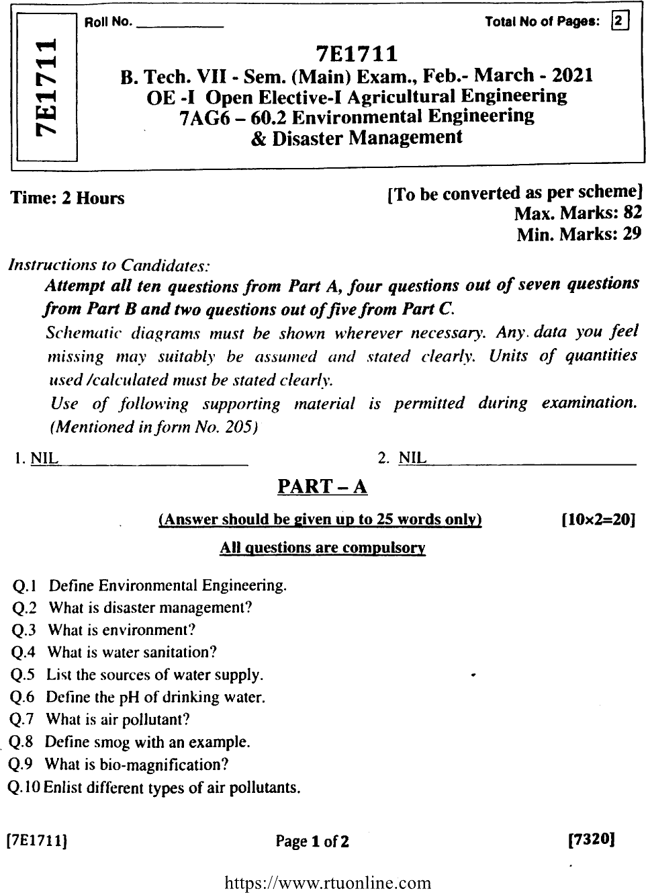

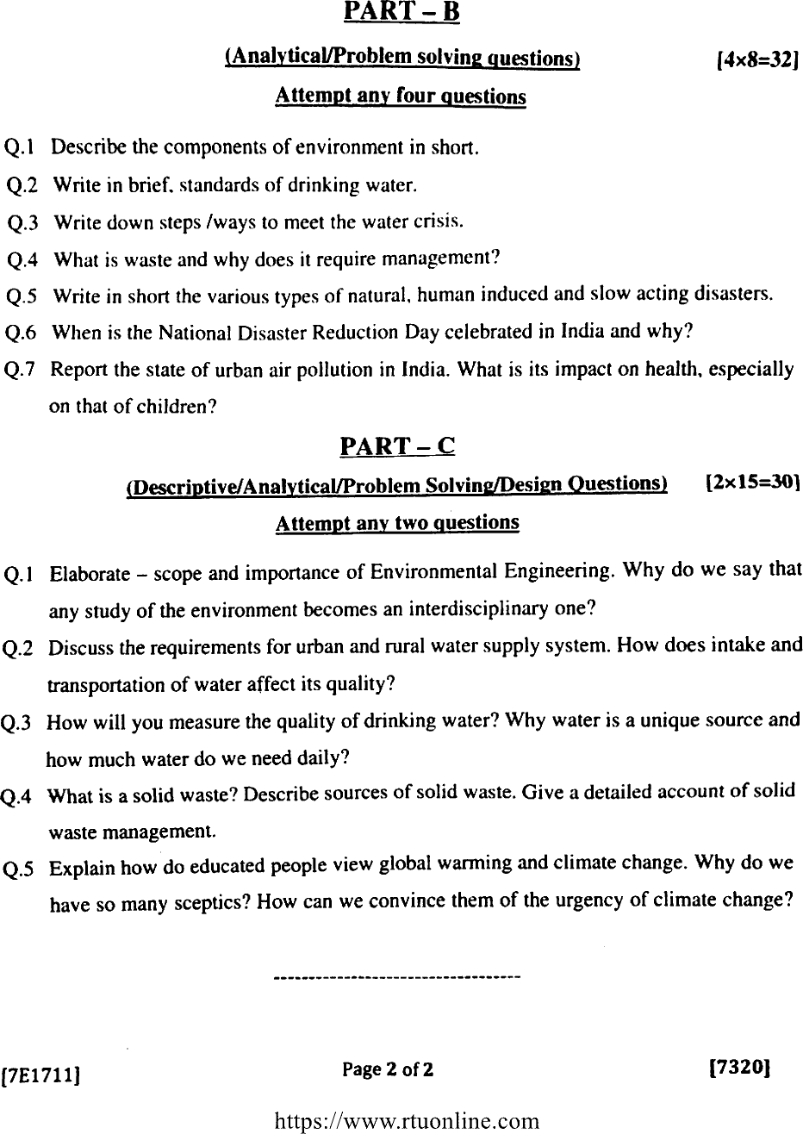

**STUDENT PERFORMANCE REPORT**

|  |  |  |  |  |  |  |
| --- | --- | --- | --- | --- | --- | --- |
| **ROLL NO.** | **NAME** | **I-MID** | **II-MID** | **AVG** | **ASSIGNMENT** | **OUT OF MARKS 50** |
| 19ETCCS001 | ABHA RATHORE | 27 | 26 | 27 | 15 | 42 |
| 19ETCCS002 | ABHISHEK MAHESHWARI | 30 | 29 | 30 | 17 | 47 |
| 19ETCCS003 | AKSH MEHTA | 22 | 21 | 22 | 18 | 40 |
| 19ETCCS004 | ANIKET KOTHARI | 22 | 21 | 22 | 19 | 41 |
| 19ETCCS005 | AVANI GUPTA | 20 | 19 | 20 | 19 | 39 |
| 19ETCCS006 | BHAVESH JINDAL | 20 | 19 | 20 | 17 | 37 |
| 19ETCCS007 | BHAVINI JAIN | 24 | 23 | 24 | 16 | 40 |
| 19ETCCS008 | CHIRAG RAMEJA | 29 | 28 | 29 | 15 | 44 |
| 19ETCCS009 | DARSHANA JAIN | 30 | 29 | 30 | 15 | 45 |
| 19ETCCS012 | DHANRAJ THAWANI | 20 | 19 | 20 | 17 | 37 |
| 19ETCCS013 | DHARMISHTHA AJMERA | 20 | 19 | 20 | 16 | 36 |
| 19ETCCS014 | DIKSHA BAPNA | 20 | 19 | 20 | 20 | 40 |
| 19ETCCS016 | DIPESH VYAS | 29 | 28 | 29 | 19 | 48 |
| 19ETCCS017 | DIVYANSH NAGDA | 30 | 29 | 30 | 19 | 49 |
| 19ETCCS018 | DIVYANSHI THAKURANI | 20 | 19 | 20 | 20 | 40 |
| 19ETCCS019 | DIVYATA SANADHYA | 22 | 21 | 22 | 18 | 40 |
| 19ETCCS020 | DIXITA MALI | 20 | 19 | 20 | 19 | 39 |
| 19ETCCS021 | GANESHAM TAILOR | 20 | 19 | 20 | 18 | 38 |
| 19ETCCS022 | HARDIK JOSHI | 30 | 29 | 30 | 16 | 46 |
| 19ETCCS023 | HARSH ARORA | 22 | 21 | 22 | 18 | 40 |
| 19ETCCS024 | HARSHIT CHAUBISA | 30 | 29 | 30 | 20 | 50 |
| 19ETCCS025 | HARSHIT PALIWAL | 23 | 22 | 23 | 17 | 40 |
| 19ETCCS026 | HIMANSHU DADHEECH | 22 | 21 | 22 | 17 | 39 |
| 19ETCCS027 | HRISHITA BHANDARI | 20 | 19 | 20 | 20 | 40 |
| 19ETCCS028 | HUSSAIN | 29 | 28 | 29 | 19 | 48 |
| 19ETCCS029 | JAI KANTHALIA | 22 | 21 | 22 | 19 | 41 |
| 19ETCCS030 | KANISHKA JAIN | 29 | 28 | 29 | 19 | 48 |
| 19ETCCS032 | KRITIKA KUMAWAT | 20 | 19 | 20 | 15 | 35 |
| 19ETCCS033 | LAVI VASHISHTH | 0 | 0 | 0 | 15 | 15 |
| 19ETCCS034 | LUCKY MURDIA | 22 | 21 | 22 | 16 | 38 |
| 19ETCCS035 | LUTISHT JOSHI | 20 | 19 | 20 | 15 | 35 |
| 19ETCCS036 | MAHENDRA GEHLOT | 22 | 21 | 22 | 15 | 37 |
| 19ETCCS037 | MANISH SAINI | 29 | 28 | 29 | 20 | 49 |
| 19ETCCS038 | MILIND GOUR | 29 | 28 | 29 | 15 | 44 |
| 19ETCCS039 | MUGDHA KUMAWAT | 29 | 28 | 29 | 18 | 47 |
| 19ETCCS040 | MUSTANSIR JUKKER | 20 | 19 | 20 | 18 | 38 |
| 19ETCCS041 | NANDESHWARI RANAWAT | 20 | 19 | 20 | 19 | 39 |
| 19ETCCS042 | NAVISHREE JAIN | 24 | 23 | 24 | 19 | 43 |
| 19ETCCS043 | NEHA PRASAD | 29 | 28 | 29 | 20 | 49 |
| 19ETCCS044 | PARIDHI SHAH | 30 | 29 | 30 | 19 | 49 |
| 19ETCCS045 | PARTHA BISWAS | 20 | 19 | 20 | 18 | 38 |
| 19ETCCS046 | PRADHUMN SHARMA | 20 | 19 | 20 | 20 | 40 |
| 19ETCCS047 | PRAGYA SINGH YADAV | 20 | 19 | 20 | 15 | 35 |
| 19ETCCS048 | PRAJJWAL PALIWAL | 22 | 21 | 22 | 20 | 42 |
| 19ETCCS049 | PRANJAL DAK | 29 | 28 | 29 | 18 | 47 |
| 19ETCCS050 | PRANJAL KATHAIT | 20 | 19 | 20 | 17 | 37 |
| 19ETCCS051 | PRIYAL JAIN | 27 | 26 | 27 | 15 | 42 |
| 19ETCCS052 | PRIYANSHU UPADHYAY | 29 | 28 | 29 | 20 | 49 |
| 19ETCCS053 | RITIKA JAIN | 29 | 28 | 29 | 17 | 46 |
| 19ETCCS054 | RIYA SHARMA | 29 | 28 | 29 | 16 | 45 |
| 19ETCCS055 | SAKSHI PAHUJA | 28 | 27 | 28 | 19 | 47 |
| 19ETCCS056 | SAMEER SHEIKH | 22 | 21 | 22 | 17 | 39 |
| 19ETCCS057 | SANJANA PURBIA | 28 | 27 | 28 | 20 | 48 |
| 19ETCCS058 | SANSKRUTI JOSHI | 20 | 19 | 20 | 17 | 37 |
| 19ETCCS059 | SANYAM SHARMA | 27 | 26 | 27 | 19 | 46 |
| 19ETCCS060 | SOURABH NAGDA | 28 | 27 | 28 | 20 | 48 |
| 19ETCCS061 | SAURABH SISODIYA | 29 | 28 | 29 | 18 | 47 |
| 19ETCCS062 | SAYYAD SARFRAZ ALI | 20 | 19 | 20 | 20 | 40 |
| 19ETCCS064 | SHIVALIKA TAK | 20 | 19 | 20 | 19 | 39 |
| 19ETCCS066 | SHREYA | 20 | 19 | 20 | 16 | 36 |
| 19ETCCS067 | SOUMYA JAITAWAT | 20 | 19 | 20 | 20 | 40 |
| 19ETCCS068 | SUHANI KHETPALIA | 20 | 19 | 20 | 18 | 38 |
| 19ETCCS069 | TAHER SANWAR | 20 | 19 | 20 | 16 | 36 |
| 19ETCCS070 | TANU SHARMA | 20 | 19 | 20 | 19 | 39 |
| 19ETCCS071 | TARANNUM PARVEEN | 28 | 27 | 28 | 18 | 46 |
| 19ETCCS072 | TARUN KUMAR PALIWAL | 0 | 0 | 0 | 19 | 19 |
| 19ETCCS073 | TUSHAR YADAV | 22 | 21 | 22 | 20 | 42 |
| 19ETCCS074 | UDIT HINGER | 20 | 19 | 20 | 19 | 39 |
| 19ETCCS075 | UTKARSH MATHUR | 24 | 23 | 24 | 17 | 41 |
| 19ETCCS076 | VAIBHAV BHATNAGAR | 20 | 19 | 20 | 15 | 35 |
| 19ETCCS077 | VAIBHAV MISHRA | 20 | 19 | 20 | 17 | 37 |
| 19ETCCS078 | VAIBHAV RAJ NATH CHAUHAN | 30 | 29 | 30 | 17 | 47 |
| 19ETCCS080 | VIPUL KUMAR TAMBOLI | 20 | 19 | 20 | 15 | 35 |
| 19ETCCS081 | VISHWAJEET SINGH | 20 | 19 | 20 | 16 | 36 |
| 19ETCCS082 | VIVEK KUMAR | 30 | 29 | 30 | 20 | 50 |
| 19ETCCS083 | VYSHNAVI HON | 28 | 27 | 28 | 16 | 44 |
| 19ETCCS084 | YASHMITH JETHI | 20 | 19 | 20 | 16 | 36 |
| 19ETCCS085 | YOGESH KUMAR | 22 | 21 | 22 | 19 | 41 |
| 19ETCCS086 | YOGIK SHUKLA | 22 | 21 | 22 | 15 | 37 |
| 19ETCCS300 | ARVIND MENARIYA | 20 | 19 | 20 | 19 | 39 |
| 20ETCCS200 | DHRUV TALETIYA | 20 | 19 | 20 | 16 | 36 |
| 20ETCCS201 | DIVYANSH POKHARNA | 20 | 19 | 20 | 19 | 39 |
| 20ETCCS202 | JAYKISHAN | 20 | 19 | 20 | 16 | 36 |
| 20ETCCS203 | MUKUL MEHRA | 20 | 19 | 20 | 17 | 37 |

|  |
| --- |
|  |
|  |

**Signature of Faculty: Signature of HOD**

**RESULT ANALYSIS**

|  |  |  |  |  |  |
| --- | --- | --- | --- | --- | --- |
| **S.NO.** | **RTU ROLL NUMBER** | **NAME OF STUDENT** | **END TERM MARKS** | **SESSIONAL MARKS** | **TOTAL** |
| **MAX MARKS** | **120** | **30** | **150** |
| **Set Target Level** | | | **60%** | **75%** |  |
| 1 | 19ETCCS001 | ABHA RATHORE | 69 | 29 | 98 |
| 2 | 19ETCCS002 | ABHISHEK MAHESHWARI | 72 | 26 | 98 |
| 3 | 19ETCCS003 | AKSH MEHTA | 66 | 25 | 91 |
| 4 | 19ETCCS004 | ANIKET KOTHARI | 58 | 25 | 83 |
| 5 | 19ETCCS005 | AVANI GUPTA | 59 | 27 | 86 |
| 6 | 19ETCCS006 | BHAVESH JINDAL | 64 | 29 | 93 |
| 7 | 19ETCCS007 | BHAVINI JAIN | 69 | 29 | 98 |
| 8 | 19ETCCS008 | CHIRAG RAMEJA | 73 | 28 | 101 |
| 9 | 19ETCCS009 | DARSHANA JAIN | 63 | 28 | 91 |
| 10 | 19ETCCS012 | DHANRAJ THAWANI | 68 | 25 | 93 |
| 11 | 19ETCCS013 | DHARMISHTHA AJMERA | 47 | 28 | 75 |
| 12 | 19ETCCS014 | DIKSHA BAPNA | 78 | 29 | 107 |
| 13 | 19ETCCS016 | DIPESH VYAS | 3 | 25 | 28 |
| 14 | 19ETCCS017 | DIVYANSH NAGDA | 19 | 25 | 44 |
| 15 | 19ETCCS018 | DIVYANSHI THAKURANI | 50 | 27 | 77 |
| 16 | 19ETCCS019 | DIVYATA SANADHYA | 67 | 29 | 96 |
| 17 | 19ETCCS020 | DIXITA MALI | 70 | 29 | 99 |
| 18 | 19ETCCS021 | GANESHAM TAILOR | 84 | 25 | 109 |
| 19 | 19ETCCS022 | HARDIK JOSHI | 48 | 25 | 73 |
| 20 | 19ETCCS023 | HARSH ARORA | 84 | 25 | 109 |
| 21 | 19ETCCS024 | HARSHIT CHAUBISA | 80 | 28 | 108 |
| 22 | 19ETCCS025 | HARSHIT PALIWAL | 59 | 26 | 85 |
| 23 | 19ETCCS026 | HIMANSHU DADHEECH | 84 | 29 | 113 |
| 24 | 19ETCCS027 | HRISHITA BHANDARI | 68 | 29 | 97 |
| 25 | 19ETCCS028 | HUSSAIN | 75 | 29 | 104 |
| 26 | 19ETCCS029 | JAI KANTHALIA | 46 | 29 | 75 |
| 27 | 19ETCCS030 | KANISHKA JAIN | 82 | 27 | 109 |
| 28 | 19ETCCS032 | KRITIKA KUMAWAT | 87 | 29 | 116 |
| 29 | 19ETCCS033 | LAVI VASHISHTH | 94 | 29 | 123 |
| 30 | 19ETCCS034 | LUCKY MURDIA | 66 | 25 | 91 |
| 31 | 19ETCCS035 | LUTISHT JOSHI | 66 | 26 | 92 |
| 32 | 19ETCCS036 | MAHENDRA GEHLOT | 66 | 26 | 92 |
| 33 | 19ETCCS037 | MANISH SAINI | 73 | 26 | 99 |
| 34 | 19ETCCS038 | MILIND GOUR | 64 | 27 | 91 |
| 35 | 19ETCCS039 | MUGDHA KUMAWAT | 72 | 29 | 101 |
| 36 | 19ETCCS040 | MUSTANSIR JUKKER | 66 | 27 | 93 |
| 37 | 19ETCCS041 | NANDESHWARI RANAWAT | 66 | 29 | 95 |
| 38 | 19ETCCS042 | NAVISHREE JAIN | 47 | 28 | 75 |
| 39 | 19ETCCS043 | NEHA PRASAD | 62 | 25 | 87 |
| 40 | 19ETCCS044 | PARIDHI SHAH | 65 | 27 | 92 |
| 41 | 19ETCCS045 | PARTHA BISWAS | 53 | 28 | 81 |
| 42 | 19ETCCS046 | PRADHUMN SHARMA | 62 | 25 | 87 |
| 43 | 19ETCCS047 | PRAGYA SINGH YADAV | 77 | 29 | 106 |
| 44 | 19ETCCS048 | PRAJJWAL PALIWAL | 74 | 25 | 99 |
| 45 | 19ETCCS049 | PRANJAL DAK | 62 | 25 | 87 |
| 46 | 19ETCCS050 | PRANJAL KATHAIT | 53 | 26 | 79 |
| 47 | 19ETCCS051 | PRIYAL JAIN | 56 | 25 | 81 |
| 48 | 19ETCCS052 | PRIYANSHU UPADHYAY | 71 | 27 | 98 |
| 49 | 19ETCCS053 | RITIKA JAIN | 64 | 29 | 93 |
| 50 | 19ETCCS054 | RIYA SHARMA | 64 | 28 | 92 |
| 51 | 19ETCCS055 | SAKSHI PAHUJA | 65 | 27 | 92 |
| 52 | 19ETCCS056 | SAMEER SHEIKH | 53 | 29 | 82 |
| 53 | 19ETCCS057 | SANJANA PURBIA | 44 | 28 | 72 |
| 54 | 19ETCCS058 | SANSKRUTI JOSHI | 55 | 29 | 84 |
| 55 | 19ETCCS059 | SANYAM SHARMA | 51 | 28 | 79 |
| 56 | 19ETCCS060 | SOURABH NAGDA | 60 | 29 | 89 |
| 57 | 19ETCCS061 | SAURABH SISODIYA | 69 | 27 | 96 |
| 58 | 19ETCCS062 | SAYYAD SARFRAZ ALI | 54 | 26 | 80 |
| 59 | 19ETCCS064 | SHIVALIKA TAK | 83 | 25 | 108 |
| 60 | 19ETCCS066 | SHREYA | 81 | 29 | 110 |
| 61 | 19ETCCS067 | SOUMYA JAITAWAT | 97 | 29 | 126 |
| 62 | 19ETCCS068 | SUHANI KHETPALIA | 80 | 25 | 105 |
| 63 | 19ETCCS069 | TAHER SANWAR | 78 | 25 | 103 |
| 64 | 19ETCCS070 | TANU SHARMA | 77 | 29 | 106 |
| 65 | 19ETCCS071 | TARANNUM PARVEEN | 74 | 28 | 102 |
| 66 | 19ETCCS072 | TARUN KUMAR PALIWAL | 72 | 28 | 100 |
| 67 | 19ETCCS073 | TUSHAR YADAV | 51 | 26 | 77 |
| 68 | 19ETCCS074 | UDIT HINGER | 72 | 29 | 101 |
| 69 | 19ETCCS075 | UTKARSH MATHUR | 64 | 27 | 91 |
| 70 | 19ETCCS076 | VAIBHAV BHATNAGAR | 64 | 29 | 93 |
| 71 | 19ETCCS077 | VAIBHAV MISHRA | 64 | 29 | 93 |
| 72 | 19ETCCS078 | VAIBHAV RAJ NATH CHAUHAN | 76 | 28 | 104 |
| 73 | 19ETCCS080 | VIPUL KUMAR TAMBOLI | 85 | 29 | 114 |
| 74 | 19ETCCS081 | VISHWAJEET SINGH | 91 | 29 | 120 |
| 75 | 19ETCCS082 | VIVEK KUMAR | 77 | 25 | 102 |
| 76 | 19ETCCS083 | VYSHNAVI HON | 68 | 25 | 93 |
| 77 | 19ETCCS084 | YASHMITH JETHI | 61 | 26 | 87 |
| 78 | 19ETCCS085 | YOGESH KUMAR | 69 | 29 | 98 |
| 79 | 19ETCCS086 | YOGIK SHUKLA | 53 | 25 | 78 |
| 80 | 19ETCCS300 | ARVIND MENARIYA | 59 | 26 | 85 |
| 81 | 20ETCCS200 | DHRUV TALETIYA | 42 | 25 | 67 |
| 82 | 20ETCCS201 | DIVYANSH POKHARNA | 56 | 25 | 81 |
| 83 | 20ETCCS202 | JAYKISHAN | 49 | 25 | 74 |
| 84 | 20ETCCS203 | MUKUL MEHRA | 49 | 25 | 74 |

|  |  |  |  |  |
| --- | --- | --- | --- | --- |
| TOTAL | PASS | FAIL | ABSENT | PASS % |
| 84 | 84 | 0 | 0 | 100 |

**Indirect Assessment:**

**Overall Teacher Self Assessment (at the completion of course) in terms of course objective and outcomes**

**Course Objectives:**

To understand the fundamental concepts of water supply system.

To learn about designing concepts of waste water systems.

To lean the importance of SWM and various pollutions.

To learn about various disasters and mitigation methods .

**Course Outcomes**:

Students can explain the theory and principles fresh water supply.

Students can design the waste water channels.

Students can implement a basic knowledge about solid waste and pollutions.

Students can explain how to mitigate a disaster.

**Methodology to identify bright student**

Considered a range of criteria, including academic performance, creativity, critical thinking, problem-solving skills, and enthusiasm for learning. Bright students often excel in multiple areas.Observed how students perform in the classroom. In terms of active participation, engagement in discussions, leadership, and the ability to grasp complex concepts.

**Efforts to keep students engaged**

1. Active Learning:
   * Incorporate active learning strategies, such as group discussions, problem-solving activities, and hands-on projects. Active participation keeps students engaged and encourages critical thinking.
2. Varied Teaching Methods:
   * Use a variety of teaching methods, including lectures, group work, multimedia presentations, and interactive activities to cater to different learning preferences.
3. Technology Integration:
   * Leverage technology, such as online platforms, educational apps, and interactive software, to make lessons more engaging and interactive.

**Methodology to identify weak student**

Considered a range of criteria, including classroom observation, formative assessment, summative assessment, assignment review e.t.c. Weak students are struggling students with sensitivity and a desire to support their learning. Some measures, such as additional tutoring, personalized assignments, or alternative assessment methods, to help students succeed.

**Targeted inventions for weak student**

**1. Additional Resources**

Offer supplementary learning materials, such as textbooks, online resources, or multimedia content, to provide alternative explanations and reinforce key concepts.

**2. Remedial classes**

Establish a tutoring program where students can receive extra help from teachers.

**3. Flipped classroom**

Students are assigned pre-class learning materials, often in the form of videos, readings, or online modules, to cover the foundational concepts before coming to class.