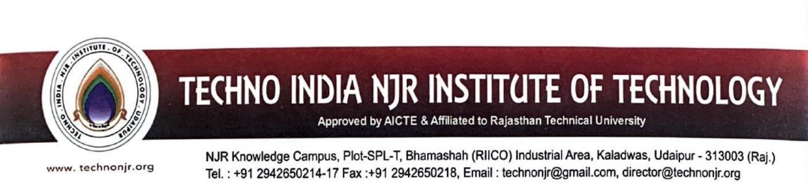

**Date: - 25-06-2024**

**To Whomsoever It May Concern**

|  |  |
| --- | --- |
| Metric ID: 1.1.3 | **Teachers of the Institution participate in following activities related to curriculum**  **development and assessment of the affiliating University and/are represented on the following**  **academic bodies during the last five years**  **1.Academic council/BoS of Affiliating university**  **2.Setting of question papers for UG/PG programs**  **3.Design and Development of Curriculum for Add on/ certificate/ Diploma Courses**  **4.Assessment /evaluation process of the affiliating University** |

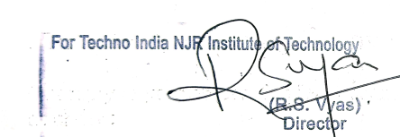



Teachers of the institution participate in following activities related to curriculum development and assessment of the affiliating university and/are represented on the following academic bodies during the last academic year 2023-2024.

|  |  |  |  |
| --- | --- | --- | --- |
| **DD-MM-YYYY** | **Name of the teacher participated** | **Name of the body in which full time teacher participated** | **Supporting Document** |
| 10-08-2023 | Dr. Vivek Jain | Maharana Pratap University of Agriculture and Technology, Udaipur, Rajasthan, Copies Examine of VLSI Technologuy, IV Year B.Tech. | <https://iqac.technonjr.org/aqar/2023-24/part-b/1.1.3/> |
| 16-10-2023 | Dr. Vivek Jain | Maharana Pratap University of Agriculture and Technology, Udaipur, Rajasthan, Copies Examine of Mobile Communication, IV Year B.Tech. |
| 27-10-2023 | Dr. Vivek Jain | Maharana Pratap University of Agriculture and Technology, Udaipur, Rajasthan, Copies Examine of Pulse Wave Shapping Circuit, III Year B.Tech. |
| 18-12-2023 | Dr. Vivek Jain | Maharana Pratap University of Agriculture and Technology, Udaipur, Rajasthan, Copies Examine of Radar and TV Engineering , IV Year B.Tech. |
| 12-2-2024 | Dr. Vivek Jain | Maharana Pratap University of Agriculture and Technology, Udaipur, Rajasthan, Copies Examine of VLSI Technology, IV Year B.Tech. |
| 08-02-2024 | Dr. Vivek Jain | Maharana Pratap University of Agriculture and Technology, Udaipur, Rajasthan, Copies Examine of Industrial Electronics, III Year B.Tech. |
| 22-05-2024 | Dr. Vivek Jain | Maharana Pratap University of Agriculture and Technology, Udaipur, Rajasthan, Copies Examine of Microwave Theory & Techniques |

