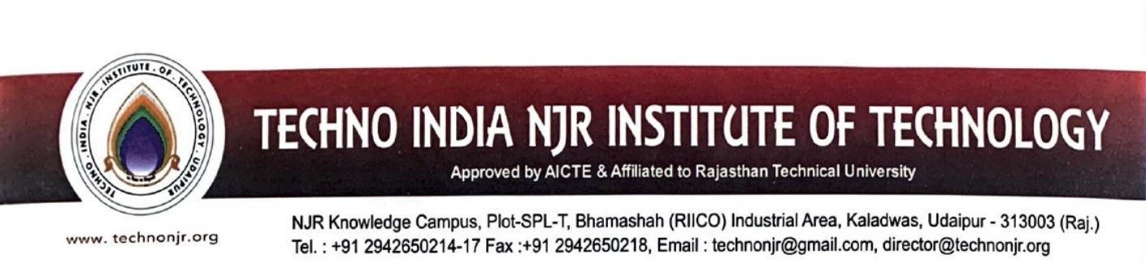

Date: 5 July, 2024

**TO WHOMSOEVER IT MAY CONCERN**

This is to declare that although there is formal MoU signed by the institute with the below listed companies, but as per the attached email confirmations the companies agreed to provide internship to the selected students.

Following is the list of the MoUs attached.

|  |  |
| --- | --- |
| S. No. | Name of Collaboration Institute /Industry |
| 1 | Cenetric |
| 2 | College Dunia |
| 3 | Entrepreneurship Cell, IIT Karagpur |
| 4 | Paccific Institute of Medical Sciences |
| 5 | GHH India Minig and Tunnelling Equipment Private Limited |
| 6 | Secure Meters Limited |

