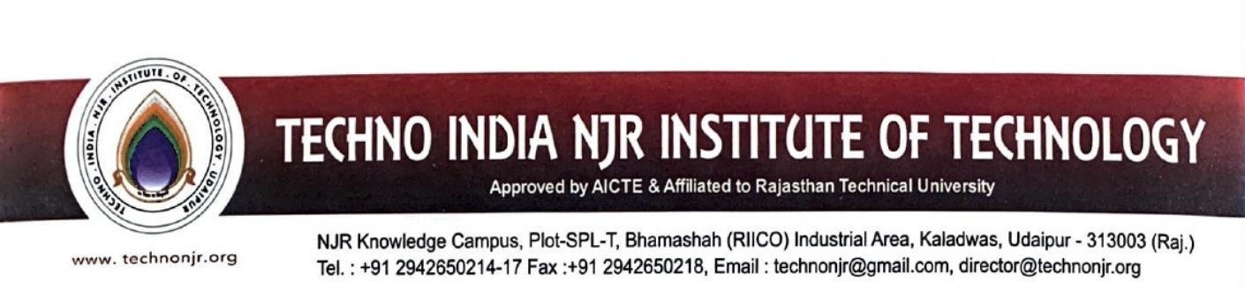

**Date:-09-7-2024**

**To Whomsoever it May Concern**

Techno India NJR Institute of Technology ensures effective Programme curriculum prescribed by Rajasthan Technical University Kota. The detailed syllabus of the courses is available at

<https://iqac.technonjr.org/naac/1/1.3.3/>

