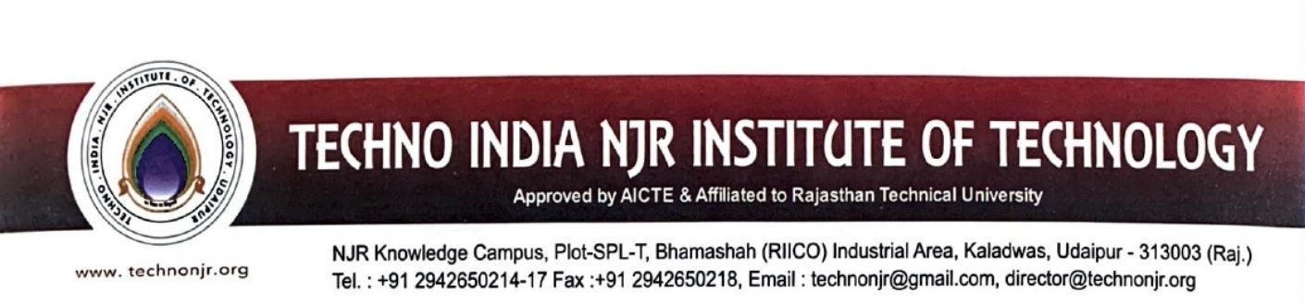

**Date:-27-6-2024**

**To Whomsoever it May Concern**

Techno India NJR Institute of Technology ensures obtains feedback on the syllabus and its transaction at the institution from the following stakeholders

1. Students
2. Teachers
3. Employers
4. Alumni

The detailed feedback report is available at

<https://iqac.technonjr.org/aqar/2023-24/part-b/1.4.1/>

