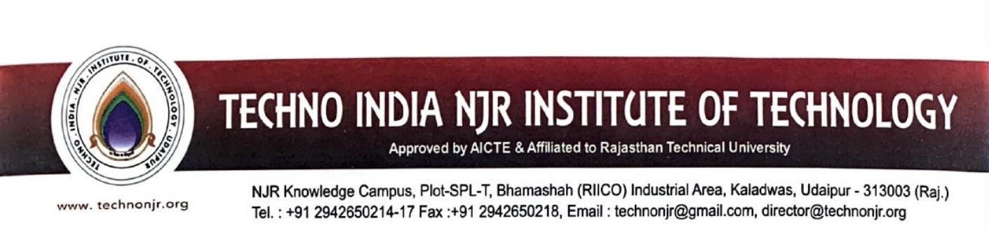

**Date: 11-02-2024**

**TO WHOMSOEVER IT MAY CONCERN**

Techno India NJR Institute of Technology ensures effective Programme curriculum prescribed by Rajasthan Technical University Kota. The detailed syllabus of the courses is available at :

<https://iqac.technonjr.org/naac/1/1.3.2/>

