

### MINUTES OF GOVERNING COUNCIL

**Minutes**

### Members Present–

1. Mr. Raj Shekhar Vyas–Trustee, NJRCF
2. Dr. Giriraj Nyati – Director, Techno NJR Institute of Technology
3. Dr. Prof Sunil Rai – VC, UPES, Dehradun
4. Mr. Lalit Kumar Yagnik– Chief Digital Officer, Cnetric Inc
5. Mr. Sunil Nanda–Mentor– Industry Projects
6. Mr. Aaditya Maheshwari–Head- Incubation and Innovation, Techno India NJR
7. Mr. Manoj Joshi – Parents
8. Mr. K K Sharma – Employer
9. Mr. Hanzala Inyat – Employer

**Venue–**Board Room, Techno NJR Institute of Technology, Udaipur **Date –** November 14th, 2024

**Agenda**

1. **Final year Results and Placement**
   1. A total of 88.48% students out of 139 who appeared for final year exams successfully completed their degree program in academic year 2023-24.
   2. Techno NJR had very good placements in academic year, a total of 102 students of 2023- 24 batch were placed in various reputed companies. Results of several interviews are still awaiting.

### IQAC Minutes of Meeting

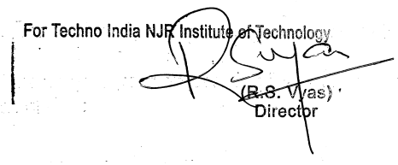In IQAC meetings some decisions were taken on results and placements. And on some other academic topics discussions were done. The complete document is enclosed as **ANNEXURE-II.**

1. **Faculty Skill up- gradation Through Certifications-**

In academic year 2023-24 faculties have successfully completed number of certifications, FDPs and workshops to enhance their skills. Faculty also received some recognition. Faculty successfully completed 16 certification, 9 international Seminar, 18 research paper, 1 patent, 55 FDPs, 6 recognitions and 16 workshops.

### Student Achievements–

The number of students of the institute holds different type of recognition in government/non-government organizations. The details of such activities areas follow:

* 1. 4 Students of 3rd year Computer Science & engineering got selected for the design boot camp run by AICTE.
  2. 3 Students of 4th year Computer Science & engineering got selected in American Express placement and gets the 18.94 LPA job offer.
  3. Startup by Civil engineering department’s students got selects as among best 3 startup in the country selected by Start-up India and NITI Aayog.
  4. Netflix has created documentary film on startup started by students of Civil engineering department and featured in Indian Film Festival 2024.

### Admission Status-

Admissions for academic year 2023-24 have been done. The institute has provided admissions to a total of 205 students in the academic year 2023-24. Including these admissions, the total strength of the college is 706 students

### Faculty Requirement-

According to AICTE guidelines, the faculty requirement should be calculated based on the sanctioned intake to maintain a faculty-student ratio of 20. Therefore, the required faculty strength should be determined accordingly. The Governing Council has sanctioned the recruitment of faculty members up to a total number of 74.

### New Infrastructure Requirement-

In view of infrastructure requirement, Governing Council has signed MoU with Nasscom and under this MoU one digital computer lab with 20 latest configuration computer system has been set in the campus for students use. To provide experiential teaching learning to students, IQAC was looking for ways to adapt and modernize the teaching experience to

allow diverse student population to learn as effectively as possible. With an ever-expanding universe of current and course-relevant content available both externally (through Internet) and internally (on campus), college needs a way to provide a way for students and professor to effectively, in a less partitioned way, supplement their course materials with newly accessible and valuable content. Total 26 rooms are ICT tools enabled for proper and efficient delivery of lectures. Along with this New ICT enabled rooms the seminar hall and server rooms are equipped with these tools. In view of new requirements some ICT tools have been purchased which includes projectors, audio systems, interactive white digital board, and projector screens.

### Starting New Course–

In view of increasing demand for engineering branches like Artificial Intelligence and Data Science, Bachelor of Computer Application (BCA). The institute started above discussed branches and course.

### AICTE Application for New Academic Year-

After detailed deliberations, the Governing Council members unanimously agreed that for AY 2023-24, in addition to extension of approval, Techno India NJR Institute of Technology should –

Apply for continuation in intake of courses, Civil Engineering (30), Computer Science and Engineering (180), Electronics and Communication Engineering (30) and Mechanical Engineering (30).

### Feedback Analysis-

Feedback from students, faculties, employers, parents and alumni as well as results for the Academic Year 2023-24 were collected and analyzed by the HODs of various departments and presented to the Governing Council for discussions and suitable actions. The reports are given in Annexure.

** The meeting concluded with vote of thanks.**

### ANNEXURE-I

**Student Feedback**

**Part-A (Student’s Feedback on Faculty Performance during the class room)**

The institute conducts student feedback on academic level and syllabus transaction. The rating is normally given on a scale of 1 to 4 based on the aspects: **Excellent (5), Very Good (4), Good (3), Average (2) and Below Average (1).**

Feedback was collected from students and based on their answers the following charts were prepared to analyze the results.

### Question-1: in the feedback form: Is teacher always punctual in coming to your class?

**Figure-1: In-Class Punctuality**

Discipline and punctuality are the major pillars of the academics. Hence the above figure shows the punctuality of teachers in different semesters. The figure reflects that in all semesters the punctuality of teachers of the institute is very good and figure approaching towards excellent in punctuality of teachers. Hence, the teachers of the institute are committed towards punctuality of their particular classes.

### Question-2: in the feedback form: Does he/she come well prepared for lecture in your class?

**Figure-2: Lecture Preparation**

Figure-2 reflects that teachers are how much prepared about the lecture and we can observe that lecture preparation of teachers in all semesters are very good and approaching towards excellent. Teachers are always well prepared with content of lecture and use notes regarding their particular topics for better and easy understanding.

### Question-3: in the feedback form: Does he/she make efforts in teaching and explanation?



**Figure-3: Efforts in Explanation**

The figure-3 shows that efforts of teachers in each semester are very good in explanation of topics. Teachers give more efforts on slow learner so that they can improve their understanding to clear the concept of topics. The graph approaching towards excellent.

### Question-4: in the feedback form: Do you understand what he/she is teaching?

**Figure-4: Understanding the Concepts Taught**

The figure-4 reflects that students have very good understanding of whatever they have been taught by teachers. Teachers explain the basic and fundamental points in very efficient way so that student can easily understand the knowhow of topics. Teachers relate each topic with industrial applications for better understanding.

### Question-5: in the feedback form: Do you feel comfortable asking him/her questions?

**Figure-5: Understanding the Concepts Taught**

The above analysis clearly points out that students can easily raise their query or doubts in fort of teachers. Also they easily participate in interaction with faculties.

### Question-6: in the feedback form: For the teacher's subject how much marks do you expect put of 100.

**Figure-7: Marks Expectation**

Since the faculties use to cover the entire syllabus hence students comfortably could mention the expected marks and it was observed that majority cases the expected marks and actual marks matched.

**PartB (Student’s Feedback on Curriculum for the year 2023-24)**

The institute conducts student feedback on academic level and syllabus transaction. The rating is normally given on a scale of 1 to 4 based on the aspects: Excellent (4), Good (3), Average (2) and Below Average (1). Feedback was collected from students and based on their answers the following charts were prepared to analyze the results.

### Question-1: in feedback form: Activities leading to Placement/Entrepreneurship

**/Life long learning/Field Projects and Internship**



**Figure-1: Placement and Other Activities**

The institute has a dedicated training and placement cell that take care of activities leading to Placement, Entrepreneurship, Lifelong learning, field Projects, and Internship. AS per analysis the above figure approximate 96% students were satisfied with the activities.

### Question-2: in feedback form: Motivation and exposure to Co-Curricular/Extra- Curricular Activities in the Institute

**Figure-2: Co-Curricular/Extra-Curricular Activities**

Along with academic activities institute also conduct co-curricular activities and as a result approx. 95% students were satisfied with these activities.

### Question-3: in feedback form: Assessment of examination at Institute Level

**Figure-3: Assessment of Examination**

The institute adopts transparent and systematically assessment of the students based on class interaction, assignments, quizzes, performance in labs and mid-term exams. Figue-3 reflects that almost all the students were satisfied with the methodology and transparency of the institute level assessment.

### Question-4: in feedback form: Does the faculty use ICT Tools for teaching?



**Figure-4: Use of ICT Tools**

The institute has several smart classrooms and all faculties adopt ICT based teaching pedagogy. As per student feedback all faculty efficiently used ICT tools during their teaching in the class.

### Question-5: in feedback form: Is the faculty successful in improving your understanding of concepts and principles in the subject?

**Figrure-5: Improvement of Concepts**

As per figure-5 approx. 96% students accepts that faculty successfully improves their understanding of concepts and principles in the subjects.

**Action Taken:** Feedback was collected at the end of each semester during the academic year 2023-24. Key observations and actions based on the feedback include:

1. **Enhanced ICT Facilities:**
   * While the institute had enhanced its ICT facilities, further upgrades were implemented to support additional training and certifications.
   * A few more ICT-enabled classrooms were prepared, and a NASSCOM lab was established under an MoU with NASSCOM to improve the technical learning environment.
2. **NASSCOM Courses:**
   * The institute partnered with Mouktik Pvt. Ltd. to offer NASSCOM certification courses to students, enhancing their industry readiness.
3. **Skill Development Initiatives:**
   * New courses, such as the “IBM Skill Build Remote Online Internship,” focusing on front-end development and data science, were introduced to develop in-demand skills.

**Parent Feedback–**

### Parents’ Feedback on Curriculum for the year 2023-24

The institute conducts Parents' feedback on institute facilities and syllabus transaction. The rating is normally given on a scale of1 to 4 based on the aspects: Excellent (4), Good (3), Average (2) and Below Average (1). Feedback was collected from Parents and based on their answers the following charts were prepared to analyze the results.

### Question No1 in feedback form: Are you happy with the progress of your ward in academics?

**Figure-2: Progress of Ward**

Analysis of figure-1reflects that all parents were extremely satisfied with the progress of their wards in the academics.

### 

### Questio-2: in feedback form: How do you rate the infrastructural facilities provided by the institute?

**Figure-2: Infrastructural Facilities**

As per figure parents were satisfied with infrastructural facilities provided by the institute.

### Question-3: in feedback form: Are you happy with the curricular (Add-on Courses/Seminar/Guest Expert Lectures) & Extra-Curricular Activities organized by the Institute?

### 

**Figure-3: Co-Curricular/Extra-Curricular Activities**

The figure-3 reflects that parents are satisfied with the co-curricular activities conducted

by the institute.

### Question-4: in feedback form: Are you satisfied with the Administration of Institute?

**Figure-4: Administration**

The institute has a well-defined administrative policy and regulation and hence parents are satisfied with the administration of the institute.

### Question-5: in feedback form: Are you satisfied with the student’s discipline of the Institute?



**Figure-5: Discipline**

The analysis of above figure shows that parents are satisfied with the discipline of the institute and there was hardly any disciplinary case.

### Question No 6 in feedback form: Does your ward/Institute regularly inform you about his/her performance?

**Figure-6: Ward Performance Report**

Even though regular parent-teacher meetings were conducted still few parents suggested to increase the frequency of the meeting on their ward performance.

**Actions taken-**Parents requested to increase frequency of parent teacher meeting. It was well taken and management is working on the same. And parents also suggested that result of internal examinations to be shared over whatsapp.

**Employer Feedback-**

### Employer’s Feedback on Curriculum for the year 2023-24

The institute conducts Employer's feedback on institute facilities and syllabus transaction. The rating is normally given on a scale of 1 to 4 based on the aspects: Excellent (4), Good (3), Average (2) and Below Average (1). Feedback was collected from employer and based on their answers the following charts were prepared to analyze the results.

### Question-1: in feedback form: Academic knowledge of the students

**Figure-1: Academic Knowledge of Students**

Most of the employers were satisfied with student academic knowledge.

### Question-2: in feedback form: Syllabus is suitable for Employability and is need based and as per current trends in market

**Figure-2: Syllabus Suitability**



Employers were satisfied with the syllabus content. However, they have suggested the students to pursue industry certification, trainings, and MOOC sessions.

### Question-3: in feedback form: Ability of the employee to apply the concepts of engineering to workplace

**Figure-3: Applying Engineering Concepts to Workplace**

As per the analysis of figure-3, the employers were satisfied with the students innovative skills to workplace. They have also suggested to teach them leadership and soft skills.

**Question-4: in feedback form: Ability of the employee to identify, formulate, interpret, analyze, and solve problems**



### Figure-4: Problem Solving Skills

Employers suggested to teach the analytical and reasoning skills to the students so that they can better solve real life problems and have the idea to formulate and interpret any problem statement.

**Question-5: in feedback form: Ability of the employee to communicate**

**Figure5: Communication Skills**

Even though the institute organizes the communication classes for the students, still the employers suggested to teach business reports preparation, presentation skills, email writing, corporate culture, and ethics.

### Question-6: in feedback form: Ability to work in a team



**Figure-6: Team Work**

As per analysis of the figure-6 employers expressed that students have very skills to work as a team and provided good results when students have worked in team.

**Actions taken**– Some special classes were organized for analytical reasoning and quantitative aptitude. Soft skills based expert sessions were also conducted. The institute participated in Smart India Hackathon and organized trainings on .Net by corporate trainers.

**Alumni Feedback**-

### Alumni’s Feedback on Curriculum for the year 2023-24

The institute conducts Alumni's feedback on institute facilities and syllabus transaction. The rating is normally given on a scale of 1 to 4 based on the aspects: Excellent (4), Good (3), Average (2) and Below Average (1). The feedback form included 2 questions related to syllabus transactions and the same was analyzed using the above4- point scale. Feedback was collected from alumni and based on their answers the following charts were prepared to analyze the results.

### Question-1: in feedback form: How do you find over all infrastructure at the Institute?

**Figure-1: Infrastructure**

Analysis of figure-1 reflects that the infrastructure of the institute was extremely well taken by the alumni and hence the feedback was excellent.

### Question-2 & 3: in feedback form: How do you rate Syllabus in preparing you for a Job/Higher Studies?

**Figure2: Syllabus to meet Job/Higher Studies**

Analysis of figure-2 shows that even though majority of the alumni were satisfied with the syllabus content still to make the student industry ready/higher studies, they should pursue industry certification, trainings, and MOOC sessions.

### Question-4: in feedback form: Did you attend industry training/internship to prepare for industry job?



**Figure-4: Industry Training/Internship for Job**

One of the salient features of the institute is that major stress is given on training internship to make the student placement ready. This is beyond the syllabus activity and hence the placement trace records were satisfactory.

### Question-5: in feedback form: Rate the various curricular, co-curricular and extra- curricular activities, during your course of study, in the Institute.

**Figure-5: Co-Curricular/Extra-Curricular Activity**

Majority of the alumni were extremely satisfied with the Co-Curricular/Extra-Curricular activity conducted by the institute.

**Actions Taken:**

1. Alumni involvement in academic activities was increased to provide real-world insights:
   * Expert lectures were arranged featuring alumni to discuss contemporary corporate needs and ethics.
   * Alumni, including Adnan Peepawala, PayalPatal, Ankush Choudhary, AkshayNandwana, Ritwik Dave, and Jayant, were onboarded as student mentors to guide current students.
2. A framework for regular interaction with alumni was implemented, aiming to improve curriculum alignment with industry demands and foster better mentorship opportunities.

**ResultAnalysisandActionTaken**

### Result Analysis of I-Year

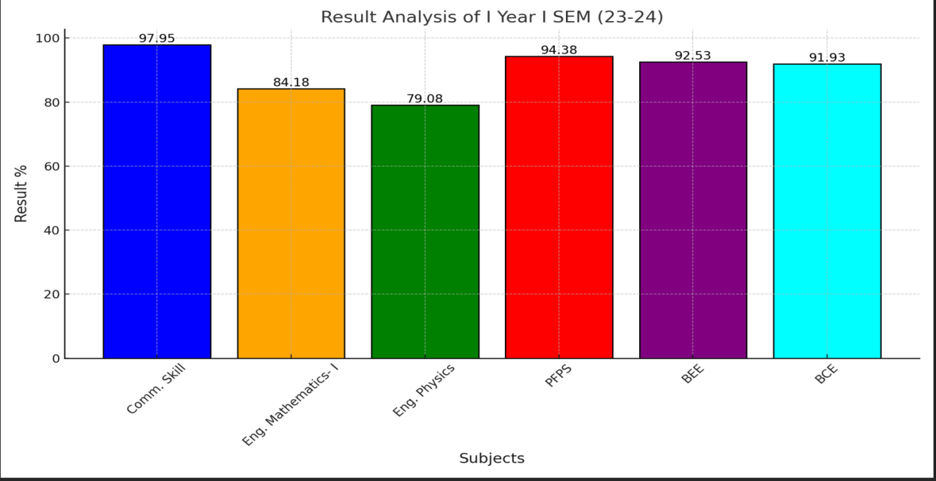

**Figure-1: Result Analysis of I Semester**

Figure-1 shows that result of I-year I Semester are above 90% in four subjects and above 80% in one subject and 79% in another subject. For this subject (79% result) the concern faculty is advised to attend training program.



**Figure-2: Result Analysis of II Semester**

Figure-2 shows that result of I-year II Semester are above 90% in four subjects and above 80% in remaining subjects. The result was satisfactory in this semester hence no action was taken on this result.

### Result Analysis of Electronics & Communication Engineering Department

**Figure-1: Result Analysis of III Semester ECE**

As figure-1 reflects that results are 100% in one subjects and in two subjects are above 90% and in remaining subjects it is below 70%. Hence, faculties are advised to attend FDP on these subjects and to do some certification course so that result could be improved.



### Figure-2: Result Analysis of IV Semester ECE

Figure-2 reflects that result of five subjects is above 80%. And result of one subject is below 80%. For these one subjects after result declaration question papers were reviewed and instructions given to the concern faculties to attend some training programs to improve their teaching.

**Figure-3: Result Analysis of V Semester ECE**

Figure-3 reflects that result is 100% in five subjects and 94% in one subject. So overall result was satisfactory so no action has been taken.



### Figure-4: Result Analysis of VI Semester ECE

As figure-1 reflects that results in all subjects are above 85%. Hence overall result is satisfactory and hence no action was taken on this result.

### Result Analysis of Electrical Engineering Department

**Figure-1: Result Analysis of VII Semester EE**

As figure-1 reflects that results are 100% in all subjects. Hence overall result is satisfactory and hence no action was taken on this result.



**Figure-2: Result Analysis of VI Semester EE**

As figure-1 reflects that results are 100% in all subjects. Hence overall result is satisfactory and hence no action was taken on this result.

### Result Analysis of Computer Science & Engineering Department

**Figure-1: Result Analysis of III Semester CSE**

As figure-1 reflects that results are above 90% in all subjects. Hence overall result is satisfactory and hence no action was taken on this result.

**Figure-2: Result Analysis of IV Semester CSE**



As figure-2 reflects that results are above 90% in all subjects. Hence overall result is satisfactory and hence no action was taken on this result.

### Figure-3: Result Analysis of V Semester CSE

Asfigure-3 reflects that results are above 90% in all subjects. Hence, overall result is satisfactory and hence no action was taken on this result.

**Figure-4: Result Analysis of VI Semester CSE**

As figure-4 reflects that results are above 90% in all subjects. Hence, overall result is satisfactory and hence no action was taken on this result.

**Figure-5: Result Analysis of VII Semester CSE**

As figure-5 reflects that results are above 90% in all subjects. Hence, overall result is satisfactory and hence no action was taken on this result.

### Figure-6: Result Analysis of VIII Semester CSE

As figure-6 reflects that results are above 90% in all subjects. Hence, overall result is satisfactory and hence no action was taken on this result.



### Result Analysis of Mechanical Engineering Department

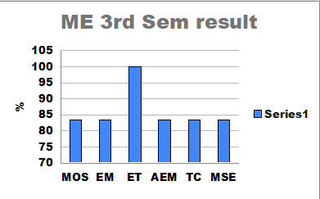

**Figure-1: Result Analysis of III Semester ME**

As figure-1 reflects that results are above 80% in allsubjects. Hence overall result is satisfactory and hence no action was taken on this result.

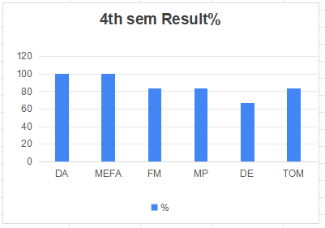

**Figure-2: Result Analysis of IV Semester ME**

As figure-2 reflects that results are 80% and above 80% in five subjects. And in one subject result is below 80%. Hence concern faculty is advised to attend certification program.

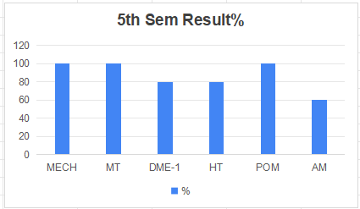

### Figure-3: Result Analysis of V Semester ME

As figure-3 reflects that results are 80% and above 80% in five subjects. And in one subject result is below 80%. Hence concern faculty is advised to attend certification program.

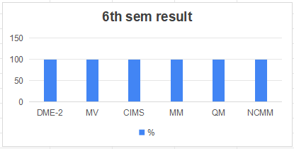

**Figure-4: Result Analysis of VI Semester ME**

As figure-4 reflects that results are above 80% in all subjects. Hence overall result is satisfactory and hence no action was taken on this result.



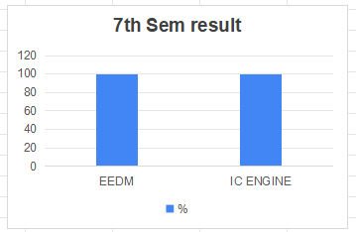

**Figure-5: Result Analysis of VII Semester ME**

As figure-5 reflects that results are above 80% in all subjects. Hence overall result is satisfactory and hence no action was taken on this result.

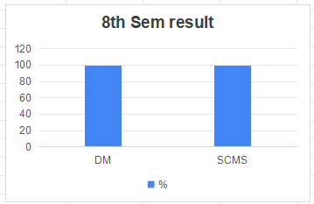

**Figure-6: Result Analysis of VIII Semester ME**

As figure-6 reflects that results are 100% in all subjects. Hence overall result is satisfactory and hence no action was taken on this result.



### Result Analysis of Civil Engineering Department

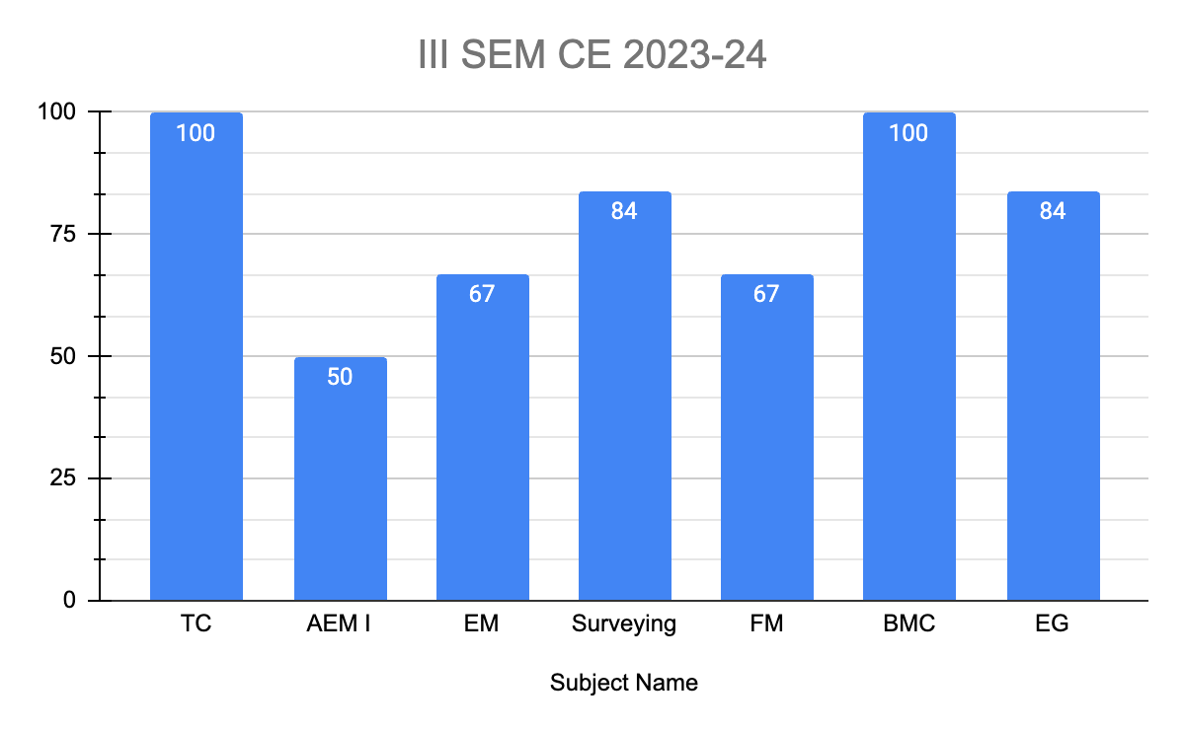

**Figure-1: Result Analysis of III Semester CE**

Figure-1 reflects that in four subjects result are above 80% and in three subjects it is below 80%. And hence the question papers were reviewed and the concern faculties were instructed to join faculty development programs or trainings to improve their knowledge of subjects.

 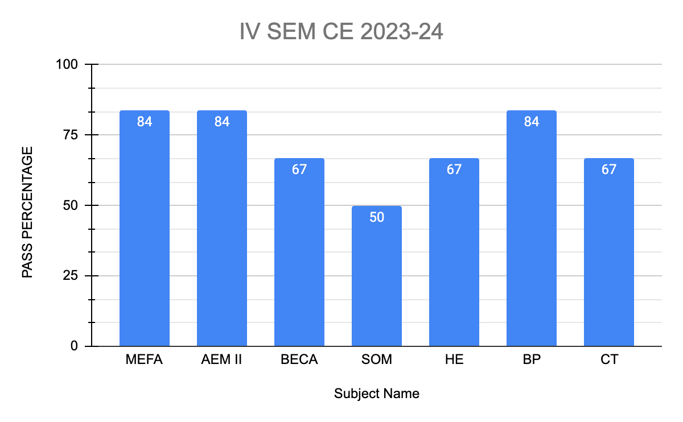

**Figure-2: Result Analysis of IV Semester CE**

As figure-2 reflects that results are above 80% in three subjects. And result is below 80% in four subjects. And hence the question papers were reviewed and the concern faculties were instructed to join faculty development programs or trainings to improve their knowledge of subjects.

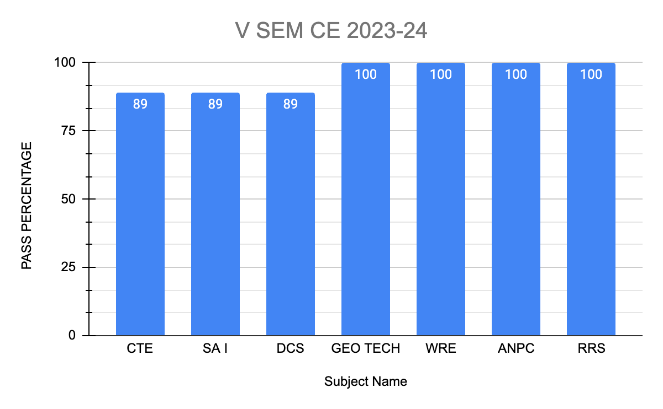

**Figure-3: Result Analysis of V Semester CE**

As figure-3 reflects that in four subjects results are 100% and above 80% in three subjects. Hence result was satisfactory and hence no action was taken.

 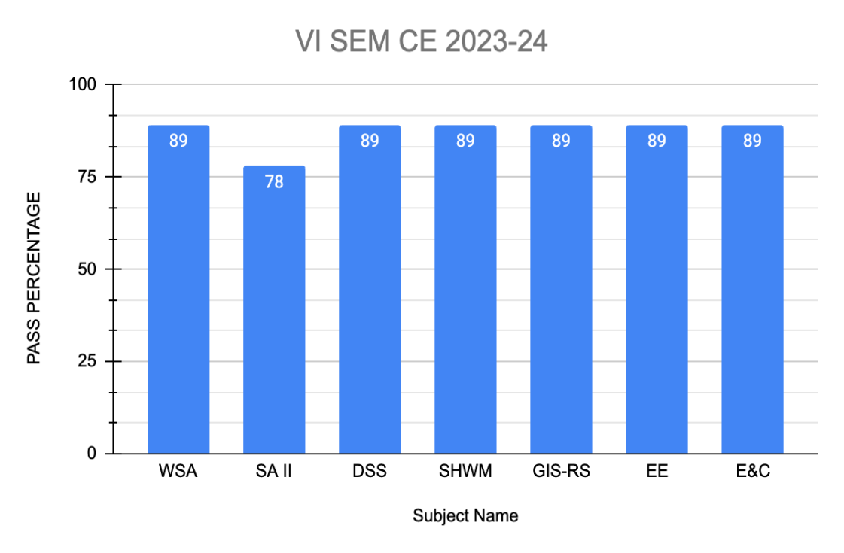

**Figure-4: Result Analysis of VI Semester CE**

As figure-3 reflects that in six subjects results are above 80% and below 80% in one subject. And hence the question papers were reviewed and the concern faculties were instructed to join faculty development programs or trainings to improve their knowledge of subjects.

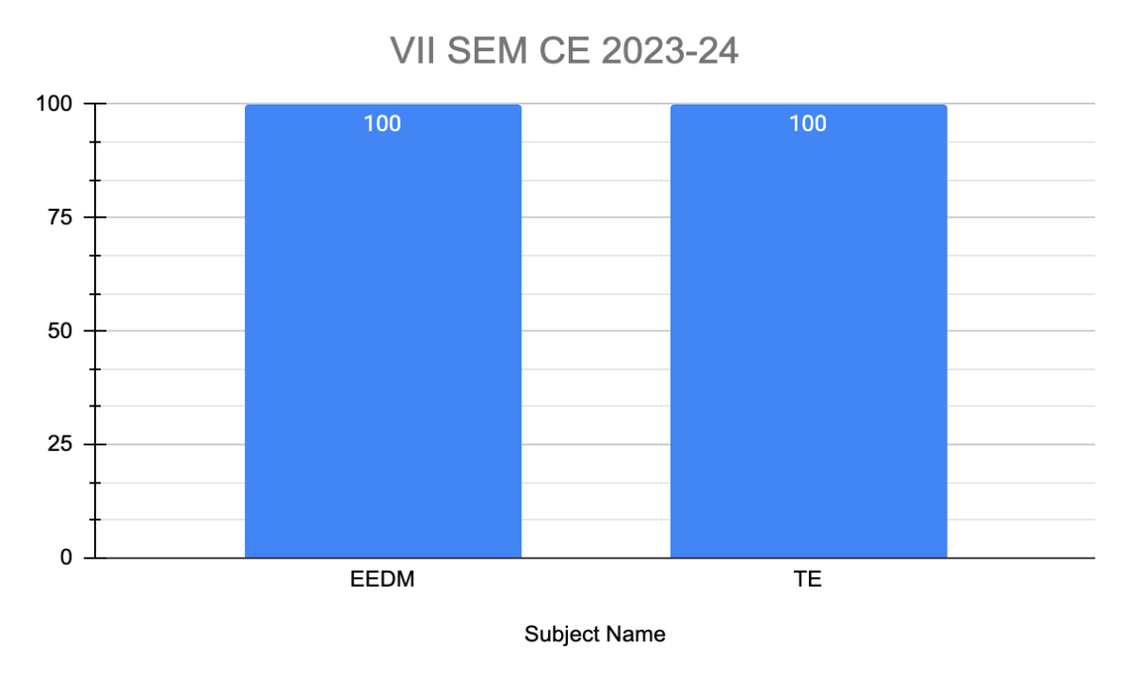

**Figure-5: Result Analysis of VII Semester CE**

As figure-2 reflects that results are 100%. Hence overall result is satisfactory and hence no action was taken on this result.

 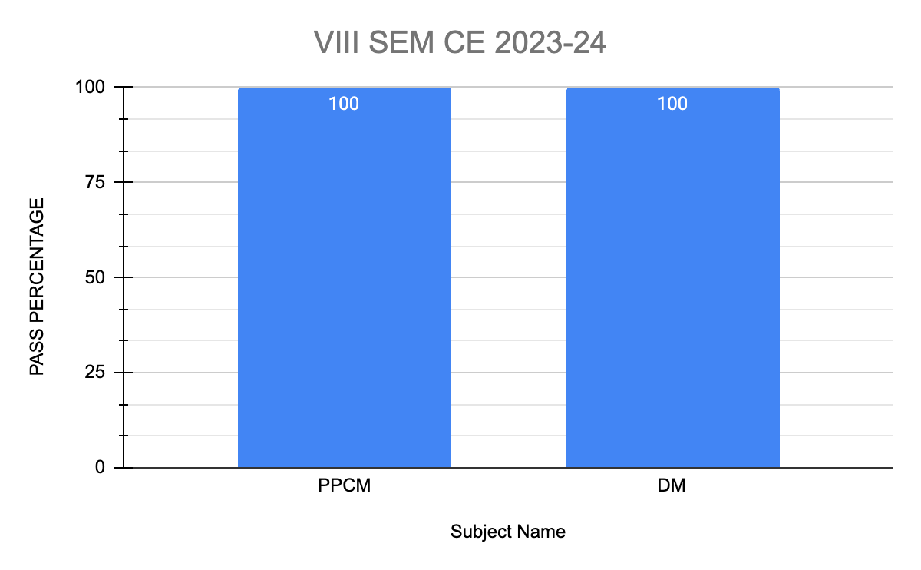

**Figure-6: Result Analysis of VIII Semester CE**

As figure-2 reflects that results are100% in all subjects. Hence over all result is satisfactory and hence no action was taken on this result.

