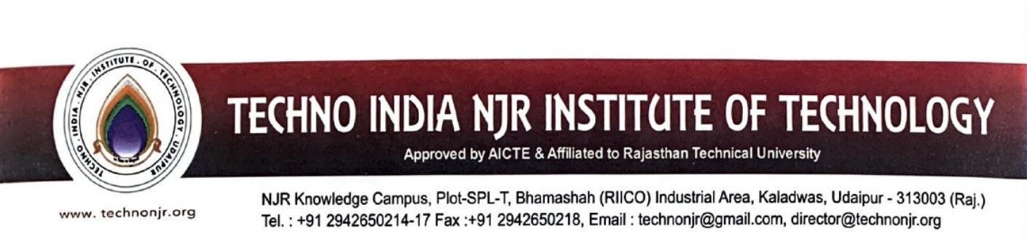

**Date:-09-7-2024**

**To Whomsoever it May Concern**

Techno India NJR Institute of Technology is pleased to inform you that we have established a number of functional Memorandums of Understanding (MoUs) with various institutions of national and international importance, universities, industries, and corporate houses throughout the year.

For more details, please refer to the link below:

<https://iqac.technonjr.org/aqar/2023-24/part-b/3.4.2>

