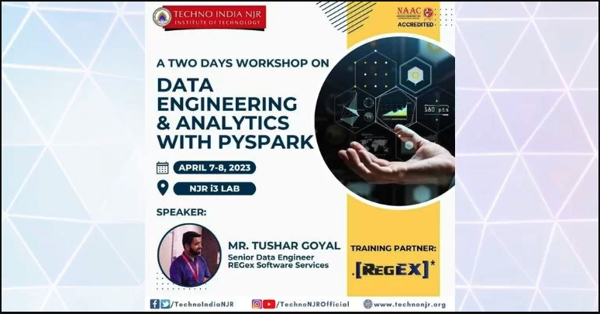

**Event Report**

**Workshop Title**: Data Engineering & Analytics with PySpark  
**Speaker**: Mr. Tushar Goyal, Sr. Data Engineer, REGex Software Services  
**Dates**: 7th - 8th April 2023  
Venue: NJR i3 Labs, Techno NJR Knowledge Campus, Udaipur

**Introduction**

A two-day workshop on "Data Engineering & Analytics with PySpark" was successfully organized, featuring Mr. Tushar Goyal, a seasoned Senior Data Engineer from REGex Software Services. The event was aimed at equipping participants with hands-on skills and advanced knowledge in data engineering and analytics using PySpark, a leading big data processing framework.

**Overview**

The workshop was divided into theory and practical sessions over two days, covering the following key topics:

1. **Day 1 - Foundational Concepts**
   * Introduction to Big Data and PySpark
   * Understanding RDDs (Resilient Distributed Datasets) and DataFrames
   * Setting up PySpark and practical hands-on installation
   * PySpark's architecture: Spark Core, Spark SQL, and Spark Streaming
2. **Day 2 - Advanced Techniques and Real-world Applications**
   * Advanced transformations and actions in PySpark
   * Handling structured and unstructured data
   * Data cleaning and preprocessing with PySpark
   * Use cases in real-world analytics projects
   * Best practices in PySpark for scalable data engineering

**Speaker's Highlights**

Mr. Tushar Goyal brought a wealth of experience to the workshop, sharing insights from his professional journey and presenting real-world case studies. His teaching methodology included:

* Clear explanations of complex concepts
* Live coding demonstrations
* Interactive Q&A sessions to address participant queries

**Participation and Engagement**

The workshop witnessed enthusiastic participation from a diverse audience of students, data professionals, and researchers. Key highlights of participant engagement included:

* Hands-on exercises with live datasets
* Group discussions to solve data engineering challenges
* Personalized feedback from the speaker

**Key Takeaways**

Participants gained:

* A deep understanding of PySpark’s architecture and components
* Practical experience in processing large-scale datasets
* Skills to implement scalable data pipelines
* Knowledge of industry best practices for data engineering

**Feedback**

The workshop received overwhelmingly positive feedback. Attendees appreciated the clarity of explanations, the balance of theory and practicals, and the expertise of the speaker.

**Conclusion**

The two-day workshop was a resounding success, providing valuable learning opportunities for all attendees. It served as a platform to enhance skills in data engineering and analytics with PySpark and inspired participants to explore further applications of big data technologies in their respective domains.

**Acknowledgment**  
Special thanks to Mr. Tushar Goyal for his exceptional contribution, and to the organizing committee for their efforts in ensuring a seamless event experience.