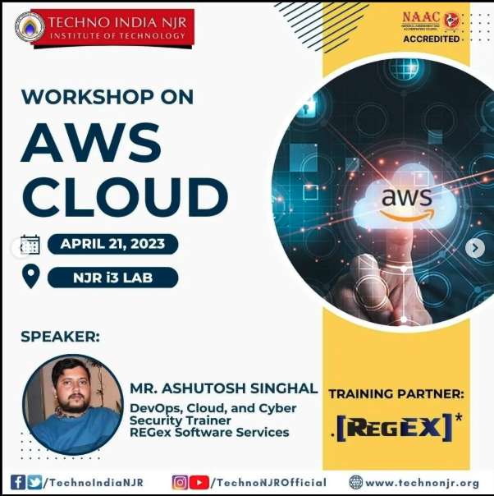

**Event Report**

**Workshop Title**: Introduction to AWS Cloud  
**Speaker**: Mr. Ashutosh Singhal, DevOps Engineer, REGex Software Services  
**Date**: 21st April  
Venue: NJR i3 Lab, Techno NJR Knowledge Campus, Udaipur  
Social Media URL: https://www.instagram.com/p/CrcRIXsJ0Pq/?img_index=1&igsh=bG55NXlzZXJ4NXI2

**Introduction**

On 21st April, a one-day workshop on "AWS Cloud" was conducted by Mr. Ashutosh Singhal, a seasoned DevOps Engineer from REGex Software Services. This workshop aimed to introduce participants to the fundamentals of AWS Cloud and its wide-ranging services, focusing on practical implementation and use cases relevant to cloud computing and DevOps practices.

**Workshop Content**

The workshop was designed to provide a mix of theoretical knowledge and practical exposure. The following topics were covered during the session:

1. **Introduction to Cloud Computing**
   * Fundamentals of cloud computing
   * Overview of cloud service models (IaaS, PaaS, SaaS) and deployment types (Public, Private, Hybrid)
2. **AWS Overview**
   * Introduction to AWS and its global infrastructure
   * Core AWS services: Compute (EC2), Storage (S3), and Networking (VPC)
   * Security and Identity Management (IAM)
3. **Hands-On Session**
   * Setting up an AWS account
   * Launching and managing EC2 instances
   * Creating and managing S3 buckets
   * Configuring IAM users and roles for secure access
4. **AWS Use Cases and Best Practices**
   * Real-world applications of AWS in business and DevOps
   * Cost optimization strategies using AWS

**Speaker's Highlights**

Mr. Ashutosh Singhal shared his expertise in AWS and DevOps, providing practical insights into industry practices. Key highlights included:

* Simplifying complex AWS concepts with relatable analogies
* Hands-on exercises to ensure practical understanding
* Sharing real-world scenarios to demonstrate AWS capabilities

**Participation and Engagement**

The workshop attracted a diverse group of attendees, including students, IT professionals, and enthusiasts keen to explore cloud computing. Engagement highlights included:

* Interactive Q&A sessions
* Step-by-step guidance during the hands-on activities
* Sharing of best practices for AWS adoption

**Key Takeaways**

Participants left the workshop with:

* A strong foundation in AWS Cloud fundamentals
* Practical experience in setting up and managing AWS services
* Insights into securing AWS environments
* Knowledge of real-world applications and cost management strategies

**Feedback**

The participants appreciated the workshop for its clarity, interactive nature, and practical approach. They particularly valued the hands-on session, which made the learning experience immersive and effective.

**Conclusion**

The one-day workshop on AWS Cloud was a great success, providing a comprehensive introduction to AWS Cloud and its applications. It empowered attendees with essential cloud computing skills, paving the way for further exploration in the domain of AWS and DevOps.

**Acknowledgment**  
A special thanks to Mr. Ashutosh Singhal for his engaging and informative session, and to the organizing team for ensuring a well-executed event.

