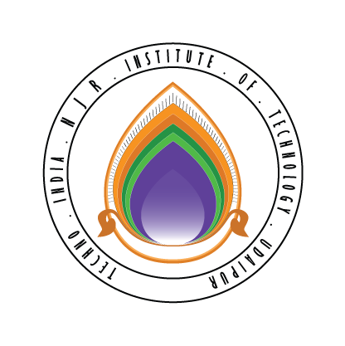 | Techno India NJR Institute of Technology  Bhamashah (RIICO) Industrial Area, Kaladwas, Udaipur

Date: 22/01/2018
IBM-BA Training
IBM-BA Training by Dr.Jitendra Shreemali will start from 29 January 2018 for 2014-18 batch students:

S.No. | Name
1 | Ajit Singh
2 | Arushi Mehta
3 | Harshvardhan Singh
4 | Janil Malhara
5 | Khushboo Chandak
6 | Kirti Joshi
7 | Manasi Pandya
8 | Neha Karmakar
9 | Nikunj Parikh
10 | Pourush Sharma
11 | Rohit Mehta
12 | Sanyam Jain
13 | Shivam Joshi
14 | Shivansh Nalwaya

Gaurav Kumawat

