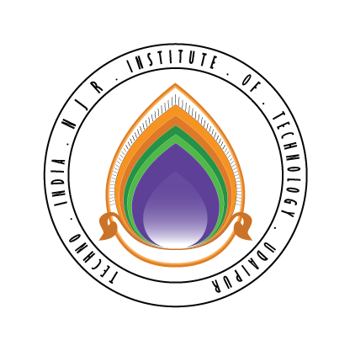 | Techno India NJR Institute of Technology  Bhamashah (RIICO) Industrial Area, Kaladwas, Udaipur

Date: 09/06/2018
IBM-BA Training
IBM-BA Training based on the IBM-BA Course by Dr.Jitendra Shreemali will begin from 6 June 2018 for 2015-19 batch students:
S.No. | Name
1 | Ananya Bhatnagar
2 | Anirudh Muhnot
3 | Anshul Porwal
4 | Dhairyaa jain
5 | Gunjan Agrawal
6 | Juhi Sankhla
7 | Kajal Gupta
8 | Kunal Bhardwaj
9 | Purvi Sharma
10 | Rohit Patidar
11 | Shivam Agrawal
12 | Shreeman Purohit
13 | Tathagat Chaturvedi
14 | Umangini Jain
15 | Vedant Sharma
16 | Vibha Mehta
17 | Yash Bhati
18 | Yogini Chaturvedi

Gaurav Kumawat

