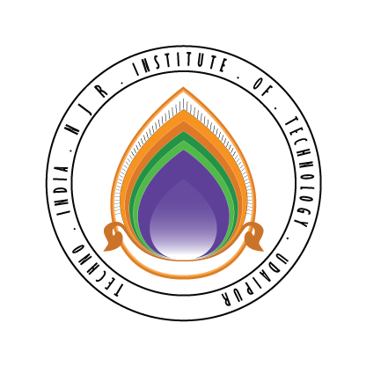 | Techno India NJR Institute of Technology  Bhamashah (RIICO) Industrial Area, Kaladwas, Udaipur

Date: 01/06/2018
IBM-BA Training
IBM-BA Training based on the IBM-BA Course by Dr.Jitendra Shreemali will begin from 6 June 2018 for 2016-20 batch students:
IBM ICE
1 | 16ETCCS033 | MOHAMMED YAHYA | IBM (BA)
2 | 16ETCCS048 | PRIYANSHA JAIN | IBM (BA)
3 | 16ETCCS054 | SAMRIDH SHARMA | IBM (BA)
4 | 16ETCCS061 | VAIBHAV PATHAK | IBM (BA)
5 | 16ETCIT013 | DANISH PALIWAL | IBM (BA)
6 | 16ETCIT024 | LAKSHIT SINGH RATHORE | IBM (BA)

Gaurav Kumawat

