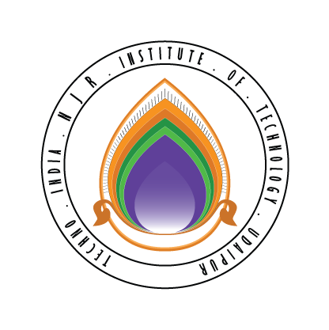 | Techno India NJR Institute of Technology  Bhamashah (RIICO) Industrial Area, Kaladwas, Udaipur

Date: 1/07/2017

C/DSA Training by Cranes Varsity

C/DSA training will be conducted from 10th July 2019 (Monday). Training will be conducted by Mr. Siknadar. Those who have enrolled for training they should reach in oops lab at 8:15am. The class timing will be from 8:30 am to 4:00 pm.

Gaurav Kumawat
(Department Coordinator)

