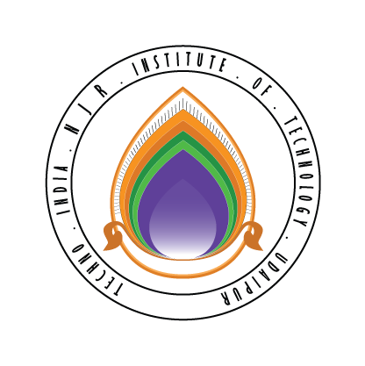 | Techno India NJR Institute of Technology  Bhamashah (RIICO) Industrial Area, Kaladwas, Udaipur

Date: 4/06/2019

C/DSA Training

C/DSA training will be conducted from 11th June 2019 (Monday). It is mandatory for all second-year students. The training will be conducted by Mr. Gaurav Kumawat. The class timing will be from 9:30 am to 11:00 am.

Gaurav Kumawat
(Department Coordinator)

