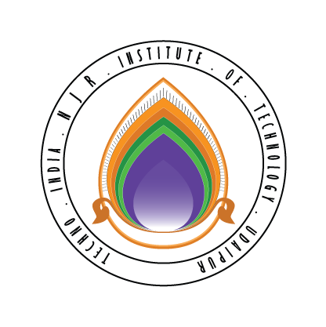 | Techno India NJR Institute of Technology  Bhamashah (RIICO) Industrial Area, Kaladwas, Udaipur

Date: 13/06/2020

Digital Marketing

Digital Marketing training will be conducted from 15th June 2020 (Monday). It is mandatory for all second-year students. The training will be conducted by Mr. Akshat Bordia. The class timing will be from 3:00 pm to 4:00 pm. Zoom Link will be shared in your WhatsApp Group.

Gaurav Kumawat
(Department Coordinator)

