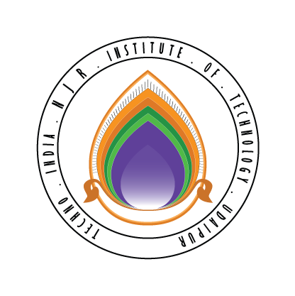 | Techno India NJR Institute of Technology  Bhamashah (RIICO) Industrial Area, Kaladwas, Udaipur

Date: 11/05/2019

Oracle SQL Training

Oracle SQL training will be conducted from 20th May 2019 (Monday). It is mandatory for all third-year students. The training will be conducted by Mr. Pankaj Chittora. The class timing will be from 8:00 AM to 10:00 AM.

Gaurav Kumawat
(Department Coordinator)

