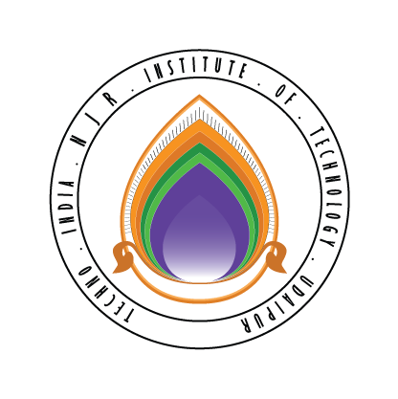 | Techno India NJR Institute of Technology  Bhamashah (RIICO) Industrial Area, Kaladwas, Udaipur

Date: 10/05/2016

Php Programming Training

Php Programming training will be conducted from 16th May 2016 (Monday). Training will be conducted by Ms. Poornima Dave. It is mandatory for all second-year students. The class timing will be from 1:00 PM to 3:00 PM.

Gaurav Kumawat
(Department Coordinator)

